2017: A Year of Amazing Anniversaries
For Israel and the World

Netanyahu’s Speech Before the United Nations General Assembly
September 19, 2017: ISRAELI PM BENJAMIN NETANYAHU FULL SPEECH AT UN 9/19/17
https://www.youtube.com/watch?v=_JF9cWmjgEc
Uploaded by Right Side Broadcasting Network - Tuesday, September 19, 2017: Israeli Prime Minister Benjamin Netanyahu will address the 72nd meeting of the United Nations
Full Text of the Speech: Times of Israel:
https://www.timesofisrael.com/full-text-of-prime-minister-benjamin-netanyahus-un-sp...
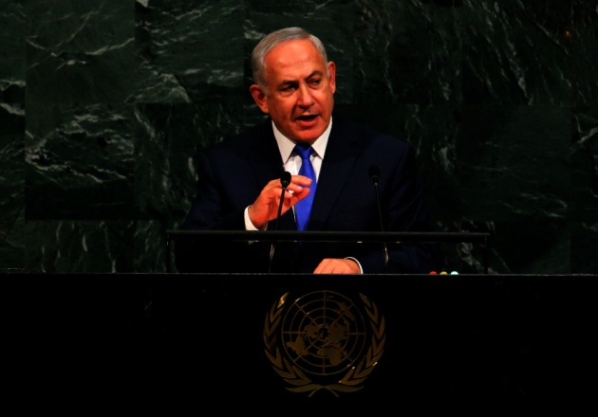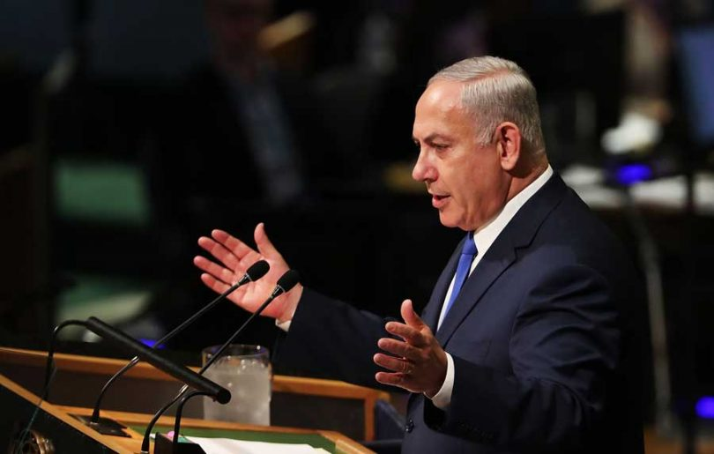
“The Light of Israel will never be extinguished”

In this awesome speech, Prime Minister Benjamin Netanyahu mentions the anniversaries that Israel celebrates in 2017
1) 120th anniversary of Theodore Herzl’s Convention of the 1st Zionist Congress.
The Congress was held in Basel, Switzerland, August 29th to August 31, 1897.
Netanyahu said: “We’ve returned to the Promised Land”
2) 100th anniversary of the Balfour Declaration: On November 2, 1917, Foreign Secretary Arthur James Balfour wrote a letter to Britain's most illustrious Jewish citizen, Baron Lionel Walter Rothschild, expressing the British government's support for a Jewish homeland in Palestine. To the Zionists, the Balfour Declaration of 1917 laid the foundation for the formation of the state of Israel.
3) 70th anniversary of the United Nations Resolution to establish the Jewish State, November 29, 1947: On Nov. 29, 1947, the United Nations General Assembly passed a resolution calling for Palestine to be partitioned between Arabs and Jews, allowing for the formation of the Jewish state of Israel
4) 50th anniversary of the Uniting of Jerusalem June 1967: Called “the Six-Day War,” this historic war, June 5-June 10, 1967, ended with the capture of East Jerusalem by Israelis, in their possession for the first time since 70 CE.
This is a historic year for many important anniversaries.

The 1947 finding of the Dead Sea Scrolls
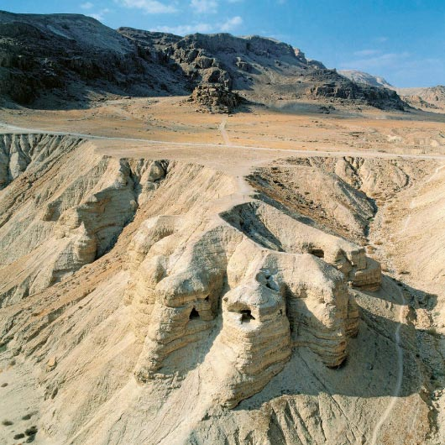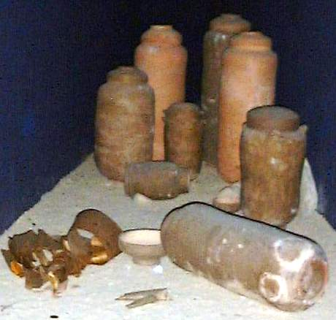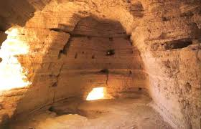
In late 1946, early 1947, Bedouin teenagers were tending their goats and sheep near the ancient settlement of Qumran, located on the northwest shore of the Dead Sea. One of the young shepherds tossed a rock into an opening on the side of a cliff and was surprised to hear a shattering sound. He and his companions later entered the cave and found a collection of large clay jars, seven of which contained leather and papyrus scrolls. An antiquities dealer bought the cache, which ultimately ended up in the hands of various scholars who estimated that the texts were upwards of 2,000 years old. Among many valuable manuscripts found was the oldest complete scroll of Isaiah, along with many other fragments of all the Scripture, except Esther, the book of Enoch I, and the writings of the “Essenes” (Zadok Priests from Jerusalem who fled the wickedness of the Romans, and rescued valuable manuscripts from the Temple which they astutely copied for many years).

Operation High Jump to Antarctica
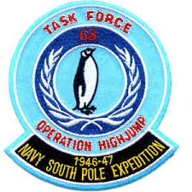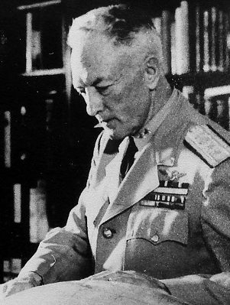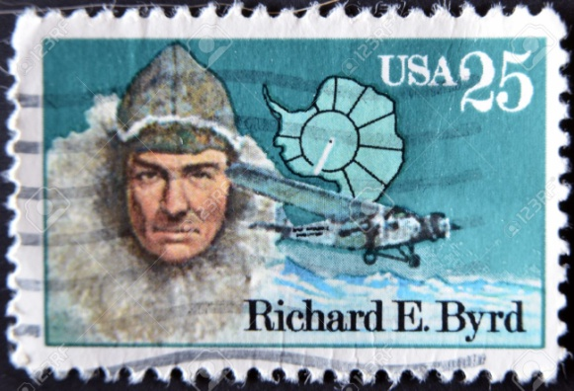
Operation High Jump commenced 26 August 1946 and ended in late February 1947. The U.S. Government sent Admiral Richard E. Byrd on a historic mission to Antarctica with a flotilla of 13 ships. It was hyped as an scientific expedition, but the real purpose was to find out what the Nazis were up to in Antarctica. They were to be there eight months, but after about eight weeks they were attacked by flying saucers who fired on them and destroyed some of the ships and killed some of the men. Byrd turned the mission back to the U.S. immediately, telling what they had seen and learned. The story was hushed up right away, but still interviews with Admiral Byrd, and his own diary, told a lot more than anyone could imagine.

The 1947 Roswell UFO Incident
An unidentified flying object crashed on a ranch northwest of Roswell, New Mexico, sometime during the first week of July 1947. Of course, the truth about that was hidden, or at least attempted to be hidden. What I am learning from much research on Hitler and the Nazi Empire--Third Reich/Third Empire--as in the book by British journalist Joseph Ferrell, The Reich of the Black Sun, is that the Roswell saucers were likely Nazi anti-gravity aircraft that was being tested in New Mexico--craft developed by former Nazi scientists, scientists who had been taken into America to further their work underground under Operation Paperclip, 1945 to recent times. As to the pilots being “grays,” is not hard to believe due to my knowledge of the hook-up between German-Nazis scientists from the 1920s with “aliens,” a.k.a. “extra-terrestrials,” or Scriptural “Nephilim” hybrids, and what is waiting under the earth to surface on the earth, i.e. Revelation 9.
From The Reich of the Black Sun by Joseph Farrell, page 282: “The government took into its possession the wreckage and the bodies for careful study and evaluation and in September 1947 officially established Operation Majestic-12 as a `top secret Research and Development/Intelligence operation responsible directly and only to the President of the United States.’ ”

The CIA (Central Intelligence Agency) was created July 26, 1947 when President Harry S. Truman signed the National Security Act into law. It was formerly announced September 18, 1947. It was founded by Dwight D. Eisenhower, Harry S. Truman, Allen Dulles, and William J. Donovan. It has proven to clearly be a covert operation Nazi-style organization, which has carried on projects of torture, and Nazi mind-splitting of children, creating MK Ultra children/Manchurian Candidates, i.e. weaponizing human beings to carry out their covert assignments to change the course of nations. They are a secret and infamous “Black-Operation” group that creates evil in order to bring the desired “order.”

The United States Air Force became a separate military service on 18 September 1947 with the implementation of the National Security Act of 1947.

2017 is the 70th anniversary of the first recorded Weather Geoengineering: Learn about this in my recent article: “70 Years of Weather Geoengineering – 70 Years of Man’s Destroying Earth’s Life Support Systems,” under the Mikvah of Preparation. Patens for weather modification go back nearly 100 years, but the implementation of it stems from 1947.

The year 2017 will mark 100 years since the Russian Revolution. Heralding the collapse of the 300-year-old Romanov royal dynasty, a bitter civil war and the rise of communism, the revolution had a profound impact on the course of world history. Centennial of the Russian Revolutions, March 8-November 7, 1917. On November 7, Lenin and his fellow “Bolsheviks” launched the October Revolution, overthrowing Kerensky’s government in a nearly bloodless coup d’état. Lenin made peace with Germany and began asserting control over the sprawling Russian empire.
This is the One Hundred Fiftieth Anniversary of the Alaska Purchase--March 30, 1867. Yes, there once was a time when the U.S. Senate acted quickly. In 1860s a cash-strapped Tsar Alexander II feared Russia might not be able to defend its claim to its distant colony in Alaska. So he decided to turn a lemon into lemonade by selling the territory to the United States. The American Civil War put the effort on hold, but talks resumed in 1867. In rapid fire negotiations that culminated in an all-night bargaining session on March 30, 1867, U.S. Secretary of State William H. Seward agreed to pay $7.2 million—or a little more than two cents per acre—for the Russian colony. In 1912, Alaska was formally made a territory of the United States. On January 3, 1959, it became the 49th state.

Centennial of the U.S. Entry into World War I, April 6, 1917.
Another notable event from the First World War – US entry into the conflict – also happened 100 years ago, on 6 April 1917. US involvement marked a decisive turning point in the war, as more than five million American soldiers ultimately fought in the conflict.
When the “Great War” began in 1914, President Woodrow Wilson immediately declared U.S. neutrality. But neutrality was hard to maintain. At 8:30 p.m. on April 2, Truman addressed a joint session of Congress to request a declaration of war, saying that “the world must be made safe for democracy.”

100th anniversary of the apparitions of Mary and the Miracle of the Sun at Fatima
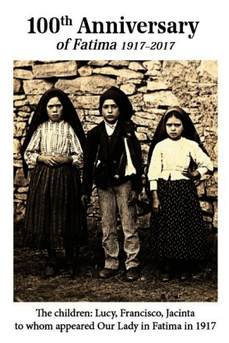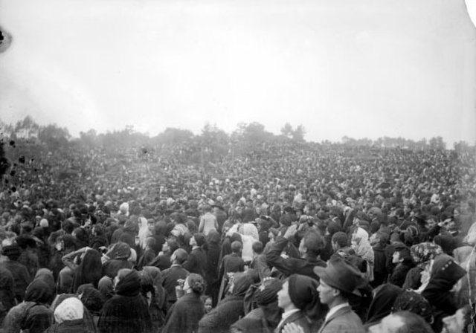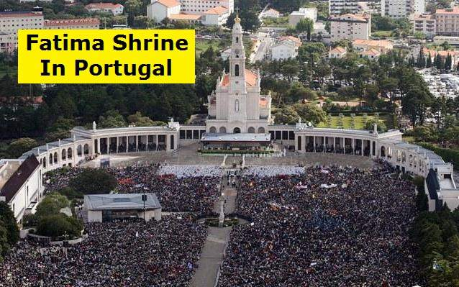
The apparitions which the three shepherd children say they saw of Mary in the Cova de Iria in Fatima, Portugal, began May 13, 1917. The “lady” appeared each month on the 13th of the month from May through October. Because of the excitement about the apparitions, the children said that the lady told them on October 13th there would be a special surprise. At least 70,000 people gathered there on October 13th to see the surprise, which turned out to be called “the miracle of the sun.” It was a rainy day. Most people were soaked from the rain, as well as the dirt. Yet, as the sun appeared to plummet to earth, everyone was dried out. The sun twirled in the sky and came down close to the people. Later
some admitted that it was not the sun (of course not) but a UFO--a large silver disc--that they saw.

Hardly anyone today, except the very religious believe it was the sun. The excellent documented book on this subject, Celestial Secrets by Portuguese historians Joaquim Fernandes and Fina D’ Armada, exposes the deceptions. I also recommend L.A. Marzulli’s new DVD “Fatima – Miracle of the Sun of Harbiner of Deception,” in which he interviews key people in Portugal about this so-called “miracle.” And, as brought out in Celestial Secrets, evidence has come to light that the oldest of the three shepherd children, Lucia, who went into a convent until her death, was told what to write by Jesuit priests, making the event into something world famous. The children never said the lady was “Mary.” But, when the Jesuit priests got through with their input, in the 1940s, the story told that it was Mary, and she told three secrets to Lucia. Yet, this event has affected multi-millions of people’s lives, and millions come each year to venerate Mary at this most famous shrine.

The Five Hundredth Anniversary of the Protestant Reformation
On October 31, 1517, Catholic priest Martin Luther nailed 95 “thesis” to the door of Wittenberg Cathedral in protest against wrong doctrines and wrong actions by the Roman Catholic pope and Vatican hierarchy in general, like the selling of “indulgences” to get out of purgatory. His action began a cry of freedom from the tyranny of Rome that rocked the world, and set Yahuwah’s people free to read the Bible in their own language and learn its knowledge taught by the Spirit of Yahuwah. It freed them to find salvation by faith alone in Messiah, and to rest in the words of the Scriptures alone as the “Word of God.”
It also launched a Jesuit-led Counter-Reformation that has never stopped, which included the slaughter of true believers and attempted destruction of the Bible.

Refer to: “The Amazing Message Behind the Numbers 3, 7, 50, 70, and 120 in Scripture” under the Mikvah of the Great Adventure. In this article, I relate how important anniversaries that changed the course of human history forever are not coincidental, but aligning to the prophetic Word of our Elohim. Abba works through time cycles. These anniversaries tell us that the timing of history has always happened by the foreknowledge of Yahuwah. Nothing is by coincidence because He is the Master organizer from the eternal realm!
These 2017 anniversaries speak of time-periods that show the wrapping up of things, along with the end of Yahuwah’s tolerance for the evil man is doing.
This is a sign to us that we must tie up all loose ends, making sure we’ve done all that He has required of us to be prepared to meet the Master and receive His “well done, good and faithful servant.”
On a personal note, November 2017 is the 50th anniversary of my oldest daughter’s birth. I can’t believe it – where has time gone? It’s also a miracle because even though my birth certificate says I was born in 1944, I am still only 20 at most, perhaps 18 at least, but still a little child in spirit.
Blessings and shalom!
Yedidah
October 10, 2017

