PREPARING TO SURVIVE A NUCLEAR ATTACK
Practical Advice

This is the first of two, or possibly three, articles on practical ways of surviving what will inevitably come to America. But, this practical advice can be used anywhere in the world, for we face a lot of nuclear activity worldwide as World War III looms ahead. Famine is raging in many countries. We must prepare as much as we can!
Noting the rise in warnings about an attack by North Korea on America, I thought I’d send you this information so you can do your own preparing for that. We all need to prepare with water and food up front, medicines if needed, etc., for a variety of things that not only could happen, but will happen as the world powers of evil are moving towards their completion of goals that go back to the tower of Babel.
The possible nearness of an EMP attack then an invasion, or a nuclear attack then an invasion, or a pandemic disease outbreak, quarantine, and then an invasion, or martial law, then an invasion, or a combination of those events, is a very real and present danger. The plans are for takeover from within or without, even if it is a false flag event by our own government, which is also very possible! Sun flares just might hit us, too, so we’ve been earned. That sounds like a good excuse for a “false flag event.”
By invasion, we think of something coming at us from the outside. That is clearly indicated in Jeremiah 50 and 51 and Isaiah 18 – referring to America. Be sure to read the “third clues,” as to the nation those Scriptures are talking about: “Thirty Clues and More Identifying America in Prophetic Scripture.” I also refer you: “The Shocking Hidden Goal of Globalism Exposed - Psalm2 and Revelation 19:19.” Both are 2017 articles and very up to date.
But, I’m sure you’re aware that we already have been invaded by the Nazis and Communists, by China and Russia, and by Islamic terrorist regimes. ISIS has camps in all of our 50 states, for example. These foreigners have “armies” as well as being business men, scientists, teachers, and military men, firmly entrenched in America for a very long time, i.e. “moles,” or in “sleeper cells.” Another way of putting it is that we’ve had Trojan Horses residing among us, most all invited in by various Presidents.
Yes, America is “hosting” Chinese and Russian troops, and martial law is in the plans, having been established years ago. Also, years ago I wrote about America’s “Operation Garden Plot” and Operation Cable Spicer.” These are operations planned for our own police and military to control the American people when they begin to riot against martial law and its “curtailments.” So, yes, this has been planned out and set up. It’s a major part of the final thrust of the globalists towards reaching their final goals.
The possibility of North Korea somehow setting off an attack on America by EMP or nuclear weapon, followed by the releasing of Chinese and Russian troops within the country to take over, plus releasing of Islamic terrorists and the “Black Awakening” programmed “chosen ones,” raises the “DEFCON rating” once again. Before the election of Donald Trump, the DEFCON rating was rising because of a possible war with Russia. [Refer to my 2016 article: “DEFCON”] Jeremiah 50 and 51 should be very familiar to you – it is about America and an attack from the North by several nations, but also attack on all sides. There is current reporting about China invading from the Gulf of Mexico. Several years ago, I wrote about the Chinese submarines in the Gulf of Mexico. Firsthand story told to me: Russian and Chinese troops were doing military exercises together near the Texas border, inside Mexico, a few years ago. When a Russian tank crossed into Texas, close-by Texas ranchers got on their horses with their rifles and headed out to meet them. The tanks tuned and fled. Now both countries have thousands of troops inside America, invited in, and given land and military bases to work on. They’ve been our “guests” for a long time. I remember the story about Obama telling the FBI to draw back from any investigations of terrorist cells of other groups in the US, before ISIS came to live with us. In other words, our takedown is being orchestrated from the highest levels. I just can’t see Trump joining in. He is trying to hold it off. So, we really need to pray for his life to be spared! If the Globalists can’t impeach him, they’ll remove him in another way. That report is current on infowars.com.
Here are excerpts from an article December 3, 2017, entitled: “ `Kim is getting closer and there's not much time left': Trump's national security adviser says the possibility of nuclear war with North Korea increases every day” by Matthew Wright For Dailymail.com: “Speaking with Fox News' Bret Baier at the Reagan National Security Forum in California, HR McMaster shared his thoughts on the increasing possibility of nuclear war. 'I think it's increasing every day,' McMaster said to Baier. 'It means we're in a race. We're in a race to be able to solve this problem.’
President Trump's national security adviser HR McMaster said on Saturday that each missile launch from North Korea increases the possibility of war…North Korea fired a intercontinental ballistic missile last week, flying 1,000 miles higher than its first ICBM launch in July. And Kim Jong Un's nuclear ambitions are the gravest national security threat that America faces, according to McMaster.
`The greatest immediate threat to the United States and to the world is the threat posed by the rogue regime in North Korea and his continued efforts to develop a long range nuclear capability,' he added.”
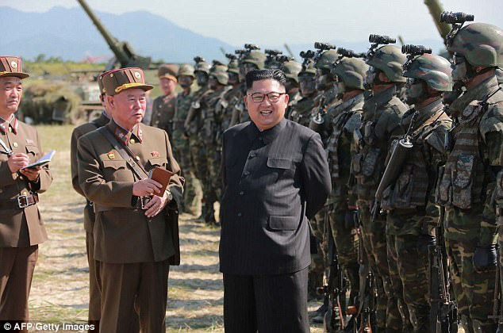
Kim is pleased with the success of his missile launch
Yesterday morning: “Largest aerial drill ever begins as 200+ US South Korean aircraft join for mock attacks on North Korea”
“The U.S. sent F-22 stealth fighters to the Korean Peninsula and will conduct a joint exercise with South Korea this week.” by Melissa Leon, December 4, 2017 – american Military news: “The U.S. has sent six F-22 stealth fighter jets to the Korean Peninsula to prepare for a joint drill with South Korea this week, in a huge show of force against North Korea – despite warnings from the country led by dictator Kim Jong Un. And, there are plans to send more aircraft, including F-35A and F-35B stealth jets, F-16C fighter planes and B-1B bombers, according to a report from South Korean Yonhap News Agency. This is the largest military aerial drill in history.
“The South Korean Air Force will dispatch F-15K, KF-16 and F-5 fighter jets and other planes for the exercises with about 230 aircraft at eight U.S. and South Korean military installations being mobilized,” it reported. “The allies plan to stage simulated attacks on mock North Korean nuclear and missile targets and transporter erector launchers that move the North’s missiles, [the South Korean Air Force] said…
`Vigilant Ace’ exercises are slated to kick off Monday and go through Friday…Experts and officials have since said the latest launch shows that North Korean missiles could reach anywhere in the world…”
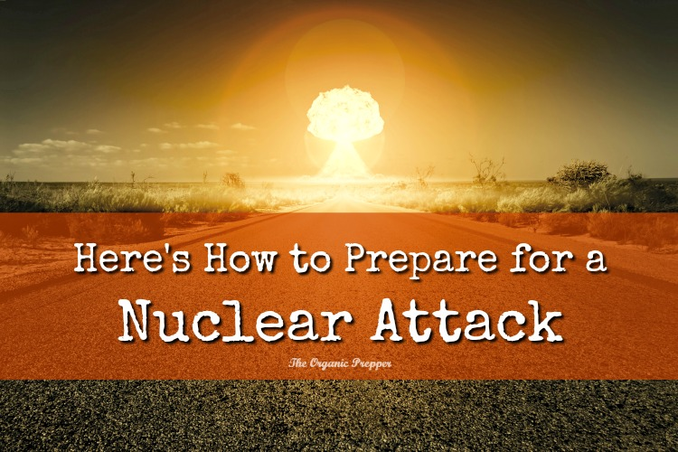
Some ideas from: Nuclear Attack How to Prepare and Survive - August 10, 2017- The Organic Prepper…
“The nuclear standoff between the United States and North Korea has intensified to a level that can lead nowhere good. It’s time to talk about how to prepare for a nuclear attack.
First, let me dispel two myths about a nuclear attack. We won’t all die, or wish we were dead, if a nuclear strike occurs. The movies – as much as I love them – have done us a terrible disservice here. If you are at Ground Zero of an attack, there is absolutely nothing you can do. Everything will be vaporized and that’s that. However, if you are outside the immediate blast zone, it is completely survivable and I don’t mean survivable in the horrible, lingering death kind of way. I mean, unharmed. You just have to know exactly what to do immediately in order to protect yourself
Here is what would happen if a 10 kiloton nuclear strike occurred.
According to the DHS, 10 kilotons is the approximate size of nuclear weapon we could expect.
Nearly everyone within a half mile radius of the point of impact would die and most of the buildings would be demolished. This would be considered Ground Zero.
The area within the next half mile would suffer extensive damage, fires, and serious injuries.
Areas within three miles could see minor injuries to people and slight damage to their homes.
The fallout would kill even more people. According to the DHS:
Within 10 to 20 miles of the explosion, radioactive exposure would cause nausea and vomiting within hours and death without medical treatment.
But for those near enough to the blast, experiencing more than 800R of radiation, not seeking shelter immediately would cause deaths with or without medical treatment, the study found.
People would not be able to evacuate this area as fallout would arrive within just 10 minutes.
People upwind of the strike and outside the 20-mile radius would be unlikely to suffer any effects. People downwind would need to take shelter. Deaths from cancer that is related to the fallout could occur for many years after.
Here’s what I’m doing to prepare for a nuclear attack.
As cool as it would be to have one, you don’t have to have a bunker to survive if you take the time now to get prepped. You can survive by learning everything you can to prepare for a nuclear attack…Every time a new threat rolls around, I discover that while I have many of my bases covered, there are a few things I hadn’t accounted for. A nuclear threat is no different. There were some supplies I had to pick up myself, particularly a bigger supply of no-cook food.
Part of your preparations will depend on where you live, so this will be different for everyone. Are you near any places that are likely targets? Places like Washington DC, Hawaii, New York City, Los Angeles, and large military bases are more likely targets than say, a low population area in the Midwest. Of course, this doesn’t mean it can’t happen. Just that it’s less likely.
Are you in a house or an apartment building? What is the best place in your home to seek shelter? Plan all of this ahead of time. If you know exactly what steps you are going to take, you will be able to better perform them under pressure.
Here are some key points to consider.
You won’t have a whole lot of notice.
Scientists say that residents of Hawaii would have only 8-12 minutes notice if an ICBM was headed their way, and residents of New York City will have an hour. Clearly, there won’t be time to run to the store – and if you did, you’d be fighting it out with a bunch of terrified, panicked people – so get your supplies together now.
Be prepared to go into lockdown.
In nearly every case, staying home is the best course of action. Imagine you are in New York City and this nuke is headed your way. If you try to evacuate, you are most likely to get stuck on one of the bridges on the way out of Manhattan and that would be far more deadly than hunkering down in your apartment and hoping you are outside the half mile radius of Ground Zero.
Experts say that you should plan to stay sheltered for a minimum of 9 days. Our personal plan is 14-21 days, depending on proximity and wind direction. I’d rather err on the side of caution, personally.
During a talk on surviving a nuclear attack, professor Iwrin Redlener, US specialist on disaster preparedness, said: “In that 10 to 15 minutes, all you have to do is go about a mile away from the blast. “Within 20 minutes, it comes straight down. Within 24 hours, lethal radiation is going out with prevailing winds.”
Prof Redlener said you should feel for the wind and begin running perpendicular to it – not upwind or downwind. He said: “You’ve got to get out of there. If you don’t get out of there, you’re going to be exposed to lethal radiation in very short order. “If you can’t get out of there, we want you to go into a shelter and stay there. Now, in a shelter in an urban area means you have to be either in a basement as deep as possible, or you have to be on a floor – on a high floor – if it’s a ground burst explosion, which it would be, higher than the ninth floor. So you have to be tenth floor or higher, or in the basement. But basically, you’ve got to get out of town as quickly as possible. And if you do that, you actually can survive a nuclear blast.”
The most hazardous fallout particles are readily visible as fine sand-sized grains so you must keep away from them and not go outside if you see them. While I’m not a professor, I would not be trying to run perpendicular. I’d be trying to get inside to shelter, ASAP.
Fortify your home against fallout.
Use duct tape and tarps to seal off all windows, doors, and vents. Get a LOT of duct tape and tarps. Turn off any type of climate control that pulls the outside air into your home. Expect to survive without heat or air conditioning for the duration. Close off your chimney.
If someone enters the home, make certain that there is a room set up that is separate from other family members so that they can decontaminate. All clothing they were wearing should be placed outside and they should immediately shower thoroughly.
Make a breezeway for putting things outdoors (like pet or human waste.) Hang heavy tarps around the door and put on disposable coveralls, gloves, shoe covers, and masks if you have to actually go out. Disrobe, discard the disposable clothing by tossing it out the door, and shower immediately when you get back inside.
Have enough supplies on hand to wait out the danger.
As with many emergencies, you need to be prepared to survive at home without help from anyone. It’s unknown whether water and electricity will be running, and if the water is running, whether it will be safe to drink. Prep as though you won’t have access to these utilities and if you do, then it’ll be a pleasant surprise.
Stock up on emergency food. In our current home, all of my emergency cooking methods rely on me being able to go outdoors. Because of this, I have stocked a one month supply of no-cook foods that do not require refrigeration. Canned vegetables and fruits, canned beans, pouches of rice and quinoa, crackers, peanut butter, dried fruit. You get the idea. The eating may not be exciting, but we won’t starve to death. You can find a more thorough list of no-cook foods here.
***Have a supply of water for all family members and pets that will last throughout the 9-day waiting period that you need to remain indoors. (Or longer, which is what we’re planning.)
Get paper plates and cutlery in the event that the water isn’t running so you don’t have to waste your precious supply washing dishes.
Don’t forget a supply of pet food.
Make certain you have a potassium iodide supplement on hand to protect your thyroid gland.
Be prepared for the potential of a power outage.
If you have pets, have supplies on hand for their sanitation – you can’t let them go outside because not only would they be exposed, they would bring radiation in with them. So, pee pads, cat litter, etc, are all necessary. Solid waste can probably be flushed.
Have the supplies to create an emergency toilet. (This one is cheap and simple.)
Make sure to have a supply of any necessary prescription medications that will last through the time that you hunker down.
Have a well-stocked first aid kit. It’s entirely likely that medical assistance will not be available, and if it is, you’ll put yourself at risk by going out to seek it.
Have a way to get the news from the outside world. An emergency radio is a must.
Learn everything you can.
This is an overview but there is much more to learn about a nuclear event and the more knowledge you have, the more likely you are to survive without any ill effects.
Lisa Bedford and I created a course over at Preppers University called The Nuclear Preparedness Intensive. It contains 2 hours of interviews with a military nuclear expert, hundreds of pages of downloadable information, shopping lists, military guides, and far more information than I could ever put together in a blog post. With this course, you will truly know everything that I know about surviving a nuclear attack. It costs $29. You can learn more about it here. We had been working on this for quite a while, but with the uptick in rhetoric, we decided now was the time to introduce the class. It will really help you be prepared.
For some free additions to your nuclear library, you can print out this manual from the US government about surviving a nuclear emergency. It was written with first responders in mind, but much of the information would be applicable for us, too. The book, Nuclear War Survival Skills, by Cresson Kearney, is also available for free online.
The more you know, the better your chances are of unscathed survival.
You CAN survive if you prepare for a nuclear attack.
The only part of your survival that is in the hands of fate is whether or not you are at Ground Zero. The rest is up to you. You can’t expect the government to save you. You can only save yourself. Get prepared today, because we just don’t know what’s about to happen tomorrow.
One thing this preparedness article doesn’t tell you is that besides taking measures to prepare yourself for nuclear attack and the radiation that follows, the most important thing you need to do is hear from Yahuwah’s Spirit within your spirit. First of all He is the only One who can maintain our peace! He will keep us clear-headed, and tell us what to do and when to do it. He wants to protect us and help us, but if His people don’t even know Him well enough to hear Him and follow what He says, He won’t be able to get through fear (our worst enemy) and an analytical intellectual mind. The reaction of panic, fear, negative emotions, and acting out of those emotions will only get us killed in the long run. He cannot, and will not, deal with these mental and emotional panics – for they clearly show they do not know Him. He promises to keep in “perfect peace” those that center their thoughts on Him. I do a lot of calling out “Abba” when I am overstressed, but no fear, no panic – just clinging tightly to Him, and He always comes through with His peace and His instructions. (Isaiah 26:3-4)
Let’s be mature believers who are prepared in the natural, especially with purified water and easy-to-eat food, but also strong in spirit as “overcomers.”
It takes discipline of the mind to align it to the re-born spirit. Once aligned, He can speak to the whole “spirit man,” because we have His nature.
In His love,
Yedidah
December 5, 2017

