100th Year Anniversary of the Bolshevik Revolution
WHAT DOES THIS MEAN FOR YOU AND ME?

There was one 2017 anniversary that I left out of my October 9th article: “2017: A Year of Amazing Anniversaries for Israel and the World.” I left out the 100th Anniversary of the Bolshevik Revolution in Russia. You might think – so what does it matter? Well, it does matter! It was the kickoff, the laying of the foundation, the setting in motion of the plan for three world wars and three forms of government that would lead to a new world order. That goal is in our sight right now as we’re near the third and final part of that plan.
On the bright side, this November 29th, 1947, we celebrate with joy the U.N. decision to partition the land called Israel for a Jewish State. The U.N.’s reasons for taking this step are rooted in the dark kingdom’s plans for the destruction of Yahuwah’s people, yet Yahuwah has the last laugh – for He will turn their plans into ashes, and He will redeem His homeland. It is where He wants to dwell with His people forever. Psalm 2 tells us that nothing is going to stop His plans!
Psalm 2:1-6, 11-12: “Why do the gentiles rage and the people meditate emptiness? The kings of the earth take their stand, and the rulers take counsel together against Yahuwah and against His Messiah, and say `Let us tear apart their bonds, and throw away Their ropes from us.’ He who sits in the heavens laughs; Yahuwah mocks at them. Then He speaks to them in His wrath and troubles them in His rage, saying `But, I, I have set My King on Zion, My set-apart mountain…Serve Yahuwah with fear, and rejoice with trembling. Kiss the Son, lest He be enraged and you perish in the way. For soon His wrath is to be kindled. Blessed are all those taking refuge in Him.’ ”
As we look at the enemy’s plans, we can look objectively, knowing that they are short-lived, while our Elohim’s plans are forever-lived.
In 1871 a plan was drawn up by the leader of the Scottish Rite Freemasons, Albert Pike, and Illuminati leader and Mafia founder Giuseppe Mazzini. So far, 2/3s of this plan has been carried out to the finest detail. The final third is in the works. Three world wars were planned with three forms of subversive government (Communism, Nazism, Globalism) to unite the world under one single ruler in a unified one world government.
WWI was to begin the basic concept of world government—communism. It begins with the confiscation of everyone’s property and their rights, forcing individuals to serve the “State,” eliminating all who are unable to serve the state. There are only two classes of people--the working class and the Elite. WWII was designed to begin the building block of Fascism, or National Socialism as Hitler called it, but again, it is the enslavement of the people to the State. It was also designed to make the Jews want to have their own homeland – a gathering for the greatest Holocaust.
We have in America what is called the “Deep State”--a hierarchy system of control. There is a visible government for the people to see, but underneath is the working to destroy the people using Bureaucracy. The definition of bureaucracy is: “a system of government in which most of the important decisions are made by state officials rather than by elected representatives; a state governed by bureaucrats—by a hierarchy, excessive complicated administrative procedures.” The third level of the “Deep State” is occult rule, rule by Luciferians or Satanists under the hierarchy of the fallen angels, today’s ever-present Nephilim.
The goal is world rule by Satan and his faithful fallen ones of all varieties, eradication of most of humanity, the enslavement of the rest of humanity, the destruction of earth, and its recreation in the image of the fallen ones.
As we’ve seen in the first two forms of government of enslavement, they have included the slaughtering of multi-millions of people for the sake of establishment their governments. Russia, WWI, Germany WWII, and now America 2017-- worldwide destruction of mankind is leading to the coming of a man empowered by the leaders of the dark kingdom of Satan.
Below I include part of an excellent summary of the Bolshevik Revolution, and the Communist Manifesto that led to it. I added pictures of Antifa displaying banners of their goals.
Though Antifa decided to “soft-pedal” November 4th this year, and the news mocked “conspiracy theorists, their statement that it was a beginning date for their goals to be accomplished is very real. Of course, no terrorist group announces the dates and times and places for their real plans, for they work in secret. But, it was a starting gate. Russ Dizdar writes and speaks of the “Black Awakening,” and it is beginning. The chaos produced will lead to the coming of the god of these fragmented, programmed, demonized `chosen ones,’—the anti-messiah/Beast, who, according to them, will be a risen Adolf Hitler. Hitler was given a vision of his rise to world power. He is the hero-god of these demon controlled people that we’re seeing killing the innocent in America.
Antifa, funded by Obama, Nazi-assisting George Soros, and others of that evil camp, have brought their own communist revolution to America—a Socialist-Communist platform that advocates the destruction of capitalism and the ownership of private property, no government, no boundaries, the destruction of righteous police, and violence against all who try to oppose them. This is reminiscent of Genesis 6!
The U.N. is stationed in America, prepared for the chaos and martial law.
But, what is the root of it – was it just Karl Marx with powerful new ideas that started it, or was there something deeper? Who helped Marx write the Communist Manifesto, and who gave him his ideas in the first place? For one thing a Jesuit priest helped him write it. [I encourage you to get the two-CD set entitled “Jesuits and Karl Marx” by Chris Pinto, Adulum Films, for a super overview of the plans of the Jesuits].
And how do the Jesuits tie into the Mazzini/Pike Plan? The founder of the Illuminati, Adam Weishaupt, was a Jesuit priest, who never did forsake his founder Ignatius Loyola and his principles for radical takeover for the Vatican. Giuseppe Mazzini was the head of the Illuminati, and Pike was steeped in Jesuit mentality. The more I study, the more I learn, that all these various forms of government that repress people, kill children and the elderly, slaughter Jews and Christians, support dictatorship, globalism, and “population control,” I see their goal is in sight – the elimination of the sons of Ya’cob from the earth, the destruction of earth, and its terraforming of earth to accommodate the pre-flood rulers who are now returning.
Mongolia was under Buddhist control for 700 years, then under Communist control for 70 years. I taught English to college students from various colleges in the capital, UlaanBataar, in a “crash course” the summer of 1996. My classroom was on the third floor. Climbing the steps from the first floor to the second floor, a huge carving of the picture below hung on the wall – pictured are Engels, Marx, and Lenin.
100th Anniversary of the Bolshevik Revolution Leading to Communism 1917 as Communism Celebrates Its First 100 Years Before Its News- November 3, 2017 by Geoffrey Grider
But a century of communism in power—with holdouts even now in Cuba, North Korea and China—has made clear the human cost of a political program bent on overthrowing capitalism. Again and again, the effort to eliminate markets and private property has brought about the deaths of an astounding number of people. Since 1917—in the Soviet Union, China, Mongolia, Eastern Europe, Indochina, Africa, Afghanistan and parts of Latin America—communism has claimed 65 millions of lives, according to the painstaking research of demographers.
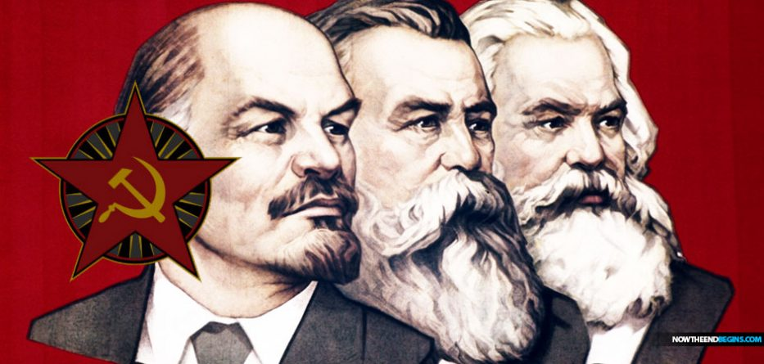
A century ago this week, communism took over the Russian empire, the world’s largest state at the time. Leftist movements of various sorts had been common in European politics long before the revolution of Oct. 25, 1917 (which became Nov. 7 in the reformed Russian calendar), but Vladimir Lenin and his Bolsheviks were different. They were not merely fanatical in their convictions but flexible in their tactics—and fortunate in their opponents.
[EDITOR’S NOTE: American hate groups like ANTIFA base their poison doctrine on the collective works of Stalin, Lenin, Marx and Engel, all of whom advocated starting their subjects out with the gateway drug of Socialism leading to Communism. Millennials voted in large numbers for Bernie Sanders brand of Socialism which is right in line with Stalin’s brand of Socialism. So let’s take a look at the century of bloodshed and death caused by the very thing Millennials are currently infatuated with.]
Communism entered history as a ferocious yet idealistic condemnation of capitalism, promising a better world. Its adherents, like others on the left, blamed capitalism for the miserable conditions that afflicted peasants and workers alike and for the prevalence of indentured and child labor. Communists saw the slaughter of World War I as a direct result of the rapacious competition among the great powers for overseas markets.
But a century of communism in power—with holdouts even now in Cuba, North Korea and China—has made clear the human cost of a political program bent on overthrowing capitalism. Again and again, the effort to eliminate markets and private property has brought about the deaths of an astounding number of people. Since 1917—in the Soviet Union, China, Mongolia, Eastern Europe, Indochina, Africa, Afghanistan and parts of Latin America—communism has claimed at least 65 million lives, according to the painstaking research of demographers.
Communism’s tools of destruction have included mass deportations, forced labor camps and police-state terror—a model established by Lenin and especially by his successor Joseph Stalin. It has been widely imitated. Though communism has killed huge numbers of people intentionally, even more of its victims have died from starvation as a result of its cruel projects of social engineering.
For these epic crimes, Lenin and Stalin bear personal responsibility, as do Mao Zedong in China, Pol Pot in Cambodia, the Kim dynasty in North Korea and any number of lesser communist tyrants. But we must not lose sight of the ideas that prompted these vicious men to kill on such a vast scale, or of the nationalist context in which they embraced these ideas. Anti-capitalism was attractive to them in its own right, but it also served as an instrument, in their minds, for backward countries to leapfrog into the ranks of great powers.
The communist revolution may now be spent, but its centenary, as the great anti-capitalist cause, still demands a proper reckoning.
In February 1917, Tsar Nicholas II abdicated under pressure from his generals, who worried that bread marches and strikes in the capital of St. Petersburg were undermining the war effort against Germany and its allies. The February Revolution, as these events became known, produced an unelected provisional government, which chose to rule without the elected parliament. Peasants began to seize the land, and soviets (or political councils) started to form among soldiers at the front, as had already happened among political groups in the cities.
That fall, as the war raged on, Lenin’s Bolsheviks undertook an armed insurrection involving probably no more than 10,000 people. They directed their coup not against the provisional government, which had long since become moribund, but against the main soviet in the capital, which was dominated by other, more moderate socialists. The October Revolution began as a putsch by the radical left against the rest of the left, whose members denounced the Bolsheviks for violating all norms and then walked out of the soviet.
The Bolsheviks, like many of their rivals, were devotees of Karl Marx, who saw class struggle as the great engine of history. What he called feudalism would give way to capitalism, which would be replaced in turn by socialism and, finally, the distant utopia of communism. Marx envisioned a new era of freedom and plenty, and its precondition was destroying the “wage slavery” and exploitation of capitalism. As he and his collaborator Friedrich Engels declared in the Communist Manifesto of 1848, our theory “may be summed up in the single sentence: Abolition of private property.”
Once in power in early 1918, the Bolsheviks renamed themselves the Communist Party as they sought to force-march Russia to socialism and, eventually, to history’s final stage. Millions set about trying to live in new ways. No one, however, knew precisely what the new society was supposed to look like. “We cannot give a characterization of socialism,” Lenin conceded in March 1918. “What socialism will be like when it reaches its completed form we do not know, we cannot say.”
But one thing was clear to them: Socialism could not resemble capitalism. The regime would replace private property with collective property, markets with planning, and “bourgeois” parliaments with “people’s power.” In practice, however, scientific planning was unattainable, as even some communists conceded at the time. As for collectivizing property, it empowered not the people but the state.
The process set in motion by the communists entailed the vast expansion of a secret-police apparatus to handle the arrest, internal deportation and execution of “class enemies.” The dispossession of capitalists also enriched a new class of state functionaries, who gained control over the country’s wealth. All parties and points of view outside the official doctrine were repressed, eliminating politics as a corrective mechanism.
The declared goals of the revolution of 1917 were abundance and social justice, but the commitment to destroy capitalism gave rise to structures that made it impossible to attain those goals.
In urban areas, the Soviet regime was able to draw upon armed factory workers, eager recruits to the party and secret police, and on young people impatient to build a new world. In the countryside, however, the peasantry—some 120 million souls—had carried out their own revolution, deposing the gentry and establishing de facto peasant land ownership.
With the devastated country on the verge of famine, Lenin forced reluctant party cadres to accept the separate peasant revolution for the time being. In the countryside, over the objections of communist purists, a quasi-market economy was allowed to operate.
With Lenin’s death in 1924, this concession became Stalin’s problem. No more than 1% of the country’s arable land had been collectivized voluntarily by 1928. By then, key factories were largely owned by the state, and the regime had committed to a five-year plan for industrialization. Revolutionaries fretted that the Soviet Union now had two incompatible systems—socialism in the city and capitalism in the village.
Stalin didn’t temporize. He imposed coercive collectivization from the Baltic Sea to the Pacific Ocean, even in the face of mass peasant rebellion. He threatened party officials, telling them that if they were not serious about eradicating capitalism, they should be prepared to cede power to the rising rural bourgeoisie. He incited class warfare against “kulaks” (better-off peasants) and anyone who defended them, imposing quotas for mass arrests and internal deportations.
Stalin was clear about his ideological rationale. “Could we develop agriculture in kulak fashion, as individual farms, along the path of large-scale farms” as in “America and so on?” he asked. “No, we could not. We’re a Soviet country. We want to implant a collective economy, not solely in industry, but in agriculture.”
And he never backtracked, even when, as a result of his policies, the country descended into yet another famine from 1931 to 1933. Forced collectivization during those few years would claim 5 to 7 million lives.
The Soviet Union’s awful precedent did nothing to deter other communist revolutionaries. Mao Zedong, a hard man like Stalin, had risen to the top of the Chinese movement and, in 1949, he and his comrades emerged as the victors in the Chinese civil war. Mao saw the colossal loss of life in the Soviet experiment as intrinsic to its success.
His Great Leap Forward, a violent campaign from 1958 to 1962, was an attempt to collectivize some 700 million Chinese peasants and to spread industry throughout the countryside. “Three years of hard work and suffering, and a thousand years of prosperity,” went one prominent slogan of the time.
Falsified reports of triumphal harvests and joyful peasants inundated the communist ruling elite’s well-provisioned compound in Beijing. In reality, Mao’s program resulted in one of history’s deadliest famines, claiming between 16 and 32 million victims. After the catastrophe, referred to by survivors as the “communist wind,” Mao blocked calls for a retreat from collectivization. As he declared, “the peasants want ‘freedom,’ but we want socialism.”
Nor did this exhaust the repertoire of communist brutality in the name of overthrowing capitalism. With their conquest of Cambodia in 1975, Pol Pot and his Khmer Rouge drove millions from the country’s cities into the countryside to work on collectives and forced-labor projects. They sought to remake Cambodia as a classless, solely agrarian society.
The Khmer Rouge abolished money, banned commercial fishing and persecuted Buddhists, Muslims and the country’s ethnic Vietnamese and Chinese minorities as “infiltrators.” Pol Pot’s regime also seized children to pre-empt ideological infection from “capitalist” parents.
All told, perhaps as many as 2 million Cambodians, a quarter of the population, perished as a result of starvation, disease and mass executions during the four nightmarish years of Pol Pot’s rule. In some regions, skulls could be found in every pond.
Marx’s class analysis denied legitimacy to any political opposition, not just from “bourgeois” elements but from within communist movements themselves—because dissenters “objectively” served the interests of the international capitalist order. The relentless logic of anti-capitalist revolution pointed to a single leader atop a single-party system.
From Russia and China to Cambodia, North Korea and Cuba, communist dictators have shared key traits. All have conformed, more or less, to the Leninist type: a fusion of militant ideologue and unprincipled intriguer. And all have possessed an extreme willpower—the prerequisite for attaining what only unspeakable bloodshed could bring.
Communism was hardly alone over the past century in committing grand carnage. Nazism’s repression and wars of racial extermination killed at least 40 million people, and during the Cold War, anticommunism spurred paroxysms of grotesque violence in Indonesia, Latin America and elsewhere.
But as evidence of communism’s horrors emerged over the decades, it rightly shocked liberals and leftists in the West, who shared many of the egalitarian aims of the revolutionaries. Some repudiated the Soviet Union as a deformation of socialism, attributing the regime’s crimes to the backwardness of Russia or the peculiarities of Lenin and Stalin. After all, Marx had never advocated mass murder or Gulag labor camps. Nowhere did he argue that the secret police, deportation by cattle car and mass death from starvation should be used to establish collective farms.
But if we’ve learned one lesson from the communist century, it is this: That to implement Marxist ideals is to betray them. Marx’s demand to “abolish private property” was a clarion call to action—and an inexorable path to the creation of an oppressive, unchecked state. (read the rest of the story on WSJ)
--------------------------------------------------------------
Mar 8, 1917 – Nov 7, 1917- The Bolshevik Revolution
WWI: July 28, 1914-November 11, 1918
“October Revolution”: November 7, 1917-November 8, 1917
WWII: September 1, 1939 – September 2, 1945
Encyclopedia Britannica: “October Revolution, also called Bolshevik Revolution, (Oct. 24–25 [Nov. 6–7, New Style Russian calendar], 1917), the second and last major phase of the Russian Revolution of 1917, in which the Bolshevik Party seized power in Russia, inaugurating the Soviet regime.”
-------------------------
ANTIFA IS A COMMUNIST ORGANIZATION – AMERICA IS IN A COMMUNIST COUP AIDED BY MEN LIKE BARACH OBAMA AND GEORGE SOROS
Look at these banners. Their ultimate goal is world rule by SATAN’S MAN -- THE “BEAST” of Revelation 13:1-10
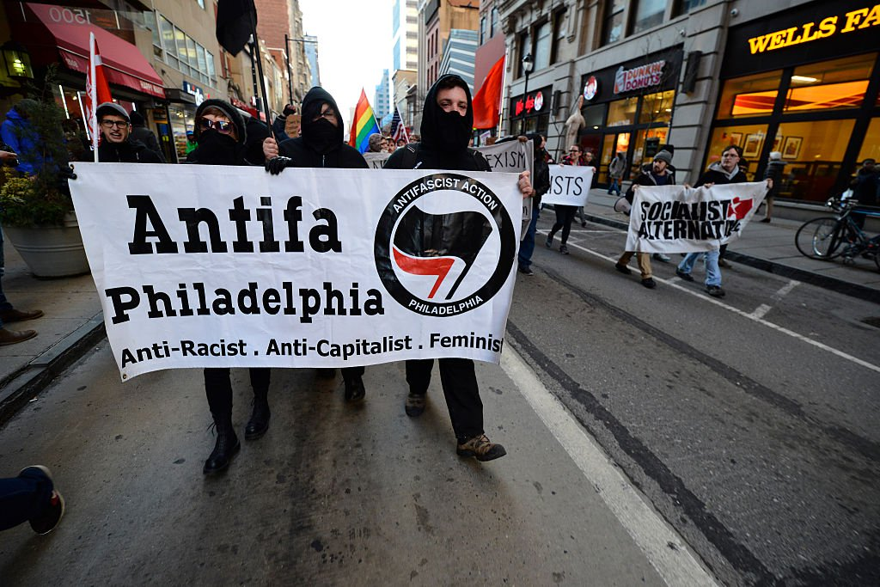
Capitalism, as in Democracy, is simply the right of every human being to work for what they want in life, to own their own property, home, car, material possessions … it is a right given to us from our Creator to make something of ourselves, and to share with those we love and care about, from family to other human being as we will. It is our right to choose our leaders and participate in good government. But, from the turn of the 20th century, America, and the world began to fall under the “plan” – the plan ultimately of Satan for our world.
To take from us our free will and give it a government we have no part in, who distributes it first to its members than as it pleases, is absolute slavery – it is death to what it means to be human.
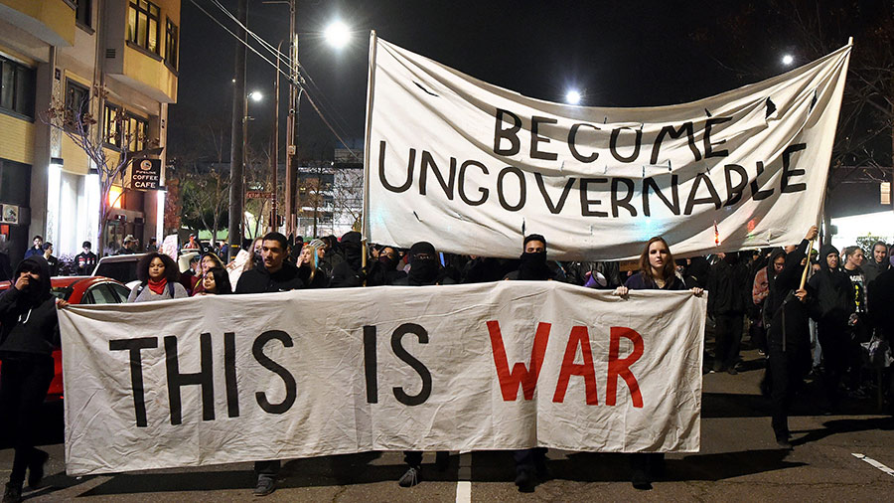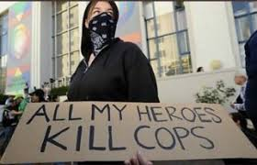
To be ungovernable is Anarchy – without strict boundaries man can do whatever he wants to do – which ends up killing and destroying – This is an attack on the Creators, but also on all human kind. To hate righteous boundaries and those that enforce them is to be an Anarchist – one without boundaries, lawless, and totally out of self-control…
Under martial law, according to Obama’s Executive Orders, all property can be seized, children taken from their parents, people put in concentration camps, and anything taken that the government deems fit to take to “continue.” [Refer to: “The New Executive Order”] and other articles I’ve written exposing these communist takeover manifestos … The seizure of private property is to relinquish all we have to make all people “equal,” yet it gives them no desire to improve themselves, they just “take.” This is paramount to being able to control every human being, with the Elite in charge. Having no national borders is paramount to the world takeover by globalists. No nation, no property, no rights, - only the right to submit to evil. This is what is coming to prepare for a new world order under the Beast with people depending on him for their needs, obeying him to stay in good favor with him.
May we walk in the authority and power of our Elohim--in His wisdom, His nature and ways, with His thinking, using our power to exalt Him and His Kingdom!
In His love,
Yedidah
November 7, 2017

