70 YEARS OF WEATHER GEOENGINEERING
70 YEARS of MAN’S DESTROYING
EARTH’S LIFE SUPPORT SYSTEMS

Revelation 11:15, 18: “And the seventh messenger sounded (his trumpet) and there came to be loud voices in heaven saying `the kingdoms of this world have become the kingdoms of our Master and of His Messiah, and He shall reign forever and ever!...And the nations were enraged, and Your wrath has come, and the time of the dead to be judged, and to give the reward to Your servants the prophets and to the set-apart ones, and to those who fear Your Name small and great, and to destroy those that destroy the earth.”
I had a vision one day around 2013 while living in Florida. It just appeared before me. I was intent on eating my dinner, but Abba interrupted. I saw the coast of Miami, and what appeared to be a 100’ wave rose up and crashed down upon it. I told my daughter that I knew Florida would get hit by huge waves, and that eventually sea water would cover the whole state. Later I saw a Navy map of their plans – with Florida totally underwater.
I highly recommend that you get the following information from an expert in the field of geoengineering: Go to the YouTube video by Dane Wigington of geoenginneringwatch.org, and watch this recent 12 minute presentation that will tell you what you must know, with documented historical data to the present. It is entitled: “Hurricane Irma Manipulation: Objectives and Agendas”
I also encourage you to read, or re-read, my article “Geo-Engineering – Severe Climate Changes by Human Manipulation,” (2017--the Mikvah of Present Reality) and “Shields of the Earth.”
When you go on Wigington’s website, click on “Documents” at the top of the main page. There you’ll find long lists of literal documents of the government and related military organizations that expose this wicked history. The list continues with Patens, and other documents on weather manipulation. It’s just facts!
This horror story began to take shape in 1947!
Like I wrote in “Jeremiah 25” about Jeremiah 25:11-12, about America’s 70 years as a super power, America used the technology gained from returned Nephilim, and from Nazis scientists whom we brought into the U.S. under Project Paperclip in 1944-45. They got their information as far back as the early 1920s when the Vril Society conducted séances and received mathematical/scientific knowledge from aliens, “sky gods,” as to how to build a flying saucer.
Werner Von Braun was a Nazi that America brought in under Operation Paperclip. We made him head of NASA. He said: “It’s not that we Germans are smarter than other people, it’s just that we got our knowledge from aliens.”
Now the geoengineering is so intense that we have all sorts of new types of clouds, even square clouds. Check out: “Geoengineering: Square Clouds and Massive Microwave Transmissions” April 18, 2017 Dane Wigington – Geoengineeringwatch.org.
Here I’ll share a few notes from Dane Wigington’s recent video, with some of my follow up research, links, and information
Project Cirrus 1947: “A pioneering weather modification effort by the Army, Navy, and General Electric Company headed by Languir…It was the first attempt at seeding a hurricane off of Florida and Georgia coasts using B-17 Bomber, and 80 kg of dry ice. Today they dump 100s of tons of chemicals into a hurricane to manipulate it.”
This project began on February 28, 1947. You can read the whole document on:
Full text of "History of Project Cirrus / compiled by Barrington S. Havens":
https://archive.org/stream/historyofproject00have/historyofproject00have_djvu.txt
At first Cirrus seems like a noble project to filter out smoke and other harmful things in the atmosphere. But, keep reading. They learned how to seed clouds to make rain, and then use it for other things. It was a beginning. You have to scroll down a ways to get to the actual document, but it’s there. You can even get a PDF copy of it.
“Project Story Fury 1970 Annual Report” US Government/military: Hurricane Manipulation Program/Cloud seeding, research projects
You can get the PDF from: www.dtic.mil/dtic/tr/fulltext/u2/730016.pdf
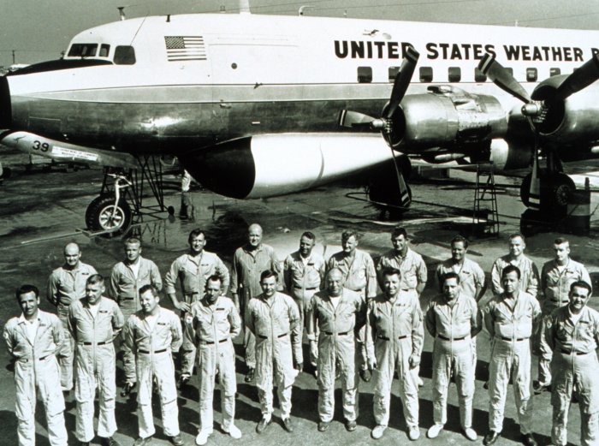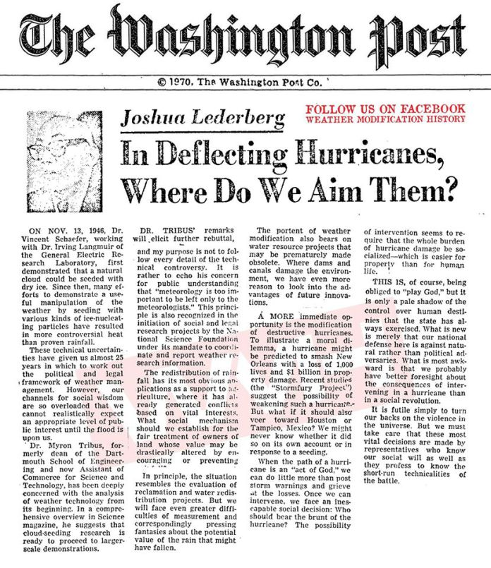
Men involved with Stormfury Note November 13, 1946

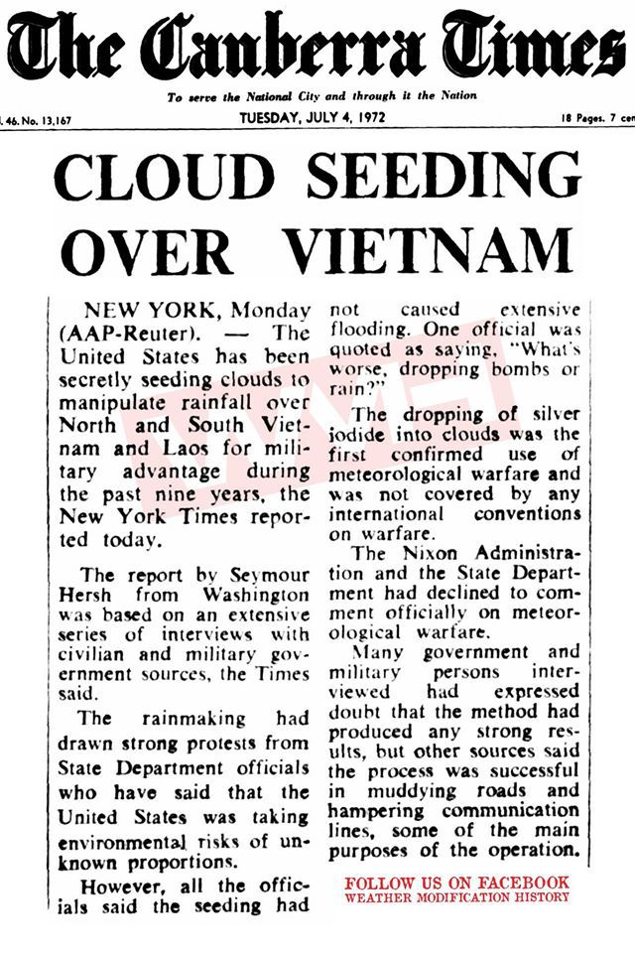
Look at that date in 1954, and look at the word “Fukushima.” We know that the tsunami that hit Japan March 11, 2011, and began releasing the radiation into the Pacific Ocean, was a man-directed tsunami. Could the weather attack on Fukushima have been for more than we know now? The radiation has done much damage in California and all along the west coast. Note the occult signature date.
Picture on the right: Wigington brought out that we used weather warfare in the Viet Nam war to flood certain areas “for military advantage,” as the article says.
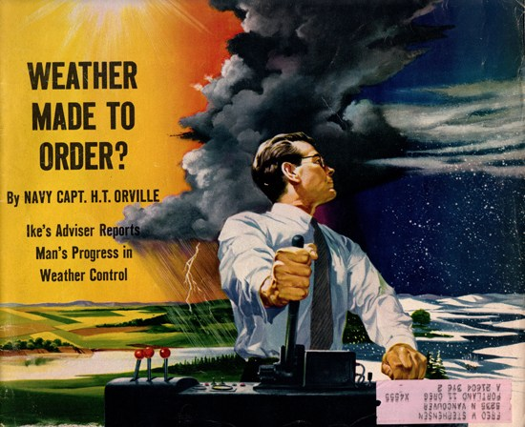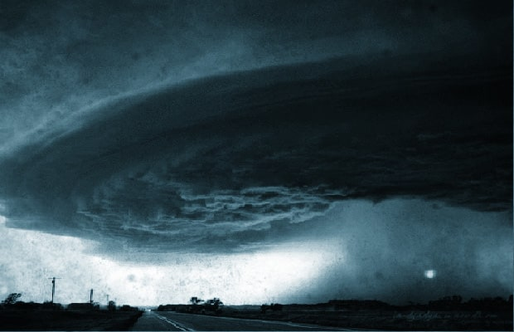
These pictures are from: geoengineeringcrimes--a website that has documentation for you to see: geoengineeringcrimes.wordpress.com/tag/geoterrorism

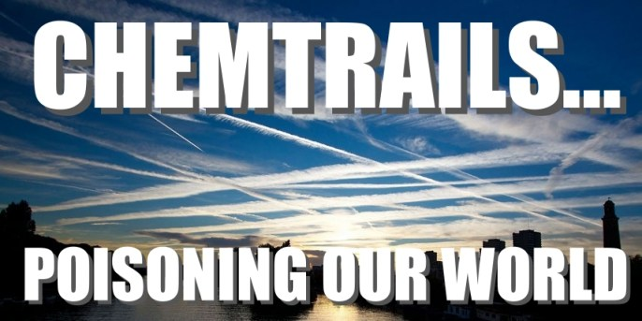
Here’s another website: “Chemtrails: The Exotic Weapon” (chemtrailsplanet.net)
For concentrated information on chem.-trails, as to what they are and what they’re doing to us, how they’re killing us and the bees, refer to my two articles: 1) “Just in Time for Halloween Designer Chem.-Trails,” and 2) “Chem.-Trails Part II – More Dangerous Than You Can Imagine” both under the Mikvah of Present Reality. I share many pictures with you that I’ve taken.
Above you see the Canberra Times in 1972, “Operation Popeye” seeded clouds for flooding in Vietnam. Here’s an article by Matt Novak of entitled “The Secret Weather Manipulation Program of the Vietnam War”:
paleofuture.gizmodo.com/the-secret-weather-manipulation-program-of-the-vietnam-1
So far these government/military documents can be downloaded in PDF form.
In the YouTube recent video by Wigington, he quotes from: Federal Activities in Weather Manipulation by Robert E. Morrison, a specialist in earth science, science policy research, chapter 3 “Overview of Federal Activities”: “The Federal Government has been involved for over 30 years in a number of aspects of weather modification, though activities of both the Congress and the Executive Branch. Since 1947, weather modification bills pertaining to research, support, operations, policy, studies, regulations, liabilities etc…A total of six public laws, specifically on weather warfare, have been enacted since 1953.”
“Engineering the Climate: Research and Strategic _ for International Coordination Report” – by Christian Bart Gordon, for the 111th Congress, Second Edition, October 2016: He says there are many weather modifications patens on file, like the one on June 17, 2000 – “Hurricane Suppression by Super Sonic Booms.”
Wigington reports that atmosphere aerosol spraying is done by military tanker jets. But, nozzles are also mounted on many commercial aircrafts. Aerosols are put into the jet stream of the plane and chemicals are defused by the aircraft into the air. Aerosols are dispersed over the ocean constantly now. It is killing the oceans. He says: “Aerosol spraying is tearing apart the life support system of the planet.” Aerosols contain toxic chemicals and also heavy metals.
“U.S. Major Hurricane Brought Ends at Record 4,323 Days” by Susan Jones, August 26, 2017 CNS News (4, 323 days, 142 months, 12 years) There have been no major landfall hurricanes in the US for 12 years. This is because “they” have been bringing cyclones and tsunamis, drought, floods, volcano eruptions and earthquakes to other nations, destroying their food supplies.
“Rising Ocean Temperatures Fuel Stronger North Atlantic Hurricanes”
“The military can create, direct, and manipulate hurricanes, or stop them== playing God.”
The NOAA map of Irma, September 7-11, 2017 shows the temperature abnormally high in the west, and abnormally low in the east. They are heating the atmosphere, and highly chemical ice creation is used to cool the air. Wigington says: “This is the greatest assault on the planet and on the human race.”
“Earth’s Sixth Mass Extinction Event Underway, Scientists say.”
Sea animals are dying, land animals are dying off. Genesis 1:2 is being reenacted by Lucifer and his fallen angels who destroyed the original creation, to get back at Yahuwah for creating us in His image and likeness.
There are other nations that have this destructive ability, yet it can be used for good if they’d use it for good. It’s called “weather warfare.” I highly recommend Steve Quayle’s book Weather Warfare and Un-Natural Disasters. It tells about weather warfare and a whole lot more.
When the Governor of Texas stood up to Obama and dogged the government’s military exercises Texas with their own militia a couple of years ago, all of a sudden Austin, Texas got horrible storms and floods, and people died. But, the Governor got the message.
I remember when Florida got hail in usually sunny weather, and how blizzards have been happening along with droughts, floods, tornadoes, heat-waves, and fires, all at the same time across the U.S., many in unusual places.
The “weather makers” create and directed Harvey. It is obvious as Harvey went in and back out, and back in and back out, battering the coast over and over. What do they have in store for Florida? They could have prevented all these destructive hurricanes, but they have no righteousness in their heart.
Now two other hurricanes are forming behind Irma. Harvey and Irma serve the agendas of the Globalist Elite, causing an oil crisis, gas crisis, food shortage, water shortage, economic hardship, causing a massive distraction from what the next agenda is, or to create a martial law scenario. FEMA is supposedly running out of money. They hope to weaken the people of America so that they can’t fight back when the government declares martial law, or gun confiscation, or if we have a social and/or economic collapse. There is already rioting and violence in the streets that shows civil war is brewing, race wars are brewing, too.
The “Military Industrial Complex” is taking control. The globalists want get on with the New World Order, and they don’t want anyone getting in their way.
Wigington says: “The goal is to exterminate life on this planet”… this makes Revelation 11:18 more real.
The great super power of the world has to fall in order for the global agenda to go forth. Europe is being destroyed. Japan is being destroyed. Thus the “Trilateral Commission,” the three, is being taken down as Daniel 7 says the “little horn” would do.
There are various reasons for these weather attacks, aimed at destroying America from within, and then the clean-up from without--crippling the nation with hurricanes, and fires, and drought, and floods, and famine, and economic collapse, and military takeover to suit their agenda. After what our government is doing, who needs North Korea Kim? It could be that the combined nations in Jeremiah 50-51 that attack the US are the “mop-up” crew.
Today, as Steve Quayle, who lives in Montana, reports, the state is burning up. There are at least 80 wildfires in Oregon and California.
Nicola Tesla in the 1920s perfected the ability to use “ball lightning,” to start fires. I know that some of them were started by arsonists. But, knowing what I do about the CIA’s MK Ultras/Manchurian Candidates and the fragmenting and programming of children to be weaponized for the purposes of the CIA and other evil groups, it is highly possible these arsonists were “on assignment.” Russ Dizdar uncovers much of this in The Black Awakening.
Yes, who needs Kim, unless he, Russia, and China, as reported in Jeremiah 50-51 are the cleanup crew? America is being taken down. We are no longer the great super power. Our economy is failing on the world scene. Vaccines have made our people sicker than ever, along with the chem.-trails, and aerosoling us with diseases and mind-destroying chemicals, plus DNA changing chemicals. Statistically we are one sick nation, a very weakened nation. The once-called “almighty dollar” is not mighty anymore. Our gold supply is about run out. On top of all of this, America is only 9 days away from famine at all times. Our supplies are limited.
And Executive Orders have been signed by the dozens by Obama and Presidents long before him that give the government the right to take over, seize property, put people in concentration camps that are all over the nation, and end life as we know it.
Check out these two articles: “HAARP Atmospheric Plasma Weapon – What You Breathe Is Slowly Taking Over Your Mind and Body” and “The “New” Executive Order.” For older articles not on my website, use the search option in the upper right hand corner of the main page of comeenterthemikvah.com. Put in the name of the article, and click the “search” tab. It will bring up older articles from laydownlife.net.
Globalists, led by the spirit of Nimrod, want all nations to blend into one big world government under one dictatorial god-like ruler. Let me bottom line this: The Word of Yahuwah is coming to pass in its entirety, without any doctrines, theology, eschatological formulas, or man’s opinions. It’s just happening.
The sea life and much of the animal life on this planet are becoming extinct, as reported a few days ago. But, before long the most extinct beings on the planet will be the human race. In all of this we see that we have a short time before the Creators take back Their Creation! HalleluYah!
Here I share with you a few photos of strange clouds, maps, and quotes…

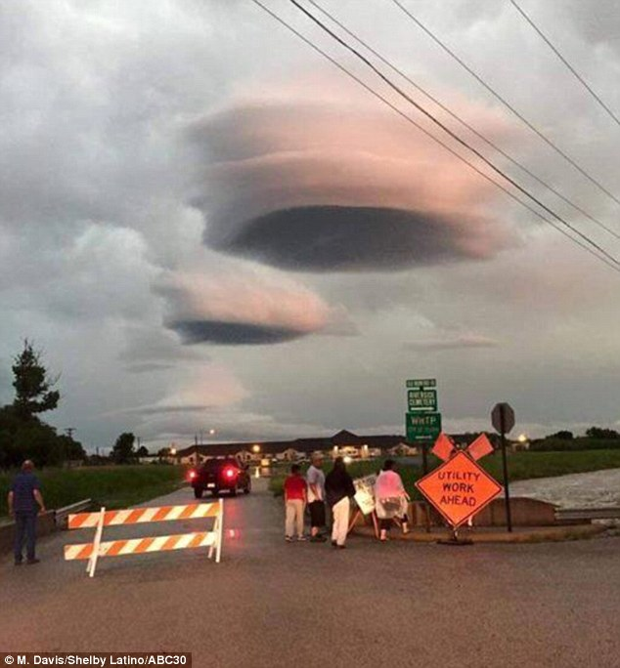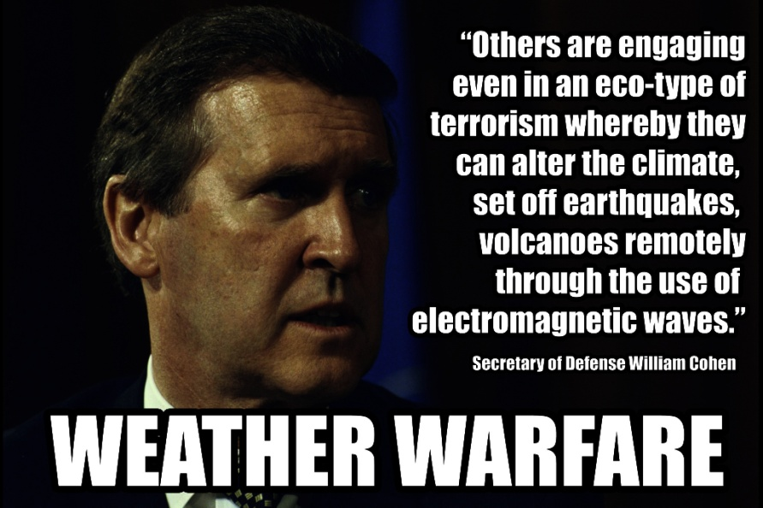
Left: Clouds over Texas 2016

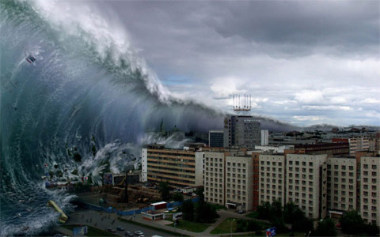
From Dave Hodges article November 30, 2015 about Russia’s super weapon: “it was revealed that the Russians have developed a nuclear torpedo capable to wiping out an entire coastline of the United States with intense radiation and a giant tsunami that could produce waves in excess of 1600 feet!”
In my article: “Geo-Engineering – Severe Climate Manipulation by Human Manipulation” (December 25, 2016) I included the map on the left. The nation was cooler in the west and warmer in the east.
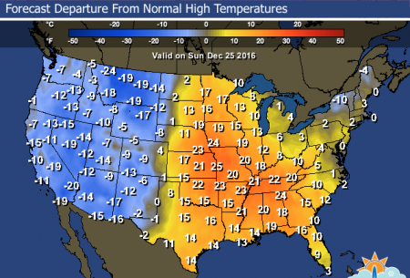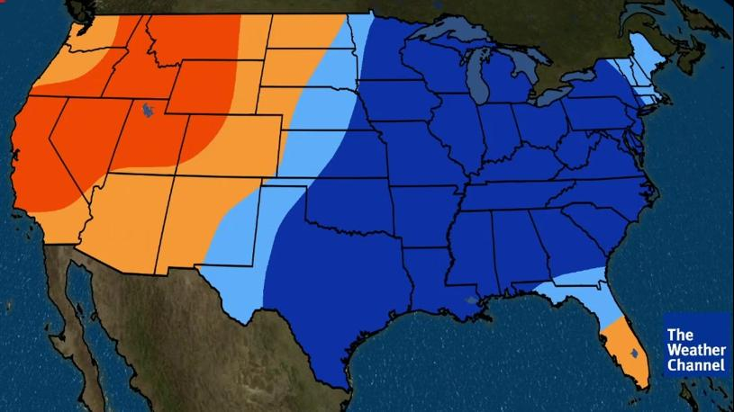
In the video I watched last night by Dane Wigington, he showed a map from the Weather Channel similar to this one on the right, and as you can see, it’s about reversed. The one on the right is from September 2, 2017. In just about 9 months the “weather makers” switched the nation’s climate to warmer in the west, cooler in the east, with the tip of Florida warmer.

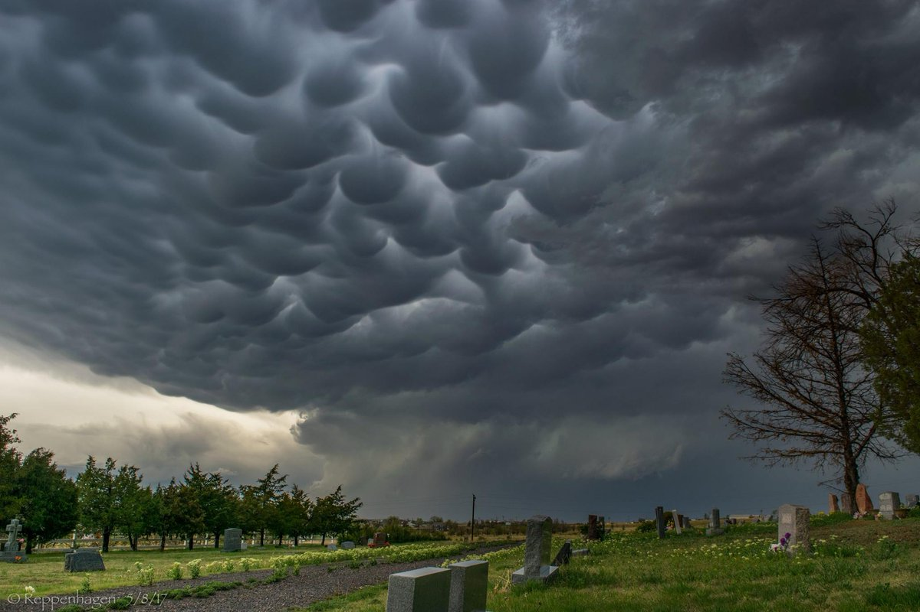
Left: Tombstones, Mammatus, and Thunderstorm Rotation. From the Evergreen Cemetery in Deer Trail, Colorado, via Reppenhagen
A freakish hailstorm pounded enormous hail stones on the Denver Metro Area on May 8, 2017. Prior this powerful storm, the sky suddenly darkened and filled up with wild Mammatus clouds.
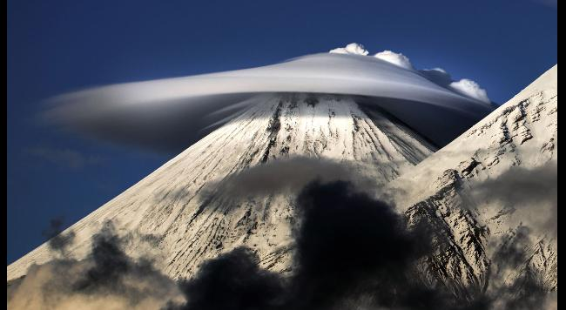
Lenticular Clouds
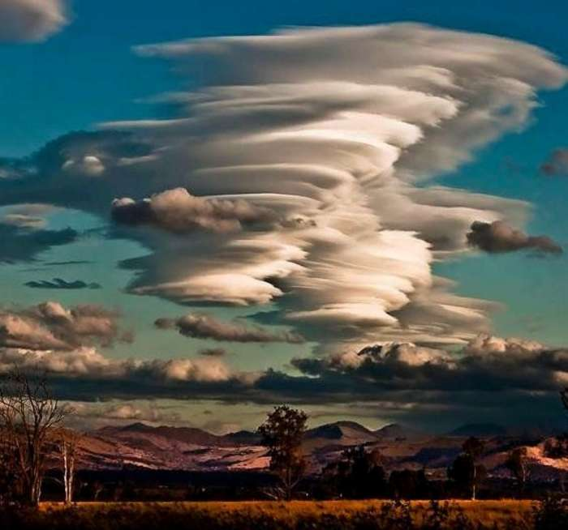
Left: Mount Teranaki, New Zealand Right: Lenticular clouds over the Andes
There are many other strange clouds appearing worldwide that the Creator had nothing to do with it, just like GMO foods.
Jeremiah 50-51, Isaiah 10, 13, 24, 18, 45 and Revelation 18 await America. But, it is beginning. [Refer to the recent article: “America’s 70 Years” under the Mikvah of Preparation]
Yahuwah drew a cross-out line across America on August 21st using the solar eclipse. It was known as “a national eclipse,” and exclusive eclipse so rare that one like it had not happened since 1776. Yahuwah is allowing man to go so far with the destruction of our planet, the changing of our DNA, the preparation of a super breed of mankind to live on Mars, trans-humanism, trans-genics, Eugenics, super soldiers, destroying the seas, the Ionosphere, melting the ice of the poles, and all the while scaring people with the hoax of “global warming.” [Refer to: “Eugenics: The Planned End of Mankind” under the Mikvah of the Great Adventure]
We don’t celebrate this 70th anniversary! We grieve with our Creators, and we proclaim the Psalms of Victory: Psalm 96, 97, 98, and 99. We celebrate Revelation 11:15-19! Let us seriously prepare for what’s ahead.
I really encourage you to watch the movie “Polycarp.” Those who call ourselves “believers” in the West need to look at this enactment of what it was like in Smyrna in the 2nd century and see the extreme difference in mind-set of those back then who accepted suffering for the sake of Messiah and the Word of Elohim as a privilege, from the attitudes of today’s “believers” who shrink away from any type of persecution. Polycarp was the disciple of Yochanan/John the Apostle. In the mid-second century, he was the Bishop of Smyrna. He was martyred for his bold stand for the faith in the face of Rome. Learn from the movie how the early assemblies of believers stood firm in the face of death, for there will be multi-millions of martyrs in our day. But, then, go to Revelation 2:8-11 and Revelation 7:9-17 and read their eternal reward.
Sha’ul wrote to those in Philippi, in Philippians 1:29: “Because it has been given to you as a favor on behalf of Messiah not only to believe in Him, but to suffer for His sake.” Don’t run from the favor Yahuwah extends to you.
Let us really use this festival season of our Elohim to press into Him, to learn from Him, and align with what is on His heart and mind, and then go forth to obey Him. Our time is short, and eternity is forever.
Share the podcasts, the website, the articles and your own testimony with your spouse, your family, friends, and those who need His salvation!
In His love and peace, joy, and blessings,
Shabbat Shalom,
Yedidah
September 8, 2017

