JUST IN TIME FOR HALLOWEEN - DESIGNER CHEM.-TRAILS

Today, October 11th, I was sitting down in the living room to have lunch. I looked out the window, and was stunned by what I saw. I hurried downstairs to my room and got my camera. I went out on the front porch and took pictures of a Halloween designer chem.-trail, which stretched across the sky from east to west. This is the most interesting chem. trail I think I’ve ever seen.
Look at the various pictures below. I’ve seen them very thick, as shown. It is amazing how frequent the X pattern is. I’ve got pictures of chem.-trails with unusual patterns, from different countries. And, there are actually some countries where I have not seen them at all – like Israel and Jordan during 1999-2014. But, whatever shape they’re in, they are dropping deadly chemicals on human beings, animals, sea life, birds, bees, reptiles, plants, trees, etc. The aluminum they’re dropping has been proven to be causing the upsurge of Alzheimer’s disease and Dementia, also inflicting these diseases on honey bees by the millions, causing their death. These little creatures are cross pollinators of our food crops. They need to be protected.
In the Western world today, and in various nations all over the earth, too, anyone who tells the truth is considered dangerous, and often imprisoned and/or killed to shut them up. In the West, also, those telling the truth are often mocked, scored, laughed at, and demeaned – i.e. character assassination. People’s reputations are ruined so that others cheer on their “punishment.”
Indeed, as Isaiah the Prophet foretold of the “latter days,” “truth has fallen in the street.” Amos the Prophet wrote “…they despise the one who speaks the truth.” The catch phrase among mockers, skeptics, and of the ones who consider truth a danger, is “conspiracy theorist.” Truth is: Things are either planned or a coincidence. By mockery and slander, people try to hide their ignorance and their laziness in not doing their own research to find the truth. Truth is considered “relative” nowadays in western culture – i.e. “there are no absolutes.” “Whatever is truth for you is truth,” so they proudly say.
But, the plumb line of all truth is the Word of Yahuwah, taught to us by His Spirit. He leads us into confirmation of His Word as we do honest research with the help of honest watchmen. But, the truth is out there. Truth is like gold nuggets in a mine--it has to be dug out, which is not an easy thing. The lazy would rather sneer and joke about the truth and “go the broad way to destruction” rather than spend time finding truth and live.
Near last Halloween, I wrote an article “Halloween”/October 22, 2015, and included lots of pictures of the Halloween decorations in our neighborhood. Like every year, the grocery stores, and stores like Walmart, are jam-packed with Halloween decorations, costumes, t-shirts, and candies to pass out to little children who go door-to-door saying “trick or treat” on Halloween night.
Below are four of the twelve pictures of the weird chem.-trails I saw this morning, starting in the Eastern sky and arching over the sky to the West, ending up heading in different directions once it was in the West. You can see that some “intelligent” beings united to make this skeleton hand, wrist, and arm.
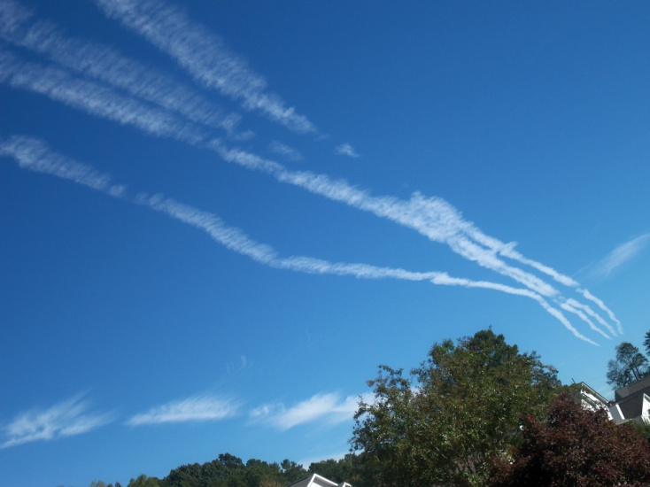
Let picture in the East, left picture arching in the sky from East to West
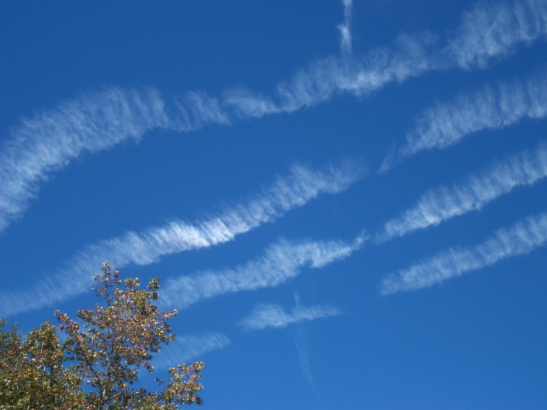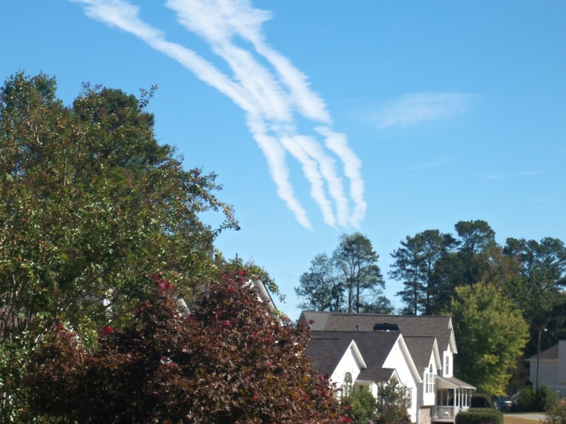
Left picture arching toward the West, right picture back in the East…
Notice the hand enlarged over about 25 minutes time, but the little cloud is still crossing it about the same place as the first picture. Isn’t that interesting! There was hardly any wind, so as you can see, the little cloud crossing the hand in the first picture and the last picture didn’t seem to move. I took about 10 pictures over 25 minutes time.
More pictures taken by other below…
So, with that introduction, let’s talk about chem.-trails. Mockers say that there is no such thing as a “chem.-trail” (chemical trail of an airplane containing poisons). Evidently they walk with their heads down all the time. Actually, no one is hiding their dirty work. Yet, there are places on earth where there are no chem.-trails, or just a few occasional ones. But, wherever there are large populations of people, you’ll see them in abundance, especially over the “first world,” the industrialized nations. I just know they’re everywhere in the U.S. where there are people and in the UK also. I’ve seen some of the most dense displays over the UK.
Years ago, I talked about, and wrote about, disease-carrying viruses and bacteria that were being dropped from airplanes onto the American people over the Fort Worth-Dallas area of Texas. People were getting the same diseases, most respiratory, all over the area and the “mid-cities.” Now, it is no secret that governments experiment with biological and chemical warfare on their own people. For example, Texas A&M University is a center for biological and chemical warfare experimentation.
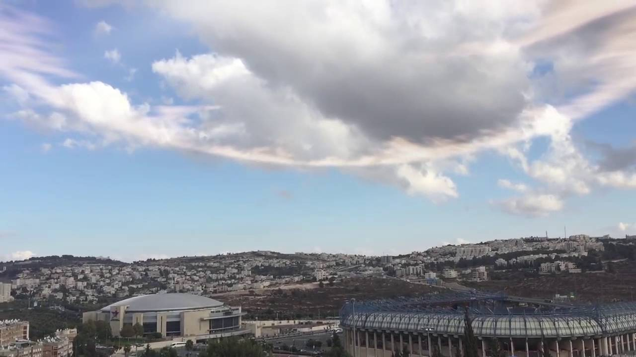
Left: The final picture from today, which I took from the living room window, shows the hand arching, and making a face with an eye and mouth--a face like a snake or dragon.
Right: A recent circular cloud over Jerusalem while sounds of shofar were heard blowing over the city on the eve of rabbinic Rosh HaShanah/Yom Teruah.
Here are pictures showing chem.-trails across America. Left picture: It appears that several pilots were playing tick-tack-toe in the sky. Right picture: Common X configuration. But look closer: See the pentagram, the 5 pointed star—a Satanic symbol.

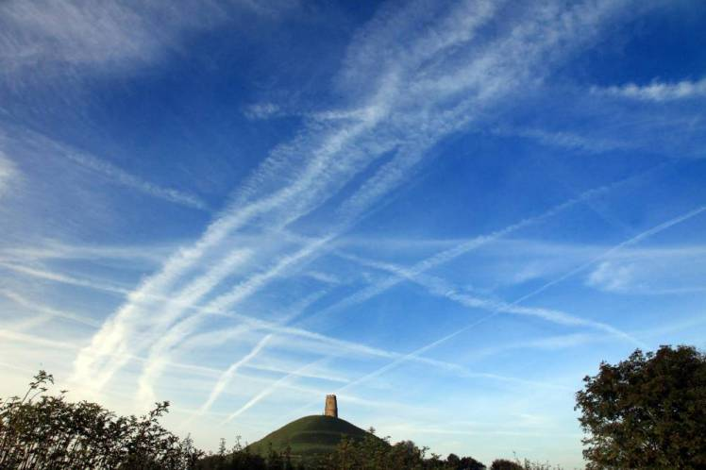
Photos from the article “Air Force whistleblower claims plane chem. trails are spraying us all with poison - Rob Waugh for Metro.co.uk Monday 5 Jan 2015


Picture courtesy of “The United Nations Exposes Chemtrails 100% PROOF We Are Being Poisoned” – Topinfo Post

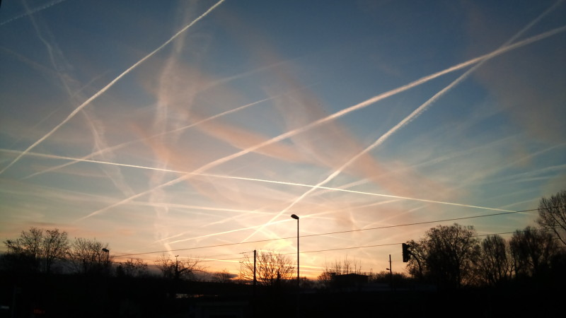
Left: From the article Conspiracy Theorists” Are Vindicated: U.S. Senate Reports Chemtrails Are Real and Are Killing Us! - davidwolfe.com
Right: same article – more tick-tack-toe and X patterns

We are seeing anomalies all over the earth in the sky … new varieties of clouds are appearing, new types of weather and producing strange sights in the sky, and new sounds are coming from the sky – like the recent sound of a shofar blowing over Jerusalem the night of the rabbinic Rosh HaShanah, from a circular cloud that arose over the city. (Picture above)
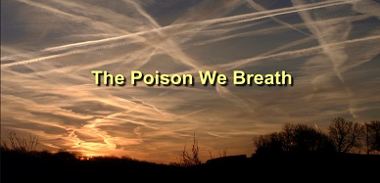

Here is some information to spark your own research. In 2007, I downloaded an article in which a doctor tells what was in chem. trails. Here are a few excerpts from his article “A Doctor Speaks Out About Chem. Trails” by Victoria Hardy March 3, 2007
“Dr. Stephen D. McKay recently sent me an email and shared the news that he has been contacted by the BBC and Channel 4 in the U.K. to work on two documentaries about weather modification and geo-engineering projects, including the chem. trail issue. And yesterday I received his findings after six years of research into the subject. Dr. McKay believes there are four ongoing projects in our atmosphere… The aerosol is probably aluminum oxide or a compound that would have similar properties…”The government and military solved the "ducting" problem by releasing an aerosol, a mixture of barium salts into the atmosphere over America. They made an atmospheric RF duct with a base of barium aerosol from aircraft. The chemical and electrical characteristics of the mixture will cause water moisture to stay in clouds. Again, the aerosol sets up an electrical and chemical environment that supports RF ducting for the RFMP / VTRPE warfare system. Fibers with barium may support ducting.
The mixture of barium salt aerosol when sprayed in a straight line will also provide a ducting path from point A to point B and will enable high frequency communications along that path, even over the curvature of the earth, in both directions... ”The third project also utilizes the mixture of barium salts in the atmosphere. Weather control is a project of the U.S. Air Force and utilizes Nikola Tesla concepts of radio frequency radiation (HAARP) against the Ionosphere above the earth. Fragile life support systems in our environment are being manipulated, tested and altered by government for military advantage. Air Force documents implied, "the risks are high but the rewards are worth it." The mixture of barium salts, supporting moisture, is encouraged along the weather fronts and manipulated in a control fashion. It is believed microwave energy is also utilized in the weather control program…”The fourth project in the atmosphere is the DARPA, Defense Advanced Research Projects Agency, biological detection and decontamination programs. The program also utilizes the mixture of barium salts as the base vehicle in aerosol along with special polymer fibers in the atmosphere. They have released biological into the atmosphere in trials, testing the detection and decontamination systems.”
”It is believed that barium salt, polymer fibers and other chemicals, in the atmosphere are the physical irritants that are either directly or indirectly responsible, for the recent epidemic increase in cases of nose bleed, asthma, allergies, pneumonia, upper respiratory symptoms and a noticeable increase in arthritis symptoms, recently reported nationwide.
Chemicals illegally sprayed into the atmosphere are producing atmospheric and ground conditions detrimental to human and animal health but favorable to the growth of harmful molds and fungus. These conditions are not conducive to good health. The soluble salts of barium, an earth metal, are toxic in mammalian systems. They are absorbed rapidly from the gastrointestinal tract and are deposited in the muscles, lungs, and bone. No case data is available from the medical community on the long term effects of barium in the human body.
The programs are secret because the Federal EPA and State Environmental Quality Agencies need to "not know" about what the by-products of the metabolites of biological, illegal and harmful agents are. It's for that reason the project has been declared secret from the citizens of the countries.”
NASA Admit To Spraying Americans with Poisonous Chem.-Trails
Posted on April 10, 2016 by Sean Adl-Tabatabai in Sci/Environment
“NASA has admitted to spraying lethal chem.-trails into our atmosphere – saying that lithium being sprayed into the Earths ionosphere helps to treat people with manic depression or bi-polar disorder… NASA personnel have come forward saying that lithium, along with other potentially harmful chemicals, are intentionally sprayed into our environment regularly.
Wakingtimes.com reports: NASA Confesses to Dosing Americans with Air-borne Lithium & Other Chemicals
There’s the official explanation for why NASA is spraying lithium, a pharmaceutical drug most often used to treat people with manic depression or bi-polar disorder, into our ionosphere, and then there is the probable reason(s)… Before I give you NASA’s official explanation of why they are spraying psych-meds over hundreds of thousands of Americans, I’d like to point you to some references so that you can do your own research, and discover that this is no conspiracy theory … Lithium alters how we think by changing the levels of serotonin and norepinephrine secreted by our endocrine system. Lithium strongly alters the brain system, yet the NASA employee in the above video states that “it is not dangerous” and doesn’t harm the population. Even doctors who normally prescribe this medication for the mentally ill have said that it is dangerous because it is hard to figure out proper dosing. Surely, spraying copious amounts of lithium indiscriminately into the air via aerosols should be questioned…” (Read the article to read about NASA’s excuses, and see the video)
Chem.-Trail Pilot Blows the Lid Off OPERATION INDIGO SKYFOLD April 3, 2015 Covert Geopolitics - “Maybe my fellow pilots will read or hear about this, and decide to come forward as well.” Indigo Skyfold Pilot
“The battle against chemical and biological warfare in all their forms, e.g. chem.-trail, vaccines, and GMO, is humanity’s battle. This is our battle against pure evil that is now occupying critical positions of power. We are hoping that more insiders would come out in the open and tell the world the whole truth about all these sinister operations…’
From another related article: “What Chem.-Trails are Doing To Your Brain are Shocking” – a Neurosurgeon - A Courageous Chem.-Trail Pilot Exposes the Global Geo-engineering Program… “Chem..-Trails are being sprayed 24/7 around the globe with terrible consequences…For those uninitiated in the ways of atmospheric engineering, chem.-trails are but one geo-engineering technique that is being systematically used by the U.S. Military… Not only does “Blue Jay 1,” as he is known, go public, he completely blows the lid off of OPERATION INDIGO SKYFOLD. This single act of identifying the name of what is perhaps the most destructive government program in recorded history is extremely critical… Chem.-Trails contain a mix of toxic chemicals and poisonous compounds such as barium salts, aluminum oxide, strontium, mercury among many others, which eventually end up falling to Earth. The chem.-Trail mix of toxins inevitably leaves its residues on farm fields and forests, lakes and ponds, and lawns and gardens. How does one possibly stop the noxious chemicals from entering one’s home and automobiles, office building and shopping malls? Whoever wants a toxic chemtrail brew dropped on them every other day?!”

“The United Nations Exposes Chem.-Trails 100% PROOF We Are Being Poisoned” – Topinfo Post: “We can no longer ignore the fact that our skies are being heavily polluted with aluminum, barium, lead, arsenic, chromium, cadmium, selenium, and silver. All of which attribute to a host of health problems including: neurological effects, heart damage, eyesight issues, reproduction failures, immune system damage, gastrointestinal disorders, damaged kidney, damaged liver, hormonal problems, and more.
The truth is the government is spraying deadly chem..-Trails in hopes of population reduction. Furthermore they have been known to use chem..-Trails as biological testing agents on the populace; all while claiming they are nothing more than mere vapor…
Rosalind Peterson, the president of Agriculture Defense Coalition... (regarding video in the article) In it she addresses the United Nations on chem.-trails, geo-engineering, and weather modification (HAARP). If you were a skeptic before, I can assure you, that you will not be after hearing what she has to say to the people in power.” (Note: Several of these articles have videos to watch)
“The United Nations Exposes Chem.-Trails: 100% PROOF We Are Being Poisoned” - by ProQuest
“By now everyone has witnessed streaks of white trailing across the sky, stretching from horizon to horizon, ultimately turning the skies into a murky haze. We can no longer ignore the fact that our skies are being heavily polluted with aluminum, barium, lead, arsenic, chromium, cadmium, selenium, and silver. All of which attribute to a host of health problems including: neurological effects, heart damage, eyesight issues, reproduction failures, immune system damage, gastrointestinal disorders, damaged kidney, damaged liver, hormonal problems, and more…” From this article you can get this document:
Document: “The Manhattan-Rochester Coalition, research on the health effects of radioactive materials, and tests on vulnerable populations without consent in St. Louis, 1945--1970
by Martino-Taylor, Lisa, Ph.D., UNIVERSITY OF MISSOURI - COLUMBIA, 2011, 838 pages; 3515886: This piece analyzes a covert Manhattan Project spin-off organization referred to here as the Manhattan-Rochester Coalition, and an obscure aerosol study in St. Louis, Missouri, conducted under contract by the U.S. military from 1953–1954, and 1963–1965…Examination of the Manhattan-Rochester Coalition and the St. Louis aerosol studies, reveal their connections to each other, and to a much larger military project that secretly tested humans, both alive and deceased, in an effort to understand the effects of weaponized radiation…”
Conspiracy Theorists” Are Vindicated: U.S. Senate Reports Chem.-Trails Are Real and Are Killing Us!” - davidwolfe.com
“Connected to “weather modification,” this document can be found here, but I’ll paste a few excerpts below to give you the gist of things. To start with, Dr. Norman A Beckman begins by requesting a report on the history of weather modification.
Washington, D.C., July 30, 1976.
Dr. Norman A. Beckman, Acting Director, Congressional Research Service,
Library of Congress, Washington, D.C.
Dear Dr. Beckman: Weather modification, although a relatively young science, has, over the years, stimulated great interest within the scientific, commercial, governmental, and agricultural communities. Such responses are readily understandable.
In the next section comes the government’s response, which has a few eyebrow-raising points:
Although the Soviets and some U.S. private operators claim some success in suppressing hail by seeding clouds, our understanding of the physical processes that create hail is still weak. The one major U.S. held experiment increased our understanding of severe storms, but otherwise proved mostly the dimensions of what we do not yet know…For over 30 years both legislative and executive branches of the Federal Government have been involved in a number of aspects of weather modification…”
“Weather modification,” is a politically acceptable term for Weather Warfare! It is a reality. It has been and is being used to create tornadoes, cyclones, tsunamis, hurricanes, ice storms, blizzards, drought, and direct them into specific places on earth. The goal: Destroy the food crops of the world. This is reality. Whether the American facilities like HAARP are still in operation or not, Russia has used its “scalar” technology, and so have countries as well. It is fascinating that Israel also has a small scalar device, and we learned in the 2006 war with Hezbollah they used it – but only for good. Weather control technology can be used to stop violent weather patterns also, and in other life-saving ways--as Israel demonstrated. Israel is a nation that glorifies life. I don’t know of any other nation on earth that puts life over death like Israel does.
Do your own research. There are a lot of articles on the web, and videos to see. But, just know that what I, and other watchman, have said through the years is true – America has been, and is, a giant laboratory for experiments with diseases and mind-control, and how the human body reacts to certain chemicals for “chemical and biological warfare.” We are the “lab-rats,” the “experimental animals” as the ruling elite call us. They also refer to us as “insects.” Our lives are nothing more than “biological units.” Our food has been modified, our water, our air, our clothing, products we use all the time contain mind-damaging chemicals, like fluoride, and aluminum. Why is Aluminum in over 350 projects we use daily in America? Why is there a poison warning on toothpaste tubes? We’re lab-rats. After our usefulness is over, we’ll be destroyed along with the laboratory. That’s the plan.
More and more people are getting Dementia, Alzheimer’s Disease, Autism from vaccines, and other bizarre mental and physical anomalies due to all this experimentation. But, Russia and other countries experiment on their citizens, too. We’re bombarded daily with fear-propaganda, designed to get citizens to do as they are told by their government. In Miami they sprayed to kill the Zika virus, and killed millions of honey bees. I’ll be writing soon about the Zika virus – another hoax. From birth to death Americans, and most all of the earth’s people, too, have been programmed to believe what we’re told by doctors, the news media, the government, scientists, and religious leaders. Why we a dumping ground for lies and deceptions when you can be a temple for the truth of Yahuwah! Research to learn truth!
I recommend that you glance through article list on stevequayle.com to check daily articles that have been filtered for truthful reporting. Another good source of news is SkywatchTV News with Derek Gilbert. Their interviews are excellent also.
But, also be sure to check the Word for what it says about what’s happening, and what will happen. Jeremiah 50 and 51 and Isaiah 18 prophesy of end-time Babylon—America. The prophecies are very close to fulfillment. No wonder the Illuminati elite want to take away the alternative news from us--they hate truth. It is exposes their lies, deceptions, and their evil plans for us. You don’t have to be deceived. If you have the Spirit within, He will help you discern what is right and what is not.
Just today, October 18th, there has been another escalation in potential war between Russia and America. America is provoking war with Russia. Joe Biden made a fool of himself, again, publically saying that America was going to attack Russia with a cyber attack. Putin didn’t take that lightly. Hillary Clinton and Obama openly want war with Russia. So much will happen within this next month, in America, and in the world as a whole. Cling to the words of the Psalms that give peace and hope. Seek Abba with all your heart. Prepare with water and food, and other necessities in case you are cut off from being able to go out of your house!
Once things begin, they won’t stop until almost all on earth are dead. Be wise – prepare in every way you can. Then peacefully trust Abba with your life.
Shalom, with His love,
Yedidah
October 18, 2016

