MYSTERIOUS and DEFINITELY NOT NATURAL CALIFORNIA WILDFIRES

There are incredible unexplained anomalies associated with the previous series of wildfires in California, in October and also with the one raging right now. These anomalies have been noticed and reported by seasoned firemen, as well as by Abba’s faithful watchmen. There is definite evidence of the use of super weapons that can target and destroy. The reason: California may be targeted by the U.S. government for their very ambitious attempts to break away from the United States, or this is just another way of destroying our main food growing areas--it’s probably both. But, it sends a message to California, to the Governor and to those busy with the “exit plans.” The way the very nice homes are being burned is in no way natural!
No, this is not a conspiracy theory report! This came to my attention in October via a video showing pictures of the remains of house fires and the remains of these fires. In normal house fires, metals don’t burn, marble counter tops don’t burn, neither do sinks, bathtubs, and toilets. In these fires, there is only ash left.
Here I present some very hard and cold facts, and lots of pictures. I ask questions, too, showing that this is a new form of government-ordered sabotage using high-tech lazar, microwave beams, electromagnetic beams, or other targeting powerful fire-starting beams of electrical energy.
Arial pictures of these fires tell the truth, so I’ve included several. I thought maybe this fire raging now would be different than the previous ones, but NO. The pictures show the same scenarios—i.e. houses reduced to ash leaving trees still standing, or trees burned from the inside out--that’s microwaving.
As I said above, normal fires do not burn metals, bathtubs, countertops, stoves, and they even leave burned belongings to be found and some of the house structure that is inflammable. The wood in the houses don’t turn to ash along with everything else while the grass and trees remain green outside the house.
In both recent out-of-control fires, high winds spread it quickly. Today they are reporting 80 mph winds “hurricane force” winds as the fire sweeps towards Los Angeles. 80 mph winds also spread the fires in October.
The most recent fire, now near Las Angeles, went from a small brush fire to destroying 500 acres in an hour. Some of the homes are million-dollar homes.
Let’s look at some pictures, then I will give you testimony and evidence.
Before the Tubbs Fire in Santa Rosa, Coffey Park Neighborhood
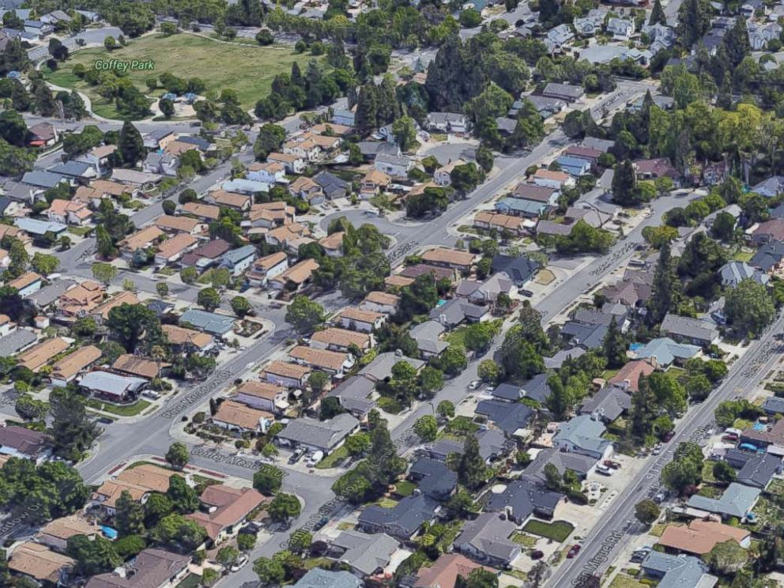
Google Earth - Coffey Park in Santa Rosa, Calif., is seen in this undated image. - Coffey Park was once full of lush trees and family homes, but the uncontrolled flames left almost every house destroyed
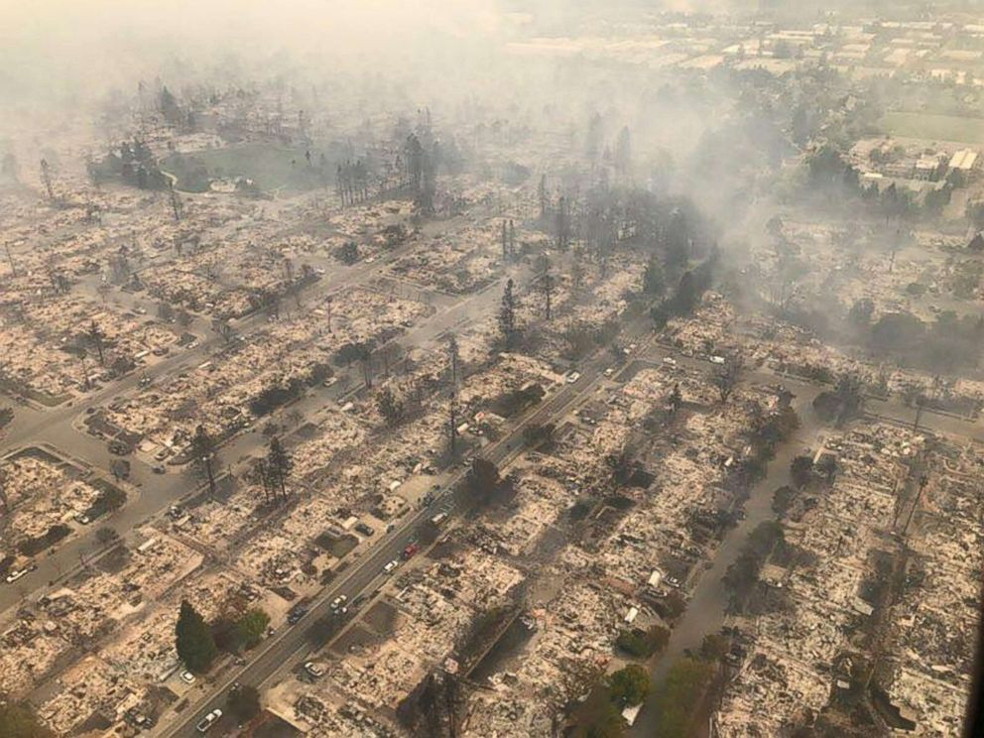
California Highway Patrol/EPA - An aerial image of a destroyed neighborhood in Santa Rosa, Calif., Oct. 9, 2017 An aerial photo taken by NASA from space shows overwhelming smoke encompassing North Bay as it moves out to sea. Look how trees are still green while the houses are reduced to ash, disintegrated …

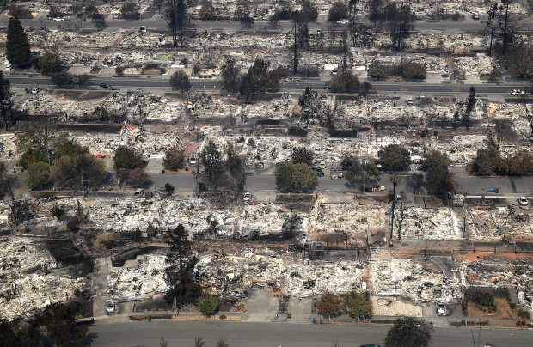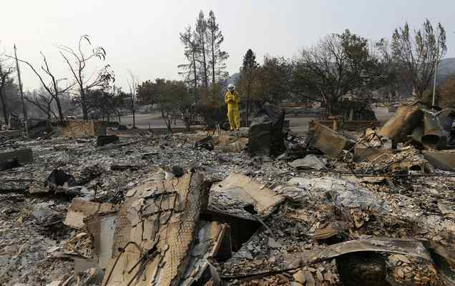

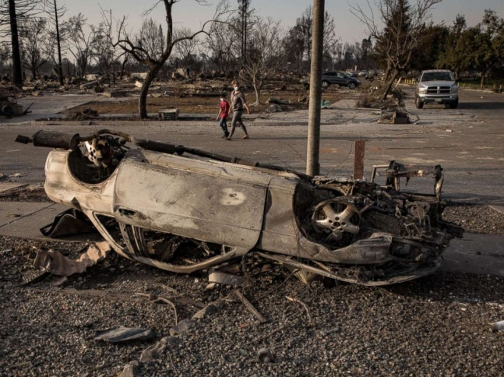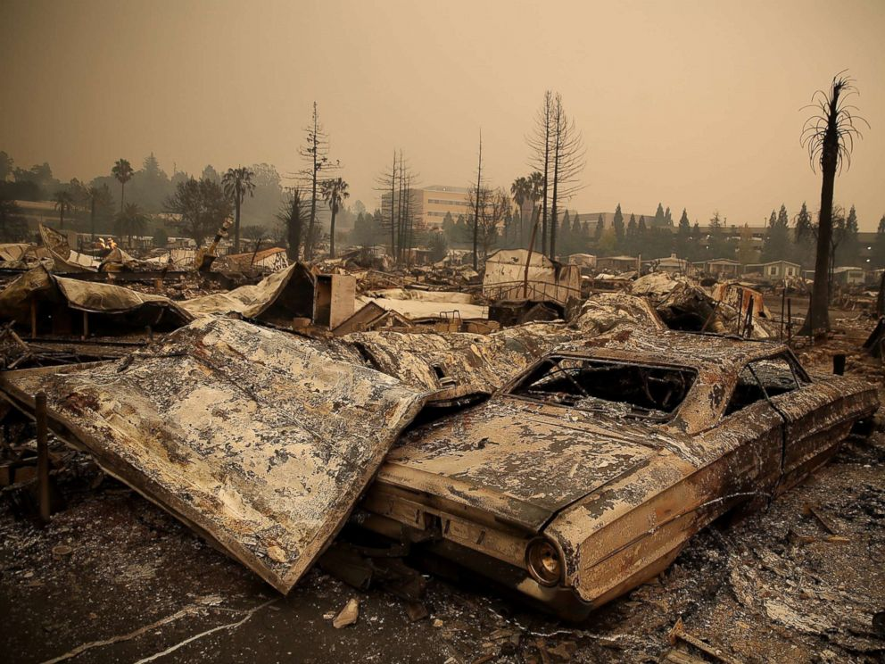

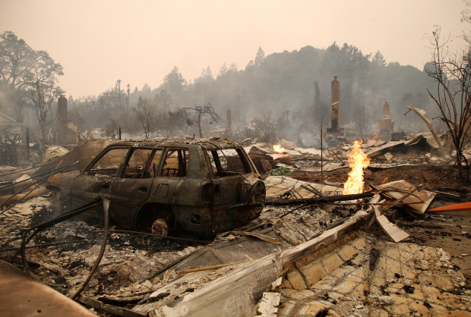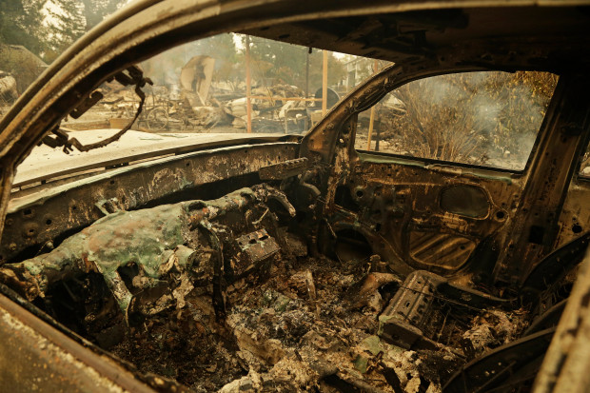

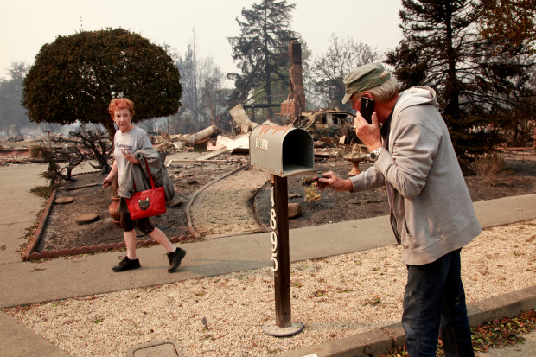
The wooden mail box post and trees are still there, but the house was reduced to ashes
One man showed a picture of a tree burning from the inside out … that’s microwaving

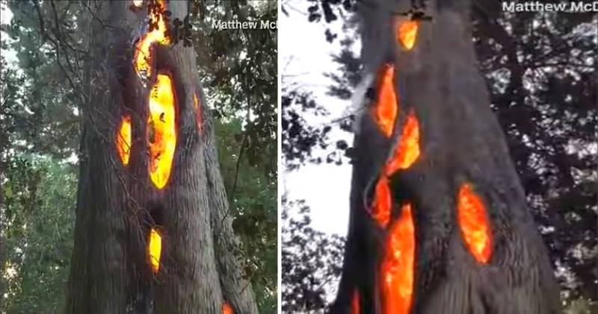
Photos of trees burning from the inside out – that’s the way a microwave oven cooks

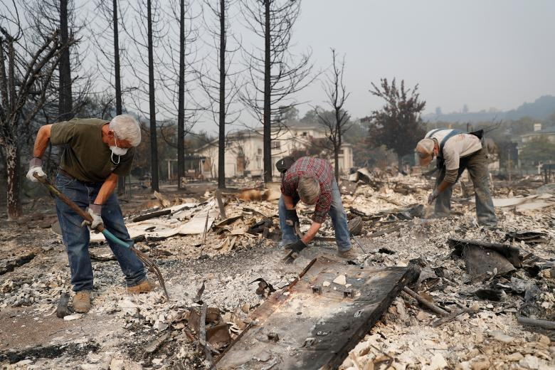
The houses were reduced to rubble, as if bombed – as if a nuclear blast was used to disintegrate houses – much as what happened in Nagasaki and Hiroshima Japan in 1945

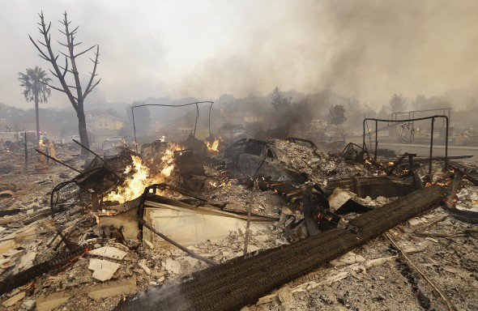
Where are the house structures? Where is evidence of any content?
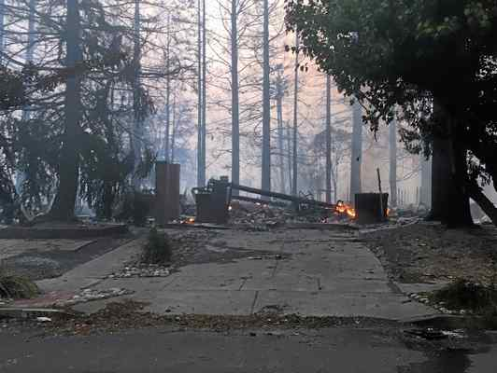
The glowing fire the lady talked about – see the greenery to the right…
AP October 15, 2017: Some of the fires were 100 miles wide.
The blazes were blamed for at least 40 deaths and destroyed some 5,700 homes and other structures. The death toll could climb as searchers dig through the ruins for people listed as missing. Hundreds were unaccounted for…

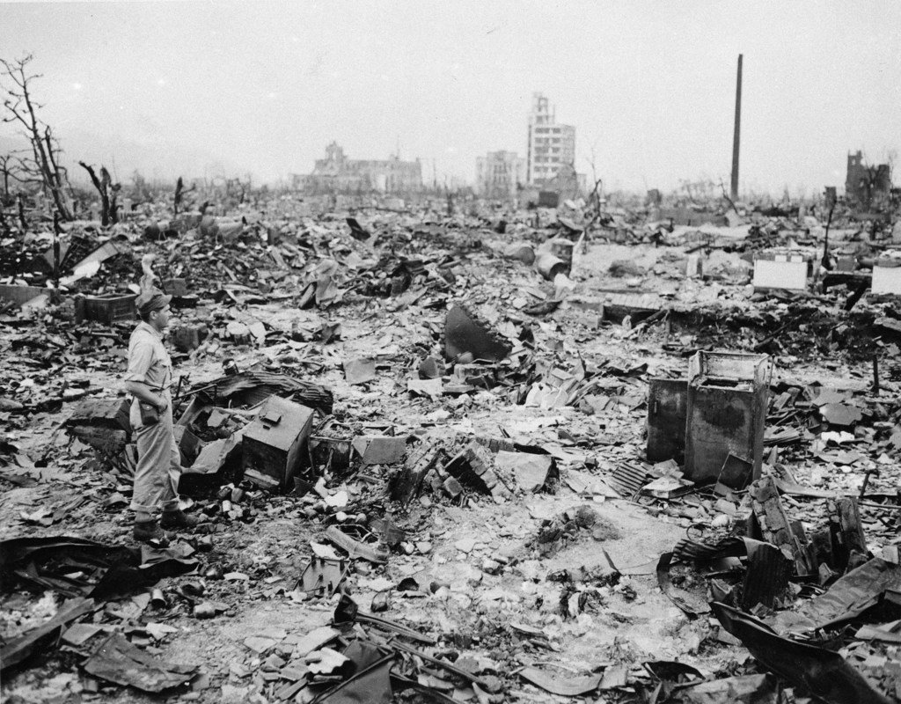
Photo taken after the Atomic bomb landed on Hiroshima in 1945, the effects look similar to what was aimed on Santa Rosa, except for here, the trees are burned.
-----
Pictures from December 6, 2017 of the “Thomas Fire” in Ventura
I thought maybe this fire might be a natural one, but look at these pictures from the Daily Mail. We see the same scenario as the fires in Santa Rosa in October.
I realize that California had been “dried out” for some time with heat waves and dry winds. But, this also can be done by manmade technology to prepare fires to ignite quickly and spread rapidly. Nicola Tesla in the 1920s discovered how to do a lot of this, and so did the Nazis. Both said they got their technology from “aliens” by séances, channeling, automatic writing, appearances from the underworld. But, as we also know, a company of fallen ones and Nephilim were allowed to return around 1896 to do a repeat of what Enoch wrote about in his book – giving man ancient technology of war and destruction, immorality, drugs/sorcery, and the depths of evil.
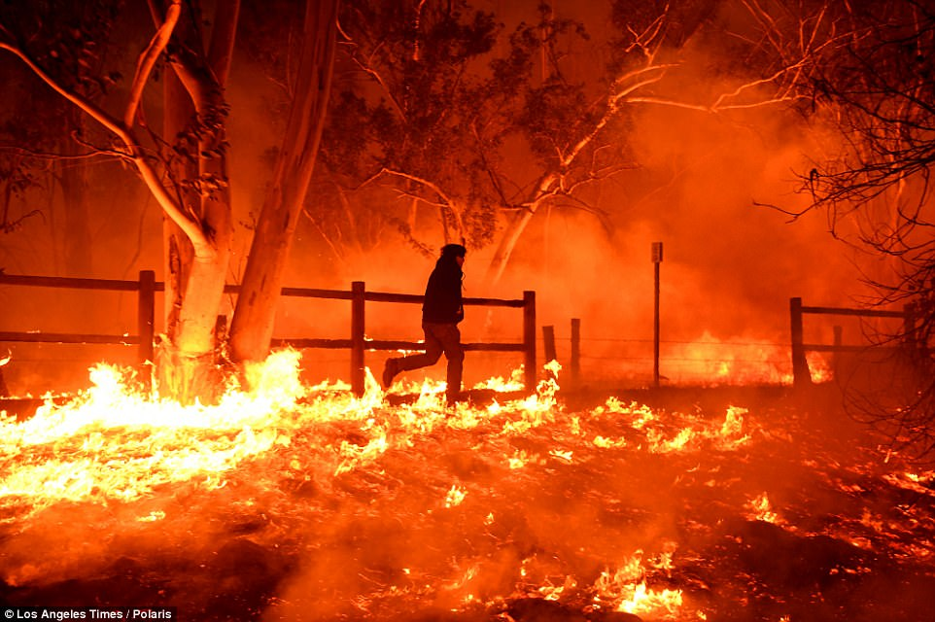
Edward Aguilar runs through the flames from the Thomas Fire to save his cats at his mobile home in Casita Springs in Ventura County, The fire broke out December 4th!

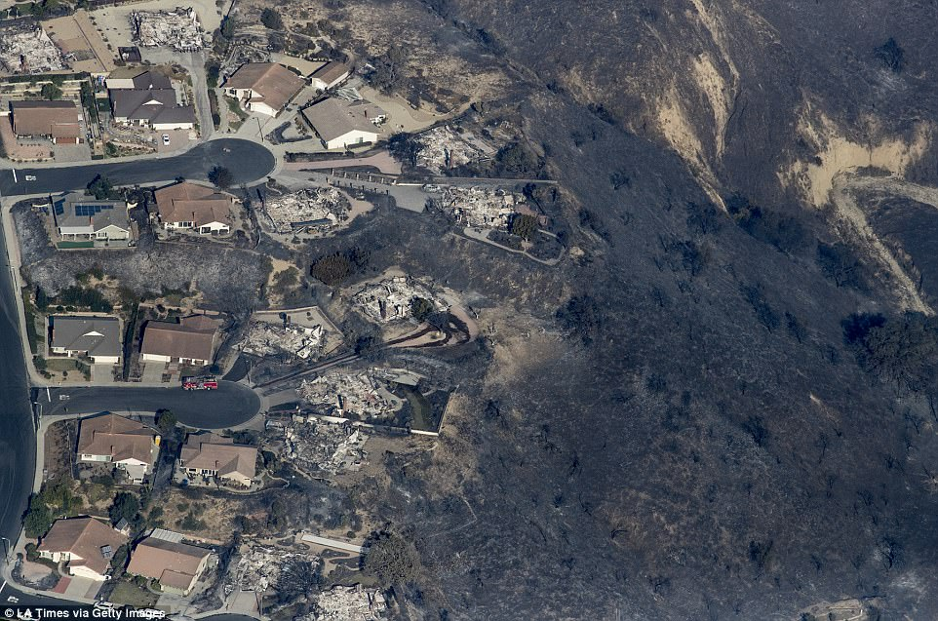
December 6, 2017: The blaze has grown to consume more than 45,000 acres in the coastal county which is just north of Los Angeles. Above destroyed homes are pictured on Tuesday in Ventura County
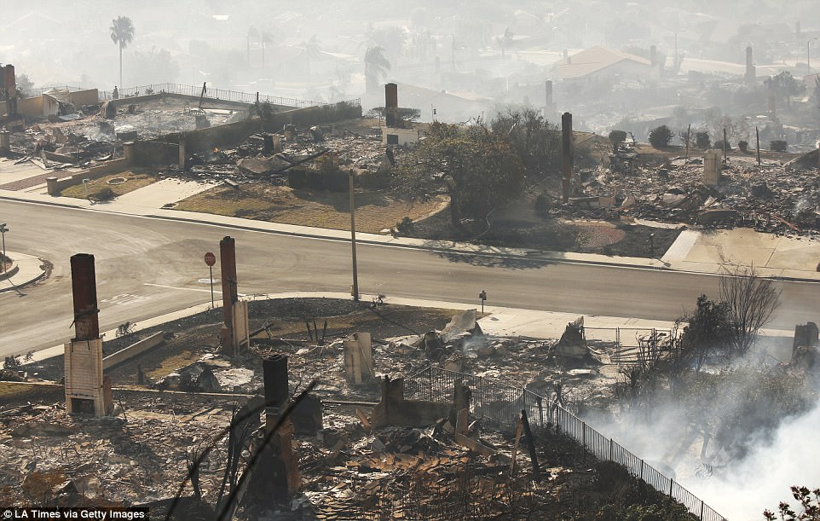
Of the fire, Brown said: 'This fire is very dangerous and spreading rapidly, but we'll continue to attack it with all we've got.'
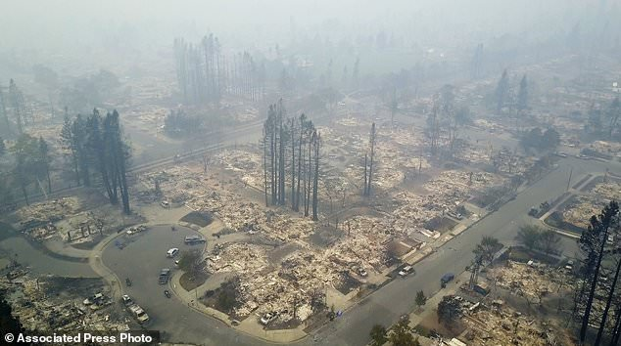
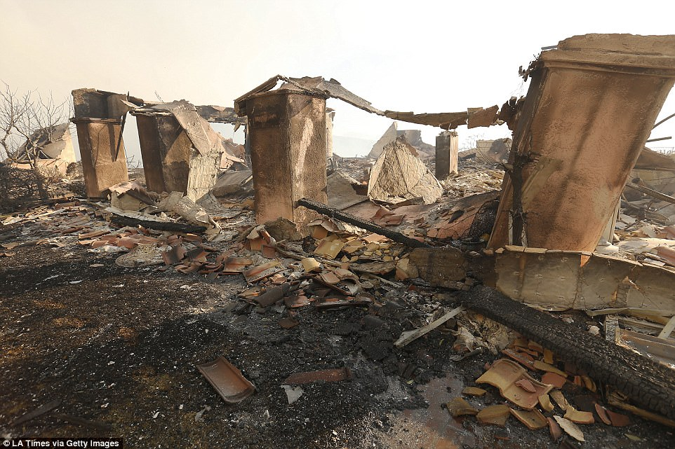
This has been an unusually bad year for California wildfires, which has seen more than one million acres (1,500 square miles) burn so far in 2017, according to data released Tuesday by the California Department of Forestry and Fire Protection. Above a destroyed home is pictured on Tuesday

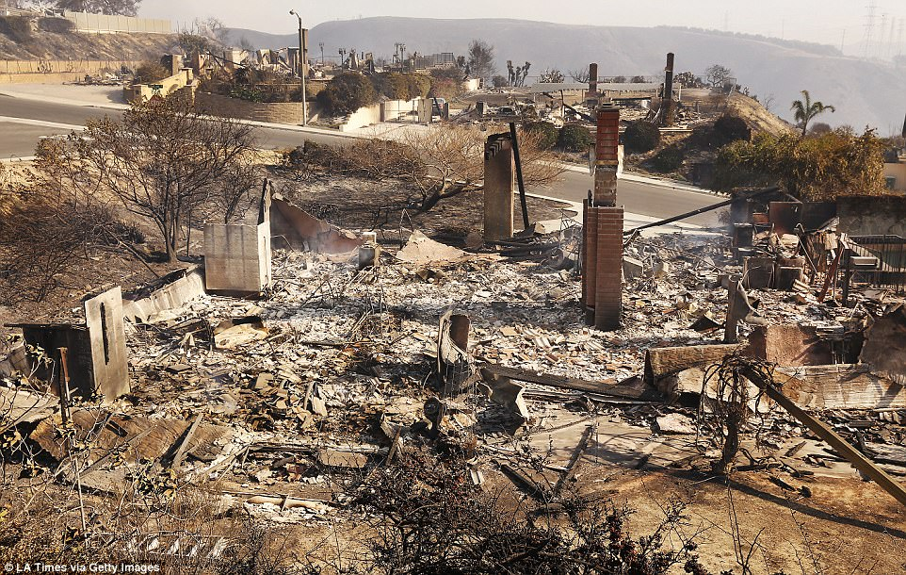
Ventura County Fire Chief Mark Lorenzen said during a news conference that the prospects for containment depended on improving weather conditions. Above a destroyed home is pictured on Tuesday

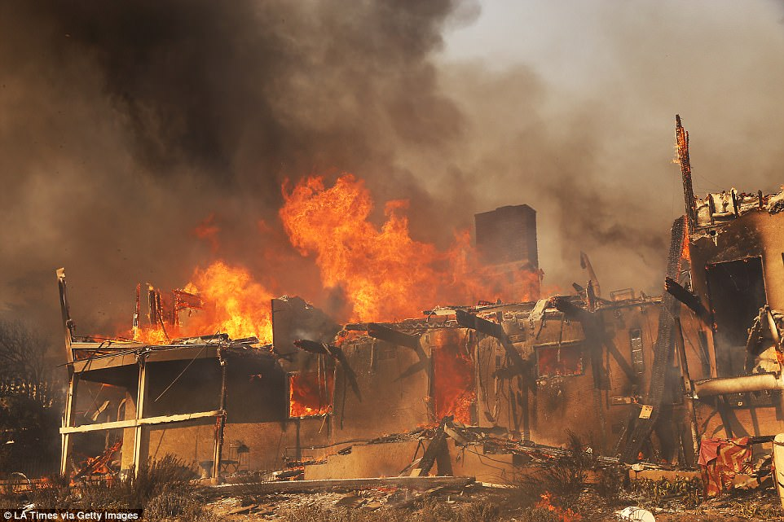
The fire has been captured in apocalyptic and frightening images with flames sometimes taking on the appearance of volcanic eruption. Above a home goes up in flames in Ventura County on Tuesday

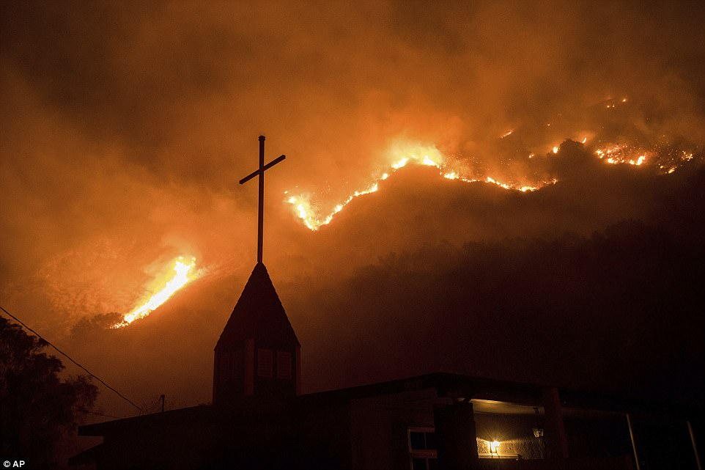
Flames from the wildfire advance down a hillside near the Springs of Life Church in Casitas Springs, Ventura County, yesterday. [This looks to me like a message to His people in America – all religion will burn, only our relationship with Him will endure]
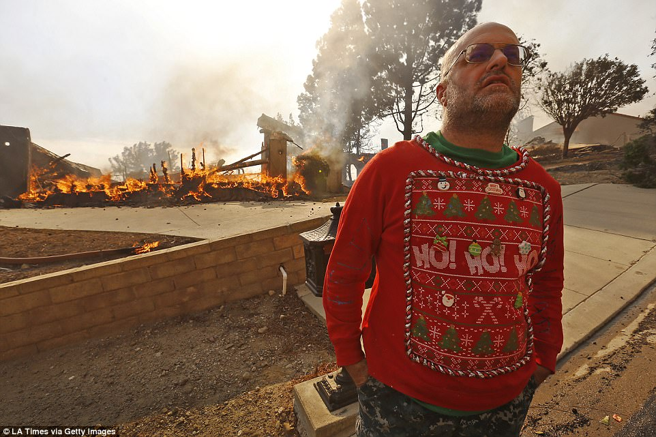
The National Weather Service said easterly Santa Ana winds fueling the fire had registered gusts of up to 55 miles per hour -- predicting they could hit upwards of 80 miles per hour into the afternoon and evening.
Above Justin Ekback watches as Firefighters fight to save multi-million dollar homes while wearing his Christmas garb
[Look behind him at the burning house, but the trees are unburned]

Now let’s look at some quotes from October articles and December 4th -6th articles, and an interview with a seasoned fireman telling how unnatural these fires are.

California Fires Not Normal According to Physics

Evidence of Super Weapons Used -Santa Rosa & Northern CA Fires DEFY THE LAWS of PHYSICS (Where'd the houses go??) inTruthbyGrace October 2017 Video (110,500 hits by Oct. 15) [Y: Nazis created super weapons, then brought the technology to the U.S. to develop even further]
My notes on the video:
Normal house fires burn at about 1,100 degrees F. Metals don’t burn … even cars are left gutted but not melted. Filing cabinets, coins, jewelry, barbeque grills, these types of things in a normal house fire don’t burn. The framework of the house is left, even though charred. It is not collapsed into dust. This video shows normal house fires, and what is left after they are burned thoroughly.
Yet, in these fires in Santa Rosa, for example, the houses of whole neighborhoods are reduced to ash, there is nothing left. The temperature of the fires is much hotter – much hotter!
Fire fighters note and have said that this is not normal. This is not according to natural physics. The fires are unusually hot and burning things that should not be burned. Houses with bricks and aluminum siding don’t burn up, they blacken, and the wood even blackens, but the structure doesn’t totally turn to dust.
As Steve Quayle notes about this: This is most likely from electromagnetic, or particle beams from up in the outer atmosphere charging the fire, electrifying it, increasing its heat.
Whole neighborhoods were turned to dust – not one house structure was left intact. So, whatever is increasing the heat to do this most likely man-made evil – something that carries “directed energy,” beamed energy is causing it and increasing it.
Some of the tall standing trees are pine trees. The lady in the video said that pine is very flammable, yet, they’re not burned enough to fall down, even very tall ones. It appears that the fires are directed, targeting certain things. Houses in between pine trees are totally turned to dust, yet the trees are not…
The garbage cans are not burned, but the cars are totally gutted – nothing left of them. Yet bushes and trees and pine needles are still there in the same place where cars are destroyed.
The houses destroyed but trees still green on the parkways. No bricks are seen … No furniture of stoves, washing machines, bath tubs, showers – nothing left to see that should be there in a normal fire.
Mail boxes on wooden posts were still standing by the driveways, yet the houses totally gone. Whole towns in the area were destroyed, yet destroyed in a totally freaky way – nothing natural about it!!!
Most of the green grass is gone! Yet, green buses and trees remained.
The narrator said that it looks like a bomb went off, because of the disintegration of the things in the house … that happens when things are close to a bomb.
Here is my input, for this led me to the book of Revelation
So many exotic super weapons are being created to use the outer atmosphere to beam electromagnetic pulse waves down on a target, or other types of pulse waves that can target. This appears to be a type of weapon with targeting abilities. Perhaps this is just an experiment, a trial run, while sending a message to the Governor too. If they can do this in California, they can do this anywhere in America or the world!
Revelation 7:2-4: “And I saw another angel coming up from the rising of the sun, holding the seal of the living Elohim. And he cried with a loud voice to the four messengers to whom it was given to harm the earth and the sea, saying `Do not harm the earth, or the sea, or the trees, until we have sealed the servants of our Elohim upon their foreheads. And I heard the number of those who was sealed, one hundred and forty-four thousand, sealed out of all the tribes of the children of Israel…”
Revelation 9:4: “And it was said to them (the locust-demons) that they shall not harm the grass of the earth, nor any green thing, or any tree, but only those men who do not have the seal of Elohim upon their foreheads.”
Between Revelation 7 and 9 Yahuwah holds back the destruction of trees (our oxygen supply), grass, bushes, grain crops, vegetable crops, fruit crops. But, there comes a point before events in Revelation 9 that He allows it to go forward. He is in total control of all of this!
I exhort you to see the current news through the eyes of Yahuwah and Yahushua, and Their Word!
California Wildfires Interview with Fire Captain John Lord About Energy Weapons and the 16 wildfires, YouTube video-aplaintruth.info (my notes from this interview)
John Lord is a veteran firefighter with over 30 years experience… he says this was not normal. Other firefighters are going on record saying this was not normal. He said that he used the word “targeted” weapon, because it looked very targeted – not a normal fire scenario, and a weapon, yes. It appears that’s the term John Lord uses, and other firemen too. He is a first responder fireman. The fires started October 9th. With them came 80 mph winds, with 2,000-3,000 degree temperatures in the fires--proof that targeting energy lazars were used in these fires. John Lord said he hasn’t watched TV in 25 years, so he got his info on the fires from his inside sources and the internet…
The number of fires and the swiftness of their moving, winds or no winds, was strange to him; it looked like something targeting.
He said he has never seen such a pattern – one side of the street nothing wrong, the other side like a nuclear war zone – houses leveled, nothing left.
He said he’d never seen this kind of fire, and he’s been in fight fires for over 30 years. Aluminum was melted into the ground. He said that fires take a while to build, but these started full heat. Nothing was left of the homes. Quite a few people said they saw blue flashes over the fires.
Other firemen are on the same page as him – something weird happened
A fire left other houses, crossed a road and torched a 700 sq. food Kmart that was totally destroyed to the ground, nothing left by 3:00 AM. Fires just don’t jump around. Other firemen perplexed – the fires were so hot they couldn’t set up a base station in some of the areas
The military police has moved into Santa Rosa to dictate to the people what they should do. What if their land is radioactive, or contains energy residue that would keep the whole area from ever being re-developed.
This is a precursor to martial law – a test obviously for future use.
`I think we got attacked’ the interviewer said, but by who--the US government of course.”
I know it sounds like “conspiracy theory” but when sane and sound men with knowledge understand what’s happening – it sure isn’t silliness. Remember, a conspiracy is simply two or more people getting together to plan something – that’s it! These things are carefully planned for a long time, then executed – just like crazy Kim and his rocket tests!
Now a little on the recent outbreak of fires: Hum… 80 mph winds in October, 80 mph winds in December – blowing fires to certain targeted areas; heat breaking out immediately to bring targeted objects to dust, not building, as John Lord pointed out. Definitely man-made terror!
Los Angeles threatened as wildfires spread, forcing thousands to evacuate
by James Rainey, Kalhan Rosenblatt and Corky Siemaszko, NBC News December 7, 2017
The national weather service was predicting near hurricane-force winds for Thursday morning in the mountains and canyons of Ventura County and northwest Los Angeles County — winds that make for rapid, unpredictable fire spreading, officials said.
Wildfire California goes from small brush fire to 500 acres in an hour - BREAKING NEWS: Small Brush Fire Explodes to 500 Acres in 1 Hour, 2500 acres in 3 hours in California - EVACUATIONS ORDERED Hal Turner Radio Show December, 4, 2017
“Shocking aerial images reveal extent of SoCal wildfire damage as 45,000 acres burn and more than 27,000 people are displaced” by Regina F. Graham For Dailymail.com - 6 December 2017
“One person has died and at least three firefighters have been injured while battling the Thomas Fire. More than 27,000 people have been forced to evacuate due to the fast-moving blaze that started Monday. At least 45,000 acres have burned in Ventura County and the fire has not been contained as of 2pm (PT)
California Gov. Jerry Brown issued a state of emergency on Tuesday for the county and urged people to flee. He said: 'This fire is very dangerous and spreading rapidly, but we'll continue to attack it with all we've got.' A massive plume of wildfire smoke now extends more than 500 miles off the Southern California coast. Not including these latest fires, more than one million acres of land have burned in the state so far in 2017”
DO YOUR OWN RESEARCH! Check out the Word on everything we’re seeing! For us, there is Isaiah 26:3-4 and Romans 8:28-39!!!!
Shalom, Yedidah – December 7, 2017

