WHAT HAPPENS WHEN THE LIGHT IS REMOVED?

John 9:4-5: “It is necessary for Me to work the works of Him who sent Me while it is still day, for the night comes when no one can work. While I am in the world, I am the Light of the world.”

“Terrifying shelf cloud engulfs Florida and turns day into night,” by Strange Sounds - May 5, 2017...The cloud engulfed the Atlantic coast of Florida on May 4, 2017…The video shows why people ran home in panic as the sky turned deep black within minutes.”
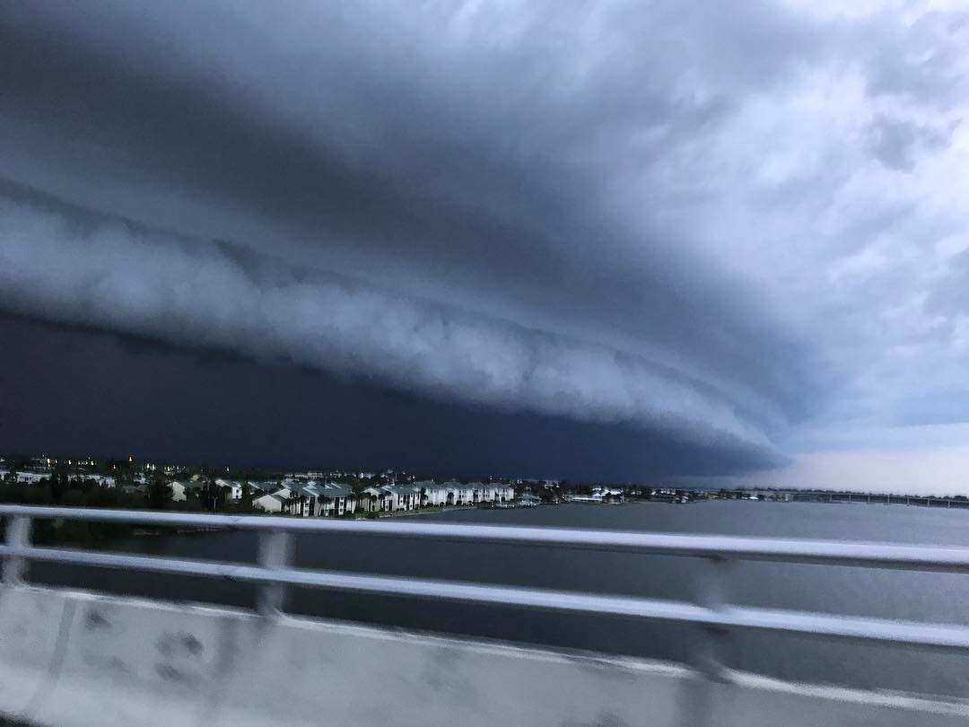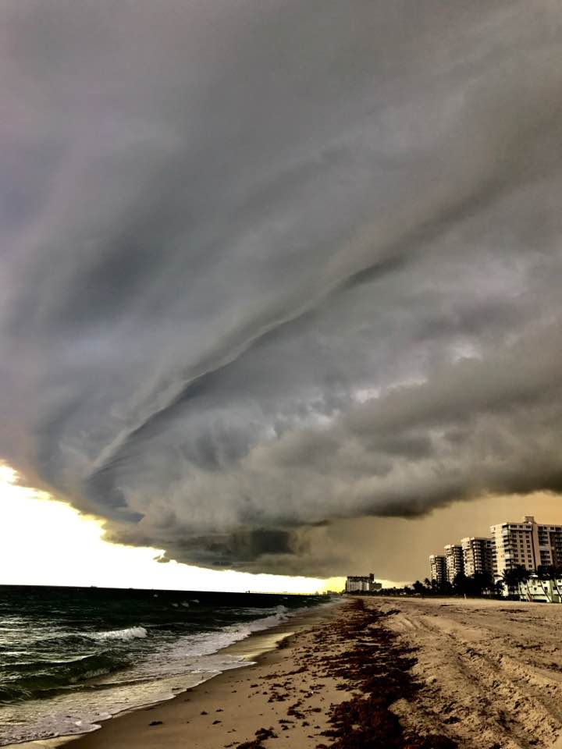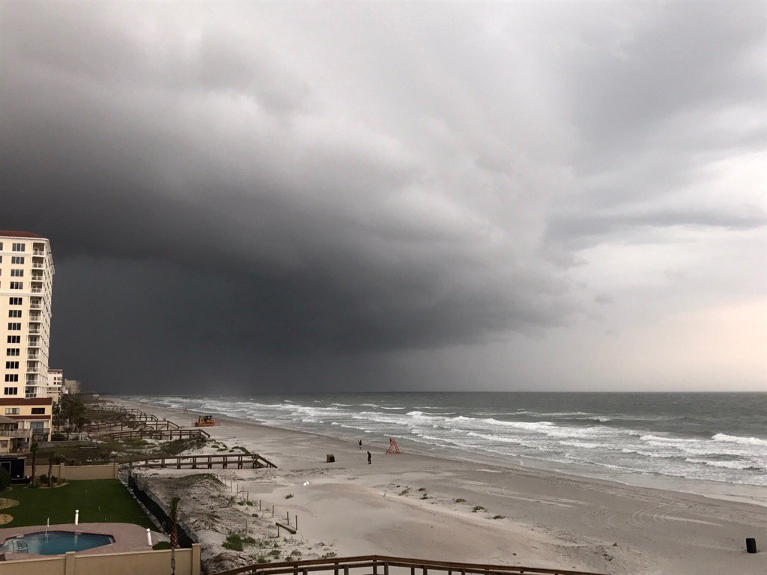

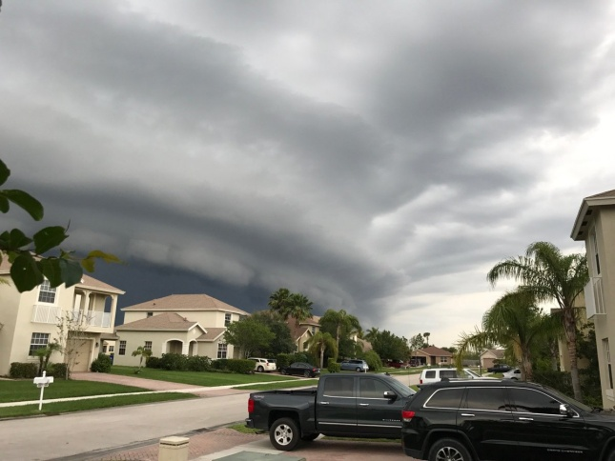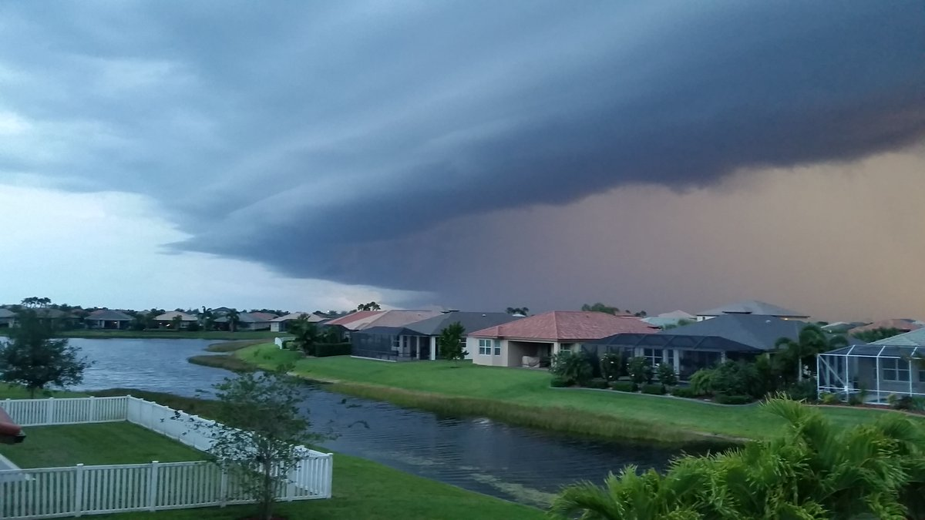
Pictures from Twitter and Instagram

A few days ago, my son, Derek, took a very similar picture of a black cloud-wall coming over his area in Texas. Just as this wall producing darkness like night came on suddenly and terrified people, so the coming darkness, both spiritual and physical, will put terror into people worldwide. “Sudden destruction” -- Genesis 6 and 7. No warning to those not hearing Yahuwah, no signs other than Noah and his sons building the ark for 5 years and Noah preaching why he was doing it. (Hebrews 11:7)
I Thessalonians 5:1-10: “Now, brothers, as to the times and the seasons, you do not need to be written to. For you yourselves know very well that the day of יהוה comes as a thief in the night. For when they say, `Peace and safety!’ then suddenly destruction comes upon them, as labor pains upon a pregnant woman, and they shall not escape.
But you, brothers, are not in darkness, so that this Day should overtake you as a thief.
For you are all sons of light and sons of the day. We are not of the night, nor of the
darkness. So, then, we should not sleep, as others do, but we should watch and be sober. For those who sleep, sleep at night, and those who get drunk are drunk at night.
But we who are of the day should be sober, putting on the breastplate of belief and love, and as a helmet the expectation of deliverance, because Elohim did not appoint us to wrath, but to obtain deliverance through our Master יהושע Messiah, who died for us, so that we, whether awake or asleep, should live together with Him. Therefore encourage one another, and build up one another, as indeed you do.”
In Podcast III, I read from Pastor Carl Gallups book When the Lion Roars about a nurse, who, while taking his blood pressure, began pouring out her heart about the awful things happening in the news. When she ended her discourse, Carl’s response is classic. He used what she said to ease into sharing the Good News of hope with her by saying: “When the darkness gets darker, the Light gets brighter.”

John 8:12, Messiah speaking: “…I am the Light of the world. He who follows Me shall by means walk in darkness, but possess the light of life.”
Mathew 5:14-16, Messiah speaking to His followers: “You are the light of the world. It is impossible for a city to be hidden on a mountain. Nor do they light a lamp and put it under a basket, but on a lamp stand so that it shines to all those in the house. Let your light so shine before men that they may see your good works and praise your Father who is in the heavens.”
Isaiah 59:20-21-60:1-2: “`And the Redeemer shall come to Zion and those turning from transgression in Ya’cob,’ declares Yahuwah. `And this is My Covenant with them,’ says Yahuwah. `My Spirit that is upon you and My Words that I have put in your mouth shall not be withdrawn from your mouth, nor from the mouth of your descendents, nor from the mouth of your descendents’ descendents,’ says Yahuwah, `from this time and forever’…Arise, shine, for your light has come! And the esteem of Yahuwah has risen upon you. For look, darkness covers the earth, and great darkness the people. But Yahuwah rises over you; His esteem is seen upon you. And the nations shall come to your light, and kings to the brightness of your rising.”
This is the awesome future of those who walk in His Light, as He walks in Light.
The truly born again are “children of light.” His children, whom He knows as His children, have submitted to His Spirit to be His servants--to stand against the spirits of darkness. They go forth to shed His light in this dark world. The Daniel 11:32 remnant is being prepared.
Recently in his podcast #128 on kingdomintelligencebriefing.com, Dr. Michael Lake said, ““Yahuwah is calling out the remnant by name…He is briefing the remnant right now. Just as leaders in our world attend `intelligence briefings,’ Yahuwah is calling His own `intelligence briefings’ to instruct and provide “the knowledge” we need for the final end-time battle to obtain the victory.” Does that excite you! It sure does me…
Dr. Lake referred to Daniel 12:4: “…knowledge shall increase.” In Hebrew this refers to “the knowledge,” specific knowledge--i.e. the knowledge that the Watchers have
given to mankind from 1896, and “the knowledge” that Yahuwah has for His remnant.
Dr. Lake referred to Daniel 12:4: “…knowledge shall increase.” He said that this knowledge has been held back for His final Daniel 11:32 remnant in these last of the last days. Look at the context of that remnant, in the days of preceding and during the reign of anti-messiah.
“They that know their Elohim shall be strong and act - doing exploits.” Dr. Lake said that the phrase in Hebrew, “know their Elohim,” meant “to be madly in love with Elohim, passionately loyal, submitted, obedient, and empowered by His might.” (Deuteronomy 6:5)
Ephesians 5:6-16: “Let no one deceive you with empty words for because of these the wrath of Elohim comes on the sons of disobedience. Therefore, do not become partakers with them. For you were once darkness, but now you are light in the Master – walk as children of light – for the fruit of the Spirit is in all goodness, righteousness, and truth – proving what is well-pleasing to the Master. And have no fellowship with the fruitless works of darkness, but rather reprove them. For it is a shame to even speak of what is done by them in secret. But, all things being reproved are manifested by the light, for whatsoever is manifested is light. That is why He says `wake up you who sleep and arise from the dead and Messiah will shine on you. See, then, that you walk exactly, not as unwise, but as wise, redeeming the time because the days are evil.”
I John 1:5-7: “And this is the message which we have heard from Him and announce to you, that Elohim is light and in Him is no darkness at all. If we say that we have fellowship with Him, and walk in darkness, we lie and are not doing the truth. But if we walk in the light as He is in the light, we have fellowship with one another, and the blood of יהושע Messiah His Son cleanses us from all sin.”
The “great darkness” is fast moving upon us. Darkness is covering the people, like that black cloud over Florida symbolizes. It is engulfing the peoples of the earth, but its target is to try to extinguish the light of the people of Elohim. The dark cloud of demonic presence is covering all the people of earth, particularly targeting the children of light in an attempt to extinguish the fire of the Spirit within them, and thus snuff out their light entirely. His tactics are to wear down, to discourage, to oppress, to crush and depress--even as a python wraps itself around its victim and crushes it to death. The spirit of the python, Apollo’s/Apollyon’s symbol, is increasing in strength in the earth right now.
On the other hand, we are called to “endure to the end” that we might be delivered. (Matthew 10:22b) If we let go of our “first love”--our passionate love for Yahushua who died and rose again for us and become like the world’s people—Messiah will extinguish our light. (Revelation 2:4-5) [Refer to the passages in “Scripture Warns…”]
When we are filled with His Spirit, (Luke 3:16) just like what happened in I Kings 8:6-14, only within our spirit, (I Corinthians 6:19-20) Yahuwah’s Spirit puts His fire into us so that we go forth bearing our light to a dark and dying world. If we let it go out – we become naked and alone. (Revelation 16:15) There is no greater darkness than to be left without Messiah, the Light of the world.
Joel 2:30-31 speaks of coming physical darkness: “And I will give signs in the heavens and upon earth – blood and fire, and columns of smoke – the sun is turned into darkness and the moon into blood, before the coming of the great and awesome Day of Yahuwah.”
(Isaiah 24; Haggai 26-7, 21; Hebrews 12:25-29; Revelation 6:12-17 and 16:12-21)
This could be talking about eclipses, but more than that, it is talking about the air filled with ash and dirt, smoke, along with blood and fire due to volcano eruptions, or the great shaking that will take place--the earth will shake nearly out of place when Messiah
Revelation 9:1-4 speaks of the coming darkness, which sounds nearly identical to Joel’s account: “And the fifth messenger sounded, and I saw a star from the heaven which had fallen to the earth. And the key to the pit of the deep was given to it. And he opened the pit of the deep, and smoke went up out of the pit like the smoke of a great furnace. And the sun was darkened, also the air, because of the smoke of the pit. And out of the smoke locusts came upon the earth, and authority was given to them as the scorpions of the earth possess authority. And it was said to them that they shall not harm the grass of the earth, or any green matter, or any tree, but only those men who do not have the seal of Elohim upon their foreheads.”
Revelation 9:4 sounds identical to Ezekiel 9:4. If we are marked by Yahuwah, we’re off limits to the “locusts” of Revelation 9 and Joel 2. It’s the same scenario – locusts symbolic of demons.
My vision of the coming darkness: Around 1993, I had a vision that was very profound. I saw myself flying over a totally darkened earth. But, every so often, here and there, I saw little campfires where the fires blazed brightly. Around each of the fires were huddled 4-5 people. I knew they were members of Yahuwah’s remnant, those whose fire still blazed in the darkness.
When the electricity goes off we head for the candles, don’t we? We stumble in pitch-darkness. We can’t see clearly. We grope for things, hoping to find what we need. Darkness is good for sleeping, but not good when you need to see and do things.
In Survival 101 May 3rd, which I read some of on Podcast IV, Ted makes a statement that goes along with the trilogy of articles I wrote in January of 2015 about the withdrawal of the Spirit. He says: “The world is buckling under great pressure--war, violence, terror attacks earthquakes, tsunamis, wildfires, tornadoes, and massive sea life dying. These things are just a fraction of the destroying forces raging throughout our world…Confusion and strife reigns everywhere in this world today. God is withdrawing His Spirit from the earth ready for the last days and Satan is gaining more and more control…The answer can only be found through a source that the majority of people have forgotten about – the Bible. When you study the Bible, you see that these things were prophesied to happen a long time ago.” Thank you Ted!
The restraining forces will soon be all pulled back, then the deepest spiritual darkness will take over almost all the people of earth, to control their minds and destroy their bodies.
Most of the churches and messianic congregations are silent about the rapid fulfillment of prophecy that we are watching, yet, as Ted points out in this article “…about one fourth of the entire Bible is prophecy, and that about 90 percent of all prophecy is for “the end-time”--the time just ahead of us.”
When Satan went before Yahuwah to ask for permission to afflict Iyob/Job, Yahuwah

gave permission to Satan to work His judgment in the earth, to separate between the Noah-types and the rest of the fallen humanity. Besides having pure human blood, Noah was a righteous man, blameless before Yahuwah. He walked with Yahuwah in absolute obedience. Therefore, Yahuwah trusted His servant that He would be stronger in faith after going through the tribulation than he was before. (Genesis 6:8, 9, 22 and Hebrews 11:7) In Genesis 6:13-14, Yahuwah gave instructions to one man – Noah.
This is part of my testimony. Luke 22:31-32: Messiah said to Kepha/Peter: “Satan has desired to have you that he may sift you like wheat, but I have prayed for you that your faith fail not, and when you have turned around, strengthen your brothers.”
When Messiah prays for us, He prays knowing the end from the beginning, and so after we go through great trials, we come out with greater faith so that we can help others to get out of the pit that Satan has them chained in. The passion of my life is to set others free! Read “Passion – Unlocking the Chains” from March 14, 2017.
He has given us the keys OF the Kingdom of Heaven to unlock the prison doors, and the chains, that the enemy has put on people, and on ourselves. We must use the keys!
Yahuwah has to thresh His wheat. He has to winnow His wheat until finally we are ready, minus the tares (the wicked, the fakes) and the chaff (our own sin), to enter His Kingdom (Matthew 13:24-50)
The coming tribulation is for our good! We can’t enter the Kingdom if we still have “chaff” clinging to us. Acts 14:22: “It is through much tribulation that we must enter the Kingdom of Elohim.”
Derek’s comments from his recent study notes: “If people read Daniel, they would understand something very unusual… that although the tribulation removes the wicked from the earth, it is really for the Set-Apart ones to refine them as white as snow...but all along, it is really the goodness of a Father who allows us to go through it in order for us to be able to look upon Him face to face. If we are not like Him we will not SEE Him…”
We’re entering darkness, a time of physical darkness whether by eclipse, or the air polluted by ash and smoke, or “nuclear night.” But, we’re entering the greatest time of spiritual darkness than ever before. Nearly 7 billion people will perish, most will be totally hating Yahuwah – Revelation 9:1-2, 20-21; 14 9-11; 16:10-11.
Revelation 16:10-11: “And the fifth messenger poured out his bowl on the throne of the Beast and his kingdom became darkened, and they gnawed their tongue in pain. And they blasphemed the El of the heavens for their pain and for their sores and they did not repent of their works.” The condition of mankind just before Messiah returns will be animalistic, having taken the “mark” of the Beast they break out in sores and their DNA is totally changed so that they are not totally human anymore.
Messiah asked: “When the Son of man comes, will He find faith on the earth?”
Yes, His transformed Bridal remnant who has remained loyal to Him. For this reason, as in Malachi 3:16-4:6, He does not destroy the earth. We must pray daily for open doors to minister life into those He wants to save.
“The mind is the battlefield.” Satan’s darkness enters into the minds of people, alluring them away from the light of Yahuwah and Yahushua. The enemy whispers his

thoughts that sound right and good, and most in western culture, or anywhere in the
“free” world of affluence, are listening to the demonic whisperings and falling prey to the sly allurements of the mind, just like the world’s people. Satan’s most convincing tactics
for the takeover of believers is to bring in a few Scripture verses that back his deception
Using a few Scriptures is a tactic that works – 43,000 denomination and organizations all calling themselves “Christian” use a few Scriptures to back their varied doctrines. The Messianic Movement does the same thing. Islam also uses Scriptures to back what Allah says, and the New Age Movement uses Scripture to back what they have to say. Judaism uses Scripture to back what the various rabbis say, yet if anything is spoken outside of a rabbis’ opinion, the text is altered to agree with the rabbi.
A large percentage of western-culture Christians do not even believe that the devil and his fallen angels are real--only symbolic of evil in man. How horribly ignorant! Yet all around us there are demonized people, worshippers of Satan or Lucifer, who are ready to kill Christians, and who kill Christians. People are doing more and more insane things that the average human mind can’t wrap around. As a naïve Baptist, when I encountered satanic ritual abuse 2 months into my marriage, my mind could not wrap around what was happened; I became as one paralyzed to help myself. The insanity of the mind of Satan and his forces is not generally known by regular humans, but as we approach the time of their appearing more openly, it will produce what Luke 21:26 says: “Men’s hearts failing them for fear…” Yet, what is most stunning to me is the dullness that is settling over believers so that they are becoming more and more zombie-like on the one hand, and emotionally unstable on the other hand – the enemy’s working.
I highly recommend you read Russ Dizdar’s The Black Awakening to learn what is going on all around you. You can also hear him speak, and read his writings, on his website: shatterthedarkness.net.
If we allow our light to dim, it will eventually go out. It has to be maintained.
Revelation 16:15: “See, I am coming as a thief. Blessed is he who is staying awake and guarding his garments, lest he walks naked and they shall see his shame.”
Keep the “Luke 3:16” fire of the Spirit of Yahuwah burning in your spirit. Let His Spirit blaze within you. His fire burns out sin, and also strengthens us with the boldness we need to do His work.
The Hebrew picture here is of the High Priest who leaves one of his servant-Levites by the fire on the altar at night to make sure it never went out. Every so often, the High Priest would come silently, like a thief, in the middle of the night to check on how the Levite was doing. If he saw the Levite asleep and the fire going out, he would silently take a few of the coals and put them on the Levites garments. The garments would begin to smoke and catch fire, and the Levite would jump up, tear off his burning garments, and run away naked. The admonition to us is not to let our fire go out.
The punishment of Yahuwah on this world is always “sudden” and “short-lived.” He’s a Father. He doesn’t want to have to punish His creation, but when He has to, He has to. He is no sadist, nothing is drawn out. The Flood was 40 days and 40 nights. He does what He has to do and then it’s over.
As long as Abba has any restrainers against the forces of darkness, He will have

mercy. But, when the final restrainers are removed, the two witnesses and their Bridal
remnant-company, then Satan will empower Apollyon to destroy all mankind and almost all of creation as a whole before Messiah comes. That’s when even the remnant has to
hide out. As long as Abba has any restrainers, Satan is limited in what he can do, but
when the light of His Presence is totally turned off, or hidden under His Psalm 91:1 “bushel basket,” then Satan has his “short time.” It won’t take 24 hours for him to destroy everything except the “Iyobs” (Job chapter 1) on earth. Satan can only go as far as Yahuwah will allow. And the phrase, it is darkest just before the dawn is true.
What happens when the light goes out? We walk in darkness; hope eventually dies, and we fall prey to what roams in the darkness. The Light of Yahuwah and Yahushua never totally leaves earth, but almost. Guard your salvation! Guard your light!
In His love,
Yedidah
May 10, 2017

