I Will Rise
The Eternal Message of Yahuwah That Baptism Gives to the Nephilim Offspring of the Watcher Fallen Angels

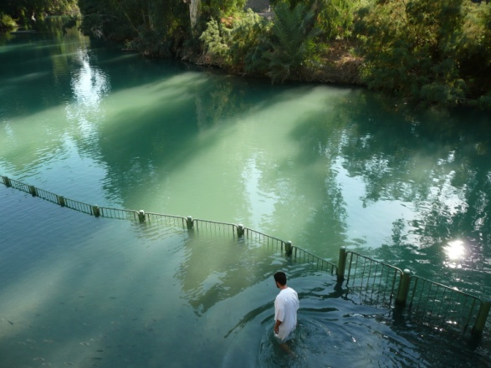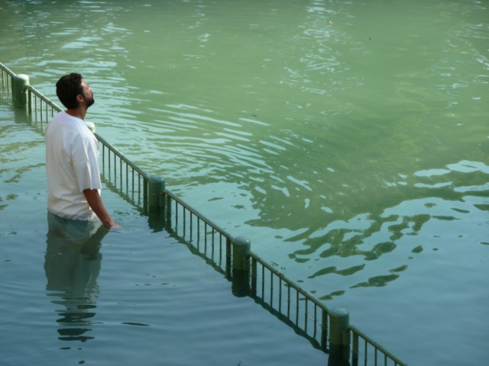

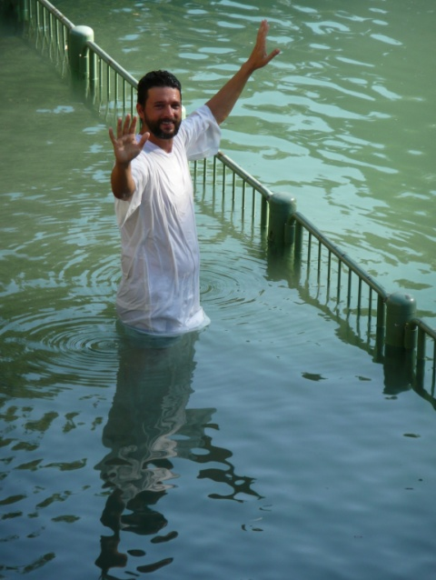

First three pictures: Derek at the Yardenit Baptism site on the Jordan River south of Tiberias, Israel--2011. His mikvah …
Last three pictures: Derek and Rivkah October of 2012 – First photo: Showing praise; second photo showing the proper way to “mikvah” by going forward into the water completely covering the head, and third photo showing rejoicing resurrection life!
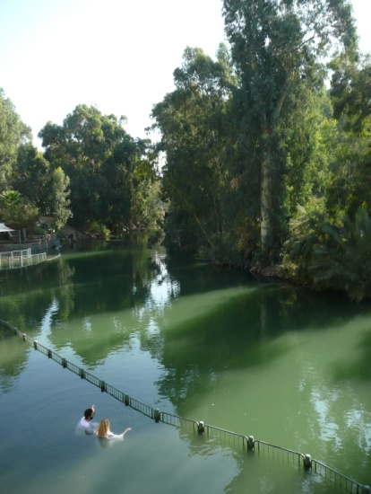

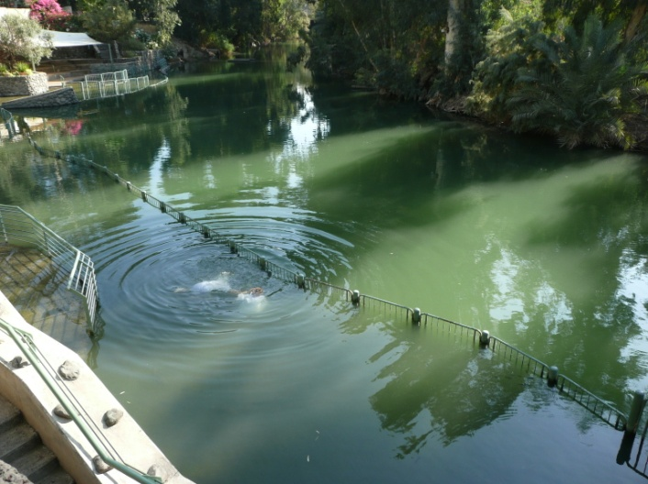
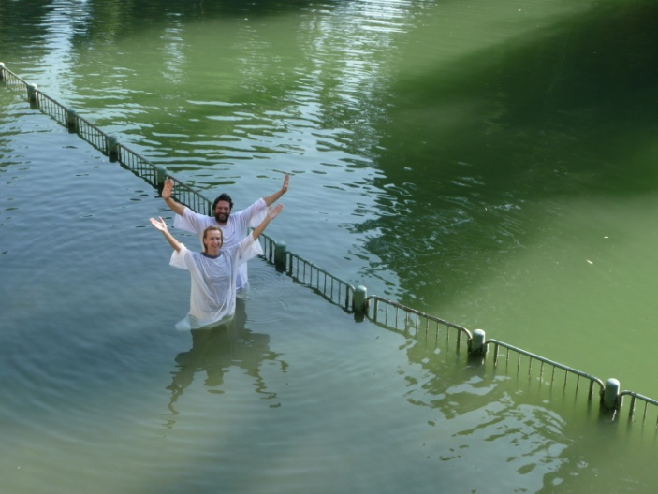

“I WILL RISE” written and sung by Chris Tomlin
There's a peace I've come to know
Though my heart and flesh may fail
There's an anchor for my soul
I can say "It is well"
Yahushua has overcome
And the grave is overwhelmed
The victory is won
He is risen from the dead
And I will rise when He calls my name
No more sorrow, no more pain
I will rise on eagles' wings
Before my God fall on my knees
And rise
I will rise
There's a day that's drawing near
When this darkness breaks to light
And the shadows disappear
And my faith shall be my eyes
Yahushua has overcome
And the grave is overwhelmed
The victory is won
He is risen from the dead
And I will rise when He calls my name
No more sorrow, no more pain
I will rise on eagles' wings
Before my God fall on my knees
And rise
I will rise
And I hear the voice of many angels sing,
"Worthy…
And I hear the voice of many angels sing,
"Worthy is the Lamb"
And I hear the cry of every longing heart,
"Worthy is the Lamb"
And I hear the voice of many angels sing,
"Worthy is the Lamb"
And I hear the cry of every longing heart,
"Worthy is the Lamb"
And I will rise when He calls my name
No more sorrow, no more pain
I will rise on eagles' wings
Before my God fall on my knees
And rise
I will rise
Songwriters: Chris Tomlin / Jesse Reeves / Louie Giglio / Matt Maher
I Will Rise lyrics © EMI Music Publishing – Hello Love album 2008
https://www.youtube.com/watch?v=WlHUKY3jBv0

[Note: I, Yedidah, substituted the Hebrew Name above all Names, Yahushua, in place of Iesous/Jesus] This is a beautiful and powerful song! Every time I hear it, my spirit vibrates with praise and my eyes fill with tears.
--------------
Romans 8:11: “And if the Spirit of Him who raised Yahushua from the dead dwells in you, He who raised Messiah from the dead shall also give life to your mortal bodies through His Spirit dwelling in you.”
John 11:23-27: “Yahushua said to her (Martha), `I am the resurrection and the life. He who believes in Me, though he were dead, yet shall he live. And everyone who is living and believing in me shall never die.”
From Matthew 28:1-7: “…He is not here, for He has risen as He said. Come see the place where the Master laid. Go quickly! Say to His disciples that He was raised from the dead…” Luke 24:4-7: “…two men stood by them in glittering garments …these said to them `Why seek you the living among the dead? He is not here, He has risen…’”
Because He has risen, we, too, can rise in the resurrection of the righteous!

To obtain a foundation for the amazing revelations I share with you here, I refer you to go my website, comeenterthemikvah.com. Click on “Foundational Articles” on my main page and learn what the mikvah really is. Also, for foundational understanding on water baptism, I refer you to the article on water baptism under Mikvah #2 “Immerse into the Waters of Baptism,” entitled “Baptism: The Beginning Mikvah for Separation -- Dying to the old life, rising to the new (December 2011)
So many times we can know something intellectually, and though it is pleasant to our mind,, it doesn’t have much life-changing depth until Abba impacts our spirit with His Spirit, and then it becomes revelation knowledge that bypasses the carnal mind and lodges deep in the eternal spirit. The knowledge then becomes life-changing. It becomes real. It becomes something that you want seek with all your heart.
I first heard this amazing insight in a recent interview on Skywatch with Dr. Michael Heiser, reviewing his new book Reversing Hermon – The Sin of the Watchers. His words leapt into my spirit, while the anointing of Abba’s Spirit confirmed it.
In my extensive researching for a great part of 54 years, comparing the prophecies throughout the Word with current events, then relating them as Yahuwah teaches me, I have done research in the book of Enoch I. I also have gone up onto a peak of the Mount Hermon ridge many times from inside Israel. I’ve seen some of the ruins where worship of pagan gods went on within the tribe of Dan, and where Nephilim hybrids inhabited Bashan (today’s Golan Heights) before the Flood. (Genesis 6)
Talk about a mighty portal for demonic entrance! [Refer to my study: “Mount Hermon and Mount Tabor”] According to the book of Enoch I, in the days of Jared, 200 Watcher’s, fallen angels, came down on Mount Hermon to mate with human women and produce what the Word calls Nephilim – giants, hybrid beings of incredible size and strength. It was because the children of these Watchers took over earth, leaving only Noah and his family with pure human blood, that Yahuwah had to send the Flood.
When Dr. Heiser began talking about baptism and Enoch’s message from Yahuwah to the Watchers, Scriptures from Genesis to Revelation began going off in my mind like an explosion of interconnecting Truth. Then on the morning of December 14th, upon awakening, Abba began downloading into me the outline for this article.
Dr. Heiser chuckled regarding I Peter 3:18-22, noting how Kepha/Peter loaded so much into this passage that each sentence seems to be talking about a different subject. Kepha compares baptism to Noah and the Flood. However, as Heiser noted, the passage is carefully connected. This former fisherman was a very intelligent man! He had been up on Mount Hermon with Ya’cob/James, Yochanan/John, and Messiah Yahushua, when Messiah began to glow and Eliyahu/Elijah and Moshe/Moses appeared on either side of Him. (Matthew 17:1-7) Kepha wanted to build booths because he knew that Eliyahu was the Groom’s attendant and Moshe was the Bride Attendant. And, Sukkot/Feast of Tabernacles/Booths was near--the time for the eternal wedding. Yochanan the baptizer had even referred to himself as an attendant to the Groom/Messiah, John 3:29, and Yahushua had referred to His little band of disciples as attendants, Mark 2:18-20.
In II Peter 2:1-9, Kepha also discusses the Watchers--the fallen angels who had descended onto Mount Hermon in the days of Jarad and brought great technology and advanced knowledge of all types to mankind. Kepha wrote about the time of their return, and of their final judgment. Because of the sin of the fallen angels, those who rebelled with Lucifer in heaven, Yahuwah sentenced them to Tartaros upon their death--the lowest hell. After 70 generations they would be allowed to return to again bring the forbidden knowledge and technology to mankind that would bring mankind and all creation into utter destruction on the Day of Yahuwah, the Day of Judgment, when Messiah Yahushua comes with the wrath of His Father. Their time allotted was 120 years. Indeed we have seen the result of their return, from around 1896 to 2016.
The original fallen angels who “left their first estate” (Jude 1:6), their original dwelling, to extend themselves into the earth by mating with human women, knew they had sinned a great sin against Yahuwah. They pleaded with Enoch to go to Yahuwah to beg Him to forgive them so that they might return to their former dwelling with Him. But, his answer horrified them.
Refer to Enoch I 11:11-16 for the 70 generation prophecy--the 4,900 years of the incarceration of the original fallen angels in Tartaros, culminating in 1896 CE when they’d rise for 120 years to finish their course before their eternal judgment. Also refer to Enoch I 12:3-14:7 about the fallen ones sending Enoch to Yahuwah to ask Him to forgive them of their sins with human women and not send them to Tartaros.
Enoch went to Yahuwah with their petition. Yahuwah rejected it! His message to them: They will have no forgiveness forever. They will have no peace forever. Their children will be slaughtered and lie upon the ground like dung. They and their children will never rise to life, but remain imprisoned forever. Of course, the fallen ones were horrified. After the Flood, they were bound and sent to Tartaros (II Kepha/Peter 2:4).
After their final judgment by Yahuwah (Revelation 20), they and their children will never rise again – but remain in the eternal prison of darkness and fire. But, then, so will all people who have rejected Yahuwah and Yahushua’s right to rule. The fallen ones were horrified at Yahuwah’s pronouncement of their future. The 120 years (Genesis 6:2-4) ended with 2016. Soon their leader, Lucifer, is coming for his short time to take vengeance on Yahuwah’s creation. (Revelation 12:7-12) The hybrid creation and offspring of the Nephilim will also rise for the short time of the rule of their king Abaddon/Apollyon (Revelation 9), but afterwards they would be incarcerated in Hades, Hell, Gehenna, forever--they would never rise.
The disembodied spirits of Nephilim are “demons.” They seek a body. Evil humans are cloning bodies for them, yet billions of humans invite them into their body, mind, emotions, houses, offices, etc., by willful sin and by simply not guarding their mind. Also, evil humans and hybrid entities are delving into the ancient sorcery of Ezekiel 13:18-20 to capture the souls and spirits of human being to make them “fly” in order for their bodies to be inhabited by the returning Nephilim. [Refer to: “The Eruption of Hidden Evil Rising Up Into the Light – Ezekiel 13:18-20/Dec. 9, 2016]
The month of December is the main month out of the year for the portals to open from the kingdom of darkness for the entrance of all types of fallen angels, Nephilim, Rephaim, hybrid creatures of all types, into the earth. It is the month when the portals are opened in billions of homes, minds and bodies, around the world for their entrance by people celebrating Christmas, not knowing they are engaged in occult worship.
In December there is more depression, more deaths, more suicides, more divorces, more theft, more murder, more drunkenness, more tragedy, filth, and debauchery, than in any other month. In December, there is also more satanic animal and human sacrifice than in any other month. The sun gods were all born on December 25th, but also they began dying on December 21st at the winter solstice, only to rise to new life at the time of the spring equinox--at Easter/Ishtar. Also, there is a clue in Haggai which alerts us to the possibility that Messiah was conceived on the 24th day of Kislev.
After the Flood the ancient knowledge of DNA manipulation to create Nephilim hybrids was used – first, it appears, by Canaan, then by Nimrod, and others, to create new hybrid races. We know from passages Deuteronomy 2-3 that Moses and Joshua fought against giants. We know from Numbers 13:30-32 that they fought against Nephilim of the tribe of the Anakim. In I Samuel 17 and I Chronicles 11 we read that as a boy and as King, David, and his “mighty men,” fought with the giant Philistines and the sons of Moab.
The Anakim and Amorites fled West across Europe, even across North America, Mexico, Central and South America, leaving traces of their presence in many ways – especially their bones and artifacts in their mounds, pyramids, and other gravesites.
Since they’ve been here 120 years, what we’re seeing is the takeover of mankind by supernatural beings/entities and hybrids posing as human beings in high places in government, economics, military, and religion. [For more understanding, listen to the three “Audio Messages” on my website from meetings in Canada November 6-8, 2015 about the days of Noah and the last 120 years]
Isaiah 26:14: “The dead do not live. The departed spirits do not rise. Therefore You have visited and destroyed them and made all their remembrance to perish.”
The word “spirits” is “rapha,” #7496 Strong’s Hebrew Dictionary. Meaning of “rapha”: spirits, shades, or ghosts.
In contrast to Isaiah 26:14 is Isaiah 26:19-21: “the earth will cast out the dead” KJV
“Will give birth to the departed spirits…” NAS
I Corinthians 15:51-58: “Behold, I tell you a mystery – we shall not all sleep, but we shall all be changed, in a moment in the twinkling of an eye, at the last trumpet. For the trumpet shall sound and the dead in Messiah shall be raised incorruptible, and we shall be changed.”
Romans 6:2b-4, 8: “…How shall we who have died to sin still live in it? Or do you not know that as many of us who were immersed (baptized) into Yahushua Messiah were immersed into His death? We were therefore buried with Him in immersion into death that as Messiah was raised from the dead by the esteem of the Father, so shall we walk in newness of life…If we died with Him, we believe that we shall also live with Him.”
The word “baptism” means to be immersed totally under the water, symbolizing our death to sin. As we come up out of the water, we rise to new life – symbolizing our resurrection.
If we are truly born again and filled with the Spirit of Yahuwah, our baptism/immersion into water is a witness to everyone that we have left the kingdom of darkness and our old life. As we come up out of the water we witness to everyone that we have taken on His life, for we have died to all self-will. (Luke 14:25-33; Matthew 10:34-39; Mark 8:34-38)
Sha’ul wrote: “I am nailed to the stake of Messiah, nevertheless I live, yet not I but Messiah lives in me, and the life that I now live in the flesh, I live by faith in the Son of Yahuwah who loved me and gave Himself for me.” (Galatians 2:20)
But, as Michael Heiser brought out, our initial baptism/immersion into water, and subsequent mikvahs, witness to the Nephilim who now walk this earth, to fallen angels, and to Lucifer himself, that we will rise, but they won’t. Beginning with our initial baptism after salvation, and continuing throughout our life with mikvahs as we can do them (immersions in running water), we send a message to the fallen ones: We are free! We will never be imprisoned in Hades. The “gates of Hades” will never prevail against us – we will rise! (Matthew 16:13-19).
The place where Yahushua was with His disciples when He delivered his famous statement about the gates of Hade was at the base of Mount Hermon. Today it is known as “Banias.” It is an Arab word--there is no “P” sound in Arabic. It was originally “Panias,” where stood the temple of Pan, and the temple of Zeus, and the temple of Caesar Philip, or Caesarea Philippi. Today there are only ruins there. I’ve been there many times. From there to the top of Mount Hermon that borders Syria is only about a 20 minute drive. There is a “bump,” or “hump,” on a peak of the Hermon range near Banias. The account in Matthew 17:1-9 speaks of Messiah leaving Panias/Banias with His disciples after six days. They walk to the base of a Hermon peak. Messiah takes Kepha, Yochanan, and Ya’cob, with Him up onto this “bump-hump.” There Messiah is transfigured. He was transfigured on the 7th day--the day of the future wedding, the day prefiguring Sukkot and the Kingdom in the 7th millennium. It was at Banias that Shimon Kepha/Peter made his famous declaration of faith: “You are the Messiah, the Son of the Living Elohim.” Upon his statement Messiah has gathered His assembly, and the gates of Hades will not prevail. His people will rise. The Nephilim, the gods of old, and their hybrid-children, will never rise. They will be tormented forever.
It is proclaimed by Orthodox Jews that this “hump-bump” on Mount Hermon is where Elohim cut the covenant with Abraham. Thus it is dubbed “Har Brit.”
There is an unusual statement made in Psalm 133:3: “As the dew of Hermon that comes down on the mountain of Zion, for there Yahuwah commanded the blessing--life forever!” What “dew?” -- The Covenant blessing that began on Hermon with Abraham (Genesis 15), was carried all the way south to Mount Zion in East Jerusalem, where Yahuwah and Yahushua, the two in the Genesis 15 Covenant-walk while Abraham slept, will dwell with us forever--Psalm 132:13-14. What began on Hermon for evil, Abba will turn it to eternal good on Zion!
Psalm 68:15-16: “A mountain of Elohim is a mountain of Bashan; a mountain of peaks is the mountain of Bashan. Oh mountain of peaks, why do you gaze in envy at the mountain Elohim desires to dwell in; Elohim even dwells there forever.”
The mountain of peaks in Bashan (Golan Heights) is Mount Hermon. The mountain Elohim desires to dwell in is Mount Zion in East Jerusalem. (Psalm 132:13-14) Why would Bashan be jealous of Zion? -- It is because Hermon is where the Bride of Messiah originally began her wedding march to her wedding on Zion when her Beloved One, Messiah, arrives on earth. Zion is her home forever with her Bridegroom! It was on the slopes of Hermon, see picture below, that the covenant was cut between Yahuwah and Yahushua with Abraham (Genesis 15). From Hermon the Bride has made a long procession--through Egypt and Sinai, where the engagement covenant was cut, then into the Promised Land, and now on to Zion. Very beautiful, very poetic, don’t you think?
For a great video on site on Mount Hermon, I refer you to the video made by Derek and Rivkah on the top of the Hermon Ridge inside Israel--under “Videos” on their website: thewelltroddenroad.org. I was up there with them taking my own pictures. This video is one of my very favorites, along with the video Derek made in August at Ein Herod, where Yahuwah chose Gideon’s 300 for him. I was there too (smile).
Around 2009, I took a bus to Manara Cliff near Kefar Shmona, in north Israel. There I rode in a cable car to the top of the cliff. After walking around for a while, I saw where I could take a tractor-train trip along the Lebanon border. I was told the trip was all in Hebrew, but if the next Jewish group let me go, I could go with them. I said I just wanted to go. And, I went. A young man drove a tractor pulling open train-like cars with seats. The tour went right along the Lebanon border fence. The young man driving the tractor stopped at the top of a hill, and after giving the Hebrew explanation, he came back to me and spoke to me in English. He then pointed way off in the distance to the Hermon “hump-bump” and said: “That is where God cut the covenant with Abraham.” Out of my mouth, with excitement, came “It’s Har Brit!” He was shocked. The Spirit of Yahuwah jumped between his spirit and mine. I’ve had that happen with believers in Messiah in Africa, but never with an Orthodox Jew. It was priceless!
Left picture below: The Har Brit “hump,” heading East towards Syria across the Golan’s north border.
Right picture of the tractor “train” that took us along the Lebanon Border fence
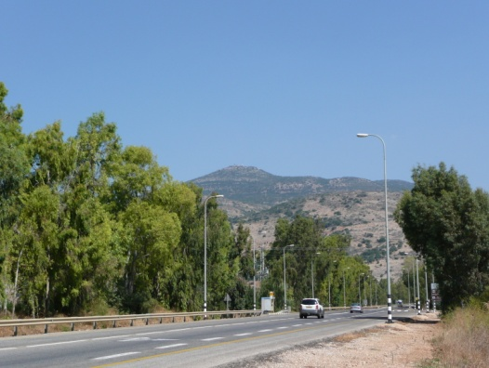

Iyob/Job 26:5: “…the departed spirits tremble” NAS. “…dead things are formed” KJV. Job 26:5-6 KJV: “Dead things are formed from under the waters and the inhabitants thereof. Hell is naked before Him and destruction has no covering.”
Isaiah 14:9: “…it stirs up the dead for you, even all the chief ones…” KJV
Ephesians 1:15-21; 4:8-10: Messiah descended into the earth. He preached to those in prison. He preached to those in Hades and in Paradise. When He ascended in Acts 1, he took with Him all those who had been in Paradise.
Psalm 24 speaks of the opening of the gates of Heaven so that Messiah could enter with the first residents of heaven. Paradise is now a suburb of the heavenly Jerusalem on High. When Messiah returns, He returns with all of His set-apart ones who have died in faith (Zechariah 14:1-5; Jude 1:14-15 (quoting Enoch I), I Thessalonians 3:13)
Revelation 1:17-18, Messiah speaking: “Do not be afraid; I am the First and the Last, and the Living One. And I became dead, and see I am alive for evermore. Amen. And I have the keys of hell and death.”
Jonah is a sign of Messiah’s descent and rising. In Jonah chapter 2, we read that he went down into the earth beyond the gates of Hades. He was there for 72 hours. Upon repentance, he rose up to new life.
Matthew 12:40-41: Messiah descended into the pit, Hades, for 72 hours, at the end of it He arose. The most often repeated prophecy by Messiah is the sign of the prophet Jonah. “As Jonah was three days and three nights in the belly of the great fish, so shall the Son of Adam be three days and three nights in the heart of the earth.” Messiah died on Wednesday and was placed into the tomb before sunset, which began Passover. 72 hours later, just after sunset, “early on the first day of the week, He arose – in other words Saturday after sunset.
As Dr. Heiser noted, baptism is a pledge of loyalty to Yahushua. It makes a statement to all who witness the initial baptism, and it makes a statement to the condemned fallen angels, and to Lucifer/Satan himself. (Isaiah 14; Revelation 20)
Dr. Heiser then brings up Galatians 3:19, where Sha’ul asks: “Why, then, the Torah? It was added because of transgression until the Seed should come to whom the promise was made.”
The Torah (instructions/teachings) of animal sacrifice, the work of Levites as priests, was added after the golden calf rebellion in order to put boundaries on rebellion and idolatry. We know that. But, Dr. Heiser brings up something we must consider, that the Torah itself was particularly given on Sinai to put boundaries around the sins of the Watchers, that their sin not defile His family anymore. This is why Yahuwah told Joshua to kill men, women, children, and animals upon entering the Land. They were not human, even the animals were hybrids. They were Nephilim! If His people had mated with them, the gene pool of the tribes of Ya’cob would have been polluted forever. I believe this is the reason why Yahuwah had to scatter the ten northern tribes out of what is now north Israel into all nations AMONG the gentiles– to save the gene pool of the ten tribes. I believe they were doing DNA-mixing and engaged in portal opening for the Nephilim to return. King Jeroboam put up an altar and a golden calf in “Dan” – what is now Tel Dan, close to Banias, at the base of Mount Hermon. I’ve seen the ruins of it.
Heiser says there are Jewish leaders who believe the Torah was given as a result of the Watcher’s sin – to keep it from spreading to Abba’s people. We learn what sin is by the boundaries of the Torah. I John 3:4: “…sin is the transgression of the Torah.” “Transgression” means “rebellion, and apostasy.”
If the Torah was given to put boundaries to keep the sins of the Watchers from returning, as well as to point out our sin, then the Torah is even more important now, or as important, than it was back then when Joshua led them into the Land, for the guarding of the Torah will protect us now from the returning Nephilim.
In other words, the Torah is our protection against the infiltration of the powers of the fallen angels and their Nephilim who want to take from us our soul and spirit, as in Ezekiel 13:18-20--making us non-human.
The guarding of the Torah puts around us a barrier between them and us, so that as born-again, Spirit-filled, obedient servants of the Master, living in Covenant relationship with Yahuwah through faith in Yahushua Messiah, we are guarded against the ability of the returned Watchers to take from us our eternal life and our mind.
The born-again cannot be taken up into a space ship and have their reproductive organs vandalized, like so many that have been abducted by “aliens.” We cannot be victims of Nephilim who want to come and “eat up our flesh.” (Psalm 27:1-3) There is a wall of protection put around us for our obedience. The Torah was given to us to hide inside, so that we would have power over all the abilities of the enemy (Luke 10:19) and the Word would make us wise as to how to use our power. These are things Dr. Heiser did not address. Abba opened them up to me.
Because Yahushua descended and conquered, then ascended, we who allow the Spirit of Yahuwah to rule us, will also rise. My testimony is Psalm 40:2-4. I descended into the pit of sin and death, but He did not let me die. He brought me out, set my feet on a rock, and established my going into a righteous path to eternal life.
If we do not descend from pride to humility, we cannot be lifted up. I Peter 5:5-10 “Humble yourself under the mighty hand of Elohim, so that He exalts you in due time.”
Ya’cob 4:6, 10: “Elohim resists the proud but gives favor to the humble…Humble yourselves in the sight of the Master and He will lift you up.”
Death is separation. At the death of the body, the spirit-man separates and rises out of the body, but if it is born again, it never separates from the Presence of Elohim!
Revelation 20:6: “Blessed and set-apart is the one having part in the first resurrection. The second death possesses no authority over them…”
If we are born from above, we die once. If a person is not born from above, they die twice. (Revelation 20:6) They do not rise in the resurrection of the righteous. But, the Nephilim will be cast into the pit forever; they cannot rise, neither can those who die without Yahushua.
Philippians 3:10-14: “…that I might know Him, and the power of His resurrection, and the fellowship of His sufferings that I might be conformed to His death, if somehow I might attain to the resurrection of the dead. Not that I have already received or been perfected, but I press on to lay hold of that for which Messiah Yahushua has also laid hold of me. Brothers, I do not count myself to have laid hold of it yet, but only this: forgetting those things which are behind and reaching out for what lies ahead, I press on towards the goal for the prize of the high calling of Elohim in Messiah Yahushua.”
This great soldier of the Master pressed on. Here he is ready to receive his prize:
II Timothy 4:6-8: “For I am already being poured out, and the time of my departure has arrived. I have fought the good fight; I have finished the race; I have guarded the faith. For the rest, there is laid up for me a crown of righteousness, which the Master, the Righteous Judge, shall give to me on that Day, and not to me only but to all those loving His appearing.”
I Peter 1:8-9: “…whom having not seen you love; in whom you exalt with unspeakable and esteemed joy, yet not seeing but believing, obtaining the goal of your faith, the salvation of our life.”
We have a beginning in the true new birth. We have a time of laying down our life, suffering for His sake, obeying, denying self-will to take up His. Then we receive the reward of our investment of our lives for Him as we pass into His Kingdom.
We must descend first in order to ascend. We must lay down our old life to pick up His new life. As we walk, filled with the Spirit, in newness of life, we walk the narrow hard-pressed path that leads to the narrow gate that leads to life eternal. (Matthew 7:13-14)
Your initial baptism after your new birth and your mikvahs all during your walk with Him are a continual message to the fallen ones that you as a frail human will do what they will never do – rise to life forever with Yahuwah and Yahushua.
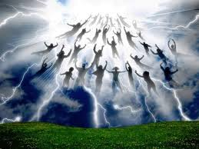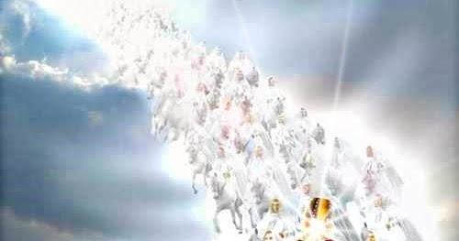
I have never seen a painting or picture of any type that comes anywhere close to what I saw in a vision of the return of Messiah.
Put a few Scriptures together, like Isaiah 34, and 63:1-6, Zechariah 14:1-5; I Corinthians 15:51-58; I Thessalonians 4:13-18; Jude 1:14-15; Revelation 11:15-18; Revelation 19… He comes on the Day of Yahuwah, with the wrath of Yahuwah.
His return path is noted in Deuteronomy 33:2-3; Isaiah 34 and 63:1-6; Habakkuk chapter 3, and Zechariah 14:1-5, Matthew 24:29-31. As He rises up over Sela/Petra/Mt. Seir, the resurrection of the righteous takes place.
I wish I could get a drawing done of my vision. Messiah leading all the set apart ones in order of their rank with Him, fanning out behind him like a flowing cape. He rides a white horse. (Revelation 19:11-16) He is dressed in the garments of the High Priest. He is dressed in the “garments of vengeance.” (Isaiah 59:14-18)
In my vision, all of His set-apart ones ride white horses. As He descends one row after another of set-apart ones has a front row seat for an instant before descending towards Jerusalem. The cape fans out far and wide for many miles, with millions of people. Directly behind Him rode Abraham, Yitzak, and Ya’cob. Just behind them, as when Ya’cob faced Esau, sat His Bride, the “bridal remnant.” To the left, sat His attendants--the Prophets and Apostles--and to the right sat the righteous Kings, King David in the lead, and warriors like Joshua and Caleb.
Before Him the earth will shake nearly out of its orbit. The Word will go forth like a sword out of His mouth. The fire of the wrath of His Father went before Him and all the wicked of earth were destroyed, leaving the planet empty except for such a few that a child could count them. We read about those running out from the tunnels under Jerusalem to meet Him in Zechariah 14:1-5. He comes with all of His set-apart ones.
Read Isaiah 10 and 24; Proverbs 2:21-22 …
Oh what we have to look forward to if we guard our salvation and obey His commands to be one of His. (I Corinthians 2:9 with Isaiah 64:4)
Your act of mikvah/baptism/immersion terrifies the fallen ones of Hell because it reminds them of their hopelessness.
Remember your life speaks loudly – to the fallen angels, the Nephilim, and to Lucifer himself, and to all those humans who observe your nature. If you are blameless before Yahuwah, you are a constant reminder of their judgment for rebelling against Yahuwah. If you are a religious game-player, they know you belong to them.
Those in the pit do not rise. The final judgment is written in Revelation 20:11-15. Make sure your life witnesses to His resurrection power and your voice witnesses to it also. Billions will soon die. We are ambassadors of the Kingdom.
Shalom in His love and joy,
Yedidah
December 22, 2016
***Dedicated to my son and ministry partner Derek Townsend, who turned 46 on December 21st … oh to be so young!

