THE GARDEN OF GETHSEMANE:
THE NARROW GATE INTO THE GARDEN OF EDEN

In the true new birth, first we must repent of sin, cutting ties with the kingdom of darkness, professing faith in the shed blood of Messiah as payment for sin and faith in His resurrection for their eternal life, followed by willful submission to a the new Master, our Savior. This is mandatory before the Spirit of Yahuwah can begin the 40 things that He does to transform us from a child of darkness on their way to hell into a child of light on their way to heaven. If we are going to be totally new creations (II Corinthians 5:17) with all things new as a child of the Kingdom of Light, we must burn the bridges that would link us to anything of the darkness/sin. The true new birth begins with “Gethsemane” as we yield to the will of Yahuwah and Yahushua as Master, and allow the carnal self-willed sin-nature die.

The Garden of Eden covered a relatively small area. Today we know it, at least its epicenter, as East Jerusalem. It is separated by three valleys which form the letter “shin,” The Kidron Valley on the East between the Temple Mount, the City of David (Zion-II Samuel 5:7; I Kings 8:1) and the Mount of Olives, the Hinnom Valley on the South, and the Tyropoeon Valley on the West of the Temple Mount and City of David. Within this small area are three of the four main portals/gateways of Yahuwah between His throne room of Yahuwah – Mount Moriah (the “Temple Mount; Genesis 22), Mount Zion (the City of David, home of the Ark of the Covenant for 40 years behind King David’s palace), and the Mount of Olives (place of the ascension of Yahuwah Ezekiel 11:23 and Messiah, Acts 1). This is clear in the Word and historically.
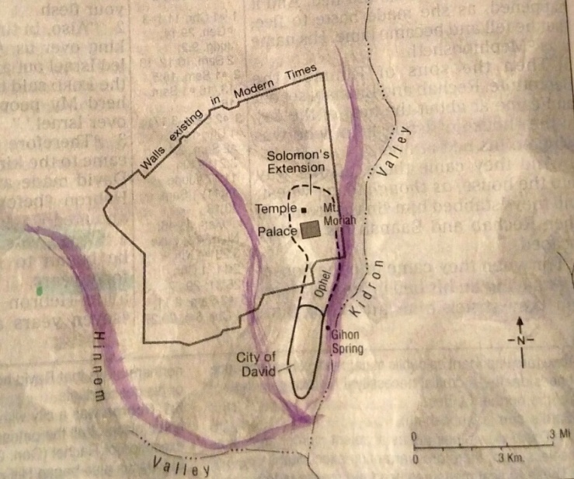
In Carl Gallups’ book, Gods of Ground Zero, chapter thirty-six, he clearly maps out the three valleys that form the “shin” in the ancient compact East Jerusalem.
The doorway into the Garden, where the flaming sword was stationed (Genesis 3:23-24) is on the east side of Mount Moriah. This door faces the Mount of Olives. Just beyond the north Kidron Valley, or the Valley of Jehoshaphat (Joel 3:12) to the East, at the base of the Mount of Olives is the Garden of Gethsemane.
The Three Valleys that form the “shin”: The Hinnom, the middle valley in the map above called the Tyropoeon Valley, also called in ancient times - the “Valley of the Cheesemakers,” and the Kidron (aka the Valley of Jehoshaphat/Joel 3:12).
From my own personal knowledge from Abba in 2010, confirmed in 2011, the Tree of Life which was in the midst of the Garden of Eden rose high where now we see the southeast corner of the Temple Mount Wall. It is still there in an eternal state. We also see it present in the throne room of heaven: Revelation 22:14.
The south wall of the Temple Mount overlooks Solomon’s “Ophel” - the connecting point for the priests between the Temple Mount and the City of David below it. (I King 8 – the Ark was “brought up” from the City of David. One of my favorite places to pray in Jerusalem is sitting among the ruins of the Ophel.
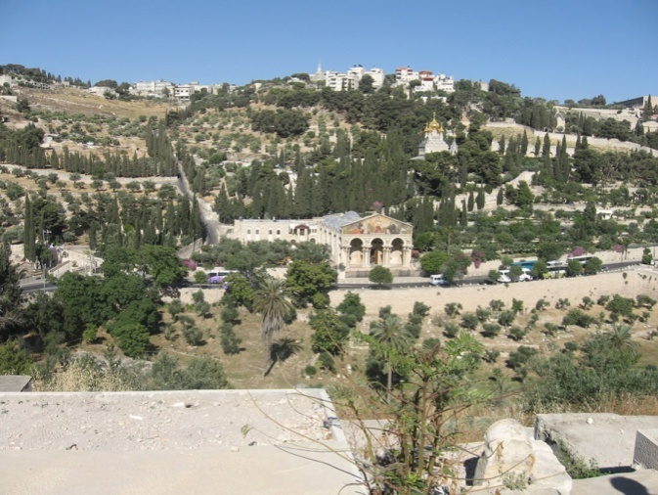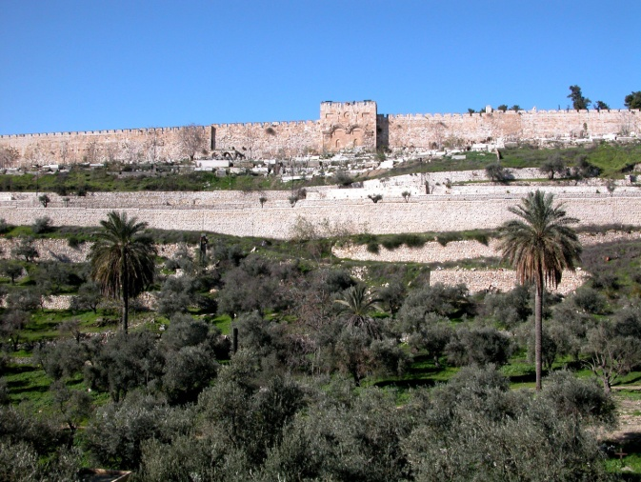
Left: Looking from the Eastern Gate of the Temple Mount, across the north Kidron Valley, you see the “Church of all Nations.” To the left of the church is what is left of the original Garden of Gethsemane, which still has fruitful olive trees dating back 2000 years or more. The “mount,” or hill, that rises above the Garden is the Mount of Olives. It is from the top of this “hill” that the Spirit of Yahuwah ascended into heaven, Ezekiel 11:23 (Ezekiel 8:1-11:23) It is from the top of this “hill” that Messiah arose back to heaven (Acts 1). It is a portal into heaven.
The north Kidron Valley is also known as “Valley of Jehoshaphat. It is in this valley that Yahushua will judge the nations (Joel 3:12).
Right: Looking from the Garden of Gethsemane West, across the Kidron Valley, to the Eastern Gate of the Temple Mount.
As Messiah prayed in the Garden, He could look across at the “Gate Beautiful,” or the “Eastern Gate,” of the Temple Mount and see the “joy set before Him at His return.
Ezekiel 40-46: Ezekiel saw this gate shut. Yahushua will open it. Sitting in Gethsemane, behind Messiah, up the “hill,” Yahushu could see where He would ascend after His resurrection.
The numbing thing is that when Yahushua prayed “not My will but Yours be done,” He was inside the Garden of Eden between the three eternal portals into the throne room of His Father. Messiah could look across the Kidron and see in the Spirit, the Tree of Life. He could see where once stood the tree of the knowledge of good and evil stood--the very place where Adam and Eve chose to rebel and bring sin into the DNA of all human beings. He could see with His eyes the end from the beginning.
From Carl Gallups’ book chapter 39, “The Garden of Sorrow: `Now in the place where He was crucified, there was a garden, and in the garden a new tomb in which no one had yet been laid. (John 19:51)
Messiah was arrested in the Garden of Gethsemane, which is inside the Garden of Eden! He suffered “outside the gate” of the old City of East Jerusalem.
Hebrews 13:12-14: “…Yahushua also suffered outside the gate, bearing His reproach. Let us go to Him outside the camp, bearing His reproach. For we have no lasting city here, but we seek the one coming.”
The Mount of Olives was outside the city Gate of ancient Jerusalem. In II Kings 23, we read how King Josiah cleared the Temple Mount of its idolatry and burned the evil in the North Kidron Valley below the Eastern Gate wall. This was outside the city limits of ancient Jerusalem. He was a forerunner of Yahushua Messiah.
Gallups’ wrote, pages 247-250: (Regarding John 19:51) “The Pulpit Commentary makes the connection of the Garden of Gethsemane and the Garden of Eden: `John clearly saw the significance of the resemblance to the `garden’ where Christ agonized unto death, and was betrayed with a kiss, and also to the garden where the first Adam fell from the high estate of original innocence.’ ”
How amazing that the second Adam, Yahushua, was in the very area where the first Adam said “not Your will Yahuwah, but mine be done.” (I Corinthians 15:20-22, 45). In saying “Not My will but yours be done, Yahushua began the process of our redemption by His yielding to death in our place.
In Genesis 3:21-24 we read how Yahushua killed the first animal in that very area of the Garden within His sight on Gethsemane, to cloth Adam and Eve with the blood of the innocent. He was preparing to be “the Lamb of Elohim who takes away the sin of the world.” (John 1:29) It was in that Garden that Yahuwah spoke the “proto-evangel” to Adam and Eve of Yahushua’s redemption: Genesis 3:15.
Page 248: “Wouldn’t Gethsemane then be the obvious place where Jesus would choose to do yet another battle with the Nachash in heavens grand design to right every wrong for the purpose of bringing about the restitution of all things?
In the Garden of Gethsemane Jesus would kneel…and cry out `Nevertheless, not My will but thine!’ This was the opposite declaration of Satan’s heart in the original Garden. It was also the opposite attitude displayed by Adam and Eve.
Satan and Eve, along with Adam, declared their mutiny in the Garden of Eden with the words `My will…’ Jesus knelt perhaps in or near the very spot of that rebellion and declared `Not My will, Your will! Let it be done!’
What the first Adam lost, the last Adam would take back! (I Corinthians 15:45, 47, 49). The victory of Jesus’ resolve would be our portal of entry into the dimension of the new and restored Garden of Eden. Jesus is the door through which we can enter the renewed Paradise (John 10:9).
Isaiah 53:5: “He was crushed for our iniquities.” Think of it! Olive oil was used for anointing. Jesus is called…`the Anointed One.’ Also the olive tree provides the imagery for Isaiah 11:1: `A shoot will come up from the stump of Jesse and from his roots a branch will bear fruit.’ Jesus was the olive branch of Isaiah’s prophecy.
[Yahushua was called `the Natzar’ – the Natzarene – the “branch.” [Refer to “The Return of the Natsarim For the Last-Days’ Exploits” Parts I and II/Mikvah of Set-Apartness.]
Furthermore, Paul tells us in Romans 11 that we are grafted into the olive tree by faith (Messiah). And now we find the `olive branch’ of God on His last day of earthly ministry in the Garden of the Olive Press. How much clearer could the imagery be?”
Matthew 7:13-14: “Enter through the narrow gate! Because the gate is wide, and the way is broad, that leads to destruction and there are many who enter in through it. Because the gate is narrow and the way is hard-pressed which leads to life, and there are few who find it.” “Hard-pressed” Gethsemane: The Olive Press!
Death to self will, death to carnal desires, death to all but His will, is the gate that leads to life eternal through the One who passed through that gate before us!

GETHSEMANE MEANS “OLIVE PRESS”
Matthew 26:36-46: Then יהושע came with them to a place called Gethsemane, and said to the taught ones, `Sit here while I go over there and pray.’ And He took with Him Kĕpha and the two sons of Zaḇdai, and He began to be grieved and deeply distressed. Then He said to them, `My being is exceedingly grieved, even to death. Stay here and watch with Me.’ And going forward a little, He fell on His face, and prayed, saying, `O My Father, if it is possible, let this cup pass from Me. Yet not as I desire, but as You desire.’ And He came to the taught ones and found them asleep, and said to Kĕpha, `So, were you not able to watch with Me one hour?
Watch and pray, lest you enter into trial. The spirit indeed is eager, but the flesh is weak.’ Again He went away, a second time, and prayed, saying, `O My Father, if it is impossible for this to pass unless I drink it, let Your will be done.’ And He came and found them asleep again, for their eyes were heavy. And He left them, went away again, and prayed the third time, saying the same words. Then He came to His taught ones and said to them, `Still sleeping and taking rest? See, the hour has come near, and the Son of Aḏam is delivered up into the hands of sinners. Rise, let us go. See, he who delivers Me up has come near.’ ”
Notice that He only took His three closest disciple-friends with Him – Kepha/Peter, Ya’cob/James, and Yochanan/John – the same three He took with Him onto Mount Hermon where He was esteemed--standing between Moses and Elijah. The three knew the horrors they would face also, for Yahushua had shown Yochanan/John that Judas had gone to betray Him earlier that evening. Only one returned to stand at the foot of the stake while Yahushua died – Yochanan. Please refer to: “For the Joy Set Before Him…”/Mikvah of Eternal Salvation.
Dear ones: Gethsemane is the narrow gate at the end of the narrow path that we must pass through to proceed on the Garden of Eden once again!
Messiah was in the Garden of Gethsemane, the “olive press,” facing the Garden of Eden across the Kidron Valley. In order for the anointing oil to flow, the olives must be pressed hard to separate the oil from the body (flesh) of the olive. The oil must be separated from the flesh of the olive to remain pure.
My son, Derek, sent me his revelation (January 17 2020): “The end aim is to enter back through the Garden Gate to eat from the tree of life, but there is another garden we must pass through first...We are entering the time of Gethsemane... where the only commandment from Him to His taught ones is to pray lest we enter into temptation. Tarry, watch, pray, lest the weak flesh overcome the spirit. We are entering the Garden of Gethsemane.”
Messiah had both great grief and agony of soul and joy, knowing the end of the agony, thus He submitted to His Father’s will. It wasn’t so much the physical pain He would suffer that caused Him such agony in the Garden, but knowing that in taking the sin of mankind onto Himself, His Father would have to turn His back on Him for a short time. However, this was planned before the foundation of the world. He knew His Father’s will, and so submitted to it – the great death of His soul preceded the death of His body.
Matthew 6:13: “Lead us not into temptation but deliver us from evil.”
Luke 12:49-50: “I came to send fire on the earth, and how I wish it were already kindled! But, I have an immersion to be immersed with, and how ditressed I am until it be accomplished.”
Yahushua’s words to His disciples before Passover are most grieving, “” This is the struggle of all those of Revelation 7:9-17 – the martyrs. Death to “self” must be a moment by moment lifestyle until it is so natural to say “Your will be done,” that it is our nature to do so. Sha’ul said: “I die daily.”
The end-days remnant understands the agony of soul and the joy of the spirit at the same time. Abba has come to me with both emotions to share them with me. But, now I realize that, we too, can have both emotions and remain pure before the Father.
Without our passing through Gethsemane, we cannot experience the first resurrection. (Revelation 20:6)
Satan tried to tempt Messiah: He said of Satan: “he could find nothing in Me.”
Yahushua had locked His will towards crossing the finish line in victory, to buy our salvation with His own blood.
Isaiah 50:5-7, Messiah speaking prophetically: “The Master Yahuwah has pierced My ear, and I was not rebellious, nor did I turn Him away. I gave My back to those who struck Me, and My cheeks to those who plucked out My beard. I did not hide My face from humiliation and spitting. And the Master Yahuwah helps Me, therefore I shall not be humiliated. So, I have set My face like a flint, and I know that I shall not be ashamed.”
Before the foundation of the world, Yahushua, whose Name means “Yahuwah is salvation,” agreed to die in our place (II Corinthians 5:21).
He knew how intently His Father wanted a family. He knew that the angels would rebel. He knew they would entice Adam and Eve to rebel. He knew there was no other way to redeem fallen man, made in the image and likeness of His Father, than for Him to be a substitute for them--taking our sin upon Himself and paying the punishment we deserve.
In the Garden, Messiah formed Adam from the dust of the earth and breathed into him the breath of life. He formed Eve and gave her life. Then just after they rebelled against His orders, He killed an animal to clothe them - covering them with the bloody skin. From the beginning of the lineage that would incarnate Him, Yahushua was involved in redemption-salvation-deliverance.
Yahuwah could not die to take the place of sin-filled man. He is Spirit. Yet, with all His Being, He wanted a family in His likeness, with His nature, with His thinking, who could be real children to Him. Therefore, He had to bring forth, from His own inner-most being, One, a Son, who would take form and relate to His chosen children, like to Adam and Eve before they sinned, Abraham and Ya’cob, who would walk among His people, and incarnate into human flesh.
Yahuwah and Yahushua wrote the Book of Life before Yahushua even spoke the world into existence under His Father’s direction.
They saw you and chose you by Their foreknowledge! (Ephesians 1:1-7; I Peter 1:1-4)
In submitting to His Abba’s will, Yahushua left an example for us. We walk a narrow path to a narrow gate that leads to life. That path is “hard-pressed.”
(Matthew 7:13-14) The olive press presses hard to extract the oil. In other words, we must submit to the “press” of Gethsemane, the “olive press,” in order to go any further on our journey to eternal life!
The Latin word “tribulum,” a farm instrument that puts pressure on wheat or other grains to remove “chaff” so that the grain is usable, is where the word “tribulation” comes from—which means to apply pressure. Messiah went through great tribulation before actual death and resurrection.
This is the pattern for all those who will enter the Kingdom of light. There must be a total separation between us and the kingdom of darkness in this world in order to go forward to the eternal Kingdom of “His Dear Son.” (Colossians 1)
In the process of the pressure, He is teaching us to fight. (Psalm 18)
In my increasing physical pain, not long ago, I cried out to Him. He said to me: “I am teaching you to fight.” He spoke of the “good fight of faith” that precedes our rewards in the Kingdom (II Timothy 4).
We know we’re breaking through to His thinking when we experience pain, hardship, attacks of the enemy, opposition, etc., and yet in our grief, our sufferings, our pain of soul and body, we keep our joy! We keep on praising. We keep on submitting to our Father, loving Him, faithfully serving Him, pressing harder into His Presence and quick to do His will. You know where you are with Him by noticing how you handle suffering. Suffering divides between those who turn to carnal reactions vs. those who press forward in His nature. (Galatians 5:22-24)
Maintaining joy by praise, worship, and peace, is the secret of going forward against all opposition of the enemy. Yahuwah has so much to teach us, to prepare us for the soon-coming of Messiah. He must be within your re-born spirit.
In order to prepare us for the Kingdom, He has to apply the “pressure.” In this way, the anointing oil of the Spirit rises in our spirit and we flow out in His nature to reach the lost. We prepare ourselves for our entrance into His Presence in heaven.
A few will not die in the coming tribulation, but will rise to meet Messiah as He descends after the resurrection of the just. (I Thessalonians 4:13-18; I Corinthians 15:51-58)
Titus 2:11-14: “For the saving Gift of Elohim has appeared to all men, instructing us to renounce wickedness and worldly lusts, and to live sensibly, righteously, and reverently in this present age, looking for that Blessed Hope and esteemed appearing of the great Elohim and our Savior Yahushua Messiah, who gave Himself for us to redeem us from all lawlessness, and to cleanse for Himself a people, His own possession, ardent for good works.”
Derek’s revelation, January 2020: “Coming home from the land this evening, I felt the realization that I have been called out of darkness into His light. What kind of people MUST we be? - A peculiar and purposeful people. The set-apartness is increasing! The good and the evil must arise to the surface so that all will have no excuse which side they end up on. We are a different people, a people of light.”
Messiah prayed a High Priestly Prayer in John 17! Unity with each other will come as we are in unity with Yahuwah and Yahuwah – as they are “echad,” so can we be “echad” with Them and with each other. But, this is only possible if we pass the “test of Iyob”/Job, which is the test of Gethsemane.
Refer to my testimony in “The Test of Iyob”/Mikvah of Set-Apartness.
Yahuwah asked Iyob/Job 60 questions without stopping to let him answer. Iyob was so overwhelmed. What could He say except “You are Shaddai Elyon - I am not.” When he finally understood, Yahuwah healed him of his leprosy. It is the test we all must pass in order to receive right to the Kingdom of Light. If there is “self” left in us at all, and the fires of tribulation cannot burn it off, there only remains darkness, being swept away in the deluge of evil because of fear.
The test of Iyob is the test of the Garden of Gethsemane! We must pass this test to go on with Him, especially now, into eternal life. For a huge number of Abba’s children, “Gethsemane” will mean choosing martyrdom rather than escape by denying Messiah’s Deity, or deny Him at all.
I know full well that if I had not passed the test of Iyob in January 2011, there’s a good chance I would have forfeited my future. I would not have been able to go on and be trusted with the intercession He gave me in 2012, 2013, or any future trust of what He has planned for me. It was a turning point in my life. It was confirmed later, very dramatically, that if I had failed the test, which I thought was unto death, the eternal position I asked of Him for decades would have been denied. I shudder to think of it! He is Elohim, we are not.
What would have happened if Yahushua had said “Abba, I can’t do it”? For millennium upon millennium past He knew His assignment. But, until He incarnated into flesh, what He had agreed to do was not fully felt. He had to say “not My will but Yours be done,” in order to continue with our salvation. I hate to think of what life would be now if He had failed. But, Yahuwah knew He would not fail. He trusted His Son. He must be able to trust us, too.
The prophecies of His return were spoken by Him to His prophets from the days of Enoch, Abraham and Moses. Moses prophesied of Him in Deuteronomy 18:17-19. “The witness of Yahushua is the spirit of prophecy.” (Revelation 19:10)
Yahuwah is cheering us on! He has had great mercy on us because He’s had faith in us! He’s had faith that we’d make the right choices under pressure of tribulation. Messiah said “In this world you will have tribulation, but be of good cheer – I have overcome the world.” He said this before the Garden of Gethsemane night.
In the story of Abraham in Genesis 22:1-18, the near “sacrifice” of Isaac, it was Yahuwah’s messenger (“malak”)--His Son, Yahushua--who spoke to Abraham twice through the portal that is over Mount Moriah – “…since you have not withheld your son, your only son…” Yahushua was able to see in Abraham, His forefather, that a human being was willing to do what His Father was willing to do. He saw in Isaac the trust that He would have in His Father on the stake. How precious!
Obedience to Yahuwah always includes a test – will we make excuses why we can’t do it, balk, go into fear, rebel, revolt, carnal reasoning i.e. “I’ll think about it,” or put the foot down with a bold “I can’t because…” or “I won’t…? Those that have through Gethsemane simply say “Your will be done,” then with His peace and joy begin to obey. It’s all about relationship – trusting Those you know and love, Yahuwah and Yahushu, to be faithful to you.
We’ve entered the Garden of Gethsemane, as Derek wrote above. How we come out of it determines if we eat of the tree of life, or perish. The pressure increases worldwide, as approximately 223 prophecies of the entire Word to do with our days, the day before Messiah returns, the olive press will either press out pure olive oil of the anointing through our lives, or be thrown away because it’s rotten.
The remnant is coming into absolute unity because all are Spirit-taught, submitted to the Spirit, flowing in the love, peace, joy, faith, long-suffering, patience, gentleness, and self-control – the fruit of the re-born spirit – and obedience to our Master. I’m beginning to see the unity of John 17 finally happening so that the Daniel 11:32 Company will be so united that they are as one under the control of Yahuwah and Yahushua. Are you seeing this too?
You won’t learn this in intellectual religion or phony spiritual religion either, both which breed pride and arrogance. The nature of Yahuwah is in His remnant. He is uniting all of His children in love for one another as we see “the Day of Yahuwah” approaching.
Millions of our brothers and sisters have been brutally killed for their faith in the Savior. Yahuwah sees their purity. They are mentioned in Revelation 7:9-17 and Revelation 14:13-14. Many have never owned their own Bible, yet they are faithful to the One who died and rose again for us. Millions more will martyred in the days to come. [Please refer to: “The Really Good News About Martyrdom and Death”/Mikvah of Preparation]
It’s 2020 - the year when things become crystal clear to the spiritual eyes of His people. But, while His people are receiving His dreams, visions, words, instructions, His Spirit, His Presence, and His revelation knowledge by His teaching, the lost and those backsliding into darkness are becoming more blind, more ignorant, more distanced from the throne of Yahuwah. Choosing to avoid Gethsemane, they choose to be left out of the first resurrection. [Refer to: “Back Beyond the Garden Gate”/Mikvah of Set-Apartness]
East Jerusalem – the Garden of Eden! No wonder the entire world wants that tiny little piece of property. It was the epicenter of Satan’s victory over humanity. But it is also the epicenter of Yahushua’s victory over Satan! Now Satan wants that piece of property from which to rule. But, the victory over him is forever!
Prepare by seeking Abba with all your heart – what does He feel, what does He want to speak to you? How does He think and feel about what concerns you? Please practice the instructions in the three articles whose titles begin with: “Waiting on Yahuwah! Waiting on Yahushua!...” under the Mikvah of the Heart of Elohim.
Shalom! In His love, Yedidah
January 20, 2020

