The Power of His Love
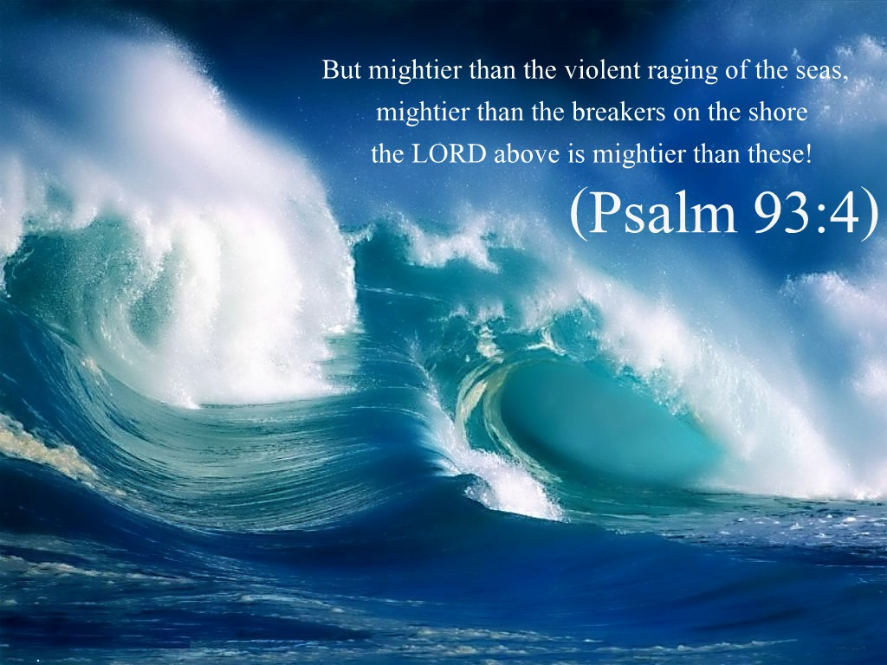
“Yahuwah is love.” There is no greater force in the universe that His love for us.
LYRICS FROM THE HYMN: “Oh the Deep Deep Love of Jesus”

Oh the deep, deep love of Jesus, vast, unmeasured, boundless, free!
Rolling as a mighty ocean in its fullness over me!
Underneath me, all around me, is the current of Thy love
Leading onward, leading homeward to Thy glorious rest above!

O the deep, deep love of Jesus, spread His praise from shore to shore!
How He loveth, ever loveth, changeth never, nevermore!
How He watches o’er His loved ones, died to call them all His own;
How for them He intercedeth, watcheth o’er them from the throne!

O the deep, deep love of Jesus, love of every love the best!
’Tis an ocean full of blessing, ’tis a haven giving rest!
O the deep, deep love of Jesus, ’tis a heav’n of heav’ns to me;
And it lifts me up to glory, for it lifts me up to Thee!
Oh, The Deep Love of Jesus - Epic Version! - YouTube
www.youtube.com

▶ 4:41
Jul 31, 2018 - Uploaded by Simon Khorolskiy

This is beautiful video. Simon Khorolskiy is a Russian Jew. His music is dynamic. The anointing on this particular presentation is awesome. [I sing “Oh, the Deep Deep Love of Yahu-shuah” for that is how He taught me to say His Name in 1995. His Hebrew Name means “Yahuwah is salvation.” However - just sing it with peace in His Presence]
Please listen to this too-short song! The music itself is like the powerful crashing of waves against huge rocks on the shore. Be prepared to feel wrapped in the anointing of His Presence.
When you grasp the enormity of His love, boldness rises in you by His Spirit that leaves you fearless even in the face of death. My youngest son-in-law had a dream not long ago. He said he and my daughter were standing together, holding hands, in peace, preparing for their martyrdom for their faith. He said they looked much older. I am an interpreter of dreams from Yahuwah, so I told my daughter that it meant she and her husband were mature in faith, bold, strong, and ready to meet the Master. My son-in-law is a relatively new believer who is maturing in faith. He gets up at 3:00 AM to read the Word and talk to Abba. Yahuwah is sharing with us what is coming, in general to the world, but also to us personally, so we prepare. This daughter and her husband are strong in nature, becoming strong in faith.
How did the early believers face death with boldness, strength, and calm, as the apostle Sha’ul wrote in II Timothy 4: “…For I am already being poured out, and the time of my departure has arrived. I have fought the good fight, I have finished the race, I have guarded the faith. For the rest, there is laid up for me the crown of righteousness, which the Master, the righteous Judge, shall give to me on that Day, and not to me only but also to all those loving His appearing.” It is said that he ran to his executioners. Boldness comes when we need it, because within us is the power of the Spirit!
The only way this kind of faith is humanly possible - to face even martyrdom with joy - is if the Spirit of Yahuwah takes total control over the mind and emotions. Daily we must walk submitted totally to Him as a lifestyle.
Two weeks ago, on Shabbat at the Prayer Center, my son put this video (above) on the overhead view-screen. Within less than a minute, everyone that could, got down on their knees in worship, some with face to the floor. His Presence was so strong in the room. The unity between us was tangibly felt, as we joined together in His love. At the end of the meeting, pastor McQueen had four people hold up a large chupa. We stood under it as my son prayed the Aaronic blessing in Hebrew.
Yahuwah is uniting His set-apart children in love for one another around the love of Yahuwah and Yahushua. There is no greater power in the universe that Abba’s love manifesting through His children for He and His Son, and for one another. He is bringing a remnant into a unity only possible by His Spirit. This remnant will be unified because they are Spirit-taught, and Spirit-empowered, thus of one mind.
John 17 is beginning to happen, as a remnant unites in unity, even as Yahuwah and Yahushua are “echad,” in unity as if one. “Echad” is used in Genesis 2:24 of Adam and Eve becoming one in marriage.
We must come to know the power of His love for ourselves every moment. As we learn to hold His hand, we walk with Him. (Isaiah 41:10, 13) “There is no fear in this love, for this perfect love casts out fear.” (I John 4:18)
Yahuwah’s love in us is the most powerful force in the universe, for even in His wrath and judgement His love and mercy never leave. In His love there is only an abiding peace and deep joy.
John 10:27-29: “My sheep hear My voice and I know them, and they follow Me. I give them everlasting life, and they shall by no means perish, and no one shall snatch them out of My hand. My Father who has given them to Me is greater than all. And no one is able to snatch them out of My Father’s hand.” Talk about security! Nothing greater! Do not presume on Their love, nor take their promises lightly, for we can jump out of Their hand if we are that stupid. (Hebrews 6:4-6)
It is this powerful love that sent Yahushua to the stake/cross to take our place in death. It is this love that caused Him to agree to die in our place before He ever spoke the words “Let there be light…!” Before He ever formed Adam and Eve, before He ever spoke the teachings and instructions of the Kingdom to His people, He thought of you as He and His Father wrote the Book of Life – written “before the foundation of the world.” You were “hand-picked,” chosen by foreknowledge, loved, wanted. (Ephesians 1:1-7; I Peter 1:1-4)
When you know Their love for you, you will never be afraid of anything. What is most important is that you press in to know Them and allow Them to know you - mutual love, mutual trust, mutual interlocking relationship.
Pastor McQueen had a dream this last week that she shared with us in our Shabbat meeting, March 14. She saw a highway that was also a bridge reaching out into the ocean. Off in the distance she saw a golden city – she tried to describe its beauty but had difficulty doing so. Yahushua told her that it was His City. She saw innumerable numbers of people pressing on that highway to the gate of the city. Yet, she knew they were not all prepared to go into it. The doors were shut.
He told her with sadness that so many wanted to enter, but they did not know Him. They knew things about Him from the outside, in their mind, but they did not know Him personally on the inside, in their spirit. He was grieved. He said they were content to know Him at a distance in their beliefs, but not intimately.
In fear many quote Psalm 91, trying to stop their fear, yet they do not understand that they have to first live Psalm 91:1. The turbulent mind must rest in knowing that Yahuwah is in control, and He loves us. Relationship has to be developed. Child-like faith has to be learned as a lifestyle. Hearing Him has to be developed so that they live in His Presence. Press in to obtain!
Oh the deep deep love of our Savior for us! Strangely, most of His people in western affluency don’t even have a desire to share His love with anyone else because they evidently do not know it for themselves. We can’t share what we do not have! If our love for Yahushua, our Beloved One, our Savior, our Master, is great and full of passion and joy, we naturally share our love for Him, even as a bride shares about her soon-to-become husband. Love overflows! It cannot be kept quiet. Listening to this song, the power and might of His love, like the crashing waves against the rocks, lifts us up into His Presence.
Take the time necessary to quieten yourself in the Presence of Yahuwah and let Him speak to you in your reborn spirit by His Spirit. Let Him transform you so that you take on His nature, walk in His ways with His thinking, and hold His hand as a little child totally dependent on a loving Abba/Daddy. Look at the pictures in “Faith in Pictures”/Mikvah of the Spirit. This is our true walk of faith. It bypasses intellectual reasoning, and, like a child, we revel in being with those we love.
We know the “love chapter,” I Corinthians 13. Love comes through our spirit from Yahuwah who is love, and Yahushua who became love incarnate. Real, genuine love, flows from our re-born spirit and it felt by others. When we love Him who first loved us, we can’t control the outpouring of His love--it comes through even if we are quiet. It puts a smile on our face, and joy in our heart, that cannot be taken away even when facing death. It radiates out of us. His Spirit having 100% control over our soul (mind, emotions, feelings, reasoning, senses) naturally expresses His love through us without our even thinking about it. It becomes our nature, just as it is His nature! In this, we prove that we are really His children!
John 13:14-15, as Messiah prepared to go to the stake in our place, He said this to His disciples: “A renewed command I give to you that you love one another as I have loved you…By this shall all men know that you are My disciples if you have love for one another.”
In this world of hate and fear, His children radiate the nature of our Father and Savior! In Matthew 24:12-13, speaking of our day, Messiah said: “…because of lawlessness, the love of many will become cold. But, he who endures to the end shall be saved.”
From Romans 8:31-39: “…If Elohim is for us, who is against us? Truly, He who did not spare His own Son, but delivered Him up on behalf of us all – how shall He not, along with Him, freely give us all else? Who shall bring any charge against Elohim’s chosen ones? It is Elohim who is declaring right. Who is he who is condemning? It is Messiah who died, and furthermore is also raised up, who is also at the right hand of Elohim, who also makes intercession for us. Who shall separate us from the love of the Messiah? Shall pressure, or distress, or persecution, or scarcity of food, or nakedness, or danger, or sword? …But in all this we are more than conquerors through Him who loved us. For I am persuaded that neither death nor life, nor messengers nor principalities nor powers, neither the present nor the future, nor height nor depth, nor any other creature, shall be able to separate us from the love of Elohim which is in Messiah יהושע our Master.”
I Peter 4:7-8: “The end of all has drawn near. Therefore, be sober-minded and attentive to prayers. Above all have fervent love for one another, because love covers a multitude of sins.”
I John 3:13-18: “Do not marvel, my brothers, if the world hates you. We know that we have passed out of death into life, because we love the brothers. The one not loving his brother stays in death…By this we have known love, because He laid down His life for us. And we ought to lay down our lives for the brothers. But whoever has this world’s goods, and sees his brother in need, and shuts up his tender affections from him, how does the love of Elohim stay in him? My little children, let us not love in word or in tongue, but in deed and in truth.”
I John 4:8-13: “The one who does not love does not know Elohim, for Elohim is love. By this the love of Elohim was manifested in us, that Elohim has sent His only brought-forth Son into the world, in order that we might live through Him. In this is love, not that we loved Elohim, but that He loved us and sent His Son to be an atoning offering for our sins. Beloved ones, if Elohim so loved us, we also ought to love one another. No one has seen Elohim at any time. If we love one another, Elohim does stay in us, and His love has been perfected in us. By this we know that we stay in Him, and He in us, because He has given us of His Spirit.”
I John 4:16-21: “And we have known and believed the love that Elohim has for us. Elohim is love, and he who stays in love stays in Elohim, and Elohim in him. By this love has been perfected with us, in order that we might have boldness in the day of judgment, because as He is so are we in this world. There is no fear in love, but perfect love casts out fear, because fear holds punishment, and he who fears has not been made perfect in love.
We love Him because He first loved us. If someone says, `I love Elohim,’ and hates his brother, he is a liar. For the one not loving his brother whom he has seen, how is he able to love Elohim whom he has not seen? And we have this command from Him, that the one loving Elohim should love his brother also.”
“For God so loved the world that He gave His only begotten Son that whosoever believes in Him shall have everlasting life.” (John 3:16)
His love in us and through us transforms us. It is the greatest of all power--in a true new birth, and continually as we submit to Him. (II Corinthians 3:17-18)
I close with a few excerpts from the Song of Songs chapter 2: “The voice of my Beloved! See He is coming. Leaping upon the mountains, skipping on the hills…My Beloved responded and said to me, `Rise up my love, my fair one and come away’…My Beloved is mine and I am His.”
Pray Ephesians 3:14-21! It is a powerful prayer! Soon our “Blessed hope,” our Beloved will call us to come to be with Him. He will hold our hand saying to us, “…fear not for I am with you.” He said to us: “I am with you always…” “I will never leave you or forsake you.”
Rest in His love! Let it flow through you to redeem others from the open pit of hell is opening wider and wider. Let His love flow through you to redeem others.
In His love, shalom, joy, Yedidah
March 18, 2020

