CHABAD LISTED AS A DANGEROUS
CRIMINAL CULT

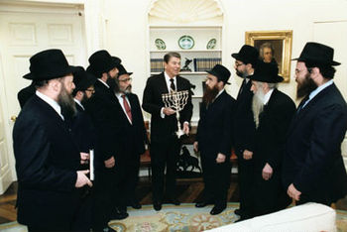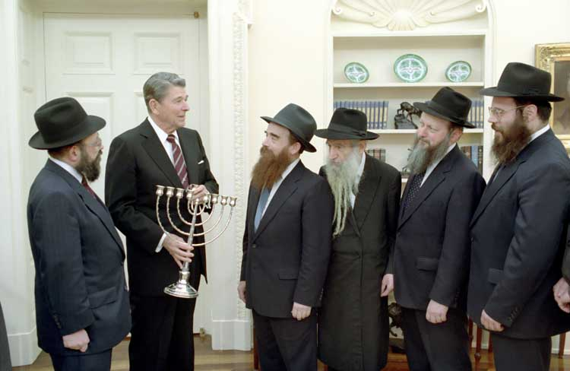
“President Ronald Regan confers with Chabad-Lubavitch rabbis in the White House to honor their Grand Rabbi Menachem Mendel Schneerson and their founder Rabbi Shneur Zalman of Lyady…” Reagan is holding a Hanukkia gift from the rabbis.
December 15, 1987
It was not until March 20, 1991 that four members of Congress in a closed session passed the Noahide Laws into American Law (“Beware of the Noahide Laws”/Mikvah of Present Reality)
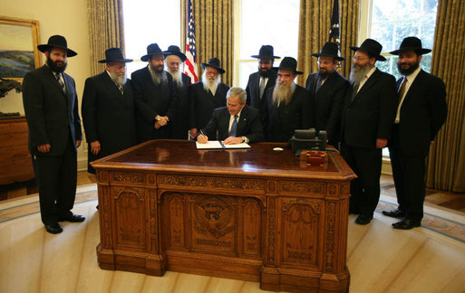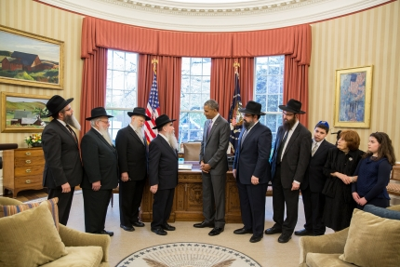
Left: President George W. Bush in the White House with a delegation of Chabad-Lubavich rabbis honoring the late Menachem Mendel Schneerson with a White House `Education Day Noahide Proclamation, April 15, 2008.”
Right: Chabad shluchim meet with President Obama
The White House Press: “On Monday, April 27, President Obama welcomed a delegation from Chabad-Lubavitch into the Oval Office to commemorate Education and Sharing Day, USA, established by Congress in 1978 to honor the life’s work of Rabbi Menachem M. Schneerson (1902-1994). The Lubavitcher Rebbe, Education and Sharing Day provides an opportunity to focus on education's importance and recognize the contributions Rabbi Schneerson made during his lifetime in the fields of education and morality, ethics and justice. Since the establishment of Education and Sharing Day, which occurs on the Rebbe’s birthday, every President has issued an annual Proclamation marking `Education and Sharing Day, USA.’ This year’s Education and Sharing Day Proclamation acknowledges the emphasis Rabbi Schneerson placed on the education of girls, noting: `In an era where a woman's education was not valued the same as a man's, the Rebbe worked to tear down barriers that stood in the way of girls who wanted to learn.’
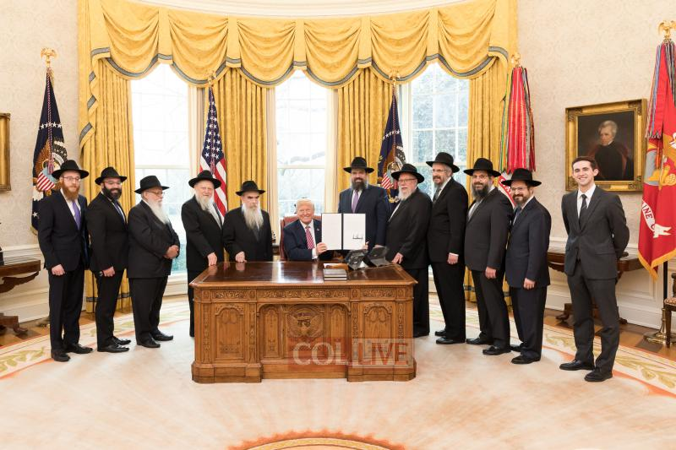
Donald Trump sits at his desk at the Oval Office with Chabad-Rabbis to honor Menachem Mendel Schneerson’s birthday on April 16, 2019 (His birthday is April 18, 2019) On April 16th, every governor of every state in the U.S. signed a renewal of this pledge to the Noahide Laws, with Chabad rabbis attending the signings.
Refer to: “Trump and 50 Governors Affirm Noahide Laws and the Celebration of Rebbe Schneerson’s Birthday”/Mikvah of Israel, Our Eternal Inheritance.
America is the leading nation that promotes Noahide Laws. The Babylonian Talmud has been the foundation for many of American’s laws for decades, and now it is foundational for Global Law. America is the leading nation in supporting Chabad financially. President Trump and Jared Kushner support them personally. In December 2017, Donald Trump converted to Judaism. Jared Kushner left Rabbinic Orthodoxy to unite with Lubavich Hasidim, honoring Rabbi Schneerson. The chief Rabbi of President Vladimir Putin of Russia is also a Chabad rabbi. Putin has made laws recently that support the Noahide Laws. Putin is dedicated to Israel through Chabad, as is President Trump, and many other world leaders.
Orthodox Jews today who know what’s going on inside Chabad globally are coming out and warning us as to who they really are. As you’ll read in excerpts from their articles below, they clearly say “Chabad is not Jewish.” They even have websites dedicated to exposing Chabad. Let us learn the truth about what is now being used by Labor/Political Zionist rulers and their rabbinic counterparts, those who say they are Jews but are not, to entrap the whole world inside a Globalist one world order/new world government, prison house.
Chabad has aligned itself to the Hasidic (Ultra-Orthodox) sect of rabbinic Judaism. The religion of Rabbinic Judaism was founded in 133 CE by Pharisee Rabbi Akiva. In founding this religious structure, he demoted Yahuwah and the Torah to an inferior level below the Pharisee rabbis, even to a state of mocking and ridiculing Yahuwah and His Torah.
Please refer to: “Exposing the Roots of Rabbinic Judaism and Its Link to Rome”/Mikvah of Present Reality.
The newly created Rabbinic religion was based on the Oral Law/Mishnah, and its very pagan and satanic commentary the “Babylonian Talmud.” Later the teachings of Kabbalah were added. Both are pure Satanic teaching. In my previous 19 articles on this subject to warn Christians and Messianics of this great deception that will deceive, if possible, the very chosen-elect, I give you many quotes from the Talmud itself, and explain why the whole system is so evil.
Please read the quotes from the Talmud in “Quotes That Forever Destroy Damning Illusions”/Mikvah of Israel, Our Eternal Inheritance.
Now I will share with you excerpts from four articles by Orthodox Jews who have dedicated themselves to exposing Chabad, the very organization that is uniting the world under the philosophy of Shabtai Tzvi and Jacob Frank to bring in a one world order under the rule of their resurrected messiah.
To learn about the world-ruling philosophy o Shabtai Tzvi ad Jacob Frank, please refer to “1666: Shabtai Tzvi and Redemption Through Sinning”/Mikvah of Israel, Our Eternal Inheritance.
Chabad is a forerunner, a way-maker, for the plans of the Sanhedrin, the most Elite Rabbis, and the Labor Zionists, to fulfill their goal of world rule. Chabad is a global power-cult. They are also a Mafia. They are a criminal organization that deals in the depths of depravity to make money for the advancement of their goals to instate their messiah, the Biblical antichrist, on the throne for world rule.
Chabad works with the Israeli Mossad, which is the Israeli equivalent of the CIA.
The average Orthodox Jew knows nothing of these plans, nor do they study the Babylonian Talmud, nor are they heavily into Kabbalah, if at all. But, they do go by the teachings of their rabbis as if they were the words of God.
***What I have been exposing in my now 20 articles, so far, does not include the “am ha’aretz,” the common Jewish folk, secular or religious. I am exposing the plans of Satan from the time of the Babylonian captivity that have now reached global proportions. I expose Elite Rabbis and Labor/Political Zionists who have set plans in place worldwide from at least the 1600s, with the goal of placing their Kabbalist bloodthirsty messiah on the throne to rule from Jerusalem, and to kill all who oppose them. Their plans are hidden from those “outside their inner circle.”
Statistics say that 95% of Jews have never read the Talmud. Women are not allowed to read the Talmud. The Talmud is the basic teaching for the ruling class of rabbis. It is aligned to Kabbalah. Both the Babylonian Talmud and Kabbalah are Satanic in nature.
At the inner core of Babylonian Talmudic and Kabbalsitic Judaism’s Rabbinic leaders is a “Secret Society.” They are themselves a secret society. It’s really old – it goes back to Ezekiel 8-11:23. Now the Sanhedrin of 70 members has an underground synagogue today just like the 70 had in Ezekiel 8.
See the pictures, read the story, in “The Hidden Underground Synagogue of the Sanhedrin”/Mikvah of Israel, Our Eternal Inheritance.
It caused the Spirit of Yahuwah to withdraw from His people. It has caused Him to withdraw again, beginning in 2016. Refer to the three Withdrawal articles from January 2016/Mikvah of the Heart of Elohim.
Freemasonry is a Secret Society. Like the Freemasons, Jews at lower levels of Talmudic-Kabbalah have little idea of what’s going on at the top. In Freemasonry, those at the lower levels, the lower “degrees,” are totally oblivious to what the Elite at the 33rd degree and beyond levels really believe, oblivious to their goals for world rule. Freemasonry’s Elite joined with the Rabbinic Elite around 1721 CE. Later they joined with the Illuminati supported by the Rothschild Dynasty. These “elite” despise the average Jewish person (the ha am’aretz) as inferior.
I surely do not talk against any race or people group, for Yahuwah looks at each person as an individual, and so do I, but evil is surfacing and has to be pointed out to Yahuwah’s people so that they can prepare for inevitable confrontation.

ARTICLE #1: “HISTORY OF CHABAD - DIGGING THE TRUTH FROM THE LIES”
Official Chabad history: "Rabbi Schneur Zalman of Liadi (1745-1812), Founder of Chabad, also known as "The Alter Rebbe," "Baal HaTanya" and "The Rav"... he formulated his distinct "Chabad" philosophy and approach to life. For twenty years he labored on his magnum opus, Tanya, in which he outlined the Chabad philosophy and ethos. First published in 1796, Tanya is the "bible" of Chabad Chassidism, upon which the hundreds of books and thousands of maamarim (discourses) by seven generations of Chabad Rebbes are based."
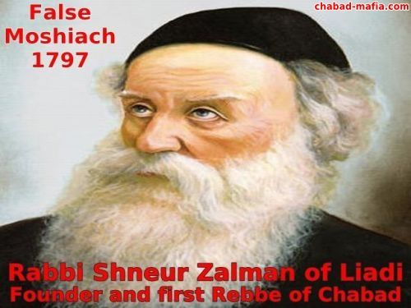
The Alter Rebbe was a violent criminal who was arrested in 1797 and 1798. The Alter Rebbe declared himself to be the Moshiach, the "King of the Jews." But after his death in 1812 his followers altered some of his writings, including the Tanya, to correct some obvious problems. All subsequent Chabad Rebbes have also declared that they are the Moshiach.
Basic Problem #1: The Tanya. Chabad `Rabbis’ and members of Chabad study the Tanya over and above other traditional Jewish texts. Only followers of Chabad give so much weight to the Tanya over traditional Jewish texts. Most Jews have never even heard of the Tanya. Many people say that the Tanya is the `New Testament’ of Chabad, because Chabad sees itself as an improvement upon traditional Judaism. The Tanya is also considered to be a very racist book, which defines all Jewish souls as good, and all non-Jewish souls as evil.
The main difference between the Jewish religion and the Chabad religious cult is that the Jewish People study the Torah, which was given to the Jewish People on Mount Sinai more than 3,300 years ago. The Tanya directly contradicts the teachings of the Torah.
Basic Problem #2: Recognition. The Chabad movement has never been recognized as a valid Jewish ideology by the mainstream Jewish Rabbis.
In 1792 the Alter Rebbe tried to meet with the Gaon of Vilna, the recognized leading Rabbi at the time, to obtain his support for the new movement. The Gaon of Vilna refused to even meet with the Alter Rebbe, and never recognized the new movement as a valid Jewish ideology. From the Gaon of Vilna to Rav Shach and beyond, Chabad has never been recognized as a valid Jewish ideology. Chabad ideology is NOT Jewish.
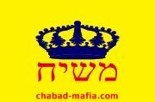
The Chabad Flag: Moshiach - King of the Jews (Photo by chabad.mafia.com)
Basic Problem #3: Messianism. Some people believe that messianism became a problem with Chabad following the death of Rebbe Schneerson in 1994. Actually, messianism was always a problem with Chabad. The founder and first Rebbe of Chabad claimed to be the Moshiach, and every subsequent Chabad Rebbe has also claimed to be the Moshiach. The 7th Chabad Rebbe said that Chabad ideology predicted that the 7th Chabad Rebbe would be the Moshiach. This is the reason Menachem Mendl Schneerson did not appoint a successor, he was the 7th Chabad Rebbe and believed that he was the Moshiach. This is the reason Chabad members still say the Chabad Rebbe, who died in 1994, is the Moshiach, and an 8th Chabad Rebbe was never chosen.
A similar story occurred 300 years before. Shabtai Tzvi publicly declared himself to be Moshiach in 1666 and a large percentage of the Jewish population at the time believed him. [Yedidah: Refer to: “Shabtai Tzvi and Redempion Through Sinning”/Mikvah of Israel, Our Eternal Inheritance]
The Chabad Lubavitch Rebbe, Schneerson, publicly declared himself to be Moshiach around 1985 and many Jews believed him. There is no doubt that the Chabad Lubavitch movement promoted its leader as the Moshiach. This was not the doing of wayward Hasidim. It was instigated, orchestrated and encouraged by their Rebbe. In the late 1970s, the Chabad Lubavitcher Rebbe began alluding to the "fact" that the Moshiach was "living among us" and left none of his listeners in any doubt as to his meaning. This inane campaign became increasingly frenzied and irrational. Rather than faltering at the time of his death in 1994, the insanity continues to spread. At Chabad headquarters in New York the expectation is that their rebbe will miraculously reappear. Shacharit (the morning prayer) is delayed each morning for 5 minutes just in case, at which point the gabai announces that "the rebbe" is apparently unable to make it today, and Shacharit begins.
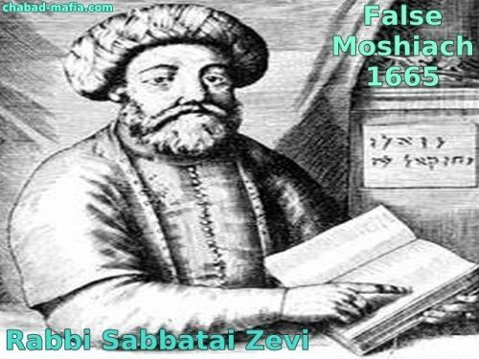
This outrageous phenomenon is not as surprising as it may at first seem. Shabtai Tzvi's followers were known as `Zoharisten’, an allusion to the fact that they, like their leader and demigod, were heavily influenced by the Zohar (Kabbalah). Chabad Lubavitch Hasidism is rooted in a literalistic reading of the Zohar and Lurianic Kabala, which when uncritically combined with the radical and pernicious notions spawned by the speculative school of Hasidic thought founded by the Magid of Mezritch, could only have led to the present heretical state of affairs.
A majority of those who openly identify themselves as Chabad Hasidim today believe that their last rebbe IS the Moshiach. A significant percentage consider him to be G-d in human form, a shocking fact about which no more need to be said.
Basic Problem #4: Religious Cult. Chabad was a religious cult from the very beginning of the movement. Chabad is a very dangerous Messianic Cult. Chabad Rabbis communicate with their Rebbe, who died in 1994, by taking pieces of paper out of a hat. They claim that their Rebbe tells them what to do. They pray to their dead Rebbe at his grave and they write letters to him with their wishes that they place in their grave. Also at Chabad weddings, they read a letter sent by the Chabad Rebbe, who died in 1994, to the couple getting married... Mazal Tov!!!
[Yedidah’s Insert: In 1991, with only 4 voting, the US Congress passed the Noahide Laws into American Law. [Please read: “Beware of the Noahide Laws”/Mikvah of Present Reaity for foundational information. The Congress in 1991 put the Laws under the authority of the Lubavich Chabad leader Rabbi Schneerson. The edict included setting aside his birthday every year to honor him. Every year the U.S. President has acknowledged his birthday and his contribution to society in America. The Rebbe lived in New York. He never went to Israel. Why in 2019, did Jared Kushner go to the grave of Rabbi Schneerson on his birthday, April 18, to pay homage to him? Why did Trump have Chabad members not only in the Oval Office with him, but with governors in their offices in all 50 states? Why do Trump and Kushner personally give of their own money to fund Chabad?]
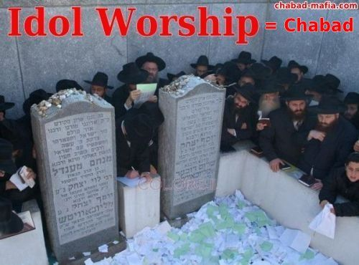
Basic Problem #5: Violence and Crime. Chabad engaged in criminal activities from the very beginning. Several of Chabad Rebbes and followers were constantly getting arrested. Chabad has always been a violent movement. Whenever a Rebbe dies there is always a violent fight for succession among the "eligible" candidates.
Basic Problem #6: Money: The only reason Chabad did not cease to exist after the death of the Rebbe in 1994 was because of the huge amount of money being made by the Chabad enterprise. Chabad is a multi-billion dollar operation active in several countries around the world. Since the Rebbe died in 1994, members of the Chabad organization have been fighting for the control of this operation, and the money left behind by their Rebbe. Chabad Rabbis appear to have an unlimited amount of money that they use, among other things, to pay bribes to politicians, judges, law enforcement officials, and Rabbis. Where is all this money coming from? Mostly from illegal operations which include drug trafficking and money laundering.
Basic Problem #7: Fantasy. Chabad theology is full of lies and fantasy about their seven Chabad Rebbes. For example, some say that the Rebbe explained to Albert Einstein the theory of relativity. Of course these stories are all false. In reality, mainstream Rabbis have always considered Chabad Rabbis as fake Rabbis. Chabad members are considered to be completely ignorant about the Torah. Chabad followers are considered stupid, crazy, and criminal, starting with their so called Chabad "Rabbis.”

ARTICLE #2: Excerpts from “C H A B A D - M A F I A – CHABAD-LUBAVITCH IS A RELIGIOUS CULT”
"While living in the Lubavitch community I was at times both abused and threatened." "It seems that the movement contains and often attracts unstable and potentially destructive people." Source: http://www.rickross.com/reference/lubavitch/lubavitch10.html
Brainwashed Chabad Children Salute The Invisible Rebbe
"Chabad's CULT and abusive tactics with young adults and minor children" "G-d blessed our family and we got Leah home and away from them... but what about other children?" - "... help us all protect our children from Chabad."
Source: http://forum.rickross.com/read.php?12,40222,page=1
“The Lubavitcher Rebbe as a god”: Haaretz, Israel - March 1, 2007. None have a problem with praying to Schneerson, using his books for divination in place of the Bible. Even amongst those viewed as moderates, "the Rebbe" is often substituted for God in normal conversation, sprinkling their remarks with comments such as "may the Rebbe help you" or "the Rebbe is watching over us." Source: http://www.rickross.com/reference/lubavitch/lubavitch47.html
They say: “Don't ever tell me Chabad is a cult. Don't ever tell me that they are conspirators in a cult designed to overthrow the Jewish orthodoxy.” Our Response: “Your cult is filled with liars and cheats. They beg and profit for their own lifestyle. They treat woman like cattle and anyone other than people like them are in the wrong.” http://frumpter.blogspot.com/2005/07/dont-ever-tell-me-chabad-is-cult

Studies of the psychological aspects of cults focus on the individual person, and factors relating to the choice to become involved as well as the subsequent effects on individuals. Under one view, an important factor is coercive persuasion which suppresses the ability of people to reason, think critically, and make choices in their own best interest. Studies of religious, political, and other cults have identified a number of key steps in this type of coercive persuasion: People are put in physically or emotionally distressing situations; Their problems are reduced to one simple explanation, which is repeatedly emphasized; They receive unconditional love, acceptance, and attention from a charismatic leader; They get a new identity based on the group; They are subject to entrapment (isolation from friends, relatives, and the mainstream culture) and their access to information is severely controlled.
Chabad is a cult, not a branch of Judaism. The only link it has to Judaism is to suck away everything that exists in Judaism. The following words are described in some dictionaries as follows: CULT: A religion or religious sect generally considered to be extremist or false, with its followers often living in an unconventional manner under the guidance of an authoritarian, charismatic leader.
Many Rabbis have actually endorsed the Lubavitcher Rebbe as King Moshiach... (Chabad website) Source: http://www.kingmessiah.com/117/700.html
Religious mentors in the major yeshivas of Chabad in both Israel and the United States, publications issued by mainstream Chabad, and influential, highly educated Lubavitch laymen, take the following assertions literally: The supremely righteous, of whom the Rebbe and Moses are the chief exemplars, annul their own essence to the point where their entire Essence is that of God. It is permissible to bow to them with this understanding. For this reason, the Rebbe is omniscient, omnipotent, and entirely without limits. He is "indistinguishable" from God. Because he is a transparent window for pure divinity, a `man-God,’ `when you speak to him, you
you speak to God.’
Source: http://answers.yahoo.com/question/index?qid=20080715210940AAnjVyZ
A religious cult is a group which has a pyramid type authoritarian leadership structure with all teaching and guidance coming from the person or persons at the top. The group will claim to be the only way to God, Nirvana, Paradise, Ultimate Reality, Full Potential, Way to Happiness, Redemption, etc, and will use thought reform or mind control techniques to gain control and keep their members. The group will have an elitist view of itself in relation to others, and a unique cause.
They will view themselves as being the only one right, and everyone else being wrong. They will view themselves as the only one doing God's will, and everyone else being in apostasy. They will promote their cause actively, and in doing so, abuse God-given personal rights and freedoms. This abuse can be theological, spiritual, social and psychological.
[Yedidah’s INSERT: I AM REMINDED OF JOHN 16:1-3: “These words I have spoken to you so that you do not stumble. They shall put you out of the congregations/synagogues but an hour is coming when everyone who kills you shall think he is rendering service to Elohim. And this they shall do to you because they did not know the Father or Me.”
This was fulfilled after Messiah’s resurrection when His followers, the Natsarim, followers of the Nazarene, or followers of “the Way,” (Acts 24) were killed by the Pharisees. Later the Pharisees manipulated the Romans to kill them.
Today, the plans of the Pharisees are seen in the Noahide Laws of the Babylonian Talmud, death to all who believe in Yahushua/Yeshua/Jesus as Deity, and all “gentiles” who guard the Torah. In other words, the focus of Satan’s wrath is on the Natsarim of today. Please refer to the first two Articles about the “return of the Natsarim,” under the Mikvah of Set-Apartness.]

CONTINUING ON WITH “CHABAD – MAFIA”
Q. Is one allowed to pray to the Rebbe? (Chabad website)
A. One is allowed to pray to G-d imagining G-d in the Rebbe King Moshiach's image somewhat similar how one is allowed to pray to G-d imagining Him clothed in the Sefirah of Chessed or Chochma etc. (see Derech Mitzvoisecho Shoresh Mitzvahs haTfliah and Sicha Acharon Shel Pesach 5710)
Source: http://rebbegod.blogspot.com/2006/01/rebbegod-blog-faq.html
Why call someone G-d?! (Chabad website)
`... the 1st Rebbe of Chabad as an explanation as to why Chassidim sometimes call their Rebbes G-d which was one of the accusations against them ... a person may sometimes be in unity with the Creator, hence they call their Rabbis “G-d" ... It's explained in the Midrash commenting on Yeshiahu (Isaiah) 52 that King Moshiach (Messiah) will be exalted even above angels thus it shouldn't be surprising that he too is called by G-d's name ... the Rebbe-Almighty ... His face shines like an angel of G-d and he himself is higher than any angel ..."
Source: http://rebbegod.blogspot.com/search/label/Calling%20Rebbe%20%20G-d.
The central synagogue at 770 Eastern Parkway in Crown Heights - the hub of worldwide Lubavitch Hasidism - is indisputably the headquarters of a messianic sect, and there the messianist slogan is a regular component of the liturgy. The slogan adorns the headquarters of the Lubavitch Women's Organization in Crown Heights. A prominent messianist directs the Lubavitch Youth Organization. Major schools in Crown Heights are shot through with messianism.
Source: http://fourquestions.us/judaism/messianic/chabad1.php
It is perfectly clear that the Rambam does not allow for just any idea of the Messiah at all to be accepted. The death of a pretender before completion of the task of redeeming the world and making it ready for a last attempt to produce souls worthy of the world-to-come proves that he was not the expected savior of the people. Source: http://fourquestions.us/judaism/messianic/chabad2.php
SOME ABUSES OF RIGHTS AND FREEDOMS by religious cults:
ABUSE OF INDIVIDUALITY -
They adopt a group mentality. They are not permitted to think for themselves apart from the group and only accept what they are told.
ABUSE OF INTIMACY -
Relationships with friends, relatives, spouses, children, parents, etc, are broken or seriously hampered.
ABUSE OF FINANCES -
Pressure to give all you can to the group. Members are always giving money to the group for some reason.
US VERSUS THEM MENTALITY -
Isolation from the community in general – i.e. Anyone and everything outside the group is seen as "of the devil" or "unenlightened" etc. Their enemies now include former friends, religious organizations, governments, education systems, the media, the world in general. Those who are involved with these in any way see such involvement as a "means to an end".
ABUSE OF TIME AND ENERGY -
The group controls and uses almost all the members time and energy in group activities. They are usually in a constant state of mental and physical exhaustion.
ABUSE OF FREE WILL -
They must unquestioning submit to the groups teachings and directions and their own free will is broken. Their "will" actually becomes the groups "will" without their realizing it. This is done either by coercive methods including low protein diets and lack of sleep, or over a period of time through intimidation. Both methods make heavy use of "guilt".
RESULTS OF THIS ABUSE by religious cults: PERSONALITY CHANGES -
Relatives will say they no longer recognize the person. From a warm, loving personality will come heaped abuse, rejection and feelings of hate. The cult member sees himself as "righteous" in comparison and this comes across in their attitude toward all outsiders.
LOSS OF IDENTITY -
They cannot see themselves as individuals apart from the group. Some even change their name as a rejection of their former life
PARANOID - WE ARE BEING PERSECUTED -
Any time you say anything negative about the group, whether justified or no, it is regarded as "persecution". Any criticism of the individual is also seen as persecution only because they are the "true believer" or "enlightened" one - not because they, as an individual, have done the wrong thing. However, at the same time they will feel free to criticize whatever you believe, say and do because they are "the only ones who are right".
SOCIAL DISORIENTATION -
They lose their ability to socialize outside the group. This can go so far as to not being able to structure their time or make simple decisions for themselves when they leave. Their world-view alters and they perceive the world through their leaders eyes. They become very naive about life in general.
SEVERE GUILT COMPLEXES -
They are made to feel guilty of everything they did before entering the group and are to strive to be "good" and "worthy" for "eternal life". Misdemeanors are made into "mountains" so that members are in a constant state of guilt for infringing even the most minor rules. Guilt comes because they aren't doing enough; entertaining doubts or questions; even thinking rationally for oneself. This guilt is piled upon pile with new rules constantly being laid down about what is sinful and what is not. Illness may be seen as lack of faith, more guilt. Emotional illness may be seen as proof of sin in your life, more guilt.
SUMMARY -
Not all these points will be found in every cult, but all cults will have some if not most of them, although these may vary to some degree.

International Congress of Shluchim
Notice the banner in Hebrew declaring "LONG LIVE THE KING MESSIAH"
The Shluchim, or Chabad Emissaries, all believe the Chabad Rebbe is the Messiah
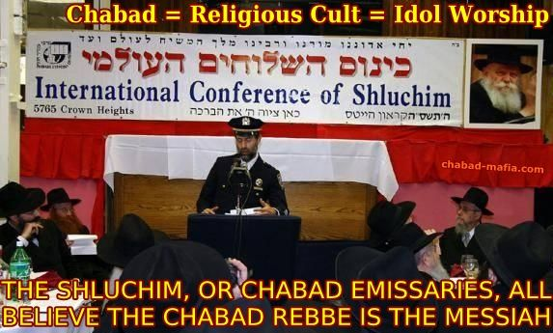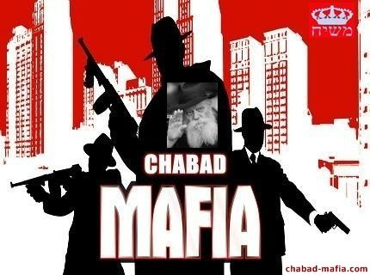
The Rick A. Ross Institute mission is to study destructive cults, controversial groups and movements. It has gathered some information about Chabad Lubavitch, which is described as "a very dangerous religious cult."
Disclaimer: Please conduct your own investigation about the issues mentioned in this website. This website is only a brief summary of the problems with Chabad. For more information, please talk to your local community Rabbi. Also, if you really care about being Jewish, come live in Israel and study Judaism.
Copyright Notice: According to Jewish Law, it is a Mitzva, a religious obligation, to provide this information to every Jew in the world, in order to protect Jewish children from Chabad, and to save Jewish lives and Jewish souls from being destroyed by Chabad. Therefore, permission is granted to copy and reproduce all of the information found on this website in any form and publication, including any website or blog, and to translate it to any language. The only requirement is that you mention that the information was obtained from this website, and in the case of internet pages, please add a link back to this website.
Source: http://rebbegod.blogspot.com/search/label/Calling%20Rebbe%20%20G-d.

Article #3: EXCEPRTS FROM: “Chabad Lubavitch Identified as Supremacist Criminal Cult in League With Mossad” by Brian Davis (henrymakow.com) (from June 11, 2011) http://educate-yourself.org/cn/Chabad-Lubavitch-Identified-as-Supremacist-Criminal-Cult-in-League-With-Mossad21aug16.shtml#top August 21, 2016 - educate-yourself.org › Chabad-Lubavitch-Identified-as-Supremacist-Crimi

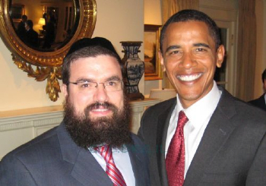
“…Founded in 18th century Russia, Chabad is a branch of Hasidic Judaism, a form of Orthodox Judaism that promotes Jewish mysticism as the path to enlightenment. Chabad Lubavitchers study the Kabbalah [also spelled Cabala], the satanic creed that erases moral absolutes and believes God is 'subjective'.

Left: President Obama with Chabad DC chieftain, Levi Shemtov
Statements from the Talmud by Chabad Rabbi Ginsburgh, a leading Chabad Rabbi, have argued that because Gentiles are genetically inferior to Jews, a Jew should be able to take Gentiles organs if he needs one. He was recorded saying, 'As for the goyim... Zalman's attitude (was):"Gentile souls are of a completely different and inferior order. They are totally evil, with no redeeming qualities whatsoever."'If every single cell in a Jewish body entails divinity, is a part of God, then every strand of DNA is a part of God. Therefore, something is special about Jewish DNA.'
The Canadian government recently gave the cult $800,000 for the building of a Chabad center in Montreal. Relations with Russia are less warm; the Russians recently refused to hand over two major collections of Chabad texts seized by early Soviet governments.
Where is Chabad's influence the greatest? You guessed it: THE USA.
Rabbi Shemtov is Chabad's Washington representative, and his enormous influence was illustrated when he lobbied successfully for the Great Rebbe to be posthumously awarded the congressional gold medal in 1995, the only religious leader ever to be given the award.
Rabbi Shemtov is an all-pervasive presence in D.C. Sue Fishkoff, author of 'The Rebbe's Army: Inside the World of Chabad-Lubavitch', writes: "It's not enough that Chabad's man in D.C. knows the name and phone number of just about every congressman, senator and foreign ambassador in the nation's capital -- he also knows their legislative assistants, their secretaries and the people who clean their offices."
Shemtov says that the vast network of shelichim inside the US generates his political power. "We have shelichimin forty-seven states and in [at least] 310 districts. ... People sometimes view the world of shelichim as three thousand people, but it's not only three thousand people, it's three thousand interconnected networks. So we can place a call from a constituent to almost any member of Congress."
"Most shelichim have good connections with their senators, congressmen and governors, who represent the most remote places in the United States. For example, when Sarah Palin, a Republican, burst onto the scene, she had already known about Jewish issues and Chabad specifically from Rabbi Yosef Greenberg in Alaska."
CRIMINAL AND TERROR ENTERPRISES
Chabad is a criminal organization with ties to Mossad. Chabad houses provides safe houses and storefronts for Israeli intelligence and criminal activity. This includes everything from terrorism to money laundering, drug running to prostitution.
For instance, in March 1989 U.S. law enforcement rounded up a criminal network in Seattle, Los Angeles, New Jersey, Colombia, and Israel that involved a Chabad House that was involved in money laundering and currency violations.
Wayne Madsen writes: `In Bangkok, Israeli military pilots and drivers who stay at the Chabad House there train Thai Army commandos, divers, and pilots who are fighting a Muslim secessionist movement along the southern border with Malaysia.
Bangkok police have long suspected Chabad House as a center for the Israeli Mafia, which runs its Ecstasy and Ice trade from Bangkok for all of Southeast and East Asia. The Israeli Mafia also reportedly runs heroin labs in Myanmar, where an Israeli military officer serves in Myanmar's feared military counter-intelligence agency.’
`Retaliation against the Chabad mafia can be seen in the Mumbai terrorist attacks when Lashkar-e-Taiba militants took hostage of the Mumbai Chabad house and murdered nine Jews, including Rabbi Gavriel Holtzberg.
Wayne Madsen has reported that mafia overlord Dawood Ibrahim ordered the attacks partly in response to Israeli mafia attempts to take over his Mumbai drug trade. [Wayne Madsen Report] has learned from Asian intelligence sources that the Russian-Israeli gangsters operating out of Chabad House tried to take over Mumbai's drug trade with the help of local Jewish mobsters so Ibrahim, while settling scores with India, the CIA, and Britain, decided to have his subcontractor LET terrorists pay a visit to Chabad House and "collect on a debt with high interest.'
Chabad is allowed to exist as a powerful international force because they serve Israel in two ways: working with them in intelligence and criminal activities, and a source of extremist ideology to fuel Zionist crimes.”
It’s all about bringing about a new world order for a small Elite group who will rule the world from Jerusalem.
The material in these articles are not my opinions!!! My opinion is Genesis to Revelation! These articles come from the astute knowledge of Orthodox Jews who are exposing what they feel they need to expose! There are religious Jews who are not tied up into this mess because, as with the Freemason degrees, they’re still in the preverbal “Blue Lodge.” They do not know the inner workings of the upper echelon of controllers.
I know that what I have been writing on is exclusive for a small group of preverbal 33 degree and beyond rabbis who work with the real 33rd degree and beyond Freemasons, the Zionists, the Sabbateans, the Jesuits, and the top of the ladder--the Illuminati. All are Jewish groups, as in Revelation 2:9 and 3:9.
My purpose in writing these now 20 articles is for one main reason: To expose the highest of the highest goals by Satan’s forces by going to the core of Yahuwah’s Truth in order to warn Christians and Messianic believers to run from getting ensnared in the adoration of rabbis or pastors, or any man.
The days of deep deception are upon us. My plea is that you give your heart, mind, soul, strength, and passionate love to your Savior, our Redeemer, Yahushua Messiah, our soon-coming King, in submission and obedience to Him, and to His Father, Yahuwah – Shaddai, Elyon!
To deny the Deity of Messiah is to separate Him from His Father who brought Him forth before the foundation of the world for our salvation. Never forget Leviticus 17:11 and Hebrews 9:22!
The secret to not being deceived is by having one Teacher. If everyone who names the Name of Yahuhua/Jesus/Yeshua had only one Teacher, the Spirit of Yahuwah, with them to teach the depths of the Word, give council, direction, conviction, comfort, and hidden knowledge, the end-time remnant would be gigantic. But, because people listen to man to tell them what to believe, there are hundreds of thousands of opinions of religious philosophy. Ignorance of the Word and the nature, ways, and thinking of Elohim is causing hundreds of thousands to throw away what they could have had for eternity – the Kingdom of Heaven. I ask that you meditate on Matthew 7:13-16 and see what Abba shows you.
Without this keen and tested gift of the Spirit - “the discernment of spirits,” –a believer is at the mercy of demonic forces in their mind and emotions. They’re at the mercy of satan’s forces. Only by this gift of the Spirit and a knowledge of the Word as taught by Him can anyone discern clearly what is of the enemy and what is of Yahuwah.
Without your Lamb as your Savior-Master and Friend, through faith in His shed blood to remove your sin, and His resurrection to ensure your eternal life, you have no hope of entering the Kingdom of Yahuwah, the Kingdom of eternal Light? Submit your life to the control of Yahuwah and Yahushua before it’s too late!
In His love, shalom!
Yedidah
August 24, 2019

