EXPOSING THE SECRET SOCIETY THAT MAY ACT AS
JUDGE AND EXECUTIONER OF THE NOAHIDE LAWS

This is article #16 in the series exposing global Babylonian Talmudic Law, its sister “Kabbalah,” the effect of these laws from ancient Babylon on International Law of nations today, and Talmudic “Noahide Laws” that will unite the world against all believers in the Deity and salvation of Yahushua/Yeshua, Yahshua, Yesu, Isa, or whatever His name used by various cultures.
The mask is off, and the war is now in progress, increasing by the day, against the powers of darkness and their human lackeys, and the children of Light empowered by the Spirit of Yahuwah within His chosen ones from the foundation of the world--His “chosen race” and “royal priesthood,” whose names are in the Book of Life.
Surely, the One who came 2000 years ago and bought our salvation with His Father’s blood coursing through His veins, by His death on the stake/cross, and His resurrection from the dead for our eternal life, the Lamb of Elohim who takes away the sin of the world’s people, is most hated of all in the entire universe, and His followers are the most of all hated people. Genocide is being carried out against truly born again believers in many places in our world today. It is coming to the western world as well. Persecution has already begun openly as well as in more subtle ways in principal western culture nations.

The list of the articles so far, each one building on the former one, back to the foundational #1 that explains the Noahide Laws:
Foundation: “Exposing the Roots of Rabbinic Judaism and Its Link to Rome”/Mikvah of Present Reality
1) Foundation of this series: “Beware of the Noahide Laws”/Mikvah of Present Reality

The Following Articles and Posted Under the Mikvah of Israel, Our Eternal Inheritance

2) “Israel’s Sanhedrin Makes Their Move Towards Internationalizing the Noahide Laws – Hanukkah Altar Dedication - 70 Nations Invited”/December 9, 2018
3) “The Frightening Reality of the Noahide Laws and a Third Temple Not Authorized by Yahuwah”/February 11, 2019
4) “Trump and 50 Governors Affirm Noahide Laws and the Celebration of Rebbe Schneerson’s Birthday”/April 18, 2019
5) “Rabbinic Judaism, Kabbalah, the Holy Serpent Messiah, and the Synagogue of Satan”/April 21, 2019
6) “Shocking Revelation! DNA Reality! `Harmless Noahide Laws,’ the Great Deception, Trump, Kushner, and the Mark of the Beast”/May 3, 2019
7) “The Hidden Underground Synagogue of the Sanhedrin”/May 7, 2019
8) “One World Religion! The Mystery Babylon We Never Imagined! The Vatican Bows!”/May 29, 2019
9) “The Great Deception Is Sweeping the Earth - Drawing Billions Towards Eternal Damnation”/June 3, 2019
10) “The Pike-Mazzini Plan of 1871: The Plan For Global Government – The Perfect Execution of Parts I, II, and Now Part III”/June 5, 2019 (59.0)
11) “1947-1948: The Fig Tree Prophecy or Zionist Manipulation?”/June 12, 2019
12) “The Equality Act, the Anti-Semitism Awareness Act, and TAPS”/June 14, 2019
13) “Quotes That Forever Destroy Damming Illusions”/July 1 2019
14) “How Intense is the Global Hated For the Son of Yahuwah?”/July 11, 2019
15) “The Sanhedrin is Hosting a Conference of 70 Nations – This is a Total Masked Deception – Yet Clearly Unmasked to Those With Knowledge and Discernment” – July 12, 2019
16) “Exposing the Secret Society That May Act as Judge and Executioner of the Noahide Laws”/July 15, 2019

My goal in writing these articles is not to shock people or be sensational, though the material is shocking and sensational, but to rescue as many Christians and Messianic believers as possible so that they are not deceived into denying our Savior, the only One who can give us eternal life. To deny Him is to have one’s name erased from the Book of Life. The Word is clear on that. Yahuwah extends to us the privilege of salvation through faith in the shed blood of His Son, and eternal life through His resurrection. He extends to us the privilege of having His own Spirit reside in our re-born spirit. But, He puts very strict guidelines on all that He gives and all that He promises to give. “The fear of Yahuwah is the beginning of wisdom!”
What is shocking is that most of His people in the mind-programmed Western culture world are afraid of Truth. They go by what they are told to believe by their pastors and teachers—Christian or Messianic. They have no personal relationship with Yahuwah and Yahushua because the mind programming has instilled rebellion, stubbornness, pride and religious attitudes. To do what is necessary to hear from Yahuwah is so often considered “too hard,” or “too boring.”
In my article series on hearing and experiencing Yahuwah and Yahushua--“Waiting on Yahuwah…” “Waiting on Yahushua…”--the last three in the series contain quotes that give detailed instruction and wisdom as to how to touch base personally with Abba Yahuwah. All five articles in that series are under the Mikvah of the Heart of Elohim.
It takes time to build faith and develop a personal intimate relationship with Father and Son. It takes time for Them to build faith in us, so that They trust us as good and reliable servants, and friends.
Here I give you some surprising information to add on this topic. What is the secret society that joined with the Kabbalah, with the Babylonian Talmudic Rabbis of Israel, to help set up worldwide courts, as proposed in the 1st Noahide Law, and to execute the offenders according to the Talmudic Noahide Laws.
There are 7 laws attributed to the Patriarch Noah, yet only aligned to a story the rabbis made up. The Talmud says that upon Noah’s leaving the ark, he wrote down 7 Laws by which mankind was to be governed so that the earth would be in unity. The kicker is that under the seven laws are loads of other laws that condemn all believes in the “New Testament.”
Does the Bible say that Noah wrote down these seven laws? NO! That is part of a spurious “Oral Law,” supposedly given to Moses on Sinai, that ended up being codified as the Mishnah, and later in the Babylonian Talmudic, a commentary of volumes of rabbinic opinions.
Of course, Moses was not given any Oral Law by Yahuwah! And, certainly not a law that would include the statements in the Babylonian Talmud, filthy statements giving a free ticket to Talmudists to enjoy sin of all types and kill anyone who does not bow to the will of the Rabbis. The Talmud creates an elite religious group that must be obeyed or punished by death.
Another shocker is that the merging of this Secret Society with Talmudic Rabbis began in the early 1700s. But, the roots of it go back into Europe and the U.K. and were brought into America where this secret society and its partner for world rule, Kabbalist Talmudic Rabbis, would bring it to what it is now – Global Law.
Because of end-time prophecy coming to the forefront from 1947-1948 with the restoration of the Land of Israel as a nation, though acquired by deceitful non-Jewish Zionists pretending to be Jews in order to usurp the Land from the true Judah, the plans for a global government ruled by Talmudic Law and Kabbalah has taken a dramatic leap forward.
As you’ve read in the articles listed above, by DNA testing those calling themselves “Jews” with right to the Land, are not of the tribe of Judah or Levi at all. 95% of all Ashkenazi Jews and some Sephardic Jews have been traced back to the Caucasus Mountains of ancient Khazaria. Khazaria was a gigantic empire in the 8th century. The King of Khazaria adopted Babylonian Talmudic Judaism as their national religion. He sent to Babylon to find teachers who would come and teach them the Talmud. The teachers came! The people of Khazaria rejected the Bible and Yahweh, but heartily embraced the Babylonian Talmud. Later, to deceive Christians and blend in with those in Russia, Europe, the UK and America, they began quoting the Bible. But, as Kabbalists later on, they turned totally toward a vile and diabolic paganism, barbarism, that the Talmud was compatible with. Thus the plan began to rule the world. Part of the plan was to infiltrate America as it began to be a nation, actually a corporation still controlled by Britain.
Now that the global plan has surfaced above ground as of December 2018, it is going forward with leaps and bounds. Tragically, Gamatria, part of Kabbalah, has been introduced in Messianic congregations as “getting deeper meaning into Hebrew words,” and Kabbalah has been introduced into the school system of America, the UK, Europe, etc.
Jewish fables and myths override the true of the Word of Elohim, the Bible. The apostle Sha’ul warned against the fables and myths of the Oral Torah used to create the “traditions” that Messiah came against with great fury during His earthly ministry. The puppet priesthood of the Hasmonean Dynasty and the Roman rule of the Levant were actually from a hybrid lineage, part human and part reptilian from Babylon. It was hybrid Levites who invented an “Oral Law” of Moses, some written down, most passed down by word of mouth. However, it took the place of the Written Torah of Moses eventually demoting the written Torah of Moses for the traditions of Babylonian and hybrid rabbis. In this series you’ll learn that today’s Pharisee lineage in the Orthodox and Hasidic Jewish leaders also goes back to the original lineage of the Pharisees.
Refer to the article “The Seed of the Viper in the Pharisees and the Seed of the Woman in the Natsarim/March 27, 2019 [Podcast CV and CVI: March 28, 2019]
Matthew 23 and John 8 do not record an angry tirade by Messiah calling the wonderful Pharisee rabbis naught names, such as “seed of vipers” and saying “…you are of our father he devil.” Yahushua was referring to their lineage by their fallen angel fathers with human mothers.
So of course, the secret societies that developed in Babylon, Nimrod’s ancient Kingdom that grew into the world government we have today, are not going to support the Word of the Elohim that Nimrod hated with all his being – Yahuwah. The whole purpose of the “tower” was to build a portal-opener to ascend into His domain to destroy Yahuwah, His Son, and angels that remained loyal to Them.
The whole concept of Sanhedrin rule is based on ruling over 70 nations. The word “Sanhedrin” comes from 70 – 70 elders who assisted Moses in judging the people. The rabbis make up laws, stories, myths, fables, ideas, reasoning that justify their overriding the Word of Yahuwah, which began with the Pharisees. Messiah condemned them totally. Today this lineage has become world-ruling. Elohim greatly condemns it.
What Secret Society will aid the Sanhedrin worldwide in setting up courts of “justice” to judge and execute punishment on those that violate the Noahide Laws of the Babylonian Talmud? The merging of this Secret Society with Babylonian Talmudic Kabbalist Rabbis began, at least its recorded it began, in 1720. But, the merging most likely began in the 1600s or before. There are many secret societies in our world from ancient times. What is their secret? - Supposedly the hidden knowledge of the fallen angels that descended on Mount Hermon before the Flood.
From Gods of the Lodge by Reginald Haupt, Jr. in his chapter regarding the 21st Degree of the Scottish Rite Freemasons under the title: “Noachite, or Prussian Knight Degree”: “This degree stands alone in Masonry. It is based solely upon the destruction of the tower of Babel and contends that the whole earth was peopled as a result of the dispersion at Babel. The Prussian Knights called themselves `Noachites,’ or `disciples of Noah,’ while they designate other Masons as Hiramites or disciples of Hiram Abif. In this degree they contend that a man named Peleg is the founder of the Degree by virtue of his position as the Grand Architect of the Tower of Babel. He is said to have traveled to Prussia during the dispersion where he died. In AD 553 his tombstone was found with this inscription: `Here rests the ashes of Peleg our Grand Architect of the Tower of Babel. The Almighty had pity on him because he became humble.’ Thus the cover story: Masons taking the 21st Degree charge of this Degree is that Masons are to be modest and humble, and that they should never place self above Deity or claim greater wisdom than him.”
Looking at Genesis 10 and 11, we see that Peleg was a descendent of Shem (`Sem,” from where we get Semite) and that he lived at the time of the tower of Babel. Scottish Rite Freemasonry sees Peleg as helping Nimrod build the tower of Babel. This lying tale is attached to the 21st degree of Masonry “Noachites” or “the Prussian Knight.”
Neither the Bible, nor the books of Jasher or Jubilees, say anything about Peleg overseeing the building of the tower of Babel, or helping Nimrod do anything.
The Bible refers to Peleg in Genesis 10:38, 11:16-19, I Chronicles 1:9, 25.
He appears to be a righteous man. Yes, it was in his day that the nations were dispersed from the tower of Babel, and the earth was divided up by Yahuwah into people groups, with “confused” separate languages.
However, that whole idea of the 70 nations is also fallacious. It’s not in the Bible! The 70 nations statement is an invention of Talmudic Levites who became known as “rabbis,” meaning “exalted teachers,” from way back in Babylon.
Deuteronomy 32:8-9 repeats Genesis 10:32, speaking of Yahuwah dispersing earth’s people from the tower in Shinar, today’s Iraq, (Genesis 11), into all nations. Over each nation, He placed one of His powerful angelic beings. Because of their power to rule humanity, we see from Psalm 82 that they became corrupt. They became the “principalities and powers” of the air – Daniel 10 and Ephesians 6:10-12.
Peleg happened to be at the right place at the right time to be the center of the myth that turned into the 21st degree of Scottish Rite Freemasons. Creating myths and fables to dilute the Truth of Yah’s Word is a common practice of Rabbis from after the Babylonian captivity to this very day. Their stories are sometimes so insane that you can’t wrap your mind around them. I gave a few examples in the article “Quotes …” (#13 in the list above).
The following is from my notes from a Steven ben Nun YouTube broadcast July 11, 2019 entitled “Uncovering Secret Society of the Freemasons as Judge and Executioner.”
In 1721, James Anderson published a book about the merging of Freemasonry with the Noahide Laws of the Talmud entitled Book of Constitutions.
In 1906, Albert Mackey wrote The History of Freemasonry Volume II. You can purchase it from Amazon for $19.95 + $3.00 S&H]
On pages 408-409, Mackey begins a chapter entitled “Noah and the Noachites”
Mackey quotes Anderson as writing: “Noah and his three sons – `all Masons true’…they brought over from the flood the traditions and arts of the antediluvians and communicated them to their growing offspring. They traveled to the land of Shinar where Noah taught the sons what would become the beliefs of masonry.”
It sounds to me like Anderson is mixing Noah with Nimrod. Anderson said, in 1721, that the three sons dwelt in Shinar as “the sons of Noah, or Noahides”
…`Noachida’ was the first name for Masons according to some traditions.”
Steven ben Nun said that it was Anderson in 1721 who pushed the Noahide Laws into Freemasonry. He quoted Anderson as saying “a Freemason is obligated to obey the Noahide Law.” In 1738 Anderson added the words that a Mason was “a true Noachida.”
Steven said that in 1723, the Noahide Laws became a part of the Freemason Constitution.
As a companion religion supported by the Talmud Kabbalah, ancient mysticism of Assyria, Egypt, Babylon, also joined Freemasonry. The Babylonian Talmud and the Kabbalah are united together, forming the beliefs of Rabbinic Judaism, as well as the basis of Freemasonry.
Two of the greatest teachers in the Scottish Rite of Freemasonry, Manly P. Hall and Albert Pike were both strong Kabbalists. Kabbalah is called “Jewish mysticism.” That is an evasive term. Kabbalah is straight out of the Constitution of the fallen angels. Today it is very popular in the world, being taught in the American school system to children.
Kabbalah’s “Seferot Tree” is their path to salvation, just like the Degrees from 1-33 of Freemasonry for initiation into the “Mysteries” at the 33rd degree.
As Mackey writes, there were two classes of Masons: 1) the descendents of Solomon and 2) the descendants of Noah.
By the 1700s, “Noahide” and “Freemasons” became synonymous – as there was a merging of Freemasonry with Judaism. The myth is told how Noah left the ark and wrote down the 7 laws governing mankind. That’s NOT in the Word of Yahuwah.
Go figure, hybrid Levites scribbled down what was given to Moses orally by God on Sinai while in Babylon. It is passed it down from Babylon by word of mouth. It is incorporated into the beliefs of the Pharisees in Jerusalem before the dawn of AD 1.
Talmudic laws, traditions, and stories, were finally written down and canonized as the Mishnah in later centuries after loads of writings of rabbis were added. You’d think with all the telling and infusion of rabbinic ideas, that what God told Moses orally would be slightly perverted after about 800-1,000 years. But, it is considered divine truth. I have to chuckle at that. All the editions of hybrids and humans to what Moses was given on Sinai after all those centuries is considered not just law under the commentary, the Babylonian Talmud, but is considered divine law, mandatory on all human beings.
Did Moses receive anything He did not pass on to us? Personal things Abba would have told him, like Abba tells us. But, to demote the written Torah of Moses given to all of His people, making it not just lower than the Talmud, but despised as well, says that we have a religion here called Rabbinic Judaism that is as far from Yahuwah and Yahushua as is Islam, Hinduism, Buddhism, or Satanism.
The rabbis say that Allah is compatible with Yahweh because both are monotheistic religions. Yet these hypocrites are polytheistic, worshipping gods and goddesses of Kabbalah.
Steven asked: “Who, in our future, is going to enforce the Noahide Laws in each nation?” GOOD QUESTION!
The Sanhedrin is a group of 70 men. They control governments of the world, the Vatican, and Freemasonry. They are mentioned by name in Mark 13:9-13. In America it is nearly imperative that all those in leadership positions be Freemasons.
Freemasonry is a “brotherhood” of darkness. Almost all of America’s “Founding Fathers” and signers of the Constitution were Freemasons.
Mackey says that other Masonic writers of the 18th century (1700s) used the term “Noachide.” Mackey in 1906 lists the seven Noahide Laws as 1) do justice 2) worship God, 3) abstain from idolatry 4) preserve chastity 5) do not commit murder 6) do not steal, and 7) do not eat blood.
These laws have been fined-tuned. The 1st law reads that an international court of justice must be established to judge the world by the Noahide Laws.
The U.S. House of Representatives voted in the Noahide Laws as American Law in March of 1991. Well, actually 4 voted that day, the rest of the Representatives were sent home. Be sure to read: “Beware of the Noahide Laws”/Mikvah of Present Reality, and “Shocking Revelation! DNA Reality! `Harmless Noahide Laws,’ the Great Deception, Trump, Kushner, and the Mark of the Beast”/Mikvah of Israel, Our Eternal Inheritance.
On page 410 of Mackey’s book it states that Noahides were not privileged to be admitted to the Jewish religion: “They were not considered equal to the true children of Abraham.” Rabbinic Judaism is an Elitist Club.
The imposters, the fake Khazar Rabbis, lower anyone not Jewish by the mother’s lineage, saying they cannot guard the Torah, they cannot have the same privileges as the Elite Rabbis. To be a Noachide/Noachite/Noahide, one cannot believe in the Deity of Jesus/Yeshua etc., because that is polytheism. Yet, they are worshippers of not just gods and goddesses that Kabbalah invented, and they also pray to Lucifer and Satan.
Albert Pike, in his book “Morals and Dogmas…”, considered the bible of Freemasonry, he clearly says: “Our god is Lucifer.”
To the Masons of the 33rd degree, the secret is revealed. The secret says that the Nachash/Serpent in the Garden was there to enlighten Eve and give her the hidden knowledge of the Mysteries. But, Yahweh, the dark and evil God took enlightenment from her and left her ignorant of what she and Adam could have had, if they had embraced the light of the “Holy Serpent.” The messiah of the Talmudic Kabbaists is known as “the Holy Serpent,” Leviathan. Leviathan rises out of the sea (Revelation 13:1) The secret is that Yahweh is against the light of knowledge of the mysteries of the ancients. Thus they put Yahuwah down as no more than a creation of their chief god Ein Sof.
Rabbis today say that the Arabs are closer to the true religion than Christians because they believe in only one god. They go so far as to say that Allah is the God of Israel.
Steven said: “Today, there was a conspiracy of the Scottish Rite Masons to bring forward Noahideism.”
The renown Jewish sage, Maimonides, called “Rambam,” wrote out the Noahide Laws around the 10th century and codified them as the Mishnah Torah
Masons are admonished to obey the seven laws of Noah. Anderson said: “The use of `“Noachide’ and `Masons’ is interchangeably.”
Mackey: “From The Krause MS under the heading of `The Laws or Obligations’ laid before His brother Masons by Prince Edwin, `The first obligation is that you should sincerely honor God and the laws of the Noachites because they are divine laws that should be obeyed by all the world.’ ”
Steven said: “The Masons work together closely with the rabbinic community regarding a day that is fast coming when the world must come under the Noahide Laws or be beheaded…as the lackeys of the rabbis; Freemasons may be conscripted into the murder process of believers.”
***Merriam Webster Dictionary: “Noachite” (noun) meaning 1) “A Freemason who has taken the 21st degree of the Scottish Rite, called also `Prussian Knight,’ 2) A Freemason
That’s kind of shocking that a Noachite is described as a Freemason of the Scottish Rite. The Book of the Ancient and Accepted Scottish Rite of Freemasonry 1884 written by Charles T. Mclenechan 21st Degree Noachite (or Prussian Knight) wrote: “The Prussian Knight is considered to be a Noahide.”
The text goes on…“it is by the Noahide Laws that a man is set free...”
Messiah Yahushua said: “You shall know the Truth and the Truth shall set you free.” He said: “I am the Way, the Truth, and the Life. No man comes to the Father except by Me.”
Mclenechan’s 1884 text reads: “In the new world order, the world will be ruled by the 7 Noahide Laws. The judgment for breaking them will be administered by Freemasons.”

THE SCOTTISH RITE FREEMASON 21ST DEGREE: NOACHIDE – THE PRUSSIAN KNIGHT

***The symbols of the 21st degree include an arm with a long sword. As described in Mackey’s book for the initiate: “The dress is entirely black accept for the gloves and the apron, with swords, spurs, and black masks.”
When Steven read that, I immediately thought: ISIS! This Jihadist organization was created by President Obama and Secretary of State Hillary Clinton as a mercenary data base, like President George W. Bush’s Al Qaeda. They are trained by our CIA, and now the Israeli Mossad, to do the evil they want done.
Steven put into Google the words, “black clothes, black masks, swords, ...” and it brought up an article about Saudi Arabia, plus a picture of an ISIS member with the same black attire as the Prussian Knights, holding a sword over a man’s head. The man is kneeling awaiting beheading.
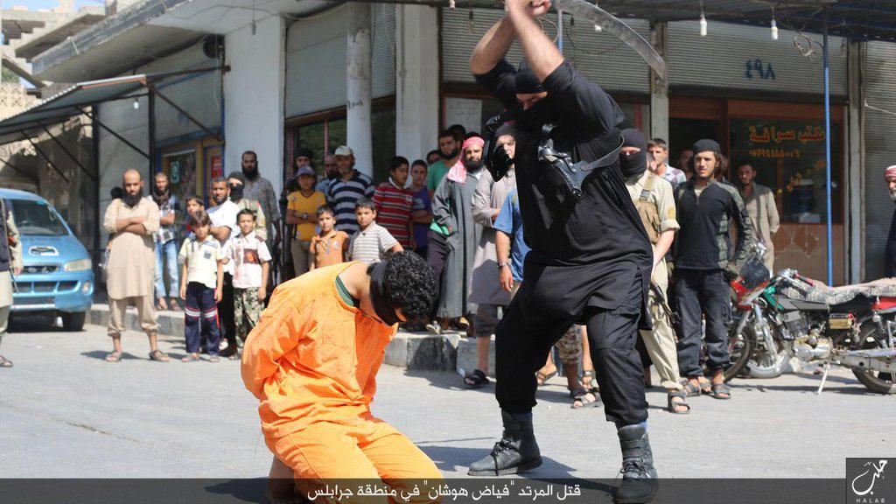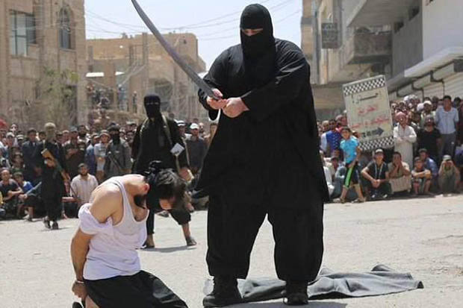
Left: This is the picture that came up for Steven: “Giant ISIS Brute Abu Sayyaf known as the scariest executioner in Iraq” - “Isis Releases `Death List’ of Executions” Right: Abu Sayyaf with another person
Steven said correctly: “Sayyaf is a Prussian Knight,” a 21st degree Freemason.
Whether this particular man is a real Freemason or not, the description of the Noachide, the “Prussian Knight” is that of a U.S. hired ISIS mercenaries.
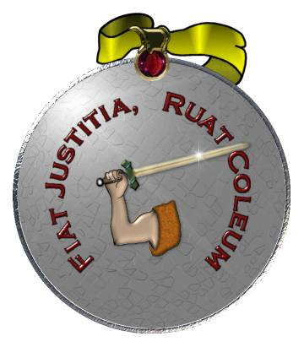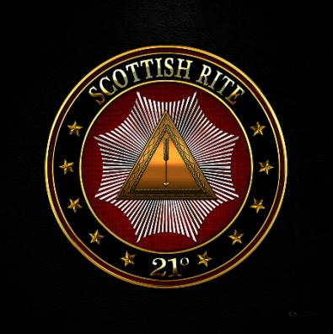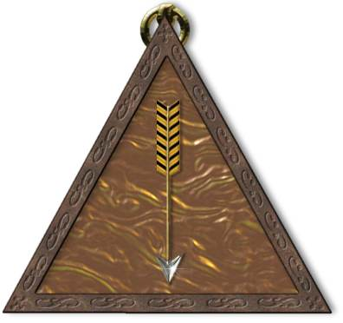
Noachite or Prussian Knight symbols of 21st degree Freemasons
Left: The Latin reads: “Let Justice be done; though the heavens fall”
Noahide Law 1: “Establish courts of Justice”
Middle emblem: Notice the star burst. In its midst is a pyramid with an arrow. Note on the back of the dollar bill. On the left is the Great Seal of the United States. Note the all-seeing eye of Horus with words calling for a new world order in Latin. Note the steps of the pyramid counting time from 1776 to 2016 Gregorian calendar.
Who created the Great Seal of the United States? FREEMASONS!
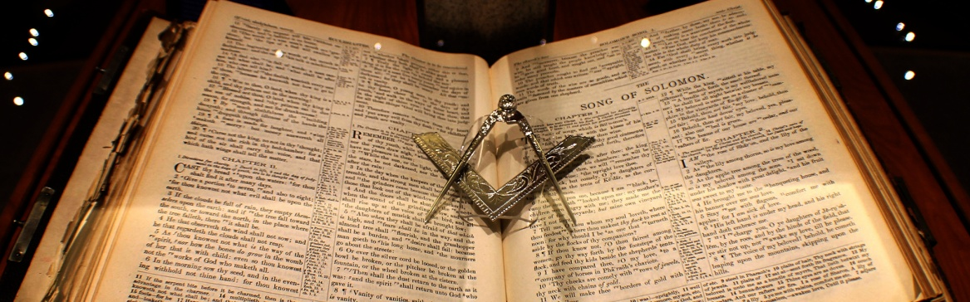
From the Scottish Rite of Georgia, a hexed Bible
The men in my mother’s family most all were 33rd degree Masons. My mother belonged to the Eastern Star. When she was seriously dating my dad, he told her that unless she left the Eastern Star and denounced Freemasonry, he couldn’t marry her. She left the Eastern Star. I am so proud of Papa.
I got my first introduction into understanding the evil of Freemasonry from a former powerful ex-Satanist who oversaw many covens in the Fort Worth area. He gave me a book by Manly P. Hall explaining a lot of this. That was in 1987.
In 2010, as part of an intercession assignment from Abba in Washington D.C., I and a dear friend took a personal tour through the 33rd Degree Scottish Rite “Temple.” She was my back-up intercessor. The ticket for the tour was $3.33. So for us two it was $6.66. The man who escorted us was very leery of me. I asked too many questions about things I wasn’t supposed to know.
I knew a lot about Freemasonry then, yet I learned a lot more. On the tour, I saw a photo of my grandmother’s 1st cousin, the famous baseball player Ty Cobb. He was a 33rd degree Mason. I also saw a picture of the comedian, Oliver Hardy, a 33rd degree Mason. In this “Temple” are the remains of Albert Pike. The Grand Masters of this “Temple” are the Elite controlling-arm of the White House! The layout of the streets forms the outline of Baphomet, the goat-headed Devil. His beard touches the top of the White House and the light on his head reaches to the
House of the Temple.

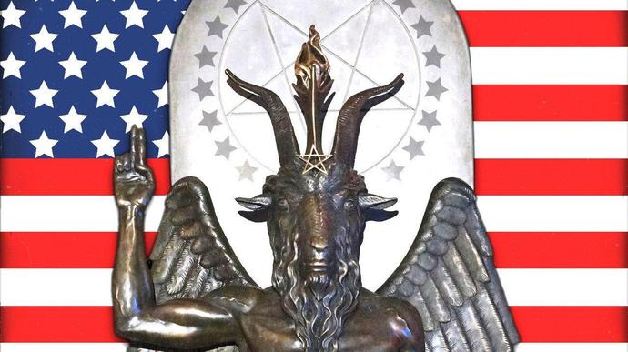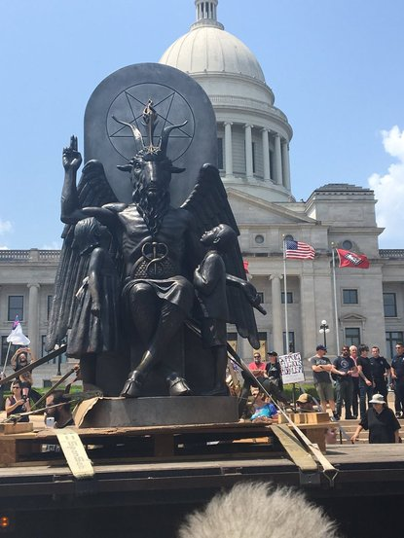
Statue of Baphomet outside the Arkansas State Capital

Part of the ritual for a man to be a 21st degree Noachite Prussian Knight is to repeat: “Dost thou agree and promise that thou wilt be just and righteous and in all things strive to emulate that Patriarch from whom we take the name Nochites, who, along with his family, was found worthy to be saved, when God destroyed mankind with the Deluge?”
Here again is the hidden deception. The Noah of the Noachites is said to be the Noah of the Bible, however the Genesis 6-9 Noah is certainly not the Noah of the Talmud! It is like the deception that the Rabbis love the Old Testament. Read the “Quotes…” from the Talmud to find out what they really believe. 95% of Jews have never read the Talmud. Probably 99.99% of Christians have never read the Talmud. But, we need to know what it says now, because our future depends on it.
Mackey tells how the Noahide laws were slipped into the Masons code of law. It was not a part of the original code of Law. It was Sephardic Jews who took Babylonian Talmudic Law into Scotland when they fled the Inquisition in Spain. This is how it infiltrated the Scottish Rite Freemasons.
Steven told how “the Grand Master of the Inquisition was actually a Jew.”
This fits in with the rabbis who ordered the slaughter of 60 million Russian Christians, Jews, and average citizens, in the Bolshevik Revolution which they started. Communism is a creation of Zionist Rabbis. Rabbis also oversaw some of the Nazi concentration camps in a Holocaust they approved of. This was all part of the Pike-Mazzini Plan of 1871. The Rabbis are now overseeing the use of Israel as a base for the new world order. Refer to: “The Pike-Mazzini Plan of 1871: The Plan For Global Government – The Perfect Execution of Parts I, II, and Now Part III”/Mikvah of Israel, Our Eternal Inheritance.
From the Inquisition Library: “In 1481 the Inquisition Started in Spain. Thomas D. Torquemada was born October 14, 1420. Wikipedia says “Torquemada came from a family of Spanish Jews, converts to Catholicism. Torquemada was a secret Jew.” Article: Masonic Papers by R.W. Bro. Leon Zeldis “Some Sephardic Jews in Freemasonry.”
Steven talked about the massive infiltration of Judaism into all the churches, Messianic congregations, Hebrew Roots groups, Pentecostal and Charismatic, Non-denominational and denominational -- ALL HAS BEEN INFILTRATED BY KABBALAH, NEW AGE, JUDAISM, TALMUDISM, and NOAHIDE LAW.
Rabbi Schneerson advocated that Jews pretend to be Christian to infiltrate their midst. I know that witches, warlocks, FEMA, the CIA, and Jews, all posing as Christians, are infiltrating all groups to get information and to turn the people away from the Bible, from faith in the Deity of Messiah, from their simple faith, to embracing world movements like the New Age Movement, Mother Earth movement, etc. The goal is to overthrow faith, overthrow the denominations and organizations of Christianity.
This is why Rabbi Yitzhak Shapira and former Messianic Rabbi Mark Biltz are infiltrating Christian groups of Sephardic Jews in South America--to undermine their faith and bring them under the rule of the rabbis. The speeches of Shapria are vicious, telling Sephardic believers to return to who they are as Jews who must submit to the Jewish rabbis. They are targeting Sephardic Jews to get them to deny Messiah. They want to bring Christianity under a Jewish umbrella.
All Christianity is now under the umbrella of the Vatican. Even the wealthy and powerful Mormon Church has come under the Vatican.
And, from Vatican Council II, in the 1960s, the Vatican is submitted to the Noahide Laws and the Rabbis. Refer to: “One World Religion! The Mystery Babylon We Never Imagined! The Vatican Bows!”/Mikvah of Israel, Our Eternal Inheritance.
It is true: Christianity is gathered under the Vatican so that the Vatican can present all of Christianity, and its attachments like the Jehovah’s Witnesses and the Mormons, to the Rabbis.
Steven ben Nun concluded: “Messiah came in mercy 2000 years ago. This time He will come with no mercy, in judgment.”
So, in conclusion, who will most likely be called upon by the Sanhedrin to exact justice upon all who violate the Noahide Laws worldwide? Most likely it will be 21st degree and up of Scottish Rite Freemasons. We can’t be 100% sure until these things are set in place, but If ISIS can dress like a “Prussian Knight” to carry out evil under the orders of the U.S., surely those of the Noachic Prussian Knight Freemasons can don the black cap, mask, and sword of the 21st degree to execute the offenders of the Noahide Laws.
Sobering! Shocking! Sickening! I plead with all of you who are still in Freemasonry to get out of it! In the “House of the Temple” in Washington D.C. the Bible is hexed on top and bottom. Their true religion is really only known by 33rd degree Masons and beyond 33 degrees. Those of the lower degrees are not told the “secrets.” “…let the set-apart be more set-apart.” “Without set-apartness no one will see Elohim.” (Revelation 22:11; Hebrews 12:14b)
I write with the love of Yahuwah and Yahushua, Shalom!
Yedidah
July 15, 2019

