Elohim’s Alarm Clock Has Begun to Sound!

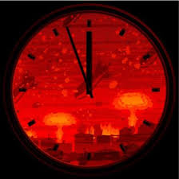
Whichever image fits it best – the alarm has gone off on the timeclock of human history – Yahuweh’s timeclock: Israel!

At present, the famous “Doomsday Clock” puts it like this:


Whether it’s 5 minutes till midnight, 4 minutes, 3 minutes, 2 minutes, or 1 minute, the Word of Yahuweh has given us many clues as to when the alarm will begin to sound--letting us know what time it is on His clock. Once the alarm begins, it will keep sounding until Messiah comes to shut it off. As the title of this prophetic news update indicates – Indeed! Elohim’s time clock has begun to sound loud and clear!
Right up front, I urge you to please listen to this 13-minute video by
a Messianic Jew, Steven Ben-Nun on Israeli News Live:
“United States Agrees to Internationalize Jerusalem”
YouTube Israel News Live by Shofar Ministries – June 8, 2015
https://www.youtube.com/watch?v=8LI2Nnt9T3Y
Here is his follow-up video:
https://www.youtube.com/watch?v=EARQOAm-zqk
These two videos will help you understand more of what I report here.

Just a few days ago, the U.S. Supreme Court made a historic decision – and it was a bad decision. From the New York Times June 8, 2015:
WASHINGTON — In an important separation-of-powers case, the Supreme Court on Monday struck down a law that would have allowed American parents of children born in Jerusalem to obtain passports saying the children were born in Israel. The president, rather than Congress, must determine national policy on the status of Jerusalem, the majority said.
…In dissent, Chief Justice Roberts said the majority had taken a bold step. “Today’s decision is a first,” he wrote. “Never before has this court accepted a president’s direct defiance of an act of Congress in the field of foreign affairs.”
Chief Justice John Roberts, along with two other justices, voted against this decision. But, we see further proof of America turning against Jerusalem, as you saw in the videos above. I remember way back in the days of President Clinton, that there was talk of internationalizing Jerusalem as a “Holy Basin.” Now, they want to the world is uniting to give Jerusalem to the Palestinians, and no Jews would be allowed there.

The 1947 U.N. Partition Plan - Wikipedia
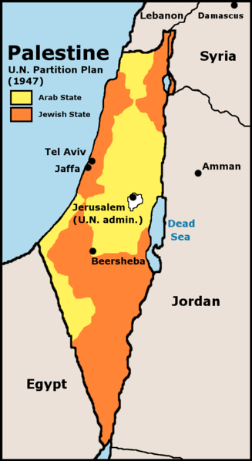
You can see from this UN map of 1947, the partitioning of Jerusalem.
Look at the land given back then to the Arab State! Look at that white
dot in the middle – Jerusalem. It is part of the Arab State – under
United Nations Administration! It was never given to the Jews for their
Capital!
But, because of the victory of the Jews in war, 1 day after the nation
was established, on May 15, 1948, and the taking of Jerusalem in 1967
by Israeli troops, the Jews have been able to “occupy” Arab land. Do
you see that Gaza was given to the Arabs in 1947, and the area near to
the Lebanese border that includes Nazareth? Even Be’ersheva in the
south is inside the Arab State. To this day, on “Nakba day” (“the day of
rage”), called by the Jews “Independence Day,” the United Nations
mourns with the Arabs that they ever gave the Jews their own state.
Jerusalem was given over to the will of the United Nations back in 1947
by Jewish Labor Zionists who were dedicated to fulfilling the
Mazzini/Pike Plan Part III. That’s what the Holocaust was created to do.
Hitler, the Nazis, and Fascism, were set in their place—financed, and
supplied with weapons and vehicles by America, England, and the
Vatican--for the purpose of carrying out Part II of the
Mazzini/Pike Plan – the Illuminati/Masonic/Jesuit Vatican plan to
“persuade” European Jews to return to their homeland, so that Part III
could happen. (Part I was the 1917 Bolshevik Revolution, and the rise
of Communism) Refer back to my last news update, “Collapsing
Inward”/May 15, 2015.
Shimon Perez is just one example of a traitor. The long list of traitors
goes back to the beginning of the State of Israel. The United Nations
and America have controlled Israel ever since its inception. Now they
are plotting to betray Israel to bring about Part III – pitting Jews
and Arabs together to begin World War III, so that out of the chaos will
come the new world order.

Matthew 24:27, 29-34: “For as the lightening comes from the east and shines to the west, so also shall the coming of the son of Adam be…And immediately after the tribulation of those days, the sun shall be darkened and the moon shall not give her light, and the stars shall fall from heaven and the powers of the heavens shall be shaken. And then the sign of the Son of Adam shall appear in the heaven, and then all the tribes of the earth shall mourn, and they shall see the Son of Adam coming on the clouds of heaven with power and much esteem. And He shall send His messengers with the loud sound of a trumpet and they shall gather together His chosen ones from one end of heaven to the other. And learn the parable of the fig tree. When its branch as already become tender and puts forth its leaves, you know that summer is near. So also, when you see all these things know that He is near – at the doors. Truly I say to you that this generation shall by no means pass away until all this takes place.”

Yahushua had just finished giving signs that we are seeing happening now. The “stars” falling from heaven, also mentioned in Revelation 6:12-17, are demonic spirits that are now entering earth at an incredle rate, some are fallen angels, some demons (disembodied spirits of the Nephilim).
The time of the blowing of trumpets is at Yom Teruah, Tishre 1 -- the 5th Festival -- also known as “the day and hour no man knows,” for its timing is set by the sighting of the new moon from Jerusalem by two or more witnesses. Notice He comes happens AFTER the time when Apollyon, Lucifer incarnate, has done his great destruction of earth—called the “tribulation?” [Refer to: “The Abomination That Lays Desolate” and “The Day of Yahuweh”] Messiah comes with the wrath of His Father (Revelation 11:15-17 at the 7th and “last trumpet,” of II Corinthians 15:51-58)
Actually, behind the word “tribulation” is the great love of our Father for us. The word comes from the Latin “tribulum,” a farm instrument that is raked over wheat to separate the chaff from the wheat. The chaff is the jacket that clings to the wheat, and without its removal the wheat is inedible, good for nothing. The tribulum cleanses His set-apart ones, and separates them from their own sins and failings that cling to them, so that their reward in eternity is great. Without the raking of the tribulum, the Kingdom would be populated by spoiled self-centered brats who don’t know what is like for their loyalty to Yahuweh to be tested and made pure. The tribulation is a gift to His true followers! So, to pull out His people to escape it -- well – that’s just not the nature of a good Father!
Sha’ul said it like this in Acts 14:27: “It is through much tribulation that we must enter the Kingdom of Elohim.” And in Philippians 1:29 Sha’ul wrote: “Because to you it has been given as a favor on behalf of Messiah, not only to believe in Him, but to suffer for His sake,…” And one more, I Peter 4:1-2: “Therefore, since Messiah suffered in the flesh, arm yourselves also with the same mind, because he who has suffered in the flesh has ceased from sin, so that he no longer lives the rest of the time in the flesh for the lusts of men, but according to the desire of Elohim.”
Above all things, know the nature, ways, and thinking of Yahuweh!
Joel 1:9 and Hosea 9:10 tell us that Israel is His fig tree. The putting forth of new leaves in Israel is around May. What happened in May of 1948? -- The historic re-birth of Israel – May 14, 1948. This is when His fig tree began to bloom. A biblical generation is 70 years (Psalm 90:10). Add 70 years to 1948! Messiah said that this generation who sees the budding of His fig tree will not pass away until He comes! That 2018 folks!
But, because the actual deal was cut by the U.N. November 29, 1947, Yom Teruah 2017, going into 2018, is most likely the ceiling.
As said above, the greatest of all the time clocks of world history is the nation of Israel, Elohim’s “fig tree.”
Within the Word of Yahuweh, the greatest time clock of all for His children is found within the Torah – in Leviticus 23.
Truly, all of human history is based on Yahuweh’s dealings with His people. The weekly Shabbat, and each one of His 7 festivals (Leviticus 23) was given to His children as a reheral for events that would bring the ultimate salvation of all of His creation. These are not the “feasts of the Jews,” these are the “feasts of Yahuweh!” (Leviticus 23:2)
All of human history has been woven around these seven festivals since the night of the Exodus from Egypt. Beginning with the first Feast, Passover, in which the shed blood of the Lamb--the perfect, blameless, innocent lamb--would atone for the sins of each person who would enter His Covenant by faith. Through faith in the Lamb of Elohim, a person become totally a new creation, in a true “new birth.” The second feast, Ha Matzot, unleavened bread, is symbolized by the “corn of wheat that falls into the ground and dies.” It represents Messiah’s burial, but also the blameless life of one who has died to self in order to rise to new life with the Lamb of Elohim, Yahushua. The third feast of First Fruits, symbolizes the resurrection of the slain Lamb of Elohim that brought everlasting life to mortal humans. The fourth feast of Shavu’ot, celebrates the giving of the instructions, our Covenant Torah, for right standing in the Kingdom of Elohim, and also the outpouring and inpouring of the Spirit of Yahuweh by Yahushua into those who have been cleansed and redeeded by the blood of the Lamb of Elohim. With His entrance into the temple of the re-born spirit, He gives gifts for our edification and that of others. He teaches, convicts, guides, and transforms us into His nature, with His thinking, so we can be His good servants as a totally “new creation.” He gives us power over sin, and authority over the demonic world. This re-born spirit within us becomes an open portal to the eternal realm of Yahuweh and Yahushua. The fifth feast of Yom Teruah, also called Ha Din (the time of trumpets and shouting, and the judgment of the wicked), represents the return of Messiah Yahushua, the Lamb of Elohim, with the wrath of Yahuweh, in power and great esteem, to set up His reign over the earth. The sixth rehersal is the solemity of Yom Kippur, the Day of Atonement, when Messiah takes the role of High Priest and declares all Israel is saved. He will also judge the nations. Then beginning 7th Festival, Sukkot (Tabernacles), Messiah enters the chupa for 8 days after He and His Bride take their nuptuals. On the 8th day, they come out of the chupa to the wedding feast, and then Messiah begins His reign over the earth.
Each of these festivals marks a progressive event in His plan for our eternal salvation. These seven festivals make up His calendar for the progression of His plans.
In Exodus 12:3, just before the first Passover, Yahuweh speaks to the whole House of Ya’cob, and to anyone else who wants to join them, saying: “This month (the month of Aviv, the month when the barley ripens) is the beginning of months FOR YOU. It is the first month of the year FOR YOU.”
The Aviv calendar is an exclusive calendar for His children to walk through the plan of salvation each year. It was not given to the world! It is the calendar for those who are in Covenant with Yahuweh! However, true to His nature, Yahuweh never trashed the creation calendar. It marks time from Creation until Yahuweh comes with His Kingdom to earth. It marks the six thousand years of man’s rule, the 7th millennium of Messiah’s Kingdom, ending with Yahuweh’s Kingdom coming in the 8th millennium, when we enter eternity. This calendar began with the re-creation of the earth and human recorded history on a Tishre 1, on a “Sunday.” This calendar is for all mankind to mark time, including His children. It is by using the Tishre calendar, that we mark the Jubilee years, every 50 years. Man was given 120 Jubilee years – 6,000 years (Genesis 6:3). So often signs in the heavens align to the timing of His festivals – like the lunar eclipses at Passover and Sukkot in 2014 and 2015, interspursed with solar eclipses at stratgic festival times. (No, it did not take Noah 120 years to build ark!) A good brother on my website list, who is also a good researcher, reasoned that the 120 years may have begun with the return of the Nephilim around 1900, to the time of Messiah’s return. This is another possibility for Genesis 6:3. From the mid-1800s to the early 1900s, great revivals swept America, England, and the world. The great missionary movement was launched. The great outpouring of the Spirit of Yahuweh was restored to mankind, first in the great Welch revival of 1904, then in America in 1906. The Spirit indeed was “striving with man.” In 2012, the Spirit, Yahuweh, began withdrawing from the earth to allow the evil ones to go ahead with their plans of destruction. He abides, or hides, in the spirit of the set-apart ones who dwell in His Presence. Yahuweh will use the evil ones to purge the earth of evil, and separate out His loyal set-apart ones.
Isaac Newton, an alchemist and occultist who was fascinated with the timing in the Bible, came up the idea that the 49 years of Daniel 9:25 could be the final 49 years from 1967, when Israel retook Jerusalem, to the coming of Messiah. It is the nature of Yahuweh to give us the end from the beginning, as in Daniel 9:24-27, the 49 being (or 7 weeks) being before the 62. Plus this Yom Kippur we enter another Jubilee year.
So, we need both calendars to understand the timing we’re in. Messiah will return on Tishre 1. He said that plainly and His disciples understood. “No man knows the day and hour” is simply a Hebrew idiom for the Feast of Trumpets – because the day and hour is set by the sighting of the new moon from Jerusalem!
In my article “Jeremiah 25”/July 18, 2015, I wrote about the 70 years for end-time Babylon (America), and how our 70 years began in 1945, as America became the world’s super power. I wrote “End-Time Babylon” in 2001 originally, with Scripures that pointed to America. I revised it in 2006. But in 2001, the teaching that America was end-time Babylon was scoffed at and mocked. Today it is the norm for watchmen to warn America as the final Babylon. It is just a historical, as well as a Scriptural, fact.
Add 70 years to 1945. Hum … Do you see anything happening in America, between Jade Helm, Russian and Chinese troops on American soil in mass, the country flooded with Muslim terrorists, weather disasters, the borders totally open to terrorists of all types, including ISIS who is in El Paso, a deal being made to help Iran build nuclear weapons, signs of famine, threat of an EMP attack, American troop movement nation-wide, the economy on the verge of collapse, America betraying Israel, and a very clearly marked communist takeover taking place?
I am so sad that most Americans don’t see what is happening, and if they do they’re not connectng the dots to get the right conclusion. Most people go on as if nothing is happening at all. The Illuminati’s mind-programming and DNA-changing chemcials added to food, water, sprayed in the air, etc., began in ernest in 1945. America has been the super power all right, under presidents who have sold themselves to demonic “aliens” to gain the ancient arcane knowledge of pre-Flood Nephilim--anti-gravity technology, technology to tap into the very secrets of creation, technology to open portals into the second heaven to return the ancient gods (Nephilim, Rephaim), technology to mix human DNA with other creatures in order to create a post-human generation (transgenics and transhumanism)--technology the Elite Illuminists hope will make them immortal, and at the same time exterminate nearly 7 billion human beings from planet earth. Enoch talks about the fallen angel Azazel, who taught men how to make weapons of war, and women how to seduce men by wearing makeup. These original fallen angels who mated with women to create the 1st set of Nephilim, known as Titans, killed themselves off. Yahuweh bound them in the deepest pit of hell, Tartaros, until the time of their emergence in our day. The leading fallen angels were Azazel and Semjaza. Well, look what happened around 1900…the explosion of vehicles to send men “to and fro,” over the face of the earth, weapons of war, cars, airplanes, and the loosening of morals. These fallen ones have, and continue to, come back to prepare the way for their leader, Lucifer/Satan/the Dragon/the Devil. The 13 Illuminati bloodline families and the nations they control are backing ways for their return, like their support of CERN.
CERN: This original acronym for their “facility” reflects the name of the god Cernernos, the horned deity. [Refer to Tom Horn and Cris Putnam’s new book On the Path of the Immortals, chapter nine, “The Secrets of the CERN Stargate.” CERN is a major player in opening portals to the second heaven, for the return of the Nephilim, the coming of the fallen angels, and “the devil”/Satan himself (Revelation 12:7-12). Their goal also, like that of Nimrod and his tower of Babel, is to open the portal to the third heaven, to destroy Yahuweh and Yahushua. Their “mascot,” the Hindu god Shiva, is known as the destroyer of worlds. His Greek equivilant is Apollo/Apollyon, also known as “the destroyer,” (“apoleia” in Greek)--II Thessalonians 2:3. Truly Psalm 2 is happening all over the world! Worldwide, people are crying to break the bands of Yahuweh off of them, and return the reign of the pre-Flood fallen ones. The Elite, behind the scenes rulers of earth, are looking to them to give them immortality.
2015 is a Shmittah year (Leviticus 25). To understand this awsome year fully, I recommend Jonathan Cahn’s The Mystery of the Shemittah. This Shmittah year ends at the sighting of the new moon for Tishre 1, and our entrance into 2016 on the Creator’s calendar.
As per Leviticus 25, on Yom Kippur 2015, we enter the 50th year after a cycle of 7 Shmittah years. The Shmittah year is the seven year of each 7-year cycle, thus 7 Shmittah years equals 49 years. The 50th is like a “super Shmittah”--a “Yobel,” or Jubilee year. This Yom Kippur we enter the Jubilee year of 2016-2017. September 23, 2015 is Yom Kippur on the rabbinic pre-set calendar, or by the Creator’s calendar, depending on when the new moon is sighted from Jerusalem for Yom Teruah.
But, it is astonishing that on September 23, 2015, the pope of Rome is supposed to have a private meeting with President Barack Obama in the White House. Anyone’s jaw dropping! The good researcher, mentioned above, put it like this--on the day (Yom Kippur), which honors past times when the High Priest would enter into the “Holy of Holies” before Yahuweh bringing blood atonement for the sins of the nation, this monstrous high priest of Rome will enter an “unholy of unholies,” where a second monstrous beast dwells who demands worship. To which he concluded—“it’s blasphemous!”
The united goal of the Illuminati--the destruction of nations, beginning with Israel and America. Remove all the distorting western-culture fluff that blinds the eyes of western people to look at things from an ancient realistic Hebrew prospective, and things look very different.
Some of the Christian watchmen dismiss the importance of Rome in the last days, saying that both Revelation 17 and 18 are talking about America. They have yet to connect the dots, but hopefully by the end of September they will. It is obvious that the woman of Revelation 17 who rides the Beast is different from the destruction of the harbor--clearly is New York Harbor, and Wall Street--in Revelation 18. It is the beast she rides that controls commerce, economics, and politics! Looking at these two chapters objectively, we see that the religious whore of chapter 17, symbolic of Roman Catholicism, and devastation of world commerce and trade 18 are speaking 1) the spirit of Lucifer through religion, and 2) an actual event – the destruction of the seaport of New York. The destruction in Revelation 18 comes upon the “hindermost of the nations” (Jeremiah 50:12) – the new kid on the block. This country even has a mother – England. The country is called “the hammer of the earth,” the superpower of the earth.” Yet, these two – the whore, and the beast she rides, though different, are totally interlocked--“echad,” a Hebrew word meaning two united as one, as in marriage.
The Revelation 17 “Mystery Babylon,” mother of harlots, is the compilation of all ancient pagan religions in the final beast-state of the Vatican. She whores against Yahuweh – whose 1st Commandment is “You shall have no other gods in My face.” Yet in chapter 17 America is mentioned in its role as the final Babylon. Revelation 18 is the destruction of the economy of America, and thus of the world’s economy, but the Vatican is there, too, because the Vatican controls world finances, trade and commerce. The woman rides a Beast to power. From its inception, the Roman Catholic Church has been the vehicle used by Roman Emperors, and then the reigning popes, to gain power over the political and economic world. The occult satanic Jesuit order of the Vatican has infiltrated all world institutions, and controls from within. Today, the woman indeed rides the power of world politics and economics/commerce to get what “she” wants – world domination!
In Revelation 17:7-18, we read that the Beast she rides has seven heads and ten horns. She’s been riding on this Beast since the days of Nimrod’s ancient Babylon, since the days not long after the end of the Flood. Her original name was Samaramis, mother/wife of Nimrod, who used her husband’s political clout to create a religion around her son, Tammuz. For details and understanding, I recommend The Foundation of Deception, my mini-book written in 2001, revised for publication on Amazon Kindle in 2014, also on my website, comeenterthemikvah.com. Use the search engine in the top right-hand corner of the main page of the website to access this study.
Revelation 17:7-11 speaks of the seven-headed beast. The ten horns are the ten economic regions by which the earth is now divided, ruled over by Lucifer’s human servants and non-human beings of the underworld.
The seven heads are the seven primary ruling civilizations of earth, each one a conqueror and ruler of the land of Israel. The characteristics of these seven have returned to earth and will unite as a whole under a world ruler using the beguiling of this “woman.” Her cup overflows with the blood of the set-apart ones. Since the days of Constantine, the Roman Catholic Church is responsible for murdering more people than those who died in all the wars of history.
The seven heads are: Assyria, Egypt, Babylon, Media-Persia, Greece, Rome (“five have fallen and one is”- at the time when Yochanan the Apostle wrote Revelation, Rome was in power – the one who “is”), and a revived Roman Empire--a Rome, whose seat of power is the Vatican, who assumes world power over all people under an “emperor”--pope--who sits as god over the nations. History tells us that the Roman Empire never died – it just hid in the papacy. But, look at the powerful nations of the west—all with the culture of Greece and Rome!
There’s your 7, but what about the 8th Beast mentioned in Revelation 17:11? “The Beast that was, and is not, is himself also the 8th.”
Refer back to Revelation 17:8: “The Beast that you saw was, and is not, and is about to come up out of the pit of the deep and go to destruction.” This is the 1st Beast of Revelation 13. Revelation 9:11; 11:7, and II Thessalonians 2:3 – this beast is the king from Tartaros--Apollyon – Nimrod, who incarnates Satan, the destroyer.
The first “Beast” of Revelation 13 is first mentioned as a system--a system of politics, economics, with a military. The ruler of this system will be a Nephilim, a hybrid mix of human and Satan’s seed, empowered by Satan—Apollyon, (Nimrod/Osiris/Apollo). He will be given “the dragon’s” power, authority, and throne! It is concluded by scholars that Gilgamesh and Nimrod are the same person. In the Gilgamesh Epic, it says that Gilgamesh was 1/3 man and 2/3 fallen angel. In April of 2003, the tomb of Gilgamesh was unearthed at the gate of Babylon. The German archeologists, overseen by American troops, found the body in good condition. It was immediately whisked away by America, along with unbelievable ancient treasures from an underground vault in the Baghdad Museum that Saddam Hussein had found while excavating Babylon.
Why did America attack Iraq? To get at 2 things: 1) the DNA of Nimrod/Gilgamesh, and 2) to get the secret technology of the tower of Babel. America got both! Rob Skiva’s excellent book Babylon Rising relates this. Tom Horn and Cris Putnam, in their new book On the Path of the Immortals, chapter 7, tells the story, including Tom’s amazing personal involvement with it, and it was discussed at length in an interview with Tom Horn and Steve Quayle on Hagmann and Hagmann, May 5, 2015. Abba told me about it December 25, 2003, from Daniel 8.
The whole new world order system is ruled by two Beasts – one who rules the political and united military might of the world, and the other one who rules by forcing the world to worship the world ruler/political Beast, and also rules the economic system of the earth.
Today’s ruler over all systems of the earth is the Vatican – especially the economic system and the religious system. All religion has its roots in Lucifer/Satan, and the teachings of Semaramis, Nimrod, and Tammuz – the most ancient religion of the Nephilim brought forth from the Flood by the descendants of Ham – Canaan, Cush, and Nimrod.
So, finally, in plain English, the 8th Beast, the final end-time Beast, is the united beast of world ruler joined with a world religious ruler – Rome and America – Rome and end-time Babylon. These two are “echad,” two in unity as one. Rome was once called “Babylon,” and America has been, and is ruled by the Vatican. They are inseparable – forming the end-time 8th beast that will “remain for a little while.”
Does this help you understand a little more about the significance of the Yom Kippur meeting of the pope and Obama on September 23rd? Don’t quote me, but at present I feel this meeting will be the uniting of the two beasts. We’ll see won’t we? The timing of the interaction of President Obama with Pope Benedict (July 10, 2009), and with Pope Francis, has been astounding. I’ve written about it, but the only other person I’ve heard of who actually saw the same things I saw from 2009 regarding this is Rob Skiba, who says the whole thing very well in Babylon Rising. (July 10, 2009 to December 21, 2012 is 42 months)
[Refer to: “America’s Secret Destiny”/January 25, 2009, which reveals the plans for the founding of America by the Luciferic Elite. It was created to reincarnate Nimrod to rule the world! In order to clone the body of Nimrod for the returning spirit of Nimrod to inhabit would require the DNA from the original body of Nimrod. They got it!
Many have asked: “What about the Ottoman Empire?” or “What about Islam?” They deduce that because it was a major empire, surely it would be listed among the 7 in Revelation 17. Yes, it was a major empire, yes. But, my reply is: So what about them? Islam was created to be a puppet – a puppet of Rome! Islam was created by the Vatican to be “sword” of the Vatican, to ultimately get what the Luciferic, Satan- worshipping pope’s and the Jesuits have always wanted--their ultimate goal – Jerusalem!
The express purpose for the creation of the Jesuit Order by the Satanist occultist Ignatius Loyola was to enthrone the pope on the Temple Mount--“for the glory of the god that sits in St. Peter’s chair,” to quote them.
[Refer to: “The Hidden Agenda Behind the Pope’s Visit”/June 2014. This is loaded with pictures that show reality]
I was in Jerusalem when the pope was there in May 2014. I know what happened. I saw things with my own eyes. I know the Muslim Wafts offered the pope a throne on the Temple Mount, in, or around, the Dome of the Rock. I know what’s going on with the pope calling the terrorist leader of Fatah, Abbas, “an angel of peace.” America pours money and weapons into Fatah, the terrorist wing of the Palestinian Authority.
Remember the words of Helel, “Lucifer” in Latin, recorded in Isaiah 14:13-14? “Let me go up to the heavens, let me raise my throne above the stars of El, and let me sit in the mount of meeting on the sides of the north, let me go up above the heights of the clouds, let me be like the Most High.”
Lucifer’s express goal is to sit enthroned on the Temple Mount, changing the Festivals of Yahuweh to those of his own worship.
Rome and Washington DC are actual sister-cities. America’s forefathers even wanted to name the capital “Rome.” The 1st century the code name for Rome was “Babylon,” as in I Peter 5:13. In the second century, (St.) Augustine called Rome, “the second Babylon.” Historically, the spirit of Babylon moved from the ancient city of Babylon in modern Iraq to Pergamum (Revelation 2:12-17), where -the seat of Satan resided in ancient times--the great altar of Zeus. The altar was removed and reconstructed in Berlin between 1878 and 1886. Hitler had a replica of this altar constructed from which to declare the “final solution”--the annihilation of the Jewish people. President Obama had a replica of this alter constructed from which he delivered his acceptance speech for the Presidency in 2008.
Washington DC is covered in statues and symbols of ancient pagan gods – primarily those of Egypt. The Capitol Building faces the largest obelisk in the world—the Washington Monument. The Vatican is a treasure trove of statues, paintings, and symbols of ancient gods – in St. Peter’s Square stands an ancient Egyptian obelisk. The obelisk, or pillar, is a phallic symbol of Ba’al, Nimrod, Osiris, Apollo/Apollyon) which stands in an occult circle opposite the dome of St, Peter’s basilica. The dome represents the womb of Isis. The whole world system is on a Luciferic foundation, but especially all religion, which has its roots in Nimrod, the sun god, Semaraimis his mother/wife, the Queen of Heaven, the “mother of God,” and Tammuz the reincarnation of Nimrod as the sun god who died and rose again. To get this whole story straight, I highly recommend the enjoyable book, complete with Jack Chick cartoon drawings, by David W. Daniels, Babylon Religion. It is also available on Amazon Kindle.
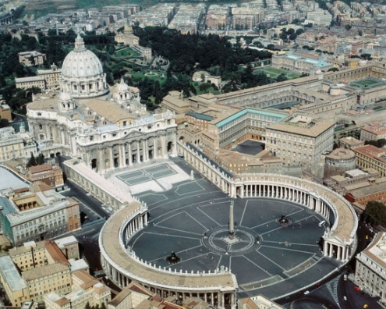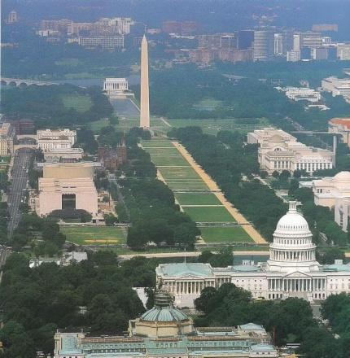
St. Peter’s Basilica Washington DC Capitol building and the
And Egyptian obelisk Washington Monument obelisk

In Tom Horn and Cris Putman’s book On the Path of the Immortals, last chapter, Tom writes that the top two leading star gates, portals to the realm of the fallen ones, are at the Vatican obelisk and the Washington Monument, along with other star gates of Osiris/Apollo.
It’s that on the Isle of Patmos, Revelation 1:9, where Yochanan received the Revelation, that the main travel bureau is named “Apollon Travel.” “Apollon,” or “Apollyon” is a common Greek rendition of “Apollo.” I got my ticket on a ship returning to Athens at this very nice travel bureau (smile).
In the floor of the Vatican Museum, below the statue of Serapis, 1st century god of Alexander, Egypt, whose worshippers were known as “Christians,” and their priests as “bishops of Christ,” is a mosaic of the women who rides the beast.
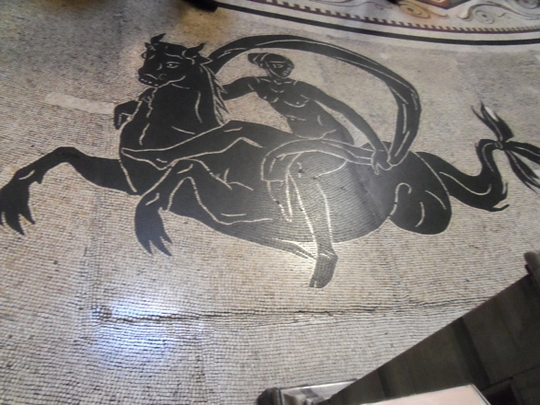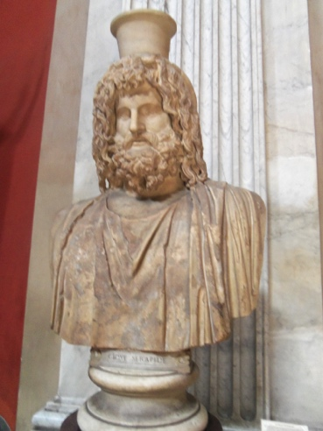
It is amazing how Serapis looks like pictures of Jesus! I have no idea, however of why that cup is on his head – maybe for donations (smile)
The very symbol of the faith of the Roman Catholic Church is symbolized in the goddess Fides, who holds up the cup as does the harlot of Revelation 17. Note the colors that this “woman” wears – Revelation 17:4 – the colors of Cardinals and Popes.
Want to know the history behind “Christ” and “Christ-ianity?” I urge you to read my mini-book The Foundation of Deception on Amazon Kindle, or from my website, comeenterthemikvah.com -- not because I wrote it, but for you to fully understand how evil the Roman Catholic Church is, and the truth about her Protestant and Muslim daughters.
The foundation of Christianity is the rejection of the Torah of Yahuweh. Find out why. I also suggest the article: “Putting the Torah in Its Proper Place”/August 26, 2014.
Today her daughters are being united together under the Vatican. Besides Christianity and Islam, the daughters include rabbinic Judaism and its Kabala, Hinduism, Buddhism, Witchcraft, and any other religion that holds Yahuweh’s creation in bondage. If you’re shocked because I included rabbinic Judaism in that mix, don’t be--just read the facts in “Exposing the Roots of Rabbinic Judaism and Its Link to Rome”/March 2009.
The “woman” is dubbed “Mystery Babylon.” She has carried forth the mysteries of the Luciferic worship that began with the Nephilim, before, and after the Flood with Nimrod. These mysteries of Lucifer include how to be a god, how to be immortal, and how to control the world, as well as the technology, the hidden secrets of Yahuweh, that they want to use to destroy Him. The joke goes that America is really controlled from Georgetown, not Washington DC. Georgetown University is a Jesuit university, and in many ways they do control America, as do the Masons from the House of the Temple, which sits above the White House as the “light” on the head of a symbolic Baphomat in the street layout.
Abba has pleaded with His people for 2,500 to flee out of this coming disaster in America. But, most of His people are too in love with the devil’s world, the satiation of their flesh, and their love of comfort, ease, and the accusation of material goods. I’m not cold-hearted. I realize that some people really cannot leave because of being physically infirmed or mentally handicapped. But, most have fallen prey to the lusts of the flesh, appealed to through the Illuminati mind-programming, so they stay in debt to creditors to pay for their unnecessary flesh-appeasing life-style. They have not taken responsibility to prepare. Some live in poverty. Some are trapped in bad marriages. Some have never known the plea of Yahuweh to flee. However, for those that know how to depend on Yahuweh, not presume on Him but depend on Him, there are very few obstacles that would keep His servants from obeying Him! I have lived below what America deems “the poverty belt,” since 1967. Yet, all my needs have been met, for my needs are simple. I am an obedient servant of Yahuweh, He has never failed me. In my obedience to Him, He has let me see things that few see, and go where few go. Whatever His servant needs, He takes care of it. I have proved Luke 18:28-30.
For the most part, the churches and the messianic congregations are not telling their people anything. Yet I keep coming back to the true new birth, the in-filling of the Spirit, and the words of the Scriptures. Luke 14:25-33, Matthew 10:34-39, Mark 8:34-38 are still active … Acts 1:8, and on and on… In the true new birth, we become servants to our new Master. Our life is not our own anymore. We die to all our own agendas, plans, and aspirations, to do His will. This is 100% opposite of the whole western culture of Greece and Rome, whose one Luciferic law is: “do as thou wilt.” Most of His people obey that law. Yes, His people, for the most part, are moral. But, forsake all to follow Him?--No! They take the position of the rich young ruler in Luke 18, when Messiah said that he should sell all that he had, give to the poor, and come and follow Him. Thus most of His people live blow His aspirations for us – and remain miserably in bondage, when they could live wonderfully free. I’ve lived in mud huts in Africa, with believers who were happier than any westerner I’ve ever know.
The pubic news media sure isn’t going you anything that would reveal solid truth. But, warnings have gone forth for several decades to flee out, and some have done so. I really encourage you to read the two novels by John Price, Second Term and Warning. They describe right now in America. John Price was in American politics and an attorney. In the novels he gives 30 clues in Scripture that end-time Babylon is indeed America. It makes me feel strange that after all the teaching I did on it for years on America is end-time Babylon, and all the mocking rebuffs I got about it, now His watchmen are using the same Scriptures, with the same understanding. I am very glad for this!
For basic Scriptures, read Jeremiah 50-51, Isaiah 13, 18, 47, Zechariah 2:7-8, and Revelation 17-18. There are 10 Scriptures that tell us to flee out of end-time Babylon. Jeremiah 50 and 51 gives details, as it is set in the context of a post 1948 nation – the super power of the earth!
Zechariah 2:7-8: “Oh Zion! Escape you who dwell with the daughter of Babel…For he who touches you touches the apple of My eye.”

In 2011, as I walked along the Old City wall down to the City of David, Zion, Abba spoke in my spirit, “You are going to the apple of My eye.”
It causes recoiling, a wince of pain, and a covering of the eyes that brings tears, if anyone touches the center of your eye. It is the most sensitive part of the visible body. The apple of His eye is that little hill across from the southern end of the temple mount – The City of David – the real Zion, flanked on the east by the Kidron Valley, on the south by the Hinnom Valley, on the west by the Tyropoeon Valley, and on the north by Solomon’s Ophel and the Temple Mount. It is a little hill, but it is the most important hill in all the world! [Refer to: “The Return of King David”]
Psalm 132:12-13: “For Yahuweh has chosen Zion. He has desired it for His dwelling. `This is my place of rest forever. Here I dwell for I have desired it.’ ”
Zechariah 2:10: “`Sing and rejoice O daughter of Zion! For behold, I am coming and shall dwell in your midst,’ declares Yahuweh.”

More key Scriptures about the return of Messiah:
Zechariah 14:1-5; Jude 1:14-15; Revelation 11:15-18; II Corinthians 15:51-58; I Thessalonians 4:13-18; Revelation 19

My story of Jerusalem June-July 2004: I wanted to return to America in June of 2004. I had just gotten back from a wonderful teaching tour in Wales. But, Abba said “No--go to Jerusalem until after the 9th of Av,” which was late July. He wanted me to spend 5 weeks in Jerusalem rather than going back for the 4th of July, for my birthday – Why? I listed 15 things that I thought might be His reason. I obeyed. I went to Jerusalem. I stayed with different people. I walked the streets of Jerusalem, I visited people I knew, I went to the Great Synagogue on King George Street, I shopped, and I pondered “why.” One day, near the end of my time there, I was going, once again, on bus 9 to the Knesset. Several days previously I had sat in on meetings of the Knesset under Prime Minister Ariel Sharon. As we made the wide turn towards the Knesset, I was just looking out the window, not thinking of anything particularly, and Abba interrupted me with a phrase from Psalm 137:5-6: “…IF I DO NOT LOVE JERUSALEM ABOVE MY CHIEF JOY.” I broke out in tears. I knew the reason why He wanted me there--He wanted me to love His city as much as He does. My chief joy was having fun in July with my children and grandchildren. His idea of joy was seeing me learn to love His city as much as He does!
Matthew 23:37-39, Yahushua speaking: “`Jerusalem, Jerusalem, killing the prophets and stoning those that are sent to her! How often I wished to gather your children together, the way a hen gathers her chicks under her wings, but you would not! See! Your house is left to you laid waste. And I say to you, `from now on you shall not see Me until you say, `Blessed is He that comes in the Name of Yahuweh.’ ”
Luke 19:31: “And when He had come near (to Jerusalem), He beheld the city and wept over it.” The word “wept” means “uncontrollable sobbing.”
Are you sobbing with Him for His city – Yerushalayim!
Psalm 122:6: “Pray for the peace of Jerusalem, let those that love you be at rest.” In praying for the city’s peace in the face of the coming disaster, you are praying for the return of Messiah! Is your heart united with His for His city?
Now, the alarm is sounding loudly from Israel to let us know what time it is on Yahuweh’s clock. Zechariah 12:1-3 is happening. Genesis 12:3 is in force against the enemies of Israel.
The five permanent members of the United Nations Security Council are
China, France, Russia, the UK, and the United States.
At this point, because President Obama and the President of France are united in preparing the petition for the Palestinian State, it looks conclusive that September will launch Lucifer’s plan forward quickly. The result will be that all Jews have to get out of Jerusalem. In the video links above, you see that the check points are all ready been built! I will take note of them when I travel on hwy I from Tel Aviv to Jerusalem this September. Possibly they will be near completion by then.
Luke 21:20-22: “And when you see Jerusalem surrounded by armies, then know that it’s laying waste is near. Then let those in Judea flee to the mountains, and let those in the midst of her go out, and let not those who are in the fields enter her. Because these are the days of vengeance, to fill all that has been written.”
Jeremiah 30:7: “Oh! For great is that day, there is none like it. And it is the time of Ya’cob’s trouble, but he shall be saved out of it.”
“Ya’cob” refers to all 13 tribes – all of His people, not just Judah!
Do the Orthodox Jews know what’s coming? Yes! Do they know where to flee – to what “mountains? Yes! Do they know how to get to those mountains? Yes! Not knowing the book of Revelation, from the Tenach itself, they know just where to go. I’ve heard it from Orthodox Jews and Karaites – Revelation 12:6, 14-17 – across the “wings of the great eagle” in the topography of the Dead Sea, down the hill from Masada, down the King’s Highway at Karak to Mount Seir, Petra--the refuge from the anti-messiah (Daniel 11:41). Petra is in Edom! I lived near there for 8 years. I saw and heard of the world’s preparation for this place of refuge, first of all as a refuge for the fleeing elite (Revelation 6:12-17).
The declaration of a Palestinian state, with Jerusalem as their capital, will kick off military force by U.N. troops, defiance by Jews, especially the Orthodox Jews, the killing of Jews, the rounding up of Jews to put them in that huge concentration camp near Tel Aviv that America built using Arab laborers, to give Jerusalem to the Palestinians, under Vatican control of course. His Word prophesied these events for over least 2,500 years. Even Moses wrote about these end-time events, quoting Ya’cob in the Torah.
By listening to the videos above, you will get real Jewish passion about what is coming.
Don’t waste your time watching the American pre-election foolishness. Don’t waste your time watching the deceiving, lying, distorted public news at all. They’re not going to tell you the real truth, only what the evil “powers that be” want you to see, and think. It is well known that both the Republican and Democrat parties work for the same Elite Luciferics, whether individuals know it or not. It is well known that the elections have always been rigged. All U.S. Presidents except Martin Van Buren belong to the infamous satanic-rooted Angevin bloodline of the Plantagenet kings (1154-1399). From 1399 to the present day, this bloodline went through these well-known English royal ruling families: The House of Lancaster, The House of York, The Tudors, The Stuarts, The House of Hanovarians, and from 1901 to today, the Houses of Saxe-Coburg-Gotha and Windsor.
From what I’m feeling and hearing, and I’m not alone in this, I do not believe there will be any election of another President in 2016. From his election I have felt like Obama is the last President.
Well trained in radical communist takeover, he has done his job well--America is under a communist siege, and its citizens are all expendable, just like Stalin, Mao Tse Tung, Pol Pot, and others, treated their citizens in their communist takeovers.
Here are three historic photographs of US Presidents with communist dictators who murdered millions of their own people. Notice the unusual handshake. It is the Masonic brotherhood handshake. Then look at the recent picture of Obama with the Raul Castro. These, and more pictures, are from Mail on Line, April 11, 2015.
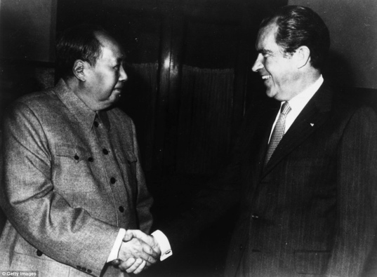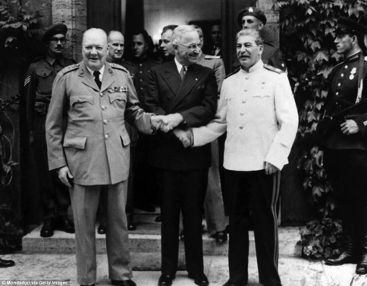

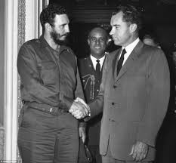
In the second picture Truman smiles at Stalin, who has his hand his pocket, while Churchill is gripping Truman’s hand in a Masonic handshake.

Attacks on Israel are about to bring about WW III, as Part III of the Mazzini/Pike Plan is set in motion, pitting Jews and Arabs together to bring in the needed chaos to establish the “new world order.”
Right now, June 2015, the IDF is having training drills for an attack from Hezbollah. Hezbollah has 100,000 rockets pointed at Israel right now. Israel knows that once America and the western powers agree to help Iran, that anything can happen to them.
The United States is working to internationalize Jerusalem. As I said above, there is a huge 25 square mile concentration camp near Tel Aviv, built by America with Arab laborers only, complete with underground facilities. The layout of the camp is identical to the FEMA camps in America waiting with their guillotines and crematories for American citizens.
Whether the “Paul” haters, Messiah rejecters, or New Testament despisers want to look at facts or not, Yahushua, Sha’ul, Kepha, Yude, Ya’cob, and Yochanan the Apostle, all prophesied things that are now happening in detail. Evidently, whether the mockers and scorners want to admit it or not, some born-again believers 2000 years ago sure did hear from Yahuweh!
My friend, Devorah, was recently in Israel. She confirmed that what Steven ben-Nun is saying about the checkpoints and the picture he showed of one being built along Hwy 1, from Tel Aviv to Jerusalem, is absolutely a reality. At these checkpoints a passport or Israeli ID will be required for anyone going into Jerusalem, because Jerusalem is about to be given to her enemies – the enemies of Yahuweh!
I will be there during the historic time of Yom Teruah through part of Sukkot. I will be right in the middle of the most dangerous area – the old city and Jewish Quarter, just a short walk to the Temple Mount. Why am I going? Re-read my above testimony from 2004: “If I do not love Jerusalem above my chief joy…” And, I am under orders from the Master.
Devorah, a dear Sephardic Jewish friend of mine, has had many prophetic dreams from Yahuweh. Recently she dreamt of a huge tornado coming towards Jerusalem, and in it a ferocious dragon was roaring. They both were stationary, but posed to attack.
Here is her dream from June 9th with my interpretation:
I was witnessing the Catholic Church in Jerusalem building a temple and the walls were being built of adobe bricks. The workers, immigrants, were given aborted babies to put inside each adobe brick! I was standing looking at a worker as he put a full term baby still alive into an adobe brick, but the adobe was also filled with wood! She says, I am still shaken over this dream. I am getting more and more revelations.
My response: Your dream shows that the lives of the innocent will be sacrificed to build this place for the Beast. Israel, per capita, has performed more abortions that any other nation. American stands at 56 million abortions since 1973, and worldwide there have been over a billion abortions. Yes, human sacrifice will be a big part of the worship of the Beast, who will sit on a throne on the Temple Mount. Adobe is red earth clay, symbolic of human beings, in this case symbolic of Israelis. The bricks for the Beast's place of worship are made from the sins of Israel!
As in Isaiah 45:20-11, the “wood” represents the pagan “cross” – the fertility symbol of the ancient evil ones, the focal symbol of Roman Catholicism.
And, tell me, what nation is the lead nation who has been setting up Israel since 2011 for its destruction, pushing for the dividing of its land, which will include the murder of His people? What President of this nation has been responsible for destabilizing the Middle East, funding and providing weapons to the destroyers of Israel? Now this President is working with the French President to throw the Jews out of Jerusalem. Do we have Ezekiel 9 in the works? Yes, we do. Who are those six that come from the “north gate?” Today, the “north gate,” is the Muslim entrance to the Temple Mount. Only Muslims can enter through it from the Arab Quarter.
Is this betrayal going to affect America? OH yes… How quickly will the backlash come? How long did it take for Katrina to build and hit the Gulf of Mexico after US troops and UN troops drug 9,000 people out of their homes in Gaza and Samaria in 2005? Something to think about, huh? That was traumatic to me. There were 15 things that made the comparison absolute between the pulling out of the Jews from Gaza and Katrina. I did on-the-spot reporting at that time, writing two articles about the “Boomerang.” It was all too real for me. In late 2004, I had been in Gaza and met with some of the same people I saw on the live Arutz Sheva broadcast being pulled from their homes.
Go on with life as usual? Go on deceived souls--your national Katrina is on its way! It won’t take Yahuweh long for the backlash to hit hard and final. Genesis 12:3: “And I will bless those that bless you, and curse those that curse you...” Yahuweh’s hand of protection has been withdrawn from America. Her destruction will come in several ways--from outside attack, to inside attack, to weather warfare, to EMP attacks, from starvation, to slaughter. It’s all in His Book! How quickly will all the final pieces fall in place once Israel is betrayed to its death? Ask Yahuweh! The intelligent align with Him in His wrath, and join with Him in His mercy for His people.
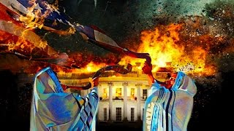
Photo taken from the YouTube presentation/interview of John Price and Steve Quayle on Hagmann and Hagmann May 28, 2015
I write with His shalom, and His love for His people,
Yedidah, June 13, 2015

