EXPLAINING THE 666: KABBALAH’S GEMATRIA and ITS
OBSESSION WITH the SIXTH HEBREW LETTER

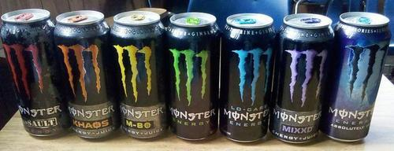
Monster Energy Drinks are symbolized by what appears to be three of the Hebrew letter “V” (Vau). Monster’s tag line is: “Unleashing the Beast”
An article from Loudwire says in response to a lady claiming that Monster Energy Drinks were Satanic: “However, it turns out that 666 in Hebrew isn’t written as “Vav vav vav” (Six, six, six), but rather “Tav resh samech vav” (six hundred threescore and sixty-six).”
Kaballah honors the 6 to an extreme. In fact, as Deanne Loper’s book Kabbalah Secrets Christians Need to Know points out, Kabbalist Talmudic Rabbis are obsessed with three 6s, the 6th Hebrew letter, which is the vav or vau.
Yet, in ancient Hebrew before the Babylonian captivity there was no “V.” The sixth letter was a Waw or Wau. Thus the name of King David was not pronounced Dah-veed, but pronounced Dah-weed (Dawid). After Babylon captivity the shape of letters in the Hebrew alphabet were changed considerably, and changed again after 70 CE.
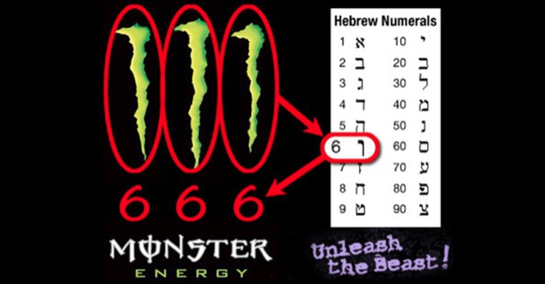
The article from Loudwire goes on to say: “Monster didn’t create their own brand. It was actually conceived by design firm McLean, who teamed up with a company called Hansen’s Natural, which had been selling fresh fruit juice since the '30s and natural soda since the ‘70s. So could a devious graphic designer at McLean have come up with the 666 concept for Monster? It’s possible, but McLean isn’t just some shoddy warehouse filled with metalheads. They’ve developed the branding for Pabst Blue Ribbon Light, Kingsford charcoal, Sunsweet Prunes, Havoline Motor Oil, Fresh Step Kitty Litter and much more. Satanic trolling, or just coincidence? The choice is yours to make.”
What this author might not understand is that certain secret symbols, kept secret from the public that is, only for an Elite group to know, carrying secret messages to those that understand the symbols, hiding the symbols in unusual ways from the unsuspecting public. This is how secret societies communicate – by hand gestures, handshakes, and symbols. Freemasonry, for example, is obsessed with its symbols, which are mainly only understood by the 33rd degree and beyond.
The enemy can only counterfeit, not create. Yahuwah has His secrets too that He only communicates to those He knows and trusts--His children who have proved themselves faithful! (Daniel 2; Amos 3:7)
From the website Canton Truth, 2008: “The Masonic Shriners wear a red hat known as a Fez named after a town in Morocco, where in 980 AD, 50,000 Christians, including women and children, were brutally murdered by the Muslims. As the streets ran red with the Christians’ blood from the massacre, the Muslims dipped their hats in that blood as a testimony to Allah. The red Fez symbolizes the slaughter of Christians in that town. The Shriners still wear the red Fez adorned with the Islamic crescent symbol. Among the oaths of the Masonic Shriner organization is one that says, `...and may Allah the God of Arab, Muslim, and Mohammedan, the God of our fathers support me to the entire fulfillment of the same. Amen, Amen, Amen.’ The fez derives its name from the place where it first was manufactured commercially, the city of Fez, in Morocco. Some say, the red color is to memorialize the color of blood, and the Muslim victories over Christians.”
Wikipedia: “Shriners International, also commonly known as The Shriners or formerly known as the Ancient Arabic Order of the Nobles of the Mystic Shrine (AAONMS, anagram for A MASON), is a society established in 1870.”
They build hospitals, and are known for their charity. Their origin is not known by most people. But look at that sword in their logo! Does anyone question that?
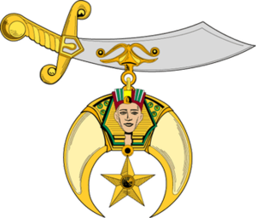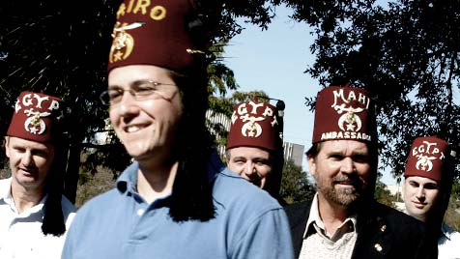
Shriner Logo
From Canton Truth: “The Shriner is given a red fez with an Islamic sword and crescent jewel on the front of it. This sword emblem originates from 7th century Arabia when the Moslems, under the leadership of Muhammad (aka: Mohammed), slaughtered all Christians and Jews who would not bow down to the pagan moon god Allah. It is a symbol of subjugation. The Shriners and their Fez have a link to and allegiance to the pagan moon god, the crescent emblem of Allah.”
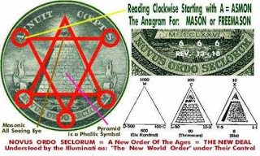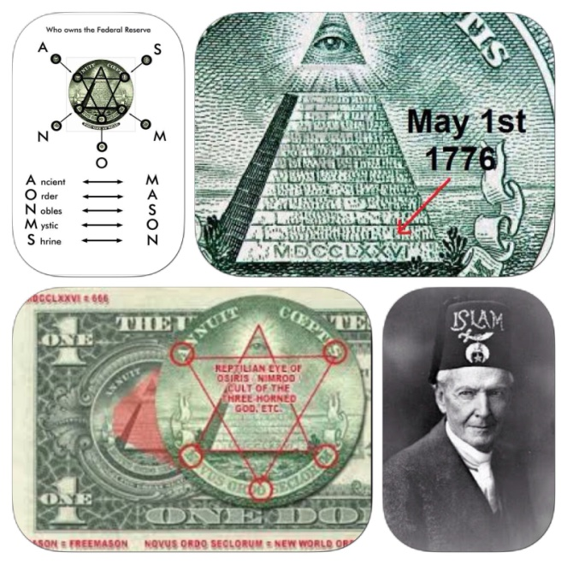
It is amazing how many sneaky 3s are in logos. Look sideways at the Golden Arches for McDonalds – it’s a sideways 3. The three is a treasured secret number of the Freemasons, as is 11 and multiples of 11, especially 33.
The Great Seal of the United States on the back of the $1.00 bill, shown above, holds loads of secrets. I recommend Chris Pinto’s DVD “Eye of the Phoenix.” Used copies are available inexpensively on Amazon.
The logo of Apple computers is known to represent the “apple” that Eve ate in the Garden of Eden, causing her to sin. Not long ago, it was been proven that Apple inventors and founders are indeed participators in Satanism, but so are the founders and leaders of many, many companies and corporations. Then there are companies like Kraft, Nestle, Pepsi and others, who use aborted baby parts in their products, listed as “natural flavoring.”
Symbols of secret and world-powerful societies like the Freemasons, Jesuits, Illuminati, Kabbalah, and Theosophy, abound in great numbers.
Deanne Loper explains the obsession of Kabbalist Rabbis with the Hebrew letter “vau,” and its multiple 666, in her book Kabbalah Secrets Christians Need to Know, chapter 8, pages 95-114.
“The real secret of every secret religion or secret society is that there is an exterior level of worship for the people of the group and a concealed level for the initiated members of the same group.”
Most Freemason’s haven’t a clue as to the deep secret until reaching the 33rd degree. After the 32nd degree, they have to be invited by their hierarchy to proceed to the 33rd based on trust of the ability of the initiate to keep the secrets.
Loper writes: “In Kabbalah, the entire cosmological order, from creation to the final redemption, is based primarily on the number six. Concealed in the writings of the Zohar are a myriad of numeric equations which must be ciphered and decoded using Gematria. The system is based on Chaldean alphabet of Babylon…There are endless methods of arranging letters, all for the purpose of confusing the uninitiated; just as Babel and Babylon mean `confusion through mingling.’ ”
On-line dictionary meaning of Gematria: “a Kabbalistic method of interpreting the Hebrew Scriptures by computing the numerical value of words, based on those of their constituent letters.”
By this ritualistic process, one leaves the Truth of the Word to descend into captivity to the gods of Kabbalah and Gematria--fallen angels and demons.
“There are no separate numeral characters in Hebrew and Chaldee…every word is a number and every number is a word, and on this correspondence between words and numbers, the `science’ of Gematria (the first division of the so-called literal Kabbalah), is based.”
“…in unwritten Kabbalah there are secrets that have never been committed to writing, but passed down orally, especially the secret of the `divine name’ – YHWH – which is a most secret Arcanum, and is a secret of secrets.”

Revelation 13:18: “Here is wisdom. Let him that has understanding count the number of the beast: for it is the number of a man; and his number is six hundred threescore and six.”
Revelation 14:9-13: “And the third angel followed them, saying with a loud voice `If anyone worships the beast and his image, and receives his mark upon his forehead or upon his hand, he also shall drink of the wine of the wrath of Elohim, which is poured out undiluted into the cup of His wrath. Ad he shall be tormented with fire and sulfur before the set-apart angels and before the Lamb. And the smoke of their torture goes up forever and ever. And they do not rest day or night, those worshipping the beast and his image, also if anyone receives the mark of his name. Here is the endurance of the set-apart ones, here are those guarding the commands of Elohim and the faith of Yahushua. And I heard a voice out of heaven saying to me, `Write, Bless are the dead who die in the Master from now on. Yea, says the Spirit in order that they rest from their labors and their works follow with them.’ ” (Read about the glorious martyrs in Revelation 7:9-17)

I’m going to skip over most of the entangling Kabbalah insanity. To those who embrace it, yielding their mind and will to it, however, it is very exciting because it includes tapping into the supernatural astro-plane of the kingdom of darkness. By rituals and chanting, and other means, the spirits of the dark kingdom take over the minds of those seeking “enlightenment” through secrets mysticism, and gods that encourage sin. They have real experiences with fallen angel.
The Kabbalists climb a salvation tree--the “Sephirot tree,” by doing certain actions, like the passing of the degrees in Freemasonry. Loper tells what Kabbalists believe: “There are 10 degrees of the Sephirot tree which is also known as the tree of life. The Sephirot tree represents the heavenly man or primordial being, the archetypal man, Adam Kadmon, the `Protogonos.’ Adam Kadmon is the creator of the earthly Adam. This god-man image of the heavenly Adam Kadmon is also known as the Divine Presence, which manifests or reflects itself in all the spiritual dimensions of the Sepfirot tree through the divine name YHVH, the Tetragammatron…thus this god has a value of the number `six’ which according to the Zohar is the number of Adam Kadman.”
“In Kabbalah the Tetragammaton is regarded as the `divine name’ and is composed of the four Hebrew letters yod, He (pronounced heh), Vau, and He. Written vertically, the Hebrew letters take the form of the Sefirot tree in the image of a man representing the heavenly Adam Kadman. The letter V (Vau) has the numerical value of 6, which corresponds to the six sepharah which form the six-sided cube or hexagon of Micoprosopus. The final H (He) represents Malkut, the Bride of Microprosopus, which is Metatron, the god of this world posing as the Logos…the bride of Metatron is collective Israel in the kingdom of Malkuth, the kingdom of god on earth. The bride – mankind – is perfected in the image of the Tetragramaton through knowledge and ascension of the six-sided cube, the V or Vau, whose number is six.”
You understand all that don’t you? Metatron is the name of their messiah.
Take a deep breath. Stretch your arms upward and praise Abba!
Judaism’s Orthodox and Hasidic rabbis say that their religion is exclusively monotheistic, and that unless we are monotheistic, we should be beheaded. To say that God has a Son is punishable by beheading under the Noahide Laws, for that is “polytheism,” they say. They are anything but monotheistic! Kabbalah is polytheistic to the core! Rabbinic Judaism is based on the Babylonian Talmud and the Kabbalah of the Zohar, not on the Bible!
Kabbalah has many gods and goddesses like the goddess Shekina for example, who is said to be the consort of the chief god Ein Sof. They continually have sex Kabbalah says. Shekina is said to be the “holy spirit,” the voice of God. She is presented as the “glory,” the “radiance,” of God.
If you recognize that terminology, you know she is no more than a disguised Semaramis, Nimrod’s mother-wife of Babylon, who is symbolized by the dove – as the “holy spirit.” Nimrod the sun god, Semaramis the “mother of god,” the mother of the son, Tammuz, conceived by the rays of the dead sun god Nimrod. She is also known as the Queen of heaven. This is where the doctrine of the trinity came from, and where Mary got so exalted in the Catholic Church.
Loper says “Revelation 13:17 reveals that there are three elements to the mark of the beast: the mark, the name, and the number. All of thee aspects can be seen in the occult Kabbalistic interpretation of the Bible, codified by the mystic sages to symbolize man’s oneness with IHVH or YHVH. Revelation 13:14-15 and 14:9, 11, both speak about the image of the beast. In Kabbalah, the sephirotic god-man imagine is represented by Adam Kadmon, who is turn reflects his divine nature through man in the lesser world.”
“Jehovah through thirty-two Paths, engraved his name using the three forms of expression called Letters, Numbers, and Sounds.” (The Sepher Yetzirah)
“The Sepher Yetzirah goes on the say `From the simple letters three were chosen and sealed so that they may be formed into a Magnificent Name, IHV. With this name was the universe sealed in six directions by Him.’ ”
Loper writes “The Sefer Yetsirah explains that Ein Sof created the cosmos in the image and form of the primordial Adam Kadman by numbers, sounds, and through the twenty-two letters divided into three groups. These are aleph-A, Mem-M, Shin-Sh and are the elements of air, water and fire, the primal substance or prima material of the universe. From the elements fire, water and air were formed the head, abdomen, and breast of Adam Kadmon, sealed and fashioned in the Tetragrammaton name IHVH.”
Pages 112-114: “The Zohar interprets the first verse of Genesis as `with beginning (Ein Sof) created God.’ which is also translated by the rabbis of Kabbalah to read “He created six.” Do you see that anywhere in the Word?
Loper: “This explains how the initiates of Theosophy like Alice Bailey and Helena Blavatsky, or the Grand Masters of Freemasonry like Pike and Hall, or the priests of Kabbalah throughout history, could believe and teach that Lucifer is the hero and the god of Genesis because of his gift of illuminating mankind.
Referring to the book by Manly P. Hall, The Secret Teachings of All Ages, he states that Microprosphus – the lesser Adam – is Elohim.
Loper writes, “Manly P. Hall was no novice. Hall disclosed that `In the Kabbalah it is declared that the yod is in reality three Yods, or which the first is the beginning, the second is the center and the third is the end.’ In other words, the yod in the IHVH Tetragammaton actually represents three yods. Using a simple Hebrew letter chart deducing the following,…the sum is 646. By adding in two additional Yod, 10 + 10 + 646 equals 666=the mystical number of the name.”
Now what do you think of that manipulation of math? Ibuprofin anyone?
Loper: “The Zohar alludes to Genesis 1:1 as containing the secret of secrets and the supernal mystery of the divine name which spans the universe through engravings of the number six. According to Kabbalah everything in creation from beginning to end is sealed with the V, the Vau, which is the six.”
Loper writes her correct opinion: “It will be further shown that the sage mystics, in step with their god Lucifer, have gone to great lengths to manipulate the Word of God by imposing the numbers 6 and 666 into the Scriptures through the sorcery of Kabbalah.”
“…rabbinic sages…see the science of Kabbalah and the magical power of Hebrew letters to effect necessary harbinger and forerunner of the sixth millennium that will precede the coming of the Mochiach. As disciples of Jesus Christ, we must be able to differentiate between the true Biblical interpretation of Scripture and the Gnostic exploitation of God’s Word as mystically translated by the Kabbalists.”
So you see that the “mark” of the Beast-man has to do with identification with Kabbalah, the Babylonian Talmud, Noahide Laws, and total submission to Rabbis-- all steeped in Satanism.
The “number of his name” is Gematria. Today, many Christians and Messianics are enthralled with Gematria, some to the point where its knowledge is a lustful craving. Thinking they are studying the deep meanings of the Hebrew words of the Bible, they are being drawn into the midst of a spider web. What they do not know is that hidden behind their excitement are demonic spirits enticing them away from Yahushua. They get so excited with Hebrew words, rituals, traditions, and mannerisms, new philosophies along with new friends, that Yahushua becomes dull to them.
When the dullness begins to take place, the person is well on their way to being taken over by Nephilim/demons and enticed into damnation. Beware of losing your “first love” and Yahuwah extinguish your light. (Revelation 2:2-6) Guard your salvation!
The deception is well hidden and the naïve are falling into it by the tens of thousands. Years ago, I was in a small Friday night Messianic gathering in Texas. We were going over the Torah portion with friends in a lively discussion. The meeting was led by a young man that we all liked. He said he was a believer in Yeshua. After we discussed the Torah portion, he proceeded to hand out printed papers telling us how to find secret meanings in word in the Bible by Gamatria. He didn’t hide the word “Gematria” like some well-known Messianic teachers do. I was horrified and came, as we Americans say “unglued,”—with righteous indignation.
All I knew was that Gematria was evil. I shut down the meeting.
I can’t sit still when people I like are being deceived by the wiles of the devil, the young in faith turned from the truth to lies. The lust for knowledge, the lust to know the secrets buried in things like the Hebrew words and numbers is a demonic trick on the mind. People who buy into it are used to being led around by the nose by deceived teachers they trust. Yet in the true new birth, we have the privilege of receiving the Spirit of Yahuwah into our spirit, who, as Messiah told us, is our Teacher of Truth. There is lust for secret knowledge, but no desire to know Yahuwah and Yahushua. That is so strange, except for the fact that the craving to know secrets not of Abba is demonic trickery – entertainment for the flesh.
If we have Shaddai as our Teacher, when we hear nonsense like I’ve quoted above, our spirit will go into STOP IT mode. We’ll become like my cousin Patrick Henry boldly proclaimed: “Give me liberty or give me death.”
I am, as you are, responsible to stand for the Truth, so that if we hear what may be damning to those around us, we can’t keep quiet. We’d just better know what we’re talking about before we speak up. Going by emotions without their being grounded in the Word and in solid facts makes a fool of people.
Once that ID mark is taken, a person loses their connection through their eternal spirit to Yahuwah. There is no repentance for denying Messiah. The Noahide Laws say that to believe in Messiah Yahushua/Yeshua/Jesus is punishable by death by beheading. Be sure you’ve read the previous 16 articles. The last one is about who probably will be in conscripted into judging and executing for the Sanhedrin.
Being filled with the Spirit gives us boldness against sin, first in our own lives, and then to rescue others with wisdom and love. We must always remain in His love and peace.
Oh yea, this article will be posted under the Mikvah of Israel, Our Eternal Inheritance as #66.0. I promise you, I did NOT manipulate anything to make this article about the 666, the 66th article under that Mikvah. I was shocked when I saw that.
Now go listen to James Block music, and read Psalm 96, 97, 98, and 99. “Come Yahushua Come!” Dance, praise, sing, and shout HalleluYah!
Shalom dear brothers and sisters, in His love,
Yedidah
July 16, 2019

