IS THIS THE ‘COVENENT WITH MANY?’
THE TRUMP-KUSHNER ISRAEL-PALESTINIAN PEACE PLAN IS
PLOWING ITS WAY TOWARD VICTORY

At midnight July 16th going into the 17th by the Gregorian calendar, there was a
partial blood moon over Jerusalem. Is this symbolic of something that is in process regarding Jerusalem right now?

Daniel 9:24-27: “The Arch-angel Gabriel gave this prophecy to the Prophet Daniel in Babylon: “Seventy weeks are decreed for your people and for your set-apart city, to put an end to the transgression, and to seal up sins, and to cover crookedness, and to bring in everlasting righteousness, and to seal up vision and prophet, and to anoint the Most Set-apart. Know, then, and understand: from the going forth of the command to restore and build Yerushalayim until Messiah the Prince is seven weeks and sixty-two weeks. It shall be built again, with streets and a trench, but in times of affliction. And after the sixty-two weeks Messiah shall be cut off and have naught. And the people of a coming prince shall destroy the city and the set-apart place. And the end of it is with a flood. And wastes are decreed, and fighting until the end. And he shall confirm a covenant with many for one week. And in the middle of the week he shall put an end to slaughtering and meal offering. And on the wing of abominations he shall lay waste, even until the complete end and that which is decreed is poured out on the one who lays waste.”

From Matthew 24:11-25, Messiah speaking: “`And many false prophets shall rise up and lead many astray. And because of the increase in lawlessness, the love of many shall become cold. But he who shall have endured to the end shall be saved. And this Good News of the reign shall be proclaimed in all the world as a witness to all the nations, and then the end shall come. So when you see the abomination that lays waste, spoken of by Dani’ĕl the prophet, set up in the set-apart place – he who reads, let him understand. Then let those who are in Yehuḏah flee to the mountains…for then there shall be great distress, such as has not been since the beginning of the world until this time, no, nor ever shall be. And if those days were not shortened, no flesh would be saved, but for the sake of the chosen ones those days shall be shortened. If anyone then says to you, ‘Look, here is the Messiah!’ or ‘There!’ do not believe. For false messiahs and false prophets shall arise, and they shall show great signs and wonders, so as to lead astray, if possible, even the chosen ones. See, I have forewarned you.’ ”

Matthew 15:24, Messiah speaking: “I was not sent except to the lost sheep of the House of Israel.” (Ezekiel 34:6, 11-16; 33:11)

Matthew 10:5-6: “Yahushua sent these twelve out, having commanded them, saying, `Do not go the way of gentiles, and do not enter the city of the Samaritans, but rather go to the lost sheep of the House of Israel.’ ”

The prophecy of Daniel 9:24-27 has been interpreted falsely by those who have no understanding of Hebrew language or grammar, or of the cultural background of ancient Israel or Babylon. They’ve listened to ignorant, or deceived teachers, as well as their own head-reasoning, and passed down lies, deceptions, and spurious theology to support doctrines that don’t even exist in the Bible at all. For example, there is no 7-year tribulation mentioned anywhere in the Word.
Actually, the prophecy from Daniel 9:24-27, spoken to Daniel by the Archangel Gabriel, speaks more about Messiah than an “anti-messiah.” Yet, ambassadors of Satan have counterfeited this prophecy and conjured up ideas around the counterfeit to the point where Christians and Messianic believers are basing much of their Eschatology on a lie, unsupported by the Word of Yahuwah.
Messiah was “cut off” for us by His death on the stake. Daniel 9:24-27 speaks of Messiah as being “cut off.” That expression is a covenant expression, meaning to seal the covenant by cutting flesh and passing around the cooked pieces for all participants to eat.
It was Yahushua who renewed the existing “Covenant with many”--the Covenant of His Father, made with the House of Judah and the House of Israel, all of the tribes of Ya’cob/Jacob. Jeremiah 31:31 prophesied that Messiah will renew the Covenant with the House of Judah and the House of Ephraim. He did by His death and resurrection. He came for the purpose of Ezekiel 37:15-28.
Today in Israel, as the Sanhedrin gains in power, even over the Israeli government, the Orthodox and Hasidic (Ultra Orthodox) Rabbis have made it plain that only those with provable Jewish lineage from their mother’s side can be citizens. They control Israeli immigration law. In a recent article by Kimberly Rodgers-Brown, she gave this statement: “`Jewish doctrine says Ephraim will never be allowed to return,’ according to one friend who heard these words from the mouth of Rivkah Lambert Adler, a supporter, or possibly member, of the rising Jewish conversion ring.” Talmudic Jews are very open about not wanting any of the House of Israel (10 northern tribes) as citizens of the state of Israel. Thus, it’s most likely gone from personal rabbinic opinion to rabbinic doctrine to rabbinic law.
The Hebrew word for “covenant” in Daniel 9:27 denotes an “already existing covenant.” In other words, the Covenant of Sinai--the Covenant of Torah! Messiah’s death restored us to His Father’s Covenant. He restored the covenant with “many” who would trust Him for salvation.
The enemy is preparing to do some counterfeiting of Daniel’s 70 week prophecy. Daniel 9:24-27 is talking mostly about Messiah, not anti-messiah. Notice that in Matthew 24:15, Messiah does not talk about the stopping of sacrifices because He would do that. Stopping of sacrifices in the middle of the week is not a prophecy about anti-messiah. He may counterfeit it however.
Today Fundamental Christian Eschatology of Evangelicals, in general, teaches that Daniel 9:24-27 is talking almost exclusively about antichrist. Hebrew grammar and wording shows that it is talking almost exclusively about Messiah.
By interpreting it as speaking of anti-messiah, it has the forerunners of anti-messiah doing things that counterfeit what Messiah would do—thus hiding the true meaning of Daniel’s prophecy. Because of this deception, many believers are putting money into things that will bring the antichrist to power.
In Matthew 15:24, 10:5-6: Messiah said He only came for the “lost sheep of the house of Israel,” also known as the House of Joseph, House of Ephraim. He told His disciples to only go to “the lost sheep of the house of Israel.”
The House of Israel is also known as the House of Ephraim or the House of Joseph. The son of Joseph, Ephraim, (Genesis 48 and I Chronicles 5:1-2) became the birthright holder for all the tribes of Ya’cob. But, because of extreme idolatry, Messiah had to break the Covenant with them and scatter those of the ten northern tribes into all nations AMONG THE GENTILES. There is not one verse in the entire Bible where He calls His people “gentiles.” He tells that He will destroy all “gentiles.” He promises to return His people from “AMONG the gentiles.”
The ten northern tribes that were exiled into the nations (723-722 BCE) lost their connection to the Father’s good Covenant teachings of the Kingdom – the Torah. After the death of Solomon, the two Houses of Judah and Ephraim separated. The House of Judah stayed in the south, around Judea, Jerusalem. The House of Ephraim went into Samaria, north of Jerusalem all the way to Mount Hermon. In the Kingdom to come, Ezekiel 47 tells us of the new inheritance appointments for each of the tribes of Ya’cob.
In the nations, the House of Ephraim turned to teachers who gave them part truth and part error. This is why we must study the Word with the Spirit of Yahuwah within us, so that He, as our only Teacher of absolute Truth, can lead us into all Truth. All Spirit-taught children of Yahuwah are in unity. Hosea chapters 1-3 speak of Ephraim in the nations, and of restoration.
No one in Messiah is a gentile! The word “gentile,” refers to one of the nations as a barbarian, pagan, heathen, a stranger, foreigner, alien to the Covenant of Yahuwah. [Refer to: “Are You a Gentile? and “Who Are the Ten?”/Mikvah of the Heart of Elohim]
Many, many prophecies are related to the restoration of the whole House of Ya’cob – all 13 tribes. Please go over the Scriptures in “Aliyah Scriptures,”/Mikvah of the Heart of Elohim to see the promises of the restoration of the two houses, especially Ezekiel 37:15-28. Messiah will unite the whole House of Ya’cob back together again as it was under King David.
Messiah renewed the Covenant of His Father for us during the week between “Palm Sunday,” and “Resurrection Day,” through His death on the stake as the Lamb of Elohim just before sunset of Passover eve, taking away the sin of the world, and His rising from the dead on the first day of the week, just after sunset Shabbat night. Remember, Abba’s days begin at sunset!
Messiah Yahushua renewed the Covenant with the House of Israel above all, whom He was forced to divorce and scatter into all nations because of their sin. After leaving Assyria, they went West, settling mostly in Europe, the U.K., Canada, and America. After 70 CE when He had to scatter Judah, they went into many nations, mostly all to the West, as did the House of Israel, and into Mexico, Central and South America. The greatest compilation of the whole House of Ya’cob – all 13 tribes – is in America.
Because of His love and faithfulness to redeem the House of Ephraim in particular, He had to die to break the Engagement Covenant with the ten tribes cut at Sinai with all the tribes. He rose from the dead, thus being able to marry a remnant of the whole House of Ya’cob. We are all in one of the tribes, whether biologically, or grafted in. That’s very clear in Scripture.
Do you remember in Matthew 1:18-25, Yosef was engaged to Miriam? But, when he found out that she was pregnant, he decided to “divorce her,” or nullify the Engagement Covenant. But, he had dream from Abba, and told to go ahead and marry her, for her baby was from the Ruach ha Kodesh.
In the prophecy of Daniel 9, given by Gabriel the Archangel, 490 years were prophesied for His people. From that time, after 483 years Messiah died on the stake and rose again – He was “cut off.” The last 7 years of the prophecy is known as “Daniel’s 70th Week.” It is called the “time of Ya’cob’s/Jacob’s troubles.”
It does not say in Jeremiah 31 “Judah’s troubles.” This prophecy refers also to tribulation over all the earth, the suffering of all the tribes, and all believers in Messiah. It is the time when the forces of anti-messiah want to eliminate all of Yahuwah’s people from the earth. I believe, as do a lot of other watchmen, that we are inside Daniel’s 70th week. We’ll see! My belief is based on study of His Word with the Spirit, for many decades. I do not set dates, but it is obvious that all 223 prophecies of the entire Word regarding His second coming are coming to pass very rapidly, and another indication is the way He is dealing with His remnant. Please refer to: “The Greatest Fear of Satan Has Begun to Grip Him”/Mikvah of Set-Apartness [Podcast CXI, April 11, 2019].
The prophecy says that in the middle of the week, “he” will put an end to the animal sacrificial offerings. Messiah did that when He died on the stake on Wednesday. But the anti-messiah is going to counterfeit that entering into the “third temple” and stopping sacrifices. Then he’ll set up “abomination that lays desolate.” In Matthew 24:15, Messiah does not mention the anti-messiah stopping the sacrifices because He would stop the sacrifices!
Yes, the third temple will be built. Many nations, like America, are pledged to help the Sanhedrin build the temple. The Sanhedrin awaits their messiah – the Kabbalist messiah, Metatron, Leviathan, the Holy Serpent, the Nachash of the Garden, a blood-thirsty god-man of war who will destroy all who oppose the Babylonian Talmudic Rabbis. We know him as “antichrist,” anti-messiah, the Beast of Daniel 7 and Revelation 13.
The counterfeit of the renewed Covenant of Messiah will be a “covenant with many,” a covenant put together by anti-messiah that will draw many nations into helping to bring it to pass, supporting it will large sums of money, and standing with it as a “peace plan” for Israel. The counterfeit covenant just might be soon preparing to be accepted, launched, and made into law.
Look at the timing of Matthew 24! Who does Yahushua tell to flee when the antichrist takes his throne on the Temple Mount? He tells the people of Yahuwah, His people, the born-again, His chosen, His elect, to flee. Ephesians 1:1-3; I Peter 1:1-5, 2:9: The ones whose names were written in the Lamb’s Book of Life before the foundation of the world are the chosen ones. There is no other “chosen race” on the face of the earth!
Human kind has been divided into basic three races – Mongoloid, Negroid, and Caucasian. Earth was divided into families by the three sons of Noah – Shem, Ham, and Japeth. The descendants of Shem (Sem – i.e. Semite) through Abraham, Yitzak, and Ya’cob were chosen by Yahuwah through which to bring His Son. It is in His Son that we become sons of the living God/Yahuwah.
There was no “race” created by any of the sons of Jacob/Ya’cob. Abraham came from what is now north Iraq. He was a “gentile.” There was no such thing as a race of righteous Jews verses beastly gentiles. Noah lived until Ya’cob was a teenager. Abraham was trained in knowing Yahuwah and obeying Shaddai by Noah! When Abraham heard the voice of Yahuwah in Genesis 12, he knew who was taking to him! Notice how quickly he obeyed. He did not have to ask “who are You?” He knew to obey, as Noah obeyed Him!!!
There was no such thing as “gentiles” being created lower than exalted “Jews.” That’s rabbinic wickedness. There is no such thing as a “Jewish race,” and neither was Abraham a Jew! That’s pure foolishness. The twelve sons of Ya’cob did not create twelve races of humanity! The 12 family groups/tribes of Ya’cob did not become “Jews.” The word “Jew” is not in the original languages of the Bible. It’s a translation thing, especially in English, that has twisted the thinking of His people.
The tribe of Judah, son of Ya’cob, became the scepter holder for all the tribes, the ruling tribe. Ephraim, son of Joseph, grandson of Ya’cob, became the birthright holder for all the tribes. Those of the tribe of Judah were called “Yehudah.” They lived in Judea. 95% of all Ashkenazi Jews and a lot of Sephardic Jews, too, have been DNA tested back to the Khazar Empire of the Caucasus Mountains of the 8th century. They are imposters bent on world rule. They are usurpers of His Land.
Read ““Shocking Revelation! DNA Reality! `Harmless Noahide Laws,’ the Great Deception, Trump, Kushner, and the Mark of the Beast”/Mikvah of Israel, Our Eternal Inheritance. Do not be deceived. Seventeen articles now exposing these things, and each one is loaded with information you must know and share.
In Revelation 2:9 and 3:9: Messiah spoke to Yochanan the Apostle (John) and gave him warnings to the seven assemblies of Asia that correspond to the assemblies of today’s Christians and Messianics. He warned that there would arise a people who would claim to be “Jews” of the tribe of Judah. He said “…but they are not, but are of the synagogue of Satan.”
Messiah spoke of the Khazar Zionists and rabbis who are working through all nations to bring the one world government under anti-messiah. By their own writings they expose it. Be sure to read ““Quotes That Forever Destroy Damming Illusions”/Mikvah of Israel, Our Eternal Inheritance.
Before being called “My people,” they were just tribes of Ya’cob’s lineage. But, He united all 13 tribes as His people. They were of biological lineage from Shem (“Sem”/”Semitic”) through Abraham, Yitzak, and Yacob. He united them also as His eternal people, as a united people under His Covenant, as His spiritual children. If you are in Messiah, you are a “chosen” member of Yahuwah’s family!
He calls us a “chosen race,” a “royal priesthood.” These are spiritual endowments. Wow have man-taught Christians and Messianic been brain washed into believing dangerous deceptions and lies! However, if each one of His children seek Truth through the Word, taught to their spirit by His Spirit, they would not be deceived.
Acts 17:26, all human beings have the same blood. We are only “chosen” because we have chosen Him who first chose us before the foundation of the world. No one in Messiah is a gentile! Gentiles are those who are outside of Messiah.
His children are those with a nature like His, who are being transformed daily into His image and likeness from “glory to glory” by the Spirit (II Corinthians 3:17-18) His children obey their Daddy/Abba. His children interact with Him, and with His “only begotten Son.” He has adopted us as His children, but He only has One “begotten” Son. Know who you are! His children know Yahuwah and Yahushua and They know them! We are loved, wanted, needed, and appreciated!

Notes from Paul Begley’s YouTube: “Prophecy Alert: “SECRET DEAL Holy Land Agreement Israel and Palestinians Jared Kushner,” July 15, 2019
How in the world could Trump and his son-in-law, Jared Kushner, come up with such an ingenious Peace Plan? It is based on an ingenious economic deal that would bring multi-billions of dollars into Israel to help the Palestinians have a good life of their own – a deal involving all the rich oil nations of the Middle East, the E.U., the U.N., America, Canada, and multi-billionaire investors? I suppose the multi-billionaire Donald Trump applied his own expertise and came up with “such a deal.” But, also Kushner is also a financial genius.
Why hasn’t someone come up with a deal like this before now? - Maybe because they weren’t supposed to (?). No other deal is even close to the genius of this one!
It is being called “The Deal of the Century.” It’s more like The Deal of the Millennium. Many Presidents have tried to bring peace to the Israel with two-state solutions for Israel and the Palestinians. Only a financial genius like Trump could have come up with this. And it’s working! Maybe because it is part of the end-game planned out by anti-messiah! The Talmudic Kabbalist Rabbis of Rabbinic Judaism call their messiah, the “Holy Serpent, Metatron, Leviathan, the Nachash.” Their messiah is our anti-messiah/antichrist.
On June 25-26, 2019, a Conference was held in Bahrain by Jared Kushner with all the oil-rich national leaders of oil rich nations like Bahrain, the UAE, Saudi Arabia, Qatar, Kuwait, and Oman, but also attending were representatives of the Vatican, America, Britain, the E.U. the U.N., Morocco, and other nations.
During the Conference Jared Kushner unveiled the Economic part of the Plan. After the Conference, Kushner was overjoyed, thrilled at the results of the Conference. Soon he will be presenting the Political part of the Plan to Israel. Already Netanyahu is very excited about it.
It’s about a ONE STATE solution. They’ve left it open for a two-state solution, but to make it really work as planned, it must be a one-state solution.
The Plan is about citizenship for Palestinians on their own land, those in Gaza being citizens of Israel and of Egypt. Those in the West Bank would be citizens of Israel and of Jordan. East Jerusalem would be their Capital, overseen by Saudi Arabia. His Royal Highness Mohammad bin Salman bin Abdulaziz Al Saud is the Crown Prince of Saudi Arabia, assumed office January 23, 2015. He is a man of great ambitions.
Crown Prince Salman is in favor of the Sanhedrin building a third temple, along with in-favor-of Muftis and Wafts who understand “the hidden plan.” America and Russia both are very supportive of the third temple.
Side note: Is Russian in tune with the new world order, the one world government? He’s imposing now strict rules on religion in preparation for the Noahide Laws. Yes, sad to say, Putin’s in on it.
However, with all this “rah rah rah,” most Palestinians are upset. So far, they’re not being made to understand what this Plan means to them--liberation to live a wonderful life, to prosper, to raise their families in peace. They have been listening to their leader Mahmud Abbas who hates the Plan. This head of the PA (Palestinian Authority) put his back up against this Plan – UNTIL July 16, 2019.
I began playing Chess before I was a teenager. I loved the game. I played all sorts of sports. I was the Badminton champion of my high school. I played many types of Poker, too. I loved games. But, Chess was my favorite. A good Chess player has to see many moves in advance, leading to “check mate,” the boxing in of the opponent, so that he cannot escape. It develops a very organized mind and disciplined mind.
Watching what Netanyahu did to get Abbas to sign onto the deal was indeed excellent Chess playing! The moves were well calculated long in advance.
One of the results of the Bahrain Conference was to present a Deal that Mahmud Abbas could not fight against. He gave in and signed this Deal yesterday with Netanyahu!
Here’s how the Chess moves worked: Abbas had his back put to the wall. The “king” of the Palestinians was cornered. Netanyahu has been withholding money from the Palestinian Authority because a lot of the money they gave to the PA was going to the families of suicide bombers who killed Israeli citizens.
In the meantime, to make up for the loss of that money, Abbas has been borrowing money from banks all over the world. The PA got into great debt and could not pay back their loans. The loans were called in for payment no later than June 30th, so they defaulted.
Begley said: “The Palestinian Authority is in a state of total meltdown. The deadline for paying his debts was the end of June.”
In rebellion, Abbas was holding back from taking the smaller amount of money given by Netanyahu because it was a much smaller amount than he needed.
Enter Jared Kushner with the economic part of the Peace Plan. Netanyahu is in favor of the Plan. So Netanyahu came up with a plan to persuade Abba to accept Kushner’s Economic Plan, and the Political Plan that will be presented shortly to Israel. Abba’s P.A. and his personal finances are in desperate straits.
Here’s the chess move: Israel still refuses to give the PA money for families of suicide bombers, which is only right, but Israel is going to pull back from requiring tax money for the P.A.’s fuel supply each money, thus releasing about 50-55 million dollars a month back to the P.A. A man named “Cutter,” I didn’t get his full name, said that he would match the 50-55 million each month.
That additional 100-110 million a month to the P.A. will pay for 60% of the bills that the P.A. has to pay each month to maintain the Palestinian’s infrastructure.
Abbas likes the idea of having relief on his debt. The catch is that in order to get the deal, Abba has to agree to the economic plan of Kushner and Trump. Talk about twisting his arm while his back is to the wall. What a Chess move!
We’re now beginning to see Chess moves to get him to agree to the political deal inside Israel. This is overwhelming: The Saudi Crown Prince said he will personally give Abbas 10 billion dollars to accept the whole Plan. How can Abbas turn that down?
Then four TRILLION dollars would be given from many nations for the creating of first-class infrastructure for the Palestinian people in Gaza and the West Bank. Talk about being boxed in. Immediately, 50 billion would be put into the Palestinian Treasury. Saudi has promised 100 billion over 10 years.
The catcher is that the P.A. needs to agree to the proposed one state solution to make it work and to get their money. How that will work out we’re yet to see. Abbas has stood against the one state solution, but how can he turn down billions of dollars that would go into his own personal treasury? He could pay off all his bills and have loads left over.
Right now, the P.A. owes international banks 1.9 billion. How can Abbas not accept the deal? He can be debt free and wallow in wealth. The whole world will applaud him. The Israeli government also wants to broker a deal with Hamas to cut down on their violence, a lot of it due to poverty.
BEGLEY SAID, as of July 16th: “THE DEAL HAS BEEN SIGNED.”
He’s talking about the economic deal so far. The political deal to give Palestinians their own capital in East Jerusalem, and the working out of the one, or two, state solution and plans for elaborate infrastructure changes is yet to come.
The economic plan is with “many” nations. The world’s rich nations are involved with it. Without the passing of the economic plan, the rest of the plan wouldn’t work. But, the economic plan has been given the go-ahead!
I believe we can expect the rest of it to pass. With its passing, we have the “covenant with many.” This would be the Counterfeit of Messiah’s confirming the Covenant with His Father with many--those who receive Him as Savior and Master.
But, wait a minute. As a counterfeit of Messiah, the anti-messiah, the one appearing as the Kabbalist messiah of the rabbis, makes the covenant and then breaks it as he takes his throne to rule. He is the “abomination that lays desolate,” and he performs abomination. That’s a brief prophetic overview.
Daniel 9:27: Who then will make the “covenant with many” and then stops animal sacrifices in the third temple? When he stops them, and sets up himself in the Temple to be worshipped, Messiah said all in Jerusalem must quickly flee to the mountains. (Matthew 24:15-16)
Is Jared Kusher a front man, a representative, a go-between, a facilitator for the antichrist? Who and what is he? Many believe Jared Kushner is the antichrist. Many note his huge New York Center at 666 5th Avenue. We’ll know before too long.
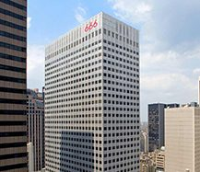
666 5th Avenue President Trump, Ivanka and Jared
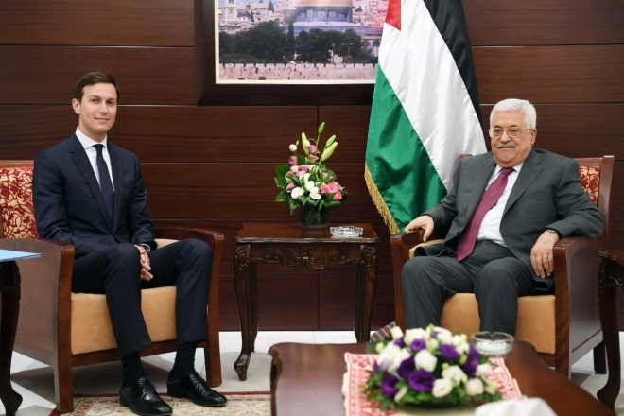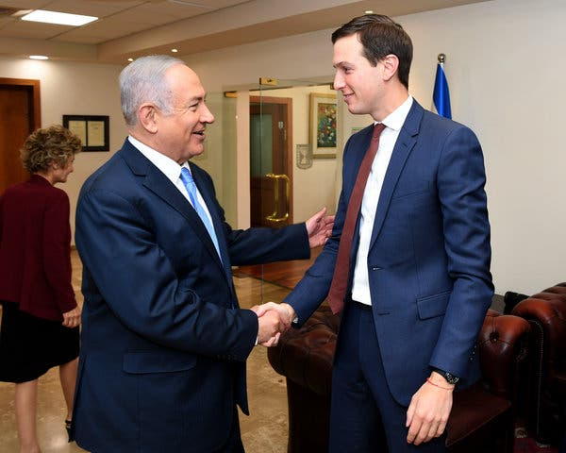
Jared Kushner with Mahmud Abbas Kushner with Benjamin Netanyahu
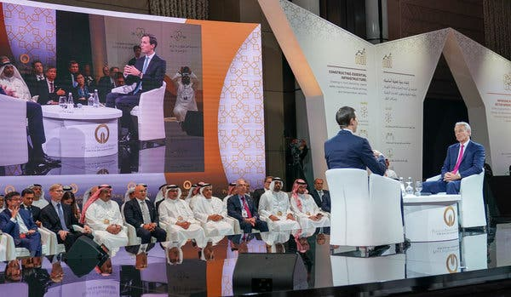
Jared Kushner in Bahrain at the Conference
To tie this together, as Paul Begley noted, with the lunar eclipse over Israel July 16-17 at midnight was a partial eclipse. The Trump-Kushner Peace Plan has been accepted in its partially revealed state at this time. You might say that the partial eclipse was symbolic of the partially presented and partially accepted peace plan.
Donald Trump is called “Cyrus” by Netanyahu, the Sanhedrin, and by Dominion Theology false prophets. Christians jump on the bandwagon thinking that Trump is truly the great Cyrus who allowed the Jews to go back to rebuild their temple in Jerusalem. The Sanhedrin has minted two coins so far with pictures of Trump and Cyrus on them. They are selling the coins to make money to build the third temple, though the world globalist community as a whole will pour money into that project.
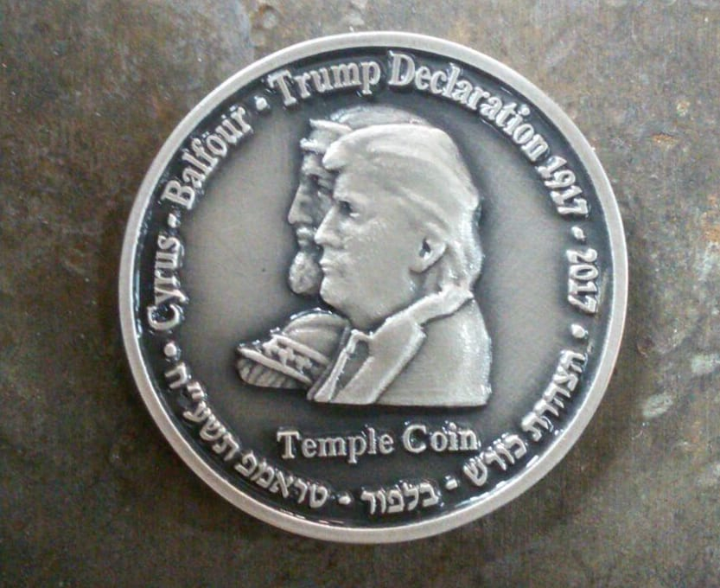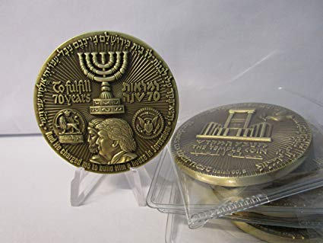
Reality: Cyrus/Koresh was a gracious Persian ruler who allowed the Jews to go back to Jerusalem to rebuild the temple. However, only about 10% went back because Babylon was too good to leave. The people wallowed in Babylonian paganism that today rules Israel.
Cyrus’ decree brought freedom to the tribes of Israel after 70 years to return home, rebuild the walls of Jerusalem, and rebuild their temple. Trump’s decree to build a third temple will bring the people into death and slavery, and great judgment from Yahuwah. There is no comparing Cyrus with Trump!
The rich and powerful nations of the world are behind it. Soon he will present the details of the political plan to Israel and the Palestinian Authority. The third temple, not Yahuwah’s temple of Ezekiel 40-46, will be built. The anti-messiah will come, and the peace plan will turn into a terrifying nightmare in fulfillment of I Thessalonians 5:3: “For when they say `peace and safety’ then terrible destruction shall come upon them as labor pains upon a pregnant woman.”
Keep watch! Ask Abba for His opinion. He’s answering questions!
Love and shalom,
Yedidah,
July 18, 2019

