Israel’s 70th Anniversary 2018 and the
Fig Tree Parable-Prophecy
Rabbinic Dating: Iyar 4/April 19th in 2018
The Creators’ dating: Iyar 4/April 21, 2018
Gregorian dating: May 14, 2018
Friday, May 14 1948: 5th of Iyar, 5708

Photos of the Iyar 4, April 19th celebration, 2018
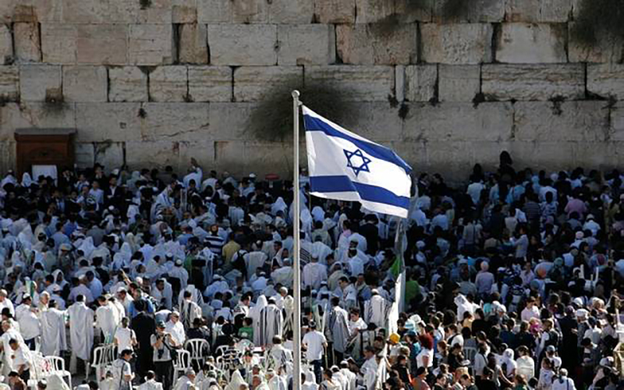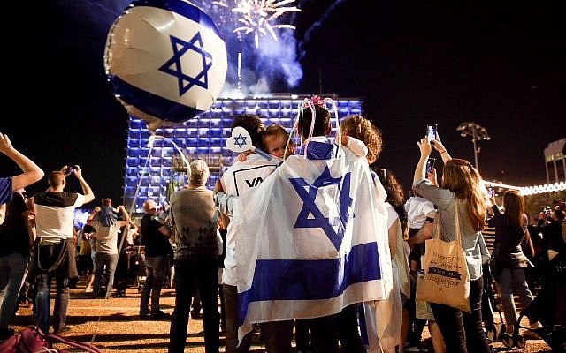
There was dancing in the streets and much celebrating in various ways

***On Friday, May 14, 1948, Iyar 5, 5708, the 20th day of the counting the omer, the Torah reading was Leviticus 19:1-22. The Haftorah reading was Amos 9:7-15
So often, the Torah reading is highly appropriate for specific events in Israel. An Israeli friend told me that that during one of Israel’s wars, most Israelis were in local bomb shelters. The Haftorah reading for the 1st day of the war was Isaiah 26:20: “Go My people, enter your chambers/rooms, and shut your doors behind you; hide yourself as it were for a little while, until the displeasure is past…”
Excerpts from Leviticus 19:1-22: “Be set apart, for I Yahuwah, your Elohim am set-apart….Do not take vengeance or bear a grudge against the children of your people. And you shall love your neighbor as yourself. I am Yahuwah…Guard My Shabbats with reverence…And you shall guard My laws and all My right-rulings and do them. I am Yahuwah.”
In this passage, specific laws are restated to emphasize how His people are to live in His land and how they are to treat the neighbors around them that are not Jewish.
Excerpts from Amos 9:7-15: “In that day I will raise up the tabernacle of David (tabernacle of praise around the Ark) which has fallen down. And I shall repair its breaches and raise up its ruins. And I shall build it as in the days of old,…`Look, the days are coming,’ declares Yahuwah, `that the plowman shall overtake the reaper and the treader of grapes him who sows seed. And the mountains hall drip new wine, and all the hills melt. And I shall turn back the captivity of My people Israel, and they shall build the waste cities and inhabit them. And they shall plant vineyards and drink wine from them, and shall make gardens and eat their fruit. And I shall plant them on their own soil, and not uproot them any more from their own soil I have given them,’ says Yahuwah your Elohim.”
Notice that He plants but will not uproot. There will be no more Diaspora for His people! He will make sure that a representation of all twelve tribes of Ya’cob are in the Land before Messiah comes, and from what we hear today, a representation of all the tribes is in the Land right now. Remember, though Judah is the lead tribe, and for some reason after the Babylonian captivity they allowed themselves to be nicknamed “Jews,” they are only one of the twelve tribes. Refer to the Scriptures in “Aliyah Scriptures”/ Mikvah of the Heart of Elohim to see how many promises there are for all the tribes who were never lost, just hidden away for a while in the nations]
In 2017, Indian Pastor Sundar Singh Savaraj said he was thinking about May 14th 1948 and Israel’s independence, looking forward to 2018 for their 70th anniversary. In his pondering, he said that God interrupted him by saying, no, not May 14, 1948-- November 29, 1947. From a Hebrew standpoint 1) November 29th 1947 was already 1948, and 2) November 29th was the tap root planting date of the U.N. decision.
How does this coincide with the return of the Nephilim and the final year of the Shmittah Year prophecy? [Refer to: “The Shmittah Year Prophecy Revisited”/Mikvah of Israel – Our Eternal Inheritance and “Noah Days Are Nowadays”]
In a newsletter by Messianic pastor Mark Biltz: The fig tree first put out its leaves in 1897 at the First Zionist Congress in Basil, Switzerland, led by Theodore Hertzyl.
The first Zionist Congress was held on August 29-31, 1897. 2017 saw so many important anniversaries, for Israel, and the world. [Refer to: “2017: A Year of Amazing Anniversaries for Israel and the World”] The 4,900 year prophecy of Enoch in Enoch I dating from about 100 years before the Flood, puts the conclusion of the prophecy at 1896-1997 for the return of the fallen ones for their 120 year allotment by the Spirit. (Genesis 6:2-4) Once that 120 year period ended, the Spirit of Yahuwah would withdraw to allow Judgment to Fall on the wicked, “as in the days of Noah.” [Refer to: “Noahdays are Nowadays/ ]
By 1906, in discussions of the homeland, Uganda was chosen as the homeland for the Jewish people. I ministered in seven trips to Africa. I learned that many Jews settled in Uganda. A funny story: In 2001, coming back on the bus from Uganda to Kenya, I sat by the window. It was hot in the bus, so I opened my window, which I shared with the white-haired Caucasian gentleman seated in front of me. He immediately closed the window. I opened it; he closed it. I opened it; he closed it. Finally I opened it about an inch and he didn’t close it. I got up at a rest stop and passed by the gentleman. Looking down to see him, I noticed he was reading a book – it was written in Hebrew. I grinned!
By 1947, the United Nations decided to create a Jewish homeland in Israel, but with scrupulous conditions that guarded their control over the Jewish State. Here we are in 2018, and for sure, the 70 years of Israel’s independence is a confirmed fact. The unconfirmed fact still hovers over Israel--which city is the capital?
In 1947, the United Nations created their Partition Map, showing that the United Nations had authority over Jerusalem. Tel Aviv was chosen for the capital. [Refer to the article: “The U.S. Plans to Move Their Embassy to Jerusalem to Officially Open May 14, 2018”/Mikvah of Israel Our Eternal Inheritance.]
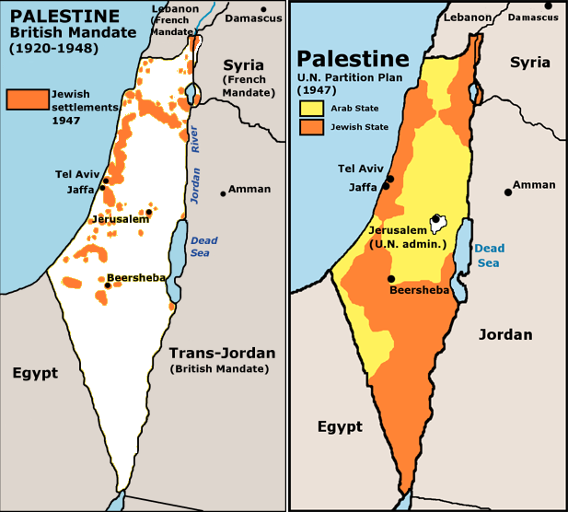
Palestine Partition Maps

By President Trump making this declaration, he incited the anger of the whole Muslim world. May 15th is the 1st day of Ramadan in the Muslim world, and also Nakba Day/Day of Rage regarding Israel’s Independence. Already Hamas had promised its 30,000 young men who stormed the Gaza gate in March, that they would keep it up until they broke into Israel. It is still to be seen if the moving of the Embassy will take place on that day, for it would only be a temporary move until the permanent embassy could be built. However, just President Trump’s Declaration that Jerusalem was the capital of Israel, angered the world in general, for it cut across the U.N. declaration in 1947 that Jerusalem beloved to them!
From the Word we know that Israel’s eternal capital is Jerusalem – forever Jerusalem! The Word speaks primarily of East Jerusalem—with its epicenter on Mount Zion, on the hill south of the Temple Mount where David took the city of the Jebusites over 3,000 years ago, and established it as his capital city. That is the “City of the Great King,” Psalm 48:1-2.
The son of David is coming to rebuild the palace of King David and reign there for 1,000 years. (Amos 9:11; Acts 15:15-16). The City that will no longer be trampled by “gentiles” is the area of the City of David – East Jerusalem – including the Temple Mount. (Luke 21:24). After the 1,000-year reign of Messiah, when Yahuwah comes with His City to hover over Mount Zion, it will be His home forever. (Revelation 21) That little hill, is known as The City of David to this day, as per II Samuel 6:7, 9.
Zion is not the “upper hill” of modern Israel who seeks to please the Catholics. The true Zion is sign-marked today as The City of David, south of the Temple Mount, Eliat Mazer, famous Israeli archeologist, did excavate and uncover of us to walk through and see the palace of David, which is in the City of David – Zion.
That little area is the hottest piece of real estate on the planet, and includes Mount Moriah, the Temple Mount, the Kidron Valley, and the Mount of Olives to the East. The Creator’s will have Their lodging with Their people forever on Zion!
Psalm 132:13-14: “For Yahuwah has chosen Zion. He has desired it for His habitation. `This is My place of rest forever. Here I dwell, for I have desired it.”
Yahuwah speaks of the City of David during the reign of David, Zion, south of the Temple Mount, where He dwelt over the Ark for 40 years in the backyard of David’s Palace, praise going up day and night--where most all Psalms were written by musicians who attended the worship. [Refer to: “Worship - The Journey of the Ark of the Covenant”/Mikvah of the Spirit of Elohim, and “East Jerusalem”/Mikvah of Israel: Our Eternal Inheritance]
Amos 9:11: “In that day I shall raise up the tabernacle of David which has fallen down. And I shall repair its beaches and raise p its ruins. AndI shall build as itn the days of old…” This passage is one of the “Aliyah Scriptures”/Mikvah of the Heart of Elohim, about the return of the whole House of Ya’cob.
Revelation 21:1-7: The Eternal City comes to dwell over Zion forever.
*Joel 1:6-7: “For a nation has come up against My land strong, and innumerable. Its teeth are as the teeth of a lion, and it has the fangs of a lioness. It has laid waste My vine and splintered My fig tree, it has made it entirely bare and cast it away … “
*Hosea 9:10: “I found Israel like grapes in the wilderness. I saw your fathers as the first fruits on the fig tree in its beginning…”
From Matthew 24:29-37: “And immediately AFTER the tribulation of those days, the sun shall be darkened and the moon shall not give its light and the stars shall fall from the heaven and the powers of the heavens be shaken. And then the sign of the Son of Adam shall appear in the heavens, then all the tribes of the earth shall mourn, and they shall see the Son of Adam coming on the clouds of heavens with power and much esteem. And He shall send His messengers with a great sound of a trumpet and they shall gather His chosen ones from the four winds, from one end of the heavens to the other. And learn a parable of the fig tree: When its branch has already become tender and puts forth leaves, and you know that the summer is near. So, then also, when you see all these things know that He is near at the doors. Truly I say to you, this generation shall by no means pass away until all this takes place. The heavens and the earth shall pass away, but My words shall by no means pass away…As it was in the days of Noah so also shall the coming of the Son of Adam be…”
Luke 21:29-21: “And He spoke a parable to them: `Look at the fig tree and all the trees. When they have already budded, observing it, you shall know for yourselves that summer is near. So you also, when you see these things take place, know that the kingdom of Elohim is near. Truly I say to, this generation shall by no means pass away until all shall have taken place.”
MESSIAH’S FIG TREE PARABLE-PROPHECY
Matthew 24:32-34; Mark 13:28-29, and Luke 21:29-32
Joel 1:7; Hosea 9:10
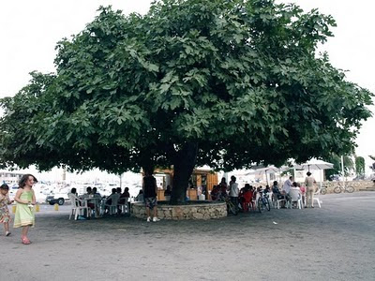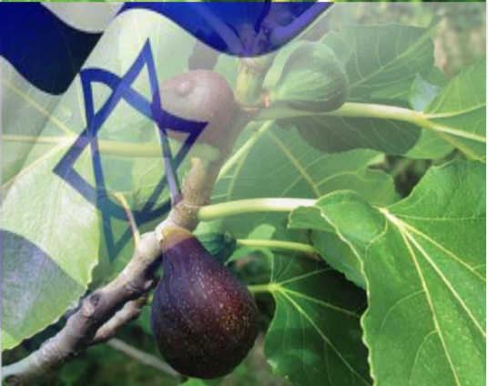
Fig tree in modern Israel
Micah 4:1, 4: “And in the later days it shall be that the mountain of the house of Yahuwah is established on the top of the mountains and shall be exalted above the hills. And people shall flow to it. And many nations shall come and say `Come, and let us go up to the mountain of Yahuwh to the House of the Elohim of Ya’cob and let Him teach us His ways and let us walk in His paths.’ For out of Zion comes forth the Torah and the Word of Yahuwah from Jerusalem. And He shall judge among many people and reprove strong nations afar off. They shall beat their swords into ploughshares and their spears into pruning hooks – nation shall not lift up sword against nation, neither teach war anymore…Each one shall sit under his vine and under his fig tree with no one to make him afraid, for the mouth of Yahuwah of hosts has spoken it.”
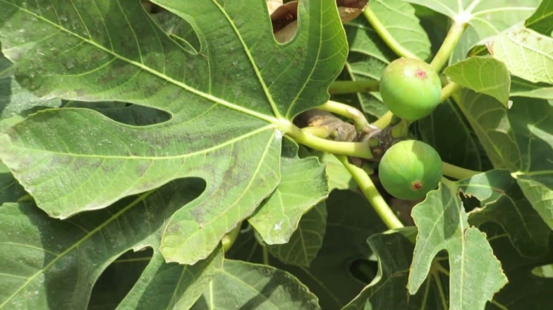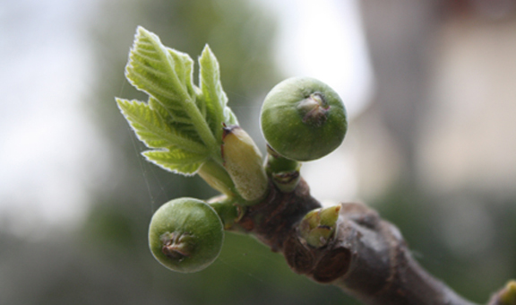
First budding in the early spring
“The tender branch” implies new wood and the coming good summer fruit on the new wood (Mark 13:28)
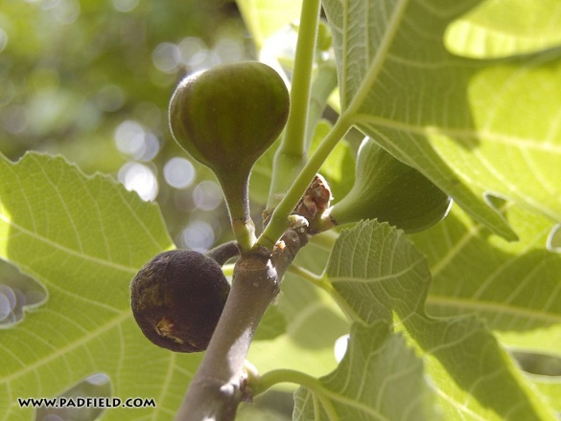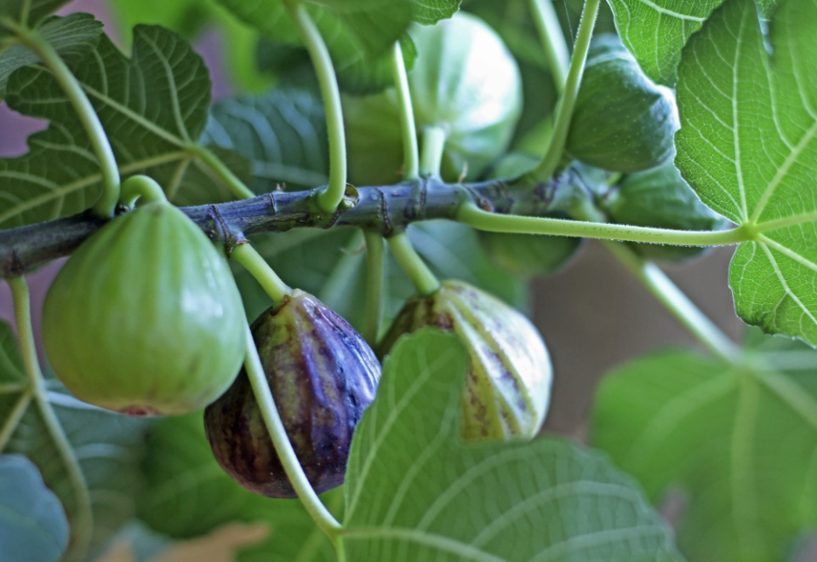
Mature fruit, harvested in late August, early September
From Luke 21:19-21: “…Behold the fig tree and all the trees…” The fig tree is Israel. But, here, he says to behold all the trees also … in other words, notice all the nations and what is happening in the world as a whole in relationship to Israel, the fig tree.
Look at what happened in 1948 among all the nations. America became the world’s super power. During her 70 years she became the “hammer of the earth,” the world’s ruler, but by the 1960s, she began to decay from within, and decline, her greatness began waning. Yet, modern Israel is still dependent on America’s financial hand outs, and military support. They are not dependent on Yahuwah – not yet! When America, and all the nations fail them together, a remnant will turn to Yahuwah!
Jeremiah 8:19-20: “Observe! The voice, the cry of the daughter of My people from a distant land: `Is Yahuwah not in Zion? Is her king not in her? Why have they provoked Me with their carved images, and with foreign worthlessness? `The harvest is passed, the summer is ended, and we have not been saved.’ ”
*Refer to: “The Season of the Coming of Messiah and Yahuwah’s Judgment on the World –- From the Grape Harvest to the End of the Olive Harvest (The time-frame of Yahuwah’s judgment on Israel, America, and the World”/Mikvah of Preparation.
Refer to: “Aliyah Scriptures”/Mikvah of the Heart of Elohim.
In this passage from Jeremiah 8:20, who is Yahuwah speaking to in a distant land, those who want to come home to Zion? This is told in detail regarding America in Jeremiah 50 and 51. It tells of a post 1948 time when Jews want to go home.
[Refer to Podcasts XXXXV, XXXXVI, XXXXVII, and XXXVIII under Audio Messages]
From a newsletter posted by Messianic leader Mark Biltz: The 120-YEAR END-TIME GENERATION 1897-2017 / Eclipse of the century and interviews about Revelation [12] signs / website pastor Mark Biltz [THE GREAT AMERICAN SOLAR ECLIPSE OF 2017] This Prophecy … Signs in Revelation 12 Newsletter Pastor Mark Biltz … September 2017! Friends of Israel - [www.vriendenvanisrael.nl/?p=1600

The 120-YEAR END-TIME GENERATION 1897-2017 ... The third time period for determining the length of a biblical generation is 70 YEARS. Israel was in the Babylonian captivity for 70 years – a number associated with COMPLETING PROPHECY. Biltz includes an article by Allen Barber PhD Biblical Studies

While I found Dr. Barber deeply entrenched in fallacious basics of Christian doctrine in some places, his overall assessment of timing, which I quote here, rings of true Scripturally. A generation: Barber gives Hebrew understanding to this word. “The Greek word for `generation’ is `genea,’ connected with `ginomai’ which means `to become,’ primarily signifying a begetting or birth, or a race of people possessing similar characteristics, pursuits, etc. Therefore, one definition of generation is that it refers to a particular people with their characteristic lineage and indentifying traits, which distinguish them from all other races of people…Notice in Vine’s Dictionary of generation he says it signifies a begetting or birth…In Matthew 24, the Lord Jesus is not speaking of an individual’s birth, but the birth of a nation.”
Psalm 90:10, 12: “The days of our lives are seventy years; or if due to strength, eighty years. Yet the best of them is but toil and exertion. For it is soon cut off, and we fly away…Teach us to number our days and let us bring the heart to wisdom.”

Barber sees the last 120 years as from 1897 to 2017, since in 1897 Theodore Hertzyl opened the First Zionist Congress in Basil, Switzerland to prepare for the Jewish people to return to their homeland in Israel. He sees this as the first budding on the fig tree. He is correct in this assessment. From the book of Enoch I and his 70 generation prophecy, we can place the 4,900 year time from about 100 years before the Flood, to 2017-2018 CE.

Some of the original Watchers, fallen pre-flood angels, and many of their first offspring, the Nephilim, returned in 1896-1897 with proof of their return showing up immediately. [Refer to “The Amazing Message Behind the Numbers 3, 7, 50, 70 and 120”/Mikvah of The Great Adventure, and “Noahdays are Nowadays”/Mikvah of the Heart of Elohim]

To counteract that return, Yahuwah began in the mid-1800s to restore what was lost through the centuries. Acts 3:19-21: “Repent therefore and turn back, for the blotting out of your sins, in order that the times of refreshing might come from the presence of the Master, and that He sends Yahushua Messiah, pre-appointed for you whom heaven needs to receive until the time of the restoration of all thing of which Elohim spoke through the mouth of all His set-apart prophets since of old.”

In the mid-1800s He began sending His Spirit for great revivals of simple salvation by faith in the blood of the Lamb and His resurrection. By 1906, the outpouring of the Spirit of Yahuwah, as in the days of Acts, was restored. In the 1920s-1950s, the restoration of the gifts of the Spirit and the manifestations of His Presence increased greatly. In the early 1900s, Jews began migrating to Israel. In 1948, the official right of return of the Jewish people to Israel began. Zechariah 12:7: “I will save the tents of Judah first…” In the 1990s, the restoration of Torah began to the House of Ephraim. The re-gathering of Ephraim/Joseph began. Praise and Worship returned as in the days of the Scriptures. So, as the Watchers returned with their first and mightiest offspring to continue what they were doing before the flood, the manifestations of Yahuwah were gathering a remnant of people to Himself.

Allen Barber saw 1917 as a second budding of the fig tree, or I would say it was a continued budding that began to put out fruit. In November of 1947 and May of 1948, the fig tree’s fruit began to ripen. We are now ready for the harvest.

The fig tree is Israel, just as the olive tree also represents Israel.

Allen Barber shows that the main number-symbols of the Word are at work here:

1) 40 years, a generation of punishment, i.e. Ezekiel 4:6

2) 50 years, from 1967-2017 (Jubilee)

3) 70 years, from 1947 to 2017 (a generation)

4) 100 years, from 1917 to 2017 (400-year timing of Ya’cob’s family in Egypt)

5) 120 years allotted the last generation under the Watchers, 1897-2017

Allen Barber sees the 1897 to 2017 as a fulfillment of Genesis 6:2-4 – the time of the Spirit’s striving with man--“with those who are also flesh,” i.e. Nephilim, as the Septuagint reads.

Barber lists these biblical numbers with events:

The 100 years as representing bondage, as with the 400 years in Egypt

The 70 years as fulfilled prophecy

The 50 years as representing Jubilee

The 40 years as years of testing, as with the wilderness journey

In this case, all of these numbers fit into the last 120 years prophetically.

Many see this 70th anniversary of Israel as the starting point for tribulation – not necessarily a 7-year tribulation, yet there is NO 7-year tribulation mentioned anywhere in the Bible, unless Daniel 9 is totally interpreted wrongly.

Tom Horn wrote a book entitled Zenith 2016. In it he asks the question: Did 2012 begin the last seven years, or does the last seven years begin in 2016? Yes, 2012 did begin a new “Era” and a “New Age” scientifically accurate by the movement of the Cosmos. I have come to realize, from the nature and ways of Yahuwah, that there is NO 7-year timing of a tribulation with a “great tribulation” beginning at a 3½ year point as fundamentalist Christians hang on to. He doesn’t do “cookie cutter” timing. Man has messed with that. [I discussed this in the Podcasts on Revelation 11, 12, and 13]

According to the Word there is a long build-up, and we’re nearing the end of it now – timing that ends with a final world takeover that only takes a very short time. Our Abba is NO sadist! When He gets ready to pour out His wrath, it will be short and final! Get to know Yahuwah!

It’s kind of like setting up dominos. It takes meticulous effort to set up a whole set of them, but when the first one is knocked over, the whole set goes down in order one at a time in rapid succession. So it will be, as Scripture tells us.
Messiah’s prophecy begins with the first budding of the leave and fruit in the early spring. Its harvest is at the time of the Fall Harvest of the five species of fruits in Israel – beginning with the grape harvest in Elul/August, and continuing with the figs, dates, and pomegranates into September. The olive harvest begins in early September, but depending on where the groves are in Israel, it can continue into November and even December. But, the harvesting of the five species in general begins in late Elul through Tishre – the timing of the coming of Messiah.
For Scriptures throughout the Word and an exciting study on the timing of the return of Messiah, again, I refer you to: “: “The Season of the Coming of Messiah and Yahuwah’s Judgment on the World –- From the Grape Harvest to the End of the Olive Harvest (The time-frame of Yahuwah’s judgment on Israel, America, and the World”/Mikvah of Preparation. Also refer to: “Aliyah Scriptures”/Mikvah of the Heart of Elohim.

“This Generation Shall Not Pass, Till All These Things Be Fulfilled” (Mt. 24:34)—Does Israel’s 70th Anniversary Mark The End Of A Biblical Generation And Signal The Start Of Great Tribulation Followed By The Second Coming Of Jesus Christ?
April 26, 2018 – from Jew News
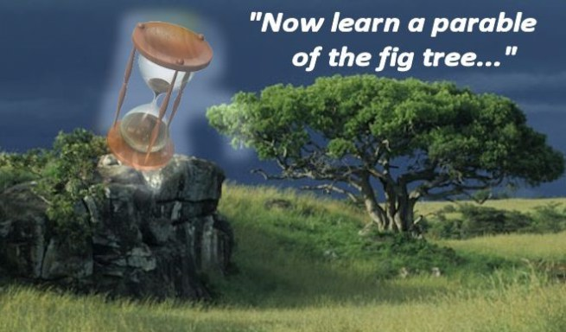
“The number 70 was singled out for special attention in ways that make this Yom HaAtzmaut (Independence) particularly meaningful. In Jewish tradition numbers have special meaning and can convey crucial insights for our understanding of Jewish history. Seventy isn’t merely a nice round number. Long ago the number was singled out for special attention in ways that make this Yom HaAtzmaut particularly meaningful. And why was that? Surely it was a reference to the verse in the book of Psalms: “The days of our lives are threescore and ten” (Psalm 90:10). Seventy is the proverbial biblical lifespan.”
Excerpts from an article by Pastor Dick Carmack, All News Pipeline, April 19, 2018:
“Seventy years ago, Zipporah (`Zippy’) Porath had joined the Haganah (defense forces) and received training as a medic. In her book Letters from Jerusalem, 1947-1948, she wrote: `Our soldiers are like no others I’ve ever seen. They don’t have much to fight with besides guts and determination--No swagger, spit or polish. No drinking, no shirking. Doing the dirtiest jobs, they sing and joke, even in the fiercest moments and never with a `here today, gone tomorrow’ attitude. Tomorrow Is what it’s all about.’
…When the modern state of Israel was established, a time table was set…One thing seems clear, we are headed for a date with destiny and May 2018 may well be the tipping point that kicks it off…The re-gathering and existence of Israel is the single most important prophetic sign of the wind-up of history…This article is about a kick-off date.”
Like many who study the Word and see its fulfillment, and watch for the signs that it so clearly gives us, Pastor Carmack sees this May 14th as a “beginning of sorrows” that will lead to Messiah’s return. It could kick off the time of Ya’cob’s troubles – Jacob’s troubles (Jeremiah 30:7) The Word does not say “Judah’s troubles,” or “Jew’s troubles.” It is talking about those of all twelve tribes who enter into tribulation, most of us as either Christian or Messianic believers. Most all true believers are of the House of Ya’cob. No one in Messiah is a gentile, no matter what their ancestry (Ephesians 2:8-19).
What is amazing is that on May 15th, British-hired Nazi Arabs in countries surrounding the new State, gathered their armies against Israel and Israel, aided by Yahuwah, won over them all, pushing them back. Today, Israelis have a different view of things than the early settlers from the 1900s – 1948 had then. Though constantly pressured from outside enemies, as Israel desired as time went on, they became a European-type nation with immorality, a high abortion rate, Gay Pride Parades, and fit the bill of Revelation 11:8, the two witnesses are killed in East Jerusalem: “…the great city which spiritually is called Sodom and Egypt, where also our Master was nailed to the stake.”
In a recent Steven ben Nun (Noon) YouTube presentation, he ran part of a speech by Netanyahu recently, in which Netanyahu encouraged the Gay Pride Community to parade in Jerusalem, as a gesture of “unity” to the Israeli people. Israel is NOT a “Holy Land!” It is a Sodom and Egypt. I wrote an article entitled “Let Us Be Like the Nations,” about Israel’s departure from its roots to its desire to be a leading nation among the nations, economically, socially, politically, etc. The Orthodox Jews have always been a thorn in the side of Zionist politics, since they stand against the surge of the New Age goals of Israel. So, don’t be disillusioned. On the other hand, the Jewish people are precious, and we need to stand with the Jewish people, and those of other tribes that have joined them, like the Bene Manasseh of India.
“Israel and the Secret of 70” by Jew News, April 26, 2018
“The number 70 was singled out for special attention in ways that make this Yom HaAtzmaut particularly meaningful.”
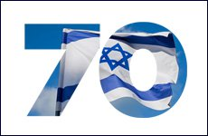 “…Seventy is the number which demands reflection. It is the number which defines a generation. It is intimately linked with judgment – so much so that in Jewish law the Supreme Court, the Sanhedrin, was composed of 70 members, just as there were 70 elders in the days of Moses. More, 70 was the key to the creation of the Jewish people. The book of Exodus, moving the story of our ancestors from family to nation, tells us “And it was that all those who were direct descendants of Jacob were seventy souls” (Exodus 1:5).
For several years, I have been reading articles from JoybySurprise.com, by our brother in faith--born again, Spirit-filled, and guarding the Torah. He has unique insight into the workings of Elohim and history that brings a new prospective on seeing the facts and truth of the Word being fulfilled. He challenges us to do more research. I appreciate his faithfulness and loyalty to our Elohim! I recommend that you visit his website. From JoybySurprise: “The Cluster of Events Around 5/14/2018:” “It was recently announced that the United States Embassy in Tel Aviv, Israel, will probably be officially moved to Jerusalem on the date of Israel's 70th anniversary as a modern sovereign state, 5/14/2018. Link: https://www.timesofisrael.com/us-to-move-embassy-to-jerusalem-on-may-14-day-of-independence-declaration/
1. The official ribbon cutting ceremony of the USA moving its Embassy to Jerusalem will probably occur on 5/14/2018.
2. The chiastic midpoint of the 70th year of the life of President Hassan Rouhani of Iran, a sworn enemy of Israel and the United States, occurs on 5/14/2018 at 2:54 AM Jerusalem time (counting noon on 11/12/1948 as the date and time of his birth). YaHuWaH Elohim has ordained that the central focus of President Rouhani's 70th year of life is the 70th anniversary of the modern State of Israel.
3. The 70th anniversary of modern Israel's protection by the United States of America (prophetic Babylon the great) occurs on 5/14/2018.
4. According to Jeremiah 29:10, YaHuWaH Elohim will visit His people after they have been under Babylon's protection for 70 Years in order to return them to the land of Israel. The reasons for YaHuWaH 's peoples to return to the land of Israel in modern times has been that the living conditions in various countries had grown intolerable for YaHuWaH 's people. [***Jeremiah 25:11-12, and 29:10-14]
5. The Islamic month of Ramadan, when enhanced heavenly rewards (greater numbers of virgins awarded to the murderer) are promised to those Muslims who kill infidels for Allah, begins 5/15/2018 at sunset. The month of Ramadan begins about 29 1/2 days earlier each year and floats through the months of the Roman Calendar. It just happens to begin on 5/15/2018, one day after Israel's 70th anniversary during this particular year.”
What are the odds of Iran’s sworn enemy of Israel, Hassan Rouhani, having his 70th birthday six months after May 14, 2018 (November 12, 1948)? That is something to investigate further! Rouhani is the one now boldly threatening Israel and also threatening Donald Trump if he pulls out of the “Iranian Deal” of 2015 made by Obama.
This May 14th is an amazing return to 1948! On the 15th Ramdan begins, which is also known as “Nakba” Day in Arabic, or “the catastrophe.” It is a “day of rage,” a day when all Muslims worldwide are called upon to show their rage against the creation of the state of Israel. In 1948, on May 15th, the 1st “Nakba” Day, Israel was attacked by nations surrounding her. This is a similar situation this year!!!
What will this daily bring, especially to East Jerusalem, especially if the U.S. Embassy begins its setting up in Jerusalem? Iran is ready to strike Israel. Netanyahu has been given the power to declare war, along with the approval of Defense Minister, Abigor Lieberman. The Knesset gave him this power recently. This means that he could set off a war with Iran all by his lonesome with Lieberman cheering him on. Israel has already told Iran what they will do if provoked. Iran has already told Israel what they will do if provoked. It’s a powder keg, and its lighting might be May 14, 2018.
As Jerry Golden reported from his inside IDF info, they expect war by this summer.
In 2016, I had a dream that I was with the IDF doing exercises inside Israel for an attack by Iran. I was told they expected war by June 20th. June 20th is the 1st day of summer, “the summer solstice.” July and August are notorious months for war. So, we’ll see, but in the meantime, we pray, and prepare ourselves.
War will not be contained in the Middle East! In the same dream, part 2, the IDF went to a school where they were preparing the children for war time. Within a week, it came out in Israeli news that the IDF was preparing the nation for war. If Abba is showing you anything about this, let me know.
What we do with this time period that we have left will determine our eternal position, and our eternal rewards. Do all you can to found blameless before Him.
Shalom, Yedidah - May 10, 2018

