JERUSALEM: TODAY, AMIDST WARNINGS, TRUMP’S BOLD ANNOUNCMENT COULD SHAKE THE WORLD

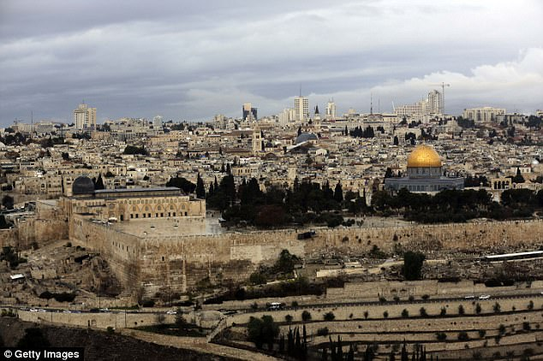
Jerusalem,…until now, was never recognized by the U.S. or most other countries, as Israel's capital. Trump's move upends what had long been U.S. policy, that recognition would be part of the peace process… (Daily Mail)

REACTIONS:
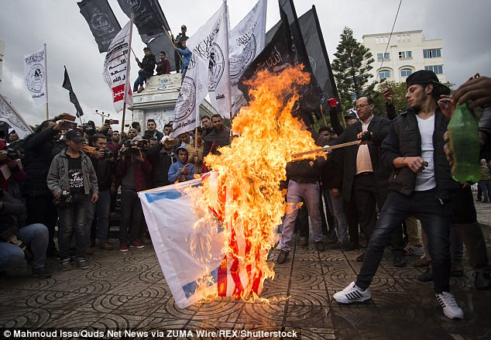
In flames: In Gaza Palestinians burned the U.S. and Israeli flags as Trump's announcement later on Wednesday was revealed
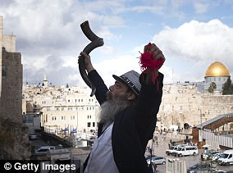
Celebration!

Zechariah 12:2-3: “For see, I am making Jerusalem a cup of trembling for all the people all around, and also against Judah it is in the siege against Jerusalem. And in that day, it shall be that I make Jerusalem/Yerushalayim
a very heavy stone for all people. Those lifting it are severely injured. And all nations of the earth shall be gathered against it.”

By David Martosko, Us Political Editor For Dailymail.com and Associated Press - 6 December 2017: “`My act of political courage’: Trump will recognize Jerusalem as Israel's capital TODAY despite international fury from the Pope, the UK, Russia, China, Turkey, Iran and Palestinians who say 'he's declaring war against 1.5 billion Muslims.'
President Trump has announced he's recognizing Jerusalem as Israel's capital city, and starting the process of moving the U.S. embassy there from Tel Aviv. 'Many presidents have said they want to do something, and they didn't do it; whether it's through courage or they change their mind I can't tell you,' he said.
International outcry was swift and furious ahead of speech expected at lunchtime in the U.S. Palestinians said it would be 'a kiss of death to the two-state solution' and Trump is 'declaring war in the Middle East.'
Pope Francis said he was 'profoundly concerned' and appealed that 'everyone respects the status quo of the city.'
China, which has good ties with Israel and the Palestinians, expressed concerns over 'possible aggravation of regional tensions.' Iran's supreme leader said Trump's new stance represented 'incompetence and failure.'
Russia, a key Middle East player, expressed concern about a 'possible deterioration' there.”

Ahead of the announcement America issued a travel advisory to those planning on visiting Israel, especially Jerusalem: Security Message for U.S. Citizens: December 5, 2017 - U.S. Embassy in Israel
“With widespread calls for demonstrations beginning December 6 in Jerusalem and the West Bank, U.S. government employees and their family members are not permitted until further notice to conduct personal travel in Jerusalem’s Old City and in the West Bank, to include Bethlehem and Jericho.”
Jerusalem Is About To Become A Cup Of Trembling As Trump Considers Historic Move – from Prophecy Newswatch - by Michael Snyder/End Of The American Dream December 01, 2017
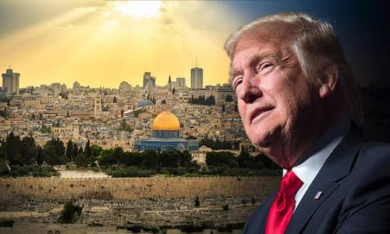
“Is President Trump about to recognize Jerusalem as the capital of Israel? If so, this would be one of the most historic events to happen in the Middle East in a very long time.
Needless to say, the government of Israel would be absolutely thrilled by such a move, while the Palestinians and Israel's neighbors would not be pleased at all. In fact, some Palestinians have suggested that if the Trump administration actually moves the U.S. embassy to Jerusalem that it could spark widespread violence or even war...”
But Donald Trump promised that he would recognize Jerusalem as the capital of Israel during the campaign, and it looks like he intends to keep his word...A senior U.S. administration official said on Thursday that President Donald Trump is considering recognizing Jerusalem as the capital of the State of Israel without moving the embassy to the Israeli capital, at least for the time being.
Trump wants the recognition of Jerusalem to be a gift to Israel on the occasion of its 70th Independence Day… There will be independence celebrations throughout the year, and recognizing Jerusalem as Israel's capital as we approach this highly significant time would be considered a great gift to the Jewish people. For the moment, however, the Trump administration will not be moving the U.S. embassy to Jerusalem. The White House recognizes that such a move could spark violence in the region, and so administration officials are treading carefully...”
Well, Trump did it! Just for Trump to recognize Jerusalem is a major affront to the 1947 U.N. partition of Israel. The 70th anniversary of that partition was celebrated November 29, 2017. Here is a look at the U.N. partition map of Israel, and the more recent one of Jerusalem.
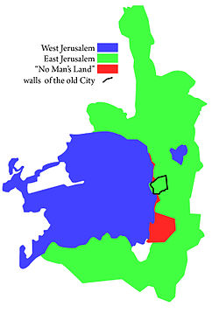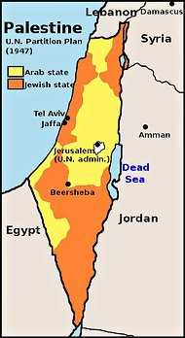
Left: UN partition of Jerusalem – “Jerusalem municipal area” from Wikipedia
Right: The 1947 U.N. Partition of Israel: Notice that it shows more territory to be given to the Palestinians, but look at the little white circle next to Jerusalem – “U.N. Administration.” Jerusalem was always retained under U.N. control.

So, with Trump starting the ball rolling towards moving the embassy to Jerusalem, amidst U.N. plans to give East Jerusalem to the Palestinians as
their capital, the ancient area of “East Jerusalem” that Yahuwah has sectioned off for Himself, Jerusalem will indeed become “a cup of trembling.”
Zechariah 3:2: “And Yahuwah said to Satan, `Yahuwah rebuke you, Satan! Yahuwah who has chosen Jerusalem rebuke you!”
Psalm 132:13-14: “For Yahuwah has chosen Zion. He has desired it for His dwelling. `This is My place of rest forever; Here I dwell, for I have desired it.” [Today that is the area of the City of David, the real Zion south of the Temple Mount, and Mount Moriah, the Temple Mount]
Yahuwah is very much involved with this historic proclamation of Donald Trump--for it will hurry the coming of His Son.
Read: Isaiah 29:1-4, “Ariel” is a name for Jerusalem. It is talking about our day! Notice, it is talking about where David dwelt. His palace has been excavated on the real Zion, the little hill south of the Temple Mount – the “City of David” – I Samuel 5:7: “But David captured the stronghold of Zion, the City of David.” Zion is flanked on the east by the Kidron Valley, and on the south by the Hinnom Valley, and the north by Mount Moriah.
Psalm 122:6, 8: Pray for the peace of Jerusalem! Let those that love you be at rest…I say `peace be within you.’ ”
Read Psalm 137! Read Isaiah 62:2, 6-7!
Shalom, shalom!
Yedidah
December 6, 2017

