NAKBA DAY: “THE CATASTROPHE”
DAY OF RAGE - RIGHT OF RETURN – RAMADAN
May 15, 1948 – May 15, 2018
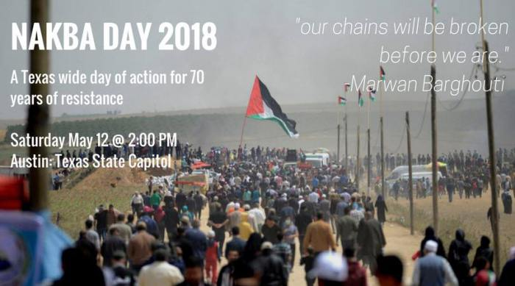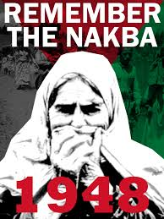
Nakba Day is not just for Israel, not just for Jerusalem – It is a Muslim Day to protest the existence of the Jewish State worldwide. The protests have begun. Look at this date for Austin, Texas.
Today in Israel, the IDF fought off tens of thousands of rioters on the Gaza Border.
Nakba Day is Tuesday, May 15, 2018 – This year it is the eve of Ramadan, which adds even more fuel to the fires of worldwide rage
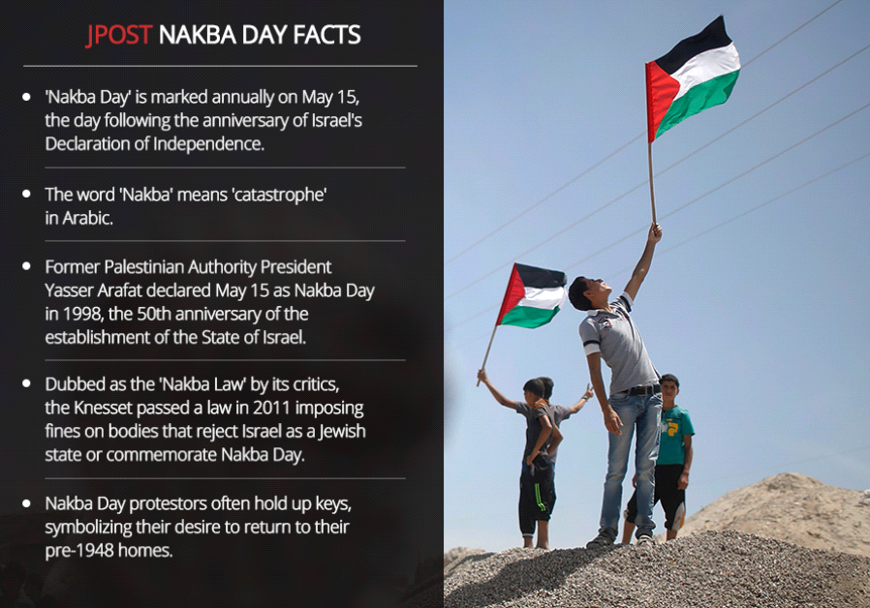
What is Ramadan? It is the name of a set-apart holy month on the Arab calendar during which Muslims fast from sunset to sunset, eating no food nor drinking any liquids. It is a month of rage against all “infidels” who resist submission to Allah.
Wikipedia: “Soon, Muslims across the world will be preparing for the holy month of Ramadan. ... Fasting during Ramadan is the fourth of the five pillars of Islam, the most important of Muslim practices.”

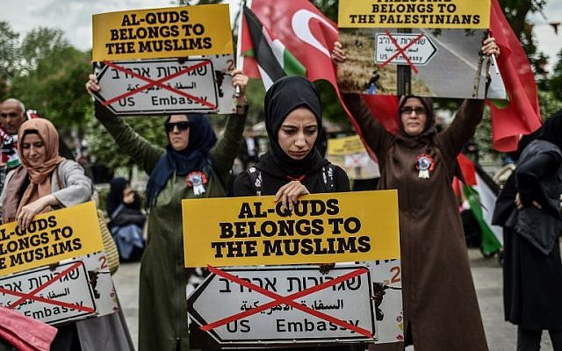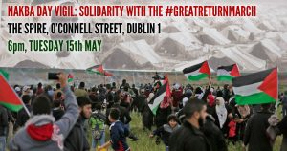
Right: Nakba Day Ireland
Left: “Al-Quds” is the Arabic name for the Temple Mount
These protesters say the Temple Mount belongs to them, and “NO” to the U.S. Embassy declaring Jerusalem to be the Capital of Israel.
Tuesday, May 14, 2018: The official ceremony to launch the U.S. Embassy coming to Jerusalem--will be held. Did you know that because President Trump made this bold move, that others nations are saying they want to move their embassies to Jerusalem.
SkywatchTV 5 and 10, May 10, 2018, Derek Gilbert in Nazareth, speaking with Avi Lipkin: Avi said that now Honduras, Guatemala, Romania, Czech Republic, Paraguay and Austria want to put their embassies in Jerusalem. He thinks it will open the door for most other nations to do the same.
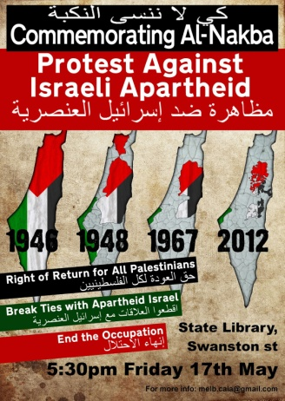 “Live From Occupied Palestine: May 15 marks the Palestinian Nakba (Catastrophe) day. In 1948, more the 780,000 Palestinians were ethnically cleansed from their homeland.”
THE LIE: There were no Palestinians until Yassar Arafat used the word to describe Arabs from many nations living inside Israel. He made them a political force. The name “Palestine” came from Roman Emperor Hadrian’s mocking statement, calling Israel “Palaestina,” after the Philistines. He re-named Jerusalem “Aelia Capitolina.” Rome has always mocked the Jews. LIE: The term “Jew” began in Babylon.
Yassar Arafat was from Egypt. He created the term “Palestinians” as a political force to get what he wanted. LIES… No Jew told the Arabs to flee their homes in 1948 – they fled out of fear of war. But, no Jew threatened them. Now they all want to return after 70 years with all their families, into the multi-millions of people. to Israel.
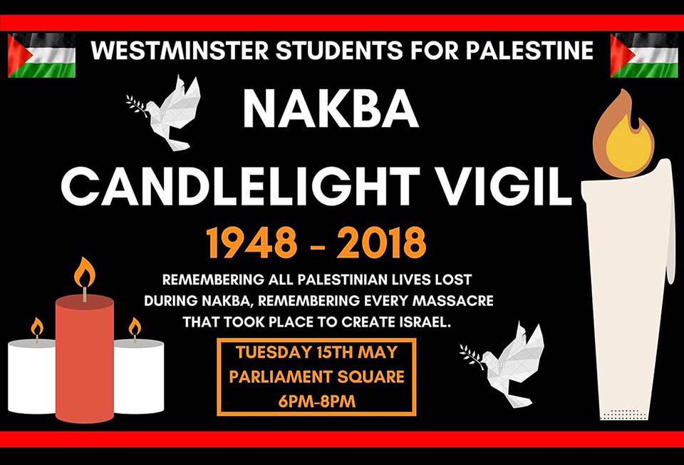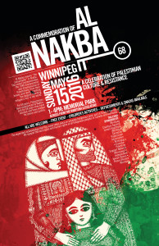
Left: England
Right: Poster May 15, 2016 Winnipeg, Manitoba, Canada
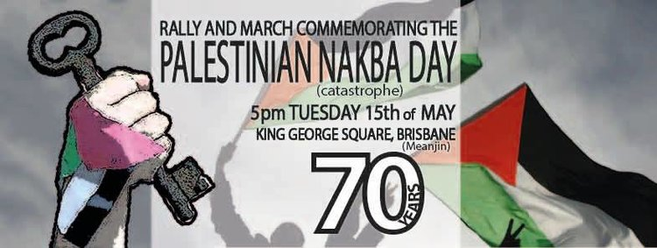
Australia
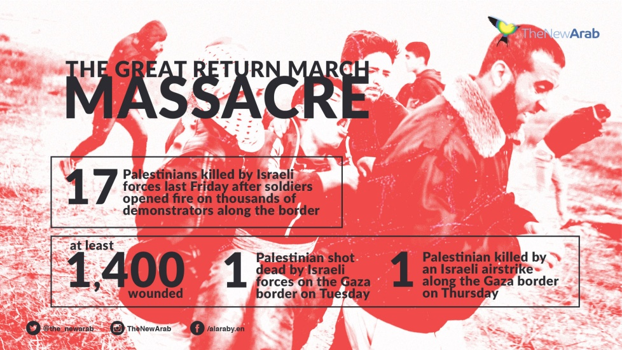
This is an example of worldwide propaganda against Israel. Today, May 12th, upwards of 30,000 or more gathered at the Gaza fence. This began in March, to protest Israel’s “occupation” of “Palestine,” and demand the “right of return by throwing fire bombs, launching rockets into Israeli settlements, as has been done by the thousands previously. The IDF shot rubber bullets, and tried to stop the rioting in several ways. When aggression reached the point of breaking through the fence, the IDF had to use live ammunition. THE KORAN SAYS THAT LYING IS A VIRTUE. The Palestinian leaders whine like babies when they are corrected for their murderous evil, and the world hears them whining and takes their side.
I know! I lived among Arabs and Palestinians for most of 16 years in Jordan and Israel. I know the good! I loved the Muslim people! I hate what’s been done to them by their leaders who are controlled by western influence. The people are fed lies by their muftis and wafts. They act on lies; they promote lies. They are stirred up by lies and react in anger because they believe the lies. Truth: The people are kept in poverty and squalor by their terrorist leaders. Israel has given them decent lodging.
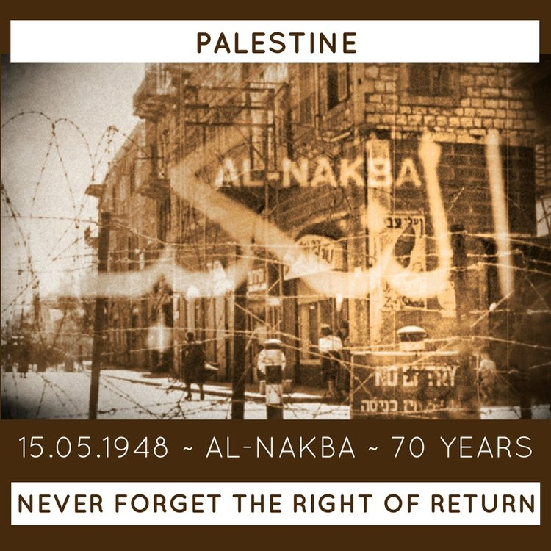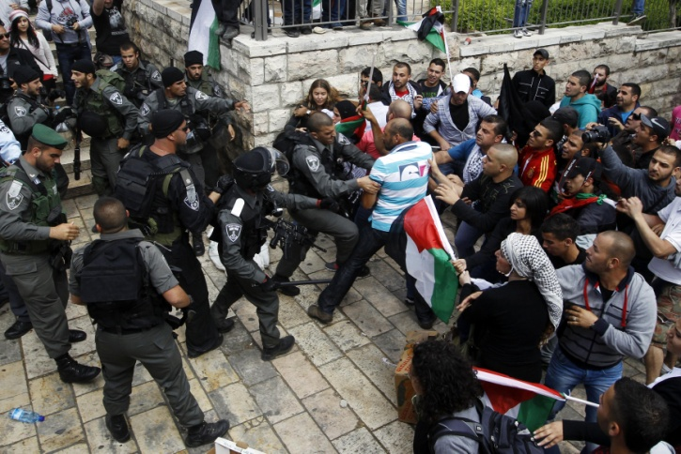
Left: Australia poster in Sidney Right: Nakba Day Lebanon, 2017, violence
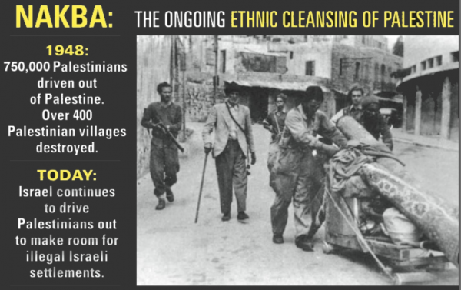
The LIES GO ON… The world’s news media perpetrate the lies. The U.N. perpetrates the lies. The U.N. funds Jihad camps for children, teaching them the glories of being suicide bombers, as early as age 5. The U.N. helped Hezbollah in the 2006 war against Israel. America has funded the PLO’s Fatah, and Russia funds Hamas – both terrorist organizations.
Do you notice that the public news speaks of the “West Bank” as “occupied territory?” Do you notice that the public news speaks of the Golan Heights as Israeli occupied territory? Do you understand that the United Nations gave Israel their state with very strict requirements – i.e. Jerusalem belongs to the U.N. under their authority?
MORE LIES: Militant Muslim men think nothing of putting their wives and children out in the front lines of fire, and then screaming that Israel has killed women and children. In the 2006 war, Hezbollah put crippled children in the basement of an apartment building, and then put a Palestinian flag on the top of the building. Israel bombed the building. Hezbollah screamed to the world that Israel had killed innocent crippled children.
Don’t be fooled, the Arabs and Palestinians are not acting alone. There are Communist Arabs and Nazi Arabs who do the bidding of their socialist controllers. They care nothing about the deaths of their own people. This goes back to Biblical days when various tribes killed each other if they couldn’t kill their attackers.
MORE LIES: ISRAEL DOES NOT DRIVE OUT PALESTINIANS TO BUILD ILLEGAL SETTLEMENTS! Israel only builds on their own land, not Palestinian owned land.
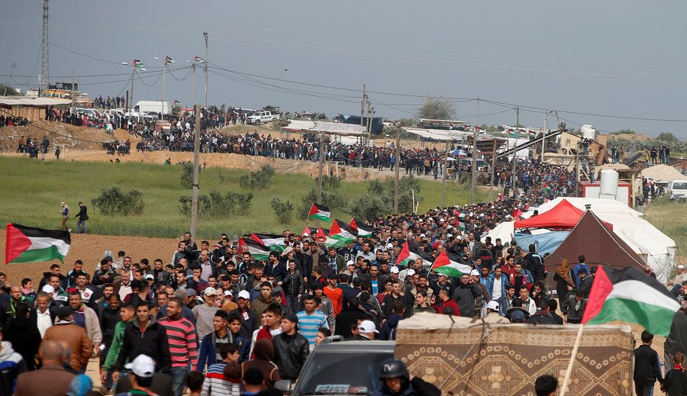
Gaza Border Crossing Protests by tens of thousands -LOOK AT THE FACES – see – they are almost all young men as Israel has reported. Hamas is behind their demonstrations. May 12, 2018
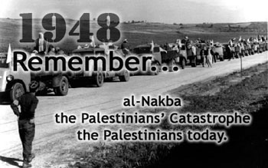
The Palestinians fled Israel in 1948 because they feared Israel – Israel did nothing to run them off. On May 15th, 1948, five Arab nations attacked Israel and Israel drove them back. It was a staged thing by Britain using Nazi Arabs to incite the attack – just real history folks.
MAY 15TH 1948: ISRAEL WAS ATTACKED BY SEVEN ARAB NATIONS …
That was Israel’s catastrophe day…
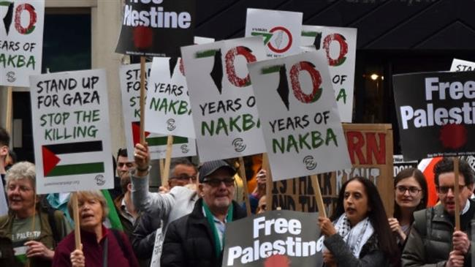
A scene from London last year …
The Nazi news media, the lying press, has turned the world against Israel, when Israel’s army is actually the most moral of all armies – caring for their enemies as well as trying to protect their own citizens against terrorists.
Yet, the Jewish people today do not protest against the Arabs. They have blessed Arabs with citizenship, whereas those that fled into other Arab nations were treated badly by their own people. Look at the huge comparison between the gigantic Arab nations and Israel and ask “WHY” the protesting?
I tell you the truth: It is controlled by the Jesuits through the Vatican, by the Vatican controlled U.N., and all those that hate Israel in general. It was the Catholic Church that created Islam, using Mohammad. “Islam” means “submission”.
Mazzini/Pike Plan Part III with World War III was to begin by inflaming war in the Middle East, to kill Jews and Arabs, and bring the world into submission to a one world government, a new world order, a global system under the control of the ultra wealthy and powerful Elite. This is not about Arabs/Palestinians against Israel. This whole thing is about a plan that was created in 1871 to bring the world under subjection to a world government. It’s coming down around our heads, and as believers we’re targeted because we are of Israel--we are of the House of Ya’cob, and “they” know it.
Determine to pray more, proclaim the Word more, witness more to salvation by faith in Messiah, and prepare yourself for the final realities.
Look up your own nation on google, and see what is being done for Nakba!
Shalom shalom! – Shalom Jerusalem!
Yedidah - May 12, 2018
*****Don’t forget to read: “Israel’s 70th Anniversary and the Fig Tree Parable-Prophecy”/Mikvah of Israel: Our Eternal Inheritance, May 10, 2018

