NEBUCHADNEZZAR’S PROPHETIC DREAM 2018

The Rise of the Final Empire and Its Beast
Daniel 2 and 7; Revelation 13:1-10; Revelation 17: 10-11

Formerly “Nebuchadnezzar’s Dream,” this 2017 update has astounding and eye-opening new information and understanding. [First published January 16, 2004, edited/revised January 18, 2007, February 2010, and January 2014]
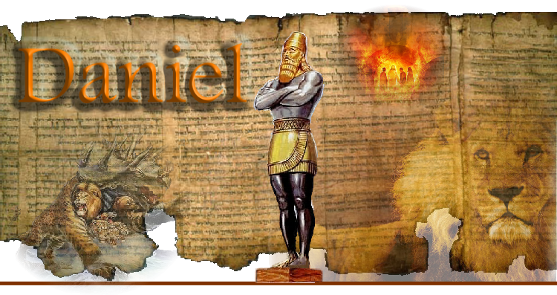
Daniel 12:9-10: “And he said, `Go your way Daniel, for these words are closed up and sealed till the time of the end. Many shall be purified and made white, and tried. But, the wicked shall do wickedly, and none of the wicked shall understand, but the wise shall understand.’ ” Study to be wise and understand the Word and will of Yahuwah!

Daniel 2:31-45: Nebuchadnezzar’s Dream interpreted by Daniel the Prophet
Before beginning, please read Daniel 2

Nebuchadnezzar was the King of ancient Babylon BCE. In 586 BCE he captured the southern kingdom of Judah and destroying Jerusalem and Solomon’s Temple, taking the people captive to Babylon, in fulfillment of Jeremiah’s 70year prophecy. Daniel prophesies from Sushan, east of Babylon. (II Kings 24:10-16)
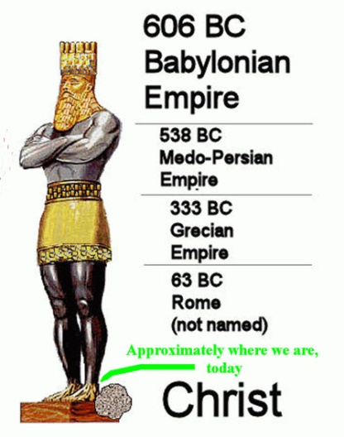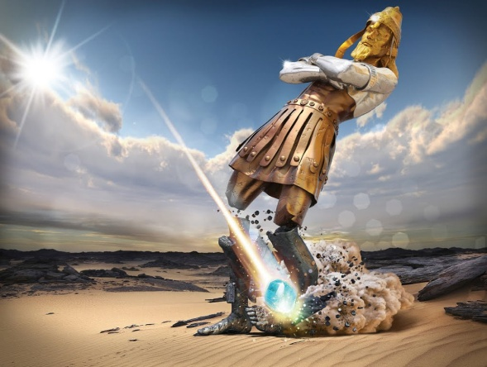
“The Kingdoms of this world have become the kingdoms of our Master and of His Messiah, and He shall reign forever and ever!” (Rev. 11:15) Messiah, the great Rock of Heaven, destroys the kingdoms of this world at His coming.
I John 4:4: “You are of Elohim and have overcome them, because greater is He who is in you, than he who is in the world.”

Head of Gold: The Ancient Babylonian Empire under King Nebuchadnezzar (Daniel 2:32-33, 38 and Daniel 7:4, 17)
The Chest and Arms of Silver: In 538 BCE, King Darius the Mede conquered Babylon, about a year earlier his nephew King Koresh/Cyrus of Persia took the reign from former Babylon (Daniel 2:32, 39, Daniel 7:5; Daniel 5:30-31; Daniel 6:28)
The Stomach and Thighs of Brass: The Greek Empire under Alexander the Great conquered the Medes and Persians in 333 BCE (Daniel 2:32, 39, Daniel 7:6 and 8:20-22)
Legs of Iron, Feet, and Toes of Iron and Clay: In the order of Kingdoms, the legs should represent Rome, the empire that followed Greece, also known as “the “second Babylon” from the first century. However, though the legs, feet, and toes represent Rome partly, it is not totally Rome; it is not a “revived Roman Empire.” America is known as the final Babylon/end-time Babylon. As Daniel 7:7 says, this 4th “Beast”/nation also represented by the legs, feet and toes of Nebuchadnezzar’s statue, is “different” than all the rest, more powerful. Out of it comes the Beast, called “antichrist,” or “anti-messiah.”
Daniel 2:27-29: “Daniel answered before the king and said, `The secret which the king is asking--the wise men, the astrologers, the magicians, and the diviners, are unable to show it to the king. But, there is an Elah in the heavens who reveals secrets, and He has made known to King Nebuchadnezzar what is to be in the latter days…And He who reveals secrets has made know to you what shall be after this…’ Then Daniel told him what he dreamed, and the interpretation, given to Him by THE KING of heaven and earth--Yahuwah. Keep in mind that what was shown to Daniel, written in Daniel chapters 2 and 7, and shown to Yochanan by Messiah in Revelation 9:11, and Revelation 13:1-2 are for our day. This is something we have to know if we are going to discern what is of Yahuwah and what is of Satan.
Let us know look at some specifics: Daniel 2:33-34, 40-43; Daniel 7:7, 17-27) In Daniel 2:31-35, we have what Nebuchadnezzar saw. In Daniel 2:37-45, we see the interpretation. In Daniel 7, we see an amplification of Nebuchadnezzar’s prophetic statue dream in the form of four beasts. But, in each case, the world empires, followed by the final ferocious one, is followed by the return of Yahushua Messiah, who vanquishes all the kingdoms of this world, and He takes the seat of authority over His entire creation.
In Revelation 13:1-2, we see the manifestation of this Beast in human form, empowered by Satan with his authority and his throne, ruling over a one world government, a united kingdom. But, just when he thinks he has it all under his power, there is a great earthquake, and Yahushua descends, the resurrection of the justified/saved takes place. The army of the Beast/anti-messiah tries to shoot down Yahushua and all of us, (Revelation 19:19), but they miserably fail. Yahushua then sends one huge angel from His Kingdom to grab the Beast (world ruler/anti-messiah), and his false prophet, and throw them into the lake of fire (Revelation 19).
What we are seeing now in America, and across the world in its many forms, is the Globalist’s takeover of the earth to hand it to this Beast. To do that, we’re watching this Elite group of world controllers, guided by their Nephilim leaders in their destroying of governments, economic systems, militaries, religions, power structures of all types, and their plans to offer the lives of billions of people in sacrifice to Satan.
For months, even years in some places, Abba has been teaching me about this secret cabal that has always been here, but began its final campaign for its final goals with America in the 1600s. Alliances were formed that are now stronger than any other alliances in the world, religions formed, wars planned, destruction of earth using ancient pre-flood technology, and uniting of the goals of all who worship the fallen ones. I have been learning day and night for several months the roots of all of this, and understanding Nebuchadnezzar’s end-time statue dream as He has taught me. Now it is crystal clear, and I am going to share it with you. You must not be in the dark about what is happening around you and where it is heading to.
There are many with opinions, but I decided years ago I wanted no human opinions. I study from Genesis to Revelation, and Yahuwah brings factual research to confirm what He is saying. Anyway, can tap into His knowledge if they’d only let Yahuwah’s Spirit teach them. He does use His trusted servants, and even secular people, to confirm what He has taught us.
He never leaves in an ethereal realm of spooky spirituality. He is a Father. He is also Teacher of solid truth, and He confirms with solid truth so that our faith is anchored in reality –not fantasy. And if we are truly born again, and have asked His Spirit to fill us, then our Teacher lives within the middle of us (our loins area) and He knows how to speak to the re-born spirit, but also to the soul’s mind--the mind of those who are totally submitted to Him that is.
A couple of days ago, I finished (for now) copying quotes from most of the 20 books and some articles I’ve been reading. I have painstakingly copied off at least 150 pages, so far, of quotes from the books. The quotes give shocking, mind-boggling information that is known by government insiders, military insiders, by astute researchers--and men and women who are privy to this insider knowledge, yet are compelled to share it.
What has NOT been told to the American public from the late 1800s especially, but back as far as the 1600s, is so huge that I have to take the knowledge in doses to keep my mind from shutting down. But, finally, I am absorbing the enormity of this vast documented information about what American has been doing – especially from the time of the return of key fallen angels and Nephilim for our final 120 years of Yahuwah’s “striving” with those who are also men (Nephilim/hybrids).
I ask Abba “why do I have to study this?” He has kept me awake many nights clarifying – especially Nebuchadnezzar’s lower statue. But, His Presence is so real and strong, that I know this knowledge is leading to future assignments for Him, connecting past assignments as well. I do not set dates, nor do I give my opinion. On his subject, I am not thoroughly solid in any conclusions. I still study--Abba will confirm conclusions/dogma.
America, as I’ve written over and over, and is spelled out in my article “America’s Secret Destiny,” from DVDs by astute researcher Chris Pinto, and a book by Manly P. Hall, was “chosen” to complete the goals of the fallen ones and their leader Lucifer/Satan, actually, the goal of Nimrod himself – to reincarnate Nimrod and bring him to power once again, and to establish a one world government, a “Golden Age,” for the Nephilim to rule earth once again, as they did before the Flood.
We sure are in “the days of Noah,” as Messiah told us in Matthew 24:37-39, and in Luke 17:26-33 which speaks not just of Noah but also of the days of Lot. Tracing history also, we find that the spirit of Babylon moved from ancient Babylon into Pergamum, the “throne of Satan,” as described in Revelation 2:12-13. The connection between this “throne,” once in Pergamum (Turkey), moved by German archeologists into Berlin in the late 1800s, Hitler, and Obama, is a fascinating understanding. You can get it all in the article “The Pergamum Altar - The Throne of Satan,” under the Mikvah of Present Reality. The article’s pictures alone tell a lot! But, the knowledge of this throne, the altar of Zeus upon which the martyr Antipas was slow roasted by fire in the carcass of a bull, has a lot to do with what we’ve seen since 1933 and will see until Messiah comes.
If you have NOT read the first article of my recent trilogy--“Israel! Yahuwah’s Chief Reason for Judging America – The Reason Why He Is So Angry and Why His Judgment Will Be So Severe”, under the Mikvah of Our Eternal Inheritance--please read it – for this is #2 in a trilogy! The information in this most basic subject is in layers from articles 1 to 3.
In that first article, I barely gave you the tip of the iceberg about why He has to judge America – because of what we have done to His people, to Israel, and what we are doing, and what we plan to do, not just regarding the nation of Israel, but His people inside America and worldwide. The aiding of the enemy to kill the sons of Ya’cob puts the blood of millions of Jews and true believers in the true Messiah of Israel on the hands of those in American government, intelligence, corporations, and banking. I am being conservative in this statement. Their blood also is on the hands of the British, but especially the Jesuit and the popes of the Vatican, and that just since 1938, even down to the British paying Nazi Arabs to conduct the attacks Israel on May 15, 1948. Nazi Arabs you might say … Think of the original terrorist group, the Muslim Brotherhood. Yip – right! - Created by the Nazis for Nazi Arabs, which spawned all the other terrorist groups. American government is full of Nazis.
And what does NAZI stand for? – NATIONAL SOCIALISM! Thus the government is filled with Nazi-thinking socialists, and their true partners, Communism and the Jesuits. Oh by the way, the Jesuits worked with Karl Marx to create his Communist Manifesto. It’s all just in black and white! There were even Nazi-Socialist presidents from the 1950s. So wow – Donald Trump has stepped into more than a swamp – he’s stepped into a cesspool that has its entry point in Hell.
So much evil has been hidden, just like now, the American press daily is centering on the sins of Hollywood stars, producers, directors, etc. and government leaders who are being charged with sexual misconduct—but not mentioning the treason and other horrors committed by Hillary Clinton and Barak Obama that are blatantly out there and found to be true. And while Americans are horrified at all the sexual misconduct, the Globalists (Nazis/ National Socialists, Communists, Fascists, Luciferians and Satanists, same-same) are about to launch their final goals, beginning with what Russ Dizdar describes in The Black Awakening, to bring the chaos that will bring the Order, New World Order. The goal is to return to a pre-flood “Golden Age,” when the world was ruled by the gods--fallen angels and their offspring.
In this article/study, I want to concentrate on the legs, feet, and toes of the statue. But, first, as stated above, the head of gold is Babylon. At that time it represented Nebuchadnezzar, king of Nimrod’s Babylon. (Genesis 10:8-11 and 11:1-9)
The head of gold is Babylon, the shoulders, chest and arms were of silver representing Media/Persia, the belly and thighs were of bronze representing Greece. But, Rome by itself is not the legs of iron, feet and toes, neither is Rome the Beast of Daniel 7:7, though it is involved. Near the end of the article you’ll see a chart showing the “Holy Roman Empire” as the fourth beast – that is close, since the “Holy Roman Empire” was neither Roman, nor an empire, nor holy! It was German!
Daniel 2:31-35, 44-45, THE DREAM: “You, O King, were looking on, and saw a great image! This great image, and its brightness excellent, was standing before you, and its form was awesome. This image’s head was of fine gold, it chest and arm of silver, and its belly and thighs of bronze, its legs of iron, its feet partly of iron and partly of clay. You were looking on, until a stone was cut out without hands, and it smote the image on its feet of iron and clay, and broke them in pieces. Then the iron, the clay, the bronze, the silver, and the gold were crushed together and became like chaff from the summer threshing floors. And the wind took them aay so that no trace of them was found. And the tone that smote the image became a great mountain and filled all the earth.”
Of course, that Stone is the Rock of our salvation – Yahushua Messiah. When it says in Revelation 11:15, “…the kingdoms of this world have become the kingdoms of our Master and of His Messiah, and He shall reign forever and ever,” we should stand, raise our hands to heaven, and praise Him, calling for our great Rock to come with His Kingdom to rule over us.
In a world that is calling loudly, and working hard, to return the gods of old, fallen angels, the Nephilim, to bring them from the pit, from the “four winds” of heaven, to call them from the cosmos too, shouldn’t we be calling for our Rock? Psalm 18:46: “Yahuwah lives! And blessed be my Rock! And exalted is the Elohim of my salvation.”
Daniel 7:7 had his own dream, in which the four empires/kingdoms of the statue appeared as beasts. Speaking of the legs, feet, and toes: “After this, I looked in the night visions and saw a fourth beast, fearsome and burly, exceedingly strong. And it had great iron teeth. It devoured and crushed and trampled down the rest with its feet. And it was different from all the beasts that were before it and it had ten horns.”
Daniel 7:9-10: “And I was thinking until thrones were set up, and the Ancient of Days was seated. His garment was white as snow and the hair of His head was like clean wool. His throne was flames of fire, its wheels burning fire. A stream of fire was flowing and coming forth from His Presence, and a thousand thousands served Him, and the Judge was seated, and the books were open.” (Also refer to Revelation 4-5 and 20:11-15)
As we read in our study of Revelation via podcasts, now also via transcripts under the Mikvah of Our Eternal Inheritance, Revelation 17:7-12, building on Revelation 9:11 and 11:7, describes the same thing that Daniel 2 and 7 described.
In the podcast on Revelation 17:7-11, I did not know what I know now! So, today, we will concentrate on Revelation 17:10-11: “And there are even kings: five have fallen and one is, and the other has not yet come, and when he comes, he as to remain a little while. And the beast that was, and is not, is himself also the eighth, and is of the seventh and goes to destruction.”
Reviewing a speck: The 7 world empires/kingdoms that have ruled over His people to harm them in the past are: 1) Egypt, 2) Assyria, 3) Babylon, 4) Media/Persia, 5) Greece, and 6) Rome. At the time Yochanan saw the Revelation in 95-96 CE, Rome was the ruling power. Eventually the empire split into two parts – West and East. In 2016, Pope Francis “reconciled” the eastern part with the Vatican. But, when it appeared that Rome totally was gone forever by the 5th century, it was not gone at all--it hid in Constantine’s Roman Catholic Church, a conglomerate of all pagan religions that he created to unify his monstrous empire. It hid in the papacy, which carried on the idea of Emperor worship and control over nations. Its arm of influence increased 100-fold with the Jesuits, from the early 1500s, who were dedicated to making sure the world came under the power of the pope. Today’s Pope Francis being a Jesuit.
But, as we see, on the surface, Rome surely is not what it was—not like under Julius or Augustus Caesar, or under Emperor Hadrian by the second century.
Today, it seems like we have power nations, vying for supremacy, like America, Russia, China, and of course the infamous new kid on the block – North Korea, plus other nations vying for power in their immediate region like Iran, now Saudi Arabia making its move. But, where are the legs, the feet of iron, and the toes, a mixture of iron and clay? You and me sure aren’t supposed to know that, but Abba reveals secrets to His servants, doesn’t He?
Daniel 2:19-22: “Then the secret was revealed to Daniel in a night vision, and Daniel blessed the Elah of the heavens. Daniel responded and said, `Blessed be the Name of Elah forever and ever for wisdom and might are His. And He changes the times and the seasons. He removed kings and raises up kings. He gives wisdom to the wise and knowledge to those of understanding. He reveals deep and secret things. He knows what is in the darkness and light dwells with Him.’ ”
Amos 3:7: “For the Master Yahuwah does nothing unless He FIRST reveals His secret to His servants the prophets.”
Mark 4:22, 25/Luke 8:17-18, (note: Yahushua opens up secrets to all who will possess what He has given to them): “For whatever is hidden shall be revealed, and whatever has been kept secret shall come to light…For whoever possesses, to him more shall be given; but whosever does not possess, even what he thinks he possesses shall be taken away from him.”
We possess knowledge, wisdom, and understand, as He teaches us His Word, and as we walk in it in obedience to Him! Matthew 25 has three parables about what it means to possess, and what it means to not possess.
As Daniel said about the 4th Beast, which is the same as the legs that cause the feet to move, legs that support the ten toes/same as the ten horns of the Beast in Daniel 7--is very different from all the others. Therefore, the fourth Beast, the Beast of Revelation 9:11, 11:7, 13:1-2, etc. is NOT a “revived ROMAN EMPIRE” – not as fundamental Dispensational end-time prophecy teachers have told us at least. It is “different!”
Yes, there are two legs, powerful legs of iron. Legs get their directives from the head. The mind is what causes the body to work, the legs, feet, and toes to move in the direction the head leads it. Therefore, since the head is Babylon, the legs, working in total union with the head/mind and its desired direction, must be controlled by the spirit of Babylon!!!
Rome, in the first and second century at least, was known as “the second Babylon.” That is well documented by sources that lived in that time-era. Pergamum was part of the Roman Empire also, a center of Roman Emperor worship, seat and throne of Satan. America is well described in the Word as the “final Babylon,” i.e. Jeremiah 50-51, in which there are 30 clues as to this end-time nation. [Refer to: “Thirty Clues and More Identifying America in Prophetic Scripture”] You can also refer to “End Time Babylon.” This is a subject I began studying in 1992. I am now, finally, not the only one so boldly teaching this – it’s obvious. But, again, America was created to bring forth Nimrod once again. The main ruler-gods of the ancient world, like Osiris of Egypt, and Apollo of Greece, are just other names for Nimrod.
So, here we have the legs, both under the control of the head/Babylon for the direction of the feet and toes, being both connected to Babylon in their history and purpose. Members of the secret Elite of Europe and America, and the papal royal Dynasty of Rome, have roots in ancient Babylon.
The amazing unity of Rome and America goes deeper than that. In its early history, the founding fathers wanted to name our capital, “Rome.” From the early 1600s, the Jesuits came over on the Mayflower disguised as Pilgrims. Their history in America is well documented, their infiltration, their takeover, along with their friends the Scottish Rite Freemasons. So, here you have a tremendous unity from Babylon through Rome to America. I have suggested that you read the autobiography of Charles Chinique many times – Fifty Years in the Church of Rome. Chinique documents the spread of Jesuit influence and their takeover of the U.S. government, finances, universities, etc., from earliest times. They didn’t stop with America, as I have said in the podcasts on Revelation. They went on to take over the whole economic, commerce, and trade systems of the world, governments, religions, and militaries, they themselves being the military arm of the Vatican. As the military arm, they have literally slaughtered, and helped other nations slaughter multi-millions of Jews and Christians – those who put the Bible over the pope’s authority.
The purpose of the priests and nuns who participated in the infamous Ustashi slaughter of citizens in Croatia and Yugoslavia, also in Belorussia, with the approval of Hitler and the Nazis, was to kill all who would not convert to Roman Catholicism, the Eastern Orthodox Christians as well as Jews. Even hardened Nazis reported that the torture and cruelty of the slaughtering by the Ustashi was sickening to them. Most of those priests and nuns were Franciscans.
The years of concentrated national Inquisitions never died, they just went worldwide. I’ve written several articles on this (2013-2014), but first refer to: “We Played the Flute for You But You Did Not Dance,” a warning of the coming Inquisition by the Jesuit-controlled Vatican, under the Mikvah of Present Reality.
America has been under the control of Jesuits for most of its existence, and other secret societies working to bring about the new world order with a resurrected and reincarnated Nimrod/Osiris/Apollo/Apollyon-Abaddon-- Revelation 9:11, 11:7, 17:8, II Thessalonians 2:3, Revelation 13.
I have studied the connection of Vatican, especially the “Society of Jesus”/Jesuits with America, for many years, and the Babylon connection. As Charles Chinique relates from his personal friendship with former president Abraham Lincoln, Lincoln knew that the pope started and funded our “Civil War,” and that he was ordering the Jesuits to kill him. By starting many wars worldwide, the body count rises from the orders of the Jesuits. Their occult and satanic philosophies also match that of the Nazis (National Socialists) and Hitler himself. They are all rooted in the ancient occult, and desire to return the fallen ones to world power. This is behind the evil of Globalism.
Below is a very small sampling of quotes by Hitler, telling of his close connection with the Vatican, before and during World War II. But, because the Jesuits and the Nazis are so in unity regarding their goals, the relationship continues today, especially in the takeover of America, and thus the world, for the establishment of “Globalism,” under one Fuhrer with his one “false prophet.”
It was the Vatican who formed the “rat lines” after the war that helped chief Nazis escape, mostly into Catholic South American countries. Adolf Hitler was a devout Catholic, but also highly admired the Jesuit order so much that he fashioned his on military from the writings of Ignatius Loyola, a Spanish military man, founder of the Jesuits.
From Edmond Paris’ Secret History of the Jesuits: ““If pope Pius XI and Pius XII’s goodwill and friendliness never failed toward the Fuhrer whom they had brought to power, we must admit that he fulfilled all the conditions of the pact by which he was bound to the Vatican.”
“…the Spanish dictator (Franco) published on the 3rd of May 1945, the day of Hitler’s death: `Adolf Hitler, son of the Catholic Church, died while defending Christianity. It is therefore understandable that words cannot be found to lament over his death, when so many were found to exalt his life. Over his moral remains stands his victorious moral figure. With the palms of the martyr, God give Hitler the reward of victory.’ This funeral oration of the Nazi chief…was voiced by the Holy See itself, under the cover of Franco’s press.”
Hitler said: `I learned much from the Order of the Jesuits,…Until now, there has never been anything more grandiose on the earth, than the hierarchical organization of the Catholic Church. I transferred much of this organization into my own party…I am going to let you in on a secret…I am founding an Order…we will raise up a youth which will make the world tremble…’ ”
“Another highly placed Hitlerian, Walter Schellenberg, former chief of the German counter-espionage, completed this confidence from the Fuhrer after the war: `The S.S. organization has been constituted by Himmler according to the principles of the Jesuit Order. Their regulations and Spiritual Exercises prescribed by Ignatius of Loyola were the model Himmler tried to copy exactly…The Reichsfuhrer SS…Himmler’s title as supreme chief of the SS—was to be the equivalent of the Jesuit General and the whole structure of the direction was a close imitation of the Catholic Church’s hierarchical order.’ ”
Hitler said of Himmler: “`I can see Himmler as our Ignatius of Loyola.’ ”
Hitler was dedicated to practicing the military disciplines found in Loyola’s Spiritual Exercises, which were really an open portal for input from the dark kingdom. Another who religiously practices these “exercises” is Pope Francis, a devout follower of the occultist, Loyola.
“…Michaele Schmaus, Jesuit theologian, presented to the public a series of studies on this subject `Empire and Church’ is a series of writings which should help the building up of the Third Reich as it unites a national Socialist state to Catholic Christianity. `Nothing is more contrary to Catholicism than democracy…The national-socialist (Nazi) commandments and those of the Catholic Church have the same aim…’
Edmond Paris goes on to say: “Quotations such as these could be multiplied by the thousands.”
OK for the legs and the unity of them. And who are the “trampling feet” that Daniel talks about that trample the whole earth, using support from the ten toes, or as Daniel 7 and Revelation 17 say--the ten horns? The Beast is political realm all of his own – the 8th Beast. But he is “of the seventh” kingdom – the empire/kingdom that was and is still supported by the Jesuits of the Vatican and by America.
THE SEVENTH EMPIRE OF REVELATION 17:10-11 is THE FOURTH EMPIRE OF DANIEL 2 AND 7:7 …
Follow me closely now: I am NOT giving you, at this point anyway, “thus says Yahuwah,” even though He has led me to this information. I cannot be dogmatic at this point on who the Beast/anti-messiah is, yet all that Abba has led me to study keeps coming back to one final empire and one final leader. I share with us as I learn, but you must learn from Abba for yourself!
Bottom line: I am not afraid of Truth, and neither should you be!
I sure didn’t seek this out because I wanted to! I really never intended to all these months of study on this subject. I’d done years of study on end-time America, Jesuits and the Vatican, on Constantine’s Christianity, too, but not the Nazis (acronym for National Socialism). Know that Socialism is what binds Communism, Fascism, and Feudalism together against Democracy and Capitalism. What the Globalists want is international Socialism, no countries with borders, all sharing earth’s wealth, with only controlling wealthy Elite and laboring slaves.
Remember! Anti-messiah comes out of the seventh empire, and he, himself, IS the 8th! Keep that in mind. Summarizing: 1) The Vatican, known as the “second Babylon,” which became a country within a country in 1929 with the Lateran Treaty of the Fascist dictator of Italy, Mussolini, is inseparably united to 2) end-time Babylon, America. The legs take the instructions from the head – which is Nimrod who sought world rule.
Look at the words of Genesis 10:10, speaking of Nimrod: “And the BEGINNING of his reign was Babel.” Nimrod began with his Babel/Babylon. He will end with modern Babel/Babylon! (Isaiah 21:9; Revelation 18:2)
Consider these basics: First of all, the seventh Empire is a relatively modern-day Empire that most of the world knows about and knows its history. Its leader is well known by face to most of the world’s people. It is an Empire that precedes the Empire of the anti-messiah, followed by the Kingdom of Yahushua Messiah. Secondly, it is an Empire that was totally, and I mean 100% intertwined with the Vatican and with America for its factories and corporations, banking support, weapons, money, and technology that it needed to conquer and bring forth the massive Nephilim technology it was receiving from the 1920s, during its “short time” of reign. Third, it was an Empire that rose up for a short time, then appeared to die and disappear from public view. It has to be a fairly recent Empire for people to be in awe and adoration of its rising and of its ruler, for them to worship and obey him.
As Revelation 9, 13, and 17 tell us, the leader of the seventh empire will return to the awe of the world! Fourth, its leader seemed to die. Whether he died as they are led to believe by bullet wound to the head, or whether he died at an old age elsewhere means little--it is what the world’s people believe that is important for pulling off the ruse. Then his body disappeared, and the world put it all into “history.” But, when he rises (Revelation 9:11) and begins his rise to power, the world will be in awe of him to the point of worship and obedience. 1) Modern man must be able to recognize him by face, 2) he must be a powerful figure that commands respect and submission by the world’s people also, and 3) his Empire not only rises too, but has increased from a National Empire to a worldwide Empire!
During the time of this final Empire’s disappearance from the public eye, it has hidden itself well and grown into a world power by slowly imbedding itself, like a tick, in the fabric of the world-recognized super power nation.
In 1945, America became known as the super power of the earth. Thus this finale empire has used America as its nourishing and hiding place, from where it has grown strong and powerful, and ready to take on the world – its goal from the beginning of its inception.
The word “Reich” means Empire! America is not only filled with infiltrating Jesuits and Masons from the 1600s, but from 1945, their friends the Nazis joined them. Between the Jesuit and the Nazis/National Socialists, haters of democracy and capitalism as Pope Francis has let us know, and the infiltration of the occult/Nephilim or fallen angels and their arcane technology from pre-flood days, we have a clearer picture of what is really happening in our nation and the world today to prepare for the rise of anti-messiah!
In America, unhindered by Jesuits and communist elements, this Empire and its Nazi key scientists, doctors, and intellects in general, went on, via Operation Paperclip, to become rulers within America, having taken been given America’s aerospace industry, weaponry, military, outer space exploration, high positions in universities, the American medical and psychological leadership, drugs, chemicals, leaders of corporations, and intelligence organizations, even creating terrorist groups from their Arab friends, and even many taking key positions in the U.S. government, as high up as the President.
SO, though this Empire seemed to die and its leader too, it is today emerging, its form of government merged with communism and fascism, so that it is now a world power rising once again to lead the world to a one world government under its resurrected leader--once again with the full support of the Vatican and America. The legs are indeed moving the feet into trampling position!!! There are many published book and articles and discussions going on now about a FOURTH REICH, emanating from America that will be a world government.

The Trampling Feet and Toes--Iron Mixed with Clay
In general, when people think of “trampling feet” they think of army military boots, in which are the feet of the army marching in unity to war.
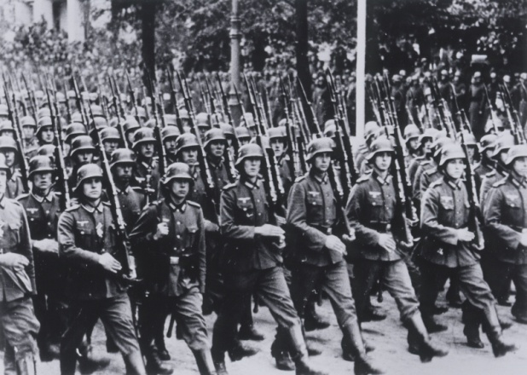
WWII photo of Nazis marching into Poland
Alexander Hyslop, famous author of The Two Babylons, (c. first in 1853) said, “…the true legitimate Babylonian Pontiff, after being driven out by the Medes and Persians was at Pergamum. Later on the Pontiff of Rome and the Pontiff of Pergamum became the same, the Pontiff of Babylon being absorbed into the Pontiff of Rome.”
[I urge you to read now, or after this article, the documented article on Pergamum, complete with pictures, relating it to Hitler and the Nazis: “The Pergamum Altar – The Throne of Satan” under the Mikvah of Present Reality. This altar not only involves Berlin, Hitler, Nazis, but also Barak Obama]
“Aurelian was the Emperor who established the sun as the supreme deity of Rome,” says C. J. Koster, and “the term `mystery Babylon’ refers to the fact that now Babel is Rome and the one world government is headquartered in the USA.” (We see America in many Scriptures, i.e. Jeremiah 50-51, Isaiah 10, 13, 47 and Revelation 18)
The historic reality of the moving of the spirit of Babylon from Babylon, to Pergamum, to Rome, into Western Europe via Rome, and into the United States cannot be disputed in any way. Are you seeing the unity of the legs and feet?
The only Empire/Reich that could possibly be rising worldwide now is the “Fourth Reich,” which is the unity of Rome and America guided by Nazis (National Socialists) who are also compatible with Communists. The pope recently said that Europe and America should return to a Feudalistic society, where everyone was equal and shared all their possessions. Yet, he did not say that this would make us slaves of the rich.
In Jim Marrs’ book The Rise of the Fourth Reich, Marrs’ gives a magnificent overall picture of the Third Reich, and how it, via America, is fast becoming the Fourth Reich sponsored by the American tax-payer’s money. IF you read any book of my long list of references, to get a good over-all picture of this whole thing, I refer you to Jim Maars’ book!!!
Bottom line: The legs assist the feet to move and give it direction, via the head/mind/will. I’ve gone into detail on the legs and who they represent. The feet, as I have come to strongly consider, not as dogma set in flint rock yet, because I am still learning, represents the seventh and modern-day Final Kingdom/Fourth Reich that grew out of the Third Reich. The Third Reich, which never would have been possible without America’s and the Vatican’s support, is now a worldwide Fourth Reich that will endured a “short while.” The Third Reich lasted from 1933-1945. It is now becoming visible as a fourth Reich, once again with the help of the Vatican and America. Again the Fourth Reich will be for a short time as per Revelation 12:7-12 – the time of the Dragon’s short time. This Final Kingdom, the Nazi Reich/Empire or Kingdom, has now grown, assisted by the Jesuits and America, into a worldwide kingdom that is returning to create a Fourth Reich, with the support of the “toes,”- financial, political support, controlled by supernatural forces – i.e. returned Nephilim--those from under the earth (Revelation 9; Joel 2; Revelation 16 with Zechariah 14:1-5 and Ezekiel 38, and Revelation 19:19)--the army that will confront Messiah at His return--the army of the anti-messiah/Beast)
That may be a mind-blower to you. It is to me. Abba is controlling my massive study with His input day and night. I still, however, have it all on the shelf before me and before Him.
It is known that one cannot walk without properly extended toes. This is where the 10 horns, or powers, of the Beast come into play, and the 10 toes of the statue of Nebuchadnezzar’s dream. Horns represent powers, leaders of powers. They are 10 who help the Beast to walk – to trample. The Beast cannot trample without them. Therefore, the toes are the SUPPORT system of the Beast.
Revelation 17:12-14: “And the ten horns (or ten toes of Nebuchadnezzar’s dream-statue) which you saw are ten kings who have not yet received a kingdom, but receive authority as kings with the Beast for one hour. They have one mind, and they shall give their power and authority to the Beast. They shall fight with the Lamb, and the Lamb shall overcome them, for He is Master of Masters and King of kings. And those with Him are called, and chosen, and trustworthy…”
This passage goes on to say that it is these ten who destroy the great murderous whore of Babylon – represented by the Cardinal Red, and the Purple garments of the pope, as described in Revelation 17:3-5. The debate has raged for many years as to who the whore of Babylon is that Yochanan saw – is she Rome? Is she America, as Revelation 18 implies—New York City. She is the wicked woman of Zechariah 5:5-11. As with many things in the Word, it is not an either-or, for both are true. The ten horns of the Beast, are the supporting factors that cause the Beast to be able to use the horns to “gore” his opponents. Without financial support, without money, without gold and silver, and whatever constitutes money, the Beast cannot attack his enemies.
Notice that the Beast has seven heads--for each of the seven empires used by Satan against the people of Yahuwah--Egypt, Assyria, Babylon, Media/Persia, Greece, Rome, and what we see today in a Reich/kingdom that also worships the same old gods/pre-flood Nephilim that the other six kingdoms worshipped.
So what ties the Nazi Reich to the other five? – Satan and the religion that came from the worship of the fallen angels and their hybrid offspring – the “men of renown,” of Genesis 6:2-4.
Yet, as in the dream that Daniel had, and in what Yoachanan saw in Revelation 17, the toes appear as horns on a great ugly Beast.
Feet and toes trample the earth and kill by trampling. But, horns are also used by beasts to ram and kill.
Armies have to have financial backing to go forth to kill their enemies. Thus, as toes support the body, and horns are used to “gore” the enemy, so these 10 economic regions of earth and their “kings” will stand with the Beast and support him and His Reich/Empire.
The Beast of Daniel 7:7, of Revelation 13 and 17, is a political Beast. But, politics and nations have to have financial support. Today we have ten economic regions of earth. Each is under the scrutiny of the United Nations, who call them “the ten kingdoms.” Their rulers have not yet manifested as world leaders. Here is a map of the already established ten kingdoms:
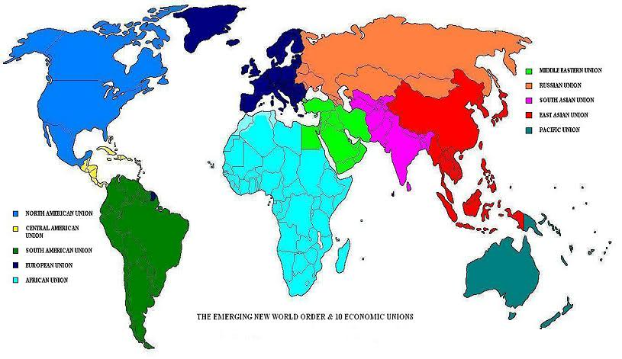
One more very important fact about the toes needs mentioning. The ten rulers that unite behind the Beast for his short time are NOT FULLY HUMAN! They are hybrids. Hybrids, offspring of the mating of fallen angels with humans, as in Genesis 6:2-4, and afterwards with the giants of Canaan, are abounding in our world, some created in underground laboratories also. But, these work with the fallen ones – the “principalities, powers, rulers of darkness in this world, spiritual wickedness in high places” from the kingdom of Satan. (Ephesians 6:1-18)
Daniel 2:40-44: “And the fourth kingdom is as strong as iron, because iron crushes and shatters all. So, like iron that breaks in pieces, it crushes, and breaks all these. Yet, as you saw the feet and the toes, partly of potter’s clay and partly of iron, the strength of the iron is to be in it, because you saw the iron mixed with muddy clay. And as the toes of the feet were partly of iron and partly of clay, so the kingdom is partly strong and partly brittle. And as you saw iron mixed with muddy clay, THEY are mixing themselves with the seed of men, but THEY are not clinging to each other, even as iron does not mix with clay. And in the days of these kings, the Elah of the heavens shall set up a kingdom which shall never be destroyed, nor the reign pass on to other people. It crushes and put an end to all these reign and it shall stand forever.” Stand and shout HalleluYah! Then read Revelation 19. The Kingdom of Messiah will crush the crushers!!!

Look at Daniel 2:44-45: “And in the days of these kings, the Elah of the heavens shall set up a kingdom which shall never be destroyed, nor the reign pass on to other people – it crushes and puts an end to all other kingdoms, and shall stand forever,” (Revelation 11:15). “Because you saw that the stone was cut out of the mountain without hands, and that it crushed the iron, the bronze the clay, the silver, and the gold, the great Elah has made known to the king what shall be after this…”
Former President Woodrow Wilson said of this secret cabal, this Nephilim-run shadow-government, this use of America to bring forth the incarnation of a “Nimrod,” or one his descendants, as the Beast to rule the world: “Some of the biggest men in the United States, in the field of commerce and manufacture, are afraid of something. They know that there is a power somewhere so organized, so subtle, so watchful, so interlocked, so complete, so pervasive, that they had better not speak above their breath when they speak in condemnation of it.”
Wilson, like so many others, know there is something hidden that is controlling what is happening, but they can’t put their finger on it. But, yes – the Revelation 18 merchants know that something is coming that will change life on earth drastically and suddenly.
Tom Horn’s newest book Saboteurs, pages 16-17, referring to the backlash of Trump’s election: “What you see happening in the media and extreme left right now is more than just the activity of `sore losers.’ This is the manifest incarnation of a FOURTH REICH (the term `Third Reich’ was coined by Arthur Moeller van den Bruck in the title of his 1923 book Das Dritte Reich. It was used by the Nazis for propaganda purposes to legitimize their regime as a successor state to the retroactively renamed First Reich (the Holy Roman Empire, 962-1806) and the Second Reich (Imperial Germany 1871-1918)…”
The term “FOURTH REICH” is appearing in books and articles, and being discussed openly, because historians see that what is happening in our world, especially in America, as a repeat of what happened in Germany from the 1920s to the end of World War II in 1945.
So YES! A Fourth Reich is now surfacing. It came out of the Third Reich as Nazis infiltrated the United States from 1945-1970s at least, under “Operation Paperclip.” Hundreds of the chief Nazi minds were quickly distributed throughout the nation, giving them citizenship, putting them in high positions in the government, in scientific research and many top-secret projects including mind control and the creation of hybrid super-soldiers for the military. Their genius, as Werner von Braun admitted, came from knowledge given to them from the 1920s by the under-earth Nephilim, whom they think of as the superior Arian race. A great number of these rocket scientists, chemists, medical doctors, psychiatrists, bankers, teachers, corporation leaders, intelligence experts, had blood on their hands – deeply involved with the murder of Jews and Christians in the death camps.
With the influx of thousands of Nazis into America, the philosophy/religion of Nazis – highly occult, highly demonic – began opening portals for the entrance of fallen angels and Nephilim forces to take over America – which they have!
IN EXCHANGE FOR NAZI SECRET OCCULT KNOWLEDGE AND TECHNOLOGY, AMERICAN LEADERS GAVE THE NAZIS THE MINDS AND BODIES OF THEIR CITIZENS TO USE IN THEIR EXPERIMENTS, AS WELL AS THEIR NATION FROM WHICH TO BUILD THEIR FOURTH REICH, OUT OF WHICH THEY WILL BRING FORTH THE WORLD RULER!
Remember they were experts in death – and in the occult – and today America is turning to the occult, to Satanism, to violence, to hate, more than ever before.
It might be good to keep in mind the word “REICH,” which in German means “EMPIRE” OR “KINGDOM.” What we see rising now in America is a Fourth Empire – the extended Third Reich - ruled by Nazi-Jesuit-Communist doctrine, and demons that drive it all.
The final Beast is mentioned under different names--32 times in the Tenach, and 13 times in the Messianic Scriptures. This is a huge subject – well covered in detail in the Word. Be taught by the Spirit and you’ll come to the right conclusions before we see it with our eyes.
Take joy in the coming Kingdom of Messiah Yahushua--the Stone cut out of the mountain that destroys the statue of Nebuchadnezzar’s dream. The 1,000-year reign on earth: Daniel 2:44; 7:9-12; Rev. 11:15; 20:6, Zechariah 14:5, 16; and Isaiah 35 as examples.

Briefly, let us look at what Daniel saw that is echoed by the dream of Nebuchadnezzar and the experience of Yochanan in heaven.
In Daniel 7:4, Daniel sees Babylon as a winged lion. In Daniel 7:5, Daniel sees Media/Persia as a bear lying on its side. In Daniel 7:6, Daniel sees a leopard, which is Greece. In Daniel 7:7, he sees the fierce beast, Rome, which is different than all the others
DANIEL 7:1-7 THE FOUR BEASTS
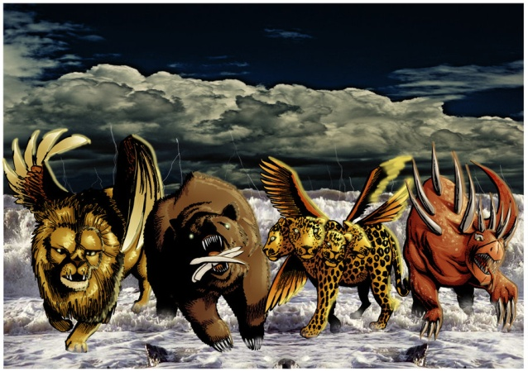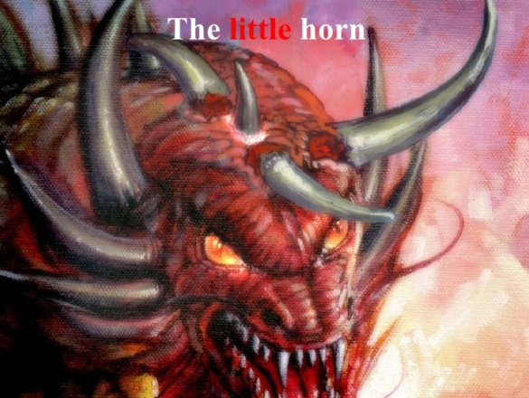
Daniel 7:1-7 Revelation 17:3-7

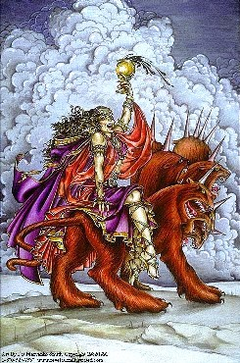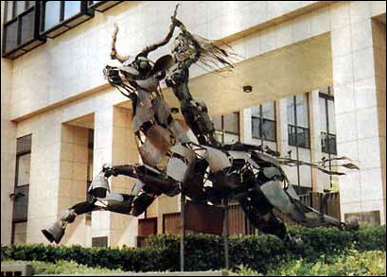
Daniel 7:8-28 Right: statue outside EU building in Brussels

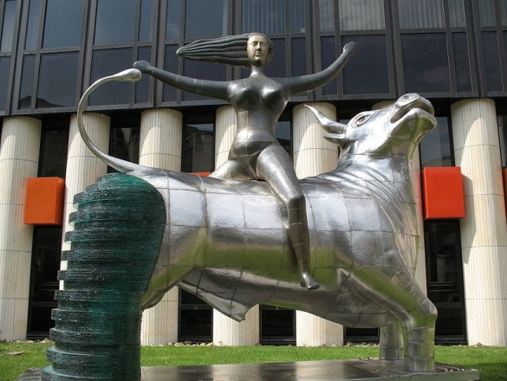
Note the EU Parliament Building built to resemble the tower of Babel
You may think me illusionary, but a spokesman for the E.U. made this statement a few years back: “What Nimrod started, we will complete.”
It is very fascinating to see all the statues of the woman riding the Beast in front of main E.U. government buildings. It goes back into myth and legend tied to reality. Europa, the woman, was captured by Zeus, disguised as a red bull, and taken away with him. The symbolism is stark, but Revelation 17:3-6 reveals its reality to us. The woman harlot of Babylon rides the political beast to power, but when the 10 kings grow tired of her, they kill her.
Daniel 7:17-18: “These great beasts, which are four, are four kings which rise up from the earth. THEN the set-apart ones of the Most High shall receive the reign and possess the reign forever, even forever and ever.”
The “little horn” is obviously the anti-messiah who comes out of this final empire of Nimrod’s Babylon, the restored “seat of Satan.”
The Masonic Statue of Liberty in New York Harbor gives us a clue about the knowledge of the Elite regarding the “little horn.” Please refer to the article, and its pictures, in “The Goddess That Rules America – In Plain Sight” under Present Reality.
Revelation 13:1-2: “And I stood on the sand of the sea, and I saw beast coming up out of the sea, having seven heads and ten horns and on his horns ten crowns, and on his heads names of blasphemy. And the beast I saw was like a leopard, and his feet were like the beat of a bear, and his mouth like the mouth of a lion. And the Dragon gave him his power, and his throne and his authority. And I saw that one of his heads was wounded as having been slain but his deadly wound was healed. And the world marveled after the Beast, and they worshipped the Dragon who gave authority to the Beast, and they worshipped the Beast saying, `who is like the beast? Who is able to fight with him?”
Revelation 9:11: “And they have a king over them, the messenger of the pit of the deep, whose name in Hebrew is Abaddon, and in Greek he has the name Apollyon.”
Revelation 11:7: “And when they have ended their witness, the Beast coming up out of the pit shall fight against the, and overcome them, and kill them.”
Daniel 7:21: “I was looking and this horn was fighting against the set-apart ones and prevailing against them.” This is anti-messiah – the 11th horn, who establishes his own kingdom.
Revelation 17:8: “And the Beast you saw, and is not, and is about to come up out of the pit of the deep and goes to destruction. And those dwelling on the earth, whose names are not written in the Book of Life from the foundation of the world, shall marvel when they see the Beast that was, and is not, and yet is.”
II Thessalonians 2:3: “Let no one deceive you in any way, because the falling away is to come first, and the man of lawlessness/sin (Greek “a nomia,” without the Torah), is to be revealed, the son of destruction (Greek: “apollea”/as in Apollyon).
Filling in more blanks: The seven heads, the seven kingdoms/world empires, and the seven mountains upon which the whore sits (Revelation 17:9: “…The seven head are seven mountains on which the woman sits) are well documented. Daniel and Yochanan emphasize the last 5 kingdoms … the first two are Egypt and Assyria.
Egyptian Empire under the Pharaohs – Exodus chapters 1-12
Assyrian Empire – (Its capitol was Ninevah, built by Nimrod) -- Genesis 2:14, 10:11.
In 722 BCE the Assyrian Empire took the northern 10 tribes of Israel captive to Assyria--later scattering them throughout the known world--II Kings 17:6-24: They lost their identity and mingled with the nations.
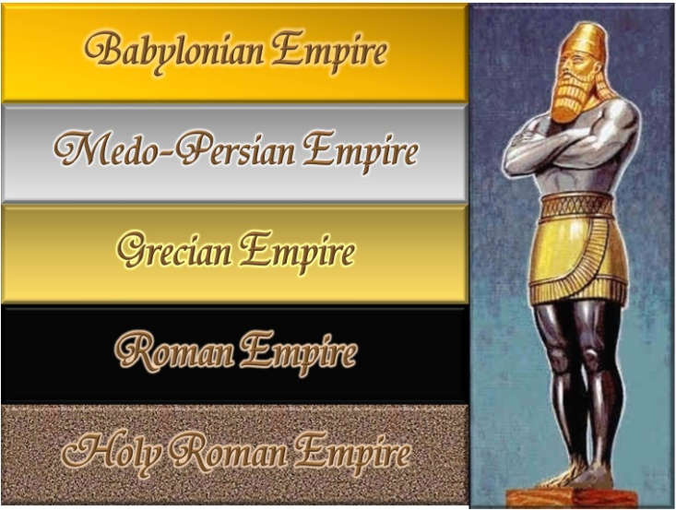
This diagram directs us onto the right path of thinking to find the path that leads to the final world Empire: Though the seventh world empire it is not the “Holy Roman Empire” revived, it has grown out of it. The first Reich or Empire was called the “Holy Roman Empire,” yet as Voltaire said, it was neither holy, nor Roman, nor an empire.
Some have opinions that the 7th is the Ottoman Empire, or a Muslim Caliphate to come. But, this is not according to the Scriptures, nor in the plans of the globalists. Though there were and are still Arab Communists and Arab Nazis, as we see from Nazi and CIA use of them, they were/are but puppets. The goal of globalists is to finally destroy all Jews and Arabs – most likely because most Arabs probably come from the union of Abraham and Katura, and the union of Abraham with all his concubines (Genesis 25), as well as from Lot and his incest-spawned offspring (Genesis 19).

I will stop here and continue with more information and more quotes and pictures in the third of the trilogy: “Nazis, Hitler, The Fourth Reich, and the Bestial Anti-Messiah.”
I conclude by repeating the glorious event from Daniel 2:44, which Daniel relates to King Nebuchadnezzar of Babylon. It is upon this event that we must focus our attention to continue in peace and joy. We are now in the “days of these sovereigns/kings”: “And in the days of these sovereigns, the Elah of the heavens shall set up a reign which shall never be destroyed, nor the reign pass on to other people--it crushes and puts to an end all these reigns, and it shall stand forever. Because you saw the stone was cut out of the mountain without hands, and that it crushed the iron, the bronze, the clay, the silver, and the gold, the great Elah has made known to the sovereign what shall be after this”.
For more good news, see Daniel 7:17-26, Revelation 11:15-19, and Revelation chapters 19-22!
Shalom, blessings and joy with expectant faith,
Yedidah
November 19, 2017

