Putting Puzzle Pieces Together
Sorting Out Truth Regarding the New Executive Order

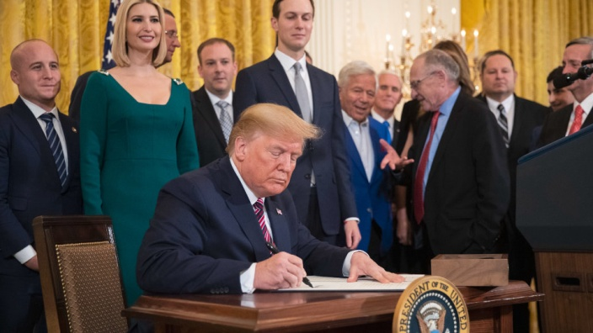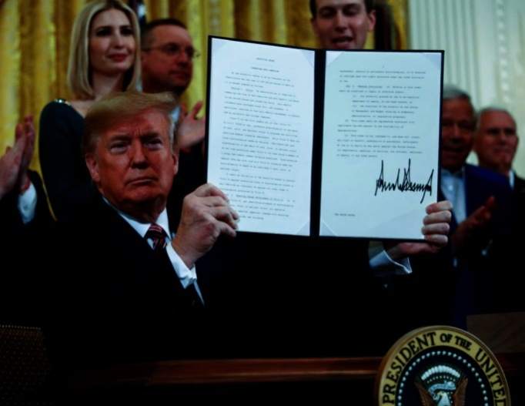

I encourage you to watch the recent video of Steven and Jana ben Nun with Pastor Chuck Baldwin regarding the recently signed Executive Order by President Trump, which Pastor Chuck Baldwin calls “treason.” Israeli News Live, December 14, 2019, “Examining Trump’s Executive Order With Chuck Baldwin.”

This article is based on information from ABC News and Baldwin’s interview. This latest Executive Order was signed by President Trump on December 11, 2019.
“Trump Signs Executive Order Targeting Anti-Semitism on College Campuses -
The Order signed Wednesday would expand the federal government’s definition of anti-Semitism.” Wall Street Journal
“Trump Signs Executive Order Aimed at Combating Anti-Semitism on College Campuses” – ABC News December 11, 2019
“WASHINGTON -- President Donald Trump on Wednesday signed an executive order aimed at combating anti-Semitism on college campuses, saying schools had an obligation to reject discrimination targeting Jewish people -- even as the president has been criticized for himself using anti-Semitic language.
The order states that Title VI of the 1964 Civil Rights Act -- which covers people who face discrimination for their race, color, or national origin -- shall apply to those who face anti-Semitic discrimination based on one or more of those factors. A senior administration official said the White House specifically had anti-Jewish discrimination on college campuses in mind.
This is our message to universities: `If you want to accept the tremendous amount of federal dollars that you get every year, you must reject anti-Semitism,’ Trump said before signing the order at a Hanukkah reception at the White House. It's very simple."
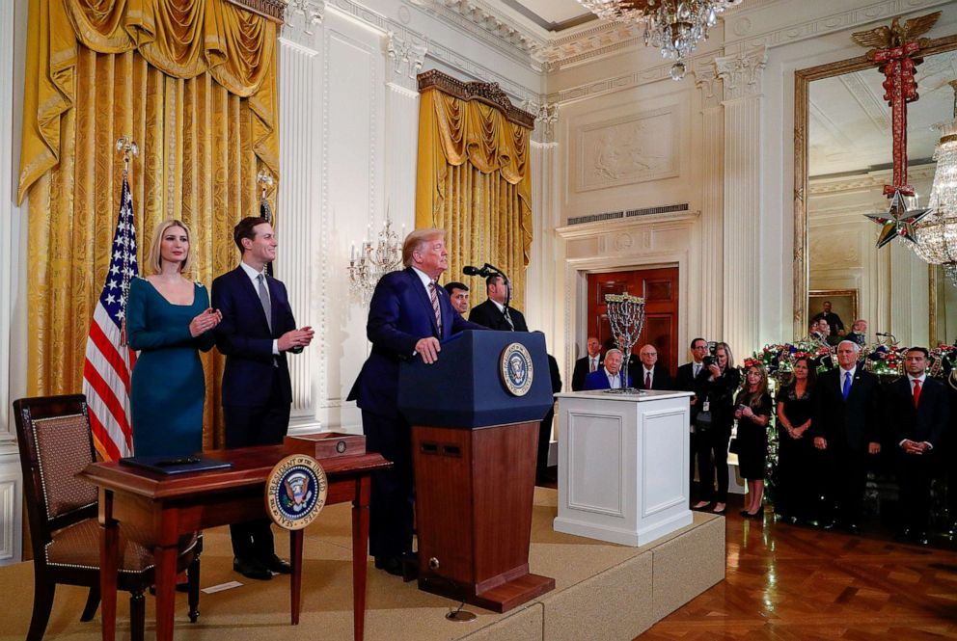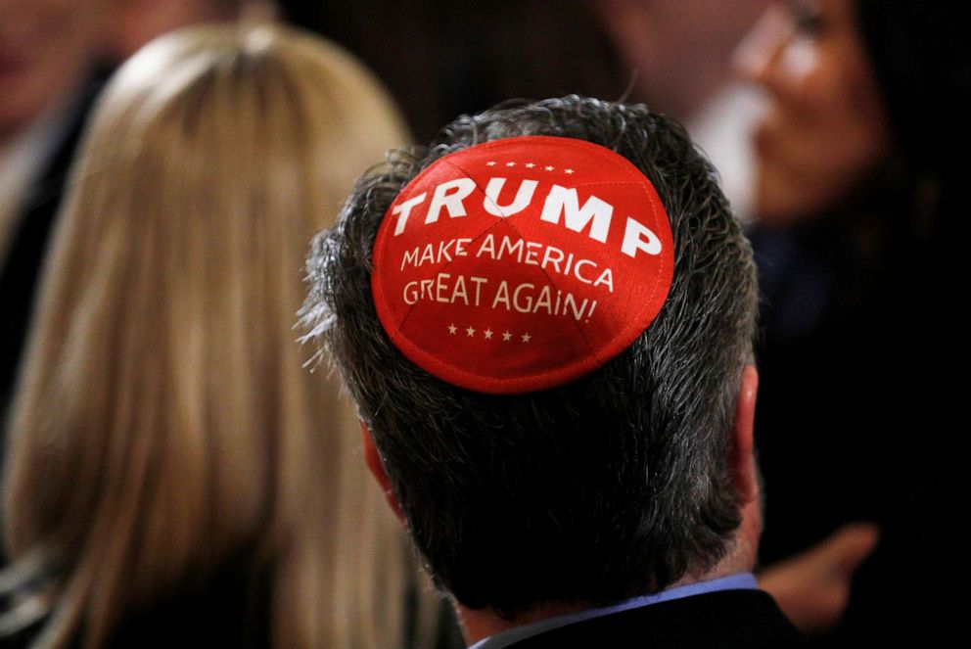
Note the Hanukkia on the white table. Note who stands behind the President…
“The White House said the directive constituted a response to a rise in anti-Semitic incidents in the United States. It instructs federal agencies to rely on a definition from the International Holocaust Remembrance Alliance that describes anti-Semitism as `a certain perception of Jews, which may be expressed as hatred toward Jews.’ The definition, posted on the State Department's website, cites examples that include criticism of Israel, such as claiming the state of Israel's existence is a `racist endeavor.’
The broad definition seemingly could include forms of pro-Palestinian speech, although a senior administration official said the executive order `includes a clear statement’ that it `should be applied consistent with the First Amendment.’
…Trump also invited Jewish members of Congress and supporters on to the front of the room, among them New England Patriots owner Robert Kraft and lawyer Alan Dershowitz, an outspoken backer of the president as he faces impeachment. Attendees sported yarmulkes with `Trump’ written on them and broke out in a chant of `four more years’ as the president finished speaking.”
I have written about the Anti-Semitic Bill that has passed the House but is in the Senate at this point. What this Executive Order exposes only confirms what Yahuwah is leading His children to understand about what is happening to bring the world under the Babylonian Talmud and its Noahide Laws.
This Executive Order, on the surface, looks like another good deed by Trump to protect Jewish people from discrimination, especially on college campuses where anti-Semitism has risen greatly in the last year. As stated above, colleges will be denied federal money if they do not observe this Executive Order.
It appears that President Trump is doing the right thing, as he did with acknowledging Jerusalem as the capital of Israel, putting the U.S. Embassy in Jerusalem, backing the Golan as rightful Israeli territory, and recently the proclamation that all Jewish settlements in the West Bank were legal. He backs Benjamin Netanyahu’s promise to annex the West Bank for legal Jewish settlements. It all sounds good – to most of his supporters.
Will Netanyahu continue as Prime Minister, even though a third election will be held in March of 2020? Will President Trump be impeached by the House? Will President Trump be impeached by the Senate? Will President Trump be re-elected?
Those two elections in 2020 are critical to the plans for the coming antichrist and the new world order. Go to Abba Yahuwah about it and remain in His shalom as

we move quickly into the fullness of the direction we’re headed.
I have written about and referred to President Trump from 2016 as the “looser” of Revelation 6:1-2. He carries no weapon, but he goes forth on a white horse to loose, and has since taking office in 2016. He began using verbal loosing as soon as he took the reigns of the presidency. Yet, since 2016, elements of the first five seals are also clearly seen on a worldwide platform.
In this Executive Order signed a few days ago, Trump made the statement that Judaism is a nationality. Pastor Baldwin cries “Treason!” He also cited that statistically Trump has 80% of the Evangelical Christian support in America. Pastor Chuck Baldwin’s said “American Christians, as a whole, are bewitched by Trump.”
Baldwin: “Trump is saying that for colleges/universities across America to continue to receive federal funding, they must squash any anti-Israel rhetoric.”
Baldwin said “Trump is crushing Christian freedom of speech also… in other words, to tell the truth about Israel is considered `hate speech.’ ”
Yet I’m sure you’ve noticed that worldwide there is silence regarding “hate speech” and hate actions against Christians and all believers in Jesus/Yeshua/ Yahushua.
About two months ago, Steven ben Nun showed a very disturbing clip from an Israeli television skit in which two young girls people, about age 13 or 14, were putting on a skit mocking the crucifixion of Jesus. One girl was acting like the dying Jesus on the cross. The other girl was mocking her as “Jesus,” poking her, and insulting her. It was horrible! The audience was laughing. This skit was aired on mainstream Israeli TV. In Israel today, Christians and Messianic Jews as well as Palestinian and Arab believers are being greatly persecuted, even killed, by radical Orthodox and Hasidic Jews. Where’s the outrage? Why are Israeli youth being taught to hate Jesus and mock Him? Are Israelis being mind-programmed to accept the antichrist and the murder of believers in Jerusalem?
As I have pointed out in 22 articles on the Noahide laws, America is ruled by Babylonian Talmudic Law in many ways already and has been for decades, going way back to the late 40s.
President Trump’s Executive Order includes punishment for any criticism of Zionism, or any telling of the mistreatment of the Palestinians by Israel, or what the Sanhedrin does or plans to do -- anything that appears to be criticism is now illegal by federal law, under the title “anti-Semitism.”
In this Order and in his speech, Trump officially named Judaism as a nationality.
Uhhhh … How can a religion be a nationality?
Baldwin, speaking the truth, says that free speech is being ended. He rightfully states that political national Zionism, basically Shabbtai-Frankism, rules the world. Yes the do, via the Rothschilds, Illuminati, Vatican Jesuits, and many organizations under these groups. By infiltration, from 1666, the followers of Shabbtai Tzvi and Jacob Frank have literally taken over the world’s governments, religion, military, banks and commerce, and the thinking of most people.
You can read all about it in “1666: Shabtai Tzvi and Redemption Through Sinning”/Mikvah of Israel, Our Eternal Inheritance. I have researched on this topic for decades, and more confirmation is coming in regarding it. The world basically is under the authority of fallen angels. The basic belief of Redemption through sinning is that we must throw out the Torah of Yahuwah and do everything opposite of what He says. Yes, this is the doctrine that rules the world!
It defies logic, but President Trump declared Judaism, which is basically Babylonian Talmudism and Kabbalah, as a “nationality.” What if a president said Christianity was a nationality?
As Baldwin said, this is a blatant attack on free speech, the First Amendment of the U.S. Constitution. It is one-sided. No one can speak against Israel, their treatment of the Palestinians, or their attacks on Syria and Iraq, but anyone can openly mock Jesus as was done on Israeli public TV recently.
Jana said about this Executive Order: “It is an education law” – connected to Rabbi Schneerson’s emphasis on education. She sees this as a Noahide-promoting law. “Judaism is Talmudism,” she said, so actually to speak against what Israeli leaders do, against wrong, or question what Israel does, is anti-Talmudism – anti-
Judaism. This is one more step to implementing the Noahide Laws worldwide.
Pastor Chuck Baldwin agrees. Knowing what I know, living next to and in Israel for most of 16 years, I know that what is being said by Jana and Steven and Pastor Baldwin is correct.
I love the Jewish people! I love the Arab and Palestinian people. They are like all people, most of whom want peace. So we pray for them, for their salvation and protection, and for wisdom to see things correctly. They are being used like pawns on a chess board; they do not know what is happening to them.
President Trump, and his son-in-law Jared Kushner, are avid servants of Chabad. To learn what Chabad is about, please read: “Chabad Listed As A Dangerous Criminal Cult”/Mikvah of Israel, Our Eternal Inheritance. It is controlling many governments around the world, including America.
Secretary of State, Mike Pompeo, recently justified the settlements in the West Bank, and now their legality is in Israeli law, also, as per President Donald Trump.
Most “millennials” today stand against the totalitarian treatment of the Palestinians in Israel. I’ve talked to concerned IDF soldiers, and read reports of an IDF inside the IDF. Israel’s Zionist government is acting criminally towards the Palestinians, Arabs, and Bedouins. Persecution of Palestinian believers is very real. Israel is bombing civilians in Syria, Iraq, and Gaza, supposedly to attack bad guys.
Pastor Baldwin sees that the college campuses are being targeted to change public opinion, for example to encourage Christian support of Israel. He sees Trump as a Zionist puppet. Yes, he does take orders from world government rulers among the Shabbtai-Tzvi/Jacob Frank inner circle, and Chabad.
I was on a bus going from Tiberias to Jerusalem just before Sukkot, in 2004. The bus was packed with IDF soldiers. They were even standing in the aisles. One Israeli soldier from Russia saw what was happening in Israel regarding the treatment of the Palestinians, and the Israelis who lived in Gaza. He poured out his heart to me. I sat in a seat by the aisle; he stood by my side. He said “there is an IDF within an IDF,” and the inside ones are causing conflict and harm to the Israeli residents in Gaza. He kept referring to the Tenach as he spoke.
At the same time, I knew that Israeli law forbade IDF soldiers from taking to anyone who lived the West Bank. One soldier took the chance to talk to a lady from the West Bank, and a fellow soldier tapped him on the shoulder warning him not to talk to her. The Israeli ambulance service is forbidden to go into the West Bank. One night late two IDF soldiers were guarding a settlement in the West Bank. Their commanding officer came in and took their rifles, saying he was taking them to be cleaned. About 30 minutes later, someone came in and killed the two IDF soldiers. This started the ban on the IDF being in the West Bank.
Pastor Baldwin said that he had been traveling in America, going to college campuses to tell them the truth about Israeli treatment of the Palestinians in their camps, not just in Gaza, but in the north, too, like Tulkarim. IDF soldiers have been known to brag that they use Palestinians for target practice. Baldwin told how soldiers in the IDF sadistically torture Palestinians.
To speak the truth now about much of anything is being stopped, and made illegal by federal law. So, this insane Christian loyalty to Israel, and Messianic loyalty, too, that they can do no wrong, they are God’s chosen people, is causing believers to mindlessly support evil. The support for the building of the third temple by Christians is mindboggling. It is for the antichrist.
This is leading to Mark 13:9-12, where family members and fellow believers will turn in family members and friends to their death? Also the words of Messiah in John 16:1-3: “These words I have spoken to you that you do not stumble. They will put you out of the congregations, but the hour is coming when everyone who kills you shall think he is rendering service to Elohim. And this they shall do to you because they did not know the Father, nor Me.”
Baldwin told how President Trump spoke at Duke University and the University of North Carolina not long ago, telling them how we are going to stamp out anti-Israel rhetoric. Baldwin said: “It is not anti-Israel to tell the truth...This is monstrous.” [In 2008 under the Constitutional Party – Pastor Baldwin ran for President. He knows the inner workings of the government.]
Here’s a very interesting observation! When President Trump entered the room to do the signing of this Executive Order, he walked over to the podium. The Vice President, Mike Pence, and his wife, were not part of walking in with the President. After President Trump walked in, behind him came Jared and Irvanka Kushner. They stood behind him. Baldwin said “This was a breach of Presidential protocol.”
You can watch the video of the signing and see that! Baldwin said it seemed that Trump made a definite statement to all that Jared Kushner and Irvanka were the #2 main couple in the United States behind he and Melania. In other words, the two main people running the government after him were his son-in-law and his daughter. Kusher and Trump designed the Peace Plan that is now taking over in the Middle East, preparing the way for antichrist. Kushner is the one promoting it to the billionaire nations of the Middle East who are pouring money into it already.
Chuck Baldwin said that Jared Kushner was a hard-core Zionist – a Shabbtaist. Oooohooo! So, he knows about the rulers of the world being Shabbati-Frankists. He used the word “Shabbtaist” twice. Shabbataist-Frankists have infiltrated all power groups on earth, all governments, and rule from behind the scenes, as you can read in the article “1666:…” mentioned above. Kushner is indeed one of these secret rulers. He has great clout with Netanyahu.
Steve Quayle pointed out that his name, Jared, is reminiscent of “the days of Jared” when the 200 fallen angels came down on Mount Hermon. Many people are watching Kushner as a possible candidate for the antichrist.
Kushner and Irvanka went to the grave of Rabbi Schneerson to honor his birthday this year in April, prayed to Schneerson for spiritual power. Refer to: “Trump and 50 Governors Affirm Noahide Laws and the Celebration of Rebbe Schneerson’s Birthday”/Mikvah of Israel, Our Eternal Inheritance.
Schneerson was the leader of Chabad, a rabbi from New York. His followers believe he will rise from the dead and rule the world. If Kushner believes this he might be the current-day “John the Baptist.” Both Jared and Irvanka are fanatical Zionists, Shabbtaists, Baldwin said. Kushner is the chief advisor in the White House. Even though he has no official position, he still is the chief advisor to his father-in-law. As Baldwin reported, Zionist Jews and Chabad, dominate the inner circles of both President Trump and Jared Kushner.
Mark Levine of FOX news, said: “Donald Trump is America’s First Jewish President.” As Baldwin reported, a rabbi taught Donald Trump about Talmud and Kabbalah. Vice President Pence, supposedly a devout Christian, is pulling back out of the lime light. It has been said that when Trump runs for his second term, he’ll pick someone else to be his Vice President.
Kushner is not a Cabinet member. He is only an advisor in an unofficial way – yet Jared and Irvanka were allowed to walk in after President Trump. He was actually replacing Pence. Baldwin said that Trump was actually making the statement that “Jared Kushner is second in power.”
Michael Higger wrote The Jewish Utopia in 1932. This book spells out the goal of Zionism -- world rule by select Jews, with gentiles to serve them as their slaves.
Jana said: “Chabad knew Trump would be elected and that he would work for their interests.” Baldwin: “Recently the state of Florida passed a law making it a crime to speak against Zionism and Israel.”
Baldwin told how when that huge hurricane hit Galveston, Texas, that many who signed up for emergency help were told they had to sign an “oath” promising that they would not speak against Israel or Zionist activity. So, if they wanted help, they had to sign a loyalty oath to Israel – an oath to end free speech against Israel or Zionism, even truthful speech. Israel is a foreign nation. Why, in order to get emergency assistance did these stranded Americans in Texas have to sign a loyalty oath to Israel? Baldwin said: “These kinds of things are happening all over the United States.”
What is anti-Semitism? The word comes from the name “Sem,” the oldest son of Noah. It means people who stand against the descendants of Noah’s son Sem.
Yet, through DNA testing by Jews in 2012, 2014 it was found that 95% of those calling themselves “Jews” (Askenazi European Jews) have no DNA tracing back to Abraham, Yitzak, or Ya’cob. Their DNA is traced back to the Khazar Empire of the 8th century CE, when the entire empire embraced the Babylonian Talmud in the name of Judaism. Please refer to: ““Shocking Revelation! DNA Reality! `Harmless Noahide Laws,’ the Great Deception, Trump, Kushner, and the Mark of the Beast”/Mikvah of Israel, Our Eternal Inheritance. This gives eye-opening foundational information to do with what we’re seeing now.
Jews calling themselves “Jews” are united simply by religion, not DNA. They are not descendants of the son of Ya’cob/Jacob, Judah through his son Peretz. Many Palestinians are from the tribe of Judah by DNA testing, as are the Kurds, some African tribes, and some Arabs.
Baldwin said that speaking against Israel in America could bring a criminal sentence in prison. Everything that historically we call decent and right and Biblical is not on their side…they’re pushing an agenda that is totally outside of historically what is righteous. This is a tyranny system … they cannot stand truth or free speech – they want total domination.
The rabbis say that Esau became Edom and Edom went to Rome and it became basic Christianity – so Esau is Christianity to their thinking. Jacob is Judaism to their thinking. Yes, Esau went into Rome, that is historic fact. Yes, Rome produced the Roman Catholic Church which was known as the official bastion of Christianity. But, along came the Reformation and those truly born again believers began returning to the Bible, and to the faith of the early Natarim in guarding Torah, like the Waldensians, for example. The Inquisition of the Roman Church went after these groups to kill them, and they did kill most of them. Today, there are those who have the original faith of the early Natsarim (Acts 24).
For some fantastic history that corresponds with my mini-book The Foundation of Deception, please refer to: “The Return of the Natsarim For the Last-Days’ Exploits Part I” [Podcast Part A and Part B CII and CIII] and “The Return of the Natsarim For the Last-Days’ Exploits Part II”/[Podcast CIV]
Steven and Jana ben Nun played part of a video: “The Deeper Meaning of the Trump Impeachment” – YouTube by 21st Century #47, Torah Thinking, a talk by Rabbi Mendel Kessin.
The rabbi says the whole thing happening in America with Trump has to do with the “Messianic process.” He says to Jews in America to look how Trump stands with Israel, and how good he’s been with raising the economy. Kessin remarks that most of those hearing the accusations against Trump are lawyers. They should know when something is right and something isn’t. He also says that Jews have to be persecuted in order to ascend in reincarnation, so God assigned 8 countries to do the persecuting – Egypt, Babylon, Persia, Greece, Rome, Islam, Jews who reject the Torah (probably referring to Christians), and America, which is the last nation. He says that Esau/Edom/Rome is the greatest persecutor of Jews – in other words Christianity. He says these eight nations administered suffering to the Jews and thus they receive atonement, expiation from punishment for their sin. (Jeremiah 50-51 speaks of the final nation, end-time Babylon, which is America.) Refer to: “Thirty Clues and More…”/Mikvah of Preparation.

Rabbi Kessin says Trump has 4 roles to play:
1) To assist the Jews to regain the whole land they once had
2) Protect Israel from its enemies
3) To make America great again so that the whole world will want to follow American in honoring Jews and Israel
4) To return America to high morality by laws through the appointment of judges (Note the Noahide law #1 rhetoric)
The rabbi says of Trump that “first up he declared Jerusalem the capital of Israel” (May 14, 2018). Trump then acknowledged Israel’s right to the Golan. Trump acknowledged the right of the Jews to settle the West Bank – all settlements are legal. Trump is encouraging the building of the third temple. Trump is putting anti-Semitism legislation into law.
As Baldwin said, “All opposition is being silenced; Trump is controlled by Chabad; …Christians see Trump as unstoppable.” He said: “The impeachment will go through, passed by the House, but the Republican Senate will not vote for impeachment.” Baldwin said: “This impeachment thing is a strategy to simply insure that Trump wins in 2020…It’s a slam-dunk that Trump will win the elections in 2020,” Baldwin said. I agree.
This impeachment game is a diversionary tactic to get the public caught up in the entertainment while the powers that be pull the strings of the world government and cause division and civil war. Rabbi Kessin also sees the impeachment proceedings as a façade. The Zionists have been involved in American politics since November 29, 1947. They have controlled the nation, but more so now through Trump and Kushner.
I believe that this impeachment is simply a smokescreen for the real agenda that lies ahead. I’ve felt that Trump has to win the election in order for everything to be set in place for the world government, the building of the third temple included. By all this flooding of the news with the impeachment, much is passing by unsaid to do with prophetic fulfillment and their plans for the demise of the American people. It’s a mind-conditioning thing to get people at odds with each other. “Out of chaos, order!” I find it really disturbing that so many of the good watchmen are being caught up in the Democrat vs. Republican fever, referring to Democrats as “Demoncrats,” while saying nothing about the Republican demons.
As Baldwin says, both Democrats and Republicans, the House and the Senate, the Supreme Court, etc., and the President are all controlled by the biggest lobbiers in Washtingon – the ADL – the Jewish Anti-Deformation League. They are buying off one group after another. They are very powerful in America.
In a video tape I recommended to you not long ago - made in the home of family and friends of Netanyahu - Bibi made it plain that America could be manipulated to do what Israel wanted it to do … America is the puppet for the establishment of world government and the arrival of antichrist.
As Baldwin said: “Chabad knows Trump will win the election in 2020.” All their plans to manipulate the American people have succeeded. The Christians are in their pocket!”
Yet, rabbis are not advocating faith in the Old Testament. They are united in the Babylonian Talmud and Kabbalah. Therefore, Judaism is not the worship of the God of the Bible but of demonic gods who promote the Shabbtai-Frankist agenda of redemption by sinning. That’s the root of it. From the days of the hybrid Pharisees it was so. Messiah and John the baptizer called them “seed of vipers,” labeling them truthfully as offspring of a hybrid human-Nephilim reptilian race.
The teachings of Shabbtai Tzvi and Joseph Frank are a reversal of the whole Tenach. Refer to the article about it “1666:…”/Israel, Our Eternal Inheritance.
I’m working through a 900 page book by David Icke, Trigger. About 1/3 of it tells who is at the top ruling the world, as have been for centuries – the Shabbtai-Frankists. From them came the Illuminati, Zionism, Jesuits, Freemasons, plus all the connected groups under them. He lays out all that I’ve studied on this subject for decades and bottom lines it.
Steven ben Nun: “The Hasmonians overthrew the true Zadok priesthood.” These pre-Pharisees, Hasmonians, were hybrids who overthrew the righteous priests who guarded the Tenach. This was BCE. The true Edomites are this fake priesthood today. Yes, Esau went into Rome and Catholicism is not the faith of the Bible. Herod was an Edomite. They hate those who believe in Yeshua/Yahushua/ Jesus. Herod was cruel murderer. Their hatred today is cruel and murderous. But, of course, the bitter and murderous hate against Christians, Messianics, Palestinians, Arabs, and the murders of true believers by the Jesuits and Jews, is not publically mentioned.
Baldwin emphasizes that Trump has created treason against the United States and the American people “absolutely.” He has initiated totalitarian law. He said this is not the first time he’s created a treasonous act – anti-American, anti-constitution. It is an act against the 1st Amendment of the Constitution.
He reminds us that Trump bribed prostitutes to keep quiet while he was campaigning.
Baldwin adds that Trump personally is profiting from his position as President--adding to his businesses via tax-payer dollars funneled into his own personal corporations. No one has challenged him in that. It is for Trump to pay back the Rockefellers and Soros for their bailing him out of debt years ago? He’s using tax payer money for his own use. This is treason! No of course they’re not bringing this out in the “impeachment,” because those trying to impeach him also have ties to organized crime. As Baldwin said, “Trump has ties to organized crime! No one will challenge him because they, too, are criminals.”
So, weird as it seems, “actually, the impeachment is a mind-control game with the objective to re-elect Trump,” said Baldwin. Baldwin is also adamant: Trump will be re-elected. I figured that out too. It seems that Trump has to be re-elected because he’s the chosen leader to finish up American’s secret destiny. Please refer to: “America’s Secret Destiny”/Mikvah of Preparation.
So what is Trump’s new Executive Order as of December 11, 2019 all about? It’s about silencing the exposing of what has been planned for the takeover of the entire world – to shut up the Truth that might upset their goals. Knowing that, helps us to clearly see the propaganda and façades of the Elite, as they set us up to do as they will without our knowing about it.
Do you see the absolute necessity of being filled with the Spirit of Yahuwah, empowered with His Presence from within, having an open channel to His voice at all times, so that you do not fall for deceptions, but stand boldly in faith and act with wisdom and knowledge?
Well, that’s enough jaw-dropping info. for one article. Let’s go back to praising, proclaiming, speaking in tongues of angels, and rejoicing that we are not a part of what the enemy is doing; we are set-apart until Yahuwah by our faith in Yahushua!
Shalom, Yedidah
December 16, 2019

