Setting the Stage
for the Death of the Two Witnesses in Jerusalem

Revelation 11:3-19: “…And I shall give unto my two witnesses, and they shall prophesy one thousand two hundred and sixty days, clad in sackcloth.’ These are the two olive trees and the two lamp stands that are standing before the Elohim of the earth. And if anyone wishes to harm them, fire comes out from their mouth and consumes their enemies. And if anyone wishes to harm them, he has to be killed in that way. These possess authority to shut the heaven, so that no rain falls in the days of their prophecy. And they possess authority over waters to turn them to blood, and to smite the earth with all plagues, as often as they wish. And when they have ended their witness, the beast coming up out of the pit of the deep shall fight against them, and overcome them, and kill them, and their dead bodies lie in the street of the great city which spiritually is called Sodom and Egypt, where also our Master was nailed to the stake, and some of the peoples and tribes and tongues and nations see their dead bodies three and one half days and not allow their dead bodies to be placed into tombs, and those dwelling on the earth rejoice over them and exult. And they shall send gifts to each other, because these two prophets tortured those dwelling on the earth. And after the three and one half days a spirit of life from Elohim entered into them, and they stood upon their feet, and great fear fell on those who saw them. And they heard a loud voice from the heaven saying to them, `Come up here.’ And they went up into the heaven in a cloud, and their enemies saw them. And in that hour there came to be a great earthquake, and a tenth of the city fell. And in the earthquake seven thousand men were killed, and the rest became afraid and gave esteem to the Elohim of the heaven. The second woe is past, and see, the third woe is coming speedily. And the seventh messenger sounded, and there came to be loud voices in the heaven, saying, `The reign of this world has become the reign of our Master, and of His Messiah, and He shall reign forever and ever!’ And the twenty-four elders sitting before Elohim on their thrones fell on their faces and worshipped Elohim, saying, `We give You thanks, O יהוה Ěl Shaddai, the One who is and who was and who is coming, because You have taken Your great power and reigned.’ And the nations were enraged, and Your wrath has come, and the time of the dead to be judged, and to give the reward to Your servants the prophets and to the set-apart ones, and to those who fear Your Name, small and great, and to destroy those who destroy the earth.’ And the Dwelling Place of Elohim was opened in the heaven, and the ark of His covenant was seen in His Dwelling Place. And there came to be lightnings, and voices, and thunders, and an earthquake, and great hail.”

Zechariah 4:1-5, 11-14: “And the messenger who was speaking to me came back and woke me up as a man is awakened from sleep. And he said to me, `What do you see?’ So I said, `I have looked, and saw a lamp stand all of gold with a bowl on top of it, and on the stand seven lamps with seven spouts to the seven lamps. And two olive trees are by it, one at the right of the bowl and the other at its left.’ Then I responded and spoke to the messenger who was speaking to me, saying, `What are these, my master?’ And the messenger who was speaking to me answered and said to me, `Do you not know what these are?’ And I said, `No, my master.’ … Then I responded and said to him, `What are these two olive trees, one at the right of the lamp stand and the other at its left?’ And I responded a second time and said to him, `What are these two olive branches which empty golden oil from themselves by means of the two gold pipes?’ And he answered me and said, `Do you not know what these are?’ And I said, `No, my master.’ And he said, `These are the two anointed ones, who stand beside the Master of all the earth.’ ”

Matthew 17:1-9: And after six days יהושע took Kĕpha, and Ya‛aqoḇ, and Yoḥanan his brother, and brought them up on a high mountain by themselves, and He was transformed before them, and His face shone like the sun, and His garments became as white as the light. And see, Mosheh and Ěliyahu appeared to them, talking with Him.
And Kĕpha answering, said to יהושע, `Master, it is good for us to be here. If You wish, let us make here three booths: one for You, one for Mosheh, and one for Ěliyahu.’ While he was still speaking, see, a bright cloud overshadowed them. And see, a voice came out of the cloud, saying, `This is My Son, the Beloved, in whom I did delight. Hear Him!’ And when the taught ones heard, they fell on their faces and were much afraid. But יהושע came near and touched them and said, `Rise, and do not be afraid.’ And having lifted up their eyes, they saw no one but יהושע only.”
Luke 9:28: “And it came to be about eight days…” Matthew says “after six days,” and Luke says “about eight days.” This is the Hebrew way of saying in both instances: 7 days.

Like Zechariah, I ask many questions of Abba about what He is saying in His Word, and about what He’s thinking and what He’s doing. Zechariah was locked in on finding out who those two beings were who stood by the Master. Finally, after questioning Zechariah strangely, the Messenger, perhaps Yahushua Himself, finally gave him a simple answer. This reminds me of I Kings 19, when Eliyahu is in that cave on Sinai. A voice comes from heaven questioning why Eliyahu is there, asking him three times. He answers the same answer three times. Most likely, again, it was Yahushua. He wanted to make it very clear to Eliyahu what he was saying before He gave His instructions. Once we make it clear to ourselves and express that to Him, we get our answers. He wants our questions to be from a pure heart, not selfish motives, so He questions us.
I send people to ask Abba for His opinion of His own Word, what is He saying. The Word is spiritual. It is extra dimensional on several levels of understanding. The written Word must be read in context of without chapter and verse, and also in context of the culture of that day, and what was actually being said. Therefore, the Spirit of Yahuwah has to be our Teacher, else we fall in a ditch trying to reason thing out in our carnal western-culture mind.
As we seek answers, Messiah tells us we have to be like the woman who pounded on the neighbor’s door late at night to get food for her surprise guest. Finally, the neighbor opened the door and gave her what she needed. He compares that to our asking Abba for what we need. Most of the time, what we really need is clarification of His will, knowing what He thinks about things, with clear direction as to how we should think and act. We must be like Zechariah – persistent! We can also go to Bible Hub, or Blue Letter Bible, or E-Sword, and check the Interlinear with the Strong’s Concordance numbers to find out original language word meanings.
Who were those men that Zechariah was so fascinated about? Messiah makes it clear. These are His forerunners--His witnesses. The book of Zechariah as a whole is prophetic of our day. In fact almost all prophecy has to do with our day because our day wraps up the earth-history of mankind. This is why Yochanan/John let us know that the two witnesses are the same two as in Zechariah 4.
The witness company of Daniel 11:32 is the end-time remnant of Revelation 7:1-8 and Revelation 14:1-5. These join with the two witnesses. Thus, as I have written recently, there are these two anointed ones, and there is also a company of marked set-apart ones who join with them from all the tribes of Ya’cob – in other words “the two Houses” of Judah and Ephraim. It is a beginning fulfillment of Ezekiel 37:15-28 and so many other Scriptures that I listed in “Aliyah Scriptures”/Mikvah of the Covenant.
In the “Ancient Jewish Wedding Ceremony,” as Kepha/Peter understood, Eliyahu is the attendant of the Groom and Moshe the attendant of the Bride. Notice the characteristics of judgment in Revelation 11:6: 1) They possess authority to shut the heavens so that rain falls in the days of their prophecy. 2) They possess authority over waters to turn them to blood, and to smite the earth with all the plagues as often as they wish.” These two characteristics are specifically related to Eliyahu and Moshe. Moshe represents the Torah, and Eliyahu represents the Prophets. They are the leaders of the final company of marked ones, i.e. Revelation 7:1-8.
How do we know this company is the Bridal remnant? Glad you asked? The same wording used in Revelation 7:3, is also used in Revelation 3:12, 9:4, 14:1-5, and 22:3-5. This is the Daniel 11:32 remnant who know their Elohim, are strong, and do exploits for Him. This is the remnant that is marked in the forehead, the remnant who stays by Yahushua’s side forever in eternity.
In Revelation 21:23-24a, with Matthew 22:1-14, we see the guests. The 10 virgins were “guests.” There will be a wedding feast, filled with “guest.” In Revelation 21:24b-26, we see the “kings of the earth.” These are the ambassadors from the earth where the guests dwell into the City where the Bride dwells. They are “attendants”--the very ones that Messiah referred to in Mark 2:19, Matthew 19:28. Yochanan the Baptizer referred to himself as one in John 3:28-31. They are “friends of the Bridegroom.” These are three levels of relationship with Yahuwah and Yahushua, symbolized in the three areas of the Temple.
In any wedding, there are these three groups: guests who witness, also helpful attendants who witness to the union and represent the Bride and Groom, and the Bride and Groom. These are represented by the 30 fold, the 60 fold, and the 100 fold (Mark 4:20). This is represented by the “outer court,” the “inner court of ministry” and the most set-apart place where Yahuwah dwelt over the Ark in the Temple. (I Kings 8)
Your question to yourself must be: How well I know Yahuwah and Yahushua? Just as importantly, how well do They know you? Our positions in eternity depend on our relationships to Them, but all are truly born again by faith in the shed blood of Messiah and in His resurrection or forgiveness of sin and eternal life. The guests are all born again. But, those that go forth to represent Him, which we must all do, are also filled with the Spirit of Yahuwah so that we are taught by Him, led by Him, and transformed by Him so that we have His nature, His ways, and His thinking.
To the degree that we die to self will and submit to Them in obedience, is the degree to which They can trust Us. If They are not in total control of us, then we are not trusted servants!
We know that Abba uses the wiles of man and of demons to bring about His plan for His people. Going back to 1897 with the first Zionist Congress, Abba began the restoration of His people to the Land. In 1917, the Balfour Declaration was signed. From online information: “The declaration was contained in a letter dated 2 November 1917 from the United Kingdom's Foreign Secretary Arthur Balfour to Lord Rothschild, a leader of the British Jewish community, for transmission to the Zionist Federation of Great Britain and Ireland.” “In December of 1917, General Allenby announced the end of the Ottoman Empire inside the Jaffa Gate in East Jerusalem.”
Early settling of the Land by Jews began in the first years of the 20th century. World War II was pre-planned by Globalists, following the Mazzini/Pike Plan of 1871, to make the Jews long to have their own homeland in Israel. The plan worked.
November 29, 1947, when the U.N. partitioned the land of Israel, it was done only with strict restrictions. Jerusalem for example would remain under U.N. jurisdiction and Tel Aviv would be the capital.
Donald Trump has really upset that apple cart. May 14, 1948, Israel officially became a sovereign nation, but the U.N. restrictions went into effect. Here is the partition map of November 29, 1947 that Ben Gurion OKed.
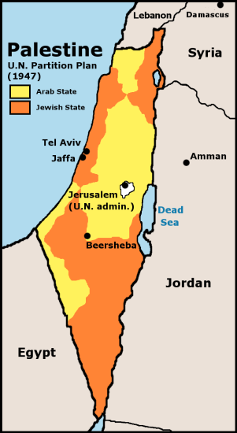
Yes, the Jews were given back their ancient land of Judea and Samaria, but under U.N. scrutiny and control. Israel is crawling with U.N. troops to this day. The U.N., as you can see from the map, divided up the Land between Arabs and Jews, with Arabs getting about ½ of the Land. Notice the map above: Jerusalem (U.N. Administration).
The Rothschild dynasty bought up a lot of the Land. The Vatican bought up a lot of the Land and they’re asking for more. Israel has been under the control of the most powerful Elite, the U.N., America, Britain, and the Vatican since it’s inception.
May 15, 1948, British-funded Arab Nazis from five surrounding countries attacked Israel. I’m not making this up. I have documented facts.
When Israel declared statehood, tens of thousands of Arabs fled into other Muslim nations for refuge, yet Israel never intended for them to flee. Israel wants peace. Today, the Arabs and their terrorist organizations, like Hamas in Gaza, are calling for the “right of return” of these multi-millions of Arabs, to flood Israel with the families of those who fled back in 1948.
So, you see, the modern nation called “Israel” has been under the jurisdiction of the United Nations, the Rothschild family, America, the nation of Jordan who controls the Temple Mount and the PA, plus the Vatican.
The plan of the Jesuits from their inception has been to put a throne for the Pope on the Temple Mount. In May 2014, Muslim Wafts on the Temple Mount told Pope Francis that they would put him a throne there. To see a picture of the pope’s throne and read about that visit, May 24-26, 2014, refer to: “The Hidden Agenda Behind the Pope’s Visit”/Mikvah of Present Reality.
Because the Vatican created Islam as their weapon to secure the Temple Mount for the pope in the first place, the Vatican is working with the leaders of Islam and the leading rabbis inside Israel for this goal. Do not doubt for a moment that Israel is in league with the Vatican. It’s known by the leading Rabbis, and also is open news.
The tight interlocking of Rabbinic Judaism, created in 133 CE by Rabbi Akiva using his influence with Roman Caesars, and later the institutionalizing of Christianity into the Roman Catholic Church by Emperor Constantine of Rome, continues to this day. After the Western Roman Catholic Church seemingly collapsed, the popes simply took the role of ruling Caesars, and like the Caesars they began their plans to bring the world under their control. That goal never ceased. Thus, to this day, the rabbis, descendants of the Pharisees who were puppets of Rome from BCE to CE first century, are still in league with Rome. Refer to: “Exposing the Roots of Rabbinic Judaism and Its Link to Rome,”/Mikvah of Present Reality. It is based on Daniel Gruber’s book Rabbi Akiba’s Messiah, and on my personal interaction with Jews and IDF soldiers. For example, IDF Orthodox soldiers believe that if they are killed in battle, they’ll go into Purgatory.
Yet, what happened November 29, 1947 and May 14, 1948 was in the perfect will of Yahuwah! But, at the same time, as the Orthodox Jews openly say that the secular state of Israel is not the final fulfillment of Scripture to return all the tribes to the Land, as in Isaiah 11, 35 and 66. They’re right!
In fact, when the “constitution” for the State was drawn up, Ben Gurion, and those with him, would not allow the word “God” to be in it, or any Scripture, or any reference to the Elohim of Israel. One rabbi protested heartily. He succeeded in getting one reference to Yahuwah into it – the title: “Rock.” Folks, the lamb and the wolf have not laid down in peace together - yet!
I love the Jewish people! I love Israel! I have friends there who love me, too! I love being with them at the Wall, through the Jewish Quarter, at the City of David, and in the Tomb of David area, too. I just feel at home with the Jews no matter where they are in Israel. I love to hear them sing and dance at the Wall. I join them for Festivals, and did so for 18 years from 1999-2017. But, I must tell the truth. It is a sinful secular state with a religious façade. It is not the Isaiah 2:2-5 Jerusalem!
From its inception, the government has been in league with the Vatican, and under the rule of the U.N. In its attempts to find favor with the world community as a whole, being a secular state, they had no problem taking America’s “package”--taking money, planes, weapons, and other handouts from America and American allies. To take America’s money help-package, and the “goodies” required that go with it, makes a country subjugated to America’s evils. In order to receive monetary and weaponry help from America, no matter what country you are in, a government has to submit to and allow America’s violent movies and music, drugs, sex trafficking, prostitution, gambling, abortion-funding, and control over the military, government and cultural decisions, or else no money. This is why Israel went from a Judaism-based state united in faith to an immoral and idolatrous state very quickly when America offered help. America rules any nation that takes our money and our “package.” America has ruled Israel’s military decisions in war to the point of Israel losing wars because of obedience to America directives of their soldiers on the field, as with General Ariel Sharon’s soldiers in the war with Egypt that cost him the lives of many of his men – the order that brought disaster being given by Henry Kissinger, America’s Secretary of State. The same thing happened in the 2006 war with Hezbollah. America told Israel’s IDF what to do. Same with the 2005 Gaza pull-out. And behind these directives was and is the United Nation’s control over Israel as was part of the deal in 1947 and 1948! Since 1945, America has ruled much of the world through “strings attached” help, along with the Vatican and the powerful Globalist elite like the Rockefeller and the Rothschild families.
The Revelation 17 Great Whore of Babylon is three-fold: The United Nations, the Vatican, and America. The Vatican was called the 2nd Babylon from the 1st century CE, and America is its extension as “end time Babylon.” Jeremiah 50-51, Isaiah 47, Revelation 17-18 is America. Refer to: “Thirty Clues and More Identifying America in Prophetic Scripture”/Mikvah of Preparation.
Israel has the highest abortion rate for its size in the world. Israeli women serving in the IDF are allowed two free abortions. Israel has legalized prostitution in Tel Aviv that even draws rabbis and their followers, as well as seculars. There is a woman’s shelter in Tel Aviv for battered wives of Ultra-Orthodox men. Because Ultra Orthodox men do not work but are on government welfare to study Talmud and Torah all day, they produce lots of children, and also many beat their wives. Their “welfare” started out as a humanitarian aid program of the government because there were so few Ultra Orthodox. But, as their number grew, so did the welfare expenses. They refuse to work or to serve in the IDF. About two years ago, the Knesset tried to rectify this problem. The Ultra Orthodox revolted against their having to work or their sons go into the IDF. On the other hand, the Orthodox work and serve in the IDF. But, with the Ultra Orthodox they have so much free time on their hands there had to be a special shelter built for their beaten wives.
Around 2014, I was in a sharut (small van-like shared taxi) going out of Jerusalem and an Ultra Orthodox man began beating a woman in the back of the sharut. The driver began screaming at him. The woman was screaming. The driver pulled over and forced the man off the sharut. The woman tried to open the door of the sharut to jump out to be with her husband, or other relative. I was sitting in an aisle seat, and all this happened right next to me.
I hold onto no fantasies, no illusions. I’ve been in 36 countries, lived in some of them, and visited some many times. I understand human nature across all cultures. I live with eyes open in the real world. I hope you do too. Evil is taking over the earth. The illusionary world is disappearing.
Therefore, I plead in all love, wherever applicable: Stop running after man-made fantasies borne of intellectual reasoning, seasoned with a few Bible verses for flavoring. Messianic believers: Allow Yahuwah to dispel any romantic religious adoration you might have about religious Jews. Love them, be with them, enjoy their singing and dancing at the Wall, pray for them, do good to them, but don’t buy into their seducing ways, and fall prey to the “wiles of the Devil,” speaking the “doctrines of demons.” Do not idolize them. Do not listen to their slick deceptions. Realize that they are not “holy,” and neither is their “takin’ot”--rabbinic tradition, myths, and made-up doctrines.
Much of their translations of Scripture and their teachings add, subtract, delete, or twist the Word to fit their anti-Yahushua beliefs, or doctrinal theories. After nearly 2,000 years, they still teach that Messiah was a bastard, Mary was a whore, her father, Eli, was evil, and that Yahushua did miracles in the power of Be’elzebub. Still, they spell His Name in their Talmud: yud hey waw, shin, ayin, pronouncing it like “Yehoshua” (English: Joshua), meaning “Yahuwah is salvation.” That’s what Yahushua means!
I am not Jew-bashing, or rabbi-bashing. I’m Satan-bashing! We must see reality and not hide from it. Religion is Satan’s invention, from the days of Nimrod. Yes! We bless the House of Judah for preserving the Torah for us! But, we must not bless them for telling their people what to think and believe based on their opinions and deceptions.
Read Deuteronomy 4:2, 12:32, Proverbs 30:5-6, II Peter 1:20, for just a few examples. Messing with His Word brings judgment!
“Man looks on the outer appearance, but Yahuwah looks on the heart.” Do not be fooled by saintly appearances! Let the Spirit help you discern what spirit you’re dealing with: 1) carnal human, 2) truly born-again human, 3) demon, 4) the Spirit of Yahuwah.
We obey the Torah as the loving instructions and teachings of our wonderful Abba Yahuwah, telling us how to identify with His nature, His ways, and His thinking, and how to treat one another with His love. That’s what Torah is – the boundaries He has set for life in His Kingdom, now and forever. It has nothing to do with the Roman Catholic Church inserted “law of the Jews.” Torah is the instructions of our Daddy.
To make a religion out of it puts it into the hands of unredeemed man, and this is unacceptable to Yahuwah. Thus He will not allow! For example, He will not sanction animal sacrifices to be made on the Temple Mount until Messiah comes! His Lamb takes away sin – not the death of animals. Messiah Yahushua is our Redeemer!
Zechariah 6:12-15. Read my personal letter to you on the Mikvah list about the July 14th sighting of the new moon for the month of Av. In contains clear instruction regarding the 9th of Av and the building of Ezekiel’s Temple (Ezekiel 40-46).
Most of the Jewish people are really wonderful people! They are a family-oriented people. I’ve had no problems with them, only blessings. I had no problems with Muslims when I lived in Jordan. They were kind to me. But, sadly, all too many western-culture Messianic folk get sentimental and religiously gooey about Orthodox Jews. Many are seduced into believing their anti-missionary arguments against “Jesus,” and convert to Judaism. It’s insane! It’s because they never had a personal relationship with Him.
All this deviation from simple truth is because of fascination that opens the volatile mind, which receives intellectualism from those that “appear holy.” This is why Yahuwah does not speak to our carnal mind that is ever-changing according to how we FEEL. Abba only speaks into our re-born spirit, located within the area from our stomach to the top of our legs. That is where His throne is within us, His Temple within us, IF we are truly born again and truly filled with His Spirit.
Leviticus 17:11 clearly says that without the shedding of blood of the innocent for the guilty there is no atonement. Messiah died in our place, paying the penalty for our sin, so that we could have atonement (forgiveness) from His Father. Why throw away the Lamb of Elohim because of an intellectual argument given by those who are deceived, no matter how sincere they appear to be. The only reason for a person to turn from Messiah or to deny His Deity is the simple fact that they never knew Him, and never knew Yahuwah. Religion is only a mental belief and/or an emotional belief. It has no power to do the 40 things that the Spirit does in a true new birth. A truly born again person has a new nature and they can’t stop talking about it. (II Corinthians 5:17-21)
We pray for the precious Jewish people to repent and receive Messiah. Many Jews are finding Messiah – the real Jewish One -- Yahushua/Yahshua. Of course, some are finding the Greek Iesous/“Jesus,” but their faith is in the One in Matthew, Mark, Luke, and John. Unless you have the blood of Messiah as your Atoning Lamb, you are like the religious, or secular Jews, and everyone else on earth--on your way to the lake of fire.
There is a demonic spirit of Phariseeism that overshadows so much of the Messianic Movement, and so much deception, too, within the Hebrew Roots Movement, though it is leading some to love the Torah.
While preparing to go to my church one Sunday morning in Fort Worth, Texas, in 2002, where I had friends and would be going out to lunch afterwards, Yahuwah spoke to me very sternly: “You will never ever go into another church again.” I was hurt. I wanted to go to lunch with my friends. I had recently returned from many months in Jordan. My suitcase was in my bedroom. As I entered the bedroom, I thought to look in the pockets of the suitcase to see if I’d left anything in them. Out of one pocket, I drew out a small white stone. I thought: Where did I get that? Then I remembered. It was in the Garden of Gethsemane. He said to me gently: “You just went through the Garden of Gethsemane.” He let me know that I had submitted to His will, not my own. It was not an easy step to take. I was planning a trip to Africa in which I would be teaching in many churches. I cancelled my trip. Later, He also let me know to stay out of the “Messianic Movement.” I did attend some home fellowships that were good, but I never “joined.” Today, I fellowship with Messianic people, and some Christians too, who are learning Torah. But, my Teacher is Yahuwah.
Do not look at the government of Israel and think they are righteous. Remember Jeremiah 17:5-10. Look at the Israeli Parliament building in Jerusalem -- Masonic, occult- design to the max. Ben Gurian believed in Buddhist philosophy. Most of Israel’s leaders of the government since 1948 have not been righteous men and women. Meacham Began was one of the best. But, we have to look at reality and not religious goo--sticky stuff like cotton candy. They are pressed to do as their American money-givers and U.N. controllers demand.
What I report here is not in any way to knock down Jews. I feel at home among them in Israel. The tribe of Judah is the “scepter holder” for all the tribes, the law-givers. The tribe of Ephraim has the birth right. (Genesis 49:1o and I Chronicles 5:1-2)
For about ½ of each year for 8 years I lived in Tiberias, Israel in my own apartment. I lived among Jews. I worked with Operation Exodus/Ebenezer in 1999 in Far East Russia to help Jews connect with the Jewish Agency so they could make Aliyah.
I feel at home among the Jewish woman at the Wall. My son loves to be with the men, and dance with them, too. But all the while, we pray for their redemption and reception of their Suffering Servant – Messiah ben Yosef. If they do not have Messiah ben Yosef as their Redeemer-Savior, then they are going to receive the anti-messiah, thinking he is Messiah ben David. They will be deceived! They are looking for a human Messiah to make Israel great. Pray that they be saved before they are deceived!
Donald Trump has done a righteous thing in recognizing Israel, and Jerusalem as their eternal capital. He’s also stirred up the whole Muslim world and advanced the plans for receiving the anti-messiah.
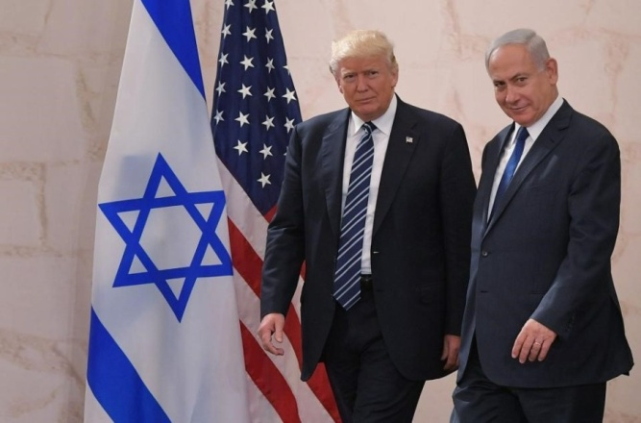
Israel Prime Minister Benjamin Netanyahu (Reuters)

“Israel Declares Itself 'Jewish State,' Jerusalem as Eternal Capital”
By Newsmax Wires | Thursday, 19 July 2018

JERUSALEM — “Israel's parliament approved a controversial piece of legislation on Thursday that defines the country as the nation-state of the Jewish people but which critics warn sidelines minorities. The government says the bill, passed in the early morning hours, will merely enshrine into law Israel's existing character. Prime Minister Benjamin Netanyahu called its passage a `historic moment in the history of Zionism and the history of the state of Israel.’ ‘"Israel is the nation state of the Jewish people, which honors the individual rights of all its citizens,’ he said. `I repeat: this is our State--the Jewish state.’ "
“The Rights of All Its Citizens”: The Rabbis control the Aliyah process, and put all applicants through “conversion training,” if they are not already Orthodox Jews. They are very hesitant to allow Christian or Messianics to become citizens, and usually block their being citizenship. During my stay there, the Orthodox Rabbis over Aliyah revoked 22,000 citizenships of those who were Christian or Messianic. There is persecution of Messianics in Israel by various Orthodox Jews. Remember the story of the Ortiz family and how a package left at their doorstep blew up and almost killed one of their sons? They are a Messianic family. It was later uncovered by the Israeli authorities that the ones planning the bomb were from a radical Jewish sect.
It is getting more and more common for Messianics who want citizenship in Israel to convert to Judaism to get citizenship. But this is often a pretense that is discovered, and their citizenship is revoked. In the meantime, they’ve denied salvation and lost their eternal life. I’ve had friends who thought it all right to convert to Judaism to gain citizenship, yet in doing so they had to deny Messiah.
But, in “setting the stage” for the death of the two witnesses, let us look at what Prime Minister Netanyahu has done recently to set up that scenario for the anti-messiah to come, and for the death of the two witnesses, by preserving “the rights of all of its citizens.”
Revelation 11:7-8: “And when they ended their witness, the Beast coming up out of the pit of the deep shall fight against them, and overcome them, and kill them, and their dead bodies lie in the street of the great city which is spiritually called Sodom and Egypt, where also our Master was nailed to the stake.”
This non-human “Beast,” the hybrid Beast, is the same one of Daniel 2 and 7, Revelation 9:11, 11:7, 17:8, and II Thessalonians 2:3. He is the “apolia,” the destroyer, from the name Apollo or Apollyon in Greek, Abaddon in Hebrew--king of the Pit. The Beast arises out of the sea--symbol of “chaos.” The Hindu god Shiva, and Apollo, are both known as the destroyers of worlds in order to build a new world with them as the ruler. The Hindu god Shiva is the mascot of CERN, perhaps a friend of Obama.
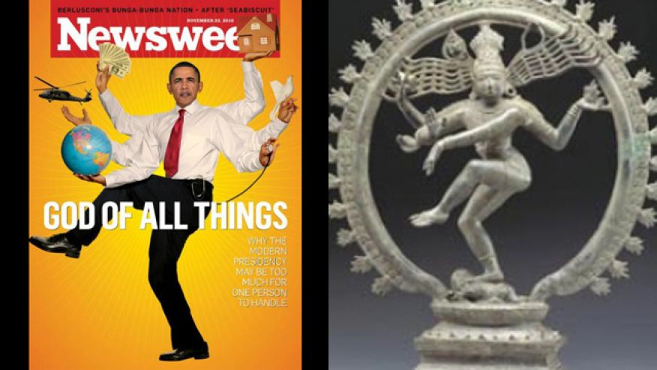
Hum! 2009: Shiva is doing his dance on the right, but who is that on the left who is called “God of All Things?” We still don’t know! He has recently admitted to being born in Kenya,…oh well, time will tell.
Revelation 11:7-8 identifies Jerusalem as becoming Sodom and Egypt. What is Benjamin Netanyahu, backed by the Israeli government, doing right now to make Jerusalem “Sodom and Egypt?”
Wrapping it up:
Notes from Steven ben Nun’s Israel News Live, May 21, 2018 YouTube video: “Netanyahu sets the prophetic stage for the Two Witnesses.”
Steven starts out in the video by showing a photo from February 2016 of a Gay Pride Flag mounted below the Israeli flag a Knesset conference room.
“Netanyahu apologizes for not being able to attend the gay-pride parade he orchestrated in Jerusalem. Netanyahu literally funded the gay community’s parade
https://www.youtube.com/watch?v=m6hMiuq4nYI
Copy and paste this link into Google search and listen to his speech!
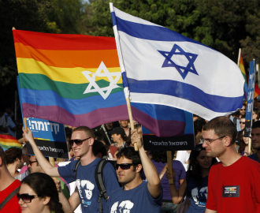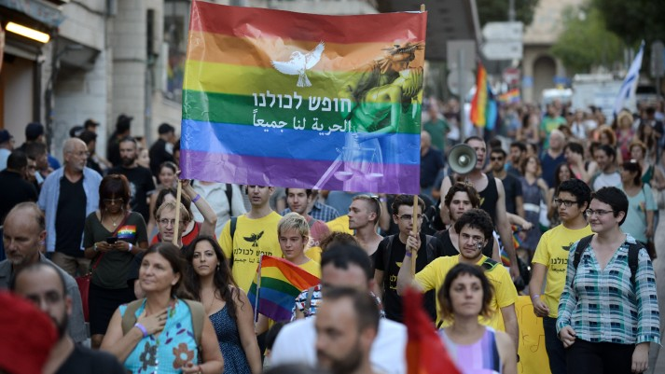
July 21, 2018
Israelis and tourists marched during the Gay Pride Parade in Tel Aviv Israel Friday, June 9, 2017. About 200,000 people from the LGBT community in Israel…Denver Post

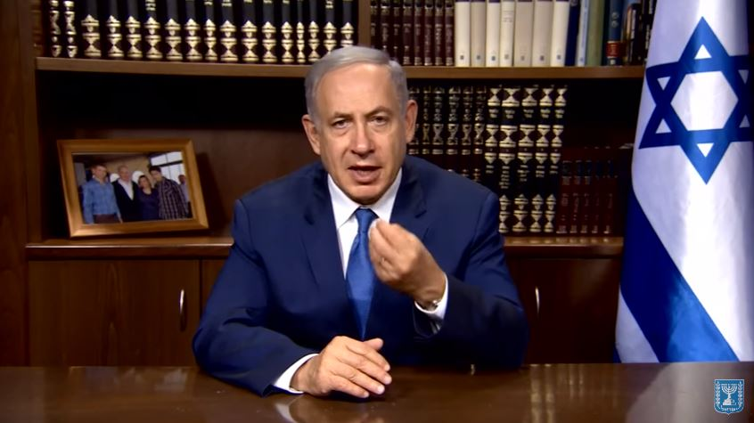
Jerusalem Gay Pride Parade Netanyahu speaks on the rights of the LGBT community to have a gay pride parade in Israel

Netanyahu said: “Today is Jerusalem's gay pride parade...we stand in solidarity with our brothers and sisters in the LGBT community...”
Steven quotes Revelation 11 about Jerusalem being spiritually known as Sodom and Egypt. Steven asks: Who causes Jerusalem to be called “Sodom and Egypt?”
He talked about “the blind leading the blind.” He talked about the church being Laodicea: “…know you not that you are blind…” He said: “Rome is leading Israel.”
He talked about Kenneth Copeland – blind leading the blind – and how he promotes unity with the Vatican. He talked about Tony Palmer and his presentation before the audience of Charismatics at the Copeland Church. He talked about the “propagandist Jesuits.” He said that as the U.N. desires, Jerusalem will be made an “International City.” It’s that way on the 1947 partition maps!
Yes, that is the goal of the United Nations. The U.N. will take over Jerusalem. The Vatican is also to take over as religious leader. The Sanhedrin is petitioning the Vatican to be the governing body for world religious matters under the Noahide Laws – which include ancient laws of the Pharisees that were used to condemn Yahushua to death!
Steven brought up things that I knew about Syria, Hezbollah, Hamas, Fatah, Iran, the Muslim Brotherhood, etc, being orchestrated by the Global Elite to fulfill Mazzini/Pike Plan Part III, out of which they will have their New World Order. I’ll skip over my notes on this to continue with why Netanyahu is facilitating what will cause the death of the witnesses in the future. You can listen to this broadcast on your own.
If you look at what Obama did, beginning in January of 2011, to singlehandedly destabilize the Middle East and call it “Arab Spring,” you’ll know that the Global Elite are working to fulfill the Part III – to create war between the Arab world and Israel to hopefully wipe both groups out. Inside of it are politicians in these groups, including Israel, who are facilitating this to their own Globalist advantage.
There is zero reason for war in Syria. America supports the killers of Christians and Syrian citizens by funding ISIS and “jihadists.” Obama created ISIS. The CIA created AlQaeda as a data base for mercenaries to do their dirty work. There are Communist Arabs and Nazi Arabs Muslims who work for the Global Elite. The whole releasing of these “refugees,” notice most area all young men, into Europe is to fulfill Hitler’s Plan to use Muslims to overrun the Christian nations and bring them under a world ruler, whom Hitler thought was him. Refer to: “Hitler’s Secret Plan for World Conquest”/Mikvah of Present Reality.
Just before Sukkot, 2004, I clearly remember talking to a young Russian IDF soldier on the bus from Tiberias to Jerusalem. He told me “there is an IDF within the IDF.” He told me things I knew, that the inside IDF was allowing the terrorists to kill Jews, looking the other way when Jewish families were being massacred. The plan was to take all Jews out of the Gaza strip and give it to terrorists. This young man was greatly disturbed by this. He was part of the “special forces” in Gaza. The bus was packed with IDF soldiers, and this young man stood by me and poured out his heart to me. He kept mentioning the Bible, then apologized for mentioning the Bible so much. I told him “don’t apologize.” The “pull out” began in July of 2005. It broke my heart. It angered me. Even Israeli, Barry Chamish, an open exposer of evil within Israel at the highest levels, knew that someone very high up had a “gun” to Ariel Sharon’ head that forced him to do it. The U.N. plan was leading it, but also the U.S. helping. There were many U.S. soldiers dressed like the IDF, as well as Turkish U.N. “Peacekeepers” who aided in the pulling out of over 8,000 Jews from their homes, leaving their homes, material possessions, greenhouses, and all they had to be “relocated” in shabby places, so that the terrorists could destroy it all, which they did. I was infuriated by public news in the U.S.
I was in Gaza in 2004. I saw the million dollar homes, the beautiful green houses, the pristine communities, their schools and synagogues. It was gorgeous. Yet U.S. news only showed Arabs destroying shacks. This was part of the plan of the Globalists, the Vatican included, the Illuminati (Jesuits) overall, to bring about Part III of the Mazzini/Pike Plan of 1871 – the final plan that would bring a world ruler to rule from Jerusalem.
So yes, whether willing or not willing, the government of Israel is controlled for the purposes of those that created it, those controlling it, like the U.N., America, Britain, the Rothschild dynasty, the Vatican, so that the Muslims vs. Israel agenda can be used to bring on World War III and destabilize the world. The anti-messiah is ready.
So whether Netanyahu is really all for the LGBT agenda, or whether he is forced to support it, I won’t judge his motives. But, he is supporting it under the idea of being politically correct with those who give Israel money – America particularly.
Steven Ben Nun: “Netanyahu is setting the stage for the two witnesses.”
Steven believes that they are here, but just biding their time until their appearance on the world scene. I believe so too…
Steven reported on Pope Francis’ visit to Israel in May of 2014: He said, “yes, Netanyahu did promote the giving of the upper hill, `Mt. Zion,’ to the Vatican.” I knew this to be true in 2014. The rabbis in Jerusalem knew this. The head of the Sanhedrin knew this and spoke against it. I support standing for righteousness.
Steven talked about the Vatican as the spirit of Egypt – sun god worship. He talked about the obelisk in St. Peter’s Square, and the Egyptian things in St. Peter’s Basilica.
Washington DC also has an obelisk facing the “womb of Isis” (the Capital Building dome), but then American and Rome are “echad,” both Babylon.
Arutz Sheva article: “Netanyahu Asked Rabbis to Allow Giving David’s Tomb to the Vatican” – 2013

Steve talks about Esau in Rome, saying the lineage of Titus was Esau – TITUS WAS AN EDOMITE!!!

Steven told how the CIA helped Erdogan of Turkey to smuggle “sarin” gas to ISIS inside Syria. Their rebels, the jihadists, blamed the use of the gas on Assad.

“Mt. Zion” is now called “The World Peace Center.” The “Upper Hill” dubbed “Mount Zion by Constantine’s mother, Helena, in the 4th century, is NOT Mount Zion! Mount Zion as I Samuel 5:7 for example tells us, is the City of David, the hill south of the Temple Mount, flanked on the East by the Kidron Valley and the Mount of Olives, to the South by the Hinnom Valley, and to the west by the Tyropian Valley. The Orthodox Jews know this. But, the nation has to keep the Vatican happy, so they go along with the Vatican lies. The state of Israel has given this “upper hill” to the Vatican who has built all kinds of churches on it. But, right in the middle of it is the “Tomb of David” and a Yeshiva. Above the “Tomb of David” is what the Vatican calls the “Upper Room,” even though it was an Ottoman room. Please, again, read the article referred above that has loads of pictures in it that I took in May of 2014 during the Pope’s visit to Jerusalem. You’ll see that the Pope had mass in the “Upper Room.” Now no Jews can go up there. It was given to the Pope.
Now the Vatican wants Israel to give them the ancient ruins of Caesarea on the Mediterranean – because “Paul” preached there.
Times of Israel: “Israeli PM in Rome says agreement could be signed this year” for the “Holy See’ to be given permission to build two new churches on Mt. Zion…
“They are setting the stage for the killing of the two witnesses,” ben Nun said. Of course, the anti-messiah will sit enthroned on the Temple Mount, which the U.N. wants to make an “international heritage site” under their control.
A Vatican cardinal said there would be no peace until the Holy City is under the control of the Vatican and the United Nations.
Steven talked about Trump – the hero of Israel. Israel has forged a coin with Trump’s picture on it along with a picture of Cyrus. Trump is not a Cyrus!
In this YouTube presentation, Steven talked about Israel’s abortion laws
From the Times of Israel: “Israel’s Abortion Law Among World’s Most Liberal.”
Steven talked about how Messiah was rejected for the murderer Barabbas, whose name means “son of the father.” He said that today, Israel rejects Yeshua/Yahushua but is embracing and accepting “Barabbas” in the shedding of blood of innocent Jewish babies. They shed the blood of the innocent Messiah. Barabbas went free with no punishment for his crimes. But, judgment is coming, and it begins at the household of Elohim, Jews and Ephraimites.
Steven spoke about the Gaza war 2018. He said this all has to do with the agenda of the new world order – to bring the world ruler to Israel, to Jerusalem, and to turn the world against Israel. As I wrote about the Russian soldier who said there was an IDF within the IDF, I remember the story of the two soldiers guarding a town in the “West Bank.” One night, their commanding IDF officer came to them and said he needed to take their guns to “clean them.” They soldiers thought that weird, but handed over their guns. During the night, as they stayed there defenseless, terrorists came in and killed the two soldiers. That incident was used to pull all of the IDF out of the “West Bank,” leaving the citizens vulnerable to attacks by terrorists. That was an evil plot!
Steve concluded that “Jerusalem is now spiritually Sodom and Egypt!”
It is Sodom: Homosexuals marching in the streets with full rights, with the friendly OK by the government. It is Egypt: The Vatican controlling Israel via the U.N. (the two work together – the Vatican controls the U.N. through the Jesuits). Egypt is a place of slavery to a dictator who is idolatrous, thinks himself a god, and demands worship of himself as God. In many ways, modern Israel is a traitor to Yahuwah, just as Judah was before the Babylonian captivity. But, always – Yahuwah is a Redeemer!
Modern Israel is subservient to the Globalist Elite rulers of this world. Israelites always did want to be like the nations. Israelis today still do. Yahuwah calls us to set-apartness.
Modern Israel, therefore, will support the world-ruling Pharaoh in the future. They are setting the stage for the anti-messiah to take his place on the Temple Mount. They are setting the stage for the death of the two witnesses who defy the anti-messiah and his hosts worldwide.
Thus Steven concludes: “We stand with the Israeli people, but not evil done by the government or the military.” I say “Ahmain!”
Is war with Iran being purposely provoked? It’s all part of the agenda of the New World Order. Mazzini/Pike Part III is being set in motion, and Israel is a main player in how it works out. But, through it all, Yahuwah will stand with his people! We see that in Ezekiel 38, which happens at the return of Messiah, as in Zechariah 14:1-5, and Revelation 19. Justice will prevail! HalleluYah!
Know Yahuwah, trust Him. Build your relationship with Him! Do not fall for the deceptions of the Hell-bound. Pray for them, witness to them in the love of Elohim, but do not join them!
Shalom, shalom, shalom! In His love,
Yedidah
July 25, 2018

