The Decision of the Supreme Court of Babylon in
Reality Pictures of Gomorrah
You sure won’t see these pictures, or hear these Scriptures, on public news!
But, the watchmen are crying out loudly in grief and warning: America is dead by its own hand! No, end-time Babylon has not physically fallen yet, as Isaiah 21:9 and Revelation 18:2 says it will… but in every other way, the great nation exposed in Scripture as “end-time Babylon” is dead--waiting for its 315,000,000 citizens to die with it in the final judgment of Yahuweh.

Gomorrah, where balls of brimstone (sulfur) still lie among the ashes
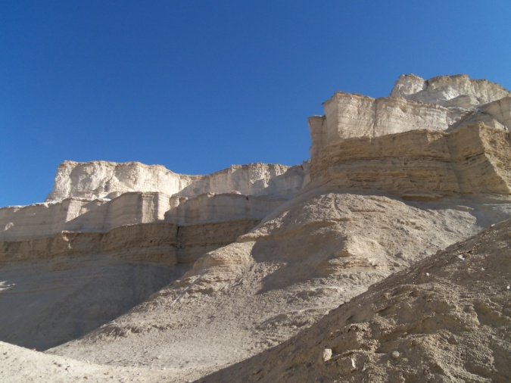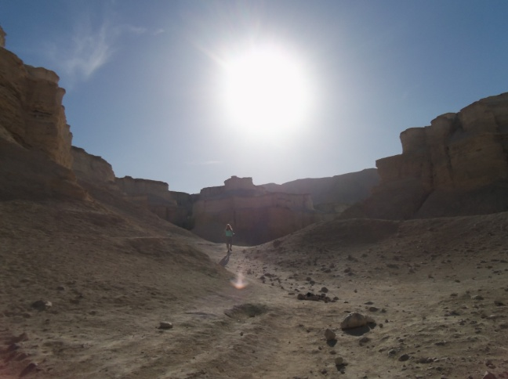
All photos by Yedidah in 2013
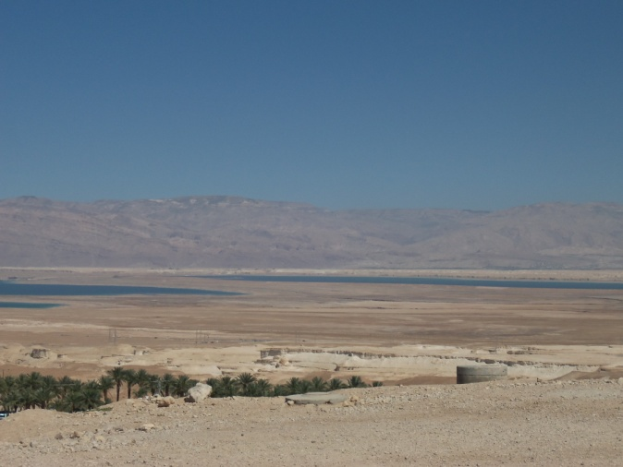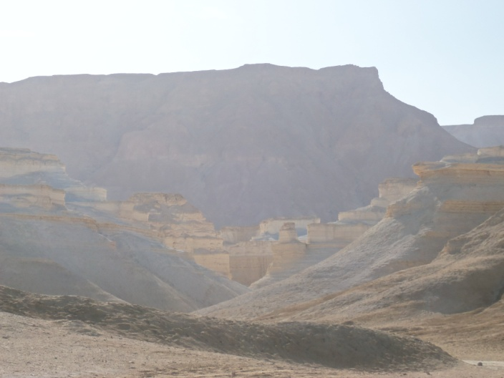
Left: Picture taken from Masada looking down towards Gomorrah, beyond the palm trees – the Dead Sea and the mountains of Jordan are in the distance…

This is what Yahuweh means when He says to America in Jeremiah 50:39-41 and Isaiah 13:19-22: “…the wild desert beasts shall dwell with the jackals, and the owls shall dwell there, and it shall be no more inhabited forever, neither shall it be dwelt in from generation to generation. `As Elohim overthrew Sodom and Gomorrah and neighboring cities,’ says Yahuweh, `so man shall abide there, neither shall any son of man dwell therein…’ ” “And Babylon, the glory of kingdoms, the beauty of Cauldean excellency, shall be as when Elohim overthrew Sodom and Gomorrah…it shall never be inhabited…but wild beasts of the desert shall lie there…”
Look carefully at these pictures exemplifying America’s near future… But what happens before this is what you need to know … the Scriptures are packed with information about the “before,” and with Scriptures that tell the “why.”
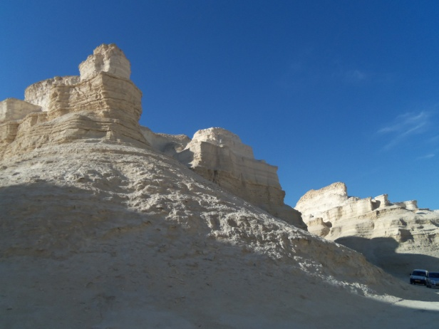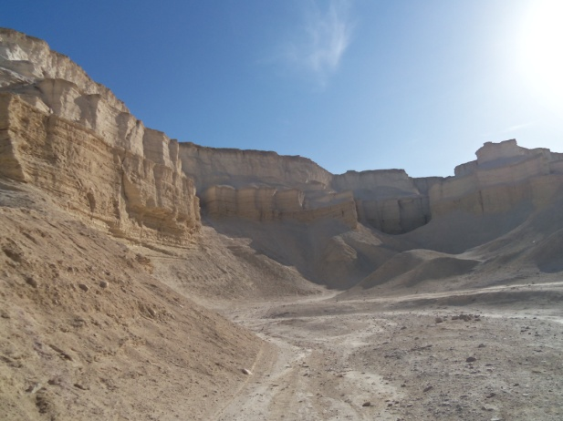
Jeremiah 50-51; Isaiah 13, 18, 47, Zechariah 2:7; Revelation 17-18
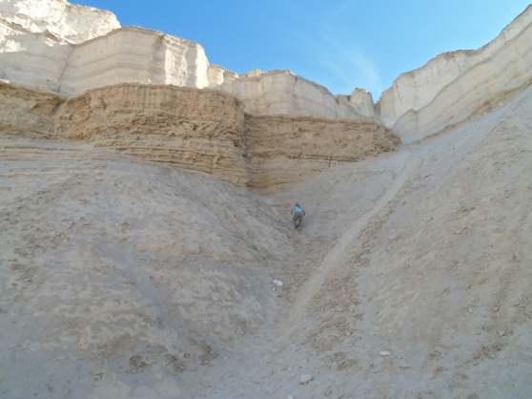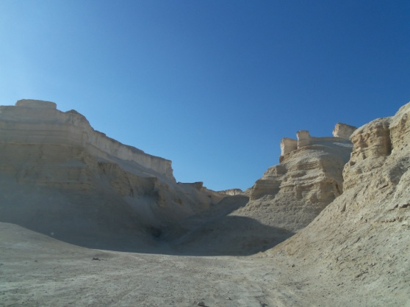

The first time I visited Gomorrah was 2003. This site was discovered years ago by Ron Wyatt. It is a true site, proving the destruction that came from Yahuweh raining down fire and brimstone and turning the five cities of the plain into ash. Whether this city was “Gomorrah,” or another one of the cities along the Dead Sea that experienced Yahuweh’s raining of fire and brimstone (sulfur) the results are still very evident. I stuck my hand into what appeared to be a solid pillar and pulled out my hand filled with ash. Upon smelling the ash--it still smelled like sulfur!
I have several little sulfur balls I found there, and one ball, about the size of a golf ball, given to me by a Baptist Pastor in Jerusalem. But, in 2003, upon my first visit with several other people, I saw a good-sized sulfur ball lit – and it burned with a greenish flame after all these thousands of years.
On June 26rd, my article “Reality America – Life or Death Decisions Must Be Made Now – An urgent message from Yahuweh to all His people,” was posted on my website, comeenterthemikvah.com. It is basically an updated revision of my article “End Time Babylon.” In it, I give 10 Scriptures and 30 “clues” as to who end-time Babylon is, along with the pleas of our loving Father for His people to flee.
The decision of the Supreme Court and the celebrating by an estimated 60% of American people, including many so-called “believers,” has put the final nail in end-time Babylon.
No, America will not be destroyed only because of sexual deviants, or by any filth they continually shove on the entire world like abortion, pornography, sex-slavery, dangerous mind-destroying drugs, violent music, violent movies, child slavery, etc..
Scripture clearly says that America will be totally destroyed because of what we have done, and will do to Israel. This President has single-handedly set up the Islamic world around Israel for her destruction, and is the one who is intent on dividing the land. Check it all out in the Word.
It is no coincidence that yesterday Steve Quayle posted this article – which I might add is a great guide to obeying the pleas of Yahuweh for His children: “FLEE Babylon -- The Steps To an Expat Life” by Ray and Tracye Gano – on Prophezine –June 26, 2015.
In my article from yesterday, I list reference materials for you to read, and videos to watch. These are not the ranting of “religious extremists.” Their compassionate message has been given by His watchmen for several years, and has now turned into the loud blowing of warning-shofars. The enemy is not out there somewhere in the distance anymore. The enemy is not even outside the gate. The enemy has breached the gate and set up camp within it.
Please use the search-engine on my website, comeenterthemikvah.com, to access the articles “Collapsing Within,” “Elohim’s Alarm Clock Has Begun to Sound,” and “Reality America.” And, for the most important preparation of all, refer to the recent admonition and exhortation from our Father given in “Beyond This Dimension – Through Your Own Portal.” The most important thing you can do, is to make sure that the portal within your spirit is opened fully to the eternal realm of Yahuweh, so that He can guide you in the details of your future. Your short-term future is dependent on how carefully you obey what He has already written in His Word. Once you begin to obey the written word, and only then, can His Spirit speak to you to direct you. Knowing His nature is paramount to survival. But, then, His true faithful servants know His nature, ways, and thinking, because they daily flow in His perfect timing, doing His will, dead to their self-willed life they live to share His truth with others.
Go back and look carefully at these pictures. This is the future of America. When great persecution of the early Messianic believers (those like the ones in Revelation 12:17) fell on those in Jerusalem, they fled into Samaria. There, they held a great revival, and many were saved and filled with the Spirit. (Acts 8) Don’t wait for the coming slaughter of true believers in America, for this will precede the destruction like you see in the pictures above. Hundreds of thousands of guillotines are waiting for American necks. (Revelation 20:1-6)
Are you happy about the Supreme Court decision? Do you think it is a good thing? Start in Genesis and read through Revelation! Yahuweh, Elohim of Israel, is very real! He is sending His Son, Yahushua, with His wrath. No flesh will be left alive except those who side with Him. Scripture clearly says that no one who sexually deviates from the order of the Creator, no matter what they call themselves, will enter the Kingdom of Yahuweh and Yahushua.
Yesterday’s decision will directly affect the churches, the Messianic congregations, and the Jewish synagogues who stand for His righteousness. Anyone heard disagreeing or speaking against these new “rights,” will find themselves in bad trouble.
It is already happening in Europe and the UK – where “hate crime” laws are being enforced. But Canada has such laws in force already, and America has them “on the books,” soon to be enforced. From John Price’s The End of America: “Around 2004, “Canada amended its national criminal code to add `sexual orientation’ to its hate crime legislation. Since then, Pastors and churches in Canada have been charged with the crime of inciting hatred by preaching the Biblical prohibition on same gender sexual relations.”
Genesis 19:23-26: “And the sun had risen on the earth when Lot entered Tsor. And rained fire and sulfur on Sodom and Gomorrah, from Yahuweh out of heaven. So He overthrew these cities, and all the plain, which were on the ground. But, his wife looked back from beyond him and she became a pillar of salt.” The salt plain beneath the surface and all around what became instantly “the Dead Sea,” flew up into the air and covered anything and anyone standing near it. An angel had to drag Lot out of the city – like Americans today--what will it take for His people to flee in time to save themselves?
Luke 17:26, 28-33: “As it was in the days of Noah, so shall it be in the days of the coming of the Son of Adam…Likewise, as it came to be in the days of Lot. They were eating, they were drinking, they were buying, they were selling, they were planting, they were building, but on the day Lot went out of Sodom it rained fire and sulfur from heaven, and destroyed them ALL. It shall be the same on the day that the Son of Adam is revealed...Remember Lot’s wife!” Abba doesn’t want us to flee just to save our pitiful skin so that we can be hold up in a cave like Lot did, and be abused like he was by his own two daughters. In the horrors to come, death will be desirable. Abba wants us to flee so that we go forth with joy to spread His Word to the nation He sends us to. Those that seek to hang onto their life in Sodom will die. Those who give their lives to the Master in His service will be led by His Spirit!
Refer to my article “And His Wife Looked Back.” Use the search engine on comeenterthemikvah.com to locate this article and all my articles.
***Also, refer to thewelltroddenroad.org videos – to view a short video by Derek and Rivkah in Gomorrah in 2014. It is entitled: “Gomorrah – A Valuable Lesson Learned” /October 2014.
Is it “life as usual” in fantasyland USA? - Not by a long-shot!
Daniel 11:32: “They that know their Elohim will be strong, and will act.”
Shalom to those who side with Yahuweh!
Love, Yedidah
June 27, 2015

