THE HIDDEN UNDERGROUND
SYNAGOGUE of the SANHEDRIN

Along with strong faith in the salvation of Yahushua Messiah, my new birth being May 13, 1951, Abba led me to guard the Torah of Yahuwah from 1995. I began teaching on how the tabernacle of Moses and the Festivals of Yahuwah pictured Messiah since 1962. The Torah is all about Messiah Yahushua and how to live in the Kingdom of Yahuwah. “Torah” simply means the instructions and teachings of Abba Yahuwah for right standing in His Kingdom after a person is truly born again by faith in the blood of the Lamb, Yahushua Messiah, and faith in His resurrection.
After Abba instructed me at the end of 1998 to move to Jordan, I arrived in Jordan in April of 1999. That spring I went to Israel for my first time. I heard that there were 613 commandments. I was told that since the pomegranate supposedly had 613 seeds, it was symbolic of the commandments of Yahuwah in the Torah. The only thing I questioned was the number of seeds being 613 in every pomegranate. Who counts every pomegranate? Recently in my study on the very real underground synagogue of the Sanhedrin, I learned that the 613 commandments are in the series of books known as the Babylonian Talmud.
Thus, the giant golden pomegranate centerpiece that graces the altar of the secretive hidden underground synagogue of the Sanhedrin reveals their real focus – which is not the Torah, but the Babylonian Talmud, from which springs the Noahide Laws, from which springs the Kabbalah, from which springs Gamatria, from which springs the plans for world domination by leading rabbinic Turkish Khazars posing as Jews and the death of Christian and Messianic “gentiles.”
Make sure you’ve carefully read these articles about the Rabbinic Judaism, the Babylonian Talmud, and the Noahide Laws, so that you have foundation for what I write here. These articles reveal “the great deception” that can “deceive, if possible, even the elect.” (Matthew 24:21-23)
1) Foundation: “BEWARE of the Noahide Laws”/Mikvah of Present Reality
2) “Israel’s Sanhedrin Makes Their Move Towards Internationalizing the Noahide Laws – Hanukkah Altar Dedication - 70 Nations Invited/December 9, 2018”/Mikvah of Israel, Our Eternal Inheritance
3) “The Frightening Reality of the Noahide Laws and a Third Temple Not Authorized by Yahuwah”/February 11, 2019/Mikvah of Israel, Our Eternal Inheritance
4) Trump and 50 Governors Affirm Noahide Laws and the Celebration of Rebbe Schneerson’s Birthday/April 18, 2019
5) Rabbinic Judaism, Kabbalah, the Holy Serpent Messiah, and the Synagogue of Satan”/April 21, 2019
6) Shocking Revelation! DNA Reality! `Harmless Noahide Laws,’ the Great Deception, Trump, Kushner, and the Mark of the Beast/May 3, 2019
Also: “Exposing the Roots of Rabbinic Judaism and Its Link to Rome”/Mikvah of Present Reality and “The Seed of the Viper in the Pharisees and the Seed of the Woman in the Natzarim/Mikvah of Israel our Eternal Inheritance (comeenterthemikvah.com)

The nature of Judah/Yehudah (Genesis 38:7-26): Note his repentance and follow-through with Tamar. Genesis 37:3-34: Judah was not a murderer. He and
Reuben saved Joseph’s life. Judah was/is the scepter holder of the tribes (Genesis 49:10). In saving Joseph, because of Reuben’s sin (I Chronicles 5:1-2), Ephraim, son of Joseph, became the birthright holder for all the tribes. Judah’s name means “praise,” not murderer, not liar, not “seed of a viper,” not a seeker of supremacy.
For all of his faults, Judah had a tender heart. This is not the nature of the warrior tribe of the 8th – 9th century Empire of Khazaria. In the 8th century their King Bulan wanted to unite his empire under a religion. He thought of Christianity, Hinduism, and Rabbinic Judaism. He had read the Babylonian Talmud. The Khazars were a warlike people. King Bulan did not like the peaceful religions of Christianity and Hinduism. He liked the warlike nature of the Talmud. So he chose to adopt not the Old Testament as his new religion, but the religion of the rabbis created by Rabbi Akiva, a Pharisee, in 133 CE. He called his new religion Talmudism. He did not base his Judaism on the Torah, but on the Babylonian Talmud, a book of murder, sexual perversion, and polytheism. King Bulan invited rabbis from the area of ancient Babylon to come teach his people Tamudism. They loved it because it talked about the Jews ruling the world and killing all inferiors to them, namely “gentiles,” those of the nations, Christian nations in particular.
Previously the basic religion of Khazaria was paganism and phallic worship. The Talmud teaches phallic worship, sexual promiscuity, the right to lie, rape, and murder anyone not a Jew, plus other horrible things. Even the Ten Commandments were altered by rabbinic interpretation. For example: “Thou shalt not kill,” became “thou shalt not kill a fellow Jew.” “Thou shalt not commit adultery” became “a married man having sex with an unmarried woman is not adultery.”
Eventually, from Khazaria, the Khazars, a Mongol-Turkish tribe, migrated West into Eastern Europe and created strongholds there by their incredible money-making abilities. Then they moved into Western Europe and took over there by their money-making abilities also. They stayed in close-knit family groups to avoid contact with bestial gentiles. The Khazars were/still are an incredibly brilliant people group. Do your own research on the Khazar Empire.
Compare the nature of Ya’cob’s 4th son, Judah, with the nature of the Khazar Jews, Ashkenazi Jews, most Sephardic Jews, of today. By DNA testing by Israel scientists, it has been proven that 95% of Ashkenazi and most of the Sephardic Jews who say they are Jews, are not Jews at all – their lineage goes back to Khazaria. Even Netanyahu knew it and commented in 2012 when the first of the news began to break to Israel, saying “we knew it.”
Look at the nature of the Pharisees who condemned Messiah to death. Those Yehudah of Samaria and Judea heard Him gladly, as did those of Syria, and Lebanon. The only ones who did not hear Him gladly were the Pharisees who were jealous of His popularity. They plotted to kill Him within a couple of weeks after He began preaching. They were murderers, “seed of viper” (Matthew 23) and “children of the devil.” (John 8) As written in the article “The Seed of the Viper…” (listed above), they were part human and part Nephilim. They were hybrids – by their father’s lineage, and of Abraham by their mother’s lineage.
Most all of today’s rabbinic Jews are direct descendants of the Pharisees. Their hatred for Messiah is pure hate, blasphemous, and murderous against His followers. The hatred of the rabbinic Jews is bitterly cruel--no mercy, no repentance, pride, arrogance, haughtiness, saying they are the super race and all others are mere beasts to serve them (quotes below). They carry the spirit of antichrist. Their nature is opposite of that of Leah and Ya’cob’s son Judah, Yehudah. Though most appear saintly to the world, the Christian world, and the Messianic world, they are not. Their hate is a hidden raging fire. By DNA testing, they have NO lineage at all to Abraham – none! They have lineage across board to Khazars and to a few other truly gentiles people groups.
As I wrote in my last article, it has been proven that many Palestinians and Arabs, Kurds, from various African tribes, the Cherokee and other American Indian tribes, those from Mexico, Colombia, and other places in Central and South America are the real Judah, with real lineage back to Abraham, Yitzak, and Ya’cob.
The evening of May 6th, during Steven ben Nun’s YouTube evening broadcast, he told this story: He said he went to his doctor recently. A lady from a Palestinian family from Israel began talking to him about Judah and the Palestinians. She said in reference to the Palestinian conflict in Israel: “It is very sad, because few know that 50% of the Palestinians are actually Jewish”/Yehudah. She's a Muslim and restricted in what she can say, but she confided in Steven because she knows him. Amazing! She just confirmed what DNA testing has found out.
The Talmud volumes, and their supporting book, the Zohar, is said to be the Oral Law of Moses given to him on Mt. Sinai, but passed on by word of mouth and written down in Babylon. I want you to think of the nature of Moses. He was called “the meekest man on earth.” He was a friend of Yahuwah. Then I want you to think of the nature of Nimrod’s seed in Babylon. Two opposite natures! How could Moses have written the Torah and also in Oral Law taught the murder of gentiles, sexual filth, and the worship of other gods, like Ein Sof--the impersonal god-force of Kabbalah. How could the precious Moshe who appeared with Messiah and Eliyahu on Mount Hermon (Matthew 17:1-8) be guilty of having the nature of Satan?

QUOTES BELOW FROM THE TALMUD AND TALMUDIC KABBALIST RABBIS
Ask yourself: Is this the nature of Yehudah/Judah, whose name in Hebrew means “Praise!” As I wrote in article “Shocking Revelation…” the word “Jew” appears 275 in the English Bibles i.e. KJV. Yet, it does not appear at all in the original languages. Look at the Hebrew meanings in that article.
From DNA Science and the Jewish Bloodline by Texe Maars: “DNA science proves conclusively that there is no Jewish race and that the Jews of today descended from Khazaria…they are not the seed of Abraham.”
I want to clarify that! I do not recommend you read Texe Marrs’ books. His extreme Christian-Baptist theology is disgusting, twisted, and in part unscriptural, to say the least, yet his research-reporting is good. He was a college professor. Thus, I quote him. He is reporting DNA findings. He says, so far DNA research has not discovered a pure race of Judah. But, it evidently exists! Yahuwah did not lose Ya’cob’s children! Their latter days’ prophecies by Moses and Ya’cob are found in Genesis 49 and Deuteronomy 33. In the words of the Pharisees and the writings of the Apostles, in the first century they knew where the tribes went, i.e. into Greece and Westward.
In Ezekiel 47-48 we read of the inheritance of the tribes in the Kingdom of Messiah. Every tribe is accounted for. Those who have no DNA lineage to Abraham, Yitzak, and Ya’cob are assigned to one of the tribes. When we are born again, 40 things happen in a true new birth. We become an entirely new creation. Our DNA changes! Thus think about it: If one is a Khazar and receives Messiah as his Savior, (I’m not talking about the deceitful liars of today that Christians believe are saved, yet they teach Kabbalah and its Gamatria), their DNA changes. They become the seed of Abraham by faith. It is possible that their changed DNA just might put them into one of the tribes.
Can you imagine Yahuwah losing pure Judah? Can you imagine Him losing the ten northern tribes? NO! He has watched over those He put into His Book of Life from the foundation of the world. He has protected His people! He sent them into the nations for protection and preservation. Derek said: Judah sold Joseph into Egypt which brought about his protection and preservation, and the preservation of all the tribes also. Does Yahuwah ever lose what He has blessed? Can you imagine Yahuwah losing Judah so that the scepter-holding tribe through which Messiah came disappeared? NO! (Genesis 49:10) Can you imagine His losing the birthright holder of all the tribes, Ephraim? (II Chronicles 5:1-2)
We read of the tribal inheritance in Ezekiel 47:15-48 of all the tribes in the Land. Judah will once again be in the area of Jerusalem in the area of Judea. There is Judah, traceable back to Abraham, Isaac, and Ya’cob in the Palestinians, the Kurds, the Arabs, many tribes of Africa, India, Asia, Mexico, Central and South America. There is a good chance that those who run out from the tunnels to greet Messiah as He descends (Zechariah 14:1-5) are Arabs and Palestinians.
From Marrs’ DNA Science and the Jewish Bloodline, page 117: “The seed of a Gentile is worth the same as that of a beast” (Jewish Talmud (Kethobeth 36)
Page 118: “U.S. Supreme Court Justice Ruth Bader Ginsburg told the New York Times that the Talmud was her `guide for daily living.’”
Page 118-119, Marrs reports: “In the Talmud we discover:
1) All Christians are to be killed
2) Jesus is a false prophet who corrupted Israel. He is said to be the son of a whore who practiced bestiality with his donkey. Jesus is today burning in hot excrement in hell.
3) It is acceptable to cheat a gentile in business.
4) The New Testament is an evil document
5) Gentiles are animals and beasts without souls
6) Gentiles exist only to serve Jews
7) The wealth of the gentiles belongs to the Jews
8) When a Jew walks past a Christian Church or cemetery, he is to grab his crotch and spit three times on the ground.”
[And there’s a lot more that is worse. It has been said by survey that 95% of Jews have never read the Talmud.]

From Holy Serpent of the Jews by Texe Marrs: Pages 25, 75-76, 107-108, 116, 129, 135-136, 147 with 149, 153, 155-156, and 201
From You Gentiles, page 155 by Maurice Samuel: “We Jews, we the destroyers, will remain the destroyers forever. Nothing that you do will meet our needs and demands. We will forever destroy, because we need a world of our own, a God-World, which is not in your nature to build.”
Professor Israel Shahak of Hebrew University in Jerusalem wrote in Jewish History, Jewish Religion: The Weight of Three Thousand Years: “According to cabbala, the universe is ruled, not by one god but by several deities of various characters and influences emanated from a dim distant First Cause..”
“Professor Shahak,” Marrs says “emphasizes that Judaism is far removed from the simple religion given by God to Moses and the prophets. It is, he relates, `a polytheistic religion of many different gods and goddesses, some quite vulgar and vein…with all these deities, Shahak explains the Kabbalah Jews also tack on `Satan’ whom they pray to and accord recognition.”
“In a letter published in La Revue de Paris (June 1, 1928, page 574) and addressed to Karl Marx, Baruch Levy wrote: `The Jewish people as a whole will be its own Messiah. It will attain dominion by the dissolution of other races, by the abolition of frontiers, the annihilation of monarchy, and by the establishment of a world republic in which the Jews everywhere excise the privilege of citizenship. In this New World Order, the children of Israel will furnish all the leaders without countering opposition. The Government of the different peoples forming the world republic will fall without difficulty into the hands of the Jews. It will then be possible for Jewish leaders to abolish private property and everywhere make sure of the resources of the State. Thus will the promise of the Talmud be fulfilled in which it is said that when the Messianic time is come, the Jews will have all the property of the world in their hands.”
This was written to Karl Marx, founder of Communism. In fact, Lenin, and Trotsky, and other founders of Communism, were Jews. Jewish writers today are very open, saying “Communism is Jewish.”
These Khazar Jews proceeded to bring down the Czar of Russia and his family to their death. They went on to start the Bolshevik Revolution which resulted in the murder of approximately 60 million Christians in Russia, along with Jews and political opposition in general. The goal of Communism is to confiscate all property of all people.
I’ve warned of this over and over: America has become a socialistic state/communist-Fascist state. I warned a few years ago, showing to you “The New Executive Order” of Obama, in which it states that the government of the U.S. has the right to confiscate anyone’s property at any time they deem necessary, for their use, including water rights, houses, cars, boats, and food. Refer to my article: “The New Executive Order.” If you have a birth certificate for the U.S., and/or a marriage certificate for the U.S., being a citizen, you have no rights to anything you own – even your children!!!
From the writings of Chabad, the ultra Orthodox Hasidic rabbinic leadership, Marrs writes: “The Chabad explains that there are actually two beasts, one from the sea and the other from the earth. The first is Leviathan. The second is named Behemoth (Job 39-40/Revelation 13:1-2; 10-12). In the coming Messianic age, the “Holy Serpent” messiah will inspire those righteous Jews who refine the physical world. It is they who will take in all the wealth of the world; the gentiles will hand this wealth over to the Jews. The righteous Jews will then refine the world by establishing Global Government which they will lead, and they will make all the rules by which men shall be governed. Christians will, under the Noahide Laws of the Talmud, renounce Christ Jesus or will be beheaded. This too is the refining of the physical world.”
“The ideal of universal immigration and the end of borders and nationalism is expressed as far back as February 9, 1883 in The Jewish World: `The great ideal of Judaism is that the whole world shall be imbued with Jewish teachings, and in a universal brotherhood of nations – a greater Judaism, in fact – all the separate races and religions shall disappear.’ ”
So, though in 2007/2008 at Sukkot, the Orthodox Jews knew that the end of Ephraim’s punishment had come after 2,730 years, and they rejoiced, at the same time they stress that Israel is only a “Jewish state.” No one can be a citizen unless they can prove their Jewish lineage from their mother’s side of the family. But, we know that Yahuwah in many Scriptures talks about the uniting of the House of Judah with the House of Israel once again (Ezekiel 37:15-28 for example) Please refer to the list of Scriptures in “Aliyah Scripture”/Mikvah of Israel, Our Eternal Inheritance.
“These types of monstrous murders are sanctioned in the Jewish Kabbalah book of Zohar (Tikkum Zohar Berdiwetsch Edition, page 886).” He refers to the raping of Gentile children by Jews as being not just OK, but desirable.
“Dr. Erich Bischoff, a well-known Jewish scholar who studied the rituals prescribed in the Zohar writes: “There is a commandment pertaining to the killing of strangers who are beasts. This killing has to be done in the lawful Jewish method Those who do not ascribe themselves to the Jewish religion must be offered up as a sacrifice to the High God.”
Does this sound like the Judah we thought we knew? By the nature of a person we know who is of Elohim and who is of Satan. Our good Abba tells us to love one another.
It is amazing how many Palestinians and Arabs whose families go back centuries in the “holy land,” are becoming believers in Messiah. Not only do the Jews hate them with bitter hatred as Muslims, but as Christians they hate them more.
President Obama created ISIS who has been used to behead Christians. America funds, and supplies weapons to, ISIS. So who is running America? We know from the 1600s it’s been secret societies from Europe, i.e. Freemasons along with Jesuits of the Vatican. But, behind all them has come the Khazars who say they are Jews but are not. (Revelation 2:9 and 3:9)
“The clearest indication of the hatred by Jews towards Gentiles is the Talmudic commandment: `The best of the Gentiles – kill!’ ”
“The Jewish people as a whole will become its own messiah…Thus will the promise of the Talmud be fulfilled…” Baruch Levy June 1, 1928 in his letter to Karl Marx.
“Rabbi David Cooper explains further that the `coming of messiah is actually the coming of messianic consciousness. Men who become divine realize their divinity and become fully conscious.’ ”
“Kabbalah explains…The borders of Israel will extend and include the entire planet and all people. However, the messiah arrives only when individual people achieve a personal state of messiah within themselves. Once a critical mass and specific threshold of people achieve this personal individual state, only then will the global messiah appear as a seal and not a savior. The messiah is a seal that confirms that we the people have achieved true transformation of our own nature and turn the planet. After this state of messiah is achieved, there will be one thousand years of paradise on earth according to Kabbaah…that is the true Super Earth.” Wow New Age Theosophy! - A perversion of Revelation 7:1-8 and 20:6. The Devil can only counterfeit. He cannot create anything new.
“The Jews are human beings, but the Goyim are only beasts.” (Babylonian Talmud 114 a-b)
“The non-Jew is an animal in human form, and is condemned to serve the Jew day and night.” (Midrash Talpiah 225)
“Since the Jews are the highest and most cultured people on earth, the Jews have a right to subordinate the rest of mankind to be the masters of the earth.” Rabbi Harry Watson.
“All non-Jews are evil by nature. The Jews are the crown of creation; the non-Jews are the scum of the earth” Rabbi Shneur Zalman
“We have to recognize that Jewish blood and the blood of a goy (gentile) are not the same. Every law that is based on equating goys and Jews is completely unacceptable.”… “The blood of Jewish people is loved by the Lord, it is therefore redder and their life is preferable.” Rabbi Yitschak Ginsburgh
“One million Arabs are not worth a Jewish fingernail.” Rabbi Yaacov Perin
***“We have a case of the Jew…a totally different species. The body of a Jewish person is of a totally different quality from the body of members of other nation of the world. A non-Jewish person comes from three satanic spheres, while the Jewish world comes from holiness.” Rabbi Mendel Schneerson (Did you celebrate his birthday on April18th. It’s U.S. Law, from 1991 – read “Beware the Noahide Laws”)
“According to the Talmud, one may kill any Gentile.” Rabbi Ido Elba
“A Jews who kills a non-Jew is exempt from judgment and has not violated the prohibition of murder” Rabbi Israel Ariel
“Most Jews do not like to admit it, but our God is Lucifer…We are his chosen people.” Harold Rosenthal The Hidden Tyranny (1970)
These quotes are mostly from living rabbis.

Revelation 2:9, to the assembly of Ephesus, Messiah speaking: “I know your works, and pressure and poverty – yet you are rich – and the blasphemy of those who say they are Jews and are not, but are of the synagogue of Satan.”
Revelation 3:9, to the assembly of Philadelphia, Messiah speaking: “See, I am giving those of the synagogue of Satan who say they are Jews but are not, but lie, see I am making them come and worship before your feet to know that I have loved you.”
Philadelphia is the assembly representing the Revelation 7:1-8 Bridal remnant. Smyrna is the assembly representing the Revelation 7:9-17 martyr remnant of Revelation 12:11.
The Sanhedrin officially returned to power a few years ago. Now they are ruling Israel to a great extent, along with key rabbis linked with the Vatican. The Sanhedrin has asked the United Nations to move to Jerusalem. Because they know that New York City will be destroyed (Revelation 18), they will move to Jerusalem to back the antichrist who will headquarter in Jerusalem. Very likely, the Sanhedrin will act as the False Prophet. They will put a mark on the foreheads of all who submit to the Noahide Laws. (Revelation 13:10-18, 14:9-11)
Yes! The Zohar says that a mark is to be put on the foreheads of all who guard the Noahide Laws and all others are to be beheaded--according to the Talmud also.
Let’s look at something very interesting! The Sanhedrin have their own synagogue. It is under a portion of the Temple Mount area. It took 12 years to build. This is the physical “synagogue of Satan.”
“Sanhedrin” stands for the 70 elders of Israel who have the right to judge in all matters of life, and death. The Sanhedrin (Council) of Mark 13:9-12 condemned Messiah to death for “blasphemy,” one of today’s Noahide Laws. What did He do to blaspheme? He spoke His Father’s Name.
Ezekiel 8:8-12, on the Temple Mount: “And He (Yahuwah’s Spirit) said to me, `Son of man please dig into the wall.’ And when I dug into the wall I saw a door. And He said to me, `Go in and see the abominations which they are doing there.’ And I went in and looked and saw all kinds of creeping creatures, abominable beasts, and all the idols of the house of Israel carved all around on the walls. And facing them stood 70 men of the elders of the House of Israel… Each one had a censer in his hand and a thick cloud of incense went up. And he said to me, `Son of man have you seen what the elders of the house of Israel are doing in the dark, each one in the room with his idols? They say `Yahuwah does not see us; Yahuwah has forsaken the land.’ And He said to me, `You are to see still greater abominations which they are doing.”
“Israel Plans for Third Temple Far Along - Meeting Place for Sanhedrin Underground” March 26, 2019 Video Youtube - Leeland Jones Shaking My Head Productions “Update on the Third Temple” This is a good video!

The synagogue was dedicated December 19, 2017
Pictures of the underground synagogue of the Sanhedrin
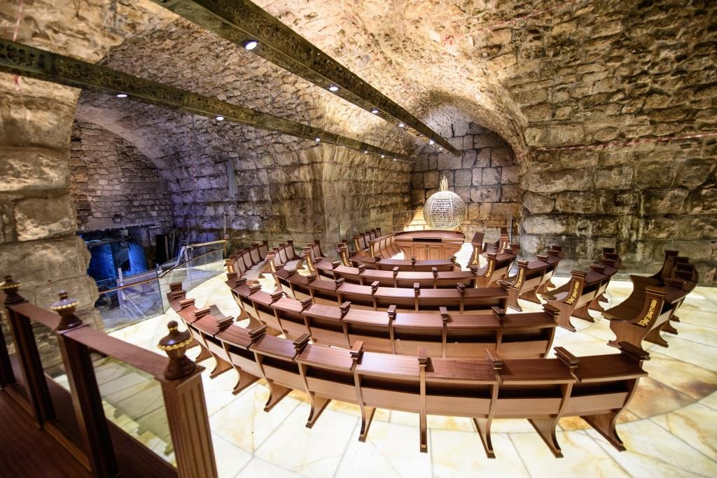

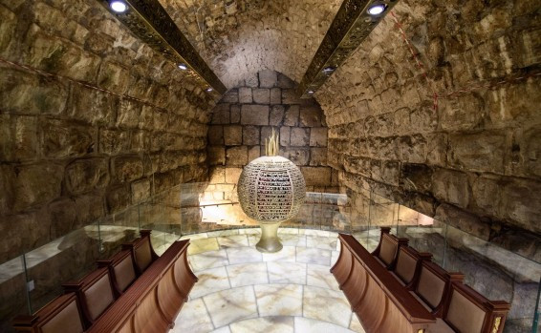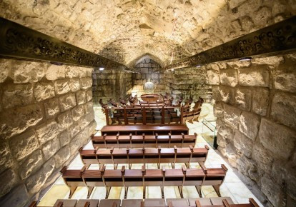
Left: Note the chairs of the “Council of 9” facing each other in front of the pomegranate. The chairs directly in front of the pomegranate number 9. Go to Wikipedia “Council of 9” for more information
The next row is 8 chairs in a semi-circle and the next is 15 in a semi-circle = 23
Ron Wyatt said the number of chromosomes in Messiah’s blood was 24. In Kaballah, their numbering system speaks of 23 + the One = 24--the “One” being their messiah, known as the “Holy Serpent” Leviathan. Messiah’s blood is 23 chromosomes plus the Y chromosome of a Levite. The enemy knows and copies ….

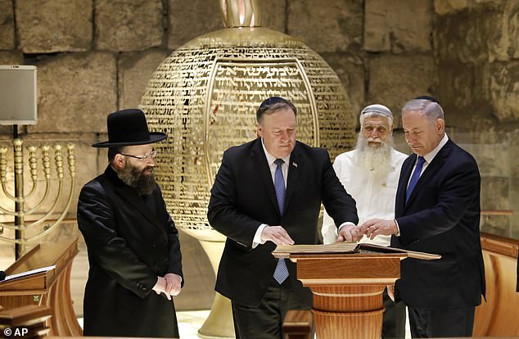
December 19, 2017 Mike Pompeo, US Secretary of State, signing dedication book of Sanhedrin subterranean synagogue facing Western Wall “stone” closest to Holy of Holies (I went into that tunnel and have a picture of that stone. I laid my hands on it and prayed (around 2004) …
Question: Why is the U.S. Secretary of State, Mike Pompeo signing the dedication of the synagogue with Netanyahu and Chabad rabbis? In the video you’ll see, there are no other heads of any country there? Pompeo is not reflecting a love pact between the U.S. and Israel. It’s a pact to bring about the new world order using the Talmudic Kabbalist Globalist Sanhedrin.
It’s just that the Khazar Jews jumped at the chance to take over the Land for themselves and drive everyone but them out of the Land, and by doing so eventually rule the world, having killed everyone they deem to be lower than them.
I'm sure a lot of Syrians and Iraqis are traceable to Abraham, Yitzak and Ya'cob, too. Those of Zechariah 12:9-13:1 and 14:1-5 who come running to greet Messiah are not what we've thought, not Jew, but are Judeans, most likely believers who are Arabs and/or Palestinians, Ethiopians, Kenyans, Sudanese, Nigerian Igbo, and the believers among “Jews,” for all in Messiah are of the SEED of Abraham, who is Yahushua.
Galatians 3:13-14; 28-29: We are redeemed from the “curse,” judgment for disobedience to the Torah, through our faith in Messiah. Through Messiah we honor Yahuwah’s “Torah”/instructions, with love, from our heart. We are one in Messiah. We will be united in His love forever in the Land of Judah and Samaria. We pray “Your Kingdom come, your will be done, on earth as it is in heaven.” [Refer to my mini-book Putting the Torah in Its Proper Place/Mikvah of the Covenant, also sold on Amazon Kindle]
Ephesians 2:8-19: No one in Messiah is a “gentile,” – a barbarian, pagan, heathen, stranger, alien, or foreigner to the Covenant of Yahuwah, and salvation through Messiah Yahushua.
In Zechariah 12, Yahuwah pours out His Spirit on the 1) House of David, 2) House of Nathan (David’s son through Miriam/Mary through whom Yahushua came), 3) House of Levi, and 4) House of Sh’mi. (Zechariah 12:10-14) Three are of the House of Judah. Sh’mi represents the House of Ephraim/Joseph/Israel. (II Samuel 19:20)
Do you see any Kazars in Zechariah 12? Yes you do! Note Zechariah 12:9: “And it shall be in that day that I seek to destroy all the gentiles that come against Jerusalem.” How ironic that Khazars posing as Jews hate “gentiles,” yet they are the gentiles that He will destroy. Yahuwah never called His people gentiles, even though the 10 tribes assimilated into gentile nations and acted like gentiles. He always saw His children as coming from Abraham, Yitzak, and Ya’cob. All who are pure gentiles that receive Messiah as Savior and Master are grafted into the tree of Israel. Refer to my article “Romans 11.”
I love our Homeland! I love Israel! I love its people! I believe you do too. However, it grieves me terribly that so many of my closest messianic friends listened to Khazar rabbi-lies and denied Messiah. This is fulfillment of Matthew 24:21-22 - the elect deceived. My friends were strong believers in Messiah, yet the next thing I knew they stopped writing to me. Then I found out they’d converted to Judaism. Oh the horrors they will reap, because to deny Him is to lose eternal life. (Matthew 10:32-33; II Peter 2:18-22)
The Talmud-Kabbalist “missionaries” operate in beguiling and seducing spirits to lie and deceive to get Christian’s money for their projects, like the third temple, and to seduce them into denying Messiah. It is the depths of evil. They are Satanists at the core. Jude 1 talks about them slyly entering into the fellowship of believers and sharing their deceptions to turn them from the true faith of the Word.
There is no repentance granted. (Matthew 10:30-39) You can’t deny someone you know well – you won’t fall of deception about someone you know well. Know Messiah well!
I lived in Jordan 7 years and about ½ of the next seven years in Tiberias. I’ve stayed in Jerusalem around 120 times at least. Israel is home to me. Even when I lived in Jordan I went over to Israel for almost every Festival. I’ve been to the tip of Jordan to the Red Sea, from Eilat to Metula in Israel. I’ve stayed in the heartland of Samaria many times in Ariel. Israel is home to me!
In November 1947, Zionists/Khazar-“Jews” worked with the United Nations to fulfill Mazzini/Pike Plan III, allowed the state of Israel. But the U.N. made sure that Jerusalem stayed under their authority. Israel was being set up for the antichrist, world government headquarters, and Sanhedrin control. Now the Sanhedrin is working with the United Nations to bring the U.N. to Jerusalem for their headquarters. The U.S., especially NYC will be destroyed, so the U.N. is in favor of moving to Jerusalem. Yes, Abba allowed all this for His Plans!
May 14, May1948, their plan came together and they became a state. On May 15, 1948, England called down Nazi Arabs from 5 countries to attack Israel. This began the final plans for world government with its epicenter in Jerusalem.
All the while, it has been Abba’s Plan to destroy Satan’s plan. He has allowed this interim 71 years so far, allowing the Mazzini/Pike III Globalist plan to mature into its fullness and go forth. And when they think they’ve got the whole world under control, ruling from Jerusalem, Messiah will split the sky and come down. (Revelation 19) HALLELUYAH!
The Land of Israel is the eternal homeland of all the tribes of Ya’cob! Ezekiel 47:15-48!
The King, “the Lion of the Tribe of Judah,” is returning! All of His Aliyah Scriptures will be fulfilled. “Aliyah Scriptures – Elohim’s Passion”/Mikvah of the Heart of Elohim
The Public schools of America plan to educate children in the Kabbalah, but this “education” is for all children of the world. The new United Nations booklet is entitled: Kaballah and Meditation For All Nations by Rabbi Yitzchak Ginsburgh sold on Amazon. Wikipedia: Yitzchak Ginsburgh (born 14 November 1944) is an American-born Israeli rabbi affiliated with the Chabad movement. He is regarded as one of Chabad's leading authorities on Jewish mysticism. Ginsburgh manifests in his generous use of the ancient tradition of gematria.
Dr. Lorraine Day stated recently to Jana ben Nun: “The Bible will be banned. Talmud and Kabbalah will be used in public schools.”
For now, this concludes my articles on this subject. This is article #7. I will update as Abba leads. Next I will begin my series on “Waiting on Yahuwah and Yahushua” - a series to instruct the remnant who truly want to know Them face to face! You can hear from Abba. It’s up to you!
In His love,
Yedidah
May 7, 2019

