THE NIGHT of the BROKEN GLASS
KRISTALLNACHT - NOVEMBER 9-10, 1938
Post U.S. Election Chaos 2016 - Globalist Plans for America
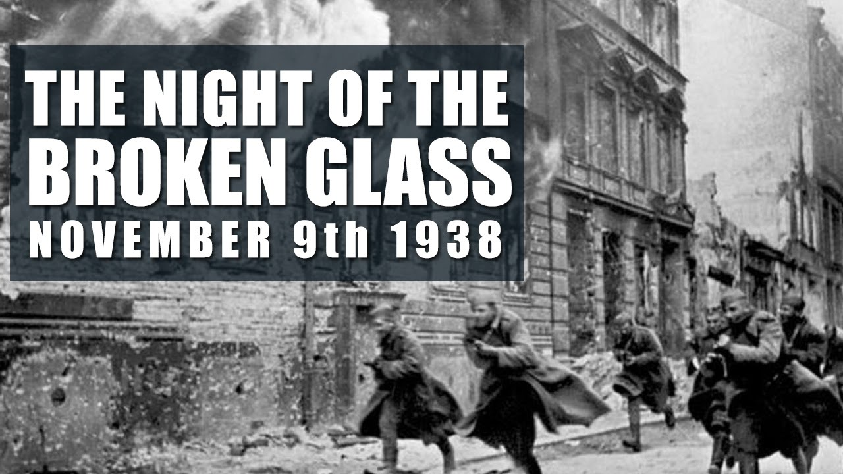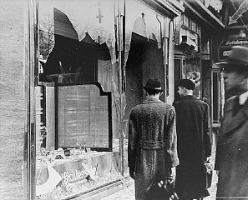
Photos from the National Holocaust Museum in Washington, D.C…
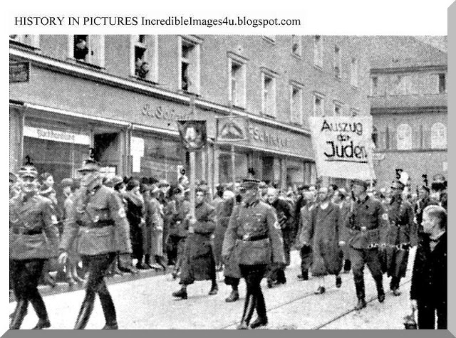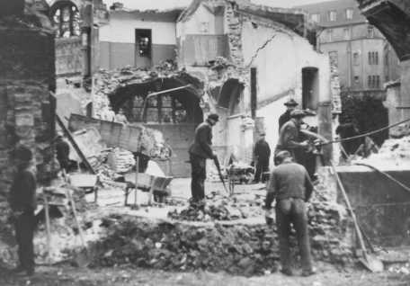
German policemen escorting Jews to Destruction of Jewish property
Dachau on November 10, 1938
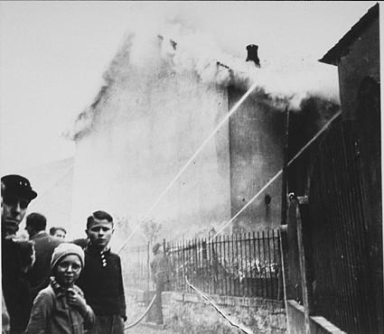
As the synagogue in Oberramstadt burns during Kristallnacht (the "Night of Broken Glass"), firefighters instead save a nearby house. Local residents watch as the synagogue is destroyed. Oberramstadt, Germany, November 9-10, 1938.
— US Holocaust Memorial Museum, courtesy of Trudy Isenberg

The most historic turbulent American Presidential Elections took place the day of November 8th through to the 9th at 3:00 AM, 2016.
I was in the living room eating dinner the evening of November 9th, and my daughter who works for CFOIC (Christian Friends of Israeli Communities) was reading their newsletter. She asked me: “Do you know what happened in Germany this night in 1938?” I guessed: “Was this the “night of the broken glass?” She said “Yes.” It really hit me hard to tears!
I knew in my spirit that there was a definite connection between Kristallnacht and what will soon happen in America. Even now, as I write this, tears well up in my eyes and a disturbed feeling from my spirit, as I think of the repeat that is soon to happen in this nation that “houses” more of the House of Judah and the House of Ephraim/Israel/Joseph than any other nation on earth.
Though Germany was beginning to persecute Jews in subtle ways a year or more before this night, it was this night that began the pogroms, the taking of the Jews to Poland, hauling them off to concentration camps, burning synagogues, homes, and businesses--basically blaming them for everything that they didn’t do.

https://www.ushmm.org/outreach/en/article.php?ModuleId=10007697
National Holocaust Museum, Washington DC
“…It appeared to be unplanned, set off by Germans' anger over the assassination of a German official in Paris at the hands of a Jewish teenager. In fact, German propaganda minister Joseph Goebbels and other Nazis carefully organized the pogroms. In two days, over 250 synagogues were burned, over 7,000 Jewish businesses were trashed and looted, dozens of Jewish people were killed, and Jewish cemeteries, hospitals, schools, and homes were looted while police and fire brigades stood by. The pogroms became known as Kristallnacht, the "Night of Broken Glass," for the shattered glass from the store windows that littered the streets.
The morning after the pogroms, 30,000 German Jewish men were arrested for the "crime" of being Jewish and sent to concentration camps where hundreds of them perished. Some Jewish women were also arrested and sent to local jails. Businesses owned by Jews were not allowed to reopen unless they were managed by non-Jews. Curfews were placed on Jews, limiting the hours of the day they could leave their homes.
OCTOBER 28, 1938: GERMANY EXPELS POLISH JEWS
About 17,000 Polish Jews are expelled by Germany and forced across the border with Poland. Poland refuses to allow the Jews to enter. Most of the deportees are stranded in the no-man's-land between Germany and Poland…
NOVEMBER 7, 1938: GERMAN DIPLOMAT SHOT IN PARIS
Herschel Grynszpan, a 17-year-old Polish Jew living in Paris, shoots Ernst Vom Rath, a diplomat attached to the German embassy in Paris. Grynszpan apparently acts out of despair over the fate of his parents, who are trapped along with other Polish Jewish deportees in a no-man’s-land between Germany and Poland. The Nazis use the shooting to fan anti-Semitic fervor, claiming that Grynszpan did not act alone, but was part of a wider Jewish conspiracy against Germany. Vom Rath died two days later.
NOVEMBER 9, 1938: JOSEPH GOEBBELS DEMANDS RADICAL ACTION
German propaganda minister Joseph Goebbels delivers a passionate anti-Semitic speech to the Nazi party faithful in Munich. The party members are gathered in commemoration of the abortive Nazi Putsch of 1923 (Adolf Hitler’s first attempt to seize power). After the speech, Nazi officials order the Storm Troopers (SA) and other party formations to attack Jews and to destroy their homes, businesses, and houses of worship.
The violence against Jews lasts into the morning hours of November 10th, and becomes known as Kristallnacht—the "Night of Broken Glass." Several dozen Jews lose their lives and tens of thousands are arrested and sent to concentration camps.
NOVEMBER 12, 1938: NAZIS FINE JEWISH COMMUNITY
The Nazi state imposes a fine of one billion Reichsmarks ($400,000,000) on the Jewish community in Germany. Jews are ordered to clean up and make repairs after the pogrom.”
From The History Place--World War II Timeline November 9/10, 1938
On this website you can read the actual “the orders to the Gestapo not to interfere with violence against Jews …From Heinrich Müller to all Gestapo offices, transmitted at 11:55 p.m.--November 9, 1938…”
It appears that the act of one angry boy was used to begin the Holocaust. It does not take much by evil planners to manipulate people’s emotions by deceit, and thus turn good people against the wrong people in order for the evil ones to get done what they want done! In America the pattern has been steady for over 2 years: A “single shooter,” who is usually killed by police, is blamed for some emotionally charged shooting. In turn, the news media and the government put it into people’s minds that all American citizens need to be disarmed. One of the first things Hitler did when he took over was disarm the German citizens.
Perhaps the boy did shoot Vom Wrath, but I suspect it was someone hired by the German government whose bullet killed Vom Wrath, and it was blamed on the Jewish boy. Too suspicious: “Propaganda Minister” Goebbels was all ready with his orders to the Gestapo immediately. And, WHO actually started the glass breaking and synagogue burning? -- Most likely it was hired thugs by the German government. Not much happens by chance, but by careful planning.
I remember reading about a gathering of Jewish Holocaust survivors in Germany years after World War II ended. One man was very bitter. He stood up and asked the people there: “Where was God during the Holocaust?” Another Jewish man stood up and said: “God was with us a year before the Holocaust began. He sent many to warn us to escape Germany, but we would not do it.”
2,500 years ago, Yahuwah began warning His American children to flee from end-time Babylon to escape being killed along with everyone else. He has sent many watchmen, in the last 20 years especially, to warn people to flee from America. I’ve been warning since 1992, and have lived overseas for many years. Abba, however, keeps me on the go. Watchman Gary Kah started warning Americans in 1992, in his book Enroute to Global Occupation. Watchman John Price started warning after Obama became President. Both of these men and their families are in Central America.
As said above, the nation of America contains more of the House of Judah (Jews/Levites/Benjamin) and the House of Israel (the 10 northern tribes scattered in AMONG the gentiles) than any other nation on earth. Now, subtle persecution of Christians in America is getting stronger, and the Hitler-like murdering of Christians, as well as Jews, will soon follow, to actually bring another Holocaust. All the facilities Hitler had for killing Jews is in America today waiting …
Have you read my article “The Executive Order,”/March 21, 2012 and “The Pergamum Altar the Throne of Satan”/September 4, 2015? I highly suggest you read these to understand what I write here. This Executive Order, the “Continuance of Government,” will take away all your rights, your property, and your life. The pictures included in the article on Pergamum are astonishing – Hitler, Berlin, Barack Obama, and the Altar of Zeus. Recently Obama made the statement that Angela Merkel was his “business partner.” How deep is Obama’s relationship to Hitler?
From the time Barack Obama began campaigning for the Presidency in 2008, Holocaust survivors began noticing signs in his words and actions that were identical to Hitler’s words and actions that preceded the Holocaust. They were quite outspoken in what they saw, but few cared what they said.
Before his election in 2008, Obama went to Germany and gave his famous speech in Berlin at the base of the Hitler memorial, even giving a hail Hitler salute, which was returned to him. This salute is against German law. No one reported that he went to the Pergamum Museum in Berlin, but when he made his outdoor acceptance speech in Denver, Colorado, in 2008, many were shocked to see that he made it from a replica of the Pergamum altar of Zeus (Revelation 2). Hitler had a replica of that altar made for him, from which he made his famous speech of the “Final Solution.” In other words, Germany’s problems would be solved if we got rid of all the Jews – his justification for the Holocaust was delivered from a replica of this altar.
[Please read the article “It’s All About Worship”/March 11, 2013, and see the pictures, regarding Obama in Germany and Denver.]
Persecution of Christians has begun worldwide. Obama and Hillary’s creation, ISIS, has performed a purge of Christians from the Middle East. Now they are in Europe, and in America. A Holocaust is coming to America! The FEMA camps and POW camps have been prepared using abandoned military bases for many years. Giant crematories are also ready inside America. I talked with Colonel Jim Ammerman, U.S. Army, about this around 2005. He confirmed all that I knew, and let me in on more.
The three story box cars are waiting also, complete with “tie downs,” shackles and guillotines. The Americans won’t be as easy to contain as the submissive Jews were from 1938. So Americans will have to be “tied down,” and beheaded if they cause “trouble.” America also built a 25 square mile concentration camp in Israel, using exclusively Arab laborers. It is identical to a FEMA camp, complete with underground vents for the crematory. The Jews in Jerusalem will not take the giving away of Jerusalem to the Palestinians lightly. This is why Messiah says to Judah: “Flee to the mountains.” They know where that is--Jordan--the Mountains of Seir/Petra.
America and Israel are interlinked as nations. Radical Islam calls Israel “little Satan” and America “big Satan.” Jihadists cry for the destruction of both. America is totally destroyed for its turning against Israel (Jeremiah 50-51), for America and Esau’s Vatican Rome are also interlinked, “echad” (two in unity as one) for a New World Order.

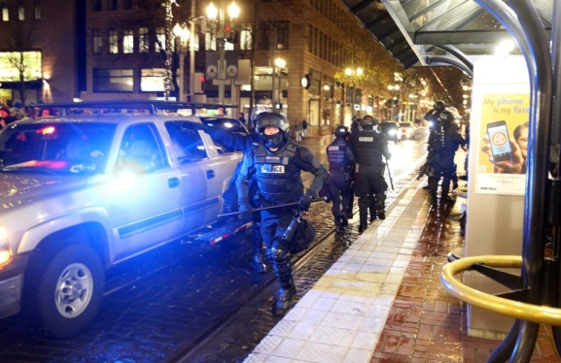
Left picture: from All News Pipeline
Right picture: From The Oregonian: “'Not my president!” - Will anti-Trump marches become a movement?” - “Protesters march in downtown Portland after a candlelight vigil at Waterfront Park by Portland's Resistance group on Sunday, Nov. 13, 2016. The group has been leading anti-Trump election protests, some of which have resulted in violence and vandalism, the past several nights in downtown Portland, Oregon.” (Dave Killen/Staff)

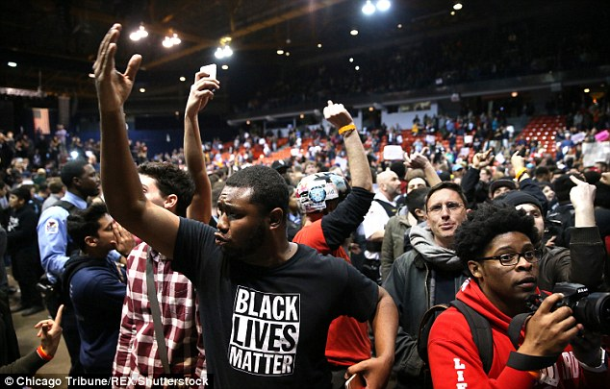
Scenes of protests in Chicago November 13, 2016

MEET GEORGE SOROS
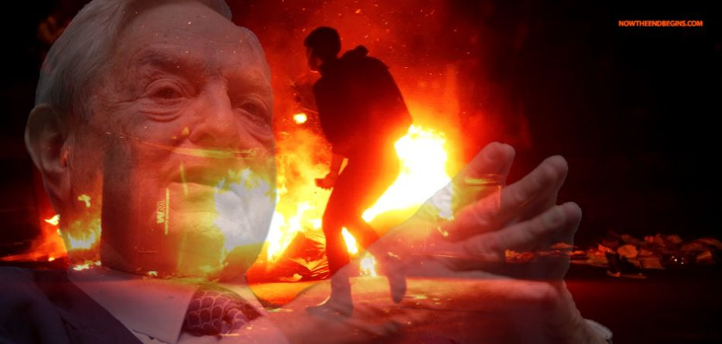
This evil-empire multi-billionaire, a communist too, is very active in causing chaos in America. America is in the midst of a communist takeover. Barack Obama and Hillary Clinton were trained by Saul Alinsky in radical communist takeover. Soros is working with them. The goal is to bring the world into the New World Order. The motto of the Illuminati is: “Out of chaos, order.”
Soros’ voting booths kept switching Trump votes to Clinton votes. But, he is far more sinister than that. Like the Clinton’s, he has his fingers in evil pies all over the world. It has been proven that he is bussing professional protesters and activists to cause the chaos in the American streets against Donald Trump’s election. He is the creator of the Black Lives Matter violence. Police have commented that Black Lives Matter activists were bused in from outside their neighborhoods. Like the CIA in Cairo, Egypt 2011, the demonstrations are faked, violence ensues, and chaos breaks out. If this keeps up much longer the Executive Orders will go into effect, and martial law will be launched. People will be quarantined to their homes as foreign troops and Black-Op mercenaries roam the streets. Their goal will be reached – a destroyed America, and a submissive world.
Just as the CIA created Al Qaeda, and President Carter the Taliban, so Obama and Hillary created ISIS, most likely with George Soros’ help. The Globalists are tired of waiting. They want world government now. And, like their Nazi friends, they want to bring about rule by the ancient Nephilim. They don’t just want some Elite human to take over world rule--they want Nimrod. They want the ten economic regions ruled by “iron and clay.” (Daniel 2:43) Daniel speaks of Nephilim and human interaction. What time-period are we in? Look at Daniel 2:44! HalleluYah!
At the same time, trans-humanists want to end the human being and replace him with part human part robot, part everything you can image, to the pleasure of the returned Nephilim and their new offspring. They’ve been in control, under Satan, since their return in 1896! [If you’re new to my articles, I’ve written a lot about their return—especially from November 2015.]

“Chicago Will Burn - Soros Thugs Moving In for the Kill” – by Dave Hodges – November 15, 2016 The Common Sense Show
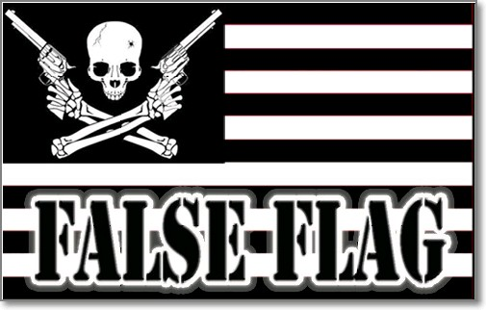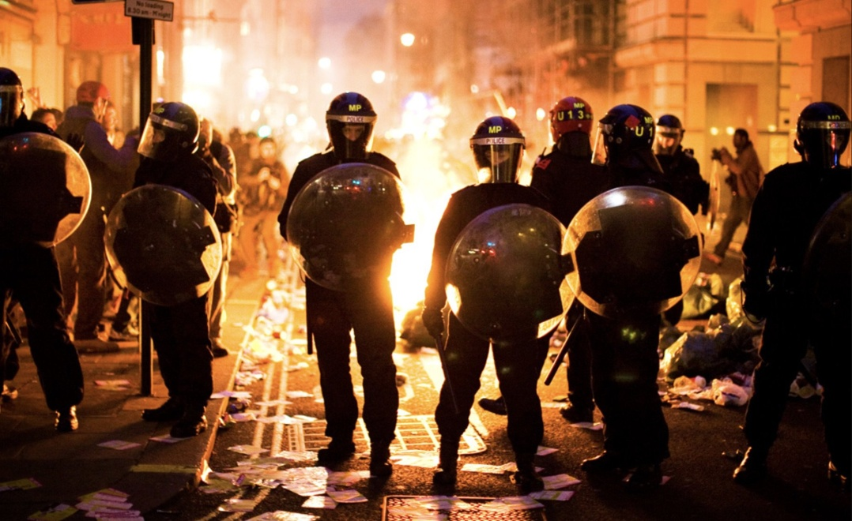

“Five blocks of buses have arrived in Chicago. These are paid protestors and they are there because George Soros has paid for them to be there.
The idea is to promote as much violence as possible so that this becomes a military issue. Some think that this will spread to other cities and national martial law will result. If this happens, Obama will never leave office. If you thought that Obama was being too nice to Trump in the transition, you are correct and now you may know why.”
Rahm Emanuel is the Mayor of Chicago. It has been brought to light that he was placed there to inaugurate a false flag. Five blocks of buses have been sent by Soros to burn Chicago. Obama will vacate Chicago and head for his new house in Hawaii, if he doesn’t stay in office. As Hodges reports, Rahm is a known Mossad agent. There is an organized plan to bring down Chicago-then to spread the violence from city to city.
I saw this in a powerful dream to do with Chicago, 2008. In the dream, I was in Chicago by myself. There I watched the launching of the takedown of America. Everything was coming down around me, but I was totally unharmed. Later I wanted to see where in Chicago I was standing when everything began falling down. I checked out the park area where Obama gave his victory speech in Chicago, 2008. I saw where I stood – outside that park.
Many prophecies have gone forth for 150 years that America would burn – prophecies, dreams, visions. But, the Word tells us that America will burn.
“Soros-funded left-wing anarcho-terrorists plotting to SABOTAGE Trump and overthrow the Republic: Dave Hodges releases urgent interview with Mike Adams - Monday, November 14, 2016-by Mike Adams:
“…tricks and tactics will be invoked by the criminal left (the Clintons, Obama, George Soros, John Podesta, etc.) to try to nullify the outcome of the election and seize power in Washington…But "alternative-media" truth overcame the lies of the mainstream media, and the People marched to the ballot box to end the Clinton nightmare for America once and for all.
Soros now funding left-wing terrorist groups that seek to overthrow the government
Now, international anarcho-terrorist money man George Soros is funding domestic terrorism organizations like MoveOn.org and Black Lives Matter to try to stage a leftist uprising…Their ultimate goal is to march on Washington…”
America, the super power of the earth since the surrender of Japan in August of 1945 after World War II, has had her 70 years of reign. (Jeremiah 25) America has fulfilled its designated role to reincarnate Nimrod and bring him back to power. America paved the way and helped finance World War I and II, and now III. Its usefulness is over. It has been an experimental laboratory for many things, using the citizens as “lab rats.” But, now, they are ready to make their move, and the “lab rats,” and the laboratory itself, have to be demolished.
Human beings are called “insects” by the global Elite/Globalists/Illuminati. Their depopulation agenda has been well on its way for many years – but now, the 7.5 billion people have to be reduced to 7 billion. The best way to do that is by a pandemic, starving the people to death, or better, by world war. (Ezekiel 14)
[Refer to “Yahuwah’s Pattern of Judgment”/December 28, 2007 OR ”The Multiple Divisions of Yahuwah’s Judgment”/an update, March 5, 2015]
5,000 years ago, Yahuwah depopulated the earth down to 8 people. He will do it again. He will use the judgment on the evil ones to depopulate earth down to so few that a child can count them. (Isaiah 10:16-27) It’s His way of erasing what is not right in order to start over with what is right/righteous. Wise people stay in His favor! True believers will heed Matthew 25:14-30 and Luke 12:37-48.
His wrath is at the boiling point. Only those He knows, His trusted servants and friends, will escape, because they obey Him. Once again I promote Derek Townsend’s mini-book For the Love of Truth – Possessing Your Eternal Life, in which he opens up revelation of Matthew 25’s three examples of the urgency to possess what He has given to you unless you want to lose it! You can find this mini-book on his website, thewelltroddenroad.org, or on Amazon books, or Kindle.
The Night of the Broken Glass is a warning to America! We have several Trojan Horses inside America united in spirit with Hitler and the Nazis, using Muslims, which were used in high places to create World War I and II, and now III. The fine-tuned Mazzini/Pike Plan of 1871 has been carried in the finest detail.
Was this election a turning point--a throw-back to the “night of the broken glass?” The timing of both is amazing. The backlash from the morning of the 9th of November 2016 in America has just begun. What will our nation, and the world, look like by January 20th, 2017?
Prepare in all ways. Be active in sharing the Truth. This is the finest hour of the truly born again! Share the Good News of your Savior, the good news of faith in Yahuwah and Yahushua, and in the promises of Their Word.
Their people who do nothing, who do not speak for the Master, those ashamed of Messiah’s death and resurrection, will be swept away in the tidal wave of evil and horror. Best to be a humble servant of Yahuwah and Yahushua and lay down your life for the One who laid down His life for you! He has been trodden underfoot by most “so-called believers” – but the Day of Judgment, the “Day of Yahuwah” is coming – the Day of great separation. (Matthew 10:34-39)
Fear only Elohim, which is the beginning of wisdom! Dive into your promises in the Psalms!
Written with soberness, yet shalom in His love,
Yedidah
November 17, 2016

