The U.S. Plans to Move Their Embassy to Jerusalem
To Officially Open May 14, 2018

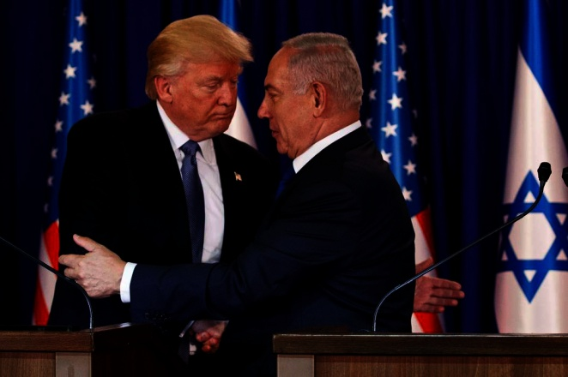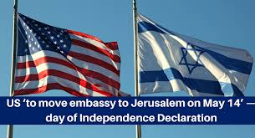
February 23, 2018

Trump Recognizes Jerusalem as Israel’s Capital and Orders U.S. Embassy to Move - by MARK LANDLER - DEC. 6, 2017 – The Washington Post
“WASHINGTON — President Trump on Wednesday formally recognized Jerusalem as the capital of Israel, reversing nearly seven decades of American foreign policy and setting in motion a plan to move the United States Embassy from Tel Aviv to the fiercely contested Holy City…”
We all remember this exciting announcement and the violence that burst forth worldwide because of it. Now it is three months away from happening, and the U.S. State Department has confirmed that yes, America intends to move its Embassy from Tel Aviv to Jerusalem--the opening date to correspond to Israel’s 70th anniversary as a nation – May 14, 2018.
On December 6th the ball began rolling…this brought immediate violence in Jerusalem and all over the Arab world, including rioting in Europe and America, too. The 1947, map of the U.N. Partition of Israel shows that Jerusalem is under the control of the U.N. How are they going to proceed with this? Will it happen in three months? The official opening of a make-shift embassy is a starter, but then the official embassy is supposed to be completed by 2019. A lot can happen between now and then. Refer to: “Jerusalem: Today, Amidst Warnings, Trump’s Bold Announcement Could Shake the World”/Mikvah of our Eternal Inheritance. In this article you’ll see a map of the 1947 U.N. Partition of Israel.
Many websites by Christian Fundamentalist pre-tribulation rapture-enthusiasts are having a heyday, giving their cookie cutter theology just like the Jesuits fed it to them through John Nelson Darby. [For documentation, refer to: “Warning! Exposing Nine Lies…” under the Mikvah of Present Reality]
Orthodox Jews are celebrating, along with wanting Putin and Trump to help them build the third temple, even though they know Zechariah 6:12-15. It’s all excitement time depending on what side of a belief-system you’re on. Some want to riot and kill, some want to dance, some want to throw their un-Scriptural eschatology in everyone’s face, and others are just flat skeptical. Of course, many could care less. But, one thing’s for sure, Zechariah 12:2-3 will certainly be a reality more than ever before from this point on.
Zechariah 12:2-3: “See, I am making Yerushalyaim (Jerusalem) a cup of trembling to all people all around, and also against Yehudah (Judah) it is in the siege against Yerushalayim. And in that day, it shall be that I make Yerushalayim a very heavy stone for all people – all lifting it are severely injured. And all the nations of the earth shall be gathered against it.”
However noble and honorable the keeping of his campaign promise is, a Congress-approved promise that has been ignored by former presidents, Trump’s timing put this action in a “that day” context, and whether he purposed it or not, he became a facilitator of the speeding up of events of end-time prophecy. Please review the foundation-article “The Day of Yahuwah” to understand “that day.” It is under the Mikvah of Present Reality.
“State Department confirms move going ahead in under 3 months
US Embassy in Jerusalem to open in May — in time for Israel’s 70th anniversary. Trump administration officials say Congress being briefed on plans; ribbon cutting could take place on May 14 -- Day of Independence declaration” - By Eric Cortellessa, 23 February 2018, Times of Israel
“CONFIRMED: Donald Trump Will Officially Relocate the US Embassy to Jerusalem on May 14, 2018 –nowtheendbegins by Geoffrey Grider
“The Trump administration will officially relocate the US embassy in Israel from Tel Aviv to Jerusalem in May, timed with Israel's 70th Independence Day, a State Department official confirmed to The Jerusalem Post on Friday. The official was responding to a message on Twitter by Transport Minister Israel Katz, who seemed to confirm the move would occur in the spring. "We’re planning to open the new US Embassy to Israel in Jerusalem in May," the US official told the Post. "The Embassy opening will coincide with Israel’s 70th anniversary."
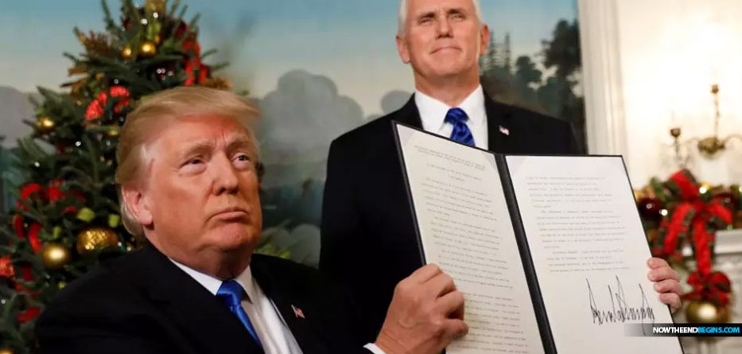
by Geoffrey Grider February 23, 2018
“The Trump administration will officially relocate the US embassy in Israel from Tel Aviv to Jerusalem in May, timed with Israel’s 70th Independence Day, a State Department official confirmed to The Jerusalem Post on Friday.”
And on and on: News from around the world is announcing this…
However, the million dollar question is: Will it happen? We’ll wait and see. But, it is a for-sure thing that on May 14th (Gregorian calendar-dating of the world) that Israel will celebrate 70 years of officially being a nation.
“Papyrus with Oldest-Known Hebrew Reference to Jerusalem Proves City Jewish 1,300 Years Before Birth of Islam” - Feb 18, 2018 by Jews News in ISRAEL by Adam Eliyahu Berkowitz
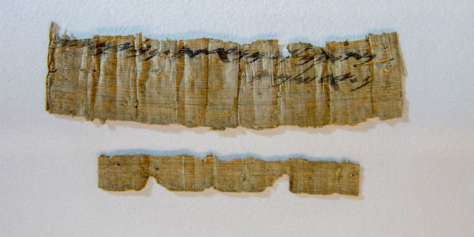
“A 2,700-year-old papyrus that is the oldest known non-Biblical Hebrew reference to Jerusalem has been found, announced the Israel Antiquities Authority (IAA) on Wednesday. The papyrus, originally stolen by antiquities thieves, was put on display in Jerusalem on Wednesday, coinciding with the second UNESCO resolution attempting to deny Judaism’s connection to its most holy city – a connection this ancient artifact so graphically proves. The two lines of writing on the tiny scrap of papyrus (4.3 inches by 1 inch) are surprisingly clear: `From the king’s maidservant, from Naharta, jars of wine, to Yerushalayim.’
The scroll was originally plundered from a cave in Nahal Hever in the Judean Desert near the Dead Sea by antiquities thieves. Professor Shmuel Ahituv of Ben-Gurion University studied the papyrus when it was first recovered. He spoke at the IAA press conference, noting that on the papyrus, the name of the city was spelled with a letter ‘yud’, as it is in modern Hebrew. Pronounced ‘Yerushalayim,’ Ahituv noted that it is spelled this way only four times in the entire Bible.”
There is more than ample proof that Jerusalem was established, just as the Word tells us, after David and his men took the ancient area of East Jerusalem from the Jebusites over 3,000 years ago. He took what became “the City of David,” the real Zion, which rises above the Kidron Valley. (II Samuel 5:7, 9-10) Here he built his palace, whose ruins can be walked through today. Behind his house was the “tabernacle of David,” where worship went on around the Ark for 40 years, where most of the Psalms were written. Zion (tyz-ion) is not the Temple Mount! That’s Mount Moriah…
I sure would like for you to read: “Worship – The Journey of the Ark of the Covenant” under the Mikvah of the Spirit of Elohim. That little hill of Zion, south of the Temple Mount, rising above the Kidron, is my favorite place on earth! It is the favorite place on earth of Yahuwah and His Son, Yahushua (Psalm 132:13-14) I also hope you read the article “East Jerusalem” to find out how very important it is. That article is under the Mikvah of our Eternal Inheritance. East Jerusalem, between Mount Moriah, Mount Zion, and the Mount of Olives, is where the Garden of Eden is still located in two dimensions. Thus, that particular “garden gate” might be the very gate that Messiah was talking about in Matthew 7:13-14!
Jerusalem doesn’t belong to the satanic-ruled United Nations or to satanic-controlled UNESCO! So, in this historic move that overrides the will of the world’s elite Luciferic/Satanic rulers, President Donald Trump is indeed unleashing the final events of the “last days.”
I wrote an article in February 2017 entitled “The Rider on the White Horse – The Crowned Conquer Rides Forth to Loose” under the Mikvah of the Great Adventure, in which I saw that Donald Trump may be the man on the white horse as “the looser,” not carrying a weapon. I don’t think he means to hurt anyone. Maybe I’m wrong, but I want to think he intends to do good. However, in doing good in this world today, which Yahuwah’s Spirit has left to the fallen powers of the air for His final prophetic agenda, good will be turned to the final purposes for the fulfillment of all Bible prophecy.
You may remember that I recently reported how the British commandeered Nazi Arabs to unite and attack the Jews on May 15th, in an attempt to hinder Jewish migration to Israel. HalleluYah! It didn’t work. What will happen as a result of this May 14th’s 70th anniversary celebration in Jerusalem? Every year’s celebration of Israel’s statehood is met by violence from the Arabs, especially in Jerusalem. So, how will the world respond, if indeed the make-shirt embassy is set up, then buildings go up for a permanent embassy?
“Israel says 10 more countries in talks about moving embassies to Jerusalem
Honduras reportedly next in line after Guatemala announces relocation of mission; Togo, Paraguay, Romania and Slovakia also floated…” December 25, 2017, Times of Israel.
Will the U.S. move start a landslide of nations wanting to do the same? No matter what happens, “the cup of trembling” is trembling more than ever. [Refer to: “The Cup of Trembling Trembles More” under the Mikvah of our Eternal Inheritance]
If this moving of the embassy actually happens, it will not bring the sought-after peace between Israel and its Arab and Persian/Iranian neighbors. It will not incur the joy of the world. It will lead to the igniting of the fires of the last days for the final fulfillments of Scriptural prophecy!
Psalm 122:6-9: “Pray for the peace of Yerushalayim. Let those who love you be at rest. Peace be within your walls, rest in your citadels. For the sake of my brothers and companions, I say `Peace be within you.’ For the same of the House of Yahuwah our Elohim, I seek your good.’’
Isaiah 62:1, 6-7: “For Tsiyon’s sake I am not silent and for Yerushalayim’s sake I do not rest, until her righteousness goes forth as brightness, and her deliverance as a lamp that burns…I have set watchmen on your walls, O Yerushalayim, all the day and all the night continually, who are not silent. You who remember Yahuwah, give yourselves no rest until He makes Yerushalayim a praise in the earth.”
Do you “remember Yahuwah?” Then daily pray for the peace of His City, proclaim Psalm 132:13-14 and other Scriptures that speak of His finished work. Pray for the salvation of Jewish people by the blood of their/our Messiah.
The peace will come when the Prince of Peace arrives, and the House of David, the House of Nathan, the house of Levi, and the house of Shm’i mourn--as they finally “look on Him whom they pierced, and realize that Yahushua is their Messiah. (Zechariah 12)
Shalom, in His love and blessings,
Yedidah
February 27, 2018

