2019
URGENT, SUDDENLY, SHIFTING, TURNING POINT

The heavenly shofars are blowing, warning us of approaching danger!
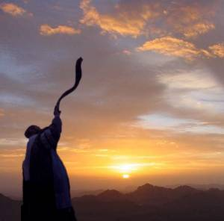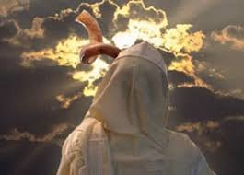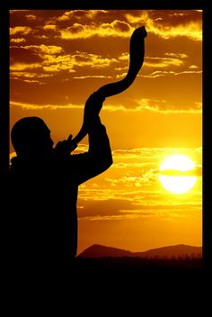
“Blow the trumpet in Zion, sound the alarm on My set-apart mountain.” (Joel 2:1)
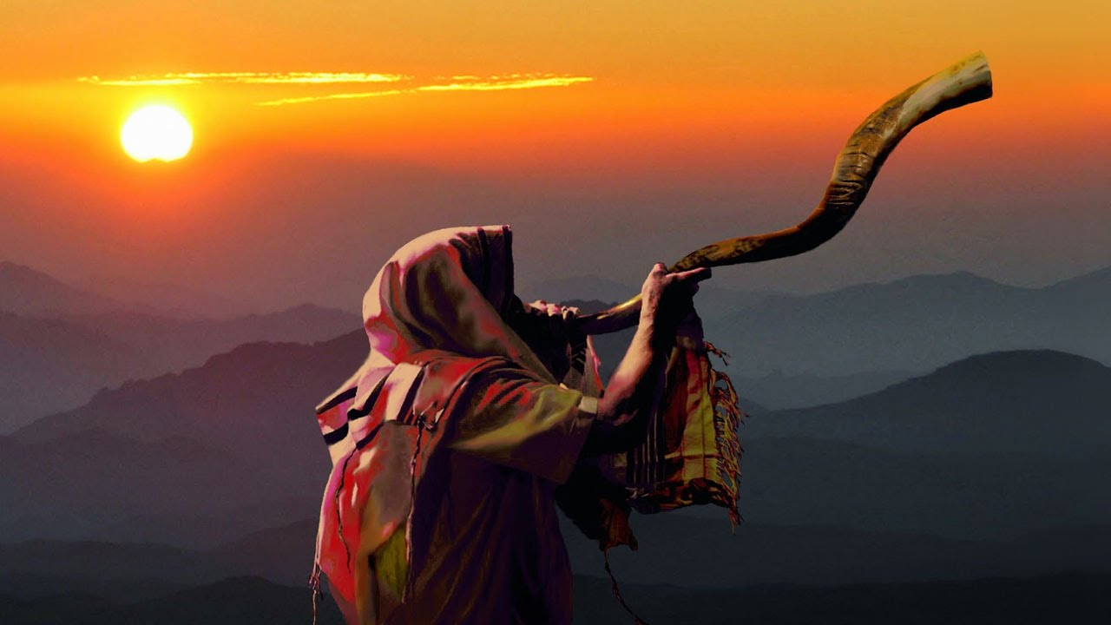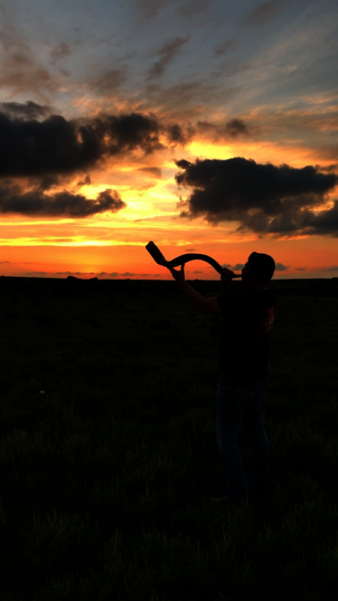

About 12:30 AM at the Prayer and Training Center last night -- December 31, 2018/January 1, 2019 -- Pastor McQueen stood up to make final remarks following our praise, prayer, testimony, fellowship, gathering that began at 10:00 PM. Pastor’s words went through me like an arrow, words that Yahuwah has given to me over and over the last few months, weeks, days--“URGENT,” “SUDDENLY,” “SHIFTING,” “TURNING POINT.” The precious time together ended as Derek blew the shofar. We just kept on fellowshipping until about 1:30. Instead of being tired, I was exhilarated from being in the Presence of Elohim with fellow believers. The anointing was there!
Many articles and video messages, coming from the watchmen of Yahuwah, include these words also, with sober warnings, exhortations, and praises to the soon-returning “Lamb that was slain.” (Revelation 4-5)
Early in 2018, Abba led my daughter-in-law’s mother to attend a small gathering in a small storefront location in southwest Fort Worth. Her daughter and my son began attending. I attended there for the first time at Passover. We now regularly attend this multi-nationality, multi-culture, Prayer and Training Center. It actually is a small family of believers, the nucleus for a larger work to come that is based on a vision that led Pastor McQueen and her family to settle here from New York, and especially from their ministry in Germany. This is not a church.
In 2001, I was back in the U.S. from my home in Aqaba, Jordan, for a short time. As I was preparing to go to my church in Fort Worth, a wonderful assembly pastored by my friend Robert Mawire from Zimbabwe, Abba spoke sternly to me: “You will never, ever, go into another church again.” It was not anything against Pastor Mawire; it was an across-board edict. Pastor Mawire was friends with Prime Minister Netanyahu, and was allowed to share the Gospel on radio there. I had to cancel my trip back to Africa and all meeting with my many Ugandan pastors. I obeyed. I know Abba’s voice. In sending me to Jordan for 8 years, He became my sole Teacher. Others confirmed, but He taught!
This small assembly of believers is not a church! It is a small community of believers who love our Abba, our Savior-Messiah, and who flow in the whole of Their Word. Last night, as the fellowship was officially ended, Pastor’s words went into me like arrows. The unity that the Spirit has drawn us into His unity is strictly His doing! In His unity, we have understanding of the times and seasons (I Thessalonians 5:1-10) We have united praise for our Elohim.
Though we know January 1st is just another day in Abba’s reckoning of time, to gather like that with like-believers was a precious time of uniting in His Presence. There are no labels, no denominational ties--no ties to man’s opinions or theology. This type of unity is what Messiah prayed for in John 17. It is a model-type of the gathering of believers that is taking place all over the world as we “see the Day approaching.”
Hebrews 10:25: “…not forsaking the assembling of yourselves together, as the manner of some is, but exhorting one another, and so much more, as you see the Day approaching.” That’s “The Day of Yahuwah”/Mikvah of Present Reality.
February 19, 1988, while I and my family were living in this same area of Fort Worth, Yahuwah gave me a very detailed dream about “the gathering” of His people. The dream showed the future condition of each member of my family. It has come to pass in absolute detail. October 2018, Abba brought me back to the very same apartment complex where I lived from 1996-1999 before moving to Aqaba, Jordan. The assembly “gathering place” is 5 minute’s drive from my apartment complex.
Pastor McQueen and family were led by Abba from New York and from Germany, where they were missionaries for many years, to this place in Fort Worth. As missionaries in Germany for several years, they started quite a number of churches in Germany and Italy. Her husband was a Bishop over these assemblies. Though the vision for the Prayer and Training Center was given to his wife, he and two of their young adult children are active in our gathering.
In March 2018, after Passover, Abba instructed me to be relocated back to this area of Fort Worth by October. It was a miracle journey. Every day I heard from Him, and I obeyed, and things day by day fell into place – things I thought were impossible. I arrived October 19th by His miraculous leading and intervention, with the help of precious believers from North Carolina.
So, as these pastor-teachers were given an understanding of the gathering of His people at this time, so we have joined with them and with those also attending. We are a family in the Spirit. Simple child-like faith reigns, and so do the miracles. It is a book of Acts type of assembly, where the people are born again, Spirit-filled, move in the gifts and power of the Spirit, yet, are deep in the Word and obedience to it as a whole. The Scripture is taught from Genesis to Revelation, and wisdom, knowledge, understanding, insight and revelation pours forth.
Genesis 49:10, spoken by Ya’cob: “The scepter shall not depart from Judah not a Lawgiver from between his feet until Shiloh comes and unto Him shall the gathering be.” [“Shiloh” is Messiah] We are gathering unto Him to prepare for His entrance!
Yahuwah is establishing centers for gathering, for prayer, for outreach to the lost, places of fellowship for believers, safety and security in like-faith in our beloved Yahushua ha Machiach and in His Father’s Torah. I came from a situation where I had no friends and no fellowship. So this is wonderful. The work is at the grass-roots level, but growing, as the vision foretold.
As you yield to being taught by the Spirit of Yahuwah, are obedient to the Spirit of Yahuwah within you, flowing with what He is asking you to do, your Abba will lead you to others of like spirit—those who are also Spirit-taught. He is establishing small gatherings in many places around the world for our edification and support – for fellowship with a spiritual family, as we “see the day approaching.”
In China, Brother Yun was in prison many times for his witnessing about Jesus. He had no Bible. His mother had memorized two verses she heard read from the Bible and was sharing them with neighbors, friends, and family. She gathered people in her home for prayer and teaching about our wonderful Savior. They were definitely “Spirit-taught.” I encourage you to read The Heavenly Man by Brother Yun. What he suffered is intensifying in China right now. Are you gathering people into your home to tell them about our Savior, to strengthen believers, to prepare people for what lies ahead?
The two main words used as Pastor McQueen as she concluded our fellowship last night were “URGENCY” and “SUDDENLY.” It was a sobering conclusion. Yahuwah’s watchmen are giving sobering messages today, as the world knows we are inside 2019 on their Gregorian calendar. Of course, as believers we entered 2019 the eve of September 11th as the new moon was sighted from Jerusalem for Tishre 1, Yom Teruah – the Festival of shofar blowing and shouting, the 5th of Yahuwah’s seven appointments with man – Festivals that are an outline of His plan of salvation through His Son, Yahushua Messiah.
Be led by the Spirit in all things; be instantly obedient to what He speaks to you; then you will arrive at the gathering place He has for you. Even the world’s people in general now know something is happening, and fear has set in. Much chaos and confusion is being stirred. The world is now in the hands of the Globalists, another name for Satanists, forerunners of anti-messiah.
Today, technology is being used to manipulate the minds of human beings. But, if you know how to live out of your spirit-temple, even if your mind shuts down, you can still function through your mind of the spirit. I don’t say that theologically.
As I have written before, when in Tanzania in 1997, I lay dying of malaria at a pastor’s house. My African director had preached 25 of my 28 meetings at the church. I could not remember my own name. I could not remember the name of my daughter who lived with me in Fort Worth. I told the pastor I wanted to preach. I could not sit up, let alone stand up. But, they took got me down to the church and sat me in a padded chair with support arms. I literally heard the voice of Yahushua in my spirit, speaking one sentence at a time. I repeated what He said and the pastor translated. I preached nearly 2 hours on the return of Messiah. While preaching I had tremendous strength. When I finished, I collapsed in weakness. I preached two more times in like manner. I was in the final stages of malaria before death, but as you can see, I’m very much alive. Messiah healed me. By this, and other examples, I know that even if the mind shut down, we can live out of our spirit. Get in touch with Yahuwah and with Yahushua through your spirit! Without Yahuwah, who is the Spirit, in your spirit, you have no recourse. Technology today can shut the mind down, even program what into you what to think through voice-skull technology.
There is a sensing in the spirit of human beings in general that something evil is approaching, yet most cannot nail down what it is, including most so-called “believers.” The churches, and Messianic congregations, are most all silent about it. Public news media is nothing more than propaganda for the evil, whitewashing it as good. Public schools are teaching global government principals.
I’ve spent a lot of the last 58 years, especially the last 33 years, keeping up with the progression of what began in the 1960s, as we turned a corner back then towards what the Bible calls “the end times,” “the last days.” I began following His 7-year cycles in 2007, the time of the beginning of the “fourth turning.”
Yom Teruah 2007, going into 2008 on the Creator’s calendar, began the last 7-year cycle prophesied by Jewish sages who traced the 7-year cycles of Yahuwah from Joshua’s entrance into the Land on a Shmittah Year. The sages prophesied the final three cycles in detail. Their prophecies were specific and exact. The final of the three ended on Yom Teruah 2015, going into 2016 on the Creator’s calendar. Plus, it just so happened that in April of 2016 the 120-year striving of the Spirit with the returned Nephilim ended. Genesis 6:2-4 … “They”--fallen angels and their offspring--were given a final 120 years (1896-2016). During that time, they gave to mankind the technology and immorality that they gave to man before the Flood, including weapons of war, automatic transportation, Eugenics, abortion, and other wickedness. When their time was up, the Spirit of Yahuwah withdrew to allow the evil ones to amass on earth, including Satan himself, to divide between His true followers, the religious deceived, and the wicked.
Without realizing it at the time, led by the Spirit, I wrote a trilogy of articles about the “withdrawal” of the Spirit in January 2016. The cycles of the sages traced from the time of Joshua and the Israelites entering the Land, ended with 2015/2016 Yom Teruah. In 2016, we entered the cycle of preparation for the return of Messiah. You can read the background articles on this in “The Shmittah Year Prophecy” and “The Shmittah Year Prophecy Revisited.” Everything that Yahuwah gave me in one form or the other has come to pass, and been confirmed. Tom Horn’s book Zenith 2016 also adds to the confirmation. Today, we hear what the watchmen are saying. The, historic and factual revelations given in the book The Fourth Turning by William Straus and Neil Howe, c. 1997, are related in my recent article “The Fourth Turning.”
Here is the link to what Steve Quayle called the best article he’s read about 2019. It is excellent. It is based on The Fourth Turning. In 2019, we approach the apex of this turning, which is predicted to be our last cycle-turning in America.
https://www.theburningplatform.com/2018/.../2019-from-a-fourth-turning-perspectiv...
Pastor McQueen spoke soberly and intently last night that we must be ready and prepared for what is “urgent,” for what is coming “suddenly.” Last night, she also referred to the “suddenlies” of the Anak Krakatoa eruption that caused the tsunami (December 24) which has killed at least 430 so far, and injured thousands. She gave some of the same quotes I included in my podcast. Listen to Podcast LXXXII under Audio Teachings on comeenterthemikvah.com to hear quotes from scientists who say that with all their equipment to detect tsunamis, this tsunami hit without warning. [Refer to: “Podcast LXXXII: Suddenly without warning – King Anak Rising” and “Podcast LXXXIII: Song of Songs,”/Audio Teachings/comeenterthemikvah.com
Many of you are standing alone for the Truth, and some of you are being persecuted by friends, and even by your own families. Abba is positioning His people. Pastor McQueen also spoke about that last night, about our positioning, our gathering, our work together to reach the lost with the saving message of Messiah’s death and resurrection. This is a time when He is calling us into prayer, into praise, into proclamations of His Word, and into testifying about His saving love.
Prioritize your life! What is really important? Be “intentional!” Focus on what is important and do that. Even if you work at a job every day, you can find time to get before Him and hear His voice speak to you in your temple, your secret place within your spirit. As you are at work, at school, in the market place, walking in your neighborhood, be aware of those around you--pray for them and He will bring you encounter-opportunities to share the plan of salvation with them, or edify and strengthen believers. As you spend time with Him, His Spirit will transform your nature into a nature like His, knowing His ways and His thinking. As you become like Them, you will be “an epistle, known and read by all men.”
Yes, we’ve turned a corner. Along with a very real pole shift that we began learning about in 2007, we are in a place of shifting rapidly towards the fulfilling of all Word-prophecies about the time of the return of Messiah, “in the third day.” We entered the 3rd day from the birth of Messiah in 1997 – the 3rd 1000 years from His birth in 03 BCE. We are inside the time of the 7th millennium.
Don’t hide from reality, because reality will find you where you are. Why die of fear, as Luke 21 says so many will do, when you can rise to who you are in Yahuwah because of the faithfulness of our Savior/Redeemer/Deliverer, Yahushua.
Your ability to hear from Him begins with the true new birth (refer to: The True New Birth/Mikvah of Eternal Salvation). As the pattern of the early assemblies, either water baptism comes immediately, and/or the infilling, baptism into, the Spirit of Yahuwah comes next. The first three mikvah categories on comeenterthemikvah.com are 1) salvation 2) baptism 3) the baptism into the Spirit of Yahuwah. Without this empowering, no one can hear Him directly from His mouth to your spirit, or be able to be strong in the day of tribulation. It is imperative that you receive the gifts and empowering of the Spirit that gives you your armor (Ephesians 6:10-18) to stand against all the abilities of the enemy (Luke 10:19). See this pattern in the book of Acts. See how it applied to the Apostle Sha’ul in Acts 9. [Note Messiah called to him, “Sha’ul, Sha’ul.” And that’s even in King James English.]
If your church or assembly is not teaching you how to hear from Abba, how to walk in the power of His Spirit with His fruit and gifts, how to obey Him on a daily basis, how to praise, how to touch His heart in prayer, how to know Yahuwah and Yahushua personally as friends, then get out of that mess. If all your getting is theology and intellectual wrangling, a pot-luck lunch every Shabbat, and a few friends, it’s worthless. You’re wasting your time. Man’s religious organizations are not just a waste of time, they can be damning.
If your assembly or church leader does not know Elohim personally, is not researching Truth, not giving you “thus saith Yahuwah,” is not moving in the gifts of the Spirit, you are in a religious mind-club, no more, no less. That will not prepare you to face what is coming on the earth. And what is coming is increasing drastically. It is not just believers saying this, but experts in all fields of earthly life.
Pastor Richard Wurmbrand, founder of Voice of the Martyrs, said that in his imprisonment in Romania for 18 years, part of the time in solitary confinement for being a Jew and being a believer in Jesus, that none of the other prisoners who were put there for their faith relied on what they knew in their head, even Bible verses. He said that it was their unity of spirit around their love for the Savior and the greatness of the Father that kept them alive.
Memorize Scripture, particularly the Psalms to get the Word into your spirit, so that the “mind of the spirit” is in operation, even if your head-mind shuts down for some reason.
Abba taught me from age 6 that there was a difference between the soul (mind, emotions, reasoning, feelings, lusts of the flesh, seat of the sin nature) and the re-born spirit within the middle of us (our naval to top of our legs). When, by discipline, the mind aligns to the spirit and submits to His Spirit in our spirit, we become a whole and blameless spirit-man who walks in great power and authority through our Master. When we suffer, when we are persecuted, tried, and even face death for our faith, the pressure serves to rid us of the lusts of our carnal nature, so that we unify with others around what is really important--our eternal life, our personal relationship with Father and Son, for examples.
Our world has taken a drastic turning towards the great tribulation and the coming of Messiah as this is the time when the enemy’s plans for generations will come to pass. It is an urgent time. It is a time of suddenlies, when things happen without warning. Isaiah 26 tells us we’ll go into hiding places. That time is near.
There are ministries now preparing hiding places, safe houses, for His people. Are you storing water – and lots of it? Are you storing food? Are you storing what you need in general? Prepare mentally and emotionally, but especially spiritually.
The word that is going forth in our small gathering is “BE INTENTIONAL.” That means be focused. Let everything you do have reason behind it, His reasoning, His instructions, His leading. Don’t do anything, think anything, or say anything that is not focused, from His heart. BE INTENTIONAL! Messiah is very intentional. He is gathering the outcasts of Israel. He is gathering the Bridal remnant. He is gathering His army who is now warring against the army of the Beast. He is giving us dreams and visions.
Many so-called believers are turning to the New Age Movement, denying the authority of the Bible, rejecting “God’s” authority over them. The Messianic Movement is becoming a Pharisee offshoot. Many are denying Messiah. I urge you to read Matthew 23 and John 8. The spirit of those that sent Messiah to His death, still seeks to turn the saved into the unsaved. Why kiss the feet of those who hate the only thing that stands between you and eternal damnation--Messiah Yahushua. Without the Lamb of Elohim, we have no hope, even by the words of the Tenach (Leviticus 19:17).
The messages I hear at my new assembly, are pure and simple, child-like, yet incredibly profound and anointed. We are being united as a family that loves one another. No gossip or back-biting, no slander, no judgment or discontent is allowed.
We walk in His love. Be sensitive to the Spirit. Use the gift of discernment, for oftentimes shady evil is presented as something good by masked false prophets. Get before Abba and meditate on Matthew 7:13-20. The narrow path is the only path that leads to eternal life. False prophet want to entice you to join them on the “broad way” that leads to damnation.
Love and shalom,
Yedidah
January 1, 2019

