A BRIEF MULTI NEWS UPDATE WITH ONE SPECIFIC MESSAGE
There is so much news pouring in, so much truth being revealed in the midst of danger for the truth-tellers, so much closing in, so much need for a particular focus so as not to be overwhelmed by it and becoming oppressed and depressed. As you know the alternative news of the most accurate truth tellers is being taken down, and they’re having to find other alternatives to keep reporting.
Here I share with you news items that are current as of this week, as well as fast-advancing plans, too, for prayer. Yet, at the same time, all we hear carries one message to Yahuwah’s children. Fine-tune your focus and move forward as the Spirit directs. Knowing the dangers, look not to the right or to the left and get distracted – press into the throne room, hear and obey the Spirit leads you.
I begin by telling you an account I heard firsthand in Hong Kong in 1994. Actually, things like this are a lifestyle for those involved in Yahuwah’s plans.
At that time, what was called the Three Self Church, controlled by the Chinese government, would issue a few Bibles to loyal members, but would not allow witnessing about the Savior, especially no witnessing to children or teens about Him. The now-President Xi has told them to take all crosses off their churches and all religious pictures, and in their place to hang pictures and saying of President Xi and the Chinese Communist Party. Many of even the once-state churches are being torn down. The people’s Bibles confiscated, and a severe purge of “underground believers” to kill or take off to prison.
In 1994, a large group of believers were meeting in secret out in the forest area in northern China. The people had no Bibles. The pastor had a New Testament. Some of this group knew that Bibles were coming in through Hong Kong. They decided to walk to Hong Kong to find at least one Bible. They were hundreds of miles north of Hong Kong. They caught rides with others, and took buses, but mostly walked. They carried a miniscule amount of food in their clothing. They arrived in ShenZhen near the border of Hong Kong, totally exhausted and hungry.
They prayed for guidance. At the same time, a team from America had brought Bibles from Hong Kong across the Lo Wu border into Mainland China. They had set up a meeting with someone in ShenZhen to receive the Bibles and take them to the underground church warehouse. They sat in a park with their suitcases waiting for their contact to show up. He never showed up. They prayed. What shall we do? How can we get these Bibles to the underground believers? As they prayed, the group of Chinese from the north, tired and weary, sat down near them. Those with the Bibles felt led to talk to them.
Long story short, the delegation from the north of China and the delegation sent by Yahuwah from Hong Kong met each other by the Spirit. They ones from the north told how they had come many days to find a Bible. Not only did they have 1 Bibles to take north, but several suitcases full of Bibles. Yahuwah works His timing miracles for those that move in His timing and know how to hear from Him on a moment-by-moment basis. How precious is the Word to you?
Pray for the lost and for the redeemed. Many of our brothers and sisters are along the Yangtze River in danger of being drowned, thus millions of unsaved Chinese people would not hear the Good News of salvation before their death.
Steve Quayle Alert: 3 GORGES DAM UPDATE-IN THE REPORT TODAY, THE ENGINEER REPORTED 1300 LONG CRACKS NOW AND 200 CRACKS ARE LEAKING WATER.HE SAID THAT IT GROWS MORE SERIOUS BY THE HOUR
CHINA WILL COLLAPSE INTERNALLY AND HAVE TO START AGAIN BECAUSE ALL THE BIG FACTORIES AND POWER PLANTS ARE DOWN STREAM FROM 3 GORGES DAM INCLUDING THE BIG SHIPYARDS AND AEROSPACE AND DATA CENTERS:
500 million people at risk below the dam. Still raining upstream from the dam with most of the manufacturing of China will be destroyed when the Dam Breaks! The big question remains on the geological consequences of the Dam Failure with the sudden shift of the water weight on the various FAULTS AND PLATES. HOW WILL THIS SUDDEN CHANGE AFFECT THE EARTH’S SPIN AND AXIS TILT--WE ARE ABOUT TO FIND OUT!
Wikipedia: “The Three Gorges Dam is a hydroelectric gravity dam that spans the Yangtze River by the town of Sandouping, in Yiling District, Yichang, Hubei province”
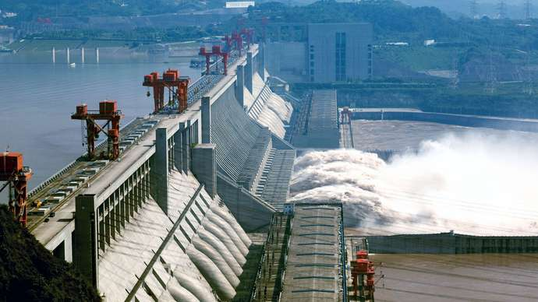
Three Gorges Dam
The Three Gorges Dam spanning the Yangtze River (Chang Jiang) near Yichang, Hubei province, China. Yao YilongImaginechina/AP Images
A straight-crested concrete gravity structure, the Three Gorges Dam is 2,335 metres (7,660 feet) long with a maximum height of 185 metres (607 feet). It incorporates 28 million cubic metres (37 million cubic yards) of concrete and 463,000 metric tons of steel into its design. Submerging large areas of the Qutang, Wu, and Xiling gorges for some 600 km (375 miles) upstream, the dam has created an immense deep water reservoir allowing oceangoing freighters to navigate 2,250 km (1,400 miles) inland from Shanghai on the East China Sea to the inland city of Chongqing. Limited hydroelectric power production began in 2003 and gradually increased as additional turbine generators came online over the years until 2012, when all of the dam’s 32 turbine generator units were operating. Those units, along with 2 additional generators, gave the dam the capacity to generate 22,500 megawatts of electricity, making it the most productive hydroelectric dam in the world. The dam also was intended to protect millions of people from the periodic flooding that plagues the Yangtze basin, although just how effective it has been in this regard has been debated.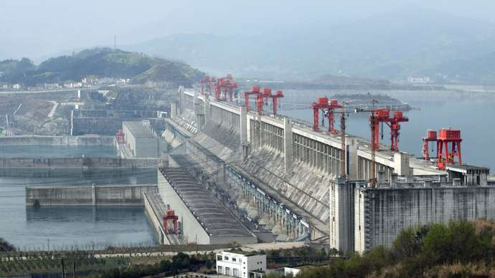
Three Gorges Dam
Three Gorges Dam on the Yangtze River, just west of the city of Yichang, Hubei province, China.
© Prillfoto/Dreamstime.com
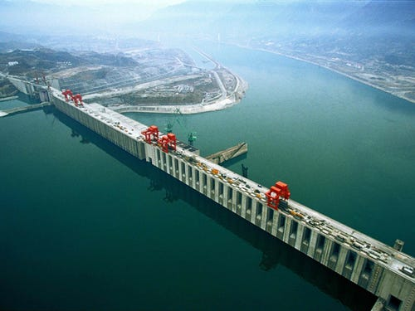AP
Pray for our brothers and sisters in the path of the 3 gorges dam … and our brothers and sisters in China in general, in Iran, in Nigeria, in Pakistan, and on and on … for great persecution, imprisonment, martyrdom and all means of death are planned for all believers in the Savior, lovers of the Word, lovers of truth, lovers of righteousness and justice in America and world-over.
Besides this, scientists reported a few days ago that the entire earth is shaking.
Please read Isaiah 24, Haggai 2, and Hebrews 12:25-29. Earth is not spinning correctly in its orbit. All of this affects food-crops, our water supplies, our air, our ability to breathe safely. It affects climate changes, bringing drought or floods, extremes in hot and cold temperatures.
In the meantime, as many have reported and are hearing from Abba, America is under judgment from Yahuwah. Interesting: The Hebrew letters for Biden - B-D-N (Bet, Dalet, Nun). Hebrew words are spelled without inclusive vowels. The name “Dan” is D-N. The “bet” symbolizes a house. D-N, Dan, is Yah’s “judgment.”
I don’t know how carefully you’ve been investigating the transhumanist attempts to turn us into robots, but the first robot that has biological tissue, a hybridized robot, has been successfully created in a laboratory. The concept is to give humanity immortality by turning them into part machine and part indestructible, or replaceable, biological material, at least downloading the brain into a robotic body. The technology to do this is already here.
The purpose is to rid the planet of human beings, and all animals, birds, insects, fish, mammal sea life, etc. making them hybrids – even mixing them with humans as I wrote in the article about the real islands of Dr. Moreau all over the world and in underground laboratories. Go to the Mikvah of “Present Reality.” Go to March 5-21, 2017. You will see various articles that speak of what we’re seeing intensify. One of the articles is: “Chimera – Turning Men Into Monsters…” on March 8, 2017.
To understand more of what I say here, please read that one.
The creation of creatures, part human, part all sort of things, as we see in the depictions of Egyptian gods, from pre-flood and post-food genetic manipulation, are no longer human. Those who have seen them say they hear their cries for help: “We are human.”
I have seen a video showing a calf with the face of a human. I have seen other creatures with human features. These mutates are being created in underground and undersea laboratories under islands, and other hidden places. Much is going on under the U.S. Many homeless people are kidnapped, troubled humans and children, too, and are taken to these laboratories, and used as experimental animals for their DNA-mixing. Even varieties of dinosaurs are being created, as Steve Quayle brought out, far more than the known “Wooly Mammoth.”
Hear me, this is real. In the days to come, these beings will be released onto the earth. The horrors we will see match Luke 21:11-12, 25-26. There is no way these people; they are no longer human. What is planned is to by many means destroy all of mankind, leaving 500,000 as mind-less bestial slaves. This plan goes way back, and is even carved into stone on the “Georgia Guidestones.” For this reason, we have the destiny of two main groups of believers in these last days: Revelation 7, 14:1-5, 12-13, and 14-15.
Perhaps you have heard that all branches of the military have been called on to “stand down” for the next two months while a purge goes on to isolate who might be a “potential” domestic terrorist within their ranks. Also, the FBI is carrying out a nation-wide “purge” of potential “domestic terrorists.” The FBI is literally going door to door to ask Trump supporters for proof that they were not in Washington DC on January 6th. They have lists of names.
Oh yes, the lights of the White House are out. The lights of the Capital Building are out. Biden is not in D.C. The staff needs direction. No one is home in the Oval Office. Lots of strangeness going on in many ways!
The executive order I wrote about in 2012 is being set in motion. The article title is “The New Executive Order…” I presented the whole Executive Order in this article. Signed by Barack Obama, THE WHITE HOUSE, March 16, 2012 http://www.whitehouse.gov/the-press-office/2012/03/16/executive-order-national-defense-resources-preparedness
It is a shocker to read what we, as American citizens, will be subjected to, in a false flag resulting in a “state of emergency.”
In case of “emergency,” you own nothing, the state can take everything if they want to. We lose all rights as human beings. Paul Begley commented on this last Thursday night: “…no “due process,” no “innocent until proven guilty,” no Constitution Bill of Rights, only tyrannical law to bring before the public to justify more purges, more arrets, more hauling people off to prepared `camps.’” No trial, no allowing lawyers to prove truth. People will be put away or sent to destruction facilities underground.
This is what the executive order and others like it open the door for – to have an excuse to round up all “suspected domestic terrorists.” A person can be arrested if suspected of wrong, based on the nature and mood of the interrogator, or if a person is considered suspicious that they “might” commit an act of terrorism.
The term “deplorables,” covers Christians, Patriots, conservatives, veterans, those against abortion, resisters to the vaccine, etc. etc. In the FBI’s 72-category list of suspected domestic terrorists, is “Evangelical Christians.” Americans are being identified as “suspect” based on their ideology or faith, based on potential threat, suspect of what they might do, no trial no defense. Are you realizing that we are no longer the land of the free?
It has been stated by the Bestial U.N., their W.H.O., and their lackey the non-government C.D.C. in NYC, that the lockdowns, and “citizen containment” orders, would continue until 2030, with restricted travel, restricted “privileges,” – restriction on all buying or selling. Of course, 2030 is a target date of a total global re-write by the U.N. Is this Revelation 13 or what! Of course, banking privileges and the ability to pay bills will be removed in a “global re-write,” planned by the Global Economic Forum, founded and control by a former Nazi leader.
Volcanos are putting toxic ash into the air, more and more erupting at the same time, glaciers are breaking loose, falling, and killing people. Earthquakes are in multiples now over 5.0, as recently in the Loyalty Islands. The earth’s tectonic plates are moving, breaking apart also. The earth itself is breaking apart, splitting in many places. Magma from deep in the earth is rising to the surface with incredible heat. I wrote several years back “Earth is Cracking Like An Egg,” and so it. There are quite a few articles under the Mikvah of Present Reality in which I talk about the earth changes and the “terraforming” of it.
Sink holes are forming that are taking down whole neighborhoods of houses, businesses, and other buildings. As the magma rises, the rocks that hold the dirt up will melt, and things will cave-in.
Let’s not forget the increase in inbound objects from a thickening debris field.
Travel-movement between states and within states will soon be restricted. Certain citizen containment and crowd control exercises, as the Jade Helm exercises in 2015, will go into effect.
The powers of Yahuwah-haters are working furiously to break down male-female realities, to stop that “division” of two genders – male and female. Anything to try to destroy the order that Yahuwah and Yahushua set in motion will be done. “They have absolutely obliterated the family unit,” Mike said on Paul Begley broadcast January 9th, 2021. The family unit is being destroyed in so many ways. The mind-programming of children in public schools is horrendous. Little children are being taught details of sex and reproduction, and told to pick their gender by age 7.
Infertility drugs for women; infertility chemicals for men, like in plastic-bottled water. The psychology and physical attacks on white males in particular has been horrendous for decades to “emasculate” them as human beings – to erase their manhood, forcing women to take leadership roles. The order of Yahuwah is being destroyed and wiped off of the earth. Only His true children seek to maintain it.
“Chaos” is the name of a powerful fallen angel. “Out of Chaos, Order” is the Illuminati motto – as said on the back of the $1.00 bill. Refer to Chris Pinto’s DVD The Eye of the Phoenix, Adullum Films. Chaos is being created in all arenas, trapping mankind, blocking any means of escape. The bars of our prison are closing in. “Jesus” is being criminalized and hated by the ruling entities preparing the way for the Beast.
Right now, as U.S. Senator Ted Cruz reported, our phone calls, e-mails, text messages, where we go to church, where we shop, what we buy, our preferences in media programming, where we live, and all details of our identity, even our patterns of how we think, are being recorded by A.I. (Artificial Intelligence).
A.I. programming has the ability to predict what you will say 14 minutes before you say it, because it reads thought patterns. Yes, there is a file on everyone on earth who has ever used technology of any type.
The vaccine! I won’t go into detail right now because of all the hundreds of pages of data I have studied exposing the truth. “It” is NOT a vaccine! It is DNA/immune-system re-write, a dehumanizing invasion of nanobots, xenobots, hooking us up to A.I. technology via 5-G. As scientists and doctors are speaking out – it is not a vaccine. It is technology to re-write the human body… and its DNA – thus making a person not a total human anymore, but hooked up to A.I. which will control the person’s life. Make sure you’ve read the recent article: “Covid 19, Life Threatening, Monsterism…”/Mikvah of Present Reality.
Of course, the “vaccine” is killing people, destroying their nervous system, their immune system, and many are being forever infirmed in body because of it. But, also the tests and the virus itself is causing irreparable damage to many. The virus is now in “variant” strains/mutations, and it is also being sprayed in many places on the people. That’s not conspiracy theory, that’s truth – not just in America, but in the British Isles and other places.
I think of those I met in Africa who lived way up in the mountains of Uganda, near the Kenya border. They have zero technology. So, of course, A.I. can’t track them. But, overall, technology can read minds, and so can the fallen ones.
As “Mike” said: “Putting A.I. into the bloodstream via the vaccine nanobots, will hook up with 5-G, making us receivers. We will believe what they want us to believe, and do what they want us to do.” However, those who are Spirit-taught, Spirit-led, Spirit-controlled, will not take this concoction, deadly to spirit, soul, and body. It will dehumanize a person. It’s not a 1-time “jab,” as they call it, but a series on inoculations that will be required to maintain the A.I. hookup. Mike said: “A person cannot con an A.I. machine. They know if you’re lying to them.”
There is also a new chip being promoted to be inserted into the brain – supposedly to help Alzheimer Disease or Dementia patents. By this chip, all thoughts can be read, and also thoughts can be implanted into the mind by the A.I.
And who controls the A.I.? Fallen angels, of course...
There is a “Serpent Brotherhood” alive and well on planet earth, doing the will of Satan and his forces, they, too, are hybrids, whether Nephilim or created hybrids. By inside information and reports, the throne of Satan, perhaps post- 1947, has been established under the ice of Antarctica. Much proof of this. Please refer to the article: “Strange Reconciliations – Mysterious Meetings – ANTARCTICA – Pope Francis, Patriarchs Bartholomew and Kirill, Queen Elizabeth, Barack Obama, John Kerry, the Ross Sea Marine Protected Area, the Nazis, the New Zealand Earthquake, FEMA, Israel, and the Secret Connections Behind Them All”/Mikvah of the Great Adventure. From many reports, the throne covers hundreds of square miles. The earth’s greatest leaders, some being mentioned in the title above, have met with him to get his instructions. One of their main comments besides fear of how awe-struck they were because of his beauty. Read Ezekiel 28, the king of Tyre is symbolic of the Cherub who once was a gorgeous Dragon-creature, covered in jewels, reflecting light. Why do the world’s chief rulers go to Antarctica in the bitterest of weather to go under the ice? Yes, the earth is under the orders of Lucifer, the Dragon, “that old Devil,” and Satan (Revelation 12). How will the awe and beauty of his “alien” display wow the world into bowing to our “saviors” in the days to come?
Couple with all this is pending world war, and the scenario of Isaiah 13, Jeremiah 50-51 and Revelation 18 in America, including the takeover of China who is already with rocket launchers hiding in the mountain areas of the U.S., ready with hundreds of thousands of troops hidden in underground bunkers as well as in shipping containers that serve as lodging, as well as rocket launchers.
The Revelation 9 200-million-man army is now obvious. If the 3 Gorges Dam breaks, it will mandate the takeover of America, our food, water, and infrastructure. Once America is eliminated, not by just China but other nations joining in, the world will plunge into total spiritual servitude to satanic darkness.
Another thing to consider is the fast-rising persecution of believers, not just in Muslim nations, but in America and other once-Christian nations. To help this along, F.E.M.A. and the D.H.S. has a huge team of pastors under their control who have lists of “members,” whom they watch over and report on, and will turn in to the authorities. It is called the pastors first response team. Please read all about it in the article: “Betrayal By Those You’d Never Suspect”/Mikvah of Present Reality.
Lots of details here, lots going on. PREPARE! For your own sake, do not complain or feel sorry for yourself, allow yourself to be oppressed or depressed, angry, or frustrated. That leads to spiritual death and invites Satan’s forces to torment you. Most Americans have no idea what it means to really suffer, or to stand for their faith when facing death. Few know the Elohim of the Bible.
Saturate yourself in the Word, in praise and worship, in hearing from Abba. Why go down the drain with those who do not seek to know Yahuwah and Yahushua personally? Just know, Abba knows where you live and is ready to meet with you and encourage you, give you peace, and help you.
In His love, Yedidah
February 13, 2021

