DO NOT BELIEVE LIES AND DECEPTIONS
THEY GET BIGGER AND BIGGER BY THE DAY IN THE U.S.
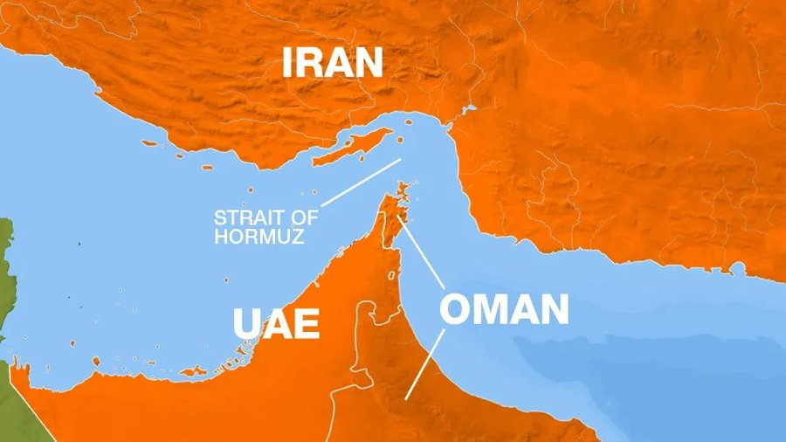

I give you information here from many articles of truthful reporting. Iran’s Parliament has approved to close the Straits of Hormuz. The approval heads to Iran’s top security body for final approval. The Strait is one of the most critical oil chokepoint in the world.
Iran has answered Trump’s attack on Iran’s 3 main nuclear facilities all to find out that the there was nothing left in the underground storage areas they hit. It was for nothing. Yet Trump brags it was a “devastating attack.” Netanyahu said it was a “devastating attack.” They both agreed it was “spectacular.”
Now onward with the shutting down of the Straits of Hormuz. Over 50 oil tankers are urgently trying to exit the Strait fearing an immediate Iranian blockade.
On top of this, Trump made a very bad decision. Not only was the attack a flop, it has called on multiple nations to be ready to directly supply Iran with nuclear weapons.
Now missile defense is being put on the rooftop of the White House and on the roofs closest to the White House. We tried to provoke Russia to strike the U.S., long story, but Russia was too smart for the Ukrainian façade. They got fooled into that game of the U.S. and NATO, but used wisdom after that.
Just remember, the White House should be retitled the Black House, the House of Slaughter. Under it in the tunnels children and tortured and killed and offered to Lucifer/Satan and the fallen angels. This is proven. Lucifer’s portal was clearly seen over it for a long time – even scientists marveled that it was a portal from another dimension. The Oval Office is the place where Noahide Laws were signed in 2019 with 50 Governors backing Trump. These laws are now international laws to kill Christians by beheading. The FEMA camps are in all 50 states, stocked with guillotines by the thousands. Let us keep objectivity to all of this, and do not believe the lies of the public media. We have fast become a Communist nation, with Nazi overtones. Let us give ourselves to knowing Yahuwah and Yahushua and leading others to receive salvation and the Spirit, and gain wisdom from the Word of God!
The Iranian Foreign Minister, Abbas Araghchi, announced that he will be traveling to Moscoe to meet with President Putin. Russia’s Foreign Ministry denounced the U.S. strikes, arguing that they “flagrantly violate International Law.”
“It violates the Charter of the United Nations.” “The United States, a permanent member of the United Nation’s Security Council, has committed a grave violation…by attacking Iran’s peaceful nuclear installations.”
Putin tells the truth! He is not a game-player or a trickster. Lies, game-playing, tricks, deceptions – that’s the U.S., and the U.K., and NATO and other like governments.
Ted Cruz of Texas gives a typical American Christian statement in an interview with Tucker Carlson. Ted Cruz said that the Bible Mandates Christians defend the state of Israel. He says all Christians must worship whoever is in charge of Israel. Biblically we are commanded to support Israel.”
Uh…what Bible is he reading? Israel is 95% Khazar, not Judah, not House of Israel. Netanyahu has admitted that. I heard him with my own ears.
Yahuwah promises to bring back HIS people into the total land – when? After Messiah returns! This Israel now is not Yahuwah’s Israel, but is was allowed to stand in until the real one comes when Messiah comes. The worship of this Israel is the outcome of a lot of mind-programming by those who use the Bible but do not know the Author. 1948 was planned by humans for Israel to be restored out of WWII. Has good come out of it? YES!
Yahuwah has to take this Israel down and wipe it out. Kabbalah reigns in this Israel, and the Babylonian Talmud, along with evil in its government- legalized prostitution, pedophilia, LGTBQ parades, and the slaughter of Christians and Messianic believers. The Babylonian Talmud reigns in this Israel over the Torah. Talmud and Kabbalah are not God’s Word.
Donald Trump adheres to these writings 100% and they are now in U.S. law in all 50 states and in international law. Please refer to my article that quotes the Talmud is very important – from 2019: “Quotes That Forever Destroy Damning Illusions”. It is #62.0 under the Mikvah of Israel, Our Eternal Inheritance. There are lots of important articles to warn you about the Noahide Laws (2018/2019) under this Mikvah. Also read from Present Reality: “Beware the Noahide Laws” #13.0.
The Talmud says to not let your children read or study the Torah, only the Talmud that originated in Babylon. The Kaballah has a different god than Yahuwah – a god with a consort, and other gods too. Trump is very dedicated to the Kaballah!
The religion of Judaism is very corrupt, and the Talmud says to behead Christians and anyone observing the Festivals and Shabbats who are not “Jewish.”
Yahuwah backs what is of Him. He has allowed the 1948-forward Israel for end-time purposes. But His Kingdom will be very different.
Do not get caught up in man’s Israel-worship like Ted Cruz states. Look at what the Israeli government has done to the people of Gaza. Remember, the Prime Minister is an MK-Ultra plant – a fragmented mind – now a Luciferian-programmed mind. Pray for those in Irael who are pure of heart and want to do right. Netanyahu wants war. He is being controlled by Lucifer. Look at what the Bible says about Israel in these last days. Remember Ezekiel 38-39 which is being set in motion now. Read Zephania and Zechariah, and Jeremiah too.
“To make matters worse, President Trump completely disregarded U.S. The action by Trump completely disregarded U.S. Intelligence Agency assessments that Iran was not building a nuclear bomb and instead acted on Israeli Mossad reports. Israeli Mossad is infamous for making up phony Intel to achieve whatever goal their country has. Mossad’s motto is “By deception we shall wage war, and deception is what they regularly utilize. This is the same as the C.I.A.. who joined with the Mossad to pull off 9/11/2001 in NYC. You can find the whole truth in detail in David Icke’s book The Trigger.
Those 3 nuclear sites that the U.S. hit - the bombs didn’t penetrate deep enough to do any harm. The U.S. is in danger because the President broke U.S. protocol and bombed what was not theirs to bomb – calling it a great success. Yes, success – to bring America down to destruction. Russia will back Iran and so will China most likely. China is upset that this hit happened.
The news site, Burning Platform, today said: “Trump’s big mouth had boxed him into a corner. Iran wouldn’t play his game. So he had to bomb Iran to save face. He bombed to empty facilities that had been previously struck by Israel. And he bounced six bombs off an indestructible facility (Firdos), claiming destruction despite the opposite was the case. … He is a national disgrace.”
I believe he is under orders from those who kept him out of jail for this very purpose – to bring America into war that Russia has avoided.
Redacted reports this today, June 23rd: “Trump said the military strike was spectacular. Israel said it was spectacular. And the truth is they did no damage to the actual nuclear facilities of Iran in any of that attack. The facilities had been emptied. It is all theatrical playing for the ignorant American people. The strike was a failure.” What does the Bible say about calling for peace and “sudden destruction comes upon them.”
Now the real warning goes out: A worldwide warning for ALL AMERICANS amid fears of Iranian sleeper cells in the U.S. and elsewhere. The State Department has issued a worldwide caution to Americans traveling abroad. Urgent worldwide warning for all Americans amid fears of Iranian “sleeper cells” coming to life.
I will stop here. Please go to stevequayle.com and read the article title list that changes almost by the hour with new ones. You can also sign up for the Qfiles’ report, the Private Briefings, and the Glyph Project on the main page.
In His love, Yedidah – June 23, 2025

