FOUR KINDS OF FIRE
ARE RAGING ON EARTH TODAY
EACH WITH AN URGENT MESSAGE
FOR US

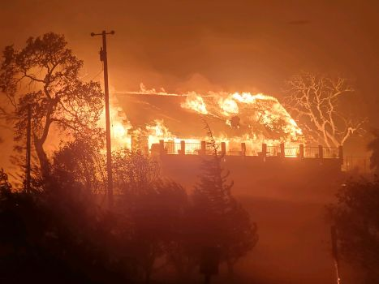
A home on Pleasants Valley Road north of Vacaville, California is fully engulfed as 20-30 mph winds drive the wildfire through the valley. Courtesy photo, Matt Henderson - The Reporter 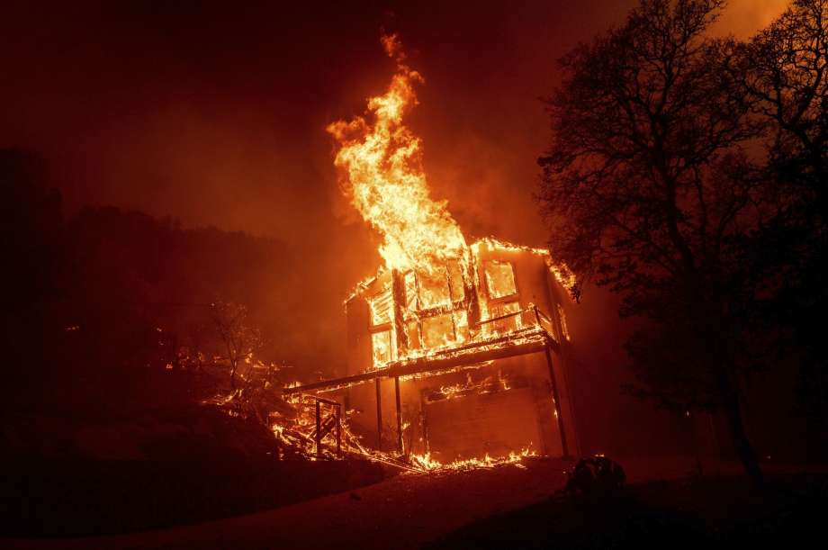
Photo: Noah Berger/Associated Press - A home burns as the LNU Lightning Complex fires tear through the Spanish Flat community in unincorporated Napa County, Calif., Tuesday, Aug. 18, 2020.

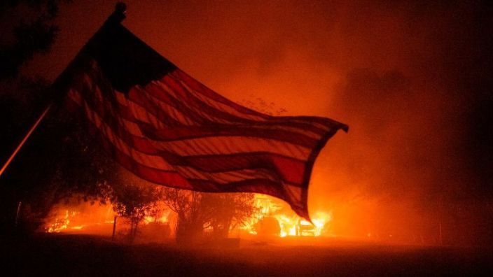
The message of this picture should impact Americans strongly! Yahuwah has loosed His tight hold on America, and drawn back to allow the fallen ones to implement their plans. He will use the enemy’s plans to separate out for Himself a true family who is totally loyal to He and His Son.

WHAT FOUR KINDS OF FIRE ARE RAGING ON EARTH RIGHT NOW THAT CARRY A MESSAGE FOR US?
1) Wildfires from earth’s violent changes and falling meteors
2) The fire of lawlessness, hate, violence, and destruction - preparing the way for the Beast-antichrist to rule earth
3) Yahuwah’s Judgment fire, preparing the way for Yahushua to come with His final wrath
4) The fire of Yahuwah’s Spirit within His Remnant, those under His command in these last days (Hebrews 12:29)

August 19, 2020: Vacaville: 100,000 people – the city itself is about to be consumed by flames.

10,000 lightning strikes have happened in 72 hours – San Francisco area

40 fires blaze around San Francisco and north

32,000 evacuated from Napa Valley – center for vineyards and wineries

Violent earthquakes and volcano eruptions, like the 6.8 and 6.9 today in Indonesia

Death Valley – historic 130 degrees Las Vegas, Phoenix, Salt Lake City – hot, dry, high winds, dust storms – fires

Earth’s core heating, magma flowing, as the binary system is already headed around the sun with its two suns …
The sun is only 3 years into an 11-year solar minimum, but because of the presence of the binary system’s hot sun affecting it, it has sprung into a solar maximum and is throwing CME’s (Corona Mass Ejections) towards earth. Today the wind speed on the surface of the sun was 695.4 km per second
Refer to: “The Heavens Will Soon Be Demonstrating” … Mikvah of Preparation.
I recommend that you listen to this interview of Steven ben Nun with Scott C’one, August 18, 2020, entitled: “Steven ben Nun Perspective on Planet X with Scott C'one -- Link to Steven’s YouTube site: Israeli News Live - YouTube - www.youtube.com/user/BenDeNoon
Scott said: “NASA is on two levels” - 1) “black ops,” and 2) limited public information-giver. They hide a lot from the public – some for a good reason. Yes, we have huge abilities in space not told the masses. Things are nearing us, but put off into the future, or just not told. Yes, UFOs are real and increasing. I’ve seen a lot of them, even very close up in various places of our world. Now the dark kingdom is sending in their forces. Yes, space flight, space stations, colonizing of the moon and Mars – yes, already – old information! The news is leaking out by the best of watchmen from inside sources. Why are the elite building underground bunkers? Why are our military forces expecting a huge “false flag” event soon? The agenda of the Elite is coming down fast.
The movie “Knowing” told us some things that are coming, though their reason for it is wrong – i.e. nice aliens want to save humanity and take them to their planet to continue the human race. But, within that movie is a news desk picture and report on TV that is exactly what was shown after the BP oil rig disaster.” Knowing” was released March 20, 2009. The BP oil rig disaster took place on April 10, 2010. How do They know what is coming so that a movie is made about it? …Because They make it happen.
It’s all planned decades ahead of time. A movie, or TV series always tells about it, but the public just says “good movie” and goes on. The same with this Covid “planneddemic.” It was a long time in the making as a means of taking control over people, nations, laws, economy, military-movement, and religion.
Here is a link to a movie-clip, sent by a friend in Israel:
It was a TV series in 2003: https://www.theburningplatform.com/2020/05/05/17-years-ago-this-episode-of-dead-zone-was-on-tv/
We know about the September 1st asteroid that NASA is watching closely, coming 44,000 miles from earth. HOWEVER, today, August 19th, the closest asteroid ever recorded in history flew over the Indian Ocean at 1,865 miles above earth’s atmosphere. Satellites cover the earth at 22,000 miles above earth. So, this one today, which was not seen ahead of time because of its smaller size, has made history. We are in clusters of debris fields now. Since mid-May more and more meteors (“fire balls”) are falling to earth, many starting fires
Now Arab oil-rich nations are beginning to unite in diplomatic relations with Israel. And why is that? President Trump’s and Jared Kushner’s “Deal of a Century” peace plan! Did you know Kushner has invited key evangelical Christian leaders to the White House to help him work it out for Israel?
The oil-rich Arab nations, the world in general too, could care less about the Palestinians. They want to make sure they are investing their billions into the new world order epicenter—Jerusalem--where the world ruler will rule from. The ceremony of the “official signing” of the accord between the UAE and Israel will take place in the White House in September – the timing of the U.N. General Assembly of September 15th. Right now, six nations are working towards similar diplomatic ties with Israel as the UAE just agreed to: 1) BAHRAIN, 2) QUTAR, 3) SAUDI ARABIA, 4) OMAN, 5) MOROCCO, 6) SUDAN. Keep a watch on this.
Earth is revolting under the real pressure of a brown dwarf star that is at least 3X the size of Jupiter. Its entourage of debris and its two suns, its radiation energy waves, gravitational pull on earth, and its presence in general, is not being told. It is causing all this bizarre and serious weather. The earth itself is splitting, separating, cracking open, being filled with radiation, even earth’s orbit is out of kilter, and its surface is revolting with great earthquakes, high winds, huge hail, heat, red snow from the iron oxide in the space dust, jet stream pressed down, and people oppressed and depressed. Great earthquakes are ready to erupt because of the ejections of the sun and the binary system’s “hot sun.” NASA is saying this binary system is on its way to Jupiter. But, Scott C’one is saying that it already going around our sun. Excellent information!
“Mike from around the world,” intelligence officer and scientist who reports on Paul Begley’s Thursday night program, is saying the same things – in coded language for his safety, but saying it. C’one has kept up with this for years. He and his wife have been threatened because of what they know.
We’re a lot further along than is known by the masses, and much further along that what would be admitted by the Fundamentalist-Evangelical prophecy teachers of a pre-7-year tribulation “rapture.” Nothing is moving chronologically. Events of the prophetic Word are layering - to shorten the time for us. A pre-7-year tribulation is not in the Bible, nor a “secret rapture” of everyone who’s prayed the prayer, to escape tribulation and banquet in heaven while those on earth suffer. This is contrary to the nature, ways, and thinking of Yahuwah! This Jesuit theology does not exist except in man’s hopeful mind. Millions of believers today live in severe tribulation, as in China, Pakistan, Iran, and about 48 other nations. [Refer to: “Warning! Nine Lies…”/Mikvah of Present Reality] (Matthew 24:29-32)
I’m sure you heard of the horrific bombing that took out the port, and much of the city of Beirut, the resigning of its government, the protests in the streets, and chaos in Lebanon. This explosion killed hundreds, and wounding over 6,000. A tactical nuclear weapon was detonated. The mushroom cloud was obvious. Everyone who is bold enough to tell who did it has been taken off YouTube, or in some way severely warned.
You’re just not supposed to know the truth. If you have a passion for the truth, you’re an avid student of the Word with the Spirit of Yahuwah as your Teacher. What about you? If you love truth, truth will find you. Messiah said “the Truth will set you free.” (John 8) Lies and deceptions keep you a prisoner of the evil ones.
Since writing the last time, I had two serious dreams that left me traumatized. I have many dreams, visions, words from Abba - for myself and to share with you. These two carried a shocking message to me. Two nights ago, I had another shocking one like the previous dream. The message: URGENT! RUN TOWARDS YOUR DESTINATION AS FAST AS YOU CAN! TIME IS SHORT! DO NOT MISS GETTING TO YOUR DESTINATION ON TIME WHICH HE HAS SHOWN YOU!

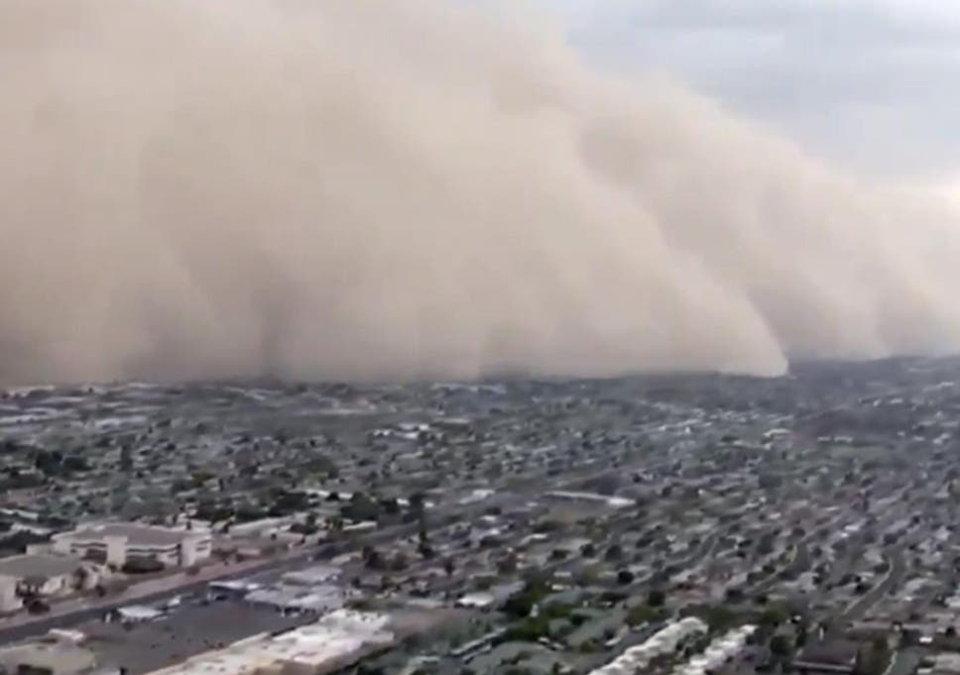
“A towering `apocalyptic’ wall of dust has engulfed Arizona city of Phoenix. Known as a haboob, the cloud was almost a mile high and 230ft wide as it swept in from the desert, leading to near-zero visibility, flight delays and treacherous on the roads.” (August 2020)
Whether a dust storm tsunami, a tsunami of water, or a tsunami of evil – our earth is being overwhelmed by the presence of fallen angels and their offspring, as in Genesis 6, as well as the beginnings of the judgment of Yahuwah from the cosmos He prepares for final judgment.
PLEASE read the article with the dream of Pastor Dana followed by the admonition in Ezra 9 by our Prayer Center Pastor: “A short space of time.” Article: “Urgent for Preparation! Prophecies and Wisdom for September and October 2020 – We Have a Small Space Left”/Mikvah of Preparation/August 15, 2020.
To reach our destination now, we must run with everything in us, in all ways – for the destination is the center of Yahuwah’s will for us. Go back to what He has shown you. Do not take it lightly! Act on it! Sit in His Presence much to learn the details of getting where He’s leading - laying down all to reach the destination of His perfect will. Daily obey, for daily obedience is mandatory for preparation!
In His love, Yedidah
August 20, 2020

