IRAN IS MOVING IN ON THE US, AND THEY ARE DEAD SERIOUS
Iran has kept quiet about their military abilities, but now, they are being forced to open up and show the U.S. what they have and what they will do with it – one step forward at a time. In this article update, I will give you headliners to watch for and pray regarding what you should think, and do.
As George Bush Sr. said during his January 1989-1993 Presidency to General Wesley Clark is coming to pass, as he announced that 7 nations had been chosen to be taken down before the one world order could come in, that Iran was the last nation. I know I keep repeating that, but America has taken one nation after the other down, and Iran is indeed the final nation to be taken down as Bush Sr. said. Ever wonder why Trump has instigated so many smaller wars?
In every aspect, America is on its way down, and has been prodding Iran, Russia, China, and North Korea for many years to do the take down. Finally, the needed scenario has been put into operation by much deceit. Iran has aways told Israel and the U.S. they do not war. Years ago, Iran sent their most intelligent students into the U.S. universities to learn Physics. In the meantime, the President of the U.S. demanded that the Shah of Iran step down. The Shah was removed, to put in the Ayatollahs who were more warlike than the Shah. The U.S. sent the students back to Iran. The knowledge they took back has helped them acquire nuclear weapons – which are underground. Iran is a mountainous country.
You can see that Iran was set up to go from peaceful to religious warriors defending their country. In other words, we set up Iran to be the instrument to begin the take down the U.S. It’s been planned a long time. Using Russia, China, and North Korea to take down the U.S., and destroy it, has been planned for a long time, too.
Being so dulled and ignorant of other countries, most Americans think that America is the #1 superpower. No! Obama, a Muslim, took care of that. He reduced our military down, introduced and promoted the LGBTQ agenda, and basically set us up for destruction. Now Iran is moving inside the US to take down major companies, and destroy us further from within. Our infrastructure is about destroyed anyway.
Our crops are being purposely destroyed, our water supply, too. Now our gas is being raised in prices, but soon trucks won’t run, planes won’t fly, trains won’t run, because the fuel prices are too high. Fertilizer, the best is from Russia, is not being shipped. The U.S. is purposely being destroyed within. Iran is to destroy along with Russia, China, and North Korea; WHY IS THIS HAPPENING? I’m glad you asked. It is in preparation for one world government. “You will lose everything, and be happy” so the WEF (World Economic Forum) tells you.
Here is the latest report on U.S. takeover, and takeover of the earth. April 1st is mentioned, but we can’t set dates. “April Fool’s Day” it is called. I hope not.
“J.P. Morgan Lays Our Persian Gulf Cut Off; Catastrophe Begins April 1, 2026”
“J.P. Morgan analysts created a transit map showing the flows of Persian Gulf Oil (from all nations) and when those flows would be delivered based on transit times. With the Persian Gulf now closed, the end of the final deliveries begins April 1.
The J.P. Morgan map shows a hypothetical Straight of Hormuz closure scenario tracking Persian Gulf oil shipments by region based on sailing times: Asia, April1, Europe April 10, North America April 15, and Australia April 20. With the real-life Persian Gulf Closure upon us, the world is now facing the actual stoppage of commerce due to lack of fuel. Some countries will even begin to see electric outages because power plants run out of fuel to run them.”
No electricity, no commerce. No gas for driving. No jobs, no money, no food – global economy stops. Get an emergency generator for electric to keep your refrigerator running and a light or two on in the house. Fuel for the generator also.
The IRGC stated: “A large number of U.S. Marines were destroyed using various types of several drones, the wounded taken to three hospitals in Kuwait.”
Iran is inside the U.S. in abundance and Iran is already attacking inside the U.S. – attacking U.S. oil fields, attacking military bases, and it will increase.
No one is afraid of the U.S. anymore – we’ve proved our weaknesses and vulnerabilities. We have prayer as our weapon, also praise, and action as He leads.
News from today, March 31st and for April 1.
“U.S. has destroyed only a third of Iran’s missiles, intelligence suggests Reuters report contradicts Trump’s claims that Tehran’s arsenal has been largely wiped out” Steve Quayle: “THERE IS NO TRUTH THAT EVER COMES OUT OF WASHINGTON! It has become:” DEMONIC CENTRAL!” Only our Father and His Son will tell you the truth 100% all the time!!!
Israel faces rising cyber threats from Iran as 'Operation Roaring Lion unfolds,' cyber chief warns: WE DO NOT KNOW THE EXTENSIVE DAMAGE IN ISRAEL BECAUSE OF A MEDIA BLACKOUT. ANYONE LEAKING NEWS FACES A 5 YEAR PRISON SENTENCE!
The earth is shaking, quaking, and revolting under the sin of man.
“Yesterday Iceland entire southwest coast split apart yesterday.” This means a lot to me since I was in Iceland twice, and near this area.
Essential US AWACS Plane Destroyed Amidst New Iranian Attacks, as US Continues Losing Critical Capability in Region PIECE BY PIECE AMERICAN MILITARY ASSETS ARE BEING DESTROYED IN AN ILLEGAL WAR TO KEEP EPSTEIN FILES SECRET. Remember that both Trump and Netanyahu have been deeply involved in Epstein Island horrors for years. Yet, no trials, no punishment, for those in the U.S. government involved in the slaughter of children and babies.
U.S. / Israel Bombing Iran Power Plants Hal Turner March 29, 2026
“A little over two hours ago, reports started coming in saying the US and/or Israel had begun bombing power plants and other infrastructure inside Iran. These claims were viewed with great skepticism because President Donald Trump explicitly and publicly said he was ordering a postponement of any such infrastructure attacks for ten days, until April 6, 2026 at 8:00 PM Eastern US time. Yet here we are, at 5:54 PM eastern time on Sunday, March 29 and a video came in showing Tehran without electric power: If we in the US or in Israel did this, after our President said we would wait for ten days, NO ONE will ever be able to trust us again. No one in the entire world. We were supposed to be the Good Guys. Turns out, we're not.”
The Doomsday Clock is now the closest it has ever been to midnight
“Is humanity running out of time? The 2026 Doomsday Clock statement warns of growing existential threats.” It is at 85 seconds to midnight. March 30, 2026
A Russian MiG 29 flew over an American beach - This jet changed the mood instantly. Russia has been checking sites and preparing! “Filmed over the beach in South Padre, this footage captures a MiG 29 in full demonstration flight. The aircraft performs tight turns and high energy passes. The jet’s Cold War design contrasts sharply with modern Western fighters. Its appearance surprised many in the crowd. It made this airshow feel different.” ‘
This was on X, a video: “I just thought he (Trump) was setting the stage for the Antichrist, however I sure am rethinking this… I pray everyone opens their eyes! He’s calling himself “I AM!” He goes on to say that by Trump’s very actions, he declares himself god. The reporter on the video speaks of God telling Moses that His Name means “I AM.” Also he gives other scriptures in which it shows that Trump is really walking on “water” with his pride and arrogance in relating himself to “I am.” The Bible says that “pride goes before a fall.” PROVERBS 16: “17The highway of the upright is to depart from evil: …18Pride goes before destruction, and an haughty spirit before a fall. 19Better it is to be of a humble spirit with the lowly, than to divide the spoil with the proud. 20He that handles a matter wisely shall find good: and whoso trusts in the LORD, happy is he.”
Matthew 23:12:“For whoever exalts himself will be humbled, and whoever humbles himself will be exalted.” Isaiah 2:11-12; “The proud look of man will be humbled, and the loftiness of men brought low; the LORD alone will be exalted in that day. / For the Day of the LORD of Hosts will come against all the proud and lofty, against all that is exalted.”
“Drone Intrudes on Palm Beach Air Space as Air Force One Takes Off”
Hal Turner Nation March 29, 2026

“A drone flew dangerously close to Palm Beach International Airport (PBI) while President Trump's Air Force One was taking off, prompting an immediate ground stop and the scrambling of helicopters to investigate the airspace.
• According to reports and live announcements from Delta pilots on the ground, the drone came too close during the departure phase, triggering standard security protocols under the Temporary Flight Restriction in place for the presidential movement.
• Helicopters were quickly dispatched for a visual sweep of the area.
• The ground stop lasted approximately 40 minutes before being lifted; normal airport operations resumed.
• The drone's origin and operator remain unknown; FAA and Secret Service are investigating. I don’t like the narrative being built right now.”
March 31, 2025: “Joe Kent: US Forces Will Be Decimated in Iran, this is CATASTROPHIC ESCALATION” | Redacted News
Israel has never sent ground troops to support American war … so they will not send ground troops now to Iran. Yet Trump is sending ground troops to the slaughter. It is a tragedy for our military.
Warning! It is said this will be a slaughter if ground troops are sent. Special military forces for this type of warfare and being called up or recalled. But, we’re losing, and we’ll keep losing – so many will die. It is a tragedy.
Joe Kent is the former director of the National Counterterrorism Center.
Clayton Morris: “Is Trump in control or is he being manipulated by others telling him what to do?” Tucker Carlson said Trump’s hands are tied. How much influence does Israel have over Trump and what does Israel wants the US to do? Israel should have no say – my question is why do we kneel to Israel and let them lead us by the nose? “He’s a puppet, or a clone,” Natalie Morris said of Trump.
Joe Kent is saying that Israel is running the show. Trump and Netanyahu are Epstein buddies – why are they not being punished for murder, rape, trafficking … ?
The Israelis are running the show Joe said. Trump, as a convert, to Babylonian Talmudic and Kabbalah belief, has yielded to partnering with Israel – a highly evil-run country – by the priesthood and the main government leaders.
The lives of our people are being thrown into death, and the US is not restraining them.
Natalie sees that Israel, the terrorist, is controlling American decisions – and why? Kent says that Israel has way too much access to our secrets, our influence, our personal rights Why are we allowing Israel to be a terrorist to us. The Mossad and the CIA work together for terrorism in the US and around the world – like 9/11/2001, and in Syria to take over that country. Israel is very evil in its use of America to fight their battles for them or with them.
Kent mentioned General Soleimani. Netanyahu told Trump to kill him, and Trump had him bombed when he was leaving Bagdad. I saw it. Soleimani was there to make peace, but Israel told Trump what to do. As a convert to Talmudic Judaism, Trump obeyed. Trump has put the Noahide Laws into effect all over the world and into the International Court of the Hague. It stems from the Illuminati. So, Israel is using nations and people to do what they want.
OK – Israel kept bombing Iranian military bases inside Syria for no reason. Iran did not retaliate because they told Israel, “we don’t want war.” Iran has said now “we don’t want war.” Why does Israel want Iran removed? So that the new world order can come to power. That’s what George Bush said.
Iran is the last holdup that includes the destruction of America. This Israel is definitely NOT the Israel of the Kingdom Age! The Bible speaks of this Israel’s destruction. This Israel is a Khazar ruled nation. It controls the Noahide Laws. It is Illuminati/Zionist. I’m wondering now if Netanyahu is still alive, or is he a clone? That has been questioned a lot.
Jeremiah 51:37: “Babylon shall be a heap of ruins, the haunt of jackals, a horror and a hissing, without inhabitation”. … verse 41and 42: “How Babylon is taken, the praise of the whole earth seized. How Babylon has become a horror among the nations. The sea has come up on Babylon. She is covered with its tumultuous waves.” Jeremiah 51:25: “Behold, I am against you, O destroying mountain” declares the Lord, “which destroys the whole earth; I will stretch our My and against you…” Verse 28: “Prepare the nations for war against her, the kings of the Medes with their governors and deputies and every land under their domain.” “Medes and Persians” – IRAN.
Hal Turner – March 31, 2026:
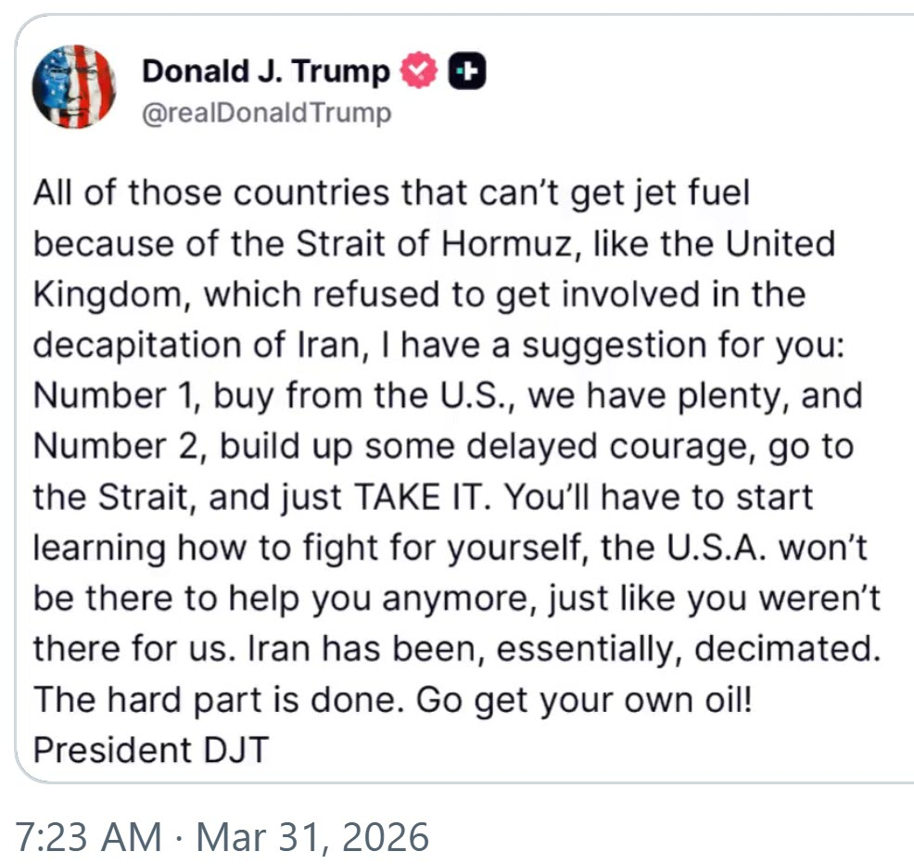
President Trump just dropped a BRUTAL reality check on our "allies," telling them FIGHT FOR YOURSELF; America is done holding your hand.”
"All of those countries that can’t get jet fuel because of the Strait of Hormuz, like the United Kingdom, which refused to get involved in the decapitation of Iran, I have a suggestion for you: Number 1, buy from the U.S., we have plenty, and Number 2, build up some delayed courage, go to the Strait, and just TAKE IT."
"You’ll have to start learning how to fight for yourself, the U.S.A. won’t be there to help you anymore, just like you weren’t there for us. Iran has been, essentially, decimated. The hard part is done. Go get your own oil!"
Hal Turner World March 31, 2026
The Iran Revolutionary Guard Corps has issued an announcement that, commencing on April 1, they will begin attacking - with the intent to destroy- certain AMERICAN CORPORATIONS. They even NAMED them!
I quote the IRGC below and wish to make it explicitly clear, these are the words of the IRGC, they are NOT my words. I do not subscribe to the IRGC viewpoints, do not support what they state, and am not -- and will not be -- involved or supportive of what they speak, below: "From now on, every American company will be destroyed for every assassination operation"
IRGC Warning to the Aggressive US Ruling Regime: You have ignored our repeated warnings regarding the necessity to stop terrorist operations, and today a number of Iranian citizens were martyred in terrorist attacks carried out by you and your Israeli allies; and since the primary element in the design and tracking of assassination targets is American information technology and artificial intelligence companies, in response to these terrorist operations, the main institutions involved in the terrorist operations will be legitimate targets for us.
We advise employees of these institutions to immediately stay away from their workplaces to preserve their lives. Residents of the areas surrounding these terrorist companies in all countries of the region must also leave a one-kilometer radius from their locations and go to a safe place.
Companies that actively participate in terrorist designs will be subject to countermeasures for every assassination operation.
Announced as follows:
1. Cisco
2. HP
3. Intel
4. Oracle
5. Microsoft
6. Apple
7. Google
8. Meta
9. IBM
10. Dell
11. Palantir
12. Nvidia
13. JPMorgan
14. Tesla
15. GE
16. Cymer Solutions
17. G42
18. Boeing
These companies should expect the destruction of their facilities for every assassination operation in Iran starting at 8:00 PM on Wednesday, April 1, Tehran time."
ANALYSIS
Do you understand what Iran just did? They didn't go after a military base or a warship. They put out a hit list of 18 American companies. Nvidia, Apple, Microsoft, Google, Tesla, Meta, Boeing, JP Morgan, starting April 1st. Iran just threatened the guts of the stock market. Those 18 companies represent over $15 trillion in market cap, more than the GDP of every country on earth except the US and China. Iran just figured out something that nobody in Washington wants to admit: You don't need to beat America's military. You just need to scare its investors.
One cyber-attack on Nvidia's supply chain and the entire AI industry goes dark. One hit on Boeing and every airline in the world is grounded for weeks.
In 2020 Iranian hackers breached dozens of US companies and government agencies. In 2022 they hit Albania so hard the entire government went offline for days! A NATO country . . . taken down by Iran's cyber unit. And now they're telling you exactly who's next. With a date. April 1st.
The scariest part is the companies on this list have more power over your daily life than the government that's supposed to protect you; and there's no missile defense system for a zero-day exploit.
“Christians in Syria Under Attack Once Again” - Pray!!!
Blessings, shalom – soon Passover! HalleluYah! Yedidah - March 31, 2026
Stay in peace, but prepare quickly! Stay close to our Father and our Savior.
In His love, Yedidah – March 31, 2026 PASSOVER SOON

