PEACE HAS BEEN TAKEN FROM THE EARTH - NUMBING REALITY!

Here I give you information and two major articles that say it all – and lead us to much prayer and hearing from Yahuwah and Yahushua.
The NATO Summit has been going on and is screaming “escalation.” Ukraine is seeking membership in NATO which will result in Russia’s being forced to attack major cities in the E.U., and the U.K.
The NATO Summit is pushing for war with Russia, while calling it peace. Zelinsky was invited to the Summit though he’s not a member.
Here is the Prophecy given to Alison Pound in Australia June 25, 2025.
“While I was preparing to publish this, the Lord reminded me of that time when I began hearing military march tunes in my head. It went on for days until Anzac Day, 25th April 2019, when I finally asked the Lord about it: He said: Get ready America, for war! Get ready to hear military marches, to see military parades, for shows of strength and power from your nation. Prepare to see posturing of such a magnitude you will almost laugh if it were not so very terrifying. For America goes to war. But I Am not with her. I am not with this nation. I have shut the book on this place. For Babylon is fallen. She has become the place of crying wolves. Desolation, desolation is upon her. Weep and wail and mourn, you who know what is coming.
Anzac day specifically commemorates the anniversary of the landing of Australian and New Zealand forces at Gallipoli in 1915 during World War I.
“WAR HAS BEGUN” Monday 23rd June 2025: I woke to news headlines this morning Donald Trump says Israel and Iran have agreed to a ceasefire. Apparently the bombing Mr. Trump ordered his Airforce to carry out has brought about peace! He promotes himself as peacemaker. God bless Iran, Israel, America, and the whole world, he says!
Which is NOT AT ALL WHAT THE LORD SAID to me when He woke me in the night! While you have slept, in that short time much has happened. More bombs have been dropped. War has begun. The war that will take the whole earth to war has begun.
These are the final days before I return. Nothing will ever be the same again.
But do not think that this is The Tribulation! We are not quite there yet.
First this war between Israel and Iran. And now America. Then more nations will come in. Egypt will come out in support of Iran. Britain will come out in support of Israel. And so it will grow. The nations will pick sides.
Things will heat up in the Ukraine also. Remember I told you that France will be pulled into the war by their President. And then there is America. America, the brave. With their oh so brave and bold leader. He has put his nation to war and painted a target on himself and the nation.
You will not have long to wait, to see My Words fulfilled. Because time is so very short now. Much, much will happen this second half of the year. And there will be cities that are not recognizable, bombed into oblivion. Yes, I speak of Tel Aviv and Tehran. And then will come the shot to the head.
Keep watching dear one. Australia will send troops to war at the end of this year. Britain, the US and France also. There will be patrolling of your coastlines and you will hear more from your air base here. Not test flights anymore but surveillance.
I Am the Lord your God. There is none beside Me. My Son shed His blood for all mankind. He paid the debt of sin. That heavy weight which was upon the whole earth. And still, mankind rejects My offer of Salvation. War! The drums of war are sounding. Mankind wants to wage war. There is hatred and distrust. There is pride and arrogance. There is fear. And all manner of wickedness at work. The hour is late. I Am coming to make recompense. Before I come, the world will go to war.
The cup of iniquity must be filled before I can come and make recompense. Because it is written. And all of My Word shall/must be fulfilled. And so, the season you are entering is the season of war. The red horse has ridden across the earth. Peace has been taken from the earth. Whatever nations that have been at peace will no longer feel at peace. All nations will be on alert.
People who never had to watch their back before will be watching their back.
The news reports and all media will be full of war talk, speculations, fear mongering, false reports. War will dominate the headlines.
And very shortly, all eyes will be on America. The eyes of the Arab world, the muslim world, the eyes of Russia, of China. Canada will be watching. Germany will be watching.
The Governments of the nations will be paying special attention to America, to their claims, and to their actions.
In the en:d, no one will come to her aid. And she will desperately need aid.
In the time to come, America will be under attack from within and from without.
And none will come to her aid.
Revlation 18:[9] And the kings of the earth, who have committed fornication and lived deliciously with her, shall bewail her, and lament for her, when they shall see the smoke of her burning,
[10] Standing afar off for the fear of her torment, saying, Alas, alas, that great city Babylon, that mighty city! for in one hour is thy judgment come.
NOTE: When God speaks, He will say a thing is done. Whilst we may see nothing happening, when God speaks it IS done, it has happened. Because God lives outside of time, He sees the end from the beginning. We must wait for His Words to manifest here on the earth. Some of you may say the Straight of Hormuz is not closed, that there is agreement to a ceasefire. But wait, watch. If God says that War has begun, it surely has.
Watch, wait and pray. Put all fear of man out! Pray for your families and loved ones that their eyes be opened to see God’s purposes and get in line with Him. His ways are higher than mans. Draw nearer to the Throne of Grace. Alison Pound

Article II
NUCLEAR WAR FIRST STRIKE What Would Happen If New York Was Hit by Russias Most Powerful Nuclear Bomb —“Satan 2” June 26, 2025 by Oppose Zone
We’re living in dangerously unstable times, yet most Americans scroll through their lives as if nothing is wrong. The media keeps the public sedated with culture wars, celebrity gossip, and political theater—while the clock ticks ever closer to midnight.
As nuclear tensions escalate at a pace not seen since the Cold War, society remains hypnotized by trivialities. We feast on distractions while the most dangerous military powers on Earth—Russia, China, NATO—drift closer each day to a catastrophe from which there may be no return.
And the margin for error? It’s gone.
One misstep. One miscommunication. One false alarm. That’s all it takes. In a matter of minutes, a city like New York could vanish in a searing white flash—its population incinerated, its skyline reduced to ash, its name remembered only as a warning.
Ask the average American what a nuclear bomb would mean, and you’ll get a blank stare—or worse, a joke.
Most people imagine it like a bigger version of a regular explosion—just another “boom.” They have no idea what a thermonuclear detonation does to human bodies, to infrastructure, to time itself. They don’t understand that once a missile is launched, there is no defense, no shelter, no second chance.
So today, we’re going to confront the unthinkable:
What would happen if New York was hit by Russia’s most powerful nuclear bomb—“Satan 2”?
What kind of destruction would it unleash?
The Satan 2: Russia’s Message to the West
Russia’s RS-28 Sarmat—nicknamed “Satan 2” by NATO—is not just a weapon. It’s a warning. It’s a monster designed to remind the world that Russia cannot be bullied, cannot be cornered, and will not go quietly.
This intercontinental ballistic missile is 116 feet long, weighing over 200 tons, and capable of carrying up to 15 nuclear warheads at once. It has a range of over 11,000 miles, which means it can reach any target on Earth—including New York City—without warning.
And perhaps most terrifying of all: the RS-28 is designed to bypass every missile defense system in existence. America’s trillion-dollar defense shield? Useless. The Sarmat uses a Fractional Orbital Bombardment System (FOBS) that allows it to orbit the Earth and strike from any direction, including the unguarded South Pole.
It travels at supersonic speed, reportedly exceeding 20,000 miles per hour, making interception physically impossible. By the time you hear the sirens—if you hear them at all—it’s already over.
Russia has dozens of these missiles in active service. A single one can end a nation. A salvo can erase a continent.
What Happens If One Hits New York?
Let’s consider the unimaginable. A single RS-28 carrying a 15-megaton warhead detonates over Manhattan.
The initial fireball would reach a radius of over 5 kilometers (3+ miles), vaporizing everything and everyone within it.
32 square miles of the city would be erased. Skyscrapers would vanish. Asphalt would liquefy. Steel would melt.
The blast wave would flatten buildings and homes across a radius of 26 kilometers (16 miles), damaging or destroying structures in 800 square miles.
Thermal radiation would cause third-degree burns as far as 60 kilometers (37 miles) away, igniting clothing, trees, cars—everything.
Nearly 11,000 square kilometers—an area larger than Puerto Rico—would be exposed to deadly fallout and fire.
Casualties?
Immediate deaths: over 7 million.
Injured and dying: 6 million more.
Survivors? Traumatized, irradiated, trapped in a collapsed city with no infrastructure, no hospitals, no hope.
This is just one missile.
If Satan 2 were armed with its theoretical maximum payload of 50 megatons—comparable to the infamous Tsar Bomba—the effects would be exponentially worse.
The flash of light would be visible from over 1,000 kilometers away—from Columbia, South Carolina, or Detroit, Michigan. The mushroom cloud would reach over 65 kilometers (40 miles) high, punching through the stratosphere like a pillar of death. It would cast a shadow over half the eastern seaboard.
The electromagnetic pulse (EMP) alone could fry the power grid across hundreds of miles, plunging the Northeast into darkness.
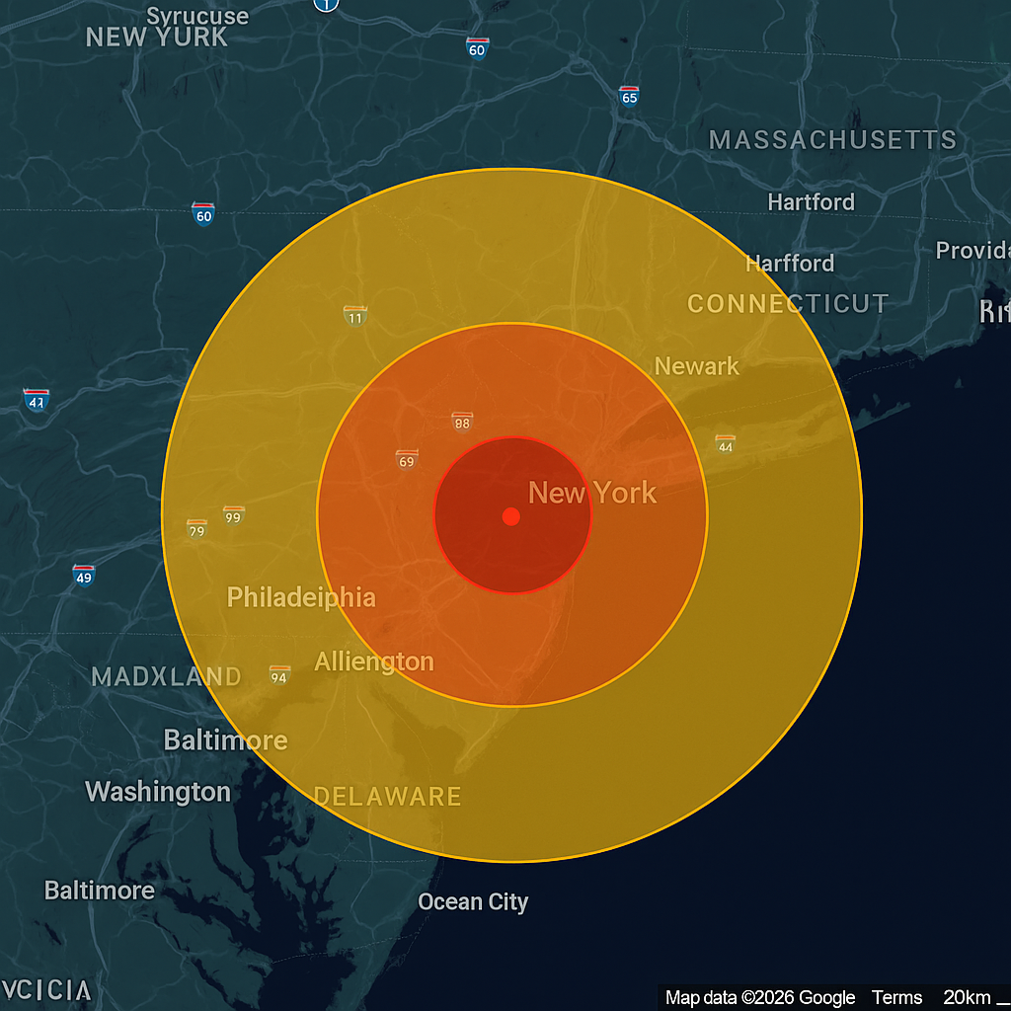
Fallout and the Collapse of Civilization
The radioactive fallout would drift for days, carried by winds across the East Coast, poisoning land, water, and lungs.
Major cities like Newark, Jersey City, Philadelphia, Baltimore, Washington D.C., Boston, Providence, and even parts of Toronto would be exposed. Tens of millions would be at risk.
Radiation sickness would set in within hours. Vomiting, internal bleeding, skin lesions. Hospitals—if they still existed—would be overwhelmed in minutes.
And what about food? Clean water? Power? None of it would be available. Supply chains would collapse. Highways would be choked with refugees. Martial law would be declared—but who would enforce it? The military itself would be crippled.
The United States would no longer be a functioning country.
There would be no presidential address, no FEMA rescue, no heroic comeback. There would only be ash, agony, and silence.
A Grim Wake-Up CallWe are not prepared for this. Not psychologically. Not stragtegically. Not logist ically. We have wasted trillions on endless foreign wars, diversity consultants, and climate summits while ignoring the very real, immediate threat of nuclear annihilation.
Our enemies have built doomsday machines.
Our leaders are sleepwalking into war.
And our people are distracted and deceived.
You may think this is fearmongering. You may scoff. But Russia has already warned the West repeatedly. And when a nation like Russia builds something called “Satan 2,” they’re not bluffing. They’re sending a message.
We just refuse to listen. One missile. One city. One moment—and everything ends.

What I share is reality. I know it is. Father has also given me prophetic gifting and insight as in 1992 in reading Jeremiah. I have studied the Word regarding Messiah’s second coming since the early 1960s. I have lived my life to serve the Master.
Last night I listened to Steve Quayle and Doug Hagmann (hagmannpi.com).
The title of their message is: “War is Coming To Our Shores and Our Front Doors.”
Beware of Iranian cyber attacks! That’s coming.
In His love, Yedidah June 27, 2025

