RUSSIA IS PREPARING ITS CITIZENS FOR NUCLEAR WAR
WHAT IS YOUR NATION DOING TO PREPARE ITS CITIZENS for Disasters?

Russia is preparing its citizens for nuclear war. Every nation should be preparing their citizens for coming disasters, for they are coming – i.e. war, famine, plagues of all types, pestilences/diseases, weather catastrophes, collapse of national economy, and the radical effects of de-population agendas in general. But, hardly any nation is preparing their people for anything!
Israel is preparing its citizens, and has been, issuing gas masks back a long time ago. [Did you know you can purchase an IDF Israeli-standard gas mask on Amazon for about $26.00?] Before I went into Far East Russia in the late Autumn, early winter, of 1999, to help Jews return to Israel, I got a thick packet from Operation Exodus/Ebenezer telling what Israel would do for those who return and make “aliyah”/become Israeli citizens. I was the first American with Ebenezer to go to Far East Russia. Abba led mightily and miraculous--what an adventure that was for 3½ months with just me and a Russian translator! Stalin had sent Jews to the gulags there, and a lot of Jews are still there. I was lying on my bed reading the material in the packet. I got ½-way into the thick stack of pages, and stopped stunned. Right in the middle of the page, in a totally separated paragraph from all the other information, they briefly made the statement that upon getting to Israel within a couple of weeks, the new citizens needed to get their assigned gas masks. I really had to laugh at that. Then they proceeded to tell more of what Israel would do for them.
But, Israel does work to protect its citizens on a daily basis. Israel does have bomb shelters erected for its citizens. Around 2016, when more-than-usual rioting broke out in Jerusalem, plans went forward to add many more bomb shelters within Jerusalem. Israel tells their citizens when there is a threat. They do have air raid sirens. I’ve been in Jerusalem when there was Arab rioting, rock-throwing, shooting, and police action on the Temple Mount and inside the Jaffa Gate-Old City area of East Jerusalem in general. I’ve been among the IDF, in the streets of the Arab Quarter, the area of the Archeological Park, below the Wailing Wall area, and within the Jaffa Gate area. Soldiers carried really big guns, and some of the time they were already pointed at specific targets. Yet, I always felt at ease because I knew that Abba was with them! Yes, the miracles of Abba’s intervention for the Israel Defense Force are staggering in number.
What about America? We’re the richest, most prosperous and powerful super nation on earth – so its citizens have been made to think. Yet, in April of 2018, we’re now the bull’s eye on the target according to the Scriptures for a Russia, China, Iran, North Korea attack, plus whoever wants to join them. [For understanding, read Jeremiah 50-51, Isaiah 13, 47, Revelation 18. Listen to Podcasts XXXXV, XXXXVI and XXXXVII under Audio Messages on comeenterthemikvah.com]

I am an American citizen by birth. Throughout my life, I’ve been very proud of our men and women who have served in our armed forces through our history up
to today! My son was in the Air Force during a strategic time of Gulf War I, and after. I honor our Veterans and pray that our government will treat them better--with respect and with the honor they deserve. Under President Obama the treatment of our Veterans fell into a disgraceful display of dishonor, even cruelty.
I grew up to love my country. I pledged allegiance to the flag and sang “The Star Spangled Banner,” often with tears in my eyes. So, when I tell the truth about its slipping downhill since the 1950s, I’m not being critical – just sadly honest!
In the 1960s and 70s, when prayer was taken out of schools along with Bible reading, and the CIA experimented on our citizens with freshly-created LSD and other hallucinogenic drugs in their MK Ultra projects, when abortion was legalized, and the race riots began, we went from a society that showed prayer and decency even in TV sitcoms, to a nation that has banned the Bible as a “hate-crime book,” and banned witnessing openly in public. In my 20s, I preached on the streets of Skid Row in Los Angles, and on the streets of Hollywood, passed out tracts everywhere I went, and openly witnessed. That is now forbidden, yet cities can have “Gay Pride Parades,” protesters can march in favor of abortion, and even do acts of vandalism and abuse, but that’s OK.
America’s judgment was passed by the prophets 2,500 years ago, and with the Apostle Yochanan/John nearly 2,000 years ago. It was passed near the time of the 70-year Babylonian captivity. This is one reason why America is associated with Babylon. The spirit of Nimrod’s Babel passed westward into Roman Pergamum, the “seat of Satan,” into Rome, “seat of Esau,” into Western Europe and into America where it has remained with the goal of restoring what Nimrod began for world government.
America, the great super power is being shamed. America has been made to be a fool by those who create false flags to provoke us to war--#1 false flags done by our own government within America, and #2 false flags perpetrated by American-hired terrorists, rebels, and insurgents in other nations, like recently in Syria. So, we appear to the world as righteous, charging to the aid of the innocent in other countries, leaving our own citizens vulnerable to attack. America has, over and over, actually provoked other nations to attack us, or attack each other, to justify a first strike on an “enemy,” or we’ve flat out lied about something they did, like George W. Bush’s reason for attacking Iraq in 2003.
This has been going on for 70 years. It began in 1945, when we brought Nazi scientists, military men, space exploration experts, into America under Operation Paperclip to take over our government, military, space program, colleges and universities, medical field, psychology field for mind-control experiments, and etc. etc. They gave us the secrets they received from the 20s, 30s, 40s, from “aliens,” “sky gods,” those of the underworld, the race of gods that is now resurfacing, and has been resurfacing since 1896. Yes, we also received their demonic spirits and occult theology.
We must remember that America was created as a nation to reincarnate Nimrod, and other pre-flood Nephilim hybrids, to bring in a Golden Age of the gods. We’ve been on an occult foundation since the earliest beginning. We are usable by the Globalists, the Jesuits/Illuminati, Scottish Rite Masons, and Elite Satanists/Luciferians. Atheist or Satanist Jesuits worked well with the Nazis in World War II, and after 1945, they worked well with them again. Thus the “echad” spirit between America and the Vatican.
What is America doing to protect its citizens with bomb shelters, gas masks, and public news broadcasts on how to prepare? Sad to say: NOTHING! The public news media is silent. We’re to be kept ignorant. I praise Abba for allowing us to have alternative news by faithful and righteous watchmen. The government’s keeping the public ignorant is Nazi concentration camp philosophy. But, then, the America citizens have been subjected victims of Nazi mind control methods for over 70 years. They invented the TV for example as a portal for ancient gods to influence us.
In going to the grocery store this morning, I thought of how nice it is in the UK, in Europe, in Israel, Jordan, China, and in Russia, to have good bus systems, train system, and decent-priced taxi service. In America, there are few public buses and taxi prices are ridiculously high, so everyone has to have a car to get around.
General apartment rent each month is near the same as the monthly mortgage fee on a $200,000-250,000.00 home. You have to have insurance on the car, which I understand is practical, and gas prices are regulated by the elite. Grocery prices are going up, up, up. Few people even know their neighbors because everyone’s life is so busy, like hamsters on a wheel inside a closed cage, running so fast but going nowhere. I find no better example of the American lifestyle except that of the life of such a hamster, or a white mouse in a cage. It’s people are so busy with the demands of the culture that few have time to get involved with what Yahuwah is doing, or are so worn out and dull that they don’t care. It is a dying culture, a dying people, spiritually dying faster than anything else – soul and spirit. Religion has its demands of performance by men who run the show. Christianity is a weakened and watered down nothing, telling people what they want to hear.
Children are becoming more and more rebellious, and people’s hearts becoming colder and colder. The words of II Timothy 3:1-7 are reality today! Believers, and I refer to really born-again believers, are slowly but surely dying with the society – dying inside--the joy and excitement they had in the book of Acts, though with great persecution, is almost non-existent. Because of the cage-wheel lifestyle, few read the Word and fewer still and obey it. Statistics are really showing the death of Western-culture Christianity. A death pall hangs over America, the UK, Europe, and truthfully the entire world too.
But, the elite, the rich, and the power brokers of this world are taking positive measures to make sure they survive what they know is coming. Transhumanists are creating hybrid bodies, which they say are indestructible, so that man can live forever. But, the elite are also getting into their “arks.”
For example: In 2005, we heard that the CIA had moved its headquarters to Denver, our new capital in case Washington DC is nuked. Under the Denver Airport, there are extensive tunnels and huge bunkers for the elite to live in, in case of attack. Under Mount Weather in Virginia, there is a whole complex for government leaders to hide out in. They even have their own President and cabinet, and a whole community set up. These kinds of facilities are in various places all over America, yet no one can enter unless they are government chosen few.
American billionaires have dumped their stocks and bought land in New Zealand, for example, to live on because they know America will be destroyed. Their bunkers are multi-million dollar complexes. They are copying Yahuwah. He has defensive shelters also for the few, both spiritual and physical!
No dear folks, I’m not being cynical, sarcastic, critical, judgmental or unloving; I’m just reporting simple facts. A word to the wise: Be independent! Make your own preparations. Find your own places of shelter, deep underground if possible. Above all: Be led by Yahuwah’s Spirit to make sure you remain clear-headed and at peace.
Let’s look at the way Russia is preparing their citizens for nuclear war, and have been preparing for some time.

The Russians Are Being Instructed To Prepare For Armageddon
April 16, 2018 danama
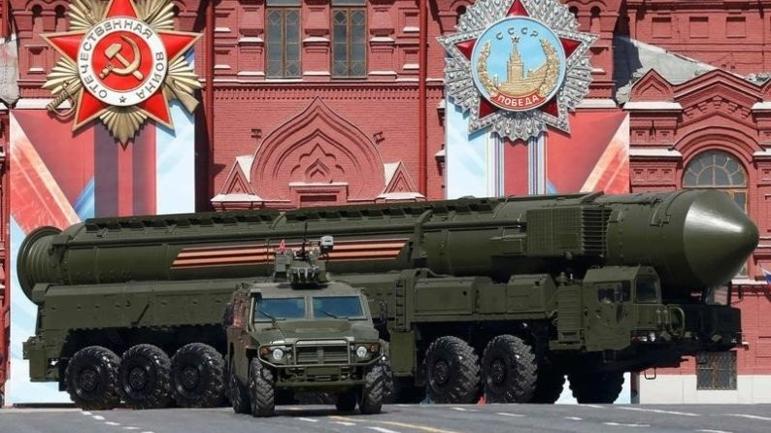
Evidently, the Russians are being instructed to prepare for Armageddon.
Russia’s State TV is broadcasting instructions for survival in a bomb shelter.
Will you ever hear or see this on American mainstream news? No! Never! However I found it surreal to watch/listen to what the Russians are telling their citizens today. Yes this is really happening.
The situation in Syria may soon turn into lots more than just a situation.
The Deep State may have false flagged the trigger in want of this war. Ships, subs, and aircraft are being positioned by all sides…There’s lots going on behind the scenes at this very moment. Let’s prepare as though the worst might happen.
Watch this 2.58 minute video of a Russian newsman telling the public how to prepare. It’s transcribed from Russian to English. Is your nation broadcasting instructions like this to your nation? It sure isn’t happening in America!”

Links carrying the same video:

***BREAKING Russia's State TV Instructing Russian Citizens ... - YouTube
▶ 2:58
https://www.youtube.com/watch?v=C-TnxwqopTs
5 days ago - Uploaded by Lion and the Lamb
Russian state television is instructing Russian citizens how to prepare for an Armageddon type war.

OR ***BREAKING: Russia's State TV Instructing Russian Citizens ... - YouTube
▶ 2:58 https://www.youtube.com/watch?v=ys2JJqcS_fc
5 days ago - Uploaded by 0007horseman
BREAKING: Russia's State TV Instructing Russian Citizens To Start Prepping For The Armageddon! Infowars

Here’s an English transcript of some of this Russian broadcast:
“So, what should one bring to a shelter?
The basic kit for Judgment Day includes many items.
But the main rule to follow when packing a survival kit is ‘fewer sweets’, ‘more water’. By the way, not all food is worth bringing along.
For instance, the most lasting grain is rice, which can be stored for up to 8 years.
Oats can be stored for 3 years, but buckwheat can’t be stored for more than a year.
You can live off of canned meats for a rather long time, they can be stored for up to 5 years. Canned fish can be stored for up to 2 years.
Also it would be hard to go on without milk, even if it’s the dry kind, as well as sugar and salt.
Russian tradition suggests to stock up on pasta in case of any disasters. However professional survivalists don’t advise stocking your bomb shelter with this product. Pasta must be stored in sealed containers, otherwise, it grows damp and goes bad quickly.
Those with a sweet tooth won’t have a sweet life in the underground world. All chocolates, candies, and condensed milk will have to be left behind. Sure, glucose is an unrivaled energy source, but sweets will make you thirsty.
And water will be the most valuable resource for bomb shelter residents.
Load up on water. You can go 2 – 3 weeks without food, but only 2 – 3 days without water. You even need water to digest your food, so you must think about water first.
Here are the norms for water consumption for the population. An adult male needs no less than 2.5 quarts of water per day. Children and nursing mothers need twice as much. About 3.5 quarts of water per person per day is used for cooking.
21 quarts are required for hygiene and cleaning purposes.
Water consumption greatly depends on the microclimate of one’s living accommodations. If the ventilation system is weak, and the air in the bomb shelter gets hot, it’ll quickly affect the water supply.
If the temperature rises to 85 F, water consumption increases 2-3x.
If the room is extremely hot, at 98 F you’ll need four times as much water.
I’ll add that, obviously, you’ll need more than just food in the shleter.
Experts, or people who believe they are such, recommend loading up on medical supplies, especially those containing iodine. They help the body cope with radiation.
Luminescent and chemical light sources may come in handy underground, as well as large sealed containers for waste storage. You might also want to grab a few liters of chlorine to disinfect your new home.”

Russian TV Instructs Citizens How to Prepare Bomb Shelters For Nuclear War - by Tyler Durden - 04/12/2018 - Zero Hedge
“Russia-24 (Россия-24), a state-owned Russian-language news channel from Moscow, spent five minutes on Tuesday advising its viewers how to prepare for a nuclear war amid the increasing tensions with the United States over Syria. The television anchor urged the country’s citizens to purchase essential items and emergency supplies to stock their bomb shelters.
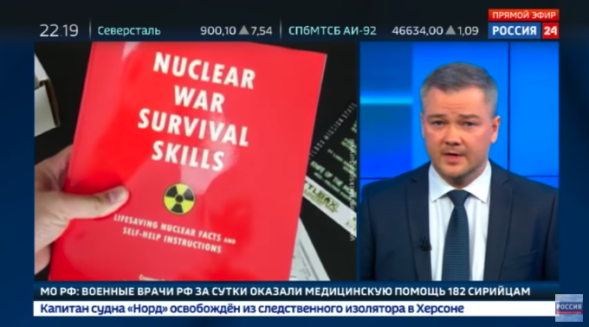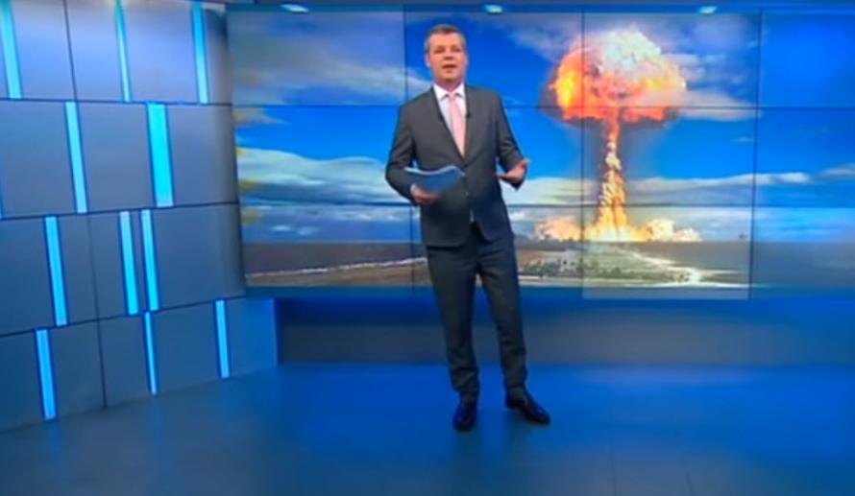
Photos from the Russian survival broadcast
“The title of the television broadcast “Inviolable stock: what should I take with me to the bomb shelter?,” explains how a nuclear war with the United States would be `catastrophic,’ as a TV anchor from Russia-24 informed citizens how to get ready for World War III. `If some people did give in to the panic, and decided to spend all their savings on a survival kit, we’ll tell you how to not waste money on something you won’t need.” He recommended that people purchase salt, oatmeal, and other products that have a long shelf life. He even said powdered milk, grains, and sugar could last for years in storage, as one video during the broadcast demonstrated how to cook pasta while hiding in a bunker. The special broadcast then transitions to the next TV presenter Alexey Kazako, who explains the number one rule of surviving a nuclear blast is “fewer sweets, more water.’ ”

This How the Russians Protect Their Citizens In War-What Is Your Government Doing for You? April 15, 2018 The Common Sense Show – Dave Hodges
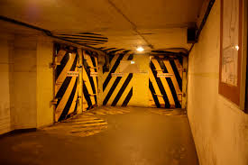
Picture inside a Russian facility …
“This is what the Russians do to protect their people in times of war, especially nuclear war. What does your government do for you?”
Paraphrasing what Hodges wrote in this article: He told of the civil defense exercises we used to do in schools, and how the TV had a civil defense warning system. I remember that growing up. Now there is now nothing … The European news is reporting that the Russians are telling their people to store food and water, and on TV they are telling their people how to prepare for nuclear disaster. Last year 40 million Russian in the Moscow area went into bomb shelters as part of a civil defense drill. The Russia government is actually working on survivability measures for their people. In the U.S. there are No drills to prepare the children or public – no bomb shelters ... There is only silence to keep the masses quiet, ignorant, and vulnerable for destruction.
The billionaires? Here are a few article titles and pictures
“Apocalypse Island: Tech billionaires are building bolt holes in New Zealand because they now fear social collapse or nuclear war. So what do they know that we don't?” Tom Leonard New York For The Daily Mail 4 February 2017
“Some of America’s richest people are spending billions quietly preparing for a global Apocalypse.”

Billionaire Bunkers Forbes June 12, 2015 Jim Dobson
“Exclusive Look Inside the World's Largest Planned Doomsday Escape”
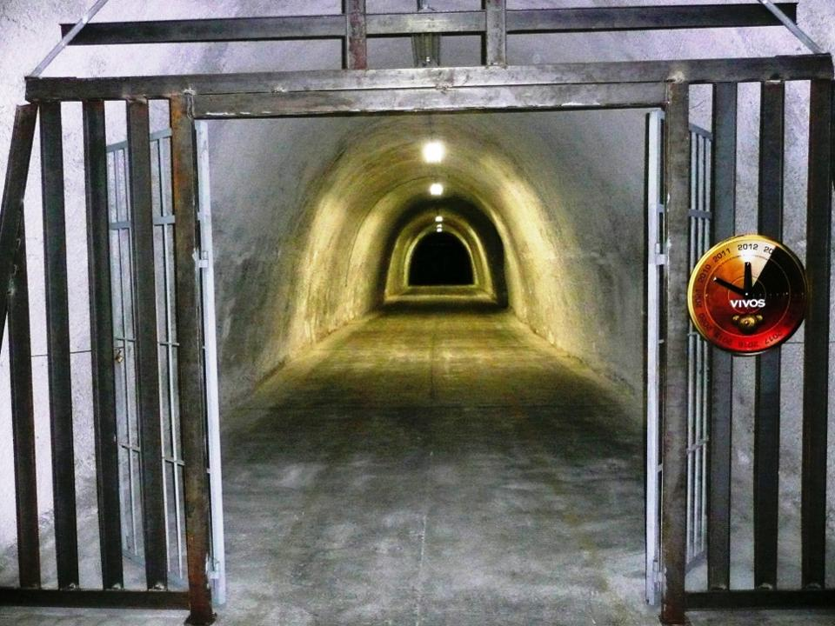
Billionaire Bunkers Forbes June 12, 2015 Jim Dobson
Exclusive Look Inside the World's Largest Planned Doomsday Escape
“…Tunnels have bars at the entrances, and special electronics to guard them, an underground engine room to keep electricity working, water pumping, lights on, etc., a huge hospital area, secret mountain entrances, an interior “blast door” to withstand blast pressure (this is all underground of course), a drive-through blast door, with ramp, an above ground generator, a hydraulic look at the drive in blast door leading into a tunnel, huge living quarters and dining room area.”
Russia’s bunkers are not as nice, but are equipped with bunk beds, bathrooms, and places to cook food.
“Billionaire Escape Plans Map Shocking Doomsday Scenario - June 10, 2017, Forbes – Jim Dobson – Updated with Navy Map showing Florida under water” September 14, 2017
They’re not just preparing for nuclear war, but for the many things that are coming on the earth, like economic collapse, a pole shift, asteroid or comet attack, the splitting of America in half and the flooding of Florida -- all the things that the Bible outlines in detail, you know – earthquakes, volcano eruptions, famine, disease

“Billionaires Are Building Bunkers in New Zealand, Prepping For The Apocalypse”
Posted, 2017-02-04 - Inquisitr

Billionaires Are Building Bunkers In New Zealand, Prepping For The Apocalypse – by JohnThomas Didymus
Some of America’s richest citizens are buying into a fast-growing movement of well-heeled doomsday survivalists or “preppers” investing billions of dollars to prepare secretly for the global apocalypse. The increasing number of billionaires who are participating in the doomsday “prepper” movement by acquiring elaborate and expensive getaways in isolated and remote spots of the world is causing concern among observers, with many asking whether America’s elite know something the rest of us don’t.”

“One False Flag Away From TEOTWAWKI, Is Covert Underground WW3 Preparation Now Taking Place? - As Putin Warns Of 'Global Chaos', Mysterious Underground Booms Return To America”
By Stefan Stanford - All News Pipeline – April 16, 2018
“In this new story over at Zero Hedge that Steve Quayle linked to on his website Monday morning written by Mike Krieger from Liberty Blitzkrieg Mike reports he feels Friday's missile strikes in Syria were the official start of World War 3 and that by the year 2025, America would be unrecognizable.
As we've reported previously on ANP, for some bizarre reason which hasn't yet been adequately explained, the heavily deep-state-sourced company (Deagel) is forecasting a 2025 population for America of only 54 million, down 270 million from 2016. Also forecasting other western nations such as France, Canada, Germany, Spain, Italy and the UK to be depopulated by 2025 (though most nowhere nearly as badly as America), as we pointed out in this March 15th ANP story, the populations of the nations of Russia and China are forecast to be roughly the same by 2025 as they are now.
`Another sign of America losing WW3?’ we asked then: Does the Deagel website's 2025 forecasts show pre-knowledge of the forthcoming destruction of America? Considering that Deagel's sources for the information seen in the graphic at the top of this story ARE the 'deep state' as seen below, we've got reason for concern, especially with what could be nuclear war coming to America should worst case scenarios come to pass with Russia.
…Vladimir Putin is now warning of global chaos should America strike Syria once again while US Ambassador Nikki Haley warns any further chemical weapons attacks will be met by further strikes upon Syria, some might say that the world is now only one false flag event away from nuclear war. And as we also see… preparation may now be taking place at the very highest levels for such chaos and destruction coming to America.
In this new story over at the Daily Star which the Drudge Report linked to on Sunday they report that 'mystery booms' across America have returned, sparking fears in those who've heard them that covert underground WW3 preparation is taking place with a secretive underground tunnel system that allegedly links together underground bases, including the Denver International Airport, being carried out…
While Russian television has been educating the Russian people on how to prepare for a nuclear war and the possibility that they may soon have to move to the underground bunkers that Russia has built to house well over 10,000 people nearly 1,000' under the surface of the Earth in Moscow, and Silicon Valley billionaires are preparing for the apocalypse in New Zealand, something is clearly happening underground…
With our planet Earth still going through massive earth changes with the 'Ring of Fire' ablaze and experts warning a massive quake is likely on the way, might these mysterious booms have a perfectly natural explanation?
While these most recent mysterious booms happened near Cleveland, Ohio, as Newsweek reported back in November of 2017, mystery booms are being recorded all across the country and nobody can explain why.
Loud, booming noises have startled people across the United States, and it was unclear what was actually happening or if the separate events were even related.
Residents in Alabama, California, Idaho, Michigan and New Jersey reported hearing similar mysterious sounds. Most recently, the noises were heard in Colorado, CBS Denver reports.
The Monday sounds left CBS Denver’s meteorologist Chris Spears baffled. The only possible conclusion he could offer was that meteors from the Leonid meteor shower were bursting in the sky, creating the loud noises. Ron Hranac, an astronomy expert, struck down that theory, saying that the meteors produced by the Leonids were way too small for that to happen, according to CBS Denver.
And now a search finds similar such booms have occurred in the 6 months since in the San Diego area in March, in San Jose also in March (accompanied by a bright flash of light), again in Denver in February, in New Jersey and parts of Pennsylvania also in March and in South Carolina also in February just to name the unexplained booms that have been reported.
With Denver hearing a lot of mystery booms recently, is that another sign that work is taking place once again underneath of the Denver International Airport? Long-rumored to be the future capital of the 'new world order' should nuclear war vaporize Washington DC, we wouldn't be the least bit surprised if they were doing some last minute work there.
With the CIA having moved their domestic headquarters to Denver back in 2005, the Denver International Airport has long been surrounded by mystery, from the project being completed years behind schedule to being billions of dollars over-budget to the sinister artwork seen throughout the airport which show apocalyptic scenes and what appears to be the death of Christianity to Nazi-swastika shaped runways as even this Denver Post story reports.
But what else are we not being told? And while this April 9th story by 'The Saker' over at the Russian-Insider reports that the mood on Russian prime-time TV is grim and that the Russian people are well prepared for the possibility that they might have to go to war against America, the majority of American people are so ill-prepared for such a war, it's easy to understand why Deagel shows a 2025 America forecast to have only 54 million people living here, down 270 million from our 2016 population.
However, our gov’t has been preparing. Back on April 21st of 2015, Susan Duclos published a story on ANP titled "MAPS - Underground Tunnels, Unexplained Booms And Mysterious 'Hums' - Has The US Government Been Setting Up Underground Facilities Throughout The United States, Right Under Our Noses?" within which she reported upon the map which is alleged to show what was rumored to be an elaborate underground tunnel system across America. [refer to this ANP article to see the map]
Linking the East coast to the West and our southern border to our northern border, we'd strongly suggest that the actual existence of such a system underneath America would be called 'fake news' by those who knew of it simply because of the highly secretive and classified nature of it all. Yet we have absolute proof that 'the elite' are preparing for the apocalypse.”
[Remember my reporting in 2016 on the underground maglev trains, electro magnetic levitation trains, that can go from New York City to California in 30 minutes? These are a reality all over America and in other major countries too]
“And with artificial intelligence experts themselves warning that AI could be even more dangerous than nuclear weapons and could bring about the apocalypse, we're not the least bit surprised that they, too, are preparing for doomsday.”
Do your own research about the murals and the bunkers under Denver Airport.

Here’s the link to the video for you to hear the mysterious trumpet sounds, which sound more like a shofar than a modern trumpet:

Video End of Days Bizarre trumpet sound heard in Hawaii - YouTube ...
https://www.youtube.com/watch?v=mxPa2gE5M4c

Syria War Meant To Demonize America, Create Pretext For Global Government - Old-Thinker News | April 16, 2018 - By Daniel Taylor
“…China’s recent statement regarding the Syria strikes gives us a clue to a wider agenda at play. As reported by Zero hedge, China’s Global Times wrote that the United States actions are a danger to world peace, and that `The US has a record of launching wars on deceptive grounds…’ The Obama administration’s treasonous alliance with radical Islam in the Middle East angered individuals with conscience in America’s military, who refused to be `Al Qaeda’s air force,’ Afghanistan, Iraq, Libya, Syria, the list goes on. From the opening salvo in the war on terror after 9/11 to the current crisis in Syria, the deep state’s wars – based on flimsy or non-existent evidence – are increasingly angering the globe.
America’s name is being dragged through the mud deliberately. Wars are being deliberately launched on false pretexts. The deep state elites, who have no allegiance to any nation, along with communist China, will hold up America as the boogeyman that a world government system will reign in. At this point in time, China could be at the helm of this future world government. This is, I believe, is the ultimate end game of the current geopolitical chaos. America is being used to provoke war to the point that the people of the world will beg for world government to stop the bloodshed. Beware, however. The government that comes in the name of peace in the aftermath will be more tyrannical and ruthless than anything the world has seen.”
America surely has launched one war after another based on false flag, false pretenses. We’re getting a reputation for being the world’s bully, sticking our nose into other nation’s affairs, telling leaders of other nations what to do, taking down their leadership to set up our military in their countries, or proxies of our military, like the Nazi-founded Muslim Brotherhood in Egypt. America is being made a fool of, and its people have been so zombified that they just keep sucking lollypops, thinking we’re the greatest ever, living in a fantasy hologram – a lot of it painted for them by religion. It’s terribly pitiful! I grieve for the American people.
H.G. Wells, The New World Order, 1939: “The New World Order cannot happen without U.S. participation, as we are the single most significant component. Yes, there will be a New World Order, and it will force the United States to change its perceptions.”
Perhaps you think I’m being overly critical of the American attitude as to what’s going on. But, the watchmen are all joining in one voice for Americans to wake up and take responsibility.
“Judgment Day' And 'The Underground World' Are Hot Russian TV Topics As Former Russian General Warns, 'If Russian Blood Is Spilled In Syria, Russia Will Retaliate' -- Even If Entire Russian Chain Of Command Is Wiped Out,' Dead Hand' Would Vaporize America - April 13, 2018 Stefan Sanford, All News Pipeline
“As Pastor Dick Carmack recently reported in this ANP story titled "As We Stagger Towards The 'Day Of God's Wrath' And All-Out War, Most Of The World Doesn't Have A Clue About The Abyss We Are Plunging Into," all things are now seemingly coming together for an event that we prayed would never come but is looking closer every day, and most Americans are clueless.”
“`We must face the possibility that we have a criminally insane government in Washington that is leading the world to destruction. The Russian view is simple: the West is ruled by a gang of thugs supported by an infinitely lying and hypocritical media while the general public in the West has been hopelessly zombified.’ ” – quoted from The Saker [And I thought I coined the word “zombified”]
“And should war break out, we pray that everybody is prepared for what has long been avoided but may soon be unavoidable with war against Russia likely coming here to America according to 'Russian insiders' living here in the US, possibly in the form of Satan 2 nuclear missiles raining down upon US states, vaporizing millions instantly.”
Ah-main! We must take the responsibility to prepare ourselves and our family. It means following the exact directions of the Spirit in peace, and not emotionally holding onto what brings material comfort, ease, and emotional security in this life.
I close with these very important verses--Hebrews 13:12-14: “And so Yahushua suffered outside the gate, to set apart the people with His own blood. Let us, then, go to Him outside the camp, bearing His reproach. For here on earth we have no continuing place, but we see the one coming.”
In His love! In His mercy in kindness,
Yedidah
April 17, 2018

