Signs In the Heavens July-August 2018
What is Their Prophetic Significance?
…and WE WELCOME ELUL!

The new moon was sighted over Israel and Jerusalem tonight August 12th. It is now the month of Elul! This is a highly significant month in prophetic Scripture!
August 11th was the first day of the harvesting of grapes in Israel. As the grape harvest begins, so the meaning of it has also been set in motion.
Please refer to “The Season of the Coming of Messiah and Yahuweh’s Judgment on the World –- From the Grape Harvest to the End of the Olive Harvest (The time-frame of Yahuweh’s judgment on Israel, America, and the world /Mikvah of Preparation 1st article, to see an incredible number of Scriptures that point to Elul as the signpost month for fulfilled prophecy regarding Messiah’s return.
Messiah will come during the grape harvest, the harvest of the 5 species of fruit (Ya’cob/James 5:7-8, aligning to many Scriptures, like Isaiah 63:1-6 and Revelation 14:16-20. The juice of grapes is called “the blood of grapes,” thus the Scriptures of His wrath and judgment are more clear.
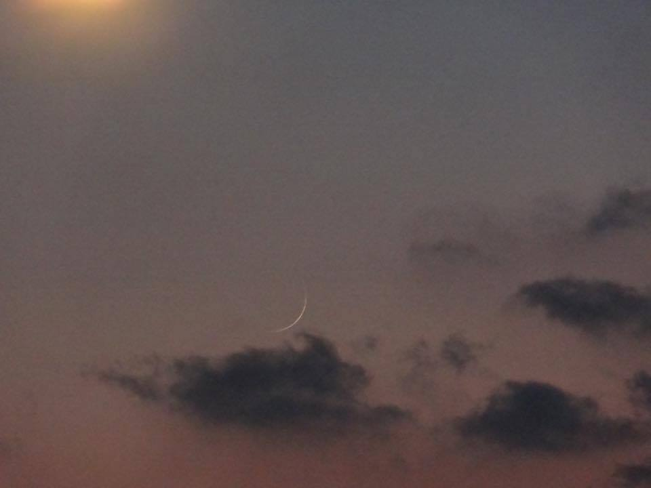Photo by Brian Hoeck
Elul is the month of T’shuvah – the return to being all that we were created to be.
Please refer to these articles: “We Welcome Elul and T’shuvah,” “Yom Teruah Psalms Prophesy of Messiah’s Coming,” and “Elul and the Message of Repentance” (written by Derek), all under the Mikvah of the Covenant.
This month is the month when we “examine ourselves” and make adjustments. It is the month when we focus on preparing for the coming of Messiah, who will come on a Yom Teruah, or a Yom Kippur, both called “Yom ha Din,”- “day of judgment.”
I wrote an article on the possibility of His coming on Yom Kippur entitled “The Yom Kippur Consideration for the Coming of Messiah”/Mikvah of Israel Our Eternal Inheritance. He is our High Priest!
I’ve been meaning to write about the blood moon, the longest eclipse of the moon of this century, the closest position of Mars at that time, and other signs that began July 27th through August 11th.
I was in North Carolina on the evening of July 27th. It was storming so I did not get any pictures of the closeness of Mars to the Moon on that night. Of course the historic eclipse was over the Middle East mainly, not over North America. In fact, it was right over Jerusalem on a clear night. I asked my son, Derek, to get pictures for me on the night of July 27th in Texas of Mars near the moon. Then on July 28th, when another storm lifted, the couple I was staying with, and I, went outside and took pictures of the red glowing pulsating close and BIG planet Mars in the sky near the moon.
Here are sample photos from all three sources…
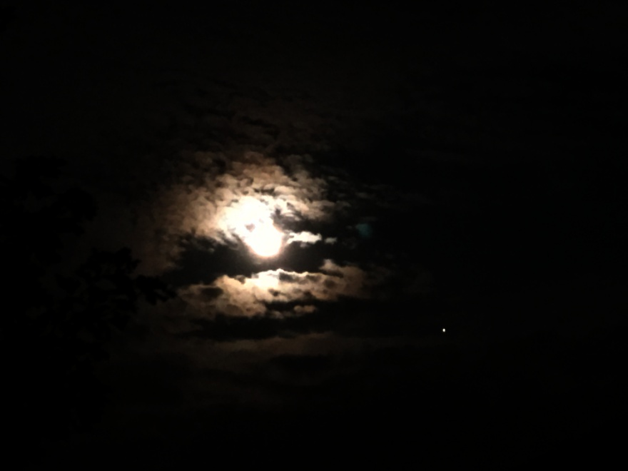
Photo by Derek July 27: The white dot to the right of the moon is Mars
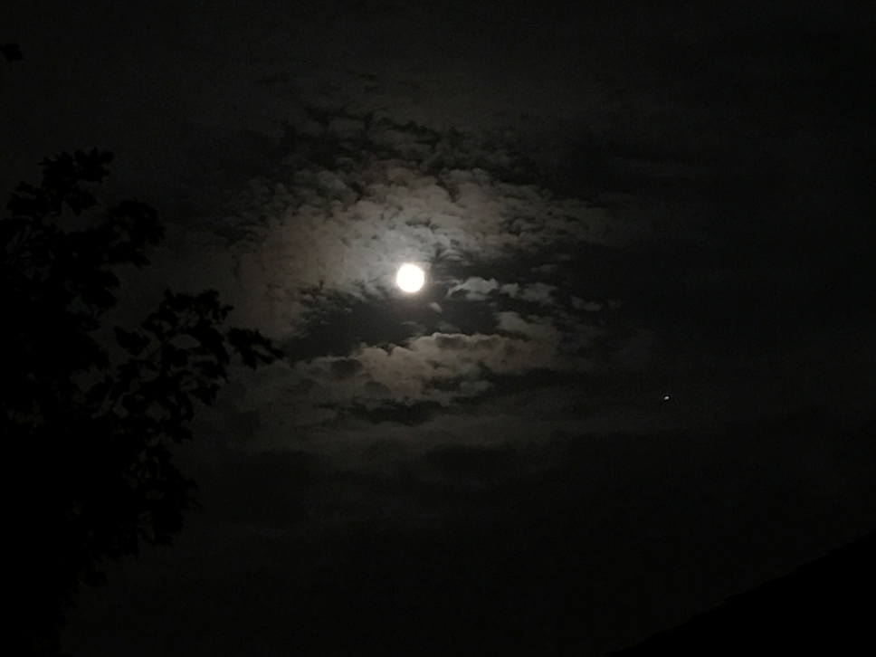
Photo by Derek in Texas July 27, 2018

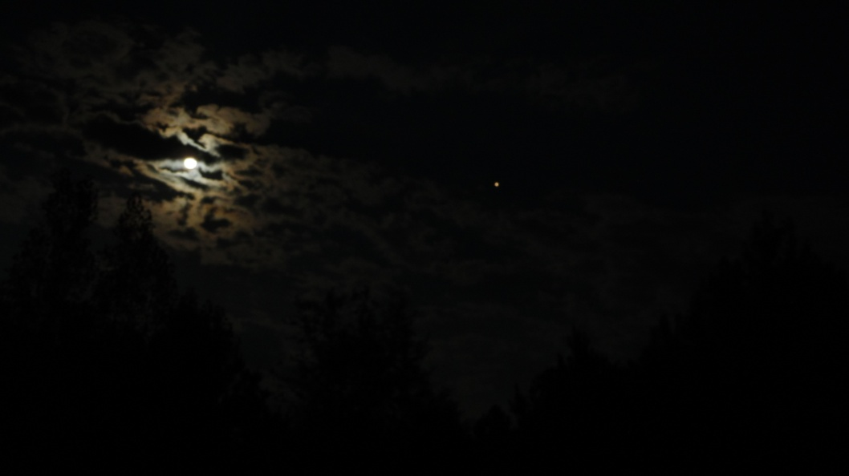
Photo by Shawn in North Carolina – July 28, 2018

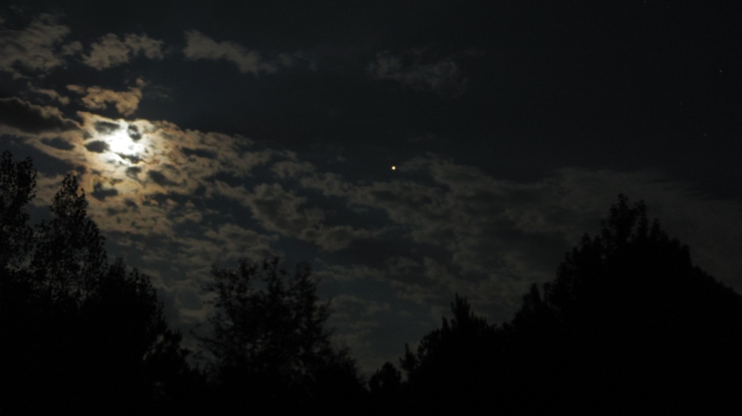
Photo by Shawn in North Carolina July 28, 2018

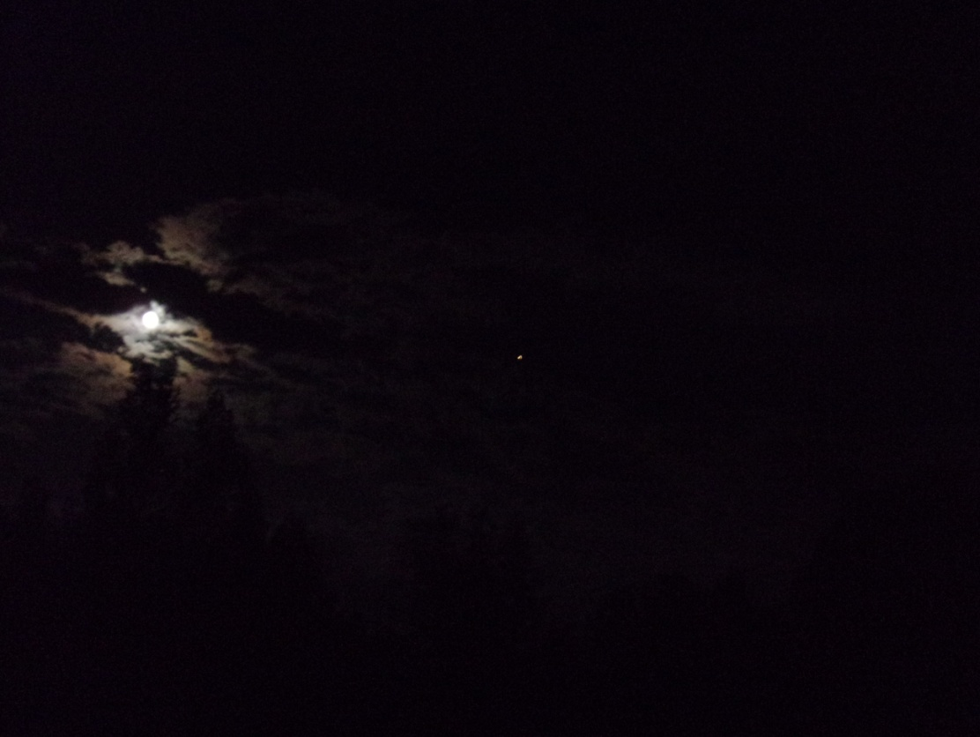
Photo by Yedidah July 28, 2018 North Carolina

Now I want to report on some highly significant signs in the heavens lately and share what they mean symbolically for us, for Israel, and for the world. The close timing of these events was NOT a coincidence!
I believe they definitely are signs we should take note of because of the time-period we’re entering into, a time of transition from all that is past to all that is future. Elul is the significant month of this transition, spiritually and now, actually.
Genesis 1:14: “And Elohim said, `Let lights come to be in the expanse of the heavens to separate the day from the night, and let them be for signs, and appointed times, and for days and years…”
I share here some notes from an interview of L.A. Marzulli with Pastor Paul Begley regarding these things, on Marzulli’s Acceleration YouTube channel. This interview took place a few days before July 27th.
Pastor Begley said the significance of this particular eclipse is that it was longest eclipse of this century. It covered 1 hour and 43 minutes. And, it was seen clearly directly over Jerusalem on Israel’s 70th anniversary of statehood.
As I have learned, a blood moon is a warning of danger to Israel. At the same time as the eclipse, the planet Mars was the closest to earth that it was been in many years. Mars is the name of the ancient Roman god of war. This clearly sends a sign from the heavens as per Genesis 1:14 to Israel and to the world, that His people have reached their 70th year, a year of completion of a full generation, and that with the blood moon eclipse, the longest of the century, along with the war god, Mars the planet, over Jerusalem, it all shouts a wakeup call, an alarm for Israel to prepare for war, and for all of His people to prepare for a great spiritual battle worldwide.
It was amazing to see the bright red glow of Mars sparkling and appearing to pulsate in the sky. Even last night, August 11, 2018, Mars was bright red and glowing big in the sky, and I got one more picture.
L.A. Marzulli told how Israeli Air Force reservists have been called up. IDF reservists have been called up. There are from 60-80 thousand Iranian troops are sitting near the Israeli border in Syria, from Damascus south, and along the Israeli border with the Golan. Marzulli and Begley discussed Turkey’s threats to Israel, Iran’s threats, Syria’s threats, Hamas’ threats, Hezbollah’s threats, and Egypt’s threats. The Muslim world is joining forces, lying down their differences of religious opinions to join around their one common connection: Hate for Israel. Yet, how many of the 43,000 Christian organizations and denominations, the many Messianic fragments, too, have joined in union to stand against the onslaught of Satan and his hoards?
All the prophecies of these last days, all 223 of them, are now in fast flow forward to the finish line. Not one prophecy is running behind schedule.
As Begley commented, Psalm 83 aligns with Isaiah 17. The finishing off of Damascus is nigh. The city is already mostly destroyed. So, we’re close to the rest of Isaiah 17, which includes the destruction of North Israel down to Samaria, just above Jerusalem.
“All the puzzle pieces are all on the table,” Begley said. Speaking of the Muslim world, he said: “They’re all on edge--their hatred of Israel is very high…” Begley talked about Lucifer’s failures to stop things that Yahuwah started. But, as Begley said, Lucifer/Satan knows his time is short. He has to make his move quickly, or miss his timing. *Very good point--the Dragon is coming to do his worst because he knows that his time is short. From what Abba is showing me, we’re further along than most realize. No, Messiah is not coming this Yom Teruah or this Yom Kippur. There are events to take place in the near future. However, the events can take place quickly, for there is no time table on these events, and as you can read in the last article posted “Geoengineering of Wildfires…” from August 10th, the main sign that will cause His timetable to step up is the destruction of His Earth and all that is on it – including His precious children.
I believe strongly in 7-year cycles! It is the timing of our Abba from creation. I wrote “The Shmittah Year Prophecy Revisited” recently. Go over that information. We’re in a time of finalities.
I believe in the 7-year cycles traced by Jewish sages 400 years ago, beginning with the time Joshua and the Hebrews entered the Land. These sages clearly predicted actual happenings in the last 3 cycles (1993/1994, 2000/2001, and 2007/2008 Yom Teruahs). Their predictions came to pass exactly! The last of the three cycles ended on Yom Teruah 2015/2016.
In April of 2016, the 120 years of Yahuwah’s striving with the returned Nephilim ended, in line with Enoch’s 70 generation prophecy and solid reality to the max. Now the Spirit of Yahuwah has withdrawn His striving to allow everything to fly forward.
Yes, 2016 was a Jubilee year, the beginning of a new cycle. We’re approaching the middle of that cycle at Passover 2019. As most of you know from my podcasts on Revelation, I’ve doubted the addition of the 3½ years in Revelation 11, 12, and 13, along with other additions of 3½ years into the “New Testament” by the Roman Catholic Church. They are not aligned to the nature of Yahuwah! But, I do believe in the 7-year cycles from Creation. That is aligned to His nature. I believe that the mid-point of the final 7-years, Daniel’s 70th week, will BEGIN the fast-track of all that is prophesied, whether right at the mid-point, or 1-2 years into the final 3½ years of the final 7-year cycle.
I do not believe our Abba Yahuwah is a sadist! Look at the Tenach—He does not set cookie-cutter timing! I cannot see, by Abba’s nature, ways, and thinking – his “modus operandi - that as soon as the mid-point of the final 7-years comes the anti-messiah will go on TV worldwide and say “I’m here guys,” or the witnesses say “We’re here,” or the fleeing to Petra begins where His people twiddle their thumbs for 3½ years. That’s just not Abba!
I am not dogmatic about the timing of everything from now to when Messiah returns. I do NOT set dates! However, I have His mind on His urgency for His servants to be position as soon as possible in preparation for our final assignments before He comes! I have my ear to His chest like Yochanan did in John 13. That’s what we all must do to hear from Him!
Pastor Begley said: “Two weeks before the blood moon eclipse of July 27th, there was a partial eclipse on a Friday the 13th. There had not been an eclipse on a July the 13th for 44 years. He said that two weeks after the July 27’s blood moon eclipse, on August 11th will be another partial eclipse of the moon.
He said that the eclipse of August 11th will also be 1st day of the grape harvest in Israel – ELUL! T’shuvah!”
Begley referred to Revelation 14:14. Messiah comes back on a cloud to reap the harvest – the grape harvest. It is also the same wording in Isaiah 63:1-6 and throughout the Word. Be sure to look up the Scriptures in “The Season of the Coming of Messiah…”/Mikvah of Preparation, 1st article. He is very astute to let us know His timing, at least by the “season” we’re in!
Yahushua returns at the time of the harvesting of the 7 species. Pastor Begley tapped into that truth! HalleluYah!
In Revelation 14, another angel will come down to reap the wicked of the earth, and cast them into the wine press of the wrath of Yahuwah.
Marzulli concludes: “Look up, for your redemption draws near!”

Rejoice! We’ve entered T’shuvah and His mercy is near to prepare us for the coming of His Beloved Son!
In His love, shalom,
Yedidah
August 12, 2018

