THE AVALANCH IS ON THE MOVE

An avalanche starts slowly and picks up speed as it cascades down a mountain taking dirt and rocks with it, destroying everything in its path until it reaches its destination. Then the avalanche rests – blocking a road or not. WWIII is such an avalanche! As we see from Pakistan and India’s war – the avalanche has only begun to increase in size and magnitude.
Tomorrow is a special day in Russia. It is Russia’s Victory Parade Day. It celebrates victory in World War II against the Nazis of Germany and Hitler. Many from many nations are coming. It is a great celebration. Russia lost thousands of its people in Germany to the war. Here are just a few of the nation’s attending the parade on the 9th of May 2025. Others who are not coming remain backers.
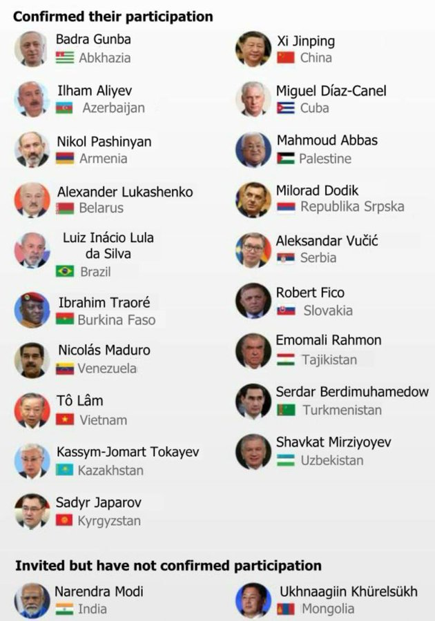

The big problem is that Ukraine has threatened to spoil the parade by attacking Moscow on May 9th. Today is May 8th. We have time to pray. But if there is an attack on Moscow it will include those above and many others.
Discernment of Spirits: I Corinthians 12:4-11. Go over the article “The Manifestations of the Set Apart Spirit” under the Mikvah of the Spirit.
“Now there are diversities of gifts, but the same Spirit. 5And there are differences of administrations, but the same Lord. 6And there are diversities of operations, but it is the same God which worketh all in all. 7But the manifestation of the Spirit is given to every man to profit withal. 8For to one is given by the Spirit the word of wisdom; to another the word of knowledge by the same Spirit; 9To another faith by the same Spirit; to another the gifts of healing by the same Spirit; 10To another the working of miracles; to another prophecy; to another discerning of spirits; to another divers kinds of tongues; to another the interpretation of tongues: 11But all these worketh that one and the selfsame Spirit, dividing to every man severally as he will.”
Probably the most important gift of the Spirit, especially now, is “discernment of spirits.” It will keep more of us alive longer. Matthew 24:1-4. Discernment is a #1 priority – by knowing the Word from Genesis to Revelation 22 – by hearing Abba, who is the Spirit, telling us truth as we go. I say this because most of you sit on the edge of your seat wondering what is coming next. No, you are not most likely in India or Pakistan or the Middle East, maybe Jordan, but you are in a danger zone if you life in any Christian nation or western world nation in general – I’m talking about the E.U., U.K. U.S. Canada Australia or New Zealand, or Mexico and central and south America. Let me be very frontal – no nation on earth is exempt from what is coming – the reign of the bestial anti-messiah – the one who serves the will of Lucifer 100%, the one world government. It really started in the days of President George Bush, Sr. who stressed world government. But now nations are aligning more than ever around a one world government agenda.
Wisdom can come by using our brain, by our gut feeling, by our human discernment of right and wrong, but only Yahuwah can tell us what we need to know to survive from our re-born spirit. He wants to warn us. Things are quickly moving and soon it will be against the law to have a Bible. It will be against the law to talk to anyone about the God of the Bible and His Son. Depending on the degree of deception and seduction – eternal heaven or hell could be determined by the path you take. Horrendous deception is coming. Don’t think you’re too spiritual to be sucked into it. Be much in prayer! Be much in the Word! Reach out to others with the Good News of salvation as long as we have left. Things are moving faster.
India has just made witnessing to its people a criminal offense. Ken , whom I’ve mentioned in podcasts, just returned from India not long ago, witnessing of our Savior. He said many were born again. HalleluYah! I don’t know if Ken knows yet about this serious law. I say this to warn you that witnessing is against the law in the states too, or praying on the sidewalk of a city, or reading the Bible. Believers are being arrested, jailed, fined. The nations are closing down the old world to bring in “the new world order.”
Bibles will be confiscated and those who speak from the Bible will be censored.
In many nations censoring of the message of salvation or any message from the Bible is considered a crime worthy of death. And truthfully I say that American government groups are paying various Islamic groups of terrorists to kill Christians. This is proven fact. So what will America do to its own?
What did a broken-hearted Samuel hear from Yahuwah? “They have not rejected you – they have rejected Me.” I Samuel 8:7: “…6But when they said, “Give us a king to judge us,” their demand was displeasing in the sight of Samuel; so he prayed to the LORD. 7And the LORD said to Samuel, “Listen to the voice of the people in all that they say to you. For it is not you they have rejected, but they have rejected Me as their king. 8Just as they have done from the day I brought them up out of Egypt until this day, forsaking Me and serving other gods, so they are doing to you.…”
Today people are turning from Jesus/Yeshua/Yahushua to their own reasoning. They are making gods of themselves. Also in the U.S. Satanism, and those who worship Lucifer, are gaining in strength and power by the day as Lucifer moves to take over the earth. The first covenant God gave mankind was the covenant of marriage and relationship with Him. Genesis 2:24 – yet today the tearing down of the family, the perversion sexually – it is against the very foundation of life from Yahuwah – the abortions, the pedophilia etc. It destroys a family – it destroys a nation!
In the U.S. today, the most sophisticated Luciferians, those in very high positions have to offer their first born to Moloch. It is also a ritual in satanism to offer babies and children to Moloch. [Johnathan Cahn’s book: The Return of the Gods.]
Proverbs 14:33-34: “Righteousness exalts a nation but sin is a reproach to every people.” The US is being vanquished. That means we are being taken apart piece by piece. “This is a nation that embraces evil,” Steve Quayle said. You can’t believe most anything said by politicians now.” Hear from Yahuwah!
NOW nuclear subs are now off the coast of Iran and China. I also read that B-52s are joining the B-2s on Diego Garcia Island. The U.S. is 20-25 years behind in military weaponry. We do not have hypersonic missiles. We don’t even know if the nukes on the submarines we have even work. Now with the tariff wars with China our military can’t get the equipment they need.
Have you done anything with the warnings that have been given? The word went out in 1985 to get out of debt, and most people went into debt. Storing food, buying life-necessities, preparing spiritually (It doesn’t happen overnight) – getting extra gas, buying what you need if all goes down. Are you preparing financially?
China is preparing to fly weapons into India. They said they would if Pakistan and India go to war, because China backs Pakistan.
Ohmagosh! I just learned that India is planning an attack on the Three Gorges Dam in China. The water that is in that dam has the strength to tip the earth when its container springs a huge leak – as in destruction. The biggest super computers in the world are monitoring this event. What will happen if the Three Gorges Dam is destroyed? Lots of lives will be lost too.
Censorship now in the U.S. is going to its height – we are being monitored day and night. Have you noticed that with your computer, with your printer? My printer is gone, so I’ll have to get another one.
Again: Ukraine is preparing to ruin Russia’s military parade on the 9th of May.
High up sources are saying Russia will absolutely obliviate Ukraine if they try it.
Lots of nations will be there for the victory parade, honoring Russia in WWII and those who died. Honoring the end of German Nazism – yet Nazis came to America under operation Paper Clip and took key positions in America. Russia knows that.
“There is a lie going around that there is dialogue between China and the US – that is a lie.” At this point U.S. shipping ports are empty or emptying. 10,000 containers on one ship and 10,000 containers from another ship were sunk at sea by China carrying what we need in many realms – things for the military, things for hospitals, medicines, technology, -- the ports are empty – no ships from China unloading, as in Seattle. Yet Chinese subs are in the Gulf waiting to fire. Do you have what you need to live without going to the store every week? Many Walmart Stores are closing because so many of their goods come from China – even Ibuprophin. Because of the tariffs on China, the U.S. has little to no ammunition for soldiers.
The U.S. and Israel are talking about hitting Iranian oil fields and America’s B-52 bombers and B-2 bombers are ready to fly. China buys oil and gas only from Iran. China is a big supporter of Iran, as is Russia. If Iran is hit – wow – the ramifications of that! Why did President George Bush, Sr. tell General Wesley Clark that we had to hit Iran before the new world order could come to power? The new world order under the antichrist/anti-messiah is well on its way.
The war with Afghanistan: We left near 100 billion dollars’ worth of weapons when we pulled out of Afghanistan. These weapons and planes were sold on the black market – and the cartels bought them. Same with billions in weaponry sold by Zelinsky in Ukraine – cartels bought our weapons. So, they are better armed than America. The cartels, drug cartel or otherwise, also got Ukrainian weapons from America, sold on the black market.
Regarding Gaza: President Trump said he didn’t care what happens to the people – he wants Gaza cleaned out once and for good. President Trump and Netanyahu are working together. Many of the Palestinians are part Judah biologically sons of Abraham or of Jacob. Many are Christians. The children are being starved. Netanyahu is a fragmented person from upper New York State, as was Biden - under the orders of Lucifer.
The children of Israel were warned and warned of foreign armies coming against them, and did not realize that Nebuchadnezzar was Yahuwah’s servant to correct His people. The U.S. today is most of the House of Israel and the House of Judah. – Vladimir Putin in My Nebuchadnezzar He said to me, to Pastor Faircloth, to Steve and probably to many others. The U.S. we knew is gone. We are in the middle of the time before the return of Yahushua Messiah - moving quickly forward. What matters? Your discernment of the lies behind deception could save your life. We’re moving fast forward to bestial reigning power – Revelation 13, Daniel 7-8. One of the major gifts of the indwelling Set-Apart Spirit of Yahuwah is “discernment of spirits.” We need this gift greatly now! Everything is moving so fast forward.
Pray for those who are in attendance of Russia’s parade tomorrow, May 9th. It is a very volatile time for those citizens and other nation’s rulers in Moscow. Pray for the Christians being literally slaughtered around the world. I got my information about this from Open Doors with Brother Andrew. I went with that organization to China three times in 1994 and 1995. Now Hong Kong has been returned to China. It is chilling to be among Christians who are targeted for death. Yet their joy is amazing. They really know what it means to be born again! Pray for the dear Christians of China!
In His love, Yedidah – May 8, 2025

