THE HEAVENS WILL SOON BE DEMONSTRATING THE SUPERIORITY OF THE CREATORS!

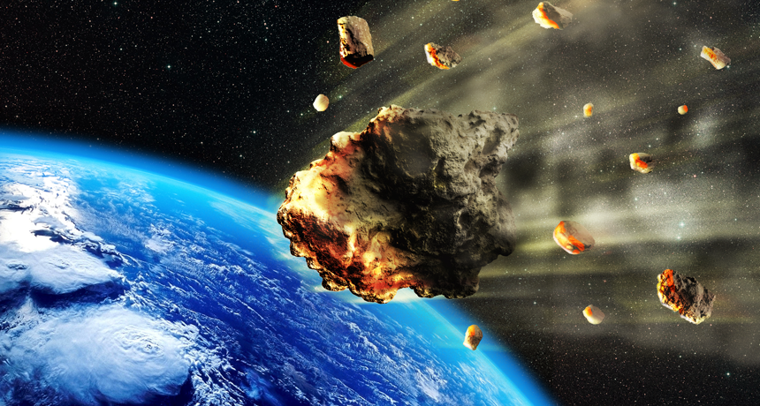
Here’s an artist’s rendering of a large asteroid breaking up as it begins to plow through Earth’s atmosphere. Note the space debris meteorites with it. RATPACK223/ISTOCKPHOTO

Psalm 19:1-4: “The heavens declare the glory of God; and the firmament shows forth His handiwork. Day unto day utters speech, and night unto night reveals knowledge. There is no speech nor language where their voice is not heard. Their line has gone out through all the earth, and their words to the end of the world.”

Psalm 8:1, 3: “Oh Yahuwah, our Master, how excellent is Your Name in all the earth You who set Your Splendor above the heavens…For I see your heavens and the work of Your fingers, the moon and the stars which You have established…”

Genesis 9:8, 11: “And Yahuwah spoke to Noah and to his sons with him saying,
`And I shall establish My Covenant with you, and never again is all flesh cut off by the waters of the flood, and never again is there a flood to destroy the earth.’”

Isaiah 66:15-16: “For look, יהוה comes with fire and with His chariots, like a whirlwind, to render His displeasure with burning, and His rebuke with flames of fire. For by fire and by His sword יהוה shall judge all flesh, and the slain of יהוה shall be many.”

Recent released insider-source information from the Pentagon and science agencies, have let us know a little about what is coming, as Yahushua steps in with His input before the coming of the Beast himself. He wants all the earth to know that He is the Almighty and nothing fallen angels or their offspring-Nephilim can do will up-stage Him. This will cause mankind to fear, yes. But, in diverting it to UFOs and aliens, the fallen ones will continue to deceive the lost, and a great portion of the carnal “saved” also, the religious.
In the final end, however, all the fallen ones, Satan included, and their hybrid-human lackies will realize “it’s over for us.”
Revelation 6:12-17: “And I looked when He opened the sixth seal and saw a great earthquake came to be. And the sun became black as sackcloth of hair, and the moon became as blood. 13And the stars of the heaven fell to the earth, as a fig tree drops its unripe figs, being shaken by a strong wind. 14And heaven departed like a scroll being rolled up, and every mountain and island was moved out of its place. 15And the sovereigns of the earth, and the great ones, and the rich ones, and the commanders, and the mighty, and every slave and every free one, hid themselves in the caves and in the rocks of the mountains, 16and said to the mountains and rocks, “Fall on us and hide us from the face of Him sitting on the throne and from the wrath of the Lamb, 17because the great day of His wrath has come, and who is able to stand?”
Luke 21:10-11, 25-26: “Then He said to them, `Nation shall rise against nation, and reign against reign. 11And there shall be great earthquakes in various places, and scarcities of food and deadly diseases. And there shall be horrors, and great signs from heaven.’ … And there shall be signs in the sun, and moon, and stars, and on the earth anxiety of nations, in bewilderment at the roaring of the sea, and agitation, 26men’s heart’s failing from fear and the expectation of what is coming on the earth, for the powers of the heavens shall be shaken.”
Revelation 8:6-9: “And the seven messengers who held the seven trumpets prepared themselves to sound. 7And the first messenger sounded, and there came to be hail and fire mixed with blood, and they were thrown to the earth. And a third of the trees were burned up, and all green grass was burned up.
8And the second messenger sounded, and what looked like a great mountain burning with fire was thrown into the sea, and a third of the sea became blood,
9and a third of the living creatures in the sea died, and a third of the ships were destroyed.”
Forget the timing of man’s theology! Yahuwah’s timing is in our favor! Yahuwah is a good Abba-Daddy. He is not sadistic. There is no 7-year tribulation found anywhere in the Bible. There is a final 7-years, but the length of “great tribulation” is determined by Yahuwah! He shortens it for our sake. Oh how we love Him!
He sends judgment; He sends His final wrath on the wicked, all the while warning His children to get behind Him and hide out under His tallit. A few are listening – the few of Matthew 7:13-14, the few of Psalm 91:1. He cannot gather anyone under His tallit whom He does not know intimately and trust to be 100% on His side. But, then, I think you know after all the writings and podcasting I’ve done on that, that there are conditions for being in His favor. We must be “worthy” of His favor. Refer to: “Revelation 5: Being Found Worthy?”/Mikvah of the Heart of Elohim.
Yes, we’re at the beginning-edge of what Messiah called “great tribulation,” which will take off strongly in the next few months - compounding, uniting, and intensifying- not in consecutive order, but one on top of the other, pushing down to compact. The Flood did its job in six weeks. Forget the timing of church, or any other, eschatology. There is a lot less to be fulfilled than man has come up with. Daniel was not in the lion’s den but one night. The three Hebrew young men were not in the fiery furnace but one day.
Our Abba is good to those He knows and trusts, His faithful ones who are filled with His Spirit and walking in His nature, ways, and thinking. He smiles at His faithful ones, and rewards accordingly.
OK folks – hold on tight – I’m going to give you some information that has oozed out of the sealed box. Please listen to Steven ben Nun’s broadcast on Steven ben Nun YouTube “July 19, 2020: New Source Confirms In-Coming Asteroids” He sums up loads of things.
I’ve reported on quite a few things “Mike from around the world” has reported for years, and recently, on Paul Begley’s YouTube Thursday night programs. Back to back hearing “Mike” last Thursday night and Steven ben Nun yesterday, they basically were reporting on what is known and has been known in the Pentagon, government intelligence agencies, NASA, and space agencies in general for years. But, now, it’s here and the information is getting out.
Of course, on September 1st an asteroid is coming incredibly close to our atmosphere, 43,000 miles, coming at us at a speed of 18,000 mph, 150’ wide. NASA is keeping a close watch on it. But, as “Mike” said, there are many coming before that.
The news has finally leaked out about the gigantic binary system that has been in our solar system for a while, for it is nearly upon us, and will be seen by September from earth. It has two suns - this is why it is called a “binary system.” The brown dwarf star that the suns rotating around it, is like a giant planet. It will not hit us, but its debris field carries monstrous asteroids, millions of meteors, comets, space dust, radiation, and tremendous waves of energy.
I recently posted an article showing the spikes on the Schumann Resonance of a recent hit by its waves of energy. The waves of energy are loaded with radiation. They are heating the core of the earth, so that the magma underneath is heating and moving, and the earth’s surface is heating. The magnetosphere is weakening, and so are all of earth’s life-support systems. Our rotation is messed up too. One of the system’s suns is a “hot sun” like ours, and one is a “cold sun.” The hot sun, as it approaches our sun will suck protons out of our sun, leaving it darkened, even though it continues to give us heat. There is much Scripture that describes this, even in Joel 2, as well as Revelation.
In my recently posted article “Hold On Tight to the Master’s Hand, July 14, #62 under the Mikvah of the Great Adventure, I give you quite a few updates on this subject, pages 5-6. “Mike from around the world” as Begley dubbed him 7 years ago, is in a high position over others in a government science job – and has access to special instruments and knowledge from NASA, GSPS, etc.
“Mike” was evidently watching the incoming of Comet Atlas, which was gigantic, and surrounded by much space debris. It was heading around the sun, but then almost directly at earth. He sounded the alarm for several months – as it showed the comet coming at us around or on May 12th. Then in the meantime, the comet broke up into 4 pieces and nothing else was said about it. However, May 12th began the incoming meteorite debris from something – and now we’re getting more from the binary system. From the week of May 12th, we began seeing more and more meteors/fire balls falling onto the earth, starting fires, destroying property, and yes, killing a few people.
Yesterday, from a researcher in England, I learned that some watching events are asking “what happened to Comet Atlas?” Nothing that huge, even if broken into four pieces, can just disappear. All word about it was stopped. I was also very curious about that. It did not disappear. We know from Revelation 8:6-10 that two asteroids or two pieces of an asteroid or comet are going to impact earth, fall into the Pacific Ocean and 1/3 of mankind will be killed (Asia), the ocean ruined more than it is now, and the deepest trenches in the world opened. We learn that as these are opened, out of them comes the imprisoned army of the Beast and the Beast himself rises (Revelation 9:1-11). I am NOT saying this describes two parts of Comet Atlas. I am just remembering what “Mike” said at that time to Begley. He said that if something is so close and so dangerous to earth that will impact earth, NASA will not report it. What can they do? Panic everyone before they die?
I’m just a curious person! But, last Thursday, “Mike” revealed more. What amazed me was Steven ben Nun saying the identical things from his inside intelligence sources.
One thing I know, and Steve Quayle said it outright in an interview with David Hodges yesterday, that the fact that things are accelerating so fast, is a clear indicator that the days are being shortened for our sake. You are loved by Yahuwah and Yahushua! Share their love!
OK, let me go over here a few statements from Steven ben Nun’s incredible broadcast yesterday. Right now, as Quayle said, and ben Nun said, people in Florida are beginning to panic to get out. Steven and Jana ben Nun live in Florida. I just know what I saw in a vision about Florida. I lived there and loved it but when you see the maps below, you’ll see what our military and intelligence agencies have known for 35 years.
Steve starts out by saying “NASA is saying thousands of asteroids are headed towards earth.” He showed a clip from a new movie that is coming out and how accurate it is: “Comet,” starring John Wick, shows what will happen if the debris field dumps on earth.
One of Steven ben Nun’s sources is saying that December 2020 is a big time for incoming debris. This is when the binary system moves towards us. So, are we looking at 2022/2023 for His coming? If this intensifies this fast, is Yahuwah really shortening the days? This system has a 3,600-year orbit. It is possible that this is what caused the breaking up of the deep, causing the Flood.
A scientist-friend in the government told Steven yesterday that 30 years ago, this information of the bombardment of earth by this binary system’s debris was shared with him in top-secret briefings. He said that Jupiter usually wards off lots of asteroids from hitting us. But, in 2021 (March I think) Jupiter is going to be hit hard with space debris which will then head towards us. Jupiter has been our protector, but now it needs protection.
Nuclear scientist-friends told him that the radiation is increasing. It is causing the earth to heat up internally. “Mike” told us the core was heating and the magnetosphere is overloaded. This is why the earth’s surface is getting so hot, the magma is flowing under the ground and seas. There are massive oceans under our oceans, and they are beginning to seep upwards. Jonah went beyond the ocean floor into another realm.
The earth is cracking, stretching, pulling apart! Water is draining under the cracks … Underground bunkers are no longer safe. Billions spent on the bunkers, and now they are too hot to live in, and flooding is a danger. So, the “Elite” are being upstaged by Yahuwah. HalleluYah!
China is giving chemical weapons to Iran. No one can fight against it. Natural disasters could hit the chemicals. Our weather will be affected drastically, earthquakes, volcano eruptions, tornadoes, severe storms, high waves, etc.
Israel is a safe place to go to, Syria, and Jordan … this is said by a scientist to Steven.
Steven received this information 6 months ago. Yes, Jordan is set-apart by Yahuwah. I lived there 8 years and went to Petra many times. Revelation 6:12-17 is talking about Petra – no doubt about it. Revelation 12:12-17 is also talking about Petra.
SEPTEMBER IS THE MONTH TO WATCH. He said what “Mike” said – that “by September no one on planet earth will not know that we are in serious trouble.”
Steven had lots of confirmation on this that by September the debris will begin to fall seriously, and we will be able to SEE “IT” -- the dwarf star/planet. “There is nothing anyone can do to save the population of earth,” he said. Around September, especially in populated areas, people will realize we’re in trouble--that will finally dawn on the world.”
By December, the earth will go erratic to do with weather because of the system’s pull on the earth, like 200 mph and higher winds are very possible. The earth is pulling apart. Parts of East Africa are showing that. Iceland is pulling apart.
Steven said that around March or April, the planet/dwarf star will also come through by itself. Our magnetosphere will collapse. We will begin our radical Isaiah 24 pole shift. Read Isaiah 24, Haggai 2, Hebrews 12:25-29. The great shaking of the entire planet is for real.
“Mike” said that as the planet shakes, the stars will appear to fall from heaven, shaking out of their orbit, as we read in Revelation 6:12-17. It will appear that they are shaking and falling – but not so – it will earth that is shaking! We are in a pole shift. I reported on it in 2007. But we’re looking at a total pole shift.
Steven is getting all this from his Pentagon science sources who have known about these things for over 30 years. He says as “the planet”-dwarf star comes through these things will happen for about 6 hours. The sun – will it be darkened by the brown dwarf star’s hot sun?
Yes, its all in the Word and it has been reported from ancient times. No, this is not the planet of the fallen angels or demons, anymore than any other planet. But, on earth the fallen ones will use fear to bring on the UFOs and aliens to take away from the fact that it is Yahuwah doing the judging of mankind.
Years ago, following a dream Abba showed me, ABBA SAID TO ME: “WHEN THE RAINS OF JUDGMENT FALL THE ARK WILL FLOAT.”
He referred it to Noah’s day, but “the rains of judgment” could be falling space debris starting fires. Millions of meteors will begin to fall, burning up all green things, all trees, crops, grass. Please look at this in Revelation 7:1-8, 8:6-10, and 9:4.
Perhaps this is the timing of the Daniel 11:32, Revelation 3:12, 7:1-8, 14:1-5 remnant to be translated and sent forth. For sure, this is the time of fleeing and protection by Abba in places like Petra, in the rocks. That is also in Isaiah 26:19-21, where Yahuwah tells His people to hide in the “chambers” – Hebrew for “holes in the rocks.” This is the time preceding the coming of Yahushua with the wrath of Yahuwah! No one will survive His wrath except the set-apart ones.
Now folks, we are seeing some things in real time. But, as Steven said, we know it’s coming but we can’t put a date on it exactly! No, we don’t put faith in what man says, even scientists with high technology instruments and telescopes.
“Mike” was seeing something evidently that “disappeared,” and yet on May 12th meteorites began falling in Russia and starting fires. What he told was about a launch pad. So many people have their charts and their beliefs from Christian fundamentalists or sceptics, as in II Peter 3, have done no research on their own, and have no in-touch information from Yahuwah. Thus, they go back to sleep and do nothing to prepare.
Steven’s scientist friend, reporting above, said that all the assets are being transferred out of Washington DC because “there will be no more Washington D.C.” - There will be two capitals because the US will be divided: 1) Colorado Springs, Colorado and Atlanta, Georgia.
I’ve began reporting on the splitting of America in two, since the BP Oil Rig blew up in the Gulf of Mexico a few years ago. I’ve seen maps, even a Navy map, showing what will happen when the U.S. splits in two, the coast lines are wiped out by the ocean, and Florida sinks under the sea. I learned about this in 2006. Now we’re close to it.
Steven showed a map of the New Madrid and the dividing of America into two parts.
Abba showed me in a dream indicating the split from St. Paul, and the Great Lakes, down the Mississippi to Memphis and the Gulf. The Great Lakes will flood down to the Gulf once the split takes place.
Steven said the split will be caused by the pole shift itself, as he was told.
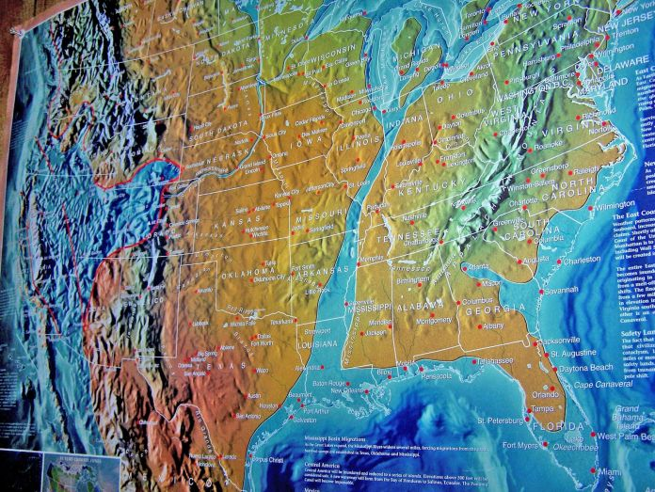
The New Madrid fault zone is six times larger than the San Andreas fault zone in California and it covers portions of Illinois, Indiana, Missouri, Arkansas, Kentucky, Tennessee and…most Americans expect the next great earthquake in the United States to come on the west coast.
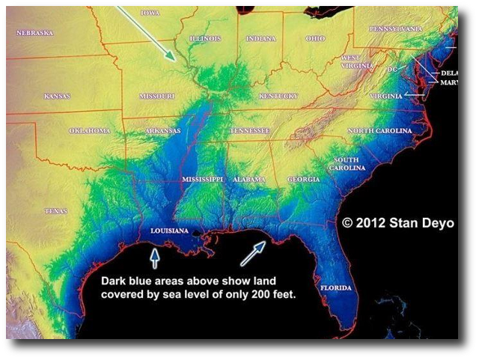

It is estimated that southern Florida will sink 200’ beneath the ocean. I saw a vision of 100’ tidal waves crashing into eastern Florida. I was in western Florida at the time.
Steven said that NASA is reporting more and more now about asteroids coming close to earth. “For look, יהוה comes with fire and with His chariots, like a whirlwind, to render His displeasure with burning, and His rebuke with flames of fire.”
So now you know some OLD News that is also NEW news to us.
Steven is just reporting. He says he can’t be dogmatic about it, but, he says, the sources he has have been accurate for many years – have never been wrong. He was in the CIA. He has contacts in high places as does Steve Quayle. They’re all saying the same things. I’m getting the same information in several places.
I don’t believe in man-made cookie cutter timing. I believe in a final 7-year cycle. For since Genesis 1:3, the earth has been moving in 7-day cycles and 7- year cycles. However, Abba’s timing is His own! This is why we must hear from Him!
We must not waste time listening to the opinions of others, or looking at anyone’s chart, or listening to theology with a few Bible verses to supposedly back it up – we must be about our Father’s business! We must learn from His Spirit, as John 16 tells us – “He will show you things to come.”
Into the midst of all the evil being brought upon mankind right now. Yahuwah is rising as an angry Father, to let the world know: I AM is in control! No matter what the evil ones can do, they cannot take-over our re-born sprit to disconnect us from Yahuwah and Yahushua. Only we can do that. So, again, I write to stir you to action and deeper devotion to the One who is coming again!
In His love, shalom and blessings, Yedidah - July 20, 2020

