THE RED ON THE RED ALERT
IS GETTING BRIGHTER
SEPTEMBER 15, 2020 - “ABRAHAM ACCORD,” WASHINGTON D.C., NETANYAHU, Israel on lockdown, WAR, AND ISRAEL’S COMING MESSIAH

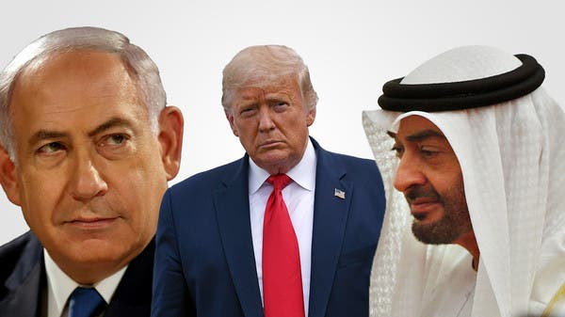

That’s quite a title, but there is so much that has to do with tomorrow, September 15, 2020 about the signing of the “Abraham Accord” in Washington D.C. between Israel and the United Arab Emirates (UAE) , the United Nations General Assembly, along with the lockdown of Israel, the Jewish messiah, Netanyahu’s role, and the peace accords of Arab nations with Israel that is continuing, and more.
Just since this morning, I have gotten information that has left me numb, overwhelmed, yet it is confirmation of what Yahuwah is saying to His remnant. How is Netanyahu connected to the coming messiah of rabbinic Judaism?

Link to Steven ben Nun’s blockbuster 14-minute video today:
https://youtu.be/4IcUM_xln-s “Israel preparing for war, or Messiah?”
Notes from Ben Nun’s YouTube video today:
The “Abraham Accord” is to be officially signed in Washington tomorrow, at the same time as the U.N. General Assembly is having their yearly meetings. The “Accord” is between Israel and the UAE. That will be officially signed in the Oval Office of President Donald Trump, September 15, 2020.
Notice the coming together of so much deception and progress of the rising Beast system just before the Fall Festivals. This is because the epicenter of the deception will be Jerusalem--the capital of the Beast Kingdom (for a short time). It has been prepared since the late 1800s by Shabbtai-Frankists -Talmudic/Kabbalist Orthodox Rabbis for their messiah. Refer to: “1666: Shabtai Tzvi and Redemption Through Sinning”/Mikvah of Israel, Our Eternal Inheritance.
“Bahrain become the newest nation to recognize Israel.” … news headline today! The nations are amassing, especially the wealthy oil-rich nations of the Arab world, to make alliances with Israel - because “the messiah” of the Jews is coming – the Beast, the anti-messiah. His kingdom is now rising. All wealthy nations want to put their money behind his kingdom. The rulers of this world know that he is coming, and this false peace deal is not just the precursor but the facilitator to draw all the money-power nations together to support the world ruler – Beast.
As Ben Nun says, most pastors are all for it among evangelical-Charismatic Christians and other church groups. 2,700 pastors so far are also behind taking the vaccine that is proven to change the DNA and unite humans with A.I.
Now why is there a lockdown in Israel?
ABC News: “Israel to Set New Nationwide Lockdown As Virus Cases Surge” – 9/13/2020. Schools, businesses, hotels, and movement within Israel is being shut down or limited - limiting gatherings, just like at Passover, limiting gatherings in synagogues as well. Is this because of pending war, or messiah madness? This lockdown is called for the next 3 weeks!
August 3, 2020: “Israeli Rabbi says he is already holding meetings with Messiah.” I wrote an article about this: “Top Kabbalist Rabbi Is In Discussion With Messiah Himself”/ Mikvah of Israel, Our Eternal Inheritance.
The chief rabbis say the “process of redemption is about to begin soon.” This is an explosive situation with the rabbis and the nation of Israel. So many of the elite rabbis are in the Knesset, and the Sanhedrin has great power over Israel. And Netanyahu is working with the chief rabbis.
From Ha’aretz: “The Cure for Covid 19 is MESSIAH.” Wow! If they believe that Messiah is the cure for the virus and his coming is soon, then the two are connected and the fervor for this is rising among the religious.
Steven reminds us that the word “corona” is the word for “crown.” The rabbis have made a “crown” for their messiah, whom they is the “holy serpent.”
Article headline by Ha’artez: “Is the Lockdown Because of Impending War,” thus they want all the people to shelter in place. Israel has worked hard to invoke a confrontation with Iran, as I have reported for months. Is that really it - or, is it because the rabbis want the nation locked down for the coming of their messiah?
Times of Israel, September 6, 2020, reports “Officials Mull Temple Mount Closure as Old City Considered a Covid-19 RED ZONE.”
Woah … the Old City closed down as a red zone? How horrible! It is my favorite place in the entire world. Yet, the “holy serpent” would only come to one place: The Temple Mount - to East Jerusalem. That is the area of the Garden of Eden. That area contains three of the four main portals between earth and the throne room of Yahuwah! Satan has wanted to rule from there since Genesis 3. He wants all out of that area who belong to Yahuwah so that he can take it over as his headquarters. This is overwhelming!
Yahuwah allows the Beast no peace. Nimrod wanted his tower to open a portal into Yahuwah’s throne room so that this self-made Nephilim could go into Yahuwah’s Presence and kill Him, and kill Yahushua. He is the Apollyon of Revelation 9:11.
The two witnesses of Revelation 11 are in his face, as well as those of the 144,000-remnant of Daniel 11:32 and Revelation 7:1-8, 14:1-5, who go to the nations also with the Jeremiah 25:1517, 27-33 message of Yahuwah, and the John 3:16 message of Messiah.
Because of the epicenter of world rule, the capital of the world government, being Jerusalem, and the control there of Shabbati-Frankist rabbis, it is not far-fetched to say that the false prophet would probably be one of the Talmudic-Kabbalist Rabbis – perhaps of the Sanhedrin … perhaps their chosen “High Priest” if they ever get that far with building a third temple. The Babylonian Talmud and Kabbalah are satanic to the core, polytheistic, and deep into the greatest evil against humanity worldwide. Just to get a taste of it, I recommend the article “Quotes That Forever Destroy Damning Illusions,” Mikvah of Israel, Our Eternal Inheritance.
It won’t take long to put up their third temple, if they do it, for part of it is “pre-fab.” According to Scripture, they do not have to erect a third temple in order for their messiah to rule. That’s in the minds of rabbis and Fundamentalist Christians.
Steven: “NETANYAHU IS SUPPOSED TO BE THE MAN WHO HANDS OVER THE KEYS TO THE MACHIACH!”
“NETANYAHU WILL HAND SCEPTER TO MESSIAH SON OF DAVID” BY ADAM ELIYAHU BERKOWITZ | BIBLICAL NEWS Israel 365. This article is printed below, page 5 ff. The pictures heading the article are of Netanyahu and a statue King David wearing a crown. It is the statue in the area of the tomb of David on the false “Mt. Zion,” known as the Upper Hill in ancient times, on which are so many Catholic structures. According to Scripture, “Zion” is the “City of David,” - not the Upper Hill, not the Temple Mount. II Samuel 5:7, 6:12 are just two examples. It is about 1½ city blocks south of the Temple Mount – today’s “City of David.”
Since Netanyahu is the chosen one to hand the scepter to messiah ben David, Steven said: “WE ARE RUNNING OUT OF TIME FOR NETANYAHU TO BE ABLE TO FULFILL HIS PURPOSE IN THAT.” Soon, Benny Gantz will take over as Prime Minister – early 2021, I think.
As referenced in the article below, in today’s YouTube broadcast of Israeli News Live, Steven ben Nun plays the old video of Netanyahu blessing the Orthodox rabbis and wishes them success. In this old video Netanyahu to the rabbis: “I have come to ask your blessing and to help you in everything.” He speaks to them of doing something to hasten “messiah ben David’s” coming. The rabbi says “we’re doing that.” Netanyahu says “apparently it is not enough.”
Netanyahu understands that certain things have to happen to make the messiah return. One of them is war – i.e. the war of “Gog and Magog,” in which Iran is a major player, as well as Turkey and Russia.
Article 3/24/18: “The Rebbe’s message to Netanyahu – a Prophecy for Today.”
Rabbi David Nachshon is a personal friend of Netanyahu. He discussed personal relationships between Netanyahu and U.S. Rabbi Schneerson. The prophecy was about what Netanyahu would have to go through with 119 adversaries – those accusing him of things and trying to get him removed from office. The prophecy was connected to the time of their machiach.
So, as ben Nun questions, is Netanyahu locking down the nation so that the messiah can be revealed, and he can give him the scepter and proclaim him the messiah, or to protect the citizens in case of an attack by Iran, or just because of Covid-19?
From the Jerusalem Post: “UAE-Israel Deal Signing Ceremony to Be Held Sept 15 in Washington” September 8, 2020
Israel is going on a lockdown to cover the time he is in Washington, even though the lockdown is 3 weeks at least. This might be a time for an attack on Israel. This would prepare the way for their messiah to come also amidst war. Are we that close to the appearing of the Beast in Jerusalem? Time will tell…
Pre-7-year rapturists say that they are gone by the time the Beast comes to power, even though II Thessalonians 2 tells us that the rise of Beast to power is at the same time as the great apostasy!!! That passage continues on to tell of those who are damned because they do not love the Truth. Many who say they are believers will instantly become non-believers when the realize there is no escaping the “bad.”
TYING THE TWO TOGETHER: IS THIS WHAT WE ARE SEEING? PREPARATON FOR A SMOKESCREEN, A WAR PERAHPS, DURING WHICH THE BEAST WILL COME TO POWER, AND THE GREAT APOSTASY SIMULTANEOUSLY, AS LAODICIAN CHRISTIANS AND MESSIANICS ACCEPT HIM AND DENY YAHUSHUA-YESHUA-JESUS?
As I wrote in “What About a Great Revival…” and today the article “Red Alert!...” these things are compacting, layered in Scripture, so that the time is short for the Beast to do his worst. Read Revelation 12:12. Abba is not going to drag it out. What is coming will eliminate most everyone on earth, but not all. There is a remnant – a hidden one, and an active one. (Revelation 12:17 for example, and Daniel 11:32 for example)
As quoted by a chief rabbi in the article “Top Kabbalist Rabbi Is In Discussion With Messiah Himself”/Mikvah of Israel… he says that we are in urgent times to bring forth the messiah, and connects it to the man-created war of Gog and Magog … if that war can be created, of which Iran is a chief player, they believe their messiah will come.
“Gog and Magog,” as taught by the sages in the Artscroll commentary on Ezekiel 38-39, says that this war happens in connection with the coming of messiah. Yes, it does – but in connection with the coming of THE MESSIAH, YAHUSHUA… Please refer to: “Ezekiel 38 and 39 – Directly Linked to the Return of Messiah”/Mikvah of Israel…
How close together does the Beast messiah’s coming precede the coming of Yahushua ha Machiach? How long is the reign of the false messiah from Jerusalem? It is shorter than the Jesuit cookie-cutter timing inserts want anyone to believe. He does not reign long – only to do the will of Yahuwah, then He is “removed” – Revelation 19.
The composite Beast, Nimrod, comes long enough to amass an army against Yahuwah. He comes long enough to try to kill as many believers if possible. He comes long enough to kill the two witnesses, but NOT long enough to play god for 3½ years!
The Beast is given the authority, power, and throne of Satan. Yet, Yahushua said that for our sake, the days would be cut short, or no one would be left alive.
How does Netanyahu connect with messiah ben David of the Talmud and Kabbalah?
OK! “NETANYAHU WILL HAND SCEPTER TO MESSIAH SON OF DAVID”
BY ADAM ELIYAHU BERKOWITZ | BIBLICAL NEWS Israel 365
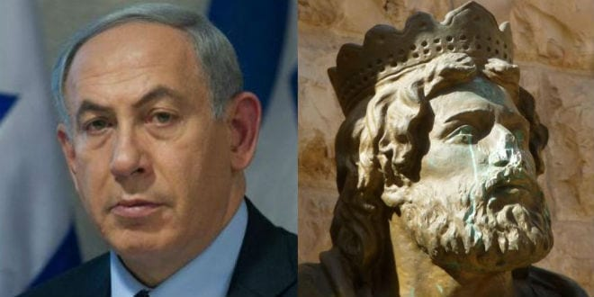
Prime Minister Benjamin Netanyahu faces many of the same trials as Biblical predecessor as leader of the Jewish people, King David. (Breaking Israel News)
Rabbi Levi Sudri, an award-winning Bible expert, makes the case that Israel’s prime minister, Benjamin Netanyahu, is the reincarnation of the biblical figure Jonathan, the son of King Saul, who has returned in order to fulfill his promise of helping David bring in the Messiah.
Rabbi Levi Sudri (Photo courtesy of Rabbi Sudri)
“…Rabbi Sudri pointed out that Jonathan was already acknowledged that he would not inherit the kingship and that David would be king. He said to him, `Do not be afraid: the hand of my father Shaul will never touch you. You are going to be king over Yisrael and I shall be second to you; and even my father Shaul knows this is so.’ I Samuel 23:17 ‘But this never came about,’ Rabbi Sudri points out. Jonathan never served as David’s second. It is impossible that something should be written in the Bible and not happen. So, if Jonathan said he would serve as David’s second, it must be something that is destined to happen in the future.”
The rabbi cited the Shem M’Shmuel, a book of Torah interpretations as taught by Rabbi Shmuel Bornsztain, the second Sochatchover Rebbe (spiritual leader) from 1910-1926. The book of his teachings was published posthumously.
The Shem M’Shmuel discusses the Jewish tradition of a two-stage process for Messiah. The first stage, referred to as Moshiach ben Yosef, is a practical, mundane process that includes the ingathering of the exiles and building up of the Land of Israel. The second stage is a miraculous process which includes the reestablishment of the Davidic Dynasty and the completion of the Third Temple.
`It is written in the Shem M’Shmuel that in the future, Jonathan will come in the reincarnation of Moshiach ben Yosef (Messiah from the house of Joseph), and it is in the end-of-days that he will serve as the second to the Moshiach Ben David (Messiah from the house of David), which will be the reincarnation of David. At that time, he will fulfill his promise to serve as David’s second in command.’
`Even within Moshiach ben Yosef, there are two divisions,’ Rabbi Sudri said. `There is a leader in the material world. Netanyahu is clearly fulfilling this function. In addition, there is also a corresponding spiritual Moshiach ben Yosef whose function is to prepare the spiritual groundwork, to make the world ready to receive the much more powerful light of Moshiach ben David.’
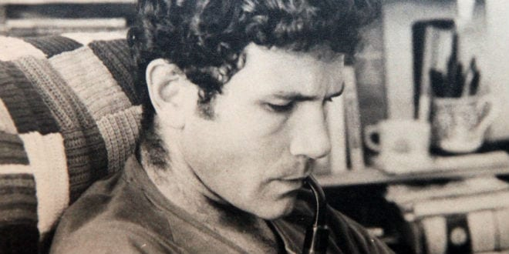
Yonathan Netanyahu, the brother of Bibi Netanyahu (Photo: Nati Shohat/Flash90)
`It is very clear that we see in Prime Minister Benjamin Netanyahu that he is fulfilling his destiny as Moshiach ben Yosef, that is to say, the reincarnation of Jonathan. The name Netanyahu (נתניהו) is composed of the same letters as the name, “Jonathan (יהונתן).’ It is also significant that the Prime Minister’s older brother, who was killed fighting haters of Israel, was named Jonathan.
Rabbi Sudri stated that as Prime Minister, Netanyahu is performing all the practical functions expected of Moshiach ben Yosef. As a former commando, Netanyahu personifies the Biblical Jonathan as well.
`Just as Jonathan fought the Amalekites before David, in the end-of-days it will be the function of Moshiach ben Yosef, or the reincarnation of Jonathan, to battle Amalek before Moshiach ben David,’ Rabbi Sudri said.
`Netanyahu is fulfilling this role by battling the enemies of Israel. When this battle is complete, he will pass the scepter to Moshiach ben David.’
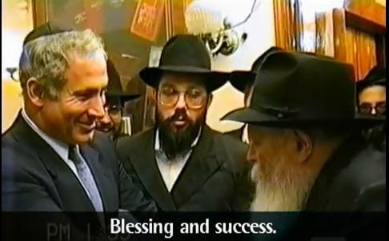
Netanyahu meets with the Rebbe (YouTube video capture)
Rabbi Sudri referred to Netanyahu’s close relationship with Rabbi Menachem Mendel Schneerson, the late Rabbi of the Lubavitch Hasidic movement known by his followers simply as “the Rebbe. In 1990, while serving as a member of Knesset, Netanyahu visited the Rebbe and requested a blessing. The Rebbe admonished Netanyahu, saying `The Moshiach still hasn’t come. Do something to hasten his coming.’ Rabbi Schneerson told Netanyahu that he would give the scepter to the Melech HaMoshiach (Messianic king, i.e. Moshiach ben David), Rabbi Sudri said…”

Wow! Two heavy-hitting articles in one day. But, hey, we’re moving fast. Check out the events for September 15th, mentioned above. It’s already 7:00 PM CDT in Texas.
Take these things to prayer. I’ve been researching and teaching prophecy of Messiah’s return since the 1960s. Abba has taught me as I have studied the Word with His Spirit, adjusting anything that I picked up from my Fundamentalist past. I dumped false Fundamentalist Dispensational Chronological Eschatology before 1970. What a man-made mess that is! It is a monstrous deceptive lie today, that will lead many weak believers into denying Jesus.
In China, when mass murderer Mao Tse Tung took power, the Christians thought the tribulation was happening and Jesus had not raptured them. They denied him by the tens of thousands saying “he is not the Jesus the missionaries told us about.” A bishop told Corrie Ten Boom to warn the believers of the West to prepare to suffer for the sake of Jesus. I taught Revelation for the first time in the late 1970s in a Bible College I helped found in California, as the Spirit taught me.
Go to Him! He is the ultimate Teacher!
In His love, Yedidah
September 14, 2020

