The Rise of Radical Jihadi Clerics, Activists, and Political Operatives in NYC Supporting Zohran Mamdani November 3, 2025

Here are two reports posted on stevequayle.com tonight, November 2rd:
- All Over America, Chaos Is Erupting In The Streets: The threat of Islamic terror on U.S. soil has never been higher. Stores around the country are bracing for a wave of crime if food stamp benefits are not restored soon
- Crazy People Are Already Shoplifting Grocery Stores And Taking Whatever They Want: From stores being ransacked to families being robbed in parking lots, the chaos is escalating fast as food pantries are being overwhelmed

“Intifada NYC”: What was interesting was who was standing directing behind the communist Islamist. From Fox News: Behind him, a Yemeni-American educator in sunglasses named Debbie Almontaser nodded. Almost two decades ago, in 2007, she was forced to resign as principal of a city school after defending a T-shirt with the slogan “Intifada NYC.” City officials viewed it as a call to violence. She said it was benign.
Her case became a rallying cry for Muslim American activists who cast her as a victim of “Islamophobia.” Now, Almontaser was back, this time as a senior advisor to Engage Action and a board member of Yemeni American Merchants Association Action, two of 110 political nonprofits, community groups and political action committees backing Mamdani as he alleges “islamophobia” against him.
Recently, when critics questioned Zohran Mamdani’s ties to hardline Brooklyn Imam Siraj Wahhaj, she sprang to action, helping to organize a protest to defend Wahhaj. That rapid, coordinated response captured the modus operandi of a network of political operatives and clerics intertwined with the shared mission of catapulting Mamdani into the mayor’s office.
Zohan Mamdani claims to be a Shia Muslim, while many of his fellow cohorts in NYC are strict Sunni Muslims. But they have found common ground in wanting to take America down from the inside, while destroying Christians, Jews, and our Constitution in the process. Muslims are coordinating to win over massive numbers of useful idiots to place them in positions of power.
There are a few dozen key players who surround Mamdani. All of them are adept at screaming about Islamophobia. As Amy Mek put it, it’s the Pakistanification of America.

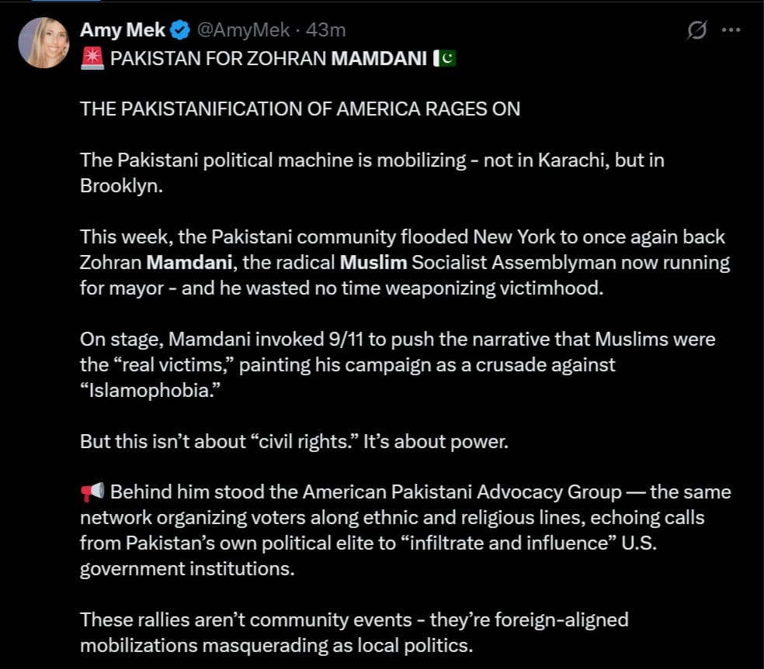

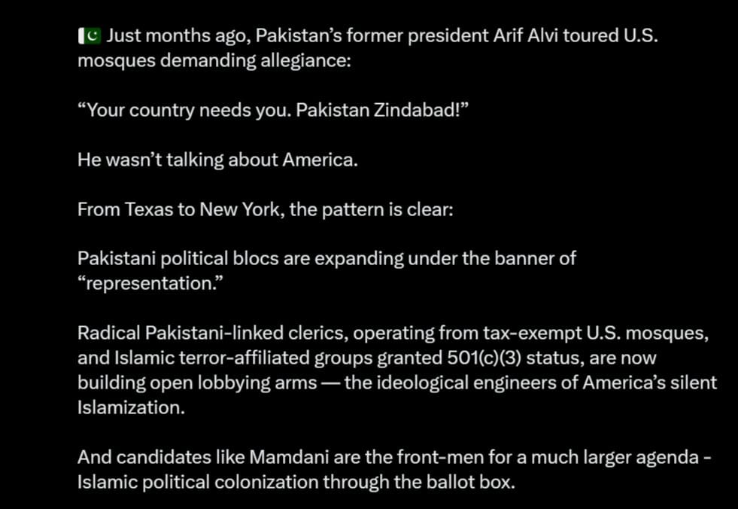
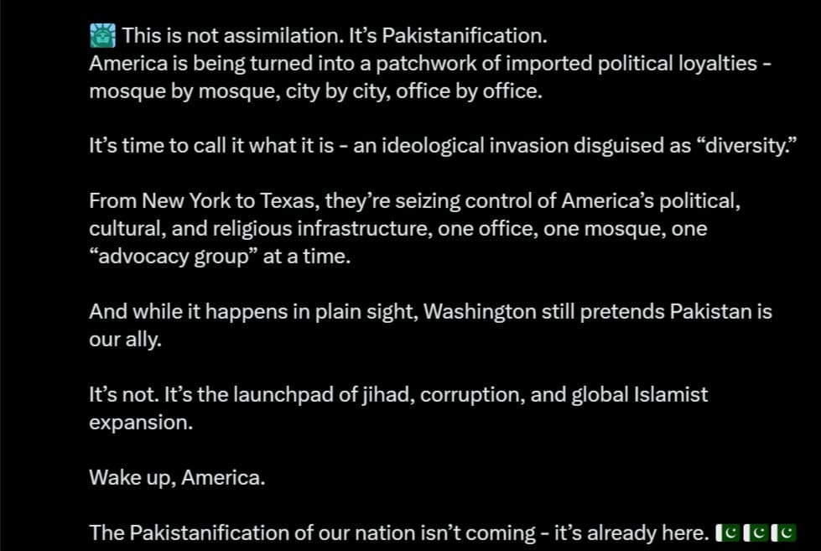

Mamdani has no problem with standing with radical imams who preach domestic terrorism. He did so on Oct. 7, the anniversary of the butchery of 1,200 Israeli innocents in 2023. That was not by accident. He strolled into Masjid At-Taqwa in Brooklyn and proceeded to post a selfie with the mosque’s imam, Siraj Wahhaj.
More from Fox News on the imam: The imam’s checkered past goes back decades. In a 1992 talk, he said American Muslims should elect an “emir” rather than choose between George Bush and Bill Clinton. Soon after, he served as a character witness in the trial of Sheikh Omar Abdel-Rahman, the so-called “Blind Sheikh” convicted for plotting the 1993 World Trade Center bombing that killed six people.
In 2018, three of Wahhaj’s children were arrested after authorities found 11 malnourished children in a New Mexico compound tied to his family; a grandchild had died in what authorities described as an attempted exorcism. He told local news reporters, “Whatever they did wrong… it’s not acceptable to us.”
Then there is the Muslim American Society, which signed a letter challenging “unmistakably Islamophobic, anti-black, and xenophobic” attacks on Mamdani. Arguably, none of that is true, but that hardly matters to those who believe lying to infidels is justified and, in fact, required.
Signatories to that letter unsurprisingly included: CAIR National, the Council on American-Islamic Relations’ New York chapter, Islamic Circle of North America’s New York chapter, the Islamic Center of Five Towns, Muslim American Society of New York, Muslim Community Network, Rockaway Islamic Center, and a “Syosset Muslim Community.”
Mohammad Badawy, youth director at the Muslim American Society, declared earlier this year at an Eid celebration that Muslims were victims worldwide and are actively persecuted by anyone and everyone who is not Muslim. He also proclaimed that Muslims would celebrate “after the destruction of the illegitimate Zionist occupiers,” Israel. Badawy loves to organize anti-Israel protests. At one of them, he incited young Muslims to “fight back” against injustice “by any means necessary.” That’s right out of the leftist playbook.
Globalize the intifada
Another activist is Abdullah Aki, who is with the Muslim American Society Youth Center. He has branded street protests as “sacred activism.” He sees them as a combination of faith and resistance that will “free Palestine.”
The Muslim American Society Youth Center has been organizing protests on Wall Street outside the New York Stock Exchange since October 7, 2023. Aki leads street protests for “Nakba Day,” branding the day Israel came into being as a “catastrophe” and youth-led demonstrations outside BlackRock. He is known for his chants of “Globalize the intifada… There is only one solution: intifada revolution.” Translation… destroy Israel and the Jews.
His hatred for Israel is very deep – on Oct 7 this year, he shouted, “We did not act enough! We will show up, stronger than we did the first October 7th!” Then he doubled down, “Saying we didn’t act enough to stop a full-blown genocide against Palestinians [is incitement?? Saying we need to be louder and protest more and continue to speak up for Gaza is a crime? Zionist tears once again for the most documented genocide in modern history.” “We will teach these folks a lesson. We are coming.”
The Council on American-Islamic Relations (CAIR) heavily supports Mamdani. Many believe they should be designated as a domestic terrorist group. They use the threat of violence and lawfare to provide cover for those like Mamdani.
From Fox News:
Basim Elkarra, executive director of the Council on American-Islamic Relations California chapter and one of the founders of a new 501(c)(4) nonprofit, CAIR Action Inc. now seems to be pursuing a new and entirely legal means of financing causes, taking a page from the powerful pro-Israel political action committee AIPAC. He told a meeting of the Islamic Circle of North America: “AIPAC had its run for 60 years, but it is over now.”
“We will teach these folks a lesson. We are coming.”
“…The game has changed. AIPAC has been around since 1961…and now they have a formidable foe!” “Make American planes crash again”
Another familiar name that is working behind the scenes for Mamdani is Mehdi Hasan, a former host at Qatar’s Al Jazeera TV network. He gave Mamdani a propagandic interview that painted the mayoral candidate as some kind of hero. Hasan has also become a full-time defender of Mamdani on social media, calling him a “once in a generation political talent.”
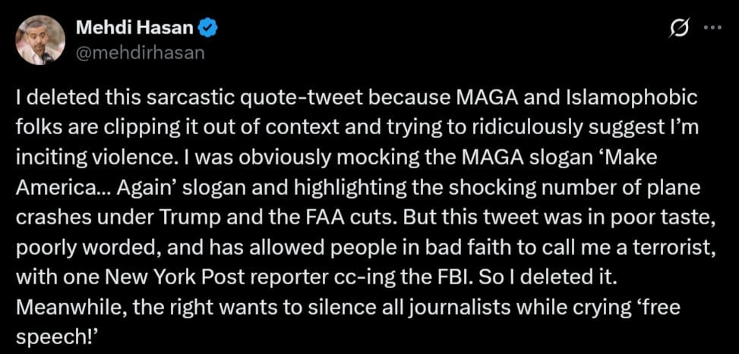
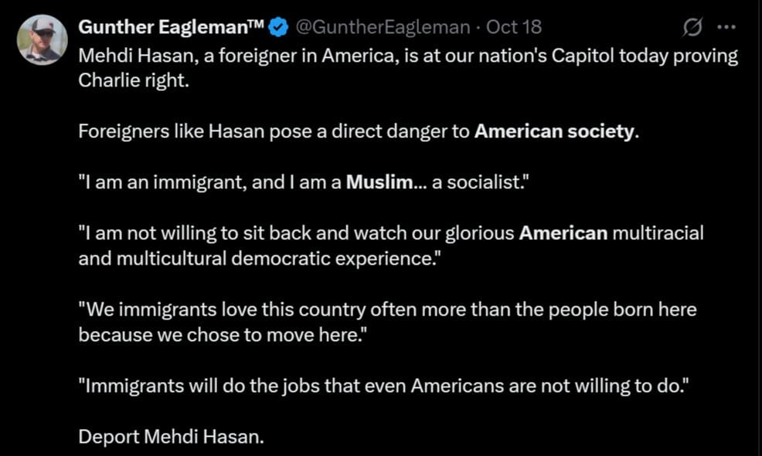

Another imam on Mamdani’s “God Squad” is Yasir Qadhi. He is the founder of the AlMaghrib Institute and MuslimMatters.com. He says that Mamdani’s win would be a sign of a “civilizational victory.” Qadhi has disparaged European Jews as “white, crooked nose, blonde hairs” and “not a Semitic people.” In the lecture where he made that reference, he recommended the book, “The Hoax of the Holocaust.”
(Video Credit: ENERSEC USA)
He also backs the Muslim housing development outside Dallas, called “EPIC City.” He claims that it is “open to non-Americans as well.” Right… just before they are converted, no doubt. Qadhi praised features of the development, such as “Islamic schools, college, and masjid.”
Another advisor to Mamdani is Imam Khalid Latif. He is a chaplain at the Islamic Center of New York City. That is a $22 million project to build a hub and “our own space” on Sixth Avenue for young Muslim professionals. Latif calls Mamdani “a bearer of compassion in a time where it is far too rare.”
From Fox News: In 2012, Latif led a pilgrimage to Saudi Arabia that included Omar Mateen, who would later murder 49 people at the Pulse nightclub in Orlando, the deadliest anti-LGBTQ attack in U.S. history. He has denied radicalizing Mateen and he hasn’t faced the same type of allegations that surround other imams.
After the backlash to Mamdani’s meeting with Wahhaj, he posted: “Happy birthday to my brother Zohran… Keep showing them who we are by showing them who you are.” He invoked the divine to bless Mamdani’s mission, revealing the fusion of religion and politics for the Mamdani God Squad: “May your 34th year be one of clarity, courage, and closeness — to your purpose, your people, and your Creator,” ending with the Arabic word for amen, “Ameen.”
On Monday, Latif posted a sassy video from the Muslim Democratic Club of New York with a narration, “The name is Mamdani, M-a-m-d-a-n-i,” with Latif mouthing the part where the narration turns to, “You should learn how to say it.”
That day, Latif delivered a speech to support Mamdani, pivoting to allege Mamdani was now a victim of “anti-black racism,” saying, “Anti-Muslim sentiment is always” a symbol of “anti-black racism.”
“Brooklyn home girl in a hijab”: One of Mamdani’s most ardent and notorious supporters is political organizer Linda Sarsour, a “Brooklyn home girl in a hijab.” She is a radical jihadist in her own right and has been grooming Mamdani for more than a decade for a seat of power.
More from Fox News:
All the while, she has been a polarizing figure, once saying about two critics, author and ex-Muslim Ayaan Hirsi Ali and activist Brigitte Gabriel, “I wish I could take their vagina away – they don’t deserve to be women.” Ali is a survivor of female genital mutilation, a practice that involves cutting the clitoris of a young girl with the idea that it will inhibit sexual promiscuity.
As a co-founder of the Women’s March, Sarsour stepped down amid criticism for alleged ant-Semitism and not welcoming Jewish feminists who support the state of Israel, or “Zionists.” The gap between former Mayor Andrew Cuomo and Mamdani has radically narrowed. Mamdani is now only leading by 6.6 points, according to the New York Post. Some of that could have to do with not all Muslims seeing Mamdani as their savior, and a lot of leftists who are beginning to realize that what they want and what Mamdani wants may not align.
However, this race is still Mamdani’s to win or lose. The jihadists and communists want him to be crowned the mayor of America’s largest city as they try to install themselves in leadership positions across the nation. It’s a method of conquering from within without firing a shot.
The election is coming down to the wire, and New Yorkers will have to decide if they want a communist jihadist ruling over their city. Cuomo believes it would be the end of the Democratic Party, and he is right on that point. Something that Mamdani’s “God Squad” couldn’t care less about.”
His win might be the key to the extermination of NYC with the help of Russian bombing. “Babylon is fallen, is fallen.” Psalm 75:6-8, Isaiah 21:9-10, Isaiah 13, 47, Jeremiah 50-51. Revelation 18.
With satanic forces ruling DC – worshippers of Lucifer in the White House, in the Government, DC a center for Lucifer and the slaughter of children in the worship of Lucifer.
Pray like you’ve never prayed before – love and blessings, Yedidah Nov. 3 2025

