THE TIME OF THE DRY TREE HAS ARRIVED
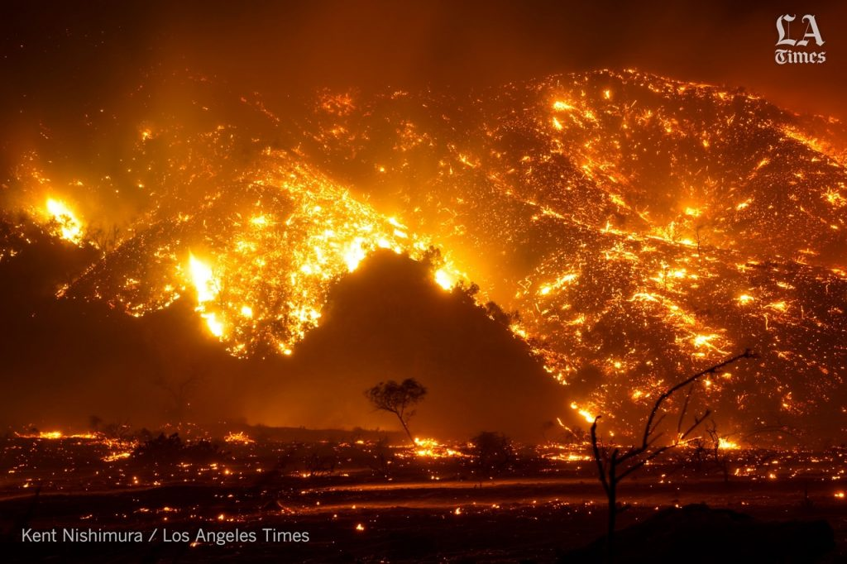
Fire explosion – Orange County, California - December 4, 2020
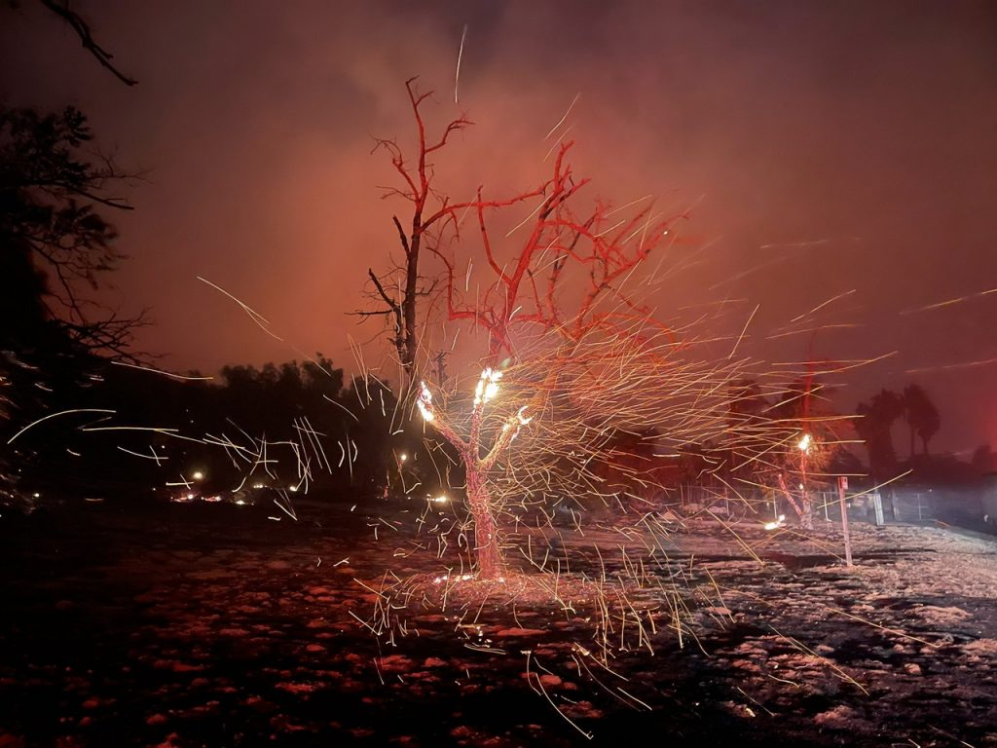
The time of the dry tree has arrived!
[Pictures from L.A. Times and Twitter, posted on Strange Sounds December 4]

Luke 23:26-31: NAS: When they led Him away, they seized a man, Simon of Cyrene, coming in from the country, and placed on him the cross to carry behind Jesus. 27And following Him was a large crowd of the people, and of women who were mourning and lamenting Him. 28But Jesus turning to them said, `Daughters of Jerusalem, stop weeping for Me, but weep for yourselves and for your children. 29 For behold, the days are coming when they will say, ‘Blessed are the barren, and the wombs that never bore, and the breasts that never nursed.’ 30Then they will begin TO SAY TO THE MOUNTAINS, ‘FALL ON US,’ AND TO THE HILLS, ‘COVER US.’ 31For if they do these things when the tree is green, what will happen when it is dry?’”
Yahushua warned us of the time of the “dry tree” on His way to His death, carrying the pole on which He would be nailed. It was actually His last message to people before His death. What was His final warning to us who are alive in the “third day?”

Isaiah 66:15-16: “For look, יהוה comes with fire and with His chariots, like a whirlwind, to render His displeasure with burning, and His rebuke with flames of fire. 16 For by fire and by His sword יהוה shall judge all flesh, and the slain of יהוה shall be many.”
Malachi 4:1: "Surely the day is coming; it will burn like a furnace ... it is burning like an oven; all the men of pride and all who do evil will be dry stems of grass: and in the day which is coming they will be burned ...”
Zephaniah 2:2-3: “The day shall pass on like chaff – before the burning wrath of יהוה comes upon you, before the day of wrath of יהוה comes upon you! 3Seek יהוה, all you meek ones of the earth, who have done His right-ruling. Seek righteousness, seek meekness, if so be that you are hidden in the day of wrath of יהוה.”
The term “the day” is “the day of Yahuwah” the day of His wrath, the day Messiah returns with His wrath. It is 24-hour day, from it comes into “earth-time.” Before it is His judgment. I Thessalonians 5:10 says that the children of Yahuwah by faith in Yahushua Messiah are “not appointed unto wrath, but to obtain salvation.” The wrath is only for the wicked, but judgment is for all to separate out His true children from the religious fakes.
Hebrews 12:29: “Our God is a consuming fire.”
Read Jeremiah 5! Jeremiah 5:7-14: “`Why should I pardon you for this? Your children have forsaken Me and sworn by those that are not mighty ones. When I had filled them up, they then committed adultery and they thronged to the house of a whore. They were like well-fed horses, every one neighed after his neighbour’s wife. Would I not punish them for this?’ declares יהוה. `And would I not revenge Myself on such a nation as this? 10 Go up on her walls and destroy, but do not make a complete end. Take away her branches, for they do not belong to יהוה.11 For the house of Yisra’ĕl and the house of Yehuḏah have utterly betrayed Me,’ declares יהוה. 12 They have been untrue to יהוה, and said, `It is not He. No evil comes upon us, nor do we see sword or scarcity of food.’ 13And the prophets have become wind, and the Word is not in them. Thus shall be done to them: 14Therefore thus said יהוה Elohim of hosts, `Because you speak this word, see, I am making My words in your mouth fire, and this people wood, and it shall devour them.’
Jump 2,500 years forward to the final link to Nimrod’s Babel:
Revelation 11 and the two witnesses and the remnant - “The Eliyahu Company”: “And I shall give unto my two witnesses, and they shall prophesy one thousand two hundred and sixty days, clad in sackcloth.” 4These are the two olive trees and the two lampstands that are standing before the Elohim of the earth. 5And if anyone wishes to harm them, fire comes out from their mouth and consumes their enemies. And if anyone wishes to harm them, he has to be killed in that way.6These possess authority to shut the heaven, so that no rain falls in the days of their prophecy. And they possess authority over waters to turn them to blood, and to smite the earth with all plagues, as often as they wish.
The first Judgment was by Flood, the final judgment will be by fire.
II Peter 3:10-14: “…the day of יהוה shall come as a thief in the night, in which the heavens shall pass away with a great noise, and the elements shall melt with intense heat, and the earth and the works that are in it shall be burned up.
11Seeing all these are to be destroyed in this way, what kind of people ought you to be in set-apart behavior and reverence…?”
II Peter 3:12 “…looking for and hastening the coming of the day of Elohim, through which the heavens shall be destroyed, being set on fire, and the elements melt with intense heat! 13But according to His promise we wait for a renewed heaven and a renewed earth in which righteousness dwells. 14So then, beloved ones, looking forward to this, do your utmost to be found by Him in peace, spotless and blameless, …”
Seeing that all will be destroyed, what should be our mind-set now as we enter the time of fire - the time of spiritual drought, the time of the “dry tree?”
From Strange Sounds: “About 25,000 residents across Silverado Canyon, Modjeska Canyon, Williams Canyon, Black Star and Baker canyons and portions of Portola Hills and Foothill Ranch live in a mandatory evacuation order.”
Strange Sounds has an article posted December 5th about the explosion of fire and the evacuation of thousands. The pictures above are from that article.
I grew up in Orange County California. I did not know I lived on the San Andreas fault line, which is now splitting and magma underneath is moving towards the Pacific Ocean. I lived in Long Beach after getting married. I knew that Long Beach was sinking a couple of inches a year into the ocean, and that the whole Southern California coast was a big shelf with noting underneath – that ran clear up to San Bernardino. In the 70s, Abba gave me a dream about it, and told me to leave California. We packed up and moved to North Carolina. Many are now fleeing from California to the East. I am so glad that we left when we did.
Now, that shelf is in great danger of breaking off and taking all with it west of Interstate 5 into the ocean. Just north of it is the Cascadia Subduction Zone with its 11 volcanoes that are becoming active. This Zone runs through Oregon and Washington and into Vancouver, British Columbia.
The bottom line is that when the split begins from northern Mexico through San Diego and north, it won’t stop – the whole West Coast will break off into the sea. Seismologists are very concerned, this event is “long over-due.” In fact, there is a purposed news “gag order” regarding the danger of this happening.
Colossians 1:12-17: “…giving thanks to the Father who has made us fit to share in the inheritance of the set-apart ones in the light, 13who has delivered us from the authority of darkness and transferred us into the reign of His Beloved Son, 14in whom we have redemption through His blood, the forgiveness of sins, 15who is the likeness of the invisible Elohim, the first-born of all creation. 16Because in Him were created all that are in the heavens and that are on earth, visible and invisible, whether thrones or rule, or principalities, or authorities – all have been created by Him.”
Yahushua Messiah, our Beloved Savior, spoke creation into existence, and by His authority He holds all of its atoms in place so that everything appears to continue on its own. However, it does not continue of its own. He holds creation together until II Peter 3. Then He speaks a new heaven and a new earth into existence. He held the nails in his wrists and feet. He holds your hand (Isaiah 41:10-13) if you are truly born again. How appreciative of Him are you. Very few appreciate Him the way He is to be honored and is honored in heaven.
Refer to the article “Revelation 5…”/Heart of Elohim. That tells of a mind-blowing revelation! Just as He holds all together, He has the right to let it all go! When He lets go – that’s it for America. Yahuwah spoke of shaking the entire earth out of its orbit. (Isaiah 24; Haggai 2:1-2; Hebrews 12:25-29).
At His coming the mountains will fall down. Seismologists are very concerned about the new fault lines that are forming and the moving of the magma deep within the earth towards the Pacific in California, but also the concern is great for the East Coast from Maine to Florida, and the Center of America with its New Madrid Fault Zone, which is cracking as far down as 9,000+ feet.
We’re in the time of dry tree and judgment by fire – this time it will be by attacks of nuclear fire. The gas reserve that covers under the U.S., southern Canada, and northern Mexico will be ignited. As it says in Revelation 18, New York will be burned and destroyed in one hour. As in Jeremiah 50-51, America as a whole will be destroyed in one day. Now with the new supersonic technology of China and Russia, and Iran, too, America can easily be taken down in 1 hour.
For whatever reason the research group/think tank for the Elite, Deagle, is saying that by 2025 America will be down to 100 million, is unknown. Yet, something is planned to actually get America down to zero, as Isaiah 10, 13, Jeremiah 50-51, and Revelation 18 tell us. Right now, America has about near 350,000 citizens. That’s 250 million Americans gone.
Trusting in man, obeying man, while forsaking trusting and obeying Yahuwah and Yahushua, a nation is under a curse.
Jeremiah 17:5-8: “Thus said יהוה, “Cursed is the man who trusts in man and makes flesh his arm, and whose heart turns away from יהוה. 6 For he shall be like a shrub in the desert, and not see when good comes, and shall inhabit the parched places in the wilderness, a salt land that is not inhabited. 7 Blessed is the man who trusts in יהוה, and whose trust is יהוה. 8 For he shall be like a tree planted by the waters, which spreads out its roots by the river, and does not see when heat comes. And his leaf shall be green, and in the year of drought he is not anxious, nor does he cease from yielding fruit.”
Psalm 1:1-3: “Blessed is the man who will not walk in the counsel of the wicked, and shall not stand in the path of sinners, and shall not sit in the seat of scoffers, but his delight is in the Torah of יהוה, and he meditates in His Torah day and night. 3For he shall be as a tree planted by the rivers of water, that yields its fruit in its season, and whose leaf does not wither. And, whatever he does prospers.”
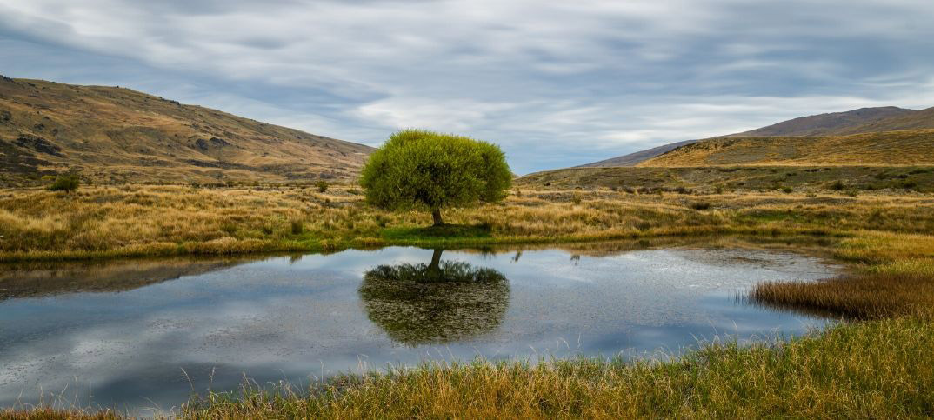

You have a choice. You don’t have to wither up, dry up, and be burned up. If you are trusting Yahushua for your salvation and eternal life, and you are trusting the Spirit of Yahuwah to sustain you, teach you, direct you, transform you, convict you, and “lead you in the way everlasting,” then when everything is dried up around you, you will still be flourishing!
Yes, in the time of the “dry tree,” water will be scarce. Water is symbolic of the Spirit of Yahuwah. Today, few have any interest in being filled with Yahuwah’s Spirit. Few have any desire to let Him teach them, for they have their adored and idolized human teachers. Most do not believe in His gifts or His miracles. They do not want to submit to Him to control their lives. They do not want Messiah as Master. Most do not want Messiah to return. Yet, they think they have a mansion in heaven somewhere waiting for them. However, what they do not comprehend is that there is no separate “Holy Spirit” dove-thing flying around. The Spirit if Yahuwah Himself, who is Himself spirit. So, in rejecting THE Spirit, they are rejecting Yahuwah.
Messiah said to do that was blasphemy and would not be forgiven in this life or the next. Yahuwah is no “dove.” He descended onto Messiah “like a dove,” which means swiftly. That “dove-thing” goes back to Semaramis, to Nimrod, and baby Tammuz … the fake trinity of the dark kingdom. She was supposedly impregnated by her dead exalted sun-god husband, Nimrod, by the rays of the sun, which came into her by the working of a white dove. For there to be a counterfeit, there has to be a genuine. The fallen ones knew the plan of Yahuwah and Yahushua for our salvation before the foundation of the world, before they fell in rebellion - so they twisted it and defiled it to come out like that – horrible!
John 7:37-39: “And on the last day, the great day of the festival, יהושע stood and cried out, saying, `If anyone thirsts, let him come to Me, and let him who believes in Me drink. 38 As the Scripture said, out of His innermost shall flow rivers of living water.’ 39And this He said concerning the Spirit, which those believing in Him were about to receive, for the Set-apart Spirit was not yet given, because יהושע was not yet glorified.”
Let’s talk at the world’s largest Aquifer, which is in the U.S. I’ve written and reported a lot on world famine. It has been planned and worked on since at least 2004, probably back to 1945 as I wrote in “America’s 70 Years of Geoengineering…”/Mikvah of Present Reality.
Using technology to do “weather warfare” is now as common as water, not just for the U.S. but Russia, China, and other countries with that capability.
The first target is the earth’s food supply. Yes, famine is upon us worldwide. However, the thing that kills faster than starvation is dehydration. The body can’t go beyond 3 days without water. Our body is 70% water. So, in order to reach the depopulation goal of the Elite of 500,000,000 total humans, dehydration works fast.
The word went out to prepare with food and water at least 40 years ago. People pick up a 36-pack of bottled water and think that’s enough. They have no idea of what will happen when the grid goes down. I encourage you to watch the movie “Amerigeddon.”
In an EMP attack all electricity will be gone – gone, gone, gone. Imagine that and you’ll see the depths of shock. In a nuclear attack, or power outage that goes on, or weather that takes out the power, or in a lockdown situation with no power, what do you do about water?
The underground water tables are becoming polluted, and many are falling apart. World-over people are dying from dehydration. Wells are becoming filled in with rock and soil – the underground is moving. Rivers are dying up. The sun’s heat will cause drought as it gets hotter during this time of its assault. How much water do you have stored?
The big holding tanks for hundreds of gallons of water are being bought up – the price for them is also going up. What about your freeze-dried food supply? What about something to cook on that is not electric? What about your 4 gal. trash liners or grocery-store sacks. Huh … what’s that for? Think people. If the electricity goes off, so does you water supply! How are you going to handle need for a toilet?
What about heat in winter? What about lockdowns and no ability to buy or sell, to go to the Post Office, the bank, the grocery store, or to work, or travel at all by any means? The flippant attitude of the lollypop crowd is “God will take care of us.” He will take of those that obeyed His pleas to prepare. He’s not our servant, or our caterer either. All this time to get to know Him, and hardly anyone is even trying.
Jeremiah 50:38: “A drought on her waters! They will dry up. For it ...
... will diminish their water supply, and it will dry up ... is a land of idols, statues
that will go crazy ... land of graven images, and in idols they do boast themselves” ...
This scripture is part of the context of end-time Babylon – America – land of Nimrod, land appointed to restore what Nimrod tried to do to rule the world. Make sure you’ve read “America’s Secret Destiny”/Mikvah of Preparation

Let’s talk about America’s #1 important Aquifer – in the farm-belt center of our nation. Why is it failing? Is it being helped to fail?
From Steve Quayle’s Q-Files of November 30th. You can get the information from duwaterlawreview.com “Crisis on the High Plains: The Loss of America’s Largest Aquifer” May 17, 2018.
“Farmers are depleting the Ogallala Aquifer BECAUSE THE GOVERNMENT PAYS THEM TO DO IT.” (My emphasis)
“A slow-moving crisis threatens the U.S. Central Plains, which grow a quarter of the nation’s crops. Underground, the regions lifeblood – water, is disappearing, placing one of the world’s major food-producing regions at risk. The Ogallala-High Plains Aquifer is one of the world’s largest groundwater sources extending from South Dakota down through the Texas Panhandle across portions of eight states. Its water supports US 35 billion in top production each year…”
Quayle asks: “When it ruptures, what happens to all the wells above ground?” Also what will happen when the New Madrid splits the nation in two parts? These things are closer to happening than the news will ever report, if they report it at all.
Water is the most precious commodity on earth for our survival. China’s water systems are polluted. They are entrenched in western Canada and in the U.S. awaiting their attack to take over the U.S. – That is very close. It will come suddenly.
What is the purpose of all of this not-pleasant information? Like all the watchmen, I want to start a fire under the lazy behinds of Yahuwah’s people in America and around the world. However, in 2003, to my “oh NO,” He called me to America in particular. I began warning in America in 1987.
Messiah said to Yochanan/John in Revelation 3:3, in the letter to Sardis, “Wake up and strengthen that which is about to die…watch and repent. If, then, you do not wake up I will come to you as a thief and you shall not know the hour that I come upon you.”
Let’s look at: “I shall come upon you as a thief.” What is He referring to?
It was the practice of the Levites who attended the altar to keep the fire going 24/7. At night, one of the Levites would remain by the altar to make sure the fire didn’t go out. Periodically, the High Priest would come to check on the Levite in charge of night duty. If he found the priest sleeping, he would take one of the burning coals and put it in his garment, which would begin to smoke, and fire break out. The priest would jump up, take off his clothes, and run away naked.”
Revelation 16:5: “See, I am coming as a thief. Blessed is he who is staying awake and guarding his garments, lest he walk naked and they see his shame.”
It is put another way in Matthew 25:1-12. The 10 virgins were waiting for the wedding and wedding feast – the coming of the Bride and Bridegroom. Five wisely kept their lamps full of oil and burning. The foolish ones were lazy and let their lights go out. They begged the wise ones to share their oil, but the wise ones wouldn’t do it. That is wisdom. Here is the division, those guests who are prepared for the coming of Bridegroom and those who are not. The prepared ones cannot give what they have earned by discipline and obedience. To the foolish Yahushua said: “Truly I say to you `I do not know you.’”
The call to prepare food and water began decades ago. The call to prepare spiritually began nearly 2,000 years ago. It is obvious that famine is created, that water destruction worldwide is created. The nation is weak in body, soul (mind, emotions, will) and spiritually – then the nuclear attack from the off-shore submarines that I wrote about in “
will strike. For those that let their lights go out, He will remove the lampstand (Revelation 2:4-5) Is this a “salvation issue?” Yes, it certain is!
We’re in the time of the dry tree. Those whose lives have been planted by the water of the Word will stay green in drought-time. Please read the article “Green Leaf in Drought Time” for edification, exhortation, and comfort.
What is full-blown in the spirit realm is becoming full-blown in the natural realm. There is a drought of hearing the Word, a famine, for few teach it, few believe it, very few live by it.
Revelation 16:15: “See, I am coming as a thief. Blessed is he who is staying awake and guarding his garments, lest he walk naked and they see his shame.”
Amos 8:11-12: “The days are coming,” declares the Master יהוה, “that I shall send a hunger in the land, not a hunger for bread, nor a thirst for water, but for hearing the Words of יהוה. And they shall wander from sea to sea, and from north to east – they shall diligently search, seeking the Word of יהוה, but they shall not find it.”
Most people today have little to no interest in the Word of Yahuwah, so Yahuwah will allow the Bibles to be taken away. Yet, it is the Word that will sustain us during the time of fire, the time of the dry tree. Memorize as much as you can.
In the time of the “green tree,” Messiah was nailed to the stake to bear our sins. In the time of the dry tree, which we’ve entered, only those planted deep in the waters of the Spirit and the Word will be a part of the coming of Messiah and the first resurrection. (Revelation 20:4-6) I also encouraging you to go forth bearing precious seed - the precious Word, the precious water of life – for we are ambassadors of the King and the Kingdom of Light. (Psalm 126:6)
Hannukah begins the night of December 10th 2020. The ultimate Antiochus Epiphanes is coming to attempt to rule the world. Yahuwah’s true children are prepared to stand for the Truth of the Word, and Deity of Messiah, to their death.
Please refer to the article: “Yahushua’s Birthday!...”/#13.0 Mikvah of Eternal Salvation! Light the first candle of Hanukkah 2020 in honor of the conception of “the Seed” that will crush the head of the serpent (Genesis 3:15).
Haggai 2: The “Seed” was conceived in the “storehouse” of Mary’s womb on day one of Hanukkah 04 BCE – the 24th of Kislev. 40 weeks later He was born, on September 11, 03 BCE, Yom Teruah. On December 25, O2 BCE, during Hanukkah, an entourage of near a thousand came from Parthia, astrologers, “wise men,” and their accompanying army, bringing several million dollars in gold, silver, and jewels – a fortune amassed by Daniel the Prophet. These “wise men” were of the House of Israel, the 10 northern tribes – looking for the “king of Judah” of the House of David to rule over them. They arrived when Yahushua was 15 months old. They followed a conjunction of Jupiter and Saturn that kept going in retrograde until it stopped over the area of Bethlehem to guide the wise men to Yahushua, and to Joseph and Miriam, both of the House of David. Make it a memorable Hanukkah!
In His love, Yedidah
December 6, 2020

