The Eclipse of the Sun and Charlottesville
Their Message to America
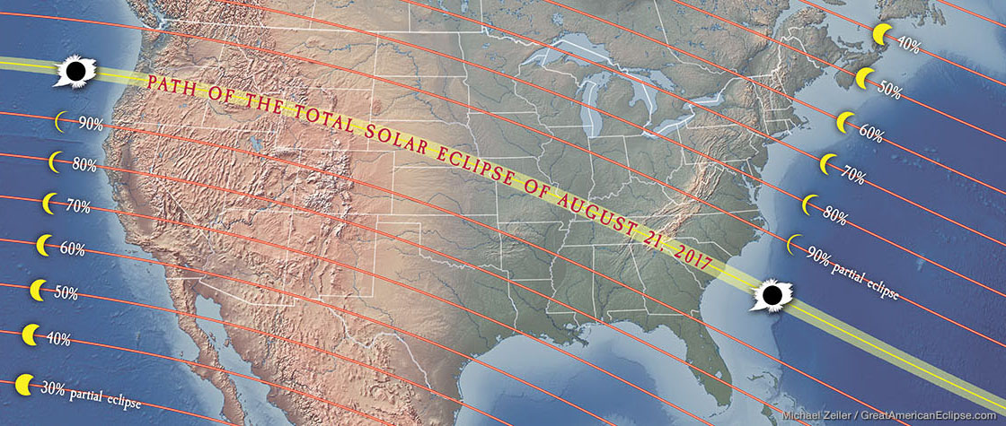
The path of the eclipse August 21, 2017

I wrote about the eclipse in “America’s 70 Years” recently, but I want to address it here along with the rioting in Charlottesville, Virginia, and tie all this together with America’s 70 years, and our time of delay. I know I’ve been writing a lot on this recently, warning of false prophets and podcasting teaching of the book of Revelation.
The book of Revelation, as it says in chapter 1, is the revealing of Yahushua Messiah. He is the Author; Yochanan/John is the scribe. Yochanan is also our example of the Bridal remnant. Revelation is a book of great joy and hope, of faith. It speaks of our great future and of the great love of Abba Yahuwah. Deceived Christians today are mocking the study Revelation because for centuries, they, and the church, have said: 1) Revelation is too Torah-related, 2) it is a book of doom and gloom, and 3) it is too cryptic to understand. Yet Revelation and Daniel shed light in the darkness, helping us to understand what is to precede the coming of Messiah. Yes, it is Torah-related – HalleluYah! But doom and gloom or cryptic – NO WAY! Not when the Spirit of Yahuwah is with us to teach us. He is the one who shows us things to come (John 16) and guides us into all truth. He is the Spirit of Yahuwah, Yahuwah Himself.
Are eclipses in the Bible? - They sure are! I want to repeat a little of what I wrote in “America’s 70 years” about this up-coming eclipse, then add a little more. Does the path of this eclipse seem strangely prophetic to you? Does it seem unusual in its slant? Does it look like someone is crossing out something on a piece paper with a broad stroke of a pen? I say “Yes” on all counts.
From the article, “America’s 70 Years”: Genesis 1:14: “And Elohim said, `Let lights come to be in the expanse of the heavens to separate the day from the night, and let them be for signs, and appointed times, and for days and years.”
August 21, 2017, America will see an eclipse of the sun from coast to coast. The NASA site says: `This will be the first total eclipse in the U.S. since 1979 and the first coast-to-coast eclipse since 1918.’
The narrow path of the eclipse is amazing--a straight line from near the top to near bottom. Those in the direct path will see the moon’s shadow totally covering the sun, so the sun will be darkened. There are Scriptures that talk about the sun

being darkened before the coming of Messiah. I know it will also be darkened by
the heavy ash filling the air from volcano eruptions, and possibly other events, but also it will be a sign in the heavens. The sun and moon are for signs, appointed times (Leviticus 23, the 7 Festivals of Yahuwah) and for days and years. The renewed moon marks each new month, the sun determines our harvest cycles and our years, the stars the timing of our Eras and Ages. They are all about our course through time, and how it relates naturally and prophetically to us.
Joel 2:30-32: `And I shall give signs in the heavens and upon the earth: blood and fire and columns of smoke, the sun is turned into darkness and the moon into blood BEFORE the coming of the great and awesome day of Yahuwah. And it shall be that everyone who calls on the name of Yahuwah shall be saved.’
An eclipse of the sun last totally crisscrossed America (1918) at a time when man began developing the technology brought to him by returned Nephilim (1896) and used it to create World War I. The 120 years allotted the Nephilim, the Spirit’s striving the them and with man, was up in April of 2016 (1896-2016). I wrote about these things in articles like: “The Amazing Messages Behind the Numbers 3, 7, 50, 70, and 120 in Scripture” and “Olympics 2016: Nephilim, the Return of Apollo, April 6th, 120-Year Timing, the End of Striving, and the Bones of Joseph Mengele.”
Jewish sages have said that the eclipse of the moon, its dark red blood color at full eclipse, sends a message to Israel of impending judgment. The moon is symbolic of Israel, thus a darkened moon symbolizes a darkened Israel. They say that the eclipse of the sun sends a message to the nations/gentiles of impending judgment, as a darkening in the spirit world over gentile nations.”
What is the symbolism in the eclipse possibly saying to us? Is Yahuwah putting a mark across the nation as in “finished?” - Perhaps not immediately, but soon. If He is right-handed, He’d draw his line across from top left to bottom right.
“For the time has come that judgment must begin at the house of Elohim, and if it first begin with us, what shall be the end of them who obey not the Good News of Elohim?” (I Kepha/Peter 4:17)
Kepha is not saying the House of Judah, or the House of Ephraim – but the House of Elohim. The screws have to be put to each professing “believer” to see where they stand with Him. The plumb line is being dropped.
Amos 7:8b: “See, I am setting a plumb line in the midst of My people, Israel…” Amos 4:12: “…Prepare to meet your Elohim O Israel!”
This eclipse, and the news that surrounds it, i.e. war, violence, civil war, economic collapse, death, disease, famine, and martyrdom of the set-apart ones, is a wakeup call to His people. It is a message from our loving Abba. Spiritual “darkness is covering the earth, and great darkness the people…Isaiah 60:1-2. Yet, for us, it is time to look up--our redemption draws near, our Light is coming!
The eclipse is a sign of spiritual darkness covering the people. As I wrote recently in “When the Voices of False Prophets Become the Standard of Truth,” in which I gave quotes, millions of Christians are looking to Donald Trump as their savior-god. They united by the many millions to pray him into office. Abba led me to Numbers 11 and the story of the quail in that article. That article will help you get a broader picture of this eclipse. Often Abba gives His people what they want, knowing it is their “carnal nature” talking, and yet, He has to let His people know harshly that what they asked for is NOT from Him!
Look at Jeremiah 14:13-16. It sure speaks into this “everything’s great” attitude of the false prophets, those speaking “peace and safety,” not warning the people. Speaking to the false prophets in Jeremiah 6:14, it says: “And they shall heal the breach of My people slightly saying `peace, peace’ when there is no peace.” Yahuwah goes on to say: “And I raised up watchmen over you, …but they said, `we do not listen.’” (Jeremiah 6:14, 17) Ezekiel 33:30-33 is reality now. The people hear the watchmen, the prophets, but they say “that’s nice,” and don’t do anything about it. The warning of Sha’ul in II Timothy 4:3-4 is happening now!
America is the great holding tank of the greatest number of Jews (House of Judah) outside Israel, and of the 10 tribes of Ephraim (House of Ephraim/Israel/Joseph) than any other nation on earth. Judgment on the world begins at end-time Babylon--America--and ends with end-time Babylon’s total destruction at the coming of Messiah. That’s in Isaiah, Jeremiah, and Revelation for starters. The spirit of Babylon is alive and thriving today – lust for world power.
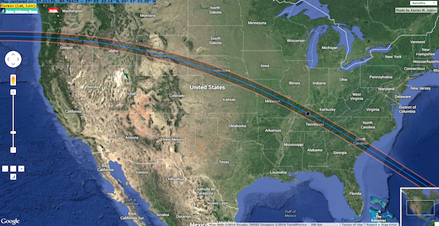
Recent maps show a broader path. So, I am near Atlanta. We’ll see a larger eclipse than first stated. I photographed a total solar eclipse over North Georgia/ Western North Carolina from the front door of our house in 1979 with a super camera and got extraordinary pictures of the eclipse as it bounced off the lens. I’m hoping my Kodak cheapo camera will get some pictures of this eclipse, if it’s not cloudy.

“August 21st Solar Eclipse Over America is Incredibly Significant” - August 13, 2017 By Rachel Baxter – Z3 News
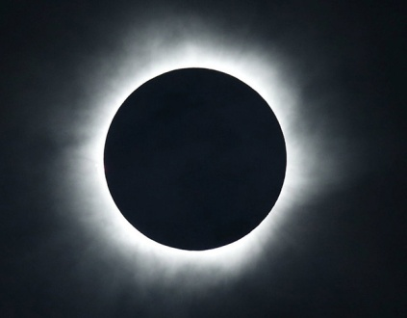
“I know without doubt that the eclipse of August 21st that cuts across America is incredibly significant. Jewish tradition holds that a total solar eclipse is a sign of judgment and a warning to the gentiles…God is calling His people to the greatest move of repentance, unseen since Moses came down the mountain with the 2nd set of tablets…The date of this eclipse is exactly 40 days before the Day of Atonement, Yom Kippur--September 30th.” [This is rabbinic dating, but it may be also by the Creator’s reckoning of time--we’ll see]
“According to the Bible, 40 is the number for waiting, preparation, testing or punishment. It is also the number to start a new chapter of the history of salvation…Rosh Chodesh Elul (tied to significance of 40 days) begins at sunset August 21st, 2017 after the total solar eclipse ends over America.” [Again this is pre-set rabbinic dating, but it could be that the new moon will be sighted over Jerusalem on this night]
“Rosh Hashana or the Feast of Trumpets begins of Sept. 20 (also the start of the ten days of awe or days of repentance, prior to Yom Kippur) and ends the evening of September 22nd, which is Shabbat (the start of the Sabbath or day of rest)…”
Interesting…I just wrote on this scenario of the golden calf in “Moses Has Been Gone Too Long on the Mountain.” She continues: “The Significance of Rosh Chodesh Elul: According to Jewish tradition, the month of Elul is the time that Moses spent on Mount Sinai preparing the second set of tablets after the golden calf incident (Exodus 32; 34:27-28). He ascended on Rosh Chodesh Elul and descended on the 10th of Tishri, at the end of Yom Kippur, when repentance was complete. Elul marked the beginning of a period of 40 days that Moses prayed for God to forgive the people for worshipping the golden calf. Moses was with God for two periods of forty days and forty nights each. The first period was recorded in Exodus 24:18 through Exodus 31:18. At the end of which, God gave Moses the first set of tablets, wherein contained the Ten Commandments written by the finger of God (Exodus 31:18). But the first set was destroyed at the foot of Mount Sinai when Moses cast them down upon seeing the people worshipping the golden calf (Exodus 32:19) that they had created, and committing the sins centered around the idol… After the golden calf was destroyed, Moses went up Mount Sinai on Rosh Chodesh Elul…and prayed to God for a second period of forty days and forty nights (Exodus 34) so that God would spare His people and return His full Presence to be among them.”
While I don’t put any stock in Jewish traditions or myths, as Sha’ul warned us in Titus 1:14, the 40 day period of time is very significant. We must keep our eyes on the sighting of the moon from Jerusalem to determine Elul 1 and Tishre 1. It could very well be that His calendar will align with the rabbis this year. I would really like that! Yet, we mustn’t put stock in anything that is not first announced by Yahuwah to ALL OF HIS PROPHETS, HIS SERVANTS. (Amos 3:7)
In a few days I will be sending out the article “The Birthday of Yahushua – September 11, 03 BCE.” This article contains scientific proof of this date. Astronomers show how this sign over Bethlehem with Jupiter could only occur in a 90 minute window on this date. This is exciting!
We must keep our ear to the chest of Messiah like Yochanan did in John 13:21-26, in order to hear what He says, hear His heartbeat, and learn what He’s thinking. Never jump on religious bandwagons. They always end up in the mud.

“Soros Dips Into the Nazi Playbook at Charlottesville”
Dave Hodges – The Common Sense Show – August 14, 2017
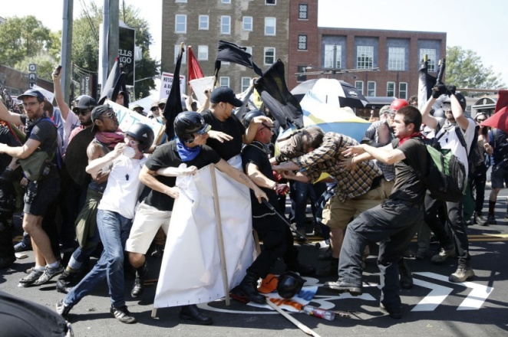
Photo by AP/REX/Shutterstock
“…A public gathering of two opposing forces turned into a violent brawl between the two groups. Beer glasses, chairs, tables, fists and clubs flew through the air, and severely injured people who were left lying covered with blood on the floor/ground. There were fatalities. No I am not talking about the deadly riots in Charlottesville, this happened in pre-Nazi Germany and the conflict between the two opposing forces, the Communists and the Nazis, set the stage for totalitarian government in Germany. The riot in Berlin was planned and executed by the late 1920’s version of George Soros, Joseph Goebbels, and Goebbels wanted Hitler’s party to show its colors in Berlin, which he described as “the reddest city in Europe besides Moscow.” Yes, this is a repeat … using Nazi techniques to manipulate the people into submission to the government’s will. It is amazing since Operation Paperclip how close America has worked with Nazis in science, medicine, space exploration, and mind programming.
“Planned Chaos in Virginia: Why Did Law Enforcement Stand Down Until Events Spiraled Out Of Control?” All News Pipeline – Susan Duclos – August 13, 2017
“EVERYTHING WAS PLANNED IN ADVANCE! The fact that the Governor issued that statement before the planned White Supremacist `Unite The Right’ rally even began, tell us a number of things, such as the event was planned, permits were obtained and the state authorities were aware that outside groups were coming in for the specific purpose, in the governor's words, to `commit acts of violence against the rally participants.’… The governor supposedly planned for potential violence as his statement before the event also said `In the event that such violent or unlawful conduct occurs, I have instructed state public safety officials to act quickly and decisively in order to keep the public and themselves safe,’ and the `outside groups’ planned to commit violence against the rally participants.
WAS LAW ENFORCEMENT TOLD TO STAND DOWN? If law enforcement was ready, aware of all these plans, as was the governor of Virginia, how did things spiral out of control to the point where one person was killed, and 19 were injured when a car plowed through counter-protesters? Police are being criticized for the slow response to the violence that started even before the rally began, for failing to keep the rally participants and counter protesters apart… `multiple reports and witnesses say the police watched the events spiraling out of control and did nothing

until it was too late?... Another aspect we haven't seen discussed is whether any of
those outside groups were `paid actors,’ as we have noted from previous riots and protests that many supposedly grassroots activists were hired by companies to attend events. For example, a Craigslist advertisement, six days ago was looking for Actors and Photographers for Charlotte, NC, stating in the ad from Crowds on Demand, that their events "include everything from rallies to protests," showing that not all rallies, protests and counter-protests are activism driven, but many times people are paid to attend and even start trouble.”
I am well acquainted with paid protesters. This type of thing is a big CIA trick, like in Cairo, Egypt in 2011, protesting for the overthrow of Mubarak. I know for a fact from Egyptians there that the protestors were brought in--they were not Egyptians. The methodic destabilizing of the Middle East was orchestrated almost singlehandedly by Barack Obama, as I have written about in many articles exposing the “why.”
I began writing about multi-billionaire George Soros in my article “Violence is Covering the Earth.” Soros is infamous. He hires people to create chaos, even paying off police chiefs to hold back, as well as government officials paid to look the other way. Why?--Too bring about civil war in America, race riots, etc., to bring about a forced martial law, during which America will be attacked, false flag or not, and taken over from the inside, in order to bring global government to power.
The Trilateral Commission has to fall – so that globalism can arise. We have that in Daniel 7. But, there are too many nationalists in America who want peace. This demonstration supposedly started peacefully until George’s Nazi-style chaos- starters began their violence. Notice the news is pumping “white nationalists” aka “white supremists.” Race riots are being planned, too.
Before the Flood, violence covered the earth. The man who backed into the people, killing one, wounding several, was most likely one of those eyes glazed-over guys who is taken away by police, or shot. These are MK Ultra controlled people, “Manchurian Candidate” types, created by the CIA from childhood to be weaponized when needed in their evil plans. It’s the same with all those shooters in schools, malls, churches, synagogues, and in the 2016 riots in Ferguson, Missouri, Baltimore, Chicago, etc.
The goal is civil war and martial law. If that doesn’t work they’ll create a disease pandemic, scare the ignorant, and keep everyone bound to their houses in quarantine. Martial law will be declared. Do you have enough food and water stored? Are you prepared spiritually? Is your faith high--knowing your Elohim?
The “reasoning” is that the super power has to be wiped out, so that everything else they’ve planned won’t get interfered with – like world government, like the return of the Nephilim to power, Nimrod at the helm, and the world wiped out with most of its people replaced by cyborgs, hybrids, non-humans of all types, robots, and a few human slaves. That’s the goal. Read about it in the Bible.
In my article “America’s 70 Years” I repeat what I’ve been teaching from at least 2014 beginning with the article “Jeremiah 25.” It goes back to what I began teaching in 1993 about End-Time Babylon.
Doom and gloom – NO! I don’t believe it in! It’s not one of the fruit of the re-born spirit! What we’re seeing is Yahuwah letting the world’s people have what they want. I’ve lived in several third world nations, and traveled to many several times, and what the people want is to be rich like all Americans, with all the freedoms to do as they please. Whatever America touches it pollutes, corrupts, and destroys. We are the biggest funder of abortions in third world nations, as well as our own. Whenever a nation needs money, America is there to fork out millions, IF they take our package. I know this first hand. What’s our “package?” It’s our pornography industry, violent movies and music industry, our sex-slave traffic, our drug industry, gambling, prostitution, pedophile, etc. etc. “industries.” I’ve seen how it has destroyed countries. Revelation 18 tells of our trafficking “in the souls of men.” Outside America we use children to run our factories at 30 cents a day for 12 hour’s work as well as their parents. Read “America’s Secret Destiny” to learn why!
The great “light” of Lucifer, whose name means “the light bearer,” has gone forth to the nations to draw them all in unity to take from the rich and destroy them. The nations want what we have, without realizing the poison in the apple.
North Korea is the fuse, or the excuse, one of the two. They are usable. China, Russia, and Iran, are ready to back up North Korea and finish off any attacking necessary to take over America. Guam and Hawaii are in serious watch-mode.
No, this is not doom and gloom--not if you’re on the side of the real Kingdom of Light. Those who dabble in the world, still hanging onto their free ticket of hell, will be swept up in the flood of evil and darkness that is covering the earth. But, there is NO doom and gloom for those in Revelation 2:8-11 and 3:7-13, Revelation chapter 7, 11:15-18, 14:1-5, 12-13, chapter 15, and chapters 19-22! It’s all just a matter of getting to Revelation 19/Matthew 24:29-31 by overcoming. Those that live in Psalm 91:1, get the promises.
It’s all about Isaiah 35 and 60, Zechariah 14:1-5, etc. Our Abba is no sadist. He is a Father and the BEST EVER! He judges to protect His children, and once the bad guys are judged, He gathers His children into eternal joy. He has to thresh His wheat, using the “tribulum,” the Latin word from which we get “tribulation.” It’s His ultimate love for us. A tribulum is an ancient threshing instrument that rids the wheat of tares and chaff. Those that want to keep their chaff (sin), and live among tares, will not be allowed in His Kingdom. This is His time of separation. We are judged by His wrath ONLY IF we’re not His children of light, aligned to Him.
II Peter 2:4-9! II Peter 2:9: “…Yahuwah knows how to rescue the reverent ones from trial and to keep the unrighteous unto the Day of Judgment to be punished...” Yes He does!
II Thessalonians 5:10: “But, Elohim has not appointed us to wrath, but to obtain salvation/deliverance through our Master Yahushua Messiah.”
The plumb line is being dropped. Abba had me drop a physical plumb line for years before every meeting I taught in. And 99% of the time, when I dropped it, within a very short time, usually less than a day, those who out of plumb with Abba raised their cobra head. Yes, He knows how to separate.
By the way, do you know what August 15th is to Catholics? It is the Assumption of the Virgin Mary into heaven without dying, where she was crowned Queen of Heaven. That’s what they say.
Do you know what August 15th means to Israelis? It was the tragic first day of the Gaza “disengagement”--the forced military removal of nearly 9,000 people from their homes in Gaza. They had to leave their homes, their possessions, their businesses, and their lives, just to satisfy evil terrorists. Was it worth it? NO!
Can a nation turn on its own people to their harm? YES! Ever hear of Stalin, Hitler, Pol Pot, Mao Tse Tung? Don’t underestimate the evil that is in the world now.
I was very involved with it in 2004/2005. In 2004, I visited several of the communities in Gaza with a group. The communities were lovely, with schools and synagogues, and some even had million dollar houses, international businesses, selling tulips to Holland and fruit to Europe grown in their greenhouses in the Gaza strip. August 15th, 2005, I sat in horror in front the TV back in Florida, and saw via Arutz Sheva news the pull out of people from homes where I was in during Sukkot of 2004. I saw them taking out a grandmother from New York I had met. She had founded one of the main settlements. I heard her; I saw her pleading. I saw the IDF pulling her out. I was numb, but also angry at myself for not being there on site. U.S. news made it look like it was only about a few Jews living in shacks. It was a horrible thing that has affected my life to this day. A year later I visited in some of their make-shift homes. The government did almost nothing to help them. They called their houses “cartons,” because they were so flimsy. All because America, the U.N., and the E.U. put pressure on Israel to give their land to Arabs who love to kill Jews.
In the 1976 Israeli war with Egypt, General Ariel Sharon was down on the Egyptian border with his finest men. They had built a bridge into Egypt to cross at night. He got word from his High Command telling him to wait 24 hours to cross. He didn’t understand: If they crossed then they would take Egypt by surprise. The Egyptians had no idea they were there. Twenty-four hours later, the Egyptians crossed the bridge and killed a lot of his best men, best friends. Sharon was furious. High Command told him to pull back a second time. He said “no – you can court martial me.” When he got back to High Command, he demanded to know who gave the order to “pull back?” They said “Henry Kissinger,” U.S. Secretary of State. Numbing isn’t it?
In 2006, the Israeli IDF was on the border of Lebanon ready to go in. They had every advantage to win the war with Hezbollah. But, the army got word: “pull back.” They did; they lost the war. America again? The U.N.? We know from Scripture that America becomes a betrayer of Israel. This is the last nail in the coffin of America. (i.e. Jeremiah 50-51)
Keep watch; stay in prayer; keep praising no matter what things look like; keep your joy. Don’t let the enemy steal your good fruit, be a light to the lost, and prepare to meet your Master. Please, don’t put your trust in man, for Jeremiah 17:5-10 is very real. Our rewards are eternal!
In His love, in His peace,
Yedidah
August 15, 2017

