THOUGH VIOLENCE IS COVERING the EARTH NOW
SOON the ESTEEM of YAHUWAH WILL COVER the EARTH as the WATERS COVER the SEA!

II Peter 2:9-13: “Yahuwah knows how to rescue the righteous from trial and to keep the unrighteous unto the day of judgment to be punished, and most of all those walking after the flesh in filthy lust, despising authority, bold, headstrong, speaking evil of lawful dignitaries,…but these, like natural unreasoning beasts, having been born to be caught and destroyed, blaspheme that which they do not know, shall be destroyed in their destruction, receiving the wages of unrighteousness…”
Jeremiah 51:58: “Thus says Yahuwah of hosts, `The broad walls of Babel are completely demolished and her high gates are burned with fire, and people labor in vain, and the nations weary themselves for fire.’ ”
II Thessalonians 2:3-4a: “Let no one deceive you in any way because the falling away/apostasy is to come first and the man of lawlessness is to be revealed, the son of destruction, who opposes and exalts himself above all…”
What we’re seeing with the increased lawlessness worldwide is a foundation being laid for the coming of anti-messiah, the supreme man of lawlessness who will lead the world into open rebellion against Elohim.
Oh how the world is quickly becoming more and more violent, “as it was in the days of Noah,” Genesis 6! People are becoming more and more angry, and most do not know why their emotions are so unstable and their minds becoming so dull. Part of it is due to man’s manipulation of the Ionosphere, the beaming of electromagnetic pulse waves down on us, dropping DNA-changing contaminants on us from airplanes, geoengineering the weather, giving us DNA-changing food to eat, water to drink, medicines and vaccines to inject or ingest. We’re being physically dehumanized and mentally and emotionally dehumanized, and our spirit is being dulled and oppressed. All of creation is groaning, and all is in some degree of upheaval, chaos, and death. It is going to crescendo to a maximum before Yahuwah sends Yahushua Messiah with His rescue for His set-apart ones, and His judgment on the wicked. (Romans 8:16-23)
Genesis 6:11-14a: “And the earth was corrupt before Elohim, and the earth was filled with violence. And Elohim looked upon the earth and saw that it was corrupt – for all flesh had corrupted their way on the earth. And Elohim said to Noah, `the end of all flesh has come before Me for the earth is filled with violence through them. And see, I am going to destroy them from the earth. Make yourself an ark…’”
The name “Noah” means “comfort.” Noah’s purity and obedience comforted Yahuwah, and gave Him peace that the creation of man was not in vain. Abba knew the work of His Son on the stake would redeem a remnant like Noah, but still, we can bless Him by our loyalty and faithfulness to Him. We can give Him joy knowing that His love will not return to Him void, but that we will love Him with all our heart, soul, and strength. He wants a family, bound together with Him in love.
Genesis 6:8: “And Noah found favor in the eyes of Yahuwah…and Noah did according to all that Elohim commanded him, so he did.”
Noah’s ark floated on top of the waters, while the waters sucked the wicked into its depths. (Genesis 7:18-21)
Are you comforting Yahuwah and Yahushua, giving Them peace and joy, having found favor in Their eyes? Are you resting, hidden in the secret place of the Most High? While the set-apart of Yahuwah and Yahushua are becoming more set-apart the evil ones are becoming more violent and hate-filled against Yahuwah:
Revelation 16:5-11, Revelation 22:11.
Below I include 16 pictures of the New French Revolution that is spreading to other nations of the E.U.
“'This is the start of a revolution': Paris rioters steal police assault rifle, torch dozens of cars and vow to 'stay in the streets until Christmas' as fuel protests continue into the night and spread across France - and even to Holland” by Peter Allen, Tim Stickings, and Connor Boyd Mailonline and Reuters and Afp - December 2, 2018
Rioting in the streets, attacks on the police, vandalism, fire, spray painting national monuments, spray painting the riot police, viciously hurting and destroying both property and people. The pressure on people from corruption is rising and few can continue to take the abuses of governments. Yes, we understand that. But, infiltrating the peaceful demonstrators are the paid thugs, criminals, the violent that use the peaceful people as shields for their wickedness. These are harming those who have not harmed them! It is a throwback to Genesis 6.

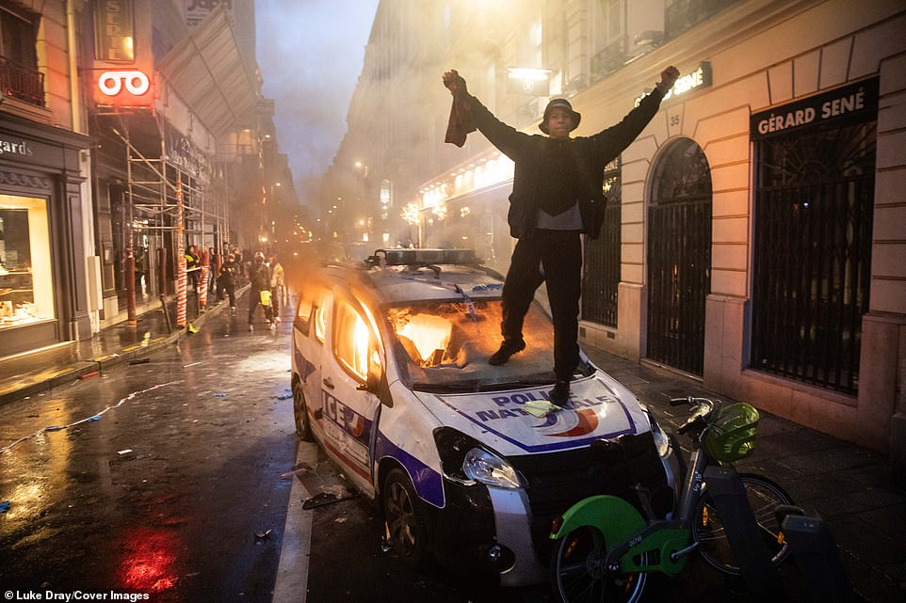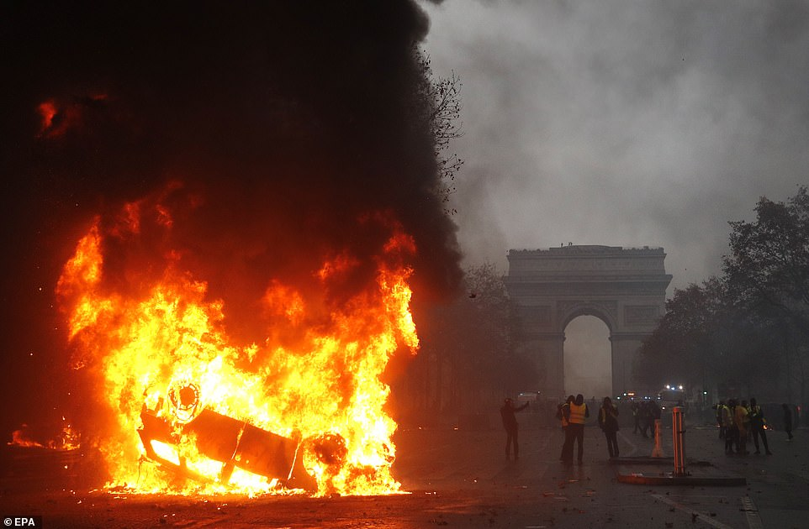
Left: A protester celebrates with his fists raised on top of a burning French police car after torching the vehicle in Paris tonight (December 1, 2018)
Right: A car completely engulfed in flames is burned in front of the Arc de Triomphe as police struggle to defuse the protests in Paris
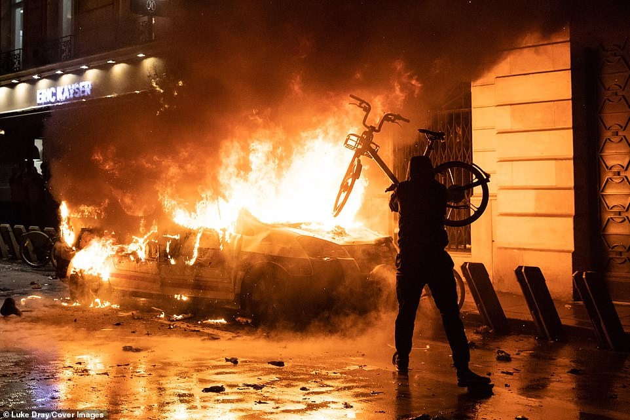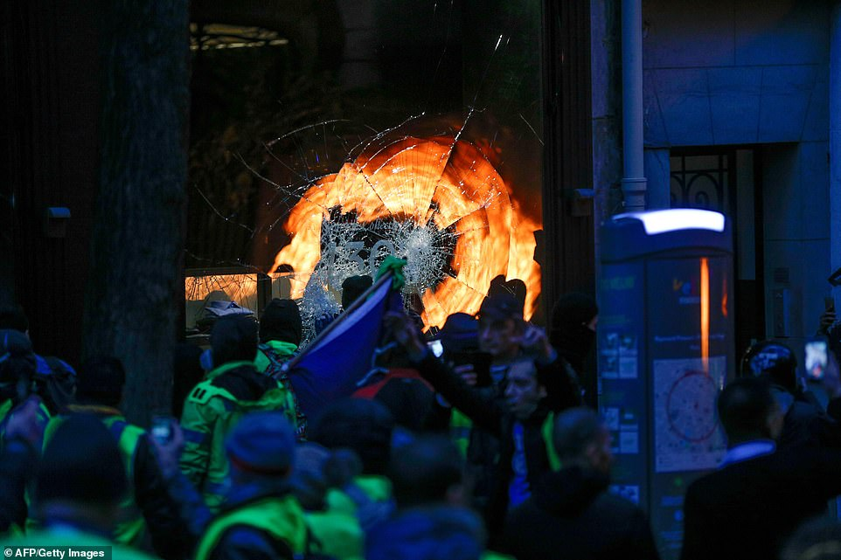
Left: A demonstrator launches a bicycle at a burning police car - which has partially melted under the heat - as night falls in the French capital
Right: A crowd of protesters smash a shop window during chaotic protests in the French capital which show no sign of slowing down as night falls in Paris
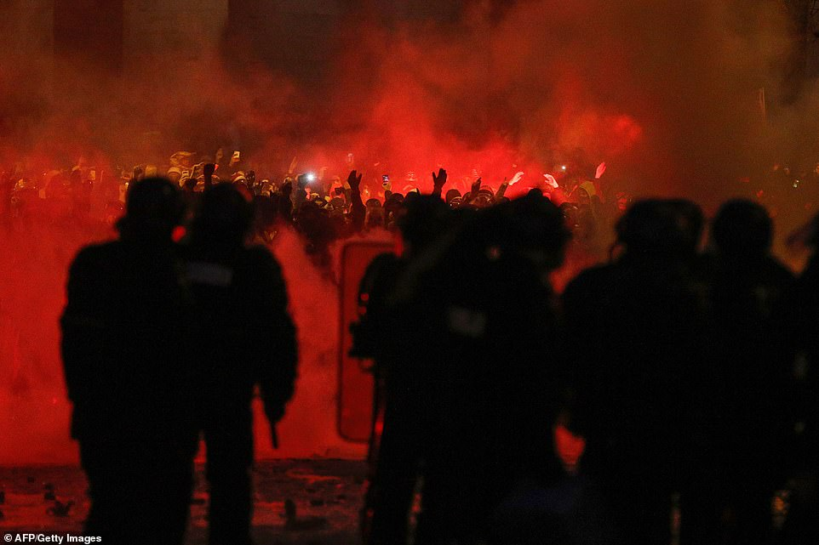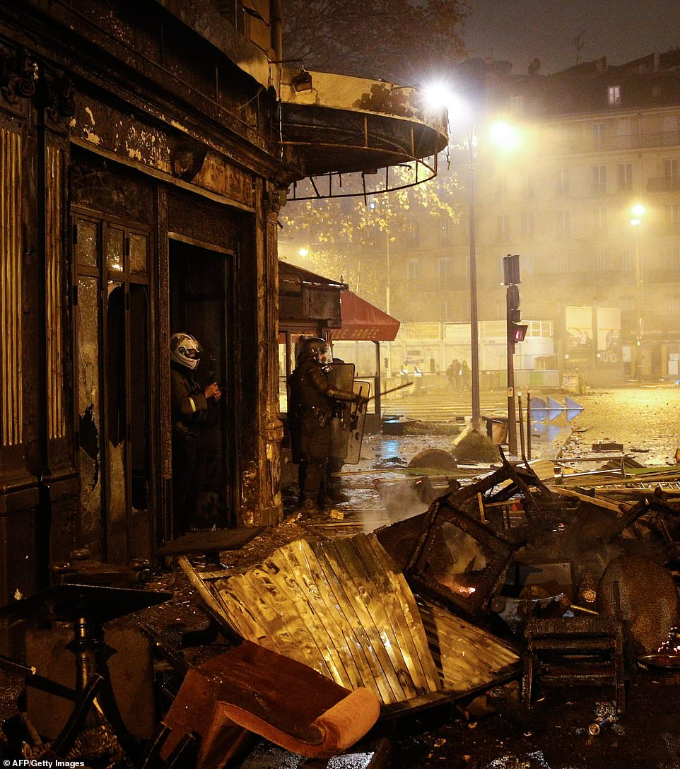
Left: Protesters let off red flares and charge at riot police in the French capita las violence continued into the night
Right: Riot police officers stand in the middle of the damage of La Belle Armee restaurant which has been ransacked and torched in Paris tonight

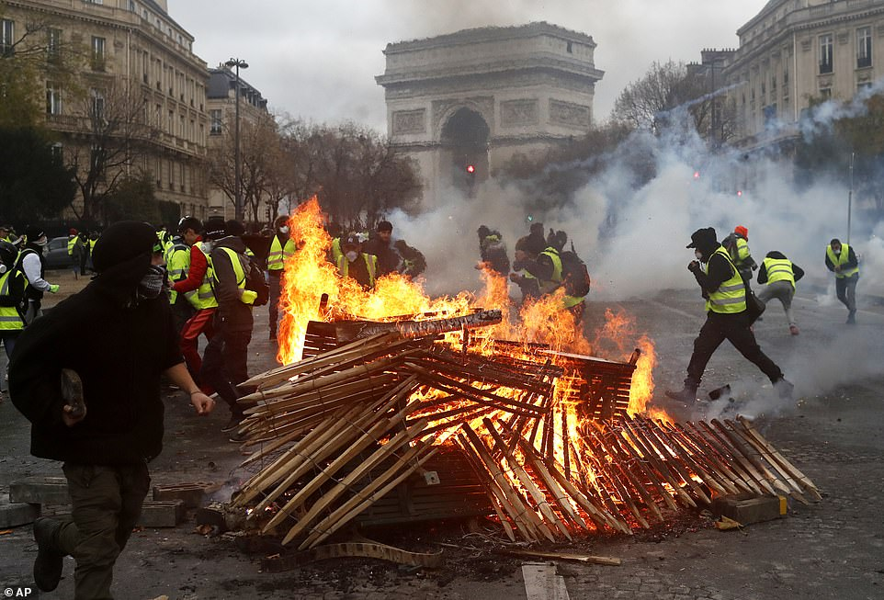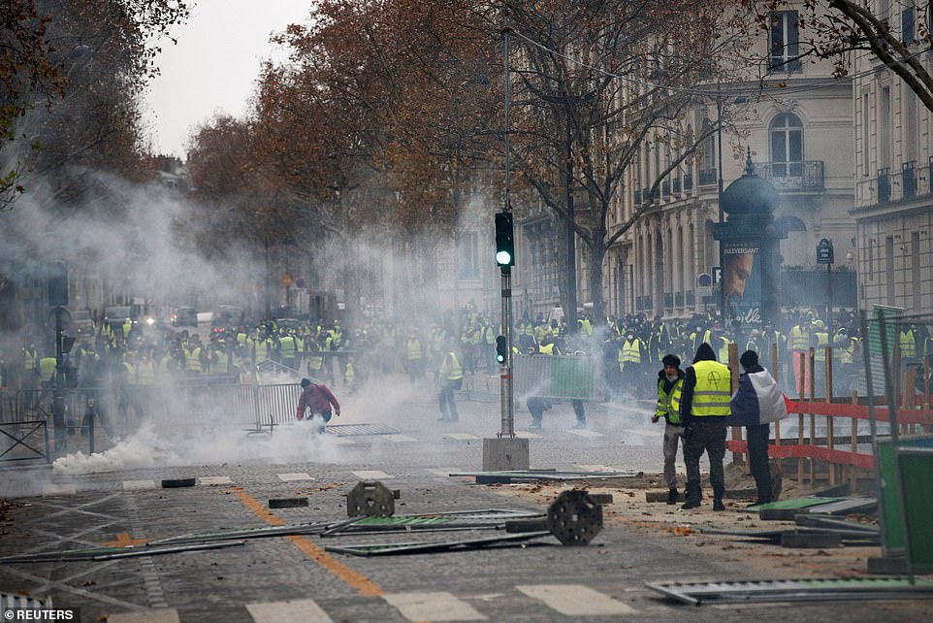
Left: Demonstrators run by a burning fire near the Arc de Triomphe during a fresh protest which has seen Yellow Vest supporters clash with riot police and more than 100 people arrested so far on Saturday
Right: Tear gas floats in the air as protesters wearing yellow vests, a symbol of a French drivers' protest against higher diesel taxes, demonstrate in Paris
“Some 5,000 police and gendarmes are being deployed today in a replica of last Saturday's chaos when Parisians smashed up shops and restaurants and battled riot squads in the first round of major protests. Trouble started as early as 10am, when a mob of Yellow Vests - who are named after the reflective jackets that all motorists have to carry in France - massed around the Arc de Triomphe.
Protesters blocked roads in Biarritz and Antibes further south and even in the Hague, in the Netherlands, yellow-jacketed demonstrators were spotted gathering outside government buildings. An estimated 75,000 demonstrators were counted across the country as of 3pm.
Paris Mayor Anne Hidalgo tweeted her 'indignation' and 'deep sadness,' saying that violence is 'not acceptable.' She wrote: 'I feel a deep indignation and a great sadness at the violence in the heart of Paris. They are unacceptable. Our country is facing a major crisis. It can only be resolved through dialogue. We must find this path as soon as possible.’ ”
However the number nationwide was well below the first day of protests on November 17, which attracted around 282,000 people, and also down from the 106,000 who turned out last Saturday.”
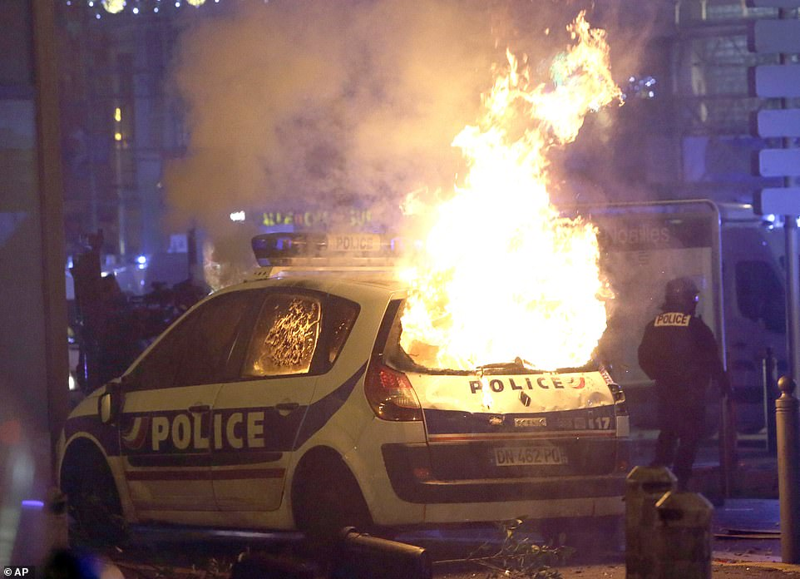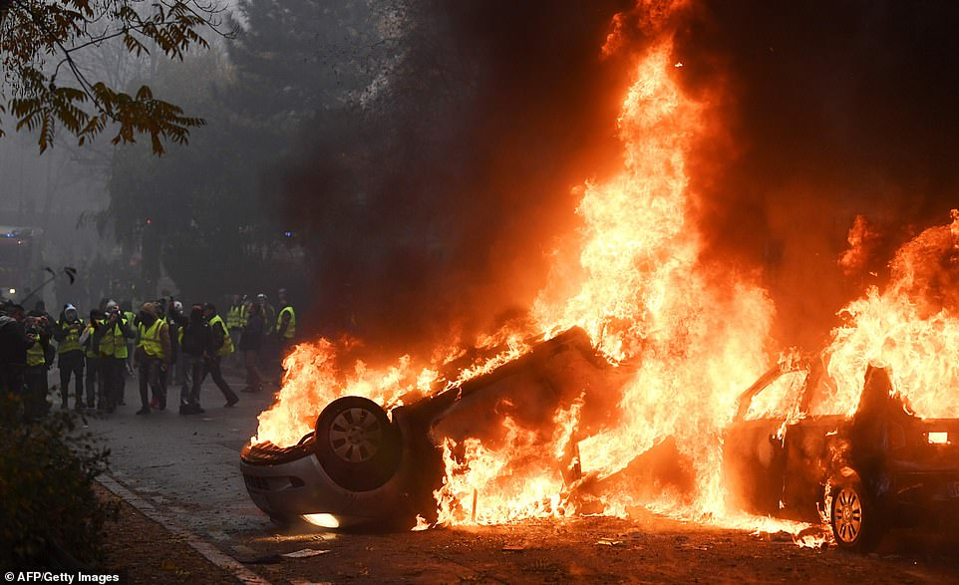
Left: A police car burns after clashes between police and protesters in Marseille as violence spread to southern France
Right: Demonstrators stand in front of a burning car during the protests which erupted again in Paris on Saturday
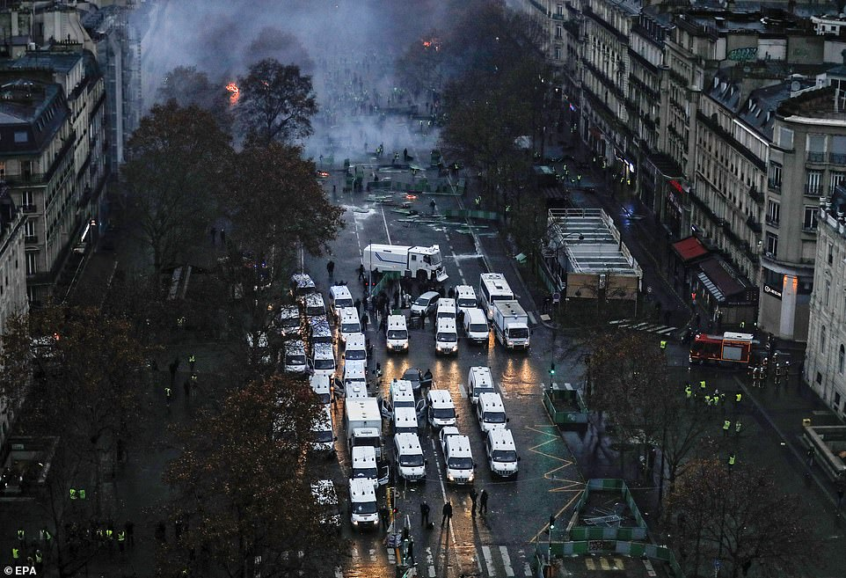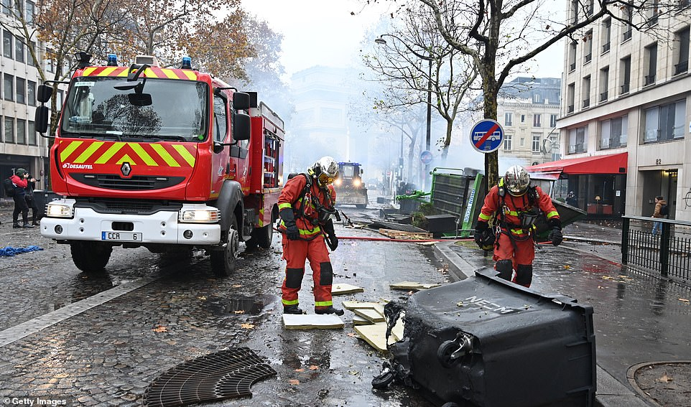
Left: An aerial shot of the chaotic scenes show dozens of police riot vans surrounding the Arc de Triomphe in the French capital
Right: Officers clean the roads with heavy duty machines in Paris after protesters gathered to protest against rising fuel taxes
Gregory Joron, of the SGP police union said: 'It is people's right to demonstrate, but extremist groups have already joined in. 'Groups intent on trouble are appearing from all directions. They include those from the extreme right and the ultra-Left.'
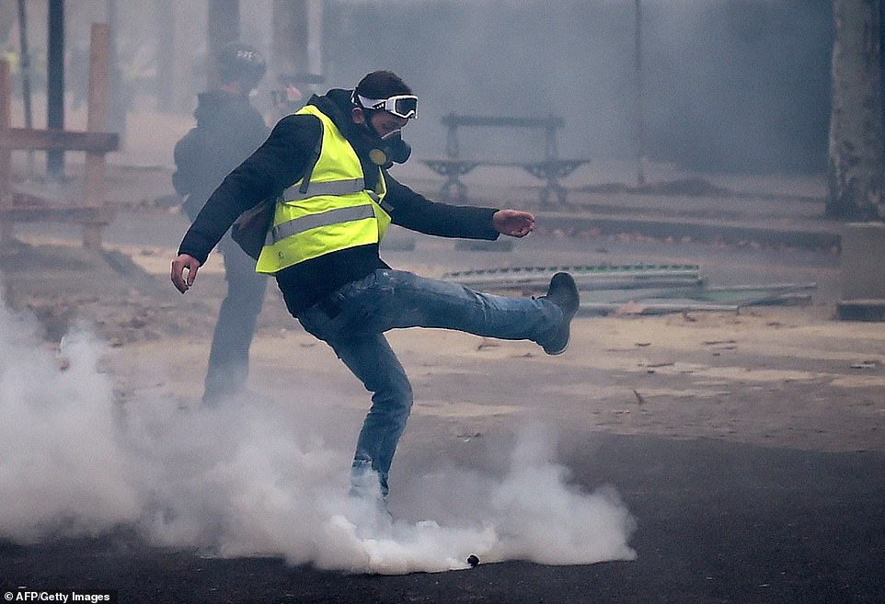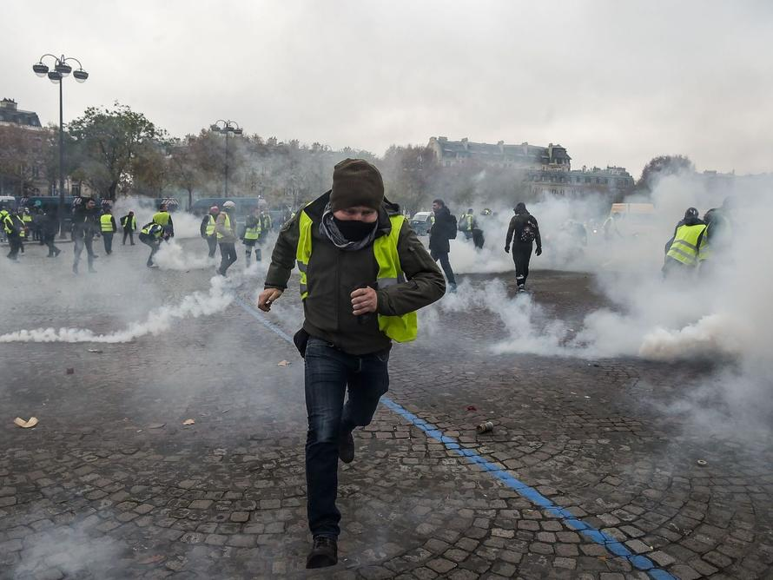
Left: A demonstrator kicks back a tear gas canister towards riot police. Some 5,000 police and gendarmes are expected to be out in force in Paris today
Right: Photo from Zero Hedge article below
The yellow jacket protests have even spread to The Hague, in the Netherlands, where people gathered outside the Dutch parliamentary building on Saturday

From: “France in Chaos; Macron Mulling State Of Emergency Amid `Yellow Vest’ Protests; `All Options’ Considered - by Tyler Durden - 12/02/2018 – Zero Hedge
“Government spokesman Benjamin Griveaux told France's Europe 1 radio that a state of emergency may be imposed to prevent `serious outbursts of violence’ after thousands of masked `Yellow Vest’ protesters fought with police, and set fires to cars, houses and banks.’ Griveaux said that around 1,000 and 1,500 protesters joined Saturday's demonstrations `only to fight with the police, to break and loot,’ and that the violent element `have nothing to do with the yellow vests’ - aside from wearing yellow vests.” I say: “Spot on!”
Important Note: This is what is happening at America’s southern border. A minority fleeing suffering in Central America were joined by paid criminals like drug cartel gang member, ISIS, and other terrorist groups from the Middle East, who were using the fleeing of the few to swell the numbers into the many thousands to storm the borders and invade the U.S. with destructive forces of evil. The women and children were added as propaganda tools to play the Globalist “compassion card,” yet women are being raped at the borders too. America is being overrun by evil, and the violence is getting worse in America, and all over the world!
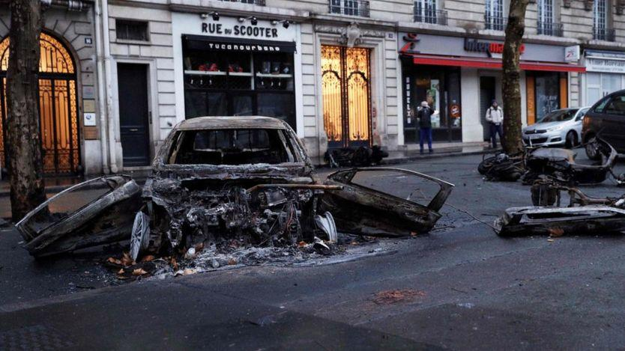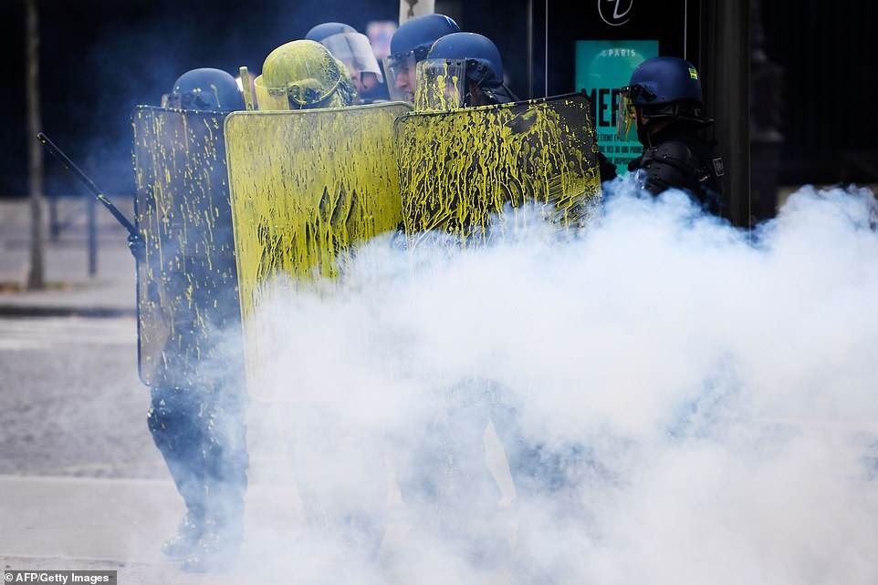
Left: “The reported size of the protest has varied between 36,000 and 75,000 yellow vests, while last week saw over 110,000 protesters at the Champs-Elysées in central Paris. Over 400 arrests were made and 113 injured in Saturday's unrest which began on November 17 over a hike in diesel prices.”
Right: Riot Police sprayed with paint during clashes with demonstrators

My notes from Paul Begley’s YouTube video on these riots: “The protesters smashed windows with clubs and axes, took a policeman’s rifle, broke glass on police cars, set them ablaze. In other words – LAWLESSNESS GONE WILD. They literally took over Paris. They even spray painted the riot police, set off red flares, and destroyed property. This protest on the gas tax hike has expanded into WEEKS OF UNREST. There is much more to this than what is being protested.”
Yes, the beginning of civil war. It has begun in America, too. It’s more than just about higher diesel prices in France. The people are being taxed to the breaking point, and the migrant Muslims are destroying their country as their violence is extreme. The yellow vests are protesting Macron’s presidency, too.
What would happen if Globalist-Leftists in America, and their financed groups like Antifa, Black Lives Matter, and other of George Soros’-paid thugs, took to the streets with gangs, drug cartels, and terrorist groups among them? Hey, folks, that’s already happened during the last two to three years! But, as the intensity rises, it will explode into a nation-wide violence in America, too.
I urge you to read Russ Dizdar’s The Black Awakening. Violence has been planned, and it’s ready to begin in America full force. Good people will protest, but among them will be the evil ones! Sincere protestors are being joined by radical and violent elements, paid demonstrators--not just in the E.U., but in America, and in many other nations.
Paul Begley made a good point: He said that the people of France are sick and tired of the escalations in all types of taxes, and the government allowing the takeover by migrants. The people are being taxed to pay for the immigrants.
I can imagine the anger in the German people, Swedish people, British people, etc. because of the violence of Muslims allowed by their governments who are not being brought to justice, while those who oppose them are being persecuted.
This sounds similar to what is happening in America. America is on the verge of Civil War. The American people are being pushed too hard, too. Like Begley said, these factors “broke the camel’s back” in France. Yes, some of the good people also acted wrongly in their protests and demonstrations, they became lawless, but people who are carnal in nature either protest in anger, acting out their bitterness, or they meekly give into the wrong like most Americans so far, and then hate themselves for condoning it.

From the Activist Post, December 4th: “Riot Police Remove Helmets, Join in Solidarity with Citizens Protesting Corrupt Government”
“Over the weekend, roughly 100,000 citizens took to the streets of Paris. Most of these protesters were peaceful, however, some of extremists from the far left and far right engaged in violence against police, smashed out windows, and set fire to cars. Of those arrested for violence, the majority of them were “professional” rioters who had come from outside Paris to infiltrate the peaceful demonstrations, according to Paris prosecutors. Despite this violence, many of the police officers in France understood the anger coming from the citizens. Instead of clashing with the peaceful protesters, many of the officers were seen joining them in solidarity. In at least two different cases, police were seen on video removing their helmets to show the people that they were on their side.”
This is what is happening with the caravans coming to the U.S. southern border. There are the few who are not violent, who just want a chance to change things for the better in their lives. But, infiltrating the sincere who do not act violently, are masses of hired deviates, paid for by evil Elite rulers to create the chaos to bring a new world order. America has to fall. All sovereign nations have to fall, in order for a one world government to arise. All nations must be without borders!
The violent are using the good intentions of righteous people to hide behind, to make themselves look good, while they pull off their evil and the righteous ones take the blame for it! I know this pattern well! I’ve been caught up in it! They must have a mask to hide behind so that they look good to the world’s ignorant masses, but inwardly they are agents of Satan. Learn all you can about this pattern so that you are not deceived and join the wrong side! II Corinthians 11:12-15.
Please read the article “Hitler’s Secret Plan for World Conquest Exposed – It is Unfold Before Our Eyes in Western Europe, the U.K., and America”/Mikvah of Present Reality, to understand the truth behind the world migrant phenomenon. This article will help you see that decent migrants fleeing from Syria were used to shield terrorists who came behind them.
We live in an upside down world where truth and righteousness are thrown into the streets, and trampled underfoot, and where lies and wickedness are exalted as being good. Isaiah 5:20: “Woe to those who call evil good and good evil…”
In conclusion let’s look at what follows the chaos, the new world order, the violence like it was in Genesis 6, and take heart, press into the love of our Elohim, Father’s love, the love of a Bridegroom!
Habakkuk 2:13-14: “See, it is not from Yahuwah of Hosts that people labor only for fire, and nations weary themselves for nothing, for the earth shall be filled with the knowledge of the glory of Yahuwah as the waters cover the sea!”
Oh how we long for the earth to be filled with His esteem, for Yahushua to rule as High Priest and King, for peace to reign! As we watch the earth moving into its last stages before anti-messiah comes, we look beyond to the return of our Beloved Yahushua, our Savior, our Redeemer, the precious Son of Abba Yahuwah who loves us so much that He died for us, taking our sin-punishment for us! Praise His Name! He was raised from the dead, and “ever-lives to make intercession for us” as our High Priest! We cannot praise Him enough! “Worthy is the Lamb that was slain…”
Micah 4:1-3: “And in the latter days it shall be that the mountain of the House of Yahuwah is establish n the top of the mountains and shall be exalted above the hills, and people shall flow to it. And many nations shall come and say `Come let us go up to the mountain of Yahuwah to the House of the Elohim of Y’cob and let Him teach us His ways and let us walk in His paths. For out of Zion comes forth the Torah and Word of Yahuwah from Yerushalayim. And He shall judge among many people and reprove strong nations afar off. They shall beat their swords into ploughshares and their spears into pruning hooks – nation shall not lift up sword against nation, neither teach battle anymore. But each one shall sit under his vine and under his fig tree with no one to make him afraid, for the mouth of Yahuwah of Hosts has spoken.”
HAPPY HANUKKAH! Antiochus Epiphanies was defeated, and the temple re-dedicated for righteousness. Let us rejoice that Satan is a defeated foe, and soon his judgment will be executed. Rejoice in Abba’s goodness! Press in to know the coming King! Submit to Him without reservation. Obey Him as Master. He loves you! Receive His love; remain in His peace!
In His love, peace, and joy,
Yedidah
December 4, 2018

