URGENCY! THE MESSAGE OF THE HUGE APRIL 8 2024 X ECLIPSE
The word “urgency” is being used as the true watchmen are feeling it, pressing forward to share it with others, knowing that it might cause their death or imprisonment. Laws have been made against truth-tellers, especially if that truth exposes their plans for Lucifer’s world government which is being set in order very quickly. I am feeling the “urgency” strongly also.
NATO is working hard using America’s chief war planes for now-being-trained Ukrainian pilots to fly to bomb Russia. Talk about hard provoking – Russia won’t stand by and allow this to happen.
As former Russian President Dmitri Medvedev said to bottom line, “Deputy Chairman of the Russian Federation Council, Dmitry Medvedev, said today that Kiev, London, Washington, Berlin and other places will be hit by Russian nuclear bombs before Russia would ever allow return of the territories it now possesses. In Medvedev's posting on Telegram Social Media, he wondered what would happen if Russia lost the war against "neo-Nazis along with their Western sponsors" and returned to its 1991 borders. He speaks to this outcome as "the irreversible collapse of present-day Russia, which under the Constitution includes new territories." Medvedev believes that after that, a "civil war with tens of millions of victims" and "the death of the future of Russia" will begin.
Quote: "And now for the main question: do these idiots truly believe that the Russian people will simply swallow such a consequential partitioning of their country? That we will all think: ‘Unfortunately, it happened. They won. Russia as we know it today no longer exists. It is unfortunate, of course, but we must continue to live in a country that is collapsing and dying, because a nuclear war is far worse for us than the death of our loved ones, children, Russia…’? And that the state's leadership, led by the Supreme Commander-in-Chief of the Russian Armed Forces, would be hesitant to make difficult decisions in this case?
Hear me out. It will be totally different. The collapse of Russia will have far worse consequences than the outcome of a conventional, even long-term war. Because attempting to return Russia to its 1991 borders will only lead to one outcome: To a global war with Western countries, utilizing our entire strategic arsenal. In Kyiv, Berlin, London, and Washington. For all other beautiful historical sites, which have long been included in our nuclear triad's attack goals.
Will we have enough guts for this if a thousand-year-old country, our great homeland, is on the verge of extinction, and the sacrifices made by the Russian people over the centuries are in vain? The answer is obvious."
Now for the map and what Abba is saying about the April 8, 2024 eclipse over America, as the 2017 eclipse, which will form a huge X from shore to shore.
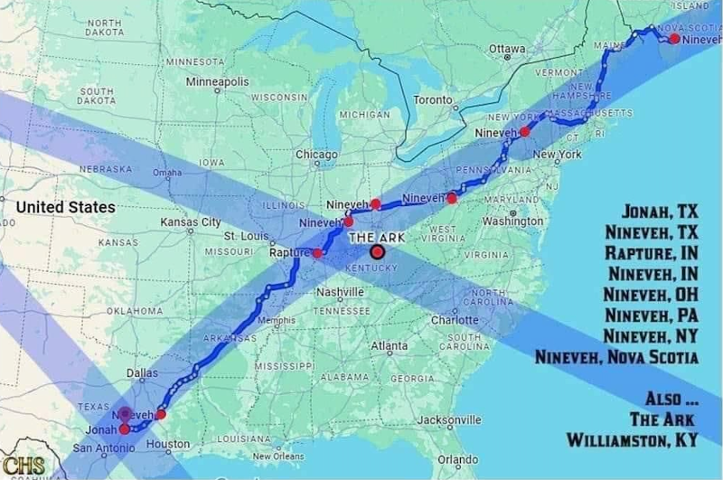 Steve Quayle: “Since the great American eclipse of 2017 we have been waiting for the Great American Eclipse of 2024, and now it is less than 2 months away. On April 8th, the Great American Eclipse of 2024 will complete the giant “X” over America that the Great American Eclipse of 2017 started. Amazingly, on that exact day the seven other planets in our solar system will “line up” in the sky.”
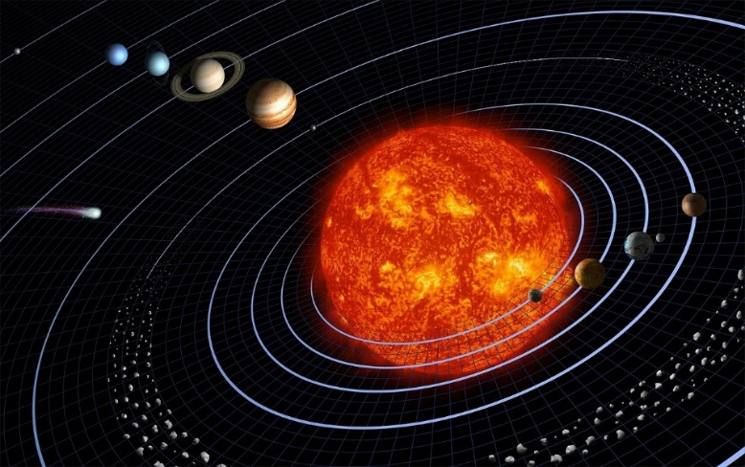
Steve Quayle of stevequayle.com wrote: “I WOULD ENCOURAGE EVERYONE TO ACQUIRE TODAY ANY LAST MINUTE, FOOD, WATER, MEDS ETC AND CASH OUT OF BANK THIS AM. BE VERY QUIET ABOUT WHAT YOU ARE DOING. THE WORD `EXTREME’ HAS NEVER BEEN USED BY ME AT ANY TIME, ANY PLACE AND I SENSED THE CHANGE IN THE WORD TO EXTREME ALERT STATUS IN MY SPIRIT, WHICH REALLY TOOK ME BY SURPRISE. I’M INCLUDING MICHAEL SNYDER'S ARTICLE ON THE ECLIPSE THAT CROSSES NINEVEH AND JONAH AS A TIMING SIGNAL AS TO THE DATE FOR THE USA DESTRUCTION. NINEVEH REPENTED OF IT'S EVIL BEFORE GOD SAID HE WOULD DESTROY IT - WILL AMERICA FOLLOW SUIT AND REPENT? NO IT WILL NOT.”
Steve Quayle (stevequayle.com) refers you to Michael Snyder’s report on this historic eclipse. Michael said: “This is an extremely rare event, and it will never be seen again.”
https://endoftheamericandream.com/the-7-other-planets-in-our-solar-system-will-form-a-line-as-the-path-of-the-great-american-eclipse-of-2024-crosses-america/ “
ONE MORE THING: A rare comet will also come towards earth’s atmosphere on this very same day – a rare comet – it has what looks like two horns proceeding out of it. Yahuwah is speaking to the wise to warn us. PREPARE! Prepare others!
I want to encourage you to sign up for Steve Quayle’s Private Briefings. The cut-off date is March 15, 2024. Go to “gensix.com.” Quayle is giving such detailed inside information that is not being told except under the greatest secrecy from the highest of intel circles, so you won’t get this on any public news. The censorship of truth tellers is going to get very serious very soon. So, tank up on the truth, and study the Word of Elohim (Father and Son) with Elohim to teach you and go forward in the Truth. Do your own Spirit-led research. Yahuwah will lead you.
I was beginning to really share truth, as I lived in Jordan and saw and heard things that were not being told in America. I was traveling when in the U.S. to many states to teach. In Louisiana, a man who was a leader in one of the groups began sending me CDs of the teachings of Steve Quayle and a man who called himself “Hawk.” I couldn’t get enough of the truth. I’d listen to 2-3 CDs at a time, sometimes past midnight. Then he came online with his own broadcast and “private briefings.” Everything that Yahuwah had shown me, was confirmed by him, because he also, as am I, “Spirit-taught.”
The private briefings are about real happenings that the news won’t tell you. I’m not promoting anything or anyone that Yahuwah has not given me the OK to promote. I am very obedient to follow His instructions! All the chief “seasoned” watchmen are aligning now – all saying the same things. That means, the “seasoned” watchmen are hearing from Yahuwah!
Isaiah 52:6-8: “`Therefore, My people shall know My Name, in that day, for I am the One who is speaking. See, it is I. 7How pleasant upon the mountains are the feet of him who brings good news, who proclaims peace, who brings good news, who proclaims deliverance, who says to Tsiyon, Your Elohim reigns! 8The voice of your watchmen! They shall lift up their voices, together they shout for joy, because eye to eye they see the return of יהוה to Tsiyon.”
One thing is for sure: Yahushua has referred us to Jonah and his preaching to Nineveh to repent. Totally different culture – back thousands of years. Nineveh repented, and it is said that Jonah’s grave is at Nineveh to this day – for he did not leave Nineveh but stayed there with the people.
Messiah gave one particular prophecy over and over and over – the prophecy of the prophet Jonah, in regards to His death and his 3 days and 3 nights in the heart of the earth, as Jonah was in the belly of the whale for 3 days and 3 nights.
So, for Jonah and Nineveh to be in this huge X eclipse over America as Yahuwah is in judgment mode and America soon to be annihilated so that the Beast can come to power, is a HUGE thing.
Matthew 12:38-40: 38 “Then some of the scribes and Pharisees said to Him, `Teacher, we want to see a sign from You.’ 39 Jesus replied, `“a wicked and
adulterous generation demands a sign, but none will be given it except the sign of the prophet Jonah. 40For as Jonah was three days and three nights in the belly of the great fish, so the Son of Man will be three days and three nights in the heart of the earth.”
Do you see on the map that the towns of Jonah and Nineveh are close together in Texas near San Antonio – the area of Texas state government? Do you see on the map five other towns with the name Nineveh going northeast up to Nova Scotia? Dear ones – this is NOT A COINCIDENCE! The message is the message of the Prophet Jonah to Nineveh of old.
The message to America who does not repent: He will destroy it. It Nineveh did not repent back then He would have destroyed it. But they did repent so He did not have to destroy it. Nineveh USA is a nation that is the leading nation of the greatest evil the world has ever known across board, now a “hissing” in the nostrils of the nations, hated by the nations, mocked by the nations, our “President” and “Vice President” laughed at by the nations. Who has the fire-power of nuclear weapons, electronic weapons, EMP weapons to destroy the whole nation – one nation: Russia.
Late 2023, Yahuwah said to me “Putin is MY Nebuchadnezzar, - My Servant.” America is end-time Babylon. Jeremiah found favor with Nebuchadnezzar by sharing the Word of Yahuwah with the people. But the people rejected it. Yet, to Jeremiah the Captain of Nebuchadnezzar said:
Jeremiah 40:1-4: “The word that came to Yirmeyahu/Jeremiah from יהוה after Neḇuzaraḏan, chief of the guard, had let him go from Ramah, when he had taken him bound in chains among all the exiles from Yerushalayim and Yehuḏah, who were being exiled to Baḇel. 2And the chief of the guard took Yirmeyahu and said to him, “יהוה your Elohim has spoken this evil on this place. 3“And יהוה has brought it on, and has done, as He has said. Because you have sinned against יהוה, and did not obey His voice, therefore this matter has come upon you.” And then Nebuzaradan said as a message from Nebuchadnezzar: 4 And now, see, I loosen you today from the chains that were on your hand. If it seems good to you to come with me to Baḇel, come, and I shall look after you. But if it seems wrong for you to come with me to Baḇel, remain here. See, all the land is before you, go wherever it seems good and right for you to go.”
There will be a remnant who will go to the nations for Yahuwah even in the time of the Beast, who cannot die. They will be joined with a few leaders of the past, some of whom I’ve met and talked to. Yes, yes … part of my life.
I have a suspicion Jeremiah will lead the messengers of Yahuwah to give his message to the nations that he had to give for 18 years in his travels before returning to Jerusalem just after King Josiah died: Jeremiah 25.
Jeremiah found favor with Nebuchadnezzar by obeying Yahuwah. Today, He sees Putin as He did King Nebuchadnezzar of the ancient Babylon – as His servant. This he said to me: “Vladimir Putin is My Nebuchadnezzar.”
Isaiah 13 tells of the annihilation of America. America has been set up for total destruction for many decades, because unless it is taken out the Beast cannot take over world rule.
America’s 70 allotted years (Jeremiah 25) from August 1945 to September 2015, America, as the world’s superpower, used their supremacy to start wars, to destroy nations, to destroy people, as world leaders of the drug trade, the pedophilia, the sex-trafficking, the selling of slaves, the destroying nations by giving them (180 out of about 190 nations) money, then dictating what they had to do to destroy their own people.
I’ve written about it and podcasted about it extensively - over and over and over. I grew up in the peaceful 1940s and 1950s. I preached on the streets of Los Angeles and Hollywood, Long Beach, etc. I went door-to-door with the Good News of salvation, preached in prisons, rescue missions, juvenile “houses,” and on and on. I taught in homes, in groups, went on mission trips, handed out tracts in shopping centers, prayed for people to receive the Savior, and on and on for many years before going to the nations beginning at age 9 to Mexico and then to the Navajo Indians and back to Mexico, to live in Jordan from 1999 – 16 years of living in the Middle East, then living in other countries, traveling to many lie nations of Africa for 7 times in six years - moving in the gifts of the Spirit – 39 nations in all, so far.
He has led me; I have obeyed. I just hear and obey. That’s the life of freedom – the life of a servant of the Supreme Deity – Yahuwah (I AM the ever-living One).
It’s just been in me to see people born again from the time I was born again at age 6. My life since age 6 has been to “win souls” for the Master.” It’s the commission for everyone who is born of the Spirit to share the Good News of salvation - the removal of sin by faith in the Savior - the Kingdom and the King.
Now, America, as we knew it, is no more. It’s gone. We are quickly becoming aligned to China as a communist nation. The people are so lost, so confused, upwards of 96% of once-called Christians are denying the Bible as the Word of God, and denying Messiah as Deity. I’m talking Evangelical and Charismatic/Pentecostal. The “high churches” of old lineage have been apostate for centuries.
A great number of “Messianics” dumped the Savior for a place in Judaism, the Talmud, Kaballah, and favor with gentile Khazars whose lineage has pretended to be “Jews” since the 8th Century.
Now, America, the U.K., and NATO nations, provoke Russia to attack us and destroy us. Yahuwah has raised up Russia, China, North Korea, and Iran, and all the drug cartels and terrorist groups, like Hamas, and Hezbollah, inside the U.S. to bring His judgment.
This eclipse is saying to us, along with planetary alignment, aligning to the will of their Creators/Father and Son, Genesis 1, along with the horned comet – that Yahuwah is in the heat of His wrath and His wrath will allow Lucifer and the fallen ones to take over for a very short time to execute His wrath. Then Messiah will come, as Matthew 24 tells us.
Jonah preached repentance. America has had its long-time chance to repent and return to the Word and submission to the Savior. But, no, America has used its freedom to go deeper into sin, where today, Holly has parties where they butcher children alive and barbeque them. America leads the world in child sex trafficking, and also the kidnapping of children to be sacrificed to Lucifer.
That goes on also under the White House, the Pentagon, the U.N., etc. Sorry to be so blunt, but it’s the nicest and the quickest I could say that. So, because no outcries from the churches, except for a very few. No “church” of “Christianity” or “Messianic assembly” is going to teach you 100% truth – for all religion is rooted in man’s opinions of the Bible. Of course, some are better than others. But 143,000 different denominations and organizations within Christianity is NOT what Yahushua died for. Read slowly John 17. This is what He wants for His family!
Read the Word, slowly, checking word meanings and references – use biblehub.com or some other site like it to learn the meanings of original languages – so that you can join Scriptures together throughout the Word and get a whole picture of what is being said. By all means unite yourself with Yahuwah, the Spirit, who teaches you from His nature, ways, and thinking: John 14-16.
We must have a personal relationship with Yahuwah and Yahushua – living in Their Presence, hearing Them, letting Yahuwah’s Spirit teach us from within! He speaks in 40 different ways, each with a predicant in the Bible. Surely He can talk to you as you submit to Him via your eternal spirit!
Most all of America has turned against the God of the Bible and soon it will be illegal to own one. What do you do – you get serious about preparing in natural ways. But, more serious about solidifying your relationship with the Master so that He knows you and will help you – through martyrdom or trusting to assign you to a task for Him.
Yes, tens of thousands of guillotines are in camps all over the US, FEMA camps mostly, and you’re being set up to go there. All over the world, Christians will be martyred. They already are in abundance. This martyrdom began seriously around the late 1800s, early 1900s, after the fallen ones returned for their 120 years in the earth, before they are sent to the lake of fire. 1896 is when they returned in mass – the main 200 who began to come into the earth not long after Adam and Eve sinned against their Creators.
So, we’re in the “last days.” Things are speeding along very fast. I’ve been keeping up with it for nearly 60 years. The chief watchman has been keeping up with it for about 51 years. Oftentimes, he confirms what Yahuwah has said to me along the way. It is because His watchmen are “Spirit-taught.” The “Holy Spirit” is Yahuwah Himself, who is omnipresent, omniscient, and omnipotent: 1) Because He’s Spirit, He can be everywhere at the same time. 2) He is “all knowing,” and 3) He is El Yon, the Most High, the Almighty, the most powerful Potentate of Eternity.
Look at the eclipse map above. Pray and act. Like I said: The watchmen are sensing the urgency that in the heart of Yahuwah. His Son is soon to come with His wrath. Be sure He does not say to you, “depart from Me, I never knew you.” (Luke 12, 13, 14). Be sure that He knows you by submitting yourself to Him and obeying, and praising, and entering into His Presence - preparing for the Kingdom. “Your Kingdom come, Your will be done on earth, as it is in heaven…”
In His love, Yedidah - February 24, 2024

