VENEZUELA JUST CALLED RUSSIA FOR HELP - AND PUTIN ANSWERED

Venezuela Just Called Russia for Help—and Putin Answered
November 22, 2025 By: Brandon J. Weichert The National Interest
“Several hundred Russian soldiers are said to be deployed in Venezuela, along with at least one general. Trump continues banging the war drums against Venezuela, without ever taking any real action to make good on those threats. Currently, around 15,000 personnel have been repositioned to the United States Southern Command’s area of responsibility (AOR). It has taken months to achieve this.
In the meanwhile, Venezuela’s regime, as led by socialist Nicolas Maduro, has had time to disperse its military assets and to call upon its allies to send reinforcements.
Is a Russian General on the Ground in Venezuela? According to a recent report in The Warzone, a popular online defense trade publication, a senior Russian general, Oleg Leontievich Makarevich, has been deployed to Venezuela to head what is described as a “rotational advisory mission” of roughly 120 Russian troops.
The report details how these Russian troops have been placed in advisory roles for the Venezuelan Armed Forces, specifically in infantry, drone operations, special forces, military intelligence/signals intelligence, armor, aircraft, artillery, even dogs and domestic surveillance.
General Makarevich’s unit has been identified as the “Equator Task Force” (ETF) as part of the Russian Ministry of Defense. But it’s part of a larger movement of Russian forces into Venezuela. For instance, the Russians have been flying planeloads of military equipment into the country since the start of the geopolitical crisis between Caracas and Washington.
Further, Russians have allegedly been getting moved into Venezuela from the Russian Africa Corps—indicating the need for Russian troops with expertise in jungle warfare. Just as American advisers are embedded in nominally non-combat roles in Ukraine, it is likely that these Russian advisers will play a similar role for Venezuela.
Although, it has been speculated that the Wagner Group mercenaries in the country will be working directly with elite Venezuelan units, preparing to build an insurgency against the invading American forces (should the White House decide to initiate an attack).
Clearly, the Russians are attempting to project power into America’s strategic backyard the way that America has been projecting power into Russia’s Near-Abroad. If these reports are confirmed, it complicates American freedom of action and signals Moscow’s willingness to hedge geographically far from Ukraine.
if Russia provides not only advisory support but actual weapons (air-defense, standoff missiles) to Venezuela, as hinted by Russian political statements, then a US mission in the Caribbean might face higher stakes—escalation dynamics become more complicated.
For regional actors—even those not aligned with Moscow—the Russian presence becomes a signal: Russia is not only in Europe’s theater, but also well inside of America’s.”
My input: Venezuela has warned Trump that if he attacks, Venezuela will start blowing up our gas and oil industry along the Gulf – for starters. With Venezuela having Russian weapons and Russia’s support, it could start an attack by Russia on the U.S. via Venezuela too. Russia has lots of weapons already near the east coast of the U.S.

Article II: New NOTAM; Tuesday - Appears US to Commence Attacking Venezuela Hal Turner World November 23, 2025
Another Notice to Air Men (NOTAM) has been issued by the United States cordoning-off the precise air space needed to refuel U.S. Heavy Bombers heading to a place like Venezuela. This one gives rise to the appearance the US may commence military attack against Venezuela on Tuesday of this week.
The newest NOTAM restricts air traffic over a portion of the Gulf of America, from Altitude 18,000 feet to Altitude 24,000 feet, which is the exact level the U.S. customarily utilizes to refuel military aircraft . . . like B-52 Stratofortress Bombers, B-1b "Lancers" and even B-2 "Stealth." The lower altitudes can also accommodate Fighter Jets, but this seems designed for Heavy Bombers. A LOT of them. At the same time.”

“U.S. Issues NOTAM over Venezuela and Caribbean Sea "Deteriorating Security Situation" Hal Turner Nov 23, 2025

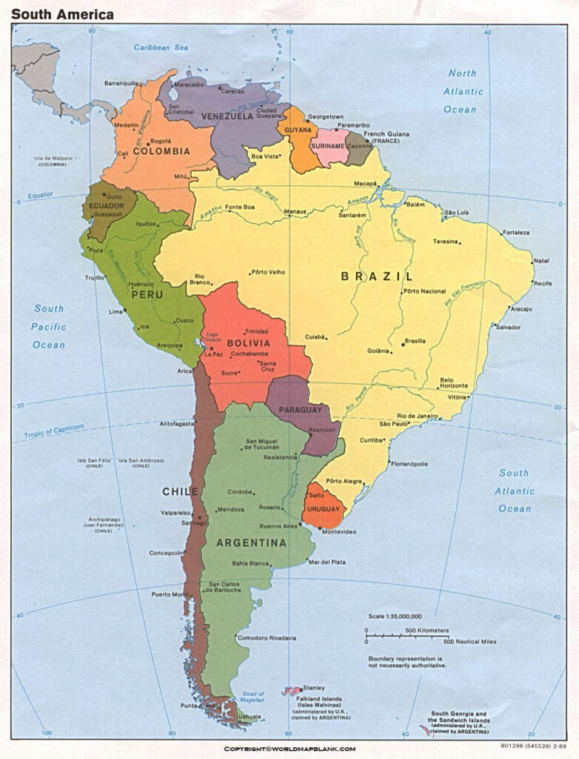
“A Russian contingent of over 120 military personnel is present in Venezuela, led by a Russian General Budanov” November 23 2025

“Russia continues to maintain its military contingent in Venezuela and expands cooperation with the regime of Nicolás Maduro. Currently, there is a Russian contingent of over 120 servicemen in the country, led by Colonel General Oleg Makarevich, who commanded the "Dnipro" troop group during the full-scale invasion of Ukraine. It was Makarevich who organized the undermining of the Kakhovka HPP in June 2023. This was stated by the head of the Main Intelligence Directorate of the Ministry of Defense of Ukraine, Kyrylo Budanov, in a comment for The War Zone, as reported by UNN.
According to him, the rotation of Russian forces in Venezuela has been ongoing for many years…”

From the New York Prepper Sunday Nov. 24, 2025: “RED ALERT!! EVACUATIONS FROM VENEZUELA BEGIN!! AIRSPACE WARNINGS ISSUED!”
“Venezuela Breaks Free — How Russian Warships Ended 200 Years of U.S. Control of American Hemispheric Dominance.” In other words, Russia coming to the aid of Venezuela, standing with Venezuela, has shown that Venezuela is breaking loose from American domination. In fact, America has become the enemy!

SOUTHCOM Troops Fed Steak & Lobster Dinner Tonight - You KNOW what that means? Hal Turner World November 24, 2025
United States Troops in the SOUTHCOM Area of Responsibility, are being fed Steak and Lobster dinner tonight. Anyone who's ever been in the military KNOWS what that means: Going to war - tomorrow.
Lest you have any doubt, SOUTHCOM just also canceled Thanksgiving and Christmas Leave for all its troops.
Today is Monday, Nov. 24. Last night, the U.S. filed NOTAMs to airlines, closing airspace in the Gulf of America (near Mexico) for three hours tomorrow 9:00 AM - 12:00 PM from flight level 18000 to 24000 which is for air-refueling of Heavy Bombers. This morning, the Federal Register published the U.S. Official Designation of Cartel de Los Soles as a "Foreign Terrorist Organization (FTO)" (Story Here)
With the publication of that Declaration, the entire world is put on-Notice that the US is going to do something.
That means the U.S. now has LEGAL AUTHORITY to strike Venezuelan military targets without declaring war. This is exactly the legal trigger they used before Afghanistan and Syria. This isn’t some rumor, it’s the official mechanism they ALWAYS use before the first strike.
Meanwhile 30% of U.S. deployable naval power is sitting in the Caribbean with Tomahawks loaded and Marines staged in Puerto Rico. This isn’t saber rattling anymore, this is the pre-war checklist getting checked off one item at a time.
It is expected that late tonight, the President will invoke the 2001 Authorization for Use of Military Force (AUMF) to deal with this "FTO" and, likely tomorrow morning, it's off-to-war we go against Venezuela.
All the legal and military hardware framework is in-place. The ships are in-position with long-range, stand-off missiles. Fighter jets and Bombers are pre-positioned in Puerto Rico and elsewhere. The NOTAMS are in-effect. The air space is cleared out. Oh, I almost forgot: The Insurance Carriers have notified airlines today they are HALTING coverage for any aircraft flying to/from Venezuela or in-to/out-of the NOTAM air space. When the Insurance companies pull coverage, you've got to figure it's "go time."
“This didn’t just “sit quiet overnight.” The cancelled leave is the NEW development and that’s the part that always marks the transition from political posturing to military action. When Southern Command locks down holiday leave, that means operations are already being scheduled. That never happened during the last flare-up.
Add in airlines pulling out, FAA alerts, NOTAMS, and the FTO designation and we’re in a completely different phase now.
Get cash money from the bank ASAP. Cyber-Attacks against the financial system are likely to commence immediately once the shooting starts. Top-off your preps.
This isn't “some news story on the other side of the world.” We’re talking: Oil potentially shooting past $150 overnight Gasoline potentially at $6–8 a gallon
Shipping and food prices potentially spiking HARD Cyber retaliation potentially hitting banks and infrastructure.
Thousands of Venezuelans potentially flooding the southern border instantly
National Guard deployments if Venezuela's Tren de Aragua gangs begin attacking us inside the USA. We also have no idea what China and Russia may do, since they both have significant assets in Venezuela.”
Well folks, we have a set up here. We know that the U.S. will be destroyed, by Russia most likely in some way. Russia in Venezuela brings them much closer to the U.S. – except their submarines with several 100 megaton nukes also sit off of Manhattan and other places on the East Coast, also in Cuba.
We don’t fear, we get pray and get closer to our Savior and our Abba. These things will happen until almost no one is left on earth when Messiah comes. So we give ourselves to Father and Son with all our spirit, soul, and body, and rest.
I want you to have a good night’s sleep and a Happy Thanksgiving!
In His love, Yedidah – November 24, 2025 8:00 PM

