ZELINSKY AND NATO WANT WAR; TRUMP AND PUTIN WANT PEACE! WHAT A MEETING!

My dear friends, what I give you here is built on the report of my last article of yesterday about the Trump-Putin meeting. It went well. Please read that article.
The meeting today between with Trump and Zelinsky started out bad. The EU/NATO delegation that came with Zelinsky were told by Trump to sit outside the door. Trump wanted only Zelinsky and he at the meeting. So, they all sat outside the door. The whole meeting was 12 minutes and they went home ashen-faced.
These two short reports I give you here, August 17th and August 18th, are in a way hilarious. I burst out laughing. What a put down. The meeting with Putin was a good one. Trump and Putin do not want war. NATO and Ukraine want war. So here we are. Another meeting … now what? We know the Bible. We know we’re in the time of Revelation 6 and 7. Now we’re moving into the time of Revelation 8 and forward.
But in reading this you have to smile. Trump’s “something else.” You want to slap him a few times sometimes, and then love him other times. We know however that his religious beliefs contain danger for Christians. Back last year Donald Trump was going to jail with no one to protect him. Then he, all of a sudden, was running for President and appointed/elected President. When he was running for President, Donald Trump told Christians that he was not a Christian but he asked Christians to vote for him because it would be the last time they’d ever have to vote for a President. He said that 2-3 times. His saying these things were recorded in a video. That statement contains many ideas for speculation. We know what time-period we’re in by the very clear 220+ prophecies in the Bible that we are seeing come to pass now. The meeting with Zelinski was 12 minutes and ended with no meal.

Here are 2 key articles that tell yesterday’s, and today’s, wild story.

ARTICLE 1: Hal Turner, August 17, 2025 “European Leaders Told They Will Wait in the Hall While Trump Speaks to Zelinsky.” TRUMP ALLOWED NONE OF THE EU/NATO IN THE MEETING!
European Leaders Told They Will Wait in the Hall While Trump Speaks to Zelensky Hal Turner World August 17, 2025
“Donald Trump has once again exposed the hollow shell of utterly powerless European diplomacy. The American president flatly rejected the idea of a joint session with European leaders, insisting instead on a solo meeting with Volodymyr Zelensky before anyone else enters the room.
The optics are brutal: Europe’s “leaders” fly across the Atlantic only to sit like schoolchildren outside the Oval Office, waiting for permission to enter. This is not partnership — it is humiliation dressed up as diplomacy; and I LOVE it!
Zelensky, visibly reluctant but cornered, will sit down with Trump alone. Reports confirm that the Europeans will only be allowed in after Trump has dictated terms to Kyiv. The choreography makes clear who holds power and who is just filling empty chairs for the cameras. The United States is 72% of NATO and it is long overdue we start acting that way.
For Zelensky, this is a nightmare—without his EU babysitters shielding him, he faces Trump directly, forced to negotiate with the man he cannot control, without the safety net of European platitudes and hollow “unity” talk.
The Europeans, meanwhile, look pathetic. Once again, they sacrifice national dignity to chase scraps of influence in Washington. Their leaders appear less like independent statesmen and more like nervous lobbyists hoping for a nod of approval. For decades, they preached about “shared values” and “equal partnership,” but the reality is plain: America calls the shots, and Europe obeys. This meeting is a masterclass in power imbalance. Trump’s maneuver humiliates Europe and exposes Zelensky as weak and dependent.
Washington dictates, Kyiv obeys, and Europe applauds like fools.
Nothing changes—except the mask of “unity” has slipped.
This is not diplomacy; it is subjugation on full display. AS it should be.
UPDATED 4:00 PM EDT -- WHAT HAPPENED:
1) Trump scolded Zelensky and wanted to force him into peace a while ago.
2) Zelensky ran to Europeans, so Macron and Starmer pushed back, also getting help from the neocons in the USA.
3) Trump then understanding the situation, gave the European their war, what they wanted and used it as leverage for trade negotiations.
4) But USA secretly held talks with Russia during this time, and the Europeans were entertained by Kellogg and Lindsey Graham.
5) When the peace talks went to a final stage, the Alaska summit happened.
6) This shocked the Europeans. They had no idea and it happen too quickly, and too far along for them to interfere.
7) Now Zelensky and Europe noticed that a deal is actually close and the war might stop.
8) Europe and Zelensky are now freaking out, they are now thinking how to push back on Trump.
9) Zelensky ran again to assemble the who European warmonger crew and they wanted to travel to Washington together. 10) Trump said no; Zelensky only meeting!
------------------------------------
ARTICLE 2 TODAY:
TRUMP AND ZELINSKY AUGUST 18, 2025 AND EUROPE’S REACTION
My 1st paragraph: “President Trump has aided in achieving peace between India and Pakistan, India and Iran (cease fire at least), Serbia and Kosovo, Congo and Ruanda, Thailand and Cambodia, Armenia and Azerbaijan, Saudi Arabia, Syria, and Lebanon.”
Daily Mail article: “Trump has told Zelinsky to make peace. Trump told Zelinsky that he hast to go along with Russian demands and remove himself from NATO nations. His entourage of NATO advisors were told to sit outside because Trump only wanted to talk to Zelinsky alone. The demands of Trump for peace left Zelinsky and his European entourage in dismay, shock, and numb. Trump says Zelinsky could end the war now – just back off and leave NATO alone. I’m sure they all went home stunned.
“What did Putin say that 'spooked' Trump's team in Alaska? How did Donald's advisers emerged from the Ukraine showdown looking 'ashen-faced' and 'terrified' - before lunch was cancelled By IMOGEN GARFINKEL - SENIOR FOREIGN NEWS REPORTER Published: August 2025
Zelensky will be backed by the UK's Keir Starmer, France's Emmanuel Macron, Germany's Friedrich Merz and Italy's Giorgia Meloni, who will all join him in Washington. Last night Trump posted a dramatic statement that claimed Zelensky could 'end the war with Russia almost immediately' and set out terms for the Ukrainians including giving up any claim to Crimea and NATO membership.
Zelensky and Trump will meet at 1pm local D.C. time at the White House for their bilateral meeting before talks between the US President and European leaders begin around two hours later.
The summit ended early, and the lunch scheduled to take place between Putin and Trump at the US military base was cancelled. At the press conference, the leaders did not take a single question from the room filled with the world's journalists. Describing the mood of Trump's aides such as Press Secretary Karoline Leavitt and Special Envoy Steve Witkoff after the meeting, NBC News Chief White House Correspondent Peter Alexander said their 'eyes were wide' and 'ashen'.
'What struck me was the looks on the faces of a lot of the American delegation,' he said. Leavitt 'appeared to be stressed out and anxious', he noted, while Witkoff 'came into the room, then left quickly, then came back in'.
'Those were some of the sort of images that will stick with me as we leave here.' MSNBC host Antonia Hylton also suggested that Leavitt looked 'ashen' and 'frightened' after what she had witnessed 'behind closed doors' as she emerged from Trump's meeting with the Russian president.
'A lot of the press corps that was there, they reported in the minutes and hours after the presser that they saw members of the administration, like Karoline Leavitt, look ashen, almost frightened after what they had seen behind closed doors,' Hylton said on Saturday night's episode of MSNBC's The Weekend: Primetime.
'What did that indicate to you?' she asked former US Ambassador to Russia Michael McFaul, a guest on the show.
'We should all be glad that we did not go to Alaska,' McFaul responded, adding that Leavitt's appearance after the meeting 'suggests to me that this was a bigger disaster than they're leading on to'. A lunch of halibut and steak - scheduled for the two leaders after the peace talks - never took place as planned.
The menu of the meal was revealed among papers relating to the summit found in a hotel printer 20 minutes from the Joint Base Elmendorf-Richardson, where the historic meeting took place.
Monica Crowley, who was in charge of creating the program for Russian leader Putin's visit, was left red-faced after the eight pages including precise locations, meeting times and private phone numbers of government employees were found at Hotel Captain Cook
The menu shows they would have had a starter of 'green salad with champagne vinaigrette' followed by a 'duet of filet mignon with brady peppercorn sauce and halibut Olympia served with buttery whipped potatoes and roasted asparagus'.
The highly anticipated meeting, that began around 3.30pm ET, ended abruptly after only two-and-a-half hours - despite a Kremlin spokesman previously saying he believed the talks could take at least six to seven hours.
Afterwards, in an extremely uncharacteristic move, Trump allowed Putin to speak first - at what had been billed as a bilateral press conference - and then didn't answer a single question.

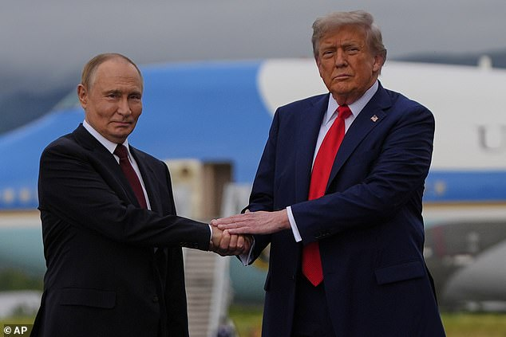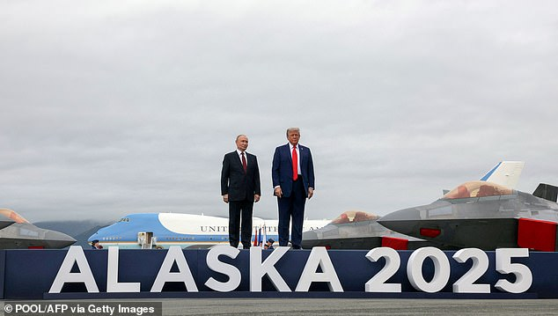
Donald Trump greets Vladimir Putin at Joint Base Elmendorf-Richardson in Alaska on Friday
He said he had an 'extremely productive meeting' with Putin but he did not answer a single question over the future of Ukraine. ‘We didn’t get there,' the usually ebullient president acknowledged, 'but we have a very good chance of getting there.' Their whole appearance before the world's press lasted just 12 minutes.
Well folks, this kind of leaves us stunned too. But with all the meetings of man, we still have Yahuwah’s Truth of how it will be. Folks, our future on this earth is not good for the human race as a whole. But our future can be filled with peace for us!
Let us press further into knowing Yahuwah and Yahushua/Father and Son as Jeremiah stated in Jeremiah 32:16-20. He is with us. Isaiah 55:6-13.
Shalom, Yedidah August 18, 2025

