5-G: RADIATION DARKNESS IS COVERING THE EARTH
FUKUSHIMA, the MARSHALL ISLANDS, NUCLEAR REACTORS, EARTHQUAKE FAULTS AND SEA COASTS

PART IV
9 pictures and maps

Radiation is coming at us from so many ways, and earth’s protective systems are being destroying. The U.S. has worked hard since 1958 to destroy earth’s radiation protection belts. So, not just from solar rays, but from satellites over the earth and power poles on the earth (5-G), electromagnetic waves, extra low frequency waves, LED and florescent lights, microwave ovens, nuclear disasters, nuclear waste, etc. within and without, we are being bombarded with death.
Chem.-trails bombard us with aluminum and barium, etc., which attract and hold in radiation on the earth and in our bodies. We’re being sealed in death trap.
In this article, as I wrote recently, “Is There a Blood Curse Over Planet Earth?” you will see more of the curse’s extensive reach.
A mighty holocaust-sacrifice is being offered to Satan. The 1 Billion+ abortions are a major sacrifice to Satan. Satan’s forces are amassing on earth in the form of fallen angels, their offspring, robots, AI creations inhabited by demons, and demon-possessed human beings.
Our only recourse is Psalm 91:1 – hiding ourselves in the secret place of the Most High, clinging to Him in much prayer, travail, speaking and singing praises in our native language and in the “tongues of angels.”
MEMORIZE SCRIPTURE! Guns will be taken away and also Bibles.

Online history of radio waves: “In November 1886 Heinrich Hertz became the first person to transmit and receive controlled radio waves. Considering how indispensable his wireless transmissions quickly became, it seems a little odd looking back that he had no practical purpose in mind for the radio or Hertzian waves he discovered. Hertz commented in 1890: I do not think that the wireless waves I have discovered will have any practical application.” “In fact Hertz’s waves would soon change the world. By 1896 Guglielmo Marconi had been granted a patent for wireless communications.”
“In 1896, French physicist and Nobel Lauriet, Henri Becquerel, became the first person to discover evidence of radioactivity. (March 1, 1896)”
Radio waves are passed off as mere communication waves, but they carry radiation. Their use for military purposes is now a major use of them, hiding under the guise of communication and a more convenient lifestyle.
As you can read from Part I of this series, the long list of health risks for humans is hard to fathom, they’re so awful. Yet, 5-G internet service is being passed off as “upgrade” for 4-G. In the first three articles of this series, I have made it clear that 5-G is not an upgrade. It is a new thing that is part of the globalist de-population and mind-control agenda. That’s not my opinion, that’s a factual statement that goes back to the development stages in the late 1800s to date. Parts I, II, and III are also on the Mikvah of Present reality.

Paul Begley: “Earth’s radiation level has gone up 18% on earth in the last 3 years – that’s 2016”
“Mike from around the world,” reporting on Paul Begley YouTube: “2019 is the hottest year on record. It is because the building magma is rising. Radiation is bombarding the earth overpowering the magnetosphere, heating the core of the earth. Radiation is heating the earth. We’re covering the earth with 5-G radiation. All the natural protection of earth has been super charged with radiation. Our life support systems weakened…The density of our outer atmosphere is increasing. The density is creating stronger winds and higher wind speeds. 120 mile per hour winds will come with an average thunderstorm.”

FUKUSHIMA WORLDS GREATEST ECOLOGICAL DISASTER POINT DESTROYING OCEANS LAND FOOD SUPPLY WATER AIR BODILY AILMENTS

Excerpts from: “An Ongoing Global Radiological Catastrophe” - “a Huge Cover up.”
Transcript of 8th anniversary interview with Dr. Helen Caldicott
By Dr. Helen Caldicott and Michael Welch - Global Research, March 21, 2019

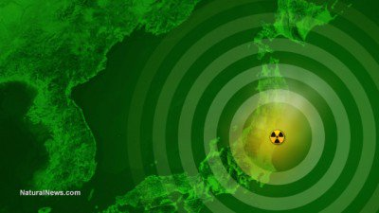
“The eight year anniversary of the triple meltdowns at the Fukushima Daiichi nuclear facility passed mostly without comment in mainstream media circles. In spite of ongoing radiological contamination that will continue to spread and threaten human health for lifetimes to come, other stories dominate the international news cycle.”
Global Research: Now the Japanese government is preparing to welcome visitors to Japan for the 2020 Olympic Games, and coverage of the 8th anniversary of the Fukushima disaster is hardly…registered given the significant radiological and other dangers…
Helen Caldicott: `…the Japanese government has authorized really only examination of thyroid cancer. Now thyroid cancer is caused by radioactive iodine and there were many, many cases of that after Chernobyl. And already, they’ve looked at children under the age of 18 in the Fukushima prefecture at the time of the accident, and … how many children… 100…no 201 by June 18 last year… 201 had developed thyroid cancer. Some cancers had metastasized. The incidence of thyroid cancer in that population normally is 1 per million. So obviously it’s an epidemic of thyroid cancer and it’s just starting now…What people need to understand is the latent period of carcinogenesis…Thyroid cancers appear early.

Leukemia appears about 5 to 10 years later. They’re not looking for leukemia. Solid
cancers of every organ, or any organ as such appear about 15 years later and
continue and in fact the Hibakusha from the Hiroshima and Nagasaki who are still alive are still developing cancers in higher than normal numbers.
The Japanese government has told doctors that they are not to talk to their patients about radiation and illnesses derived thereof, and in fact if the doctors do that, they might lose their funding from the government. The IAEA, the International Atomic Energy Agency interestingly set up a hospital – a cancer hospital – in Fukushima along with the Fukushima University for people with cancer, which tells you everything. So there’s a huge, huge cover up...it’s an absolute medical catastrophe I would say, and a total cover up to protect the nuclear industry and all its ramifications.
HC: Well there are ongoing emissions into the air consistently, number one. Number two, a huge amount of water is being stored –over a million gallons in tanks at the site. That water is being siphoned off from the reactor cores, the damaged melted cores. Water is pumped consistently every day, every hour, to keep the cores cool in case they have another melt. And that water, of course, is extremely contaminated.
Now they say they’ve filtered out the contaminants except for the tritium which is part of the water molecule, but they haven’t. There’s strontium, cesium, and many other elements in that water – it’s highly radioactive – and because there isn’t enough room to build more tanks, they’re talking about emptying all that water into the Pacific Ocean and the fishermen are very, very upset. The fish already being caught off Fukushima, some are obviously contaminated. But this will be a disaster.
…now the three molten cores in contact with that water flowing under the reactors and so the water flowing into the Pacific is very radioactive and that’s a separate thing from the million gallons or more in those tanks.
The mountains are highly radioactive and every time it rains, down comes radiation with the water…there are over 200 radioactive elements made in a nuclear reactor. Some have lives of seconds and some have lives of millions of years or lasts for millions of years will I say. Also fish, being caught on the west coast of California contained some of these isotopes. So, it’s an ongoing bio-magnification catastrophe…May I say that parts of Tokyo are extremely radioactive.
…to have the Olympics in Fukushima just defies imagination.”

“Fukushima: Japan Will Dump Radioactive Water Into Pacific, Minister Says”
By Strange Sounds - Sep 10, 2019
“More than a million tonnes of contaminated water lies in storage at Fukushima.
But the power company says it will run out of space by 2022, forcing Japan to dump radioactive water into the Pacific Ocean.
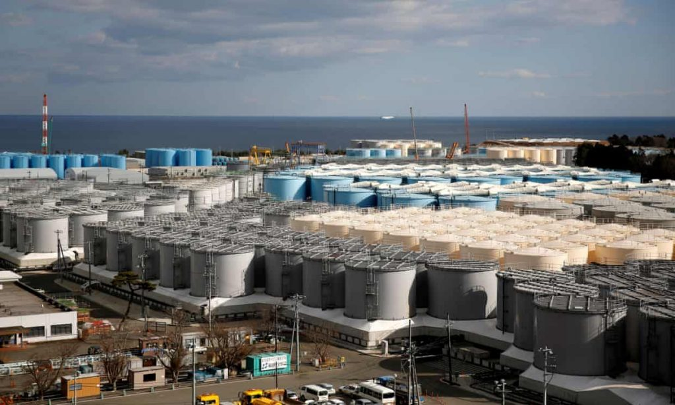
Fukushima: Japan will have to dump radioactive water into Pacific, minister says. Picture: Issei Kato/Reuters (Picture: Stored radioactive water…)
The operator of the ruined Fukushima Daiichi nuclear power plant will have to dump huge quantities of contaminated water from the site directly into the Pacific Ocean, Japan’s environment minister has said – a move that would enrage local fishermen. And probably also the rest of the world!
More than 1 million tonnes of contaminated water has accumulated at the plant since it was struck by a tsunami in March 2011, triggering a triple meltdown that forced the evacuation of tens of thousands of residents.
Tokyo Electric Power (Tepco) has struggled to deal with the buildup of groundwater, which becomes contaminated when it mixes with water used to prevent the three damaged reactor cores from melting.
…Tepco admitted last year that the water in its tanks still contained contaminants beside tritium.
Currently, more than 1 million tonnes of contaminated water is held in almost 1,000 tanks at the Fukushima Daiichi site, but the utility has warned that it will run out of tank space by the summer of 2022. `The only option will be to drain it into the sea and dilute it,’ Yoshiaki Harada told a news briefing in Tokyo on Tuesday.”

Radiation Fukushima Bags of Radioactive Waste Earthquake
“5.2-magnitude quake on Wednesday struck off Japan's Fukushima Prefecture were thousands of bags of radioactive waste and 1,000 tanks of dangerous radioactive contaminants are stored” - The Big Wobble – December 12, 2019
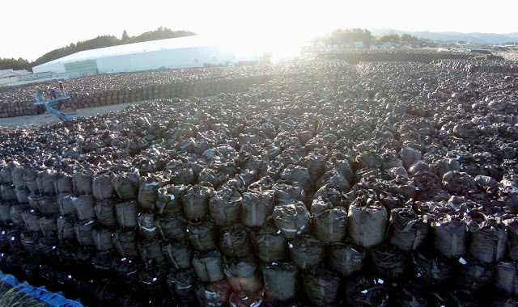
Bags of radioactive waste are seen piled up at a temporary storage site in Tomioka, Fukushima Prefecture| KYODO
A 5.2-magnitude earthquake on Wednesday struck off Japan's Fukushima Prefecture, according to the Japan Meteorological Agency (JMA). The quake shows just how vulnerable the stricken plant is with thousands of bags of radioactive waste and 1,000 tanks of dangerous radioactive contaminants.
A system meant to purify contaminated water has failed to remove dangerous radioactive contaminants at the stricken Fukushima plant according to Tokyo Electric Power Co, (TEPCO) the owners. Most of that water is stored in 1,000 tanks around the plant. TEPCO is already running out of space to store treated water. And should another big quake strike, (which is a question of when and NOT if), experts say tanks could crack, unleashing tainted liquid and washing highly radioactive debris into the ocean. During the summer of 2017, 50,000 trillion Becquerel’s of radiation leaked into the Pacific, however. Yesterday's quake is a timely reminder of just how dangerous the situation is at the Fukushima plant, it is literally a ticking time-bomb. [Note: “Becquerel,” named for Henri Becquerel, is the name of the French physicist, who in March of 1896 became the first person to discover evidence of radioactivity] The East Coast of Japan is one of the most volatile quake areas in the world.”
“Radiation Fukushima Nuclear Waste Release Into Pacific Ocean or Air
Japan gov't proposes Fukushima water release to sea or air”- Dec. 23, ‘19 AP
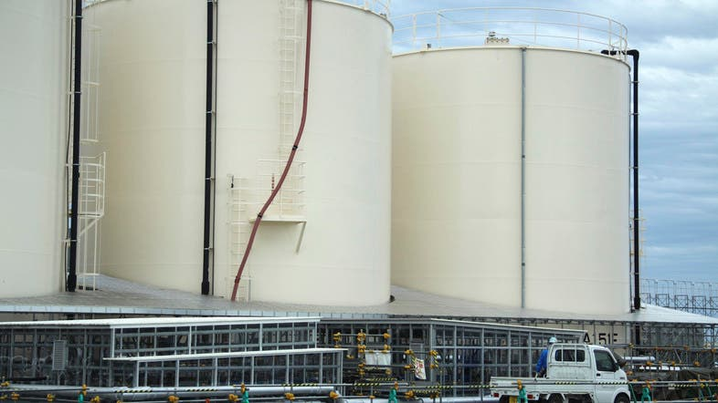
In this Oct. 12, 2017 photo, ever-growing amount of contaminated, treated but still slightly radioactive, water is stored at the wrecked Fukushima Dai-ichi nuclear plant. (File photo)

The Associated Press, Tokyo - Monday, 23 December 2019
“Japan's economy and industry ministry has proposed gradually releasing or allowing to evaporate massive amounts of treated but still radioactive water at the tsunami-wrecked Fukushima nuclear plant.”
…Nearly nine years after the 2011 triple meltdowns at Fukushima Dai-ichi, the radioactive water is still accumulating as the water is needed to keep the cores cooled and minimize leaks from the damaged reactors.
For years, a government panel has been discussing ways to handle the crisis and to reassure fishermen and residents who fear potential health impacts from releasing the radioactive water as well as harm to the region's image.
In Monday's draft proposal, the ministry suggests a controlled release of the water into the Pacific, allowing the water to evaporate, or a combination of the two methods…TEPCO says it has space to store only up to 1.37 million tons and only until the summer of 2022, raising speculation that the water may be released after the Tokyo Olympics next summer... The tanks also could spill out their contents in a major earthquake, tsunami or flood.
The panel has also discussed possibly storing the radioactive water in large industrial tanks outside the plant, but the ministry proposal ruled that out, citing risks of leakage in case of corrosion, tsunamis or other disasters and accidents, as well as the technical challenge of transporting the water elsewhere.
Radiation Marshall Islands US dumping ground radioactive material and plutonium
“The Marshall Islands in the Pacific have radiation levels up to 1,000 times higher than Chernobyl and Fukushima: With Plutonium-239, a radioactive half-life of 24,100 years” - The Big Wobble – July 20 2019

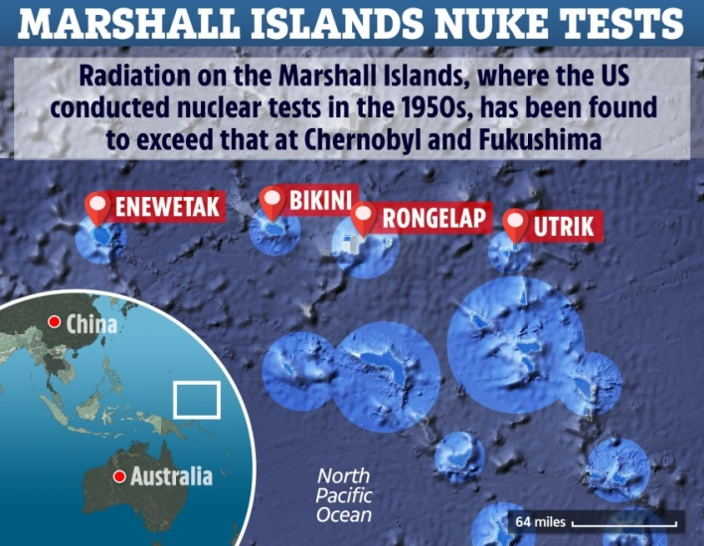

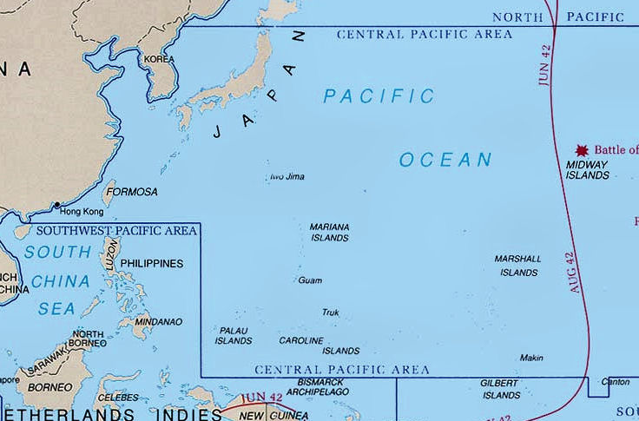

“67 nuclear tests were conducted by the U.S. in the area from 1946 to 1958. Researchers claim that radiation in the area is up to 1,000 times higher than Chernobyl and Fukushima.

Runit Dome leaking radiation into the sea
The 377-foot-wide crater in Enewetak Atoll contains groundwater samples with radiation levels 1,000 to 6,000 times higher than those found in the open ocean.
According to a 2017 report by the Australian Broadcasting Corporation, among the fallout material was plutonium-239, an isotope that is one of the world’s most toxic substances, and one with a radioactive half-life of 24,100 years.
The fragile dome still there, only 18 inches of concrete away from waters that are rising. This week the world has been bombarded with the 50th anniversary of the moon landing with billions of dollars being promised to go back in the near future. Meanwhile, a group of islands in the Pacific, hundreds of thousands of miles closer to the US than the moon is now considered to be the most toxic area in the world with radiation much higher in some areas than Chernobyl and Fukushima decades after nuclear testing. Radiation levels are still dangerously high.
Bikini Island considered ground zero for testing had the highest level of any area studied. Its residents were relocated by force in 1946 because of the
high levels of radiation. Around 75,000 people now live on the Marshall Islands.
To make matters even worse, high levels of radiation have been monitored in giant clams close to the Central Pacific site where the United States entombed waste from nuclear testing almost four decades ago, raising concerns the contamination is spreading from the dump site’s tainted groundwater into the ocean and the food chain.
The findings from the Marshall Islands suggest that radiation is either leaking from the waste site — which U.S. officials reject — or that authorities did not adequately clean up radiation left behind from past weapons testing, as some in the Marshall Islands claims.
According to the LA Times, the radioactive shellfish were found near Runit Dome — a concrete-capped waste site known by locals as “The Tomb” — according to a presentation made by a U.S. Department of Energy scientist this month in Majuro, the island nation’s capital. The clams are a popular delicacy in the Marshall Islands and in other nations, including China, which has aggressively harvested them from vast swaths of the Pacific.
…Today, due to disrepair and rising sea tides, the dome is dangerously vulnerable. A strong storm could breach the dome, releasing the deadly legacy of America’s nuclear might.
…Enewetak Atoll was subjected to repeated blasts during the testing, and inhabitants were forced to relocate before the explosions began. Beginning in 1977, 4,000 US servicemen began collecting an estimated 73,000 cubic meters of tainted surface soil across the islands, according to the Marshall Islands’ government. The material was then transported to Runit Island, where a 328-foot crater remained from a May 1958 test explosion.
`For three years, the American military dumped the material into the crater. Six men reportedly died during the work. Locals took to calling it The Tomb,’ The Guardian reported.
In 1980, a massive concrete dome – 18 inches thick and shaped like a flying saucer – was placed over the fallout debris, sealing off the material on Runit. But the $218 million (£172 million) project was only supposed to be temporary until a more permanent site was developed, according to The Guardian. However, no further plans were ever hatched.
In 1983, the Marshall Islands signed a compact agreement of free association with the US, granting the island nation the right to govern itself…According to a 2017 report by the Australian Broadcasting Corporation, among the fallout material was plutonium-239, an isotope that is one of the world’s most toxic substances, and one with a radioactive half-life of 24,100 years. The staying power of that material is the problem. It’s still there, only 18 inches of concrete away from waters that are rising.
Cracks reportedly have started to appear in the dome. Part of the threat is that the crater was never properly lined, meaning rising seawater could breach the structural integrity. `The bottom of the dome is just what was left behind by the nuclear weapons explosion,’ Michael Gerrard, the chair of Columbia University’s Earth Institute, told ABC. `It’s permeable soil. There was no effort to line it. And therefore, the seawater is inside the dome.’
“EXCLUSIVE: California’s nuclear power plants built in close proximity to the San Andreas fault, setting up catastrophic “Fukushima” event for the West Coast
Wednesday, July 10, 2019 by: Mike Adams
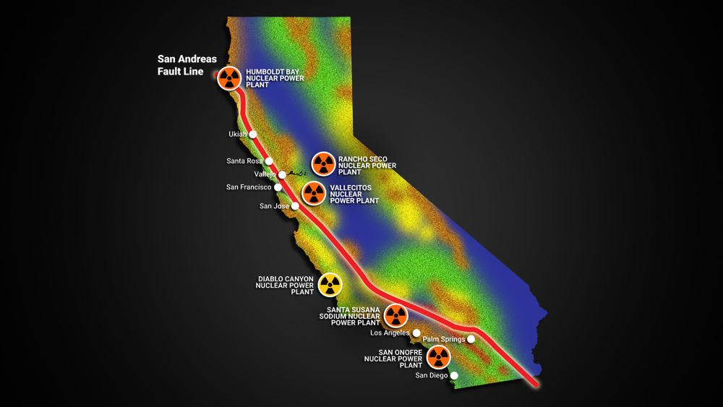
(Natural News) “A Natural News investigation into the geolocation of nuclear power facilities in California reveals that five nuclear facilities were built in close proximity to the San Andreas fault line, with some constructed right in the middle of earthquake zones that have up to a 50% chance of a severe earthquake every 30 years.
One nuclear power plant – the Diablo Canyon Nuclear Power Plant which produces 2,160 megawatts — was constructed on the coast, making it extremely vulnerable to the very same kind of ocean water surge that destroyed the Fukushima-Daiichi facility which suffered a 2011 meltdown in Japan. That nuclear catastrophe, which was dutifully covered up by the entire western media for months, was caused by an underwater earthquake that produced a tsunami wave which engulfed the facility. California’s Diablo Canyon Nuclear Power Plant is positioned on the coastline in the exact same way, making it highly vulnerable to underwater earthquakes or other events such as underwater caldera explosions that can produce massive tsunami waves.
There are five additional nuclear power facilities in California which are in various stages of being decommissioned, and many of them continues to store nuclear fuel on sight. Four of the five were constructed in close proximity to the San Andreas fault, with only one — the Rancho Seco Nuclear Power Plant — located in an area with a near-zero chance of an earthquake. The Humboldt Bay Nuclear Power Plant, located north of San Francisco, was constructed almost exactly on the San Andreas fault.
…The Humboldt Bay plant is now closed and in the process of decommissioning. Specifically, PG&E requested a total updated decommissioning cost of approximately $982.3 million for its Humboldt Bay Power Plant, a $483 million increase from its 2009 estimate. Crucially, PG&E filed for Chapter 11 bankruptcy in January of this year (2019), after dealing with costs from the devastating wildfires that burned up huge regions of California, which were blamed on PG&E. Thus, it’s not clear whether PG&E has any money to continue funding the nuclear fuel SAFSTOR / decommissioning procedures across multiple nuclear power plants.
With California now offering free health care to illegal aliens, the bankruptcy of the state seems inevitable. Who will fund the continued decommissioning of the nuclear fuel in California once public money runs out and the big infrastructure corporations are all bankrupt? The Diablo Canyon Nuclear Power Plant has been scheduled for decommissioning beginning in 2025, but will PG&E have any money left by then?
Why the San Andreas fault will unleash “the big one” that may devastate California’s nuclear power facilities
As the Fukushima-Daiichi nuclear power facility was being constructed, the people of Japan were assured the power plant was safe and could never suffer a nuclear meltdown. Once the tsunami took out the plant’s batteries and backup generators, however, the meltdown was only a matter of physics and time. As the meltdown accelerated, Japan’s TEPCO power company turned off the dosimeters to avoid having to report extremely high radiation levels, just as the former Soviet Union did with the Chernobyl accident in 1986.
The same professional liars and nuclear “experts” also assured the California public that California’s nuclear power facilities would be “earthquake proof.” They are constructed with reinforced concrete, after all. What could possibly go wrong?
The answer is simple: A 9.0 magnitude earthquake could go wrong. There is no nuclear facility in the state of California that was designed to withstand a 9.0 earthquake, which releases 100 times more energy than a 7.0 earthquake.
A collapse of an active nuclear power plant could result in runaway fission (Diablo Canyon), resulting in a meltdown event that would likely burn through the foundation of the power facility and poison both groundwater and ocean water, turning California into another haunting echo of Fukushima.
Cesium-137, one of the radioisotopes released in this type of accident, has a roughly 30-year half-life, meaning much of Southern California would be uninhabitable for 300 years (it requires ten half-lives to be considered gone). Imagine the logistics of attempting to evacuate Los Angeles, San Diego and San Francisco.
Even in nuclear facilities that are not currently active, the crumbling of storage pools and power plant walls could place nuclear fuel rods in fissionable proximity, resulting in a runaway fission event that leads to a meltdown. This might be even more difficult to control, given that these non-active nuclear power facilities don’t have full-time staff or, in some cases, even the equipment necessary to deal with a full-blown nuclear emergency.
In other words, even nuclear fuel rods currently kept in cold storage are not entirely safe from a powerful earthquake. It simply isn’t safe to store nuclear fuel anywhere near the San Andreas fault line… not under any conditions.
Understanding the San Andreas fault
…This steady movement of the tectonic plate on which the entirely of the West Coast of California rests means that massive, high-energy earthquakes will be unleashed every few decades, seemingly at random. But it isn’t random. The large earthquakes actually follow periods of low earthquake activity, since “low earthquake activity” indicates rising geological tension that has yet to be released.
Notably, California has experienced decades of low earthquake activity, meaning “the big one” is being wound up, ready to be released at a future time and day that will be impossible to accurately predict.
…The very idea of building nuclear power facilities on or near this San Andreas fault line highlights the sheer stupidity and suicidal nature of humankind. Clearly, somebody got paid off, the corporation hired a P.R. firm to lie to the public, the hands of regulators were greased and California ended up with a whole series of nuclear power facilities that are just begging to be destroyed by a massive earthquake (that’s sure to come, sooner or later).
It’s almost as if California raised its hand and begged to win the Darwin Award for fatalistic human stupidity. No person in their right mind would build nuclear power facilities on or near one of the most dangerous fault lines on the planet, yet that’s exactly what California officials did. All in the name of “clean energy,” of course.
If you are currently living on or near the San Andreas fault line, you are not just playing Russian roulette with your own property and home; you’re living right in the middle of a future radiation fallout zone that will never be solved by left-wing bureaucrats for the simple reason that they are incredibly stupid, shortsighted and entirely focused on their own greed and power, regardless of the real cost to humanity.”

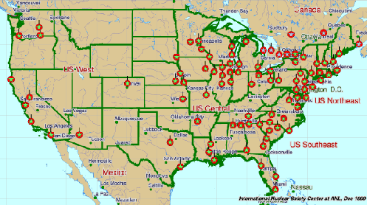
Take a look at the number of Nuclear Reactors that are on the sea coasts!
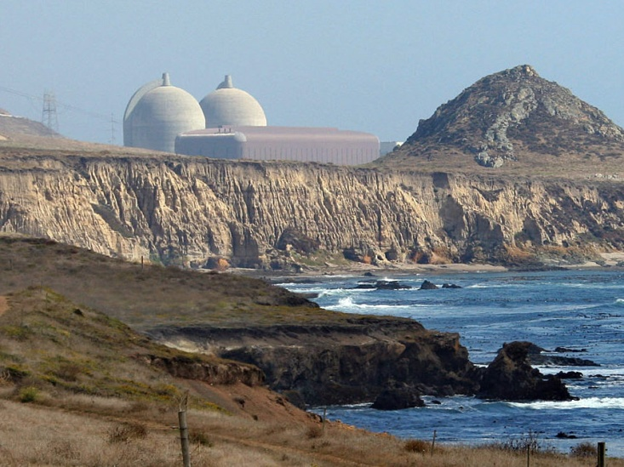
The Diablo Canyon Nuclear Power Plant, south of Los Osos, Calif., sits near earthquake fault lines, and is slated to close by 2025. Michael A. Mariant/AP
A majority of America’s nuclear reactors are very old, and some are leaking … even though this nuclear power plant sits on the San Andreas Fault line, it won’t be shut down until 2025.
Radiation is blanketing the earth by thousands of 5-G satellites being put up. The Ionosphere and other protective shields surrounding the earth by our Creators, are being greatly purposely damaged for use by the military as weapons.
Our Earth is becoming uninhabitable. Creation is groaning and dying.
Refer to: “Earth is Cracking Like an Egg – Historic Earthquakes and Volcano Eruptions, Plus Chunks of Earth’s Mantle Are Peeling Off” and “The Oceans and Their Sea Life Are Being Purposely Murdered”/both under the Mikvah of Present Reality.
As we watch the purposed destruction of earth, and it has been well documented, that the disaster at Fukushima was a targeted-hit, just like many earthquakes, volcano eruptions, tsunamis, hurricanes, cyclones, wildfires, and other weather extremes. The purpose is to destroy the earth, destroy our food crops, to permeate the earth with death.
What does this earth-sea based radiation have to do with us? Everything! Our oceans and all sea life is being contaminated. All life on earth is being contaminated. The cancer rate has risen drastically on the U.S. West Coast. Radiation has been found in deep ocean fish and mammals, sea plankton, salmon, Crustaceans, cow’s milk, and plants. Imagine what it is doing to people! Radiation is also air-borne. Refer to: “Radiation Clouds…”/Mikvah of Present Reality.
Revelation 11:15-18 now makes a lot more sense, for at Messiah’s return He will “destroy those that destroy the earth.” “Come Yahushua Come!!!”
In His love, shalom, shalom! Yedidah
December 31, 2019

