5-G Weaponized Technology
Satan’s Latest Gift to Humanity and Planet Earth

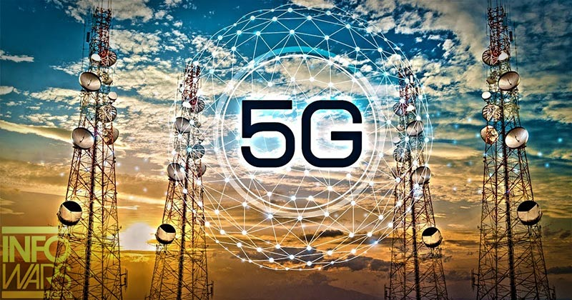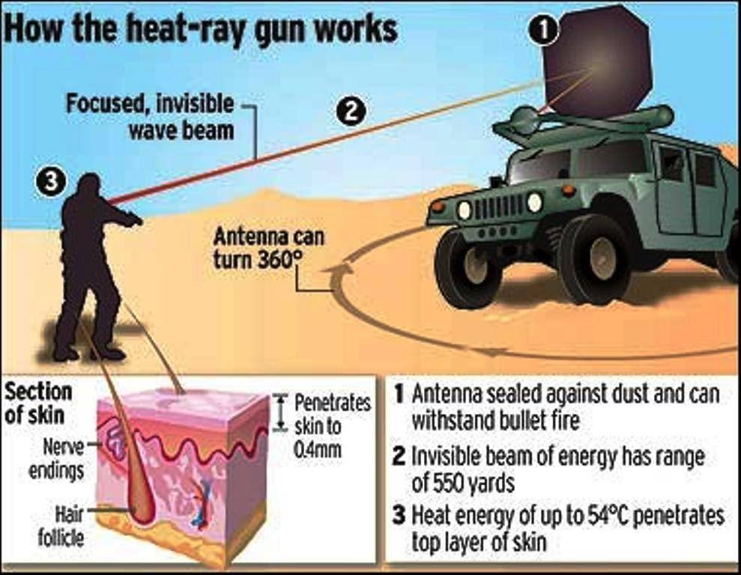
Am I being dramatic in that statement, “Satan’s latest gift to humanity and planet earth?” Am I an old-timey prude, putting down such fabulous new technology designed for our pleasure? NO! I like good usable technology. But true, whatever appeals to pride and the desires of the flesh always has a satanic base. Those who do no research on their own, who listen to opinions of scoffers and mockers, usually live in a bubble of fantasy for the most part, believing the lies of a satanic-driven government, with goals beyond imagination for humanity’s total destruction, believing the deceitful propaganda of the pubic news media of an ever-growing one world government, being educated by the public school system into the “world brain,” as it is known, live to be entertained and pampered. This is the “if it feels good do it” generation.
Therefore they scoff at truth, mock reality, put labels on both, with words fed to them by wicked man’s new mind-programming vocabulary. They live in a world of illusions. Many fear the truth. Most don’t want to hear anything that they don’t want to hear. It’s the age of people thinking of themselves as gods, or transcending into gods. It is an age without love, mercy, compassion, kindness, gentleness, goodness, peace, joy, and beauty. These things are mocked, not just by Islam but by people in general. “Because of lawlessness, the love of many will grow cold.”It is the age of scoffers, mockers, doubters, false prophets, liars, and illusionists.
Below I give you basic facts from some off the articles and videos I’ve collected so far. You see, in order to rid the earth of nearly eight billion people, leaving the desired 500 million as slaves of the ultra elite and their fallen angel overlords, they are getting tired of waiting on things like disease, famine, abortion, deadly components in food, water, air, medicines, vaccines, chemicals dropped in chem.-trails, geoengineered weather, and even wars. These things are hit and miss, even though a couple of billion may die in a nuclear world war, still, the problem remains – how to get the population of earth from nearly 8 billion down to 500 million?
A few years back the infamous think tank, the “Club of Rome,” actually said that all the created diseases are not killing off the masses fast enough, we have to find faster means.” Code words for 5-G are: “fast” and “quick.” I mean they really want to get rid of all but 500 million, as carved into stone on the “Georgia Guidestones.”
My friend Sharon, and I, were at this site in March of 2010, on that cold and windy hill, doing intense intercession and proclamations regarding the spirit behind these very telling guide-statements. They are written in several languages. The top rule of Globalist law is no surprise.
I remember back in the 1970s hearing Ted Turner talk about getting the population of the world down to 500 million. It’s not a secret that the world’s Elite have this goal. The secret is hidden in their plans on how to do it. But, 5-G has the ability to accelerate their plans exceedingly!
The answer is in technology that can be used over the whole of the earth’s surface at once, or in the heaviest population centers for starters. Well, the returnee fallen angels and their Nephilim offspring that gave mankind weapons of war, means of death, harmful drugs, fast transportation, and more ways to sin, in the late 1800s to present, are now giving mankind technology to finish off the human race, the animals, insects, and any other life form that gets in the way of the terraforming of earth to “their” liking.
[Refer to: “Terraforming the Earth – We Have Little Time Left! – Our Planet is Being Radically Destroyed to Prepare It For “Them”/Mikvah of the Heart of Elohim]
When it’s all said and done, the ruling principalities and powers, rulers of wickedness in high place, and their human or hybrid lackeys, will overtake the Elite also to be used as their slaves – for “as it was in the days of Noah, so shall it be…”
Unless you live in a very remote place like Patagonia, Antarctica, or a remote desert somewhere, you’ll feel the effects of 5-G and all that accompanies it. You do have to breathe air no matter where you run to. You have to eat. You have to drink water, and at times take medicines. So, somewhere somehow you’ll not escape it all, even if you live in Tasmania with the “Tasmanian Devils.”
This is real. The facts are everywhere, even in Congressional reports in America. As you will see, man’s craving for speedy entertainment, cars that warn of danger, technology that can satisfy your every desire, will end up as the noose around his neck, the preverbal “gun to the head” - the end of their mind and body.
I will also give you links, like the link to the video by Justus Knight with super condensed info. that he reports dramatically.
The watchmen, too, are getting more passionate with their pleas to warn people to WAKE UP BEFORE YOU DIE. Messiah’s word to the assembly at Sardis to the apathetic, lazy, mind-dulled believers reads: “Wake up and strengthen that which remains and is about to die…” (Revelation 3)
The old expression “the mind is the battlefield” has taken a drastic step forward. It’s not just our thoughts we need to bring into captivity to Messiah (II Corinthians 10:3-6), we need to wear the “helmet of salvation,” helmet of deliverance, to protect us from what is being beamed at us that has been turned into a military weapon. What the military and police will be beaming at us can fry the skin right off of us on the spot, or sneakily destroy our central nervous system, cause cancer, brain tumors, interfere with our ability to think/reason, bring insomnia, control emotions, destroy our memory, and our ability to function at all in any capacity. It’s coming to a neighborhood near most of us!
“Sound of silence” technology, used on Iraqi troops in Gulf War II that instantly changed Saddam Hussein’s finest troops into blithering crybabies, was sneakily put in place in most homes of the world’s people around 2005 via “digital TV.” Now, this technology upgraded comes to you via cell phones, computers, car technology, and lots of other means directly from the source to your mind, emotions, and body. [Refer to: “Digital TV Beware/Mikvah of the Great Adventure.” In this article, the name Col. Stubblebine appears quite a lot. I met him, and his wife, in Panama. Talk about a demonic presence! They are leaders in the “sustainable development” movement]
HalleluYah! Good News! The only thing 5-G cannot touch is your re-born spirit. My plea for so many years, at least from 1997 after my mind-shut down and near death by malaria in Tanzania experience, is to get His people to learn how to live out of the mind we have in our re-born spirit, the mind that has a direct link to the throne room of Yahuwah via His reigning Spirit within us.
Ever wonder why damnable man-made religion has made a point of mocking the gifts of the Spirit, saying they are not for today, mocking “tongues,” mocking hearing from Abba, mocking miracles, prophecies, healings, and the baptism into the Spirit? -- Because if you have tapped into that connection between you and the eternal realm, even if your mind shuts down, like me in Tanzania dying of malaria when I did not even know my own name, you can function just fine through your pre-born spirit, because Abba will tell you what to say, what to do, what is what. In 1997, I heard Yahushua’s voice in my spirit (behind the navel area) telling me what to preach, when I did not know my own name, nor could I sit up in a chair without being propped up with pillows. I was dying, yet my spirit was in such tune with Him that it was as if I had no malaria, that is as long as His anointing was flowing through me. He is Shaddai, Elyon, the Almighty, the Most High!
I have emphasized this truth for many years, and rarely has anyone even commented on it, or talked to about their living out of their spirit. I am thrilled that the gathering congregation Abba has led me to in Fort Worth has leadership that knows how to live out of their spirit, and so do most all those now attending. We are seeing His miracles. But, then, the leaders are African Americans, the pastor is from Jamaica, and most of the congregation are African Americans. They have no problem having “child like faith” that confounds the wise. They read Acts and find it very normal. They know how to live by faith and hear from Abba and Messiah. I find Acts to be very normal, too. I’ve lived it much of my life.
Intellectualism in religion has set people up to be taken over by the powers of darkness now in control of this world. Abba’s Spirit has stepped back. He’s no longer striving with man, or Nephilim for that matter. We are in tribulation now! Believers world over are being slaughtered by the most heinous people. “Be bold, be strong, for Yahuwah your Elohim is with you.”
OK folks the facts, just the facts – 5-G deadly technology – Satan’s gift to mankind! Here are key excerpts from nine articles and video notes.

Frightening Frequencies: The Dangers of 5G & What You Can Do About Them by Jody McCutcheon – January 3, 2019 – Eluxe Magazine
As the old saying goes, give us an inch and inevitably we’ll want a mile. And certainly, this sentiment is true with technology. Who doesn’t want faster, bigger (or smaller), more efficient? Take wireless mobile telecommunications. Our current broadband cellular network platform, 4G (or fourth generation), allows us to transmit data faster than 3G and everything that preceded it. We can access information faster now than ever before in history. What more could we want? Oh, yes, transmission speeds powerful enough to accommodate the (rather horrifying) so-called Internet of Things. - Which brings us to 5G.
Until now, mobile broadband networks have been designed to meet the needs of people. But 5G has been created with machines’ needs in mind, offering low-latency, high-efficiency data transfer. It achieves this by breaking data down into smaller packages, allowing for faster transmission times. Whereas 4G has a fifty-millisecond delay, 5G data transfer will offer a mere one-millisecond delay–we humans won’t notice the difference, but it will permit machines to achieve near-seamless communication. Which, in itself, may open a whole Pandora’s box of trouble for us – and our planet, i.e. more bandwidth – more dangers of 5G.
Let’s start with some basic background on 5G technology. Faster processing speeds require more bandwidth, yet our current frequency bandwidths are quickly becoming saturated. High-frequency MMWs travel a short distance. The idea behind 5G is to use untapped bandwidth of the extremely high-frequency millimeter wave (MMW), between 30GHz and 300GHz, in addition to some lower and mid-range frequencies Furthermore, they don’t travel well through buildings and tend to be absorbed by rain and plants, leading to signal interference. Thus, the necessary infrastructure would require many smaller, barely noticeable cell towers situated closer together, with more input and output ports than there are on the much larger, easier to see 4G towers. This would likely result in wireless antennas every few feet, on every lamp post and utility pole in your neighborhood.
Here are some numbers to put things into perspective: as of 2015, there were 308,000 wireless antennas on cell towers and buildings. That’s double the 2002 number. Yet 5G would require exponentially more, smaller ones, placed much closer together, with each emitting bursts of radiofrequency radiation (RFR)–granted, at levels much lower than that of today’s 4G cell towers–that will be much harder to avoid because these towers will be ubiquitous. If we could see the RFR, it would look like a smog that’s everywhere, all the time.
Serious health concerns
First, it’s important to know that in 2011, the World Health Organization’s International Agency for Research on Cancer classified RFR as a potential 2B carcinogen and specified that the use of mobile phones could lead to specific forms of brain tumors.
Many studies have associated low-level RFR exposure with a litany of health effects, including: DNA single and double-strand breaks (which leads to cancer) oxidative damage (which leads to tissue deterioration and premature ageing), disruption of cell metabolism, increased blood-brain barrier permeability, melatonin reduction (leading to insomnia and increasing cancer risks), disruption of brain glucose metabolism, generation of stress proteins (leading to myriad diseases).
As mentioned, the new 5G technology utilizes higher-frequency MMW bands, which give off the same dose of radiation as airport scanners. The effects of this radiation on public health have yet to undergo the rigors of long-term testing. Adoption of 5G will mean more signals carrying more energy through the high-frequency spectrum, with more transmitters located closer to people’s homes and workplaces–basically a lot more (and more potent) RFR flying around us. It’s no wonder that apprehension exists over potential risks, to both human and environmental health.
…the new 5G technology utilizes higher-frequency MMW bands, which give off the same dose of radiation as airport scanners.
Perhaps the strongest concern involves adverse effects of MMWs on human skin. This letter to the Federal Communications Commission, from Dr Yael Stein of Jerusalem’s Hebrew University, outlines the main points. Over ninety percent of microwave radiation is absorbed by the epidermis and dermis layers, so human skin basically acts as an absorbing sponge for microwave radiation.
Disquieting as this may sound, it’s generally considered acceptable so long as the violating wavelengths are greater than the skin layer’s dimensions. But MMW’s violate this condition. Furthermore, the sweat ducts in the skin’s upper layer act like helical antennas, which are specialized antennas constructed specifically to respond to electromagnetic fields. With millions of sweat ducts, and 5G’s increased RFR needs, it stands to reason that our bodies will become far more conductive to this radiation…
…MMWs may cause our pain receptors to flare up in recognition of the waves as damaging stimuli. Consider that the US Department of Defense already uses a crowd-dispersal method called the Active Denial System, in which MMWs are directed at crowds to make their skin feel like it’s burning, and also has the ability to basically microwave populations to death from afar with this technology if they choose to do so. And the telecommunications industry wants to fill our atmosphere with MMWs?
Other distressing research
Unfortunately, innocent animals have already been the victims of testing to see MMW’s effects on living cells. [Rats developed tumors and DNA-changing, and cancers.] …Russian study revealed that exposing healthy mice to low-intensity, extremely high-frequency electromagnetic radiation severely compromised their immune systems.
And a 2016 Armenian study concluded that low-intensity MMW’s not only depressed the growth of E. coli and other bacteria, but also changed certain properties and activity levels of the cells. The same Armenian study noted that MMW interaction with bacteria could lead to antibiotic resistance–distressing news, considering immunity to bacteria is already compromised due to the overuse of antibiotics.
Again, if these findings translate to humans, our rampant cellphone use would likely cause profound, adverse health effects; an increase in MMW’s as more bandwidth is introduced could further complicate the matter. But what’s also important to note here is that 5G technologies will not only have a profound impact on human health, but on the health of all living organisms it touches, including plants, as we shall see.
5G harms planet, too. Equally disturbing, 5G technology puts environmental health at risk in a number of ways. First, MMWs may pose a serious threat to plant health. This 2010 study showed that the leaves of aspen seedlings exposed to RFR exhibited symptoms of necrosis, while another Armenian study suggested low-intensity MMW’s cause “peroxidase isoenzyme spectrum changes”–basically a stress response that damages cells–in wheat shoots. Plant irradiation is bad news for the planet’s flora, but it’s bad news for us, too: it could contaminate our food supply. Second, the 5G infrastructure would pose a threat to our planet’s atmosphere.
Third, 5G will potentially threaten natural ecosystems. According to several reports over the last two decades–some of which are summarized here–low-level, non-ionizing microwave radiation affects bird and bee health. It drives birds from their nests and causes plume deterioration, locomotion problems, reduced survivorship and death. And bee populations suffer from reduced egg-laying abilities of queen bees and smaller colony sizes. More evidence of ecosystem disruption comes from this 2012 meta-study, which indicates that 593 of 919 research studies suggest that RFR adversely affects plants, animals and humans. It bears repeating: 5G is bad news for all living creatures and the planet we share!
BEWARE OF THE PROPAGANDA DELUGE
Despite being fully aware of all these unsettling results, threats and concerns, the US corporatocracy continues to maintain a gung-ho attitude about 5G. The Mobile Now Act was passed in 2016, and many US states have since gone ahead with 5G plans. The telecom industry’s biggest players have basically co-opted government powers to enforce their 5G agenda, with companies like AT&T and Qualcomm having begun live testing. And despite research showing serious threats to humans and the planet, the FCC Chairman announced intentions to open low-, mid- and high-frequency spectrums, without even mentioning a single word about the dangers. They’re going to sell this to us as ‘faster browsing speeds’ – but the truth is, you’ll barely even notice the difference.
They’re going to call anyone who protests against 5G a ‘Luddite’ or ‘technophobe’. But why such a willingness to embrace another new technology – even though it carries serious risks and brings spurious benefits? Why not heed the lessons learned from killer products like asbestos, tobacco and leaded gasoline?
Because a tiny percentage of people will gain an awful lot of money, is one reason. And because companies and governments will be given unprecedented amounts of power over civilians is the other.
The state of Hawaii has stopped 5G and smart meters by collectively, threatening to charge every person who installed such meters with liability for any health problems residents may suffer. Moreover, 180 scientists have started a petition to warn of 5G potential health effects. Maybe these actions will afford more time for additional studies and data collection. Just as importantly, maybe they’ll cause other politicians and figureheads to reflect on what they’ve been pushing for.
Protect yourself with an EMF Shield to mark and protect you from hotspots. Try a patented product that neutralizes the harmful effects of mobile phones and other EMF emitting devices on humans. Whenever possible, limit your exposure: use an anti-radiation headset or speaker mode while talking on a cell phone.
Refuse to use 5G phones and devices. And discourage those you know from doing so. Refuse to buy anything ‘smart’ – ‘smart’ appliances, ‘smart’ heaters, etc.
No matter what, do NOT get a smart meter – these put high levels of 5G radiation right in your home. Spread the word! Please share this article with everyone you know. Even if the policy drivers and governments aren’t doing their due diligence, at least we can say we’re doing ours.
---
Notes from the video: “5-G: Urgent! Ultimate 5G Silent Weapon of War Dispatched: The Deceit Of A Decade Has Deadly Consequences!” January 2, 2019 - Justus Knight: https://justusaknight.com/.../urgent-ultimate-5g-silent-weapon-of-war-dispatched-the
A few years back, I wrote an article from Bill Cooper’s top-secret expose Behold a Pale Horse, entitled “Quiet Wars and Silent Weapons.” (Mikvah of Present Reality) Truly as being reported in this video, and in many articles, 5-G technology is part of many silent weapons being used on the American people, but also on all people in all nations of varying kinds – all DNA and mind-changing “weapons” used against humanity and all life on planet earth.
From the article: Predictions 2019: What we can expect for 5-G this year
December 31, 2018 - These towers contain microwave technology that can be turned up to microwave whole areas of population – cooking us. This, along with the Pentagon’s microwave weapons that can be aimed at crowds, dissolves the flesh, literally cooking a person while they stand on their feet.
From another article Knight brings to light: “The 5-G Will Be Way More Important Than You Think.” 5-G is and/or will be used to convey information to modern cars. If there is danger of impact, for example, the car will be told instantly to stop. It sounds wonderful, but it is also a weapon against humanity.
***5-G has much “military application,” as in controlling crowds, or armies, or other nation’s population, by directing the beams onto human beings.
From International Appeal Magazine: “An Emergency Appeal to the World’s Governments, by Scientists, Doctors, and Environmental Organizations”
They are worried that it will kill our wildlife and bee population – etc. – the good parts of creation that sustain our world.
From: “Senators Demand Proof That 5-G is Safe…”
December 3, 2018 the appeal went out. They know about it… Studies have been made on the effects of 5-G on the human brain. Not good! Microwave frequencies have been proven to cause cancer. The old regulations are now obsolete – they safe guard nothing – so they do not alert the public to these dangers, but Congress knows.
The human brain is one of our “organs” that is most vulnerable to microwaves …
Microwaves are electromagnetic waves!
Microwave technology is used in business, the medical world, the tech-world, etc.
But, also these targeting beams can start fires, as we have seen in California and Greece, etc., that target only what they are aimed at.
Microwaves cause a very serious reaction to the central nervous system! THIS IS DIRECTLY LINKED TO MENTAL AND MEMORY IMPAREMENT!
The waves cause brain dysfunction: Cell phones, smart phones: The 5-G waves are causing brain tumors and other horrible things in the brain and the body.
5-G waves also contribute to autism…So between the vaccines and the microwaves, the TV, the computer, the video games, etc., a child doesn’t have a chance. The microwaves also impair learning ability. They affect short-term memory especially. These affects, as reported in 1995, are less, but still there, in the 2-G. These frequencies are causing: Anxiety, social dysfunction, insomnia, nervousness, and severe depression. Except for social dysfunction, these waves cause instability of emotions causing anger and unrest, confusion, and disorientation.
From the article: “5-G Cell Service is Coming – Who Decides Where It Goes?” (March 2, 2018) “Instead of relying on large towers placed far apart, the new signals will come from smaller equipment, placed an average of 500 feet apart in neighborhoods and business districts. Much of the equipment will be on street lights or light poles, often accompanied by containers the size of refrigerator on the ground. More than 300,000 cell stations now provide wireless connection, and 5-G will bring hundreds of thousands, perhaps millions, more.”
These microwaves disrupt our bodies at the molecular level - our very cell functions – our very being that gives life to our bodies, and has the ability to shut down our minds, and with the new Voice-Skull technology, the mind can be reprogrammed, spoken to, manipulated, so that a person has no will of their own! Thus the only way to continue is via a re-born spirit in which the Spirit of Yahuwah dwells.
So, how to kill nearly 8 billion people in a short time – microwave them!
ACTIVE DENIAL TECHNOLOGY
“Non-lethal weapons program - U.S. Department of Defense” - May 11, 2016
The “active denial technology” “projects a focused beam of direct energy to provide the military with a weapon to stop, deter, or turn back suspicious individuals with minimal risk of injury.”
It uses radio frequency millimeter waves at 95 gegahertz. Traveling the speed of light, this technology can focus the beam on a single person, or a group.
5-G operates at 95 gegahertz. The impact of the waves on the skin creates a burning sensation … What if the frequency was turned up – more than 95 gegahertz? What would it do to the skin? It could fry us on the spot.
So many want 5-G stopped, because it is a weapon in our neighborhoods, business district, 500 feet apart. These are also beams of microwave energy that have serious effects on our minds.

From Life Wire article: “5-G availability around the world” - “Most countries will have 5-G networks in most countries by 2020”
5-G will cover every major population center in the world. How to kill 8 billion quickly, making them mental slaves, or killing them … just turn on the beam and watch them cook. This is a quick source of food – dead meat, microwaved meat. Cannibalism is at an all-time high worldwide.
This is definitely a Globalist agenda – how to get the world down to 500 million. There was a think tank, perhaps the Club of Rome, who came to the conclusion that using disease was too slow in killing massive areas of population. War does not target everyone. Famine is also slow. I suppose they’ve come to the conclusion that zapping with microwave technology and cooking the people quickly, once it’s turned up, is much faster. Microwave ovens do cook faster than an over or a stove.

5G: DARPA Scientist Warns of Lethal Attacks From Microwave Towers
Senior DARPA Scientist Warns of Widespread LETHAL ATTACKS Upon the Public Coming From Microwave Towers The Common Sense Show September 1, 2018
Cell towers disguised as trees …
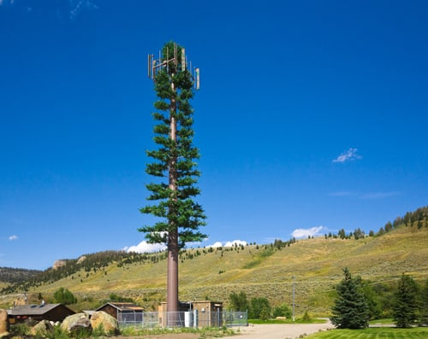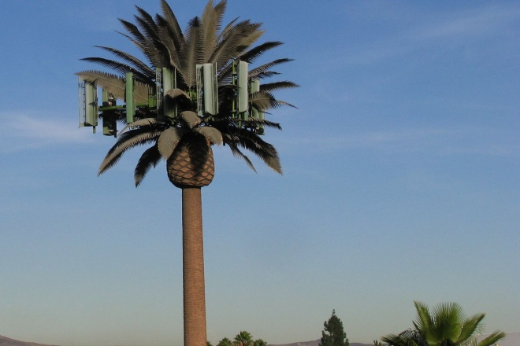
Former DARPA Senior Scientist, Dr. Paul Batcho, asserts that cell phone towers pose an intentional and immediate lethal threat against the general public of the United States … These transmissions will cause harmful health affects in the form of enhanced microwave radiation illness. It is
imperative that these frequency bands be measured and verified by an official source. These frequency bands do not exist naturally, and there is a technology targeting individuals…Civilians are being harmed by the deliberate transmissions of an established technology. The verified measurement and existence of these RF band transmissions constitutes a terrorist act.
Cell Towers Radiating Our Children
“The rollout of smart meters proceeds alongside increased installation of wireless technology and cell phone towers in and around schools in the US. In 2010 Professor Magda Havas conducted a study of schools in 50 US state capitols and Washington DC to determine students’ potential exposure to nearby cell towers. A total 6,140 schools serving 2.3 million students were surveyed using the antennasearch.com database. Of these, 13% of the schools serving 299,000 students have a cell tower within a quarter mile of school grounds, and another 50% of the schools where 1,145,000 attend have a tower within a 0.6 mile radius. The installation of wireless networks and now smart meters on and around school properties further increases children’s RF exposure. Many school districts that are strapped for cash in the face of state budget cuts are willing to ignore the abundance of scientific research on RF dangers and sign on with telecom companies to situate cell towers directly on school premises. Again, the FCC’s thermal effect rule is invoked to justify tower placement together with a disregard of the available studies.
In nearly every major university in America, wireless carrier corporations and the various governmental alphabet soup agencies have combined to place dangerous arrays of electromagnetic towers on campuses frequently near dorms and college offices. Some of these towers are merely cell phone towers. Some towers have implications for “national security.” Regardless, universities all across this country are displaying profound sense of depraved indifference towards the well-being of students, staff and faculty who live and work on these campuses.
These institutions of higher learning are paid big bucks in order to accept these towers. And if these towers are not dangerous, then why do the corporations spend millions trying to disguise the towers by making them look like trees?

***Voice to Skull Technology is Embedded in 5G-Mind Control Reaches Its Apex - Dave Hodges – The Common Sense Show, August 10, 2018
THE SPIRAL DOWNWARD: Recently I was approached by a self-described “insider” who had at one time worked for DARPA. He insisted that the new 5G technology being rolled out across the country was both lethal and contained mind control elements that should alarm all people…I know that mind control exists, however 5G being an element of mind control surprised me. Subsequent to my search, I found the patent that should scare the hell out of all Americans. “United States Patent 6,017,302 Loos January 25, 2000, Subliminal acoustic manipulation of nervous systems.”

[Refer to the complete article about the patent: “5G and Mind Control – the Patent, posted June 17, 2018 by Bradford S. Weeks, MD | WeeksMD
Re: Electromagnetic (EM) Mind Control – But Worse -“United States Patent 6,017,302, Loos, January 25, 2000]

“…In human subjects, sensory resonances can be excited by subliminal atmospheric acoustic pulses that are tuned to the resonance frequency. The 1/2 Hz sensory resonance affects the autonomic nervous system and may cause relaxation, drowsiness, or sexual excitement, depending on the precise acoustic frequency near 1/2 Hz used. The effects of the 2.5 Hz resonance include slowing of certain cortical processes, sleepiness, and disorientation. For these effects to occur, the acoustic intensity must lie in a certain deeply subliminal range. Suitable apparatus consists of a portable battery-powered source of weak sub-audio acoustic radiation. The method and apparatus can be used by the general public as an aid to relaxation, sleep, or sexual arousal, and clinically for the control and perhaps treatment of insomnia, tremors, epileptic seizures, and anxiety disorders. There is further application as a nonlethal weapon that can be used in law enforcement standoff situations, for causing drowsiness and disorientation in targeted subjects. It is then preferable to use venting acoustic monopoles in the form of a device that inhales and exhales air with sub-audio frequency.
Inventors: Loos; Hendricus G. (Laguna Beach, CA)Family ID:25505170Appl. No.:08/961,907 Filed:October 31, 1997…
The patent goes on to further describe the workings of this acoustic technology.
Experiments have shown that atmospheric acoustic stimulation of deeply subliminal intensity can excite in a human subject the sensory resonances near 1/2 Hz and 2.5 Hz. The 1/2 Hz resonance is characterized by ptosis of the eyelids, relaxation, drowsiness, a tonic smile, tenseness, or sexual excitement, depending on the precise acoustic frequency near 1/2 Hz that is used. The observable effects of the 2.5 Hz resonance include a slowing of certain cortical functions, sleepiness, and, after long exposure, dizziness and disorientation.
According to my inside source, that when the brain reaches the 2.5Hz, it is vulnerable to implantation of ideas and suggestions for behavioral modification. I was stunned when I found this passage in the description section of the patent because it matched what I was told by the former DARPA source.
The finding that these sensory resonances can be excited by atmospheric acoustic signals of deeply subliminal intensity opens the way to an apparatus and method for acoustic manipulation of a subject’s nervous system, wherein weak acoustic pulses are induced in the atmosphere at the subject’s ears, and the pulse frequency is tuned to the resonance frequency of the selected sensory resonance. The method can be used by the general public for control of insomnia and anxiety, and for facilitation of relaxation and sexual arousal.
Based upon the above description, we are seeing acute and dramatic behavioral modification as a result of this technology.
Clinical use of the method includes the control and perhaps a treatment of anxiety disorders, tremors, and seizures. A suitable embodiment for these applications is a small portable battery-powered sub-audio acoustic radiator which can be tuned to the resonance frequency of the selected sensory resonance.
The ability to embed mind control into the 5G range is discussed in the patent...The invention can also be implemented as a sound tape or CD ROM which contains audible audio program material together with subliminal sub-audio signals. The recording can be done by mixing the audio and sub-audio signals in the usual manner. In choosing the sub-audio signal level, one must compensate for the poor frequency response of the recorder and the electronics, at the ultra low sub-audio frequencies used.
The above paragraph contains a description of what is known as voice-to-skull technology--the process was popularized by Dr. Nick Begich. In his book, Angels Don’t Play This HAARP, Begich describes how he provided the European Union legislature with a personal demonstration of implanting voices into someone’s head in a technological approach, Begich referred to as voice-to-skull technology. The European Union leaders were so stunned, they passed a resolution against the use of the technology.
Unmistakable Referencing to Mind Control
Brain mapping under the guise of research has the strong appearance of being a whole lot more than someone’s laboratory investigation. Consider the very telling excerpt in which project managers state that they want to implant electrodes in hundreds of cell membranes by an army of nanoparticles which will allow these nanoparticles to become a part of the cell membrane functioning. The process is described in the project managers own words: `…Nanoprobes bearing several dozen electrodes, for instance, could be stacked to probe hundreds of thousands of recording sites and transmit data wirelessly. Alternatively, nanoparticles carrying molecules that bring them to specific cell types could lodge in cell membranes so surgical placement wouldn’t be necessary. The nanoparticles could also carry molecules that can sense electrical activity, pressure, or even certain chemicals revealing brain activity.’
United States Patent 5,159,703, Lowery, October 27, 1992, Silent Subliminal Presentation System, Inventors: Lowery, Oliver M. Appl. No. 458339 Filed December 28, 1989, discusses the microwave technology necessary for mind control.
In this patent we witness the move from the mind control of certain individuals who might have been programmed, which is frightening enough, to witnessing entire populations being controlled. 5G coming to a neighborhood very soon! Welcome to the Brave New World, where very soon, the globalists will own everything, including your thoughts.
The behavior of an entire population can be changed by using this technology on a mass scale.

Voice to skull technology is already being used by HAARP!
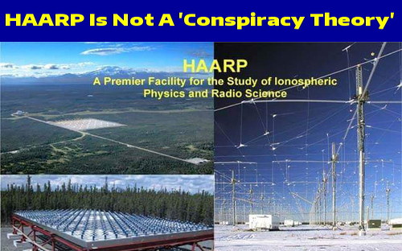
Hodges: “Haarp is bouncing electromagnetic messages off of the Ionosphere into the minds of the humans on Earth.
The signal can come back as a long beam, a broad beam, it can be weaponized as a stimoceiver, or it can be tuned to the frequency of the brain. If you change the frequency of the brain you can change the function of the brain.”
In 1961, this was proven in Barcelona, Spain. Using this technology, Dr. Jose Manual Rodriguez Delgado entered a bull fight ring. The bull was released into the ring. Just using this technology as a transmitter, Delgado changed the brain function of the bull, and the bull went from being a charging bull to a docile bull in a few seconds. Delgado ended up working for Stanford University with the CIA in mind control and psy-ops.
This technology was used on Iraqi soldiers in Gulf War II, changing them from hostile soldiers into pacific men; some put their heads on the shoulders of U.S. soldiers and cried. I know about this from the “inside” for I was living west of Iraq during the onset of this war.
5G is an updated, new and improved version of this technology – so that it becomes a voice to skull mind programming, control-of-the-masses device.
5G electromagnetic waves reach a larger area because of the towers they broadcast from, broadcasting at a subliminal level that can alter the behavior of human beings. But, would it also be used to weaponize animals, and perhaps reptiles and birds, and insects, to be used against humans? The 5 G is going to be combined with the original technology, which would make it super effective. ***Total mind control for earth’s population!
Commentator 1: `Thanks for this illuminating article. Unfortunately, it is also true that 5G millimeter wave technology is being used for crowd control and defense purposes by the army in its ‘Active Denial System.’ Though many deny the health and biological effects of directed energy beam technologies as well as the indiscriminate atmospheric pollution from wireless microwaves, there is a reason the defense departments of many countries are developing these types of weapons.’
Commenter 2: `5G can also use “spot beam” technology where bandwidth is increased by focusing a personal beam of RF at your device at a distance. This is done through phased array antennas on the tower.
The public position will be that these technologies, if developed into weapons, will be used against terrorists and those who pose a threat to national security. However, because these are “stealth” technologies where the person being targeted would not even know they were being targeted, they could potentially also be used against people who object to mandatory vaccination, medical kidnapping, the nationalization of our private health data, the use of toxic chemicals in food, mandatory indoctrination of children in the public education system, mainstream media brainwashing, the collection of information about our religious and political beliefs, the denial of the right to assemble in peaceful protests against the overreaching power of national and state government, to name just a few.’
The U.S. Military uses its microwave based Active Denial System (ADS) as a non-lethal weapon…a tightly focused and invisible beam of 95 GHz microwaves can be projected a long distance – farther than the reach of standard military rifles. This beam of millimeter radiation travels at the speed of light and is able to penetrate human skin about 1/64 of an inch.
This microwave radiation heats the water molecules in the skin and triggers pain nerves located on the surface of the skin. This intense heating causes people to immediately jump away from the beam and go wherever the system operator pushes them.
Vehicle-Mounted Active Denial System (V-MADS): This non-lethal microwave weapon was designed for crowd control. It can move a crowd of civilians out of the way of military activity or disperse civilians who are watching military activity. (see picture page 1 above) It can also target individual enemy agents in urban warfare or battlefield conditions. It can penetrate automobile window glass and subdue the driver with intense heat and pain, thus causing the vehicle to stop.
A recent article in the Washington Times reported that the Russian military is equipping aircraft with microwave weapons. Some of these weapons are so dangerous to the lives of human pilots that they must be placed on unmanned aircraft and controlled from a distance.
5G Cell Towers Also Direct Microwave Beams at People
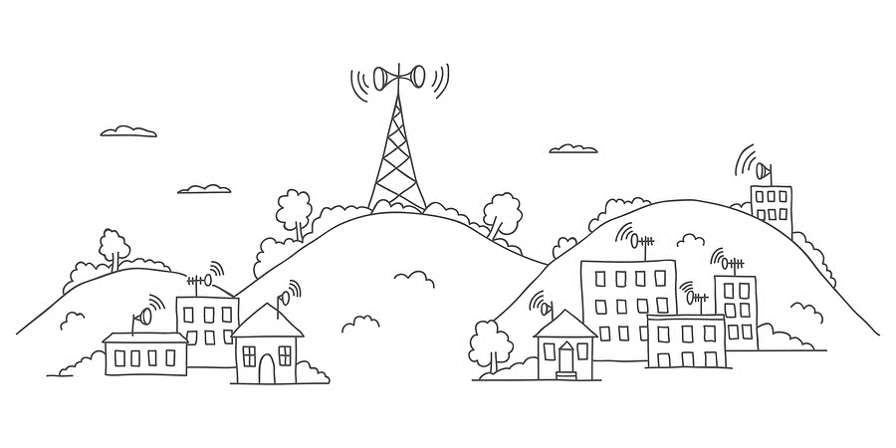
The previous information about the military’s Active Denial System confirms that microwaves can be directed toward a specific target.
We also know that the 5G wireless technology system that Telecom companies want to install across America has the ability to steer microwave beams toward objects. In fact, this is one of the key features of the 5G system. This allows each 5G cell tower to direct multiple beams of millimeter microwaves to a cell phone, an iPad, tablet PC, automobile, or any other device that will provide a GPS location.
If you are using a cell phone as you drive, the nearest 5G tower will lock a beam on you and your phone as you travel. It targets your phone and tracks your every movement. It makes frequent adjustments in the trajectory of the microwave beam to keep you connected. If your car has built-in GPS, then your car can be tracked in the same way.
5G Cell Towers use Antenna Arrays to Create a Microwave Beam Which Locates Nearby Devices. 5G cell systems use phased array antennas and electronically variable phase shifters, to simultaneously project a large number of microwave beams toward multiple users across a band of frequencies.
Antenna arrays consist of hundreds and sometimes many thousands of individual antennas, which are clustered together in a specific pattern to create many steerable beams of microwaves.
These fixed antenna arrays are also called adaptive or smart antenna arrays, because the microwave beams they produce are electronically steered by computers.
Simply initiating a cell phone call or making an internet connection triggers an automatic response from the antenna array on the 5G cell tower to adjust its output and to direct a microwave signal toward your device. Even when your phone is in standby mode, it will periodically make contact with the cellular system, during which it provides its location.
The Military Uses Fixed Array Antenna Systems to Track Satellites – See Through Walls
Fixed array antenna systems are also used by the military for its newest generation radar systems. These antenna arrays scan the sky and track satellites. The electromagnetic frequencies they use are much lower than 5G, which means their beams can travel great distances.
Fixed array antenna radar systems can also be used at close range to see through walls into buildings.
Fixed antenna arrays consist of small antennas arranged in one of several configurations such as a grid, a circle, or a line.
Basic Facts that Explain How the 5G System could be used as a Weapon
I am sharing this information to help you follow a logical train of thought about the potential of using 5G technology and smart meters for weapon-like purposes.
1. The higher the frequency the shorter the wavelength. This means that the military use of 95 GHz frequency involves radio waves that are quite short. They are in the 1-millimeter frequency band, which generally ranges from 30 GHz to 300 GHz. Because they are short, they cannot travel as far as longer length waves. They also are less able to penetrate objects. This is why it is claimed that they can only penetrate human skin to a depth of 1/64 of an inch.
2. The microwaves that are used for 5G communication are usually in the 28 GHz and 38 GHz frequency bands, though testing has also been done in the 78 GHz frequency band. As far as we know, exposure to these frequencies do not heat human bodies, because the microwave density is much lower than military microwave weapons. Density refers to the amount of radiation that passes through a square centimeter or square meter in a second.
The higher the density, the greater the potential for doing harm.
3. Microwave ovens use microwaves that are around 2.8 GHz. These are longer waves than those used in 5G. As we know, they penetrate food easily and when the density is high, they cook the food. Most of the microwave activity is contained in the cooking chamber so that the microwaves won’t cook the human beings who use the ovens. Though it should be understood that almost all microwave ovens leak microwave radiation, which is a health risk for people who stand close to them.
4. Microwaves used for Wi-Fi routers are also in the same range as microwave ovens, though the density of their transmission is much lower. Their health risks come from the fact that the microwave radiation is constant and has longer wave lengths than 5G. These microwaves can penetrate into the body and produce cellular changes.
5. Cell phones and smart meters operate at various frequencies that are in the range of 2.8 GHz down to 900 MHz. This means their microwave radiation can penetrate even deeper into the body. Because of the proximity effect, cell phones can produce a heating effect in the skull and brain when they are held up to the ear.
6. If you wanted to use a cell phone to cook food, then it would be necessary to increase the microwave density produced by the phone. If you did this it would cook your hand when you held it. This is why cell phone manufacturers keep the density high enough to reach cell towers but low enough to not cook the brains of users too much when they hold a cell phone next to their ear.
7. In practical terms the difference in wave length between the telecom’s 38 GHz and the military’s 95 GHz is not that great since this is all in the 1-millimeter frequency band. The factor that differentiates a weapon from a cell tower is primarily microwave density.
8. Since frequencies in the range of 28 to 38 GHz can’t travel as far as lower frequency transmissions, it is necessary to place the cell towers much closer together. This is why the proposed implementation of the 5G system in California will require the addition of 50,000 new cell towers to make the 5G system operational. The cell towers could be as close as 100 to 300 meters apart.
Putting the Facts Together – Potential Outcomes of 5G Technology
Now, this is where it gets very interesting. What would happen if the density of 5G cell tower transmissions could be jacked up to a much higher density level? Could 5G technology become a directed energy weapon? Instead of sending a beam of low density microwave radiation toward you and your cell phone or toward you and the GPS system that is built into many automobiles, could the system be adjusted to send a much more powerful beam of high density microwaves toward you or a crowd of people such as is done with the U.S. military’s Active Denial System?
…However, all electromagnetic radiation produces an effect on the human body. What impact will the slightly longer microwaves from 5G have on us when they penetrate more deeply into the body than the 95 GHz of the military’s Active Denial System?
We have very little data at this point to inform us of what exposure in the 28 GHz, 38 GHz or the 95 GHz range will do to human life in the long-term. All we know at this point is that microwave radiation from devices in the 900 MHz to 3 GHz frequency range can cause many symptoms of distress and illness as described in my previous articles.
Telecom companies who are promoting 5G and utilities that are using smart meters continue to claim that their microwave technology is harmless, but as I explained in the previous articles, this is false information. Even the military indirectly admits that there are some risks associated with their active denial microwave weapon, though they don’t define what they mean by “minimal risk.” ]
What would happen if a 5G tower directed a microwave beam at someone 24-hours per day whether or not they were using their cell phone? What if they increased the density of the microwave beam and directed it at someone’s bedroom, so that their ability to sleep was disturbed and their ability to enter into normal biological rest and repair was stopped?
What if the microwave stream was intentionally randomly pulsed like a smart meter? What would happen to someone’s heart if the constant microwave activity continually disrupted normal heart rhythm? What would it do to increase the likelihood of developing some form of heart disease or cancer?
How would long-term sleep deprivation affect one’s cognitive processes? Could sleep deprivation drive someone into some type of mental illness? Sleep deprivation is one of the tools used by mind control agents to break a human being so that they can be easily programmed to carry out the will of another person. Inadequate sleep also can set in place a pattern of declining health, which eventually leads to life-threatening illness.
But could people who publicly disagree with the plans that the government is making for America, such as those who oppose mandatory vaccinations for example, become targets of a silent form of microwave attack from 5G towers – attacks that disrupt sleep, immune system functioning, normal body rest and repair, cognitive activity, and emotional balance? Could 5G and Smart Meters become Lethal Weapons?
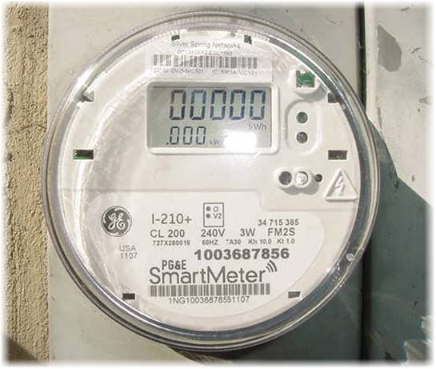
Could smart meters also be used to covertly deliver elevated levels of microwave radiation to the occupants of a house or office over a period of months or years? We already know that the microwave bursts from normally functioning smart meters disrupt human heart rhythm. (See my previous article on smart meters for the details.)
However, we don’t know what secret research might have been done to determine the best way to use bursts of microwave radiation from smart meters to maximize heart damage, particularly in counter-terrorism research.
What if the smart meter in anyone’s home or office could be programmed to deliver an intentional pattern of pulsing microwave radiation with the intent of producing damage to someone’s heart? How much damage could be produced over a period of months or years? Could this push someone towards having a coronary episode such as a fatal heart attack? Some doctors think so. (See my previous articles for the details.). Would the real cause of death ever be identified? From the standpoint of an autopsy, death from a heart attack would probably be called death by natural causes.”

5G Will Use the Same Frequencies as Pain Inflicting Military Weapon
Health Freedom Idaho December 29, 2018
What does 5G network and a non-lethal weapon developed by the military have in common? The Department of Defense has developed a non-lethal crowd control device called the Active Denial System (ADS). The ADS works by firing a high-powered beam of 95 GHz waves at a target—that is, millimeter wavelengths. Anyone caught in the beam will feel like their skin is burning. The burning sensation stops once the target leaves the beam.
This weapon operates on 95GHz waves and 5G will operate on the same frequencies.
I love my devices as much as anyone else but I don't want to the health of my grandchildren at risk. I don't want to put them in harm's way. We now know that the skin, our largest organ does respond to 5g, and in fact our sweat ducts they can act as antennas that can receive signals. 5G has not been tested for safety. The fact that it can interact with our sweat ducts may have much more profound meaning for our overall health and well-being. The idea that we're going to saturate this country with a network that has never been tested is appalling. I am joining with many other scientists from around the world now to express concerns.
Dr. Davis' group - Environmental Health Trust - explains: Israeli research studies presented at an international conference reveal that the same electromagnetic frequencies used for crowd control weapons form the foundation of the latest network - branded as 5G - that will tie together more than 50 billion devices as part of the Internet of Things. Current investigations of wireless frequencies in the millimeter and submillimeter range confirm that these waves interact directly with human skin, specifically the sweat glands. Dr. Ben-Ishai of the Department of Physics, Hebrew University, Israel recently detailed how human sweat ducts act like an array of helical antennas when exposed to these wavelengths. Scientists cautioned that before rolling out 5G technologies that use these frequencies, research on human health effects needed to be done first to ensure the public and environment are protected.***
[Dr. Davis notes] "This work shows that the same parts of the human skin that allow us to sweat also respond to 5G radiation much like an antenna that can receive signals. We need the potential adverse health impacts of 5G to be seriously evaluated before we blanket our children, ourselves and the environment with this radiation."
...The number of sweat ducts within human skin varies from two million to four million. The researchers pointed to replicated peer research of these biological effects in laboratory research conducted in other countries and considered this mechanism of action well proven. Today's cellular and Wi-Fi networks rely on microwaves - a type of electromagnetic radiation utilizing frequencies up to 6 gigahertz (GHz) in order to wirelessly transmit voice or data. However, 5 G applications will require unlocking of new spectrum bands in higher frequency ranges above 6 GHz to 100 GHz and beyond, utilizing submillimeter and millimeter waves - to allow ultra-high rates of data to be transmitted in the same amount of time as compared with previous deployments of microwave radiation. Now a US weapons that relies on the capability of this electromagnetic technology to induce unpleasant burning sensations on the skin as a form of crowd control is being rolled out. Millimeter waves are utilized by the U.S. Army in crowd dispersal guns called Active Denial Systems…”
…There’s no opting out of 5G—in fact it will become more ubiquitous than wireless technology is right now. As Verizon boasts on its website, the “Internet of Things” will thrive on 5G technology. The Internet of Things refers to the expanding number of devices, appliances, utilities, and other technologies that collect, transmit, and share data through the internet. Essentially, many processes that have not previously relied on the internet will start to once 5G roles out: switching light bulbs on or off with a smart phone app, driverless cars—even “smart cities” that will use wireless networks to collect and analyze data about the environment, traffic, water, transit, lighting, waste management, security, and parking.
…the pulsed nature of these high frequency, high signal intensity signals do not harbor good news for humanity, particularly in relation to the functioning of our DNA.”
So dear brothers and sisters: Plans of Satan and his hosts for humanity are finally coming to light. It’s too bad that the general public is kept too busy with work and enjoying the comforts and entertainments of life to keep up with the death-sentences given to the human race by the hosts of the dark kingdom, let alone keep up with the return of Messiah and the glorious promises of His Kingdom.
This ministry is dedicated to helping Abba’s children “keep up,” “keep awake,” and “go forward” with courage, faith, strength, peace, joy, and pure intent to enter the Kingdom with rewards following.
All articles and podcasts are directed to keeping up with the enemy, but more so - tapping into the mind of our Abba and Messiah--knowing Them, loving Them, hearing Them in our spirit, obeying Them, and being ready for Messiah’s return!
Shalom, Yedidah
January 3, 2019

