A PROPHETIC LOOK AT THE DEADLY EARTHQUAKE IN TURKEY
NEAR THE HEADWATERS OF THE EUPHRATES RIVER

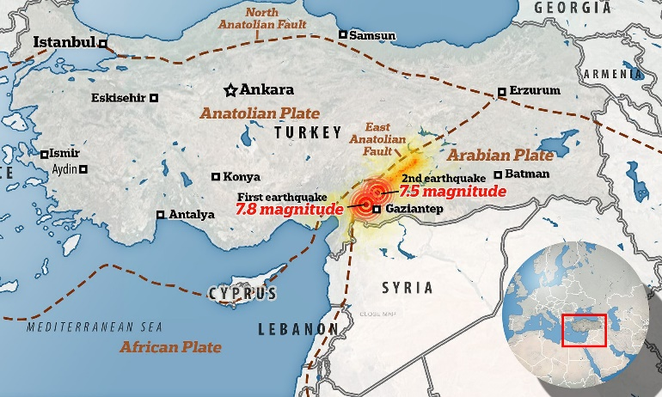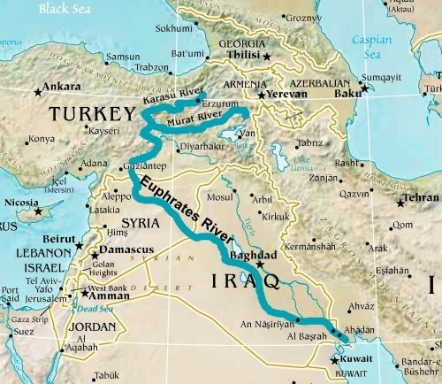

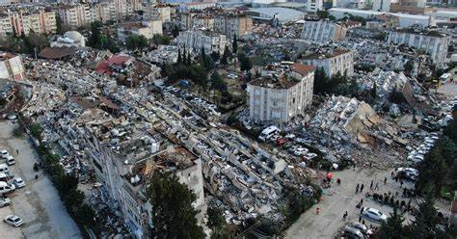

Excerpts from Revelation 9:12-18, 20-21: “The first woe is past. See, two woes are still coming after this. 13And the sixth messenger sounded, and I heard a voice from the four horns of the golden altar which is before Elohim, 14saying to the sixth messenger who had the trumpet, `Release the four angels, those having been bound at the great river Euphrates.’ 15And the four angels, those having been prepared for the hour and day and month and year, were released to kill a third of mankind. 18A third of mankind was killed by these three plagues, by the fire and the smoke and the sulfur which came out of their mouths…20 And the rest of mankind, who were not killed by these plagues, did not repent of the works of their hands, that they should not worship the demons, and idols of gold, and of silver, and of brass, and of stone, and of wood, which are neither able to see, nor to hear, nor to walk. 21And they did not repent of their murders, nor of their drug sorceries (“pharmakia”), nor of their whoring, nor of their thefts.”

Revelation 16:10-15: “And the fifth messenger poured out his bowl on the throne of the beast, and his reign became darkened. And they gnawed their tongues from pain. 11And they blasphemed the Elohim of the heaven for their pains and their sores, and did not repent of their works. 12And the sixth messenger poured out his bowl on the great river Euphrates, and its water was dried up, in order to prepare the way of the sovereigns from the east. 13And I saw coming out of the mouth of the dragon, and out of the mouth of the beast, and out of the mouth of the false prophet, three unclean spirits, as frogs, 14for they are spirits of demons, doing signs, which go out to the sovereigns of the entire world, to gather them to the battle of that great day of יהוה the Almighty. 15 `See, I am coming as a thief. Blessed is he who is staying awake and guarding his garments, lest he walk naked and they see his shame.’” Messiah speaks in verse 15, take note!
In Ezekiel 38, we see a list of nations that come against Israel, the main nation is Russia, but also Iran, and Turkey. These nations right now are united, as Israel has boldly said they will strike Iran with 3,000 pre-emptive strikes – most likely EMP and nuclear. Israel has been provoking Iran for a long time by bombing Iranian sites inside Syria as well as inside Iran itself. Iran said a long time ago that they did not want war with Israel. Though Iranian leader, Ahmadinejad, boldly proclaim Israel to be the “little Satan,” and America to be the Big Satan. Knowing the grass roots truth, he was right.
Not the people, but the government leadership and their plans to take out Iran.
As I’ve relayed many times, President George Bush, Sr. said to General Wesley Clark, which he publicly related to us all, there were 7 nations to be taken out and once they were, the globalist agenda would take over – aka the Beast system. Well folks, true to his nasty word, 6 have been taken out, Iran was to be the last one. It’s all been planned!
February 6, 2023, a massive series of earthquakes, the largest registering 7.5 and 7.8 near the border of Turkey with Syria, sent shock waves as far northwest as Greenland. To date, the death toll has gone way over 11,000 since yesterday, and rising.
What is the prophetic significance of this happening now, amidst all the other prophetic events taking place, pointing us to the return of Yahushua Messiah as “King of kings and Master of masters?” (Revelation 11:15)
Our Father, as in the days of Noah, shortened the days for the sake of Noah and his family by having everything to do with His judgment occurring at once. Six weeks, from start to finish, and the worst of it was over. Messiah said “As it was in the days of Noah, so shall it be at the coming of the Son of man,” referring to Himself.
He confided the details to His “taught ones,” (disciples) whom He knew as “friends.”
He used ancient culture terms that they would understand to pinpoint the timing to the “time period” in which we now live.
His Truth is often hidden in what all knew back then but because of the use of Roman words translated as Roman words, those of the western world today understand little of the enormity of what He shared with His friends. “You are My friends, He said, IF you do as I have commanded you,” (John 15)
He is “Master of all, or He is not Master at all,” so said Hudson Taylor, the great missionary who opened up the interior of China to the Good News in the late 1800s.
The true new birth is when we realize Yahushua Messiah “bought us” off the slave block of slavery to the dark kingdom of Lucifer/Satan and fallen angels, the damned ones, to become His servant in training for reigning in the Kingdom of Light, the Kingdom of heaven.
I have studied the Word and allowed the Spirit of Yahuwah, the Father, to teach me from Genesis to Revelation, so that what I believe is like a solid rock that cannot be moved, but is anchored in Truth. He started me out with a passion for the prophetic Word in 1963, where I learned the significance of the layout of the tabernacle of Moses, and later the Temple of Solomon. However, He never meant us to have to go through human priests to His Presence.
By the death of Yahushua, taking our place to pay the punishment for our sins against a righteous, set-apart El (God) the Father, and His resurrection to give us eternal life, He opened the door for Friendship between us, so that we might “know” Father and Son intimately as They are – and in return be as a little child in love, joy, peace, forgiveness of others – taking on Their nature, ways, and thinking. The Spirit of Yahuwah is then able to enter our belly area, (John 7:37-39) where our eternal spirit dwells, so that we become the temple where He can dwell within us – teaching, guiding, directing, cleansing, transforming, healing, empowering, preparing us to be ready to enter the Kingdom of heaven.
Having a religion, a belief-system does not save us. It is what we do with it as we allow Them, Father and Son, to remold us, transform our mind, emotions, and will – so that we know Them, and They know us.
They are not mocked by religious pride and performance. That does not impress Them one little bit. What impresses them is our passion to know Them and do as they lead us to do without self-will getting in the way.
Yahuwah dwelt over the Ark of the Covenant in a Most Set-Apart Place of Solomon’s Temple, but when the priesthood became so corrupt, so idolatrous, so sinful, He quietly moved off the Ark and ascended from the top of the Mount of Olives into His throne room. He did not return until Acts 2! It was then that He came into a reborn spirit by faith in His Son, so that we might be a temple not made with hands of humans.
Today Christians and Messianics are saying we don’t need the book of Acts. But, without our own personal Pentecost/Shavu’ot as in Acts 1 and 2, we can’t enter the Kingdom. He must rule from within us and transform our mind, emotions, will, desires, reasoning, so that it is His – so that we think and act, feel, and reason like He does.
To reject the Spirit’s enthronement on the ark within the born again spirit, is blasphemy against Yahuwah, the Most High, Shaddai/Almighty. To reject His control over us from within, from the “Speaking Place” of our innermost “set-apart” perfected place at a true new birth, is indeed insanity leading to damnation. (Matthew 12:22-32) It is Yahuwah, the Spirit, who causes us to be born-again, and who sustains us … to say His entrance into our “temple” is not important is truly to reject all He has given us through His Son!
We must saturate 9ur mind in His Word, or else all of the prophetic guidelines we are seeing now, over 200 of them compacting together at once, will not be noticed for what they are. We will not see Abba’s judgment so that He might set us apart unto Himself to be ready for His Son’s return.
1963-2023: That’s 60 years of study in the Word, led by His Spirit, who speaks to us in 40 different ways with examples through the Bible. The main way He speaks is to us as we study His Word. His voice is often heard in our re-born spirit. John 3: “Unless you are born again, you cannot enter the Kingdom of heaven.” Please refer to: “The True New Birth,” under the Mikvah of Eternal Salvation. He speaks to us, in the Speaking Place (I Kings 8:6,8) within our spirit (John 7:37-38; I Corinthians 6:19-20 and 7:23). You were “bought” – therefore as a servant of Messiah, in training for reigning, we do not hold back any of “self” but go forward to the Kingdom of “His Dear Son.”
Messiah warned us to be careful of all the lies and deceptions that Lucifer and fallen angels will give to us that sound so good. But, unless we know His Word, taught by Him from within, and we get to know Father as Abba/Daddy and Yahushua (Yahuwah is salvation) as Savior and Master, we will be easily deceived. 143,000+ Christian organizations and denomination.
John 17 is the passion of Elohim (Father and Son), “that They (us) might be one, even as We are one.” Father and Son, individuals, yet united “as if they were one,” Hebrew “echad,” in mind, emotions, feelings, reasoning, purpose, love, peace, joy, forgiveness, kindness, humility, obedience…
Question: The massive historic earthquakes in Turkey on February 6th were so powerful that they were felt clear to Greenland. The strongest ones had their epicenter at the headwaters of the Euphrates River. With the great damage done to the Ataturk Dam near the headwaters, it will dry up more.
Below: Ariel view, Ataturk Dam lower left
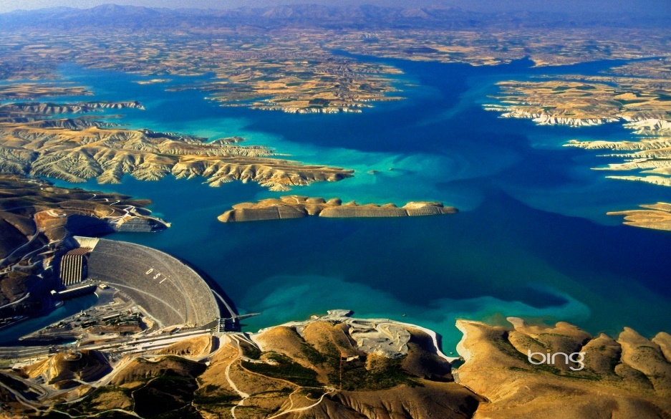
My first question to Abba, and for your consideration: Has this massive earthquake rattled the underworld of the fallen ones so greatly that it would allow these fallen ones to surface?
Few understand or want to understand how close we are to utter destruction, in the U.S., the U.K., … More than food and water, though we must be prepared with that, we must be prepared to go before the judgment seat of Yahushua Messiah and be prepared to enter His 1,000-year Kingdom on earth.
More questions: The River Euphrates is drying up. I did research on this in 2022 and downloaded many pictures from the whole of the River down past Baghdad. It is very dry. Now this earthquake has not only sent shockwaves thousands of miles away, but has shaken the underworld beneath earth’s surface. Has the release of the fallen ones begun? We know that Nimrod of Genesis 10 and 11 was unearthed in Iraq in April 2003. We know he was cloned by DARPA scientists. We know that the plans for the Genesis 11 tower were given to CERN, which used them to open the portals into the cosmos that Nimrod intended to open, as basically to go into the heavenly realm and “kill God,” and all of his angels. Nimrod was also known as Osiris, Horus, Apollo/Apollyon of Revelation 9:11.
Is this drying up of the Euphrates and the earthquake related, pointing to the fulfillment of Revelation 9, 16, and the destruction of America that is very close now?
Today he is out making demands for trillions of dollars to be used for his purposes, and was coronated in November of 2022 in Sharm El Sheik, Egypt, in secret, as part of the United Nations conference held there. I wrote much covering that, and the replacement Ten Commandments written and spoken on top of the false Mount Sinai by some of the representatives. The globalist’s worship of Lucifer/Satan is a reality. Their leading the world to worship Lucifer and his cloned entity Beast is in Revelation 13.
It is near time for the fallen ones to surface, since their leader, Apollyon, has surfaced. The name “Apollo” or “Apollyon” means “destroyer, as with “Shiva” of India – whose statue is at the entrance to CERN. The one goal of Nimrod was to destroy Yahuwah, Yahushua, their angelic worshippers, and destroy Their Kingdom. It is His goal now as Lucifer rules him.
The fallen ones, the aliens of their creation, the Nephilim of their hybridizing with human women, all are united under Lucifer with all the sold-out humans and cloned humans and hybridized humans by A.I. technology, by vaccination technology.
The drying up of the Euphrates signals the “kings of the east” are preparing their march towards the West. The armies of the China, for example, are moving worldwide, filling the U.S. and Canada as well. The great battle just before Messiah descends has been planned. The supernatural forces waiting under the earth all over the world are about to be loosed.
The demon spirits of Revelation 9 have been loosed. We’ve seen a marked increase in the compacted prophetic events of prophecy preparing the way for the return of Messiah. But, in America, most all are spiritually, and mentally asleep, awaiting all the coming delusions and frightful events that will paralyze them with fear.
Luke 21:10-17, 24-27: “Then He said to them, “Nation shall rise against nation, and reign against reign. 11And there shall be great earthquakes in various places, and scarcities of food and deadly diseases. And there shall be horrors, and great signs from heaven. 12But before all this, they shall lay their hands on you and persecute you, delivering you up to the congregations and prisons, and be brought before sovereigns and rulers for My Name’s sake. 13“And it shall turn out to you for a witness. 14 Therefore, resolve in your hearts not to premeditate on what to answer. 15 For I shall give you a mouth and wisdom which all your adversaries shall not be able to refute or resist. 16 And you shall also be betrayed by parents and brothers and relatives and friends. And some of you shall be put to death. 17 And you shall be hated by all because of My Name. 24-27 And they shall fall by the edge of the sword, and be led away captive into all nations. And Yerushalayim (Jerusalem) shall be trampled underfoot by the gentiles until the times of the gentiles are filled. 25 And there shall be signs in the sun, and moon, and stars, and on the earth anxiety of nations, in bewilderment at the roaring of the sea, and agitation, 26men fainting from fear and the expectation of what is coming on the earth, for the powers of the heavens shall be shaken. 27 And then they shall see the Son of Aḏam coming in a cloud with power and much esteem.”
II Kings 23:29: “While Josiah was king, Pharaoh Neco, king of Egypt, went to the Euphrates River to help the king of Assyria. King Josiah and his army marched out to fight him, but King Neco killed him when they met at Megiddo.
I loved to go to Megiddo when I lived in that region, and climb the hill, then sit on a rock at the entrance to Megiddo, a hill rising up off the floor of the Jezre’el Valley, so prominent in Scripture. The view is so beautiful, even including Mount Tabor.
I have written in detail about this valley of Jezre’el. Refer to: “Why Megiddo? Why the Jezre’el Valley?”/Mikvah of the Great Adventure #26.0. The third picture on page 1 shows the rock I sit on when I go, before going up into the top region. In this article, I compare Josiah (Yoshiyahu) with Messiah – amazing how Yoshiyahu put on the greatest Passover uniting all the tribes that will not be again until we are in the Kingdom!
II Kings 22:1-2: “Yoshiyahu was eight years old when he began to reign, and he reigned thirty-one years in Yerushalayim. And his mother’s name was Yeḏiḏah the daughter of Aḏayah of Botsqath. 2And he did what was right in the eyes of יהוה, and walked in all the ways of his father Dawiḏ, and did not turn aside, right or left.”
The Jezre’el valley is the oldest and biggest battle field on the earth. More battles have been fought there than anywhere else on earth from ancient times. It begins at Mount Carmel and ends near Tiberias. This is what the English language as covered up, as it has covered up so much of reality in Scripture: Armageddon is just a Greek word for Megiddo. Megiddo is near the ancient palace of Ahab and Jezebel at the once-town of Jezre’el near modern-day Afula.
Megiddo is a hill created by many civilizations from ancient times rising and falling in that spot. There is no battle at Armageddon. It is a meeting place for the armies of the Beast. As Messiah descends, He sees these massive armies waiting to shoot Him down. He speaks His “word” to them, and they all die – and their hybrid blood flows to the horse’s bridles.
Revelation 14:19-20: 19So the angel swung his sickle over the earth and gathered the grapes of the earth, and he threw them into the great winepress of God’s wrath. The grapes were trampled in the winepress outside the city, and blood flowed from the winepress in a stream about 180 miles long and as high as a horse’s bridle.” (Read about it in context)
I carefully studied this as I listened to Steve Quayle’s broadcast on the earthquake, in which he read Revelation 9 and 16. As I listened and downloaded maps, Abba began showing me things in scripture that tied into this. I look forward to more insight into what happened February 6, 2023 and prophetic Scripture. I only want “thus says Yahuwah,” not speculation or theory or ideas or reasoning or anything of human minds.
One thing I know! Yahuwah is preparing His people for what is shortly ahead. We’re either “sold out” to He and Yahushua as Master, as Teacher, as Transformer, or we’ll be “sold out” to the forces of darkness.
In His great love and wisdom, Yedidah – February 9, 2023

