AFGHANISTAN UPDATE II, GIANTS, PRESENT REALITY, AND
WHAT’S BEEN PLANNED
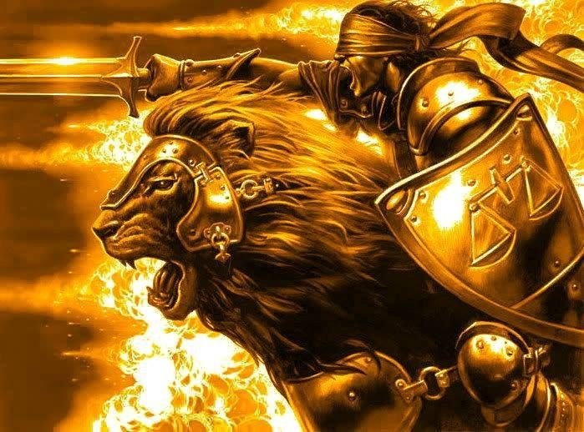
Time for warring in the spirit! Our Lion is leading us into Battle!
From Isaiah 59:14-20, Amplified: “Justice is pushed back, and righteous behavior stands far away; For truth has fallen in the streets and integrity cannot enter. 15Yes, truth is missing; and he who turns away from evil makes himself a prey. Now the LORD saw it, and it displeased Him that there was no justice. 16He saw that there was no man, and was amazed that there was no one to intercede [on behalf of truth and right]; Therefore, His own arm brought salvation to Him, and His own righteousness sustained Him. 17For He [the LORD] put on righteousness like a coat of armor, and salvation like a helmet on His head; He put on garments of vengeance for clothing, and covered Himself with zeal [and great love for His people] as a cloak. 18As their deeds deserve, so He will repay: Wrath to His adversaries, retribution to His enemies; to the islands and coastlands - He will repay. 19So they will fear the name of the LORD from the West and His glory from the rising of the sun. For He will come in like a narrow, rushing stream, which the breath of the LORD drives [overwhelming the enemy]. 20 `A Redeemer (Messiah) will come to Zion, and to those in Jacob (Israel) who turn from transgression (sin),’ declares the LORD.”
The future is glorious for those who are 100% loyal in faith and obedience to the coming King of kings and Master of masters and to His Father Yahushua - with all their love, devotion, dedication, heart, mind, and soul, and strength!
I Corinthians 2:9-10a: “…Eye has not seen, nor ear heard, nor has entered in to the heart of man what Elohim has prepared for those who love Him. But Elohim has revealed them to us by His Spirit…”
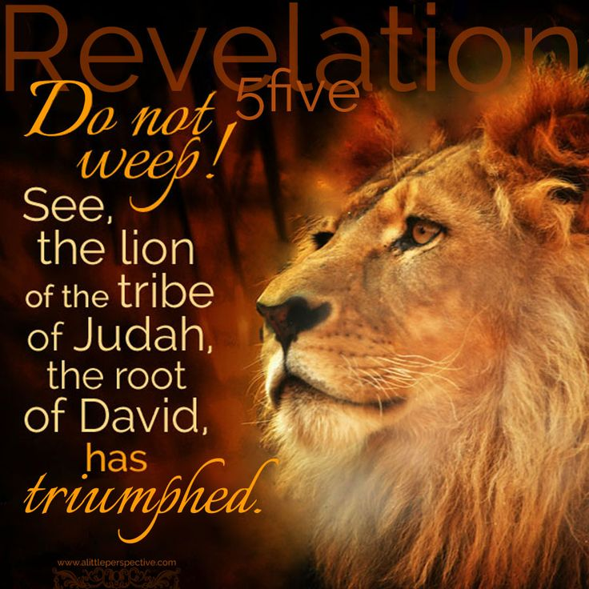
Our “Lion” is Mighty - Revelation 5:5: “…See, the Lion of the tribe of Judah, the root of David, overcame to open the scroll and loosen its seven seals.”
August 22nd: This came to me today from a friend in England: From Scripture Keys for Kingdom Living – June and Norman Davis, Denver Colorado, reporting on Afghanistan believers: “We received word that the underground church in Kabul, Afghanistan, has been martyred. Our friends have been in contact and met together last night in deep prayer. The last words she spoke: “We feel your prayers, because this supernatural boldness came over us and we were singing in the Spirit. Even the kids said `mom, we will not deny Jesus.’ As they were on the phone, they heard screaming and gun shots. God is so powerful. They went to their Creator, singing with joy. We will be fasting tomorrow for the churches still fighting, please join. Keep praying. Their reward is great. May the enemy encounter Jesus and His love, and they repent.”

Preparing for the Kings of the East – for China and its 200,000,000-man army:
Revelation 16:12: Look at the map below. There is just 48 miles between the border of Afghanistan and China.
As Paul Begley pointed out on Thursday night, August 20th, in interviewing “Mike from around the world,’ that Afghanistan is only 48 miles from reaching into China. The 200-million-man army of Revelation 9, is from China. They can now march across Afghanistan and into Israel.
Here is some recent information from Afghanistan. Take these things to Yahuwah in prayer. These things are coming to America soon than expected.
Steve Quayle, August 21 2021: “RIGHT NOW, AFGHANISTAN IS HOME TO THE LARGEST ASSORTMENT OF GIANTS BROUGHT BACK FROM STATIS ON EARTH”
The largest assortment of giants in stasis has been found on Sardinia, and other islands of the Mediterranean. These are not mummified or just bones of giants, these are real giants who were put into a type of suspended animation (stasis) and revived. Regarding Afghanistan: L.A. Marzulli and Steve Quayle reported on one about 2-3 years ago that was 15’ tall. The first regiment of soldiers that was sent to kill him were all killed and eaten by him. The second set of soldiers came prepared, knowing to aim at the head. They found the bones and decaying body parts of their fellow soldiers outside his cave. They aimed at the head and finally brought him down. He was flown out of Afghanistan to the U.S. Is there cloning going on, using the DNA from the giant’s bones? Is the Smithsonian also involved with this, since they confiscated hundreds of giants intact in graves all of the United States, especially at the turn of the 20th century.
U.S. military men have reported seeing giants in Iraq also. They are in many countries of Asia, Central and South America, Mexico, and the Middle East.
A lady had a dream of what’s going on in Afghanistan. She wrote it out and sent it via e-mail to Steve. He read it in his August 23rd briefing. She was astonished at seeing a man about 12’ tall. Yahuwah spoke to her: “The giants are among the Taliban.”

AFGHANISTAN BILLIONS OF DOLLARS WORTH OF MILITARAY EQUIPTMENT LEFT FOR THE TALIBAN
Biden just turned over hundreds of billions of dollars-worth of expensive military gear to the Taliban Thursday, August 19, 2021 by: JD Heyes
(Natural News) “For most of the past two decades, American taxpayers didn’t just support our military men and women deployed to Afghanistan, they also supported — to the tune of hundreds of billions of dollars — the building and training of the Afghan National Army. American training and weapons and tactics would surely build a lasting force capable of holding off a numerically inferior, far-less-equipped group of Taliban fighters — or so our generals and successive presidential administrations thought (or were told).
But as it turned out, the fighting force built by American taxpayers melted away ahead of advancing Taliban troops like ice cream on a hot summer day. But not only did America lose face, so, too, did we lose billions of dollars’ worth of military equipment — everything from older M-16 rifles and body armor to some state-of-the-art air assets. Built and trained at a two-decade cost of $83 billion, Afghan security forces collapsed so quickly and completely — in some cases without a shot fired — that the ultimate beneficiary of the American investment turned out to be the Taliban. They grabbed not only political power but also U.S.-supplied firepower — guns, ammunition, helicopters and more,” The Associated Press reported this week.
`The Taliban captured an array of modern military equipment when they overran Afghan forces. Bigger gains followed, including combat aircraft, when the Taliban rolled up provincial capitals and military bases,’ the AP continued.
A video posted online by a military contractor at the international airport in Kabul shows a plethora of personal gear and weapons that have simply been abandoned by the Afghan military which will fall into the hands of the Taliban once the U.S. military has completely withdrawn from the country, which will happen sooner rather than later.
In addition to small arms and other equipment, the Taliban have managed to get their hands of fleets of up-armored Humvees and MRAPs — mine-resistant armored vehicles U.S. and Afghan troops used to traverse the countryside to protect themselves from roadside improvised explosive devices (IEDs).
The AP noted that on Monday, defense officials confirmed that the Taliban was now in possession of “enormous” caches of U.S.-supplied weapons. `The reversal is an embarrassing consequence of misjudging the viability of Afghan government forces — by the U.S. military as well as intelligence agencies — which in some cases chose to surrender their vehicles and weapons rather than fight,’ the newswire reported.
In fact, according to a Washington Post report, the latter (surrender) was the norm rather than the exception, which explains why the Taliban, at about 75,000 men, were able to overrun the 300,000-strong Afghan National Army. [Yedidah insert: “Mike from around the world,” Washington insider, said that 90% of the U.S.-trained Afghan army will defect to the Taliban. Now, the U.S. has flown plane loads of men from the Afghan army to Wisconsin and to Texas to military bases there – hopefully these men are loyal to the U.S., but maybe not]
`The spectacular collapse of Afghanistan’s military that allowed Taliban fighters to walk into the Afghan capital Sunday despite 20 years of training and billions of dollars in American aid began with a series of deals brokered in rural villages between the militant group and some of the Afghan government’s lowest-ranking officials,’ the paper reported. `The deals, initially offered early last year, were often described by Afghan officials as cease-fires, but Taliban leaders were in fact offering money in exchange for government forces to hand over their weapons, according to an Afghan officer and a U.S. official.’
Reporting further, the Post said that these negotiations began about 18 months ago, beginning at the district and then the provincial levels, `culminating in a breathtaking series of negotiated surrenders [our emphasis] by government forces,’ multiple interviews with Afghan troops, special operations soldiers, police and military officers revealed.
In other words, the fix was in: There was never going to be a “fight” for control of Afghanistan; the Taliban was always going to be back in charge.
We don’t have all the details yet, but there are reports emerging that U.S. military and political leaders knew this years ago. When those details become available, as we know they will, we’ll report them. In the meantime, the American empire most of us never wanted is collapsing.
Sources include: NaturalNews.com, WashingtonPost.com, APNews.com

Paul Begley August 19th with “Mike from around the world”
Begley said the Taliban is going to run the country; they’ll now going to have a seat in the U.N. general assembly.
China will come in and have access to their diamond mines and all the heroin and opium fields of poppies. Billions of dollars in advanced technological weapons were left to the Taliban – helicopters, vehicles, tanks, guns and ammunition, -- all just left for them. Of course, it was planned that way.
The Taliban, like ISIS, like Al Qaeda, like the Muslim Brotherhood – and other terrorist organizations started by the US, will be given plenty of weaponry to destroy countries and bring them into subjection to the world government.
That commander of the Taliban who was at Gitmo was released by Obama and sent back to Afghanistan.
There are thousands of U.S. citizens still in Afghanistan. About 4,000 have gotten out so far. But most are trapped there.
“Gold mines, lithium, silver, diamond mines, opium, heroin – Afghanistan is rich in what the Elite want control of. The U.S. wouldn’t give it to them, but the Taliban will.”
As Begley said, the Taliban is also going to sell the high-tech helicopters to China and/or Russia, to Iran perhaps – and other weaponry that Biden just told the military to leave there for the good ol’ Taliban to use.
It’s another Viet Nam – a no-victory -- a shame to the America military. Twenty years of holding back the Taliban in Afghanistan because of Bin Laden, who died in 2001 of kidney failure – the lies are unbelievable.

Natural News August 23, 2021: “Same Biden regime that won’t even bother to save Americans in Afghanistan claims everyone should take vaccines because the government cares about saving lives.”

Begley said: “AFGHANISTAN FELL IN THREE DAYS”
Begley showed a picture of a teenage boy, a soccer player in High School in Afghanistan. He said he was one of three who clung to the outside of a plane taking off, and before the plane got very high, the boys were thrown off by the air thrust and of course they died. So, I guess the story was real. I heard it was not real.
The 200-million-man army can make its move now, Paul said, because they can go across Afghanistan without any problems now.
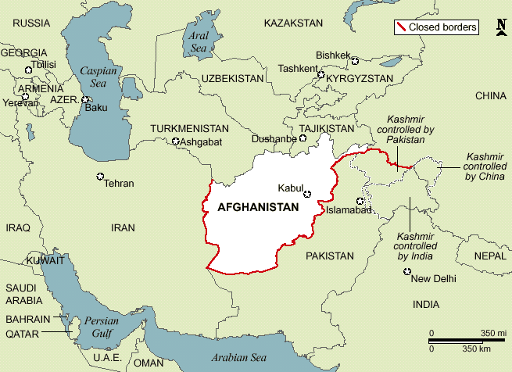
Note: Just about 48 miles from the tip of Afghanistan to China border
Begley said that their 200-million-man army can cross through Afghanistan now and Iran, Iraq and into Israel. (Revelation 9)
This transition was supposed to happen in May. Kamila was pushing for it then. Why the wait? Trump had already pulled some of our troops out.
Mike said that the Taliban invited Al Qaeda leadership into the Taliban. Uh ha! Obama created Al Qaeda … it was NOT bin Laden. It was Obama and Hillary’s baby. It was blamed on bin Laden, a dead man by late September 2001.
So, now Jimmy Carter’s Taliban and Obama’s Al Qaeda are joined together – to work together! Obama, trained by Saul Alinsky, on radical Communist overthrow of the United States, is uniting his “babies:” ISIS and Al Qaeda. The Muslim Brotherhood, created by the CIA, is even inside the U.S. government. The smaller terrorist groups, created by the U.S. are still in Syria killing Kurds and Christians.
Not just American citizens are stuck in Afghanistan now, but citizens of the UK, Canada, Australia, Germany, France, etc… school teachers, businessmen, military-related employees, etc.
Back in 2020, the chatter went off the scales, Mike said, regarding removing troops from Afghanistan. The Taliban heard it and decided form a coalition with Al Qaeda to take over the country. If the troops were leaving, they were not going to wait around to take over. It was an open door to them.
Mike said that the helicopters were full of top technology that can be shut down from a distance – they require a trained pilot also – so America can shut them down so they are of little use. The only problem is, like Begley said, they can be sold to China or Russia for a profit.
Taliban and Al Qaeda, Mike said, are basically funded by Russia, China, and Iran. They are ground forces for those super powers. They can give these terrorist groups weaponry and train them how to use it.
North Korea, Mike said, is a factory for Russia, China, and Iran also – they make weapons, they have given weapons to Iran.
Mike said that if we don’t “drop the hammer” to the Taliban, those people stuck in that nation are going to die. We’re talking over 10,000 – mostly American citizens, but also from those western-world countries mentioned above. “Those that are left back there – they know they have a death sentence,” Mike said. “The Taliban will purge the nation.” It’s like in Isaiah 13 – no mercy – death across board to get rid of all Americans and western world citizens.
You read in the first update a few days ago, how Obama got a chief Taliban leader out of Gitmo and restored him to Afghanistan, while swapping him for a man who was a U.S. military deserter to take his place in Gitmo. This whole thing has been planned for a very long time!!! That “Leader” is in control of the Taliban now.
Some of the trapped Americans hold special visas, they are U.S. special ops forces. Mike said they are trapped, and right now no one can get hold of them. They may try to cross the border into another country – but which one would let them in? All surrounding countries are Muslim nations, hostile to the U.S.
“Allied personnel” cannot be reached. They may be dead, Mike said.
Mike said that the U.S. trained 300,000 troops in Afghanistan. What will happen to them? Mike said that 275,000 of them will defect and join the Taliban. But some are on their way to Wisconsin and Texas for some reason, as Hal Turner reported.
Those that defected from the Taliban and joined the U.S. and Afghan forces, will be killed, of course. Some of the defectors of the Afghan army are in Texas and Wisconsin – flown out, as Hal Turner reported.
China is on the border of India. Mike: `China will get involved in Afghanistan – for sure. They’re only 48 miles from the Afghan border.’
`Pakistan may get involved with the Taliban,’ Mike said, `there’s the problem.’ If the U.S. doesn’t get tough and act, Mike said the world will change drastically from now on – `I’d stake my life on it.’
It’s just that, with the Taliban winning over the U.S. and Britain, and all the other troops there, their ego/pride will inflate and they’ll seek to take over more and more. Mike is concerned that all the western world civilians in Afghanistan won’t get out, but will be killed. Talk about a fuse to light to ignite WWIII.
Pakistan has already told the world that if war breaks out, they will be loyal to Islam, and the nations of Islam – not the West.
Mike said with loyalty to a religion like Islam, we have a problem like those of ancient empires – wars between kings. It’s not something we know in modern times for sure.
Mike said we have a lot of people in America from foreign nations. They’ll enjoy the U.S. as long as their mother-land is not at war with America. If their mother-land is at war with the U.S., they will be loyal to the agents inside America from their homeland. We have many from Muslim nations in the U.S. even in the House of Representatives and other high government positions. They’ll turn on us from within and join rebel groups of their own nationality.

WE HAVE SO MANY ENEMIES POSITIONED INSIDE THE U.S.!!!

From Steve Quayle, August 21, 2021 “Battle Stations! Battle Stations! Full Steam Ahead!”
“Fight in prayer! Cry out imprecatory prayers – for they are at war with Yahuwah and Yahushua. Pray these things be exposed.” Unless God intervenes, they will start shutting down the airports on 9/11 through 11/11. That would be private airports, but also airports for cities. This will ruin businesses for sure … ruin a lot of lives. This Bill is being passed in the House of Representatives.
Doesn’t the Senate have to approve also? Yes! However, since Joe got in, all three Branches of government are under the power of the Luciferians, the Satanists, the fallen angel-controlled globalist movement.”
Steve: “A false flag is coming. I don’t know the time or the details of the event, but a false flag is coming.” “Yes, probably several – the Hegelian Dialectic will once again be put in activated.” “Bloodshed is coming on the streets of America more than anything we can imagine.” Steve has had visions of what’s coming. He’s seen 2 billion dying. He’s “agitated;” what can he, or I, or anyone else, say now that will stop anything that’s been set in motion on a national or world level – it’s over?
Steve: “Our military, under our government now – they are ALL under the control of the evil one!” Don’t forget I John 5:19: “We know that we are of Elohim, and all the world lies in the evil one.”
Steve quotes from Psalm 2: The kings of the earth have gathered together against Yahuwah and His Anointed…” They are saying “we will not have this Man, Jesus, rule over us.”
Is Hillary still involved in world changes? We heard she was hanged at Gitmo a few months ago. However, that doesn’t stop her influence, as she could, like Bill, be cloned and programmed. So many of our leaders are now cloned, and programmed by the fallen angels and their direct agents, like Obama. So, “the U.S. Embassy in Kabul is being told by Hillary Clinton to tell Americans in Afghanistan not to go to the airport in Kabul `due to security threats.’ Yes, Hillary is still operating with Obama – hanged or not – whatever is posing as Hillary. On some things, we just watch and wait for the truth to surface. Truth is surfacing, and the evil ones are doing all they can to wipe it out, squish it down, or make a mockery of it before the public, so that people only believe lies, not the Truth. (Isaiah 59:14-15)
Steve said that on 9/11, they told the people in the Trade Center to stay in the building and they’d be all right. Those who fled out of the building lived, the ones who stayed died. Listening to the advice of the government appears to be the opposite of truth – because it is the opposite of truth.
Well that’s it for now. Keep up with alternative news, with articles on stevequayle.com, or with Natural News with Mike Adams and Dave Hodges of the Common Sense Show, and those like them. These men are close friends of Steve Quayle, who has been reporting truth for 50 years. The tragedy is that these men are laying their lives on the line to do so- pray for them! Dave Hodges in Arizona is getting many death-threats as is Steve Quayle.
Satan is the “father of lies.” He can’t tell the truth unless its twisted somehow. He puts the spirit of lying into public news and into politicians, and releases his fallen angel army into the earth to spread the lies. People follow what they hear on T.V., or from renegade pastors and Messianic leaders, loyal to Pharisee-lineage rabbis. Few hear from Abba and let Him give the truth into their spirit. Few are hooked up to the Kingdom of Heaven.
Be one of them – hook up solid with the Kingdom through the King.
In His love, Yedidah
August 24, 2021

