America: Civil War Has Begun
Along with the Persecution of Christians

Sen. Rand Paul's Wife: 'I Now Keep a Loaded Gun By My Bed' - We Are Not Heading Toward Civil War, We Are Already Fighting It - Prepare Now Because It Is Going To Get Far Worse - By Susan Duclos - All News PipeLine – October 4, 2018
“The latest hysteria over the upcoming vote to confirm Judge Brett Kavanaugh to the Supreme Court can be seen in the over-the-top reaction to Senate Majority Leader Mitch McConnell's decision late Wednesday night to file a motion to invoke 'cloture' on Kavanaugh’s nomination, a step which will lead to a final weekend vote, but in the bigger picture look at events, this whole Kavanaugh spectacle is just another phase of the civil war this nation is now in the midst of.
THIS IS WAR
Civil war is simply a war between citizens of a country and that is exactly what we are seeing. It is time to stop saying we are heading towards a civil war and to admit that we are already fighting it. There has already been blood in the streets, literally, as we have seen a mass shooting at a baseball practice where an unhinged leftist opened fire on GOP members of Congress back in June 2017, critically injuring House Majority Whip Steve Scalise, R-La., and injuring three others.
We have seen countless videos and images of Conservatives harassed, beaten, attacked and bloodied. Bike locks to the head, property destroyed during riots, women maced, teenagers attacked for wearing a MAGA hat in public, Republican politicians attacked in their own yards, heckled and driven out of restaurants.
Breitbart's Rap sheet of media approved harassment and violence against conservatives, shows 567 incidents since September 2015 until September 11, 2018, with 169 in 2018 alone.
Since September 11, 2018, as Stefan Stanford highlighted on Wednesday, the harassment and violence has continued unabated and is occurring with increasing frequency.
As the media continues to terrorize Americans, deliberately inciting more and more anger, harassment and violence against conservatives, Democrat politicians have publicly urged liberals to create `crowds,’ and confront political opponents (Maxine 'Mad Max' Waters in June), and to harass conservative politicians and Trump administration officials (i.e. Senator Cory 'I am Spartacus' Booker in July).
This morning I read a heartbreaking open letter to Booker from Kelley Paul, the wife of Senator Rand Paul. A woman who was terrified when news of the GOP baseball practice shooting broke until she heard her husband was alright, followed by her husband being attacked in their own yard, suffering five rib fractures including three displaced fractures.
She had her open letter published at CNN (archive is link here) and the very first paragraph includes the quote I used to begin my headline when she explains to Booker: "It's nine o'clock at night, and as I watch out the window, a sheriff's car slowly drives past my home. I am grateful that they have offered to do extra patrols, as someone just posted our home address, and Rand's cell number, on the internet -- all part of a broader effort to intimidate and threaten Republican members of Congress and their families. I now keep a loaded gun by my bed. Our security systems have had to be expanded. I have never felt this way in my life."
Think about that...A mother of three, a woman that maintains a board position at Helping Hero, a charity that builds homes for wounded war veterans, so terrified that she has to sleep with loaded gun by her bedside. Mrs. Paul goes on to describe what the last 18 months of constant threats and intimidation have been like for her and her family, and she concludes with a plea to Booker:
`Senator Booker, Rand has worked with you to co-sponsor criminal justice reform bills. He respects you, and so do I. I would call on you to retract your statement. I would call on you to condemn violence, the leaking of elected officials' personal addresses (our address was leaked from a Senate directory given only to senators), and the intimidation and threats that are being hurled at them and their families.’ Sincerely, Kelley Paul
A week-and-a-half ago Republican Senator Ted Cruz and his wife were harassed at a restaurant by anti-Kavanaugh protesters from the Antifa group Smash Racism DC, and Mitch McConnell was accosted at an airport. Other Senate members are being accosted and threatened in the Senate building by protesters, which has forced Capitol Police to boost their security.
Let me make this clear by reiterating, these latest attacks against conservatives are citing the Brett Kavanaugh confirmation process, but previous incidents including targeted harassment and intimidation tactics were about illegal immigration.
The Democrats highlight an "issue," the media jumps right onto it for them to incite liberals across the nation, then unhinged liberals start attacking.
Each time the protests get bigger, louder, more violent and receive more coverage. This isn't politics; this is a blood sport to them. This is civil war.
BOTTOM LINE - GOING FORWARD
In the short term, heading into the weekend, the media and Democrat politician’s hysteria will incite liberals online and off into more raging, threats and intimidation, as the Senate votes on cloture on Friday, leading to a confirmation vote on Saturday or Sunday. After the vote, if Judge Kavanaugh is confirmed to become Justice Kavanaugh, we can fully expect some epic meltdowns, again, online and offline.
The point, the bottom line here is that the harassment, intimidation, and violence will increase with every manufactured outrage and I personally think it is time to acknowledge the active, ongoing civil war that is being waged right now...”

Yedidah’s insert: A great lot of the protesters are paid by men like billionaire George Soros, and also some instigating the violence are CIA-MKUltra-programmed zombies with fragmented minds, programmed and controlled by the forces of evil. I once again urge you to read Russ Dizdar’s The Black Awakening. It will explain what is coming to your neighborhood, no matter where you live in this world.
Many are young people who have been mind-programmed and mind-controlled through the use of drugs, or just by propaganda, like what goes on in public schools, from elementary to high schools, colleges and universities.
The propaganda has included that Kavenaugh intends to overthrow the decision of Roe vs Wade, and stop legal abortion. Wouldn’t that be great!

“Brett Kavanaugh Confirmed to Supreme Court After Fight That Divided America”
ideo
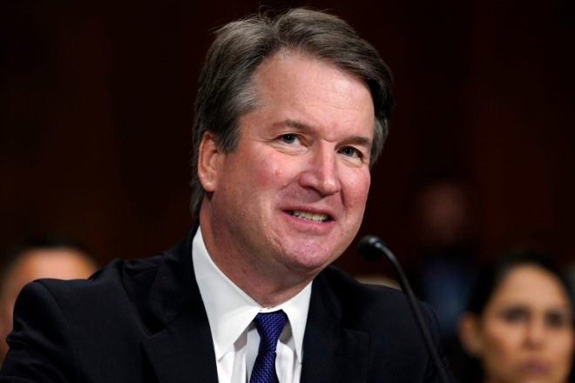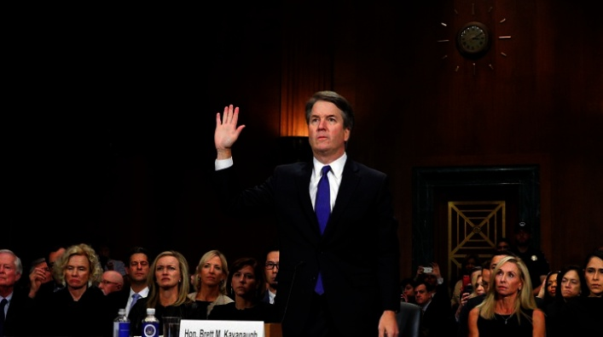
By Alana Abramson - Updated: October 6, 2018 4:50 PM ET Time Magazine
“Judge Brett Kavanaugh will soon be Justice Brett Kavanaugh. But the consequences of his confirmation Saturday will inevitably be analyzed for years to come – not only on the Supreme Court and the Senate, but across the country.
The Senate voted 50-48 to confirm Kavanaugh to the highest court in the land, a relatively anticlimactic finale to one of the most contentious Supreme Court confirmation fights in recent history. The vote was consistently interrupted by protesters shouting from the gallery, causing Vice President Mike Pence, who was presiding, to call for order. Protesters also descended on the Capitol to express their dissatisfaction with the confirmation.
The confirmation not only exposed the raw emotions of sexual misconduct allegations, but sparked intense national conversations on class, privilege and gender. Chief Justice John Roberts and retired Justice Anthony Kennedy – whose seat Kavanaugh is taking – will swear him in as a justice later Saturday, `…so he can begin to participate in the work of the Court immediately.’
Kavanaugh’s path the Supreme Court seemed all but assured before allegations surfaced from Christine Blasey Ford that he had tried to rape her at a house party in 1982 when they were both in high school. Two other accusations followed – all of them decades old. Deborah Ramirez alleged that Kavanaugh exposed himself to her when they were in college, and Julie Swetnick alleged she wasn’t gang raped at a party Kavanaugh attended. Ford, a California psychology researcher, was called before the Senate and her testimony Sept. 27 riveted the country, sparking numerous women, including high profile figures like Connie Chung, come forward with their own stories of sexual assault. Kavanaugh’s testimony in response, later that same day, was a boisterous emphatic denial of any of all claims of impropriety.
…An FBI investigation was unable to corroborate her allegations, although Democrats decried that process itself was a sham and purposely manipulated by the White House to reach that conclusion.
…`I think there’s going to be a cloud over Justice Kavanaugh for most of his career,’ said Paul M. Collins, Jr., a political science professor at the University of Massachusetts-Amherst and co-author of Supreme Court Confirmation Hearings and Constitutional Change, a book about the history of Supreme Court confirmation hearings. `This was possibly the most controversial Supreme Court nomination in American history…it doesn’t look good for Kavanaugh and it doesn’t look good for the Supreme Court.’ The political implications will likely be found at the polls in the upcoming midterm elections on Nov. 6…’”

My note: The “circus” of those accusations, publically stated, was a sick Leftist/Globalist “joke,” a staged set-up to bring down a conservative Judge. During the proceedings the cameras did not show the violence and demonstrations within the hall, some very nasty and sick by perverts, so much so that the police had to drag some off and out.
Judicial Watch said the public proceedings were unconstitutional. It should have been handled by the FBI from the beginning. Trump called in the FBI to investigate, which should have been done before the “circus” started, and the programmed actors took center stage. A huge replica of the Arch to the entrance of the temple of Ba’al in Palmyra, Syria, was set up in Washington during this circus. It was erected by a Roman emperor as a victory Arch of their triumph over Parthia, an Israelite nation. The whole fiasco was an example of the depths of the depravity that America has sunk to!
During this ugly tragedy, Brett Kavenaugh’s wife received evil hate mail, and threats of murder. Kavenaugh, age 53, has children also at home. Vicious threats being made to our conservative Politicians, is increasing!

“US Kavenaugh Sworn in as 114th Supreme Court Judge GOP Senators Receive Death Threats” - October 6, 2018
“BREAKING: GOP Senators Receive Death Threats on Their PERSONAL CELL PHONES Following Kavanaugh Confirmation” - by Cristina Laila October 6, 2018 Gateway Pundent
“Brett Kavanaugh was sworn in as the 114th Supreme Court Justice in US history Saturday evening, October 6, 2018. The Democrats, led by Dianne Feinstein and Chuck Schumer launched the most evil smear campaign against Kavanaugh in modern times–and they still lost. Republican lawmakers have been screamed at, assaulted and intimidated by unhinged leftists leading up to Kavanaugh’s confirmation–now the GOP lawmakers are receiving death threats on their personal cell phones.
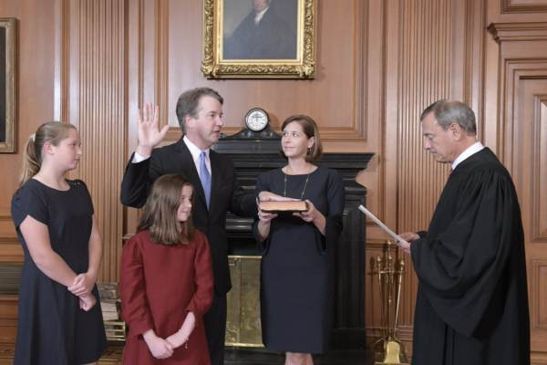
The hysterical liberals aren’t taking the news well–tears flowed and they screamed at the sky.
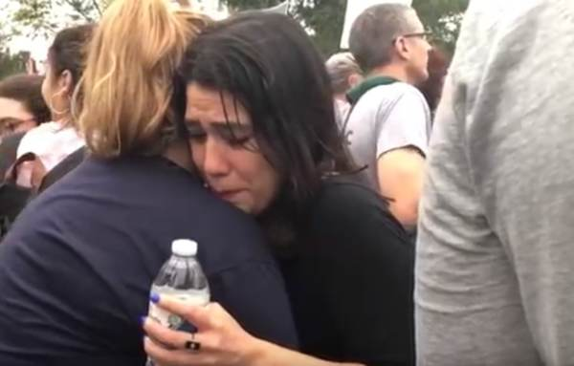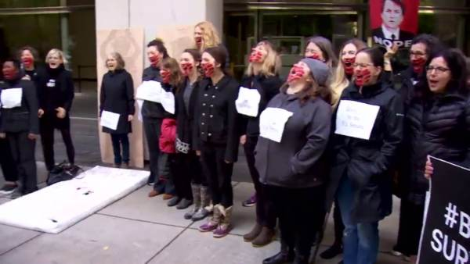
Unhinged leftists also stormed the SCOTUS steps and pounded on the courtroom doors!
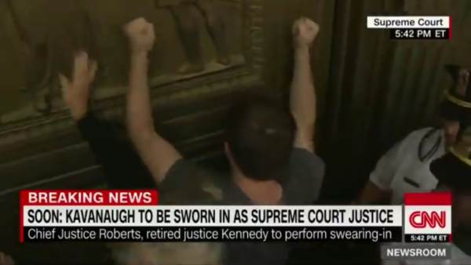
Now they’re threatening to kill Republican Senators.
An unnamed GOP Senator told FOX News that Senators have had death threats text messaged and called in to their personal phones. The Senator also said this is `unusual.’ ”

“UPDATE! Kavanaugh Confirmed! Pandemonium Alert! With Total Bedlam From The Left One Possible End Result Of Today's Supreme Court Confirmation Vote - Will Violence Become A Permanent Part Of Politics In America?”
By John C. Velisek - US Navy, Retired - All News Pipeline – October 6, 2018
“(ANP Update: Kavanaugh Confirmed! Confirmation vote video embedded at bottom of story. Vote is expected to be sometime after 4:30 p.m. eastern time Saturday.)
…Today America is split into different groups, pitting white against black, men against women, rich against poor, and various other groups that the progressive socialists can use to separate our country…George Soros funded group MoveOn, org is planning violence along with others…The University of Maine is giving college credits to students who leave to protest. Yale closed classes to allow their students time to protest. They will claim that it is their right to protest but refuse to give the same right to pro-Kavanaugh supporters. They have torn up signs, attacked the supporters and shouted them down.
…Now that the FBI has finished the investigation and found no proof of the allegations, the next step in coming into focus.
So now the paid shills of George Soros, the socialist of the Hollywood crowd, and the political sycophants that are promoting the violence against members of the political class which you do not agree with are promising violence to President Trump, Judge Kavanaugh, and even the citizens of our country who do not agree with the socialist policies that they are attempting to force on the American people.
The American left is anti-Christian, anti-unity, and have been shown to have no morality, no shame, and no decency. In the past, Republicans and conservatives have meekly allowed the progressive socialist Democrats to push the agenda. The reason for the escalating violence and intimidation attempts is because the conservatives are fighting back and see through the lack of policy of those socialists who think they are our betters and should be given the opportunity to run our lives.
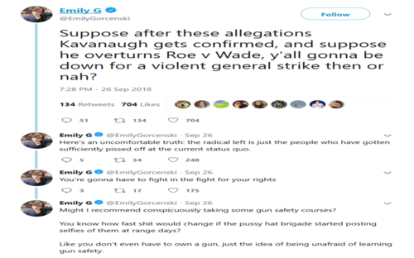
The examples are growing day by day. Rep. Andy Harris, Republican from Maryland faced protesters who tried to break into his office. Republican Senators who are supporters of Judge Kavanaugh have been accosted in airports, restaurants and even Capitol Hill by protesters who are nothing more than sociopathic malcontents bought and paid for, and encouraged by the leftists. This is nothing more than what the progressives socialists learned at the altar of Alinsky follower Barack Obama and the old Soviet system. We even have…Joe Biden calling conservatives the “dregs of society.”
…The American people do not want the country to turn into Venezuela, and reject the policies that would make it so. Using the Alinsky principles, the only avenue left to the progressive socialists is personal destruction and violence. The American people understand that Judge Kavanaugh is a constitutionalist who will interpret the law as written. The leftists cannot allow that to happen. If they allow Judge Kavanaugh on the bench, they will no longer be able to use activist judges to push through the laws that the American people don’t want or need.
The American people don’t want a weaponized government…I do not think the sliming will work with Judge Kavanaugh, whose stature has been beyond reproach until the progressive socialists started trying to shame him out of becoming the next Justice of the Supreme Court. They did not consider that Judge Kavanaugh and the American people are stronger than that.”

The target of anger and violence in America is fast turning on true born-again dedicated Christians. I urge you to read Tom Horn’s book Blood on the Altar. The atheist and Satanic groups within the U.S. military are turning on Christians who witness about the Savior, even trying to take down officers that are righteous.
***Take note: I go by no labels. I am not a “Christian.” I am not a “Messianic.” I don’t slot into a religious man-created file folder. Neither does the Word, or Elohim. But, my belief in the entire Word of Yahuwah and Yahushua, my careful obedience of it, and my knowing Elohim personally, slots me with Christians and Messianics in the minds of those that hate the Word and hate Yahuwah, and Yahushua, no matter what English names are used. Therefore, persecution is not going to notice you’re not in a file folder, because your life style and open faith prove where you stand!
With the appointment of Judge Kavenaugh to the Supreme Court, following a satanic circus openly displayed to the world, America’s future has been set in motion. This satanic demonstration was used by Satan’s emissaries to put the plans for world government into place, to create violence, chaos, and evil to go forth to bring America down. So, the push is on! Yahuwah has given His nod to the kingdom of darkness to go forth and do as they will, but they know full well, as do we, that Yahuwah holds the leash around their necks!
More and more public school teachers are forbidding any sort of Bible-related talk or expression in their class rooms, with Principals agreeing. But, this began years ago in the 1990s. When the “See You at the Pole” began in Texas on the 1st day of school in September, and students gathered to pray together, some Principals actually called the police on the students and had them arrested. The attitude of the students, and I mean High School students, was that of those in Acts 4 and 5. They felt privileged to be persecuted for loving Jesus.
This is very dear and close to my heart. Being led by the Spirit via His words to me one morning as I dropped off my 2nd daughter at her school, using Acts 18:9-10, I contacted her Christian Biology teacher. My daughter said he refused to teach evolution and told her class so. He asked me to join the early morning prayer meetings with a group of Christian teachers at her Middle School (Fort Worth, Texas.) They were praying for a breakthrough to reach the children with the Gospel. So, through many morning prayer sessions, lots of discouragement, and obstacles, Abba came through for us. We were allowed to form a student-led Bible Club that was very well attended for years. It was a miracle that the Club was allowed. It was a huge miracle, as it had to be signed into existence by an antagonistic agnostic on the Fort Worth School Board. The school Principle was very much for the club, standing with me, and with the Christian teachers for it. I mean it was a miracle! The praying Christian teachers were so excited. A few years later, I was in my car waiting to pick up my youngest child from the same Middle School, and a nice-looking young man walked by the car with a big Bible under his arm. I rolled down the window and called to him. I asked him where he was going with that big Bible. He said he was the president of the Bible Club and was going to a meeting. Oh how that warmed my heart. I often wonder how it is doing now with persecution so rampant by teachers, Principals, and other students.
I remember my friend Karen, a natural witness to those in market places, a former missionary to Nigeria, who was sitting in the Parks Mall in Arlington, Texas. She sat by a young soldier. Then she pulled out her small New Testament. When the solider saw it, he acted fearful. He told her to put it away because of all the cameras that were trained on people in the Mall. That was around 2007. As Tom Horn points out in his book, the U.S. military has made it illegal to give a Bible to a soldier.
I began witnessing about the Savior at age 6. At age 20, I preached openly on the streets of Los Angeles and Hollywood. I passed out tracts in malls and shopping center areas. I talked to people on the street about their salvation. I did street evangelism for many years, even leading a “church on the street” down by the Port of Long Beach, California. Evangelism was my life. It still is. But, nowadays, a person can be arrested for preaching on the street, or praying openly in public, and fined heavily. The Bible has become an international “hate crime book.” The Name of Yahuwah/Yahweh has become a banned name. Under Pope John Paul II, the use of “Yahweh” was taken out of Catholic Bibles, like the Jerusalem Bible, and out of their hymnals, and the edict went forth worldwide that it was illegal to use that Name even in prayer or in private home meetings, and especially not in church.
Even into high levels of the U.S. government, those that hold home meetings are questionable, and sometimes liable for arrest, meetings where people pray and read the Bible, and talk about it. Police were called on a home meeting in California a few years back and the police asked if they were praying and reading the Bible. When the pastor said “yes,” he was warned not to hold any such meeting again.
A few years ago in the U.K., a pastor went to deposit the tithes on a Monday in his bank. He was told that his account had been closed. It was because he spoke against homosexuality the previous Sunday.
I remember the case of a Kindergarten child who drew a picture of Jesus on the cross at Easter time. She was sent home by the teacher for breaking school rules.
In another such case, a young boy brought his Bible to school to read during recess and at lunch. He was sent home for bringing a Bible to school and reading it.
I remember watching the proceedings of the taking down of a Ten Commandments monument outside of an Alabama Courthouse – official November 18, 2002. Many people were on their faces praying as the monument was removed. The news commentator said of them, “they are the militia.”
It used to be that copies of the Ten Commandments were put up in schools. But, since this happened, they were not allowed anymore. The Governor of Alabama said: “We cannot say for the State of Alabama that there is a one true God.” The Supreme Court backed the taking down of the Ten Commandments in public schools saying that children might read them and do them. Uh… Doesn’t that ring of insanity! Ten Commandment monuments were taken down all over the U.S. Georgia took them down from courtrooms. The monument was even taken down from the grounds of the convent of born-again, Spirit-filled, Lutheran nuns in Arizona. “…you will be hated by all men for My Name’s sake,” Messiah warned us.
Are you spiritually pressing in to know Yahuwah and Yahushua as Persons, so that you hear from them in your spirit, and are able to follow Their daily directives? I do not know what I would do if I could not hear from Them in my spirit daily! My whole life is hearing and obeying. And oh the peace They give--“peace that passes all understanding.”
America is already in the early stages of full-blown civil war, but the violence is increasing drastically. It is also happening all over the world. The situation in South Africa is horrendous. The slaughtering of the white people is condoned and encouraged by the government. White farmers have had to flee--their land being taken from them with no compensation. Many have been killed. Read my recent article: “South Africa – Learn and Watch”/Mikvah of Present Reality.
The mid-term elections will spark even more violence. They are coming up fast on November 6th. There are many very dedicated Muslims running for high offices, as well as sexual perverts, and haters of Trump who want him dead as they openly say. There are those who condone the sex-trafficking of children who are getting major votes. The voices of pro-abortionists, haters of God/Yahweh and Jesus, haters of the Bible, sexual perverts, insane killers, haters of “white nationalists,” “white extremists,” “white privilege”-haters, and all radicals for chaos and upheaval, are greatly increasing. America is becoming another South Africa, but also becoming very much like China, who leads the pack in murdering Christians.
As is openly proven, America created AlQaeda, the Taliban, ISIS, and several other terrorist groups like them, funding and providing weapons for them. These groups have stirred up hate for Christians in the Middle East, Africa, Europe, and all over the world. As Tom Horn’s book Blood on the Altar states, America is behind the world’s increasing persecution and slaughtering of Christians, behind the massive beheadings. We are also the world’s #1 supporter and funder of abortion worldwide, drug trafficking, and sex-slave trafficking. I’ve worked among the persecuted in China. Now, under President Xi Jinping, hailed as the new Mao TseTung, the persecution has increased and the hunting down and killing of true believers is in full force. This breaks my heart.
Live in Abba’s Presence! Press in to know Abba and Messiah! Prepare to stand strong in the face of the enemy, and not deny Messiah, nor deny the Word, nor deny who we are because of our Yahuwah and Yahushua.
II Timothy 3:12-14: “And indeed, all those wanting to live reverently in Messiah Yahushua shall be persecuted. But, evil men and imposters shall go on to the worst, leading astray and being led astray. But you stay in what you have learned and trusted…”
In His love, shalom!
Yedidah
October 8, 2018

