**BEACH-FRONT PROPERTY?**

**PLANNING ON LIVING ON A HOUSE BOAT OR**

**PERHAPS IN A CANOE?**

**TODAY’S ALERT!**

**Actually, this is anything but humorous. People are seriously working on moving out of Florida to higher ground, as well as from other states that are in the path of the dividing of America in half.**

**I’ve been reporting on this over several years as the topic kept arising. It’s not just speculation, or a “maybe.” Signs are showing it to be an approaching reality, just like the great divide along the West Coast due to the very real potential of the Cascadia Fault Line. Already Southern California is having swarms of earthquakes as the unsupported shelf it sits on is very unstable. The San Diego area is expected to lift up and slide into the ocean.**

**Yes, this might happen at Messiah’s return when the earth will shake and quake at His Presence. We’ve got Isaiah 24 yet to come. Whatever Yahuwah speaks of is a for-sure thing - in His timing of course. But, what benefit would these things be in the Kingdom of Messiah on earth? None! So, they will come before. These things will put the world’s people into a terror mode, during which the fallen ones may orchestrate an “alien invasion” or a fake “rapture,” which is actually been planned by the Luciferic elite using Nephilim technology. They’ll cause so much chaos in general that the survivors will accept anything that appears to help. See Luke 21:11, 25-26, Isaiah 24, Haggai 2, Hebrews 12:25-29.**

**We’ve been hearing for a long time about the New Madrid fault line. I spent months reporting on it at the time of the BP Oil Rig explosion. The result of that is still pumping oil into the Gulf, and affecting the Jet Stream along with other outside factors. But, now the underearth conditions along the New Madrid Fault Line are making the likelihood of its rupturing and separating a real and serious danger.**

**When living in Panama, I had a dream. The next morning, I checked it out on a map. It was very clear. In the dream I saw two little wooden holders, like you put business cards in and set on a desk. On the left I saw “St. Paul” written on a white card in all capital letters. On the right, I saw a card with a pyramid on the left, and overlapping the pyramid a bit was the name “Memphis.” Down the Mississippi, from the Great Lakes area, past where the Ohio River flows in and moving south to the Gulf are the cities of St. Paul and Memphis. Memphis is known for its big symbolic pyramid. It is amazing how many rivers join the Mississippi River.**

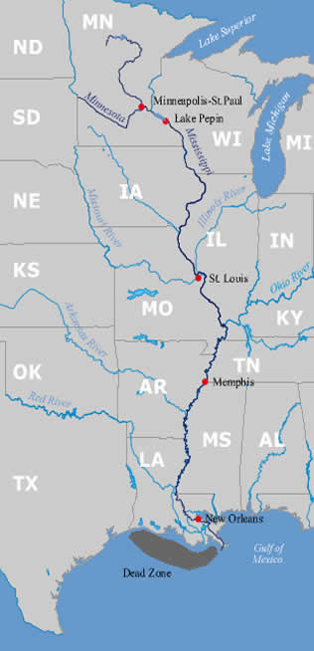

**The dead zone area is where the rigs were**

**The explosion of the Deep Horizon BP Oil Rig happened April 20, 2010, which just so happened to be Hitler’s birthday. Adolph Hitler was born April 20, 1889. The oil rig explosion set off an oil spill under the Gulf that killed much of sea life, affected the Jet Stream, and continued on to damage the sea floor. There was so much symbolism to this event that I wrote many, many articles about it. And mysteriously, the event was exposed a year earlier in the Hollywood movie “Knowing,” which came out March 9, 2009. The news announcement of an oil rig explosion in the Gulf in the movie with pictures, was nearly a double of the real news report in 2010. A BP Oil Rig game came out in the 1970s and an explosion of an oil rig. The explosion on Hitler’s birthday was planned far in advance! NOTE THE RED DOT BELOW IN THE MAP.**

**When the New Madrid splits, the water from the Great Lakes will spill down the Gulf and divide the United States, as you can see from the Navy map below.**

**Here is Quayle’s report from today, October 7, 2020**

EMERGENCY REPORT: THE NEW MADRID FAULT

UNIMAGINABLE EARTH CHANGES UNDERWAY  
  
Steve Quayle: "LADIES AND GENTLEMEN, I'M REACHING OUT TO YOU EARLY THIS WEEK BECAUSE OF A LOOMING CRISIS THAT MAY BE ABOUT TO LITERALLY RIP OUR COUNTRY IN HALF, AND CHANGE THE U.S. COASTLINES FOREVER. **SIMULTANEOUS TECTONIC SHIFTS, EARTHQUAKES AND VOLCANIC BULGES INDICATING ERUPTIONS, ARE SIGNALING THE COMING SPLIT OF NORTH AMERICA ALONG THE NEW MADRID FAULT LINE!**MASSIVE HOT SPOTS, COUPLED WITH MAGMA MOVEMENT BENEATH THE NEW MADRID, ARE RAISING VERY SERIOUS CONCERNS AT THE HIGHEST LEVELS OF GOVERNMENT. THIS U.S. NAVY MAP SHOWS IN GREAT DETAIL WHAT MAY HAPPEN TO WATER LEVELS ACROSS THIS LAND, IN A VERY SHORT TIME.  
  
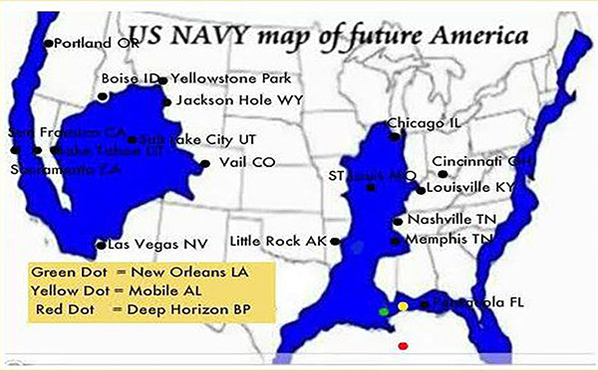   
 Hello Steve -- This report is about the **DANGEROUS things happening along the New Madrid Fault Line** and extending to the edges of the NORTH AMERICAN PLATE.  
  
**1>** There are totally visible hotspots along the fault even going to the bayou and gulf coast. Some hot spots are 1,100 degrees, and some have been measured by locals as high as 1,350 degrees at ground level.  
  
**2>** There are now planes constantly flying over this area because the results of the North American plate BENDING AND CRACKING into 2 pieces is a huge event. What the planes have discovered so far is that there are sub-surface cracks which go as DEEP as 600 kilometers down.  
  
**3>** The cracking and BENDING has already tripled the SUBDUCTION ZONE stress IN CASCADIA, 3X FROM 2 WEEKS AGO.  
  
**4>** The stress on the east coast IS also increased at least 3x in the SUBDUCTION ZONE.  
  
**5>** THE ENERGY REQUIRED TO CAUSE THIS TYPE OF EVENT IS BEYOND THE ABILITY OF HUMANS TO DO. THIS MEANS DIRECTLY THAT **GOD IS SPEAKING TO PEOPLE** TRYING TO GET THEIR ATTENTION AND CONFESS SINS AND PRAY FOR THE NATION.  
  
**6>** THE VAST ENERGY RELEASE HAS ALSO RUINED MUCH OF THIS YEAR'S HARVEST SO DO NOT EXPECT A HUGE THANKSGIVING FEAST. JUST BE THANKFUL FOR HAVING FOOD TO EAT KNOWING THAT AT LEAST 50% OF OTHER AMERICANS DO NOT HAVE ENOUGH TO EAT TO STAY ABOVE THE STARVATION LEVEL.  
  
**7>** WHEN EVENTS DO OCCUR IN EARNEST **EXPECT EARTHQUAKES 7.9 TO 10.2 TO HIT THE WEST COAST THE MIDWEST AND THE EAST COAST**. ADDITIONALLY WE CAN EXPECT LARGE VOLCANIC ACTION HITTING BOTH WEST AND EAST COASTS.  
  
God bless and protect all of you in these days.... Doc  
  
**1811–1812 New Madrid Earthquakes**

earthquakes 7.2–8.2 magnitude on December 16, 1811

**LINK:** [NewMadridQuakes/Wiki](https://gensix.us15.list-manage.com/track/click?u=88befd3e64cb064b755b53d1c&id=74015adb1c&e=2005cc5759)  
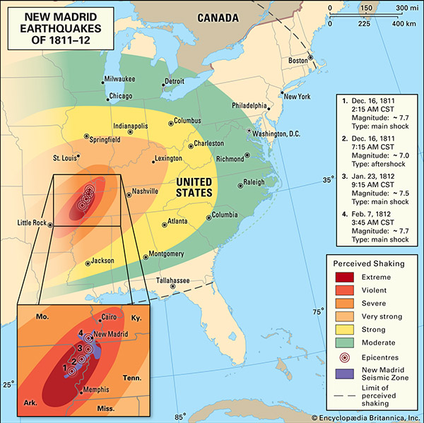

In 1811-1812 an earthquake hit the New Madrid fault line and the water. Read about it on line. The water of the river went backwards. An earthquake of this intensity has far-reaching potentials.

Seismologists have long said that another earthquake along this fault line is way overdue, and will split the U.S. in half. The earthquake magnitudes were strong. On July 5, 2019, an earthquake hit the Ridgecrest area of California with a 7.1 magnitude. The aftershocks happened over months, numbering in the thousands. It had last destabilizing of the fault line there, and released magma from a deep volcano to flow towards the San Andreas Fault Line to the West and the Pacific Ocean. With the 7.0 to 7.7 magnitude quakes in 1811-1812, look at how far the quakes reached. This time Seismologists look for another massive quake along the New Madrid Fault Line that will divide the Mississippi River down the middle, allowing the Great Lakes to flow into the gap from Minneapolis–St. Paul down to the Gulf, passing the pyramid in Memphis down to the Gulf.

Read **Isaiah 20**. The pole shift is already happening and the earth is already destabilized in many ways. Space debris is falling, etc. etc.

Press hard into the Presence of Yahuwah, and allow His Spirit to rule your life!

In His love, Yedidah

October 7, 2020