BIDEN IN ISRAEL MEETING WITH NETANYAHU OCTOBER 18 2023 – WORLD RIOTING
DECEPTION INTENSE

NOTES FROM VIDEO: “EMERGENCY ALERT!! ISRAEL WAR UPDATE!! RUSSIAN JETS W/ HYPERSONICS TO PATROL WITHIN RANGE OF ISRAEL!” NYPrepper

Biden is also meeting with the Israeli war-cabinet. Putin is in China now talking to Chinese President Xi. Russia will have fighter jets with hypersonic missiles patrolling the Black Sea – to be ready to fire on whoever tries to start trouble – which probably would be Israel. These missiles have a 1,000-mile range. Russia doesn’t mess with the puny stuff.
Looking at the map: The Russian position puts the US Navy ships in the Mediterranean Sea within firing distance. So, Russia can hit Israel and U.S. ships from their position in the Black Sea.
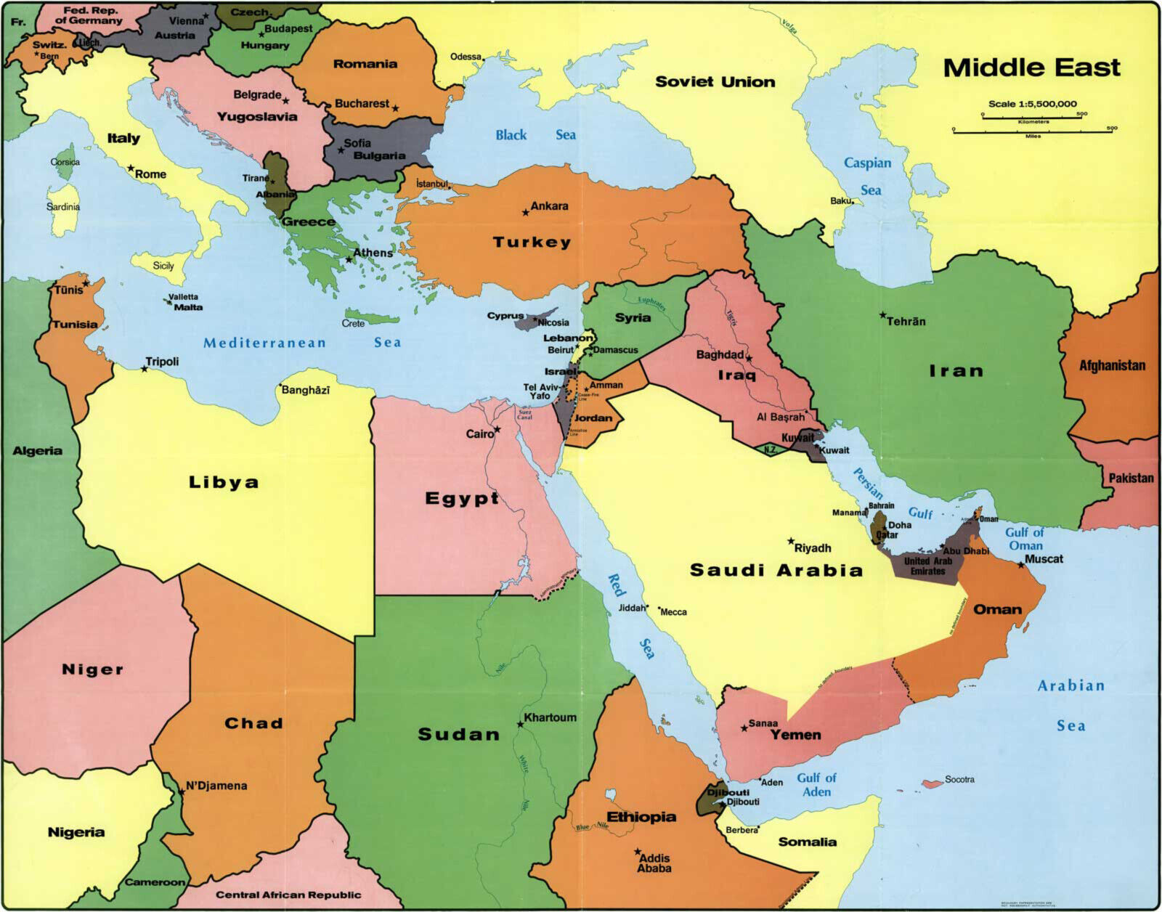
Obviously! Russia patrolling the Black Sea with fighter jets loaded with nukes, while the U.S. is coming into the Mediterranean Sea near Israel/Syria, gives Russia an easy strike advantage.
Biden is blaming the destruction of the hospital in Gaza on Hamas. He is coming in with defense of Israel against Hamas, against Syria, Lebanon … and Iran. Isn’t this what George Bush Sr. said – that 7 countries that had to be destroyed before the new world order could come – the only one left for destruction on Bush’s list is Iran.
The evil ones join together to perpetrate the great evil – which Russia and team can destroy.
Biden definitely let Israel know that America would stand in war with them against their “enemies.” But who are the enemies? Who tore up the Middle East peace beginning with the attacks on Syria. Who continued to attack Syria? Who uprooted Egyptian President Hosni Mubarak? Who are the war-starters? Sad to say but they are the sanctimonious “Holy Nations,” both so adored for so long (over 70 years): Israel and America.
Russia contacted Israel for satellite images to prove that Israel did not attack the hospital, Hamas did. However, it’s more than likely that Israel did and blamed it on Hamas. Israel, being the land of Khazars, is an evil place right now. They are provoking war, just as America is provoking war with Russia.
Egypt is telling Israel that if they kick out the Palestinians from Gaza into the south, Egypt will consider it an act of war … and Egypt will join the fray.
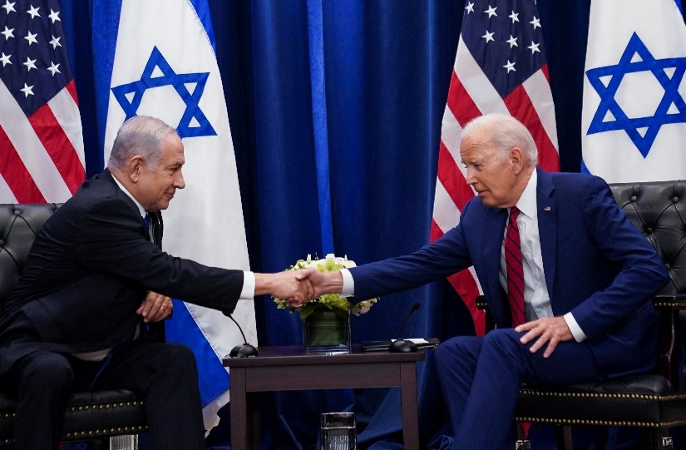

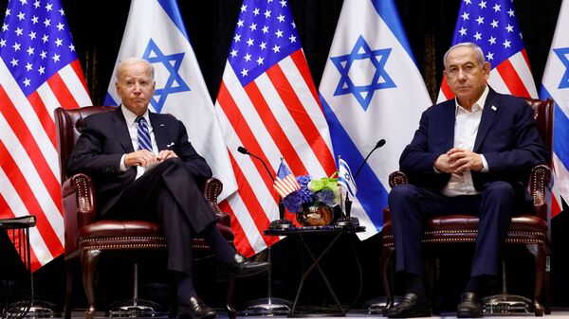
Oh how American lollypop fantasyland Christians are standing with Israel, waving the American flag, and calling for God to protect Israel. Well, in the Word “God” does not protect Israel. He has to purge it. He has to judge. He has to take down America.
I lived in Jordan 8 years: 1999-2007. I lived in Israel 8 years: 2007-2014. I understand the Middle East. I understand the façade of “holiness” in Israel/in Jerusalem and among the Pharisee Talmudic/Kabbalistic rabbis. I also understand the hypocrisy of the government and of Judaism as a whole. It is so pitiful that American Christians do not study the Word for truth, for when a person loves Truth, they come to understand what is true and what is false by the Spirit of Yahuwah.
It does appear that Ezekiel 38 could be very well in the works. They don’t know the Word, nor Abba. They live in a religious mirage that makes Lucifer mock and laugh. All the prayers going up for loved Israel and America, yet the real minister of Yahuwah’s will in all of this is Russia. It’s a sick joke the religious devils are playing on the emotions and mentalities of the ignorant Christians, and/or Americans in general. The mind programming via the TV and the culture in general has taken its toll, as well as the mind programming of the public school system.
Sad to hear, the commentator of this video say: “even Jordan is turning on Israel.” “Right now, there are masses of people in Amman protesting against Israel.” That’s very sad for me. Jordan was a peaceful nation.
I know King Abdullah will do all he can to protect Jordan and its citizens. But Jordan and Israel are kissing distance from each other there on the Red Sea at Aqaba. Plus, realistically, Israel is the very evil one pulling the strings for war.
3 million Iranians today have registered themselves for jihad. Iran has a gigantic military, top ground/below ground. Yet, these citizens want to fight against Israel. Well! How can a person who sees as Yahuwah sees, blame Iran.
Israel has been bombing Iranian sites in Syria on a semi-regular basis for a long time! Israel has been bombing Damascus and pledges to wipe it out (Isaiah 17). Israel has even bombed some areas of Iran not long ago. So, Israel has been begging for Iran to attack. Israel has been begging for Syria to attack, Lebanon, Iraq, Egypt, just as the American government has been begging Russia to attack from the U.S. East Coast to West Coast, and everything in between. Iran knows they’ve been provoked over and over, yet, like Russia, Iran has had restraint. Now, all the restraints are coming off. How long can a nation be continually tormented and do nothing to retaliate? Russia has reached the end of their patience with America. Iran has reached the end of their patience with Israel. Other nations round about have reached the end of their patience with America’s insane destabilization of the Middle East, killing of innocent people, etc. and do nothing to retaliate?
***For the 1st time since 1982, since the Lebanon war, the entire reserve Israeli military and all battle tanks have been called up: 1,000 battle tanks; over 360,000 troops
“Israel is preparing for war with ALL OF THEIR NEIGHBORS.” video narrator. Today, Iran sent two drone bombers to target an American Military base in IRAQ.
“Right now, Lebanese people are storming the US Embassy in Beirut.”
People are starting to riot against Israel and the US in the Middle East. It’s all been provoked by America and Israel mainly. The Middle East was peaceful but peace makes no banker richer. So, Obama had to destabilize Syria. In the 1990s the U.S. President had to make Iraq appear to be bad, thus making it a U.S. battle zone. Then later with Gulf War II, the President had to create the war in Afghanistan. They had to create Gulf War II (2003).
American bankers thrive on creating, funding, controlling war. U.S. Bankers sent agents to kill the Russian Czar and his family to start WWI. They allowed Pearl Habor to be blown up, and our boys with it, in order to enter WWII. Now, they are creating WWIII by illusion – the bad guys look like saints. The good guys are made to be wicked, evil, sons-of-Satan enemies. And the lollypop fantasyland joy-riders love it, believe it, stand up for the evil, and condemn the good (Isaiah 5:20).
Hezbollah targeted an Israeli Naval Base today. Israel has done a magnificent job of starting WWIII and even bringing Russia and the U.S. into it.
Biden was getting tired of Ukraine. He said he’d send no more weapons there.
Money laundering most likely continues. Now, the big angry nations with their unstable religious leaders are turning to killing in the Middle Eastern nations.
Stirring up the most prone to violence – i.e. Muslims – is doing the job for the big money nations, just as in 1948. The British military brought down the armies of the Nazi Arabs to attack Israel on May 15, 1948.
The commentator spoke of the night of October 17th. He said all over the world U.S. and Israeli Embassies were being attacked. It was a night of Chaos. But, then, “the night of the broken glass,” Kristallnacht, is what Hitler arranged to turn the nation against the Jews. What is happening now is so close to what Hitler pulled off November 9-10, 1938. We are so close to an anniversary of this in the upcoming November.
Assault on Jews
“The assassination provided Adolf Hitler with the excuse he needed to launch a pogrom against German Jews. It would become known as Kristallnacht, "the night of broken glass." His deputy Joseph Goebbels orchestrated the violence across Germany. On the night of November 9, 1938, rampaging mobs attacked Jews in the street, in their homes, and at their places of work and worship. Nazi storm troopers allowed the destruction and arrested as many Jews as the jails could hold. Broken glass littered the streets in front of burning synagogues. By the end of the night, 91 Jews were dead, more than 900 synagogues were burned, nearly 7,000 Jewish businesses were destroyed, cemeteries and schools were vandalized, and 30,000 Jewish men had been deported to concentration camps. The following day Goebbels wrote in his diary: "As was to be expected, the entire nation is in uproar. This is one dead man who is costing the Jews dear. Our darling Jews will think twice in future before simply gunning down German diplomats."
Turning Point
Three days later, on November 12, the top Nazi leadership met to enact a wide-ranging set of anti-Semitic laws that segregated Jews into ghettos, placed a curfew on their activities, banned their ownership of guns, suspended their driver's licenses, and confiscated their radios. In addition, the Nazis fined German Jews one billion marks for vom Rath's assassination and for "broken windows." At the end of the meeting, Hermann Göring announced, "I have received a letter written on the Führer's orders requesting that the Jewish question be now, once and for all, coordinated and solved one way or another." Kristallnacht became a turning point in German policy, setting into motion the Nazis' systematic extermination of Jews, the Romani people, Communists, Christians, homosexuals, the mentally ill, and other Nazi enemies: the Holocaust.”
Please refer to my article: “Kristallnacht…” November 19, 2016, #30, Mikvah of Israel, Our Eternal Inheritance.
Seeing the parallels, it is amazing that what is happening now was a Nazi tactic. The article has quite a few pictures with it. As you note what happened then, and the now rise of the Nazis again, the “Fourth Reich” coming, you’ll see how Hitler’s tactic is working again!!!
And who was Josef Goebbels, or who did he become to Hitler? He became his CNN, NBC, major newspaper story controlled, too, etc. He became his propaganda news reporter that turned Germany against the Jews. U.S. public news is basically another “Josef Goebbels” new network.
In Turkey mobs attacked a U.S. military base. All over the Muslim world, U.S. positions are being attacked. Strangely in France, many attacks by Muslims are happening. 4 French airports are being evacuated. Remember how western European nations took in loads of Muslim “refugees” a few years back, like Germany. They began undermining and destroying European nations.
Who are these people. Many are mercenaries, hired, created terrorists by the U.S., like ISIS. Many are just regular people who have been stirred up, actually by the truth.
Stay in the peace of Yahuwah and Yahushua. Messiah said: “From your innermost being, your belly, shall flow rivers of living water. This He spoke of the Spirit, who was not yet given because He was not yet esteemed.” He had not died and rose again. But, Acts 1, after His ascension, is followed by Acts 2 when He fulfilled His promise to send Yahuwah’s Spirit into the spirit of His disciples/apostles. He still does it. We are the temple of Yahuwah – let Him dwell and rule from your spirit! His Presence is our empowerment for going through what we must soon go through, with His peace, even joy.
In His love, shalom, Yedidah
October 18, 2023

